Provisioning in a Grid system is the process of modifying or adjusting the configuration of a domain of resources and capabilities to meet the needs of the activities (e.g. jobs, tasks, and services) that need to be “run”. Provisioning includes the planning these changes, allocating sufficient resources and then deploying and configuring those resources into capabilities that support the desired activities. The provisioning process is carried out in support of activities, functions, services or other requirements. It is triggered by other processes in the Grid such as job scheduling, workload management, systems management etc. Many of these processes (including Provisioning) are implemented as activity control loops that monitor resource state, analyze that state as it relates to policies and objectives, and then make adjustments to their domain of resource management.

Provisioning encompasses the following activities:
- Receiving requirements for changes to the configuration of capabilities and resources within their domain. Requests for changing the configuration of the domain may be a result of the changing requirements of activities to be supported by the domain, the failure of components in the domain, or the addition or removal of components by external actions.
- Planning configuration changes to the resources and capabilities involves examining the collection of resources (both existing and possibly newly added) in the domain, determining how they must be configured (or re-configured) to achieve desired capabilities and developing a sequence of actions that will accomplish that change. This planning function will need to “understand” relationships between resources and the composition or configuration of those resources that are required to realize particular capabilities. For example, to provide an execution capability for a particular type of service (such as an EJB-based service) a combination and configuration of system resources such as processors, memory, network bandwidth, temporary storage etc. might need to be allocated and configured. Further particular software including an operating system, specific middleware, and even application may need to be deployed. This planning activity further requires examination of policies, constraints and objectives that may limit the flexibility of some provisioning options.
- Allocating and Deployment are involved with the execution of the plans described above to achieve the configuration of a specific set of resources into capabilities that can be used in support of activities. when the activity starts.Allocation of hardware resources may involve processes that actually manipulate physical or logical capabilities (such as logical partitions or processors in multiprocessor complexes, or network switch configuration). Deployment of software resources may include copying needed executables and installing (or uninstalling) programs in a specific sequence. Some logical resources may actually be created as a part of the provisioning process (indeed this may be the goal of some provisioning actions). Actually starting or stopping hardware or software resources or execution of processes may also be part of Allocation or Deployment.
- Verifying is a process that will test adjusted configurations to insure
- that the capabilities are in a ready state to support activities. Verification may involve sending test transactions or messages to newly configured capabilities to ensure that they are available.
Un-provisioning is actually integral to the overall provisioning process. Logically unprovisioning is specific workflow within the provisioning cycle that is opposite to provisioning and operates in reverse of the provisioning cycle described above. Un-Provisioning first Verifies that hardware or software processes that were in use by activities have been quiesced. Then it Deallocates and Un-Deploys constituent resources. This could possibly involve reconfiguring hardware and uninstalling software. Resources that are un-provisioned are returned to the domains pool of available resources that can be used in other provisioning actions.

Grid resources including hardware (for example processors, memory, storage and networking resources), software (for example applications, data and any applicable licenses), Grid services (upon which the requesting Grid service depends) and other configurable entities (for example user accounts, expert support teams, etc.).
Relationship to Other Management Activities:

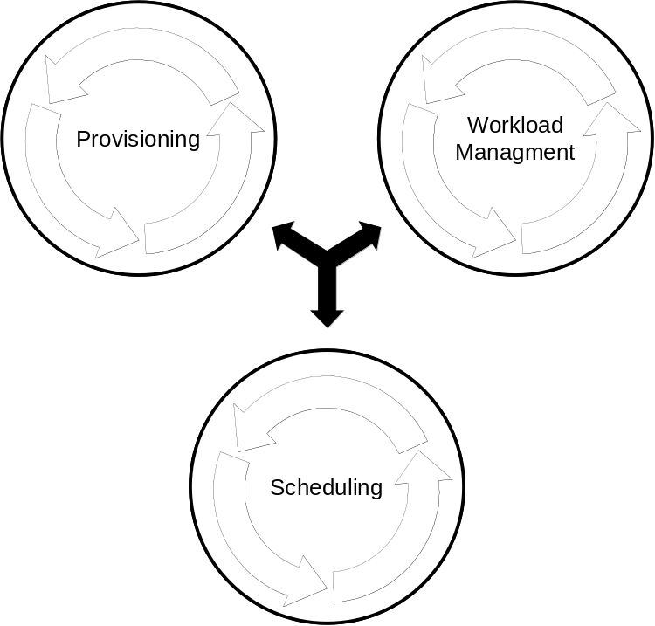
Operating outside the provisioning process and employing it, are other systems management components that are involved in service level attainment activities. This management processes ensure that resources maintain a desired Quality of Service (QoS). The QoS addressed by these management activities may relate to performance attainment such as processor capacity or utilization (workload management), specific activity objectives like job progress or time to completion (scheduling) or more qualitative objectives like security levels.
These management activities are generally instances of a generic control loop pattern that may be used to control and adjust various system activities. The service level attainment activity is a cycle consisting of the following phases.
- Monitoring:
Service execution and monitoring of resource utilization, for example, monitoring the load and utilization of resources, the running states of service components, and detecting faults. Such information is used as input to the Analysis phase.
- Analysis and Projection:
Analyze information such as overall resource utilization and information acquired in the monitoring phase to determine whether resources are meeting QoS objectives and operating within defined policies. Analysis can also predict future resource behavior based on history and projections. requirements.
- Execute (Actions):
Determine what actions must be taken to bring QoS levels into compliance with objectives and policies. These actions may be strictly local to the resource manager or may require interaction with other resource managers. For example a workload manager may adjust priorities and process shares of task executing within a cluster of processors to meet service level objectives and policies. Or in cases where local action against a pool of resource is either impossible (in violation of policy or constrained) or ineffective a resource manager may “appeal” to other management functions to remedy the situation. For example a workload manager might make a provisioning request to add additional processors to a cluster.

Analysis and Projection
Execution and Monitoring
AllocatingPlanning

Allocating & Deploying
Releasing
SchedulingReceiving
Provisioning
Service level attainment loop
Unprovisioning
Stopping
CDDLM Lifecycle management from here…?

…CDDLM Lifecycle management to here?

Overlap with CDDLM Lifecycle Management?
Matches CDDLM Deployment?
Provisioning
StartingVerifying
Undeploying
Deallocating
Adjusting

