Guidelines of Requirements for Grid Systems Ver.0.2

Status of This Document
This memo provides information to the Grid community on guidelines of requirements for Grid systems. It has recommendations on the designing grid systems. Distribution is unlimited.

Copyright Notice
Copyright © Open Grid Forum (2008). All Rights Reserved.

Abstract
This document describes the requirements for construction and operation of grid systems. This document does not say “Grid Systems must satisfy these requirements”. It says “These requirements shall be considered when someone designs / constructs / operates on Grid Systems”.

Contents

1. Introduction 3
1.1 Scope of the document 3
2. Terms and Definitions 4
2.1 Service 4
2.2 Supplier 5
2.3 Consumer 5
2.4 Access 5
2.5 Agreement 5
2.6 Control 5
2.7 Usability 5
2.8 Controllability 5
2.9 Confidentiality 5
2.10 Integrity 5
2.11 Availability 6
2.12 Policy 6
3. Grid System Model 6
4. Requirements for Grid System 6
4.1 Access 6
4.2 Agreement 7
4.3 Control 7
4.4 Cooperation between Systems 8
5. Contributors 8
6. Intellectual Property Statement 9
7. Disclaimer 9
8. Full Copyright Notice 9

Introduction
This standard describes requirements to be considered in integration and operation of grid systems that effectively provide services by virtualizing and flexibly assigning, collaborating and using various resources including computers, storages and networks in accordance with different purposes. In order for the systems to effectively function, clarification and operational management of many related activities are required. In grid systems suppliers provide services to consumers, and in many cases consumers themselves may become suppliers and provide services to other consumers.
Coordinated construction and operation of grid systems generate opportunities for ongoing management, greater efficiency and continual improvement.
This standard is assumed to target people who use and operate grid systems.

Scope of the document
This standard specifies requirements for construction and operation of grid systems of an acceptable quality for customers.
This standard may be used by the following business enterprises, organizations and applications.
a) Organizations who design, construct and operate grid systems
b) Commercial Data Centers that provide hosting and housing services as their business.
c) Service providers who provide applications, IT resources and others.
d) Organizations that mediate various information services
This standard, as Figure 1 shows, defines a grid system as a hierarchical structure that consists of four layers. The first layer is the physical environment layer that consists of hardware components associated with servers, storages and networks. The second layer is the operating environment layer that consists of a number of software such as an operating system and a file system that makes the first layer operable. The third layer is the platform layer that consists of a number of softwares to achieve operations over multiple components such as database and grid middleware. The forth layer is the application service layer that consists of applications and portals. Consumers who use the forth layer are called end-users.
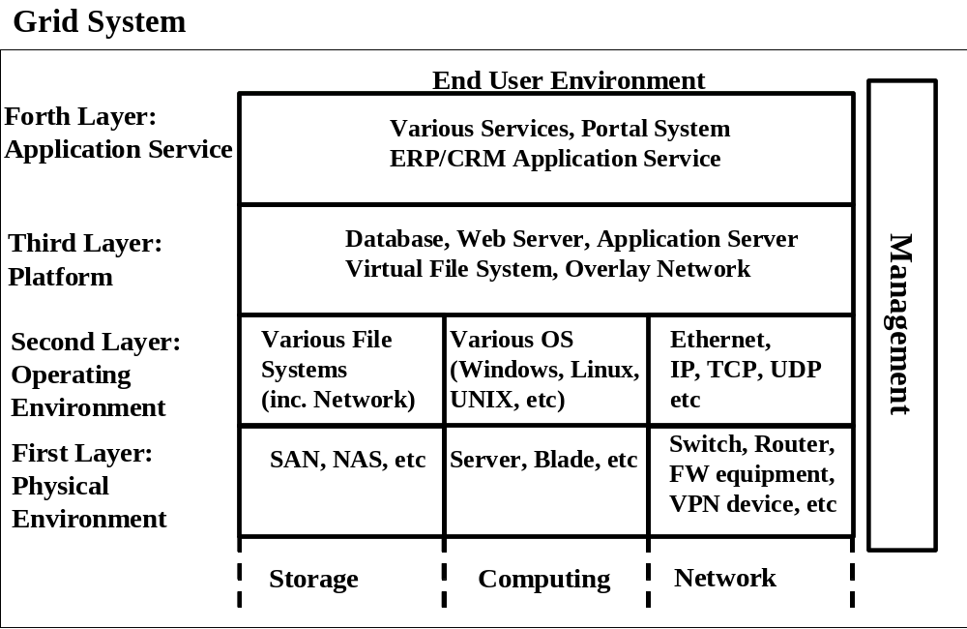
Figure 1: Hierarchy Diagram of the Grid System
Suppliers operate the entire or a part of grid system and provide them as services to consumers. Consumers may add components of hardware or software where needed. In this case consumers become suppliers who provide services with added components to other consumers. As Figure 2 shows, such pairs of suppliers and consumers are concatenated to form a chain and the consumers at the end are called end-users. Although end-users access to services through the forth layer, there may be services without the forth layer. This standard applies to a pair of a supplier and consumer and the service provided between them.
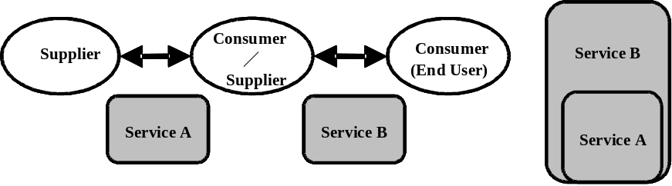
Figure 2: Chain of Supplier and Consumer

Requirements included in this standard are limited to minimal and therefore, addition of any requirement that is needed to satisfy the needs of a specific business may be considered. The way requirements in this standard are implemented to achieve the entire objective depends on the characteristics of the relations between suppliers and consumers.

Terms and Definitions
Terms those are used in this document is explained in this chapter.

Service
A system provided by a supplier is called a service.
Note: A service may corresponds to both the entire grid system and a part of grid system. In other words, multiple services provided by multiple suppliers may be integrated to form one grid system.

Supplier
A supplier is a person who provides either the entire or a part of a grid system as a service.
Note: Suppliers include system operators and they use this standard from the standpoint of designer and operator of systems. Multiple suppliers are present in a grid system that consists of multiple services.

Consumer
A consumer is a person who makes use of a service provided by a supplier.
Note: The consumer may refer not only to a person but a part of a system. This means that services provided in the layers below the forth layer may be accessed directly by the components in the upper layer that a consumer has added. Furthermore, consumers may not necessarily be the members of a single organization and members of a virtual organization that consists of multiple organizations are also treated as consumers.

Access
Access is an operation for consumers to directly use the services under their privileges.
Note: Submissions of jobs to computing resources and writing records to database resources correspond to this operation, for example.

Agreement
Agreement is an operation of consumers that enable indirect use of services by making requests to suppliers to implement processes that consumers have no privilege to implement.
Note: Change of priorities of job submissions to computing resources and retrieval of log data of submitted jobs and database access correspond to this operation, for example.

Control
Control is an operation by suppliers to manage/operate services.
Note: Allocation of resource for each consumer, setting of priority and configuration of consumer access privilege to resources correspond to this operation, for example.

Usability
This term indicates the characteristics related to ease of use from the viewpoint of consumers.
Note: This does not only mean "availability".

Controllability
The term indicates the characteristics related to ease of use and control from the viewpoint of supplier.
Note: This does not only mean "ability to control".

Confidentiality
The term indicates the property that information or information processing/storing system is not made available or disclosed to unauthorized consumers.

Integrity
The term indicates the property of safeguarding the accuracy and completeness of information or information processing/storing system.

Availability
The term indicates the property of being accessible and usable to information or information processing/storing system upon demand by an authorized consumer.

Policy
The term refers to the content specified for the way of allocating services in advance.
Note: This is used for the purpose of data sharing that do not have effect on the load distribution, prioritized processing for each consumer, prioritized processing for each access and other consumers of the service. Policies include operation policies for suppliers to manage and operate services and usage policies for consumers to use services.

Grid System Model
Types of operations performed between suppliers, consumers and services are shown in Figure 3. Actions that suppliers implement against services are operations to manage services and therefore called "control". Actions that consumers implement against services are classified two ways. One is the direct operation performed using consumers’ own privileges and this is called "access". The other is the indirect operations performed by making requests to suppliers to implement some process and this is called "agreement". This "agreement" includes disclosure of service information and prioritization of executions.
Requirements for "access", "agreement" and "control" are described in 4.1, 4.2 and 4.3 respectively.
There is a case where a grid system is used in cooperation with other external grid systems. Requirements for grid systems in such case are described in 4.4.

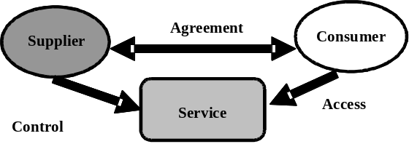
Figure 3: Operations between Supplier, Consumer and Service

Requirements for Grid System
This section describes requirements those are required to be investigated for Grid System. Requirements are categorized by kinds of players and operations.

Access

Usability
The following items shall be considered as requirements from a usability point of view when consumers access services.
- a: Consumers can access services without being aware of the lower level layers (including location, OS and middleware) (layer 4)
- b: Services are accessible using a uniform interface (layer 3, 4)
- c: Access protocols to services are selectable where there is more than one access protocol present (layer 2, 3)
- d: Existing applications are operable without any change (layer 3, 4)
- e: When more than one authentication mechanism is present, only a minimal authentication mechanism is required (layer 3, 4)
- f: Expected performance of the system is estimated in advance. (layer 2, 3, 4)

Security
The following items shall be considered as requirements from a security point of view when consumers access services.
- a: Consumers and services are mutually authenticated (layer 3)
- b: Confidentiality, completeness and availability of accesses to services by consumers are guaranteed (layer 3, 4)
- c: Confidentiality, completeness and availability of contents such as data generated by accesses to services by consumers is guaranteed (layer 3, 4)
- d: Logs of access to services by consumers can be recorded (layer 3, 4)
- e: Confidentiality, completeness and availability of access logs to services by consumers can be guaranteed (layer 2, 3, 4)

Agreement

Usability
The following items shall be considered as requirements from a usability point of view when consumers perform agreement-related operations against services according to service levels.
- a: Static information including configuration information and performance of services is disclosed to consumers (layer 2, 3)
- b: Dynamic information including load status, processing capacity and failure of services is disclosed to consumers (layer 2)
- c: Consumers can configure usage policies for each service individually at the time of usage (layer 2, 3)
- d: Consumers can view a record of service level (layer 2, 3)

Accounting
The following item shall be considered as a requirement from the accounting point of view when consumers perform agreement-related operations against services.
- a: Accounting information such as log data of services used by consumers are disclosed to consumers (layer 3)

Security
The following items shall be considered as requirements from the security point of view when consumers perform agreement-related operations against services.
- a: Confidentiality, completeness and availability of operations related to agreements implemented by consumers to services can be guaranteed (layer 3)
- b: Confidentiality, completeness and availability of information including usage history and accounting generated by operations on agreements implemented by consumers to services can be guaranteed (layer 3)

Control

Controllability
The following items shall be considered as requirements from the controllability point of view when suppliers perform control-related operations against services.
- a: Priorities configured by and for each consumer are configurable. (layer 3)
- b: Services have the mechanism that users can access services without being aware of lower level layers (including location, OS and middleware) (layer 3)
- c: Resource allocation is dynamically altered according to suppliers’ operation policy (layer 3)
- d: Management items required to construct and operate upper level layers are configurable (layer 2, 3)
- e: Suppliers can monitor status of services (including failure and risk) by inquiry or notification (layer 2, 3)
- f: Suppliers can view access status of consumers (layer 2, 3)
- g: Policies for service allocation are configurable with regard to consumer access(layer 2, 3)
- h: Services include a mechanism to easily perform maintenance (layer 2, 3)
- i: Configuration change, expansion and destroy of services can be performed according to service levels without halting the whole system (layer 2, 3)
- j: Suppliers can easily monitor status of the whole services (layer 2, 3)

Accounting
The following item shall be considered as a requirement from the accounting point of view when suppliers perform control-related operations against services.
- a: Usage history of consumers is viewable by suppliers (layer 2, 3)

Security
The following items shall be considered as requirements from the security point of view when suppliers perform control-related operations against services.
- a: Suppliers and services can be mutually authenticated. (layer 3, 4)
- b: Confidentiality, completeness and availability of services can be guaranteed (layer 2, 3)
- c: Confidentiality, completeness and availability of operations related to controls implemented by suppliers to services can be guaranteed (layer 2, 3)
- d: Confidentiality, completeness and availability of contents generated by operations related to controls implemented by suppliers to services can be guaranteed (layer 2, 3)
- e: Logs for controls implemented by suppliers to services can be recorded (layer 2, 3)
- f: Confidentiality, completeness and availability of operation logs related to controls implemented by suppliers to services can be guaranteed (layer 2, 3)
- g: Suppliers can configure security policy of services (layer 2, 3)

Cooperation between Systems
The following items shall be considered as requirements when a service cooperates with an external grid system.
- a: Ways to establish mutual trust relations are specified(layer 2, 3)
- b: Each other’s services are cooperable(layer 2, 3)

Contributors
This document has been originally developed by “Grid Computing Industrial Guidelines Standardization Committee” on February 2008. The committee was organized in 2005 by AIST and was funded by METI through INSTAC from FY 2005 to FY 2007.
AIST: National Institute of Advanced Industrial Science and Technology
METI: Ministry of Economy, Trade and Industry
INSTAC: Information Technology Research and Standardization Center, JSA (Japanese Standards Association)

Intellectual Property Statement
The OGF takes no position regarding the validity or scope of any intellectual property or other rights that might be claimed to pertain to the implementation or use of the technology described in this document or the extent to which any license under such rights might or might not be available; neither does it represent that it has made any effort to identify any such rights. Copies of claims of rights made available for publication and any assurances of licenses to be made available, or the result of an attempt made to obtain a general license or permission for the use of such proprietary rights by implementers or users of this specification can be obtained from the OGF Secretariat.
The OGF invites any interested party to bring to its attention any copyrights, patents or patent applications, or other proprietary rights which may cover technology that may be required to practice this recommendation. Please address the information to the OGF Executive Director.

Disclaimer
This document and the information contained herein is provided on an “As Is” basis and the OGF disclaims all warranties, express or implied, including but not limited to any warranty that the use of the information herein will not infringe any rights or any implied warranties of merchantability or fitness for a particular purpose.

Full Copyright Notice
Copyright (C) Open Grid Forum (2008). All Rights Reserved.
This document and translations of it may be copied and furnished to others, and derivative works that comment on or otherwise explain it or assist in its implementation may be prepared, copied, published and distributed, in whole or in part, without restriction of any kind, provided that the above copyright notice and this paragraph are included on all such copies and derivative works. However, this document itself may not be modified in any way, such as by removing the copyright notice or references to the OGF or other organizations, except as needed for the purpose of developing Grid Recommendations in which case the procedures for copyrights defined in the OGF Document process must be followed, or as required to translate it into languages other than English.
The limited permissions granted above are perpetual and will not be revoked by the OGF or its successors or assignees.

