Service description template (ver. 2)

This is the second version of OGSA-WG service description template. Please use this template to draw up your service description in chapter 5 of “OGSA platform document.” We expect each description is about two page long.
If you have any comment or suggestion to improve this template, please send it to OGSA-WG mailing list (ogsa-wg@ggf.org).
Hiro Kishimoto (hiro.kishimoto@jp.fujitsu.com)

OGSA Platform Services

<Service Category Name>
Service Category include but not limited to the followings:
5.1 Core Services
5.1.2 Service Interaction
5.1.3 Service Management
5.1.4 Service Communication
5.1.5 Policy and Agreement
5.1.6 Security
5.2 Data Services
5.3 Program Execution
Provide summary of the service category and include overall architectural figure if appropriate.

<Service Name>
Different from service category, service is a non decomposable entity from the view point of the archtecture.
Issue#1: It is unclear how to handle composite services. E.g. Meta-Scheduler consists of Job Service and Reservation Service. Is Meta-Scheduler first class citizen or not?
Provide 1/2 page summary of the service. What it covers and does not. Explain its properties and attributes. Please include figures if possible.

List of interfaces
Please list up interfaces provided by this service. Explain each interface by a couple of paragraphs.
It may include portType level definition but such descriptions intend to give concrete idea what this service is but these definition is just an example (informative). Instead, owner-WG should define normative interface in detail.

Standard schema/document
If the service uses standard schema or document, explain in this section.

Underlying services
Explain which services (infrastructures) are extended by this service.

Related services
Explain which services are used by this service. Related services are peer not underlying.

Related standard
If one or more related standards are already exist, please specify them and which standard body define them.

Owner WG(s)
Please specify owner GGF-WG of this service if exist. Owner WG is expected to define actual service interface or portType. OGSA-WG will talk with owner-WG and agree the definition of the service and schedule for the specification creation.
If there is no appropriate WG, OGSA-WG will spawn new WG for this service.

The following is an example.

Program Execution
Program Execution is the key component of Grid middleware that enables applications to have coordinated access to the underlying resources of the VO, regardless of their physical location or access mechanisms. When an application utilizing the Grid makes use of more than one physical resource during its execution, Program Execution middleware maps the resource requirements of the user application to the multiple physical resources that are required to run that application. Metaschedulers are the key to making the resources of the VO easily accessible to end-users, by automatically matching the requirements of a Grid application with the available resources, while staying within the conditions that the VO has specified with the underlying resource managers.

Figure 1 shows the Grid services required for Program Execution. These services include:

- Job Service – creates, monitors and controls compute jobs
- Reservation Service –guarantees resources are available for running a job
- Queuing Service – provides a service where administrators can customize and define scheduling policies at the VO level, and/or at the different resource manager levels
- Global Information Service – allows for the propagation of information between resource managers and the metascheduler.
- Resource Manager Adapter Service (RM Adapter) – provides a Grid service interface that bridges the Grid service protocol and resource managers (e.g. LSF or PBS).
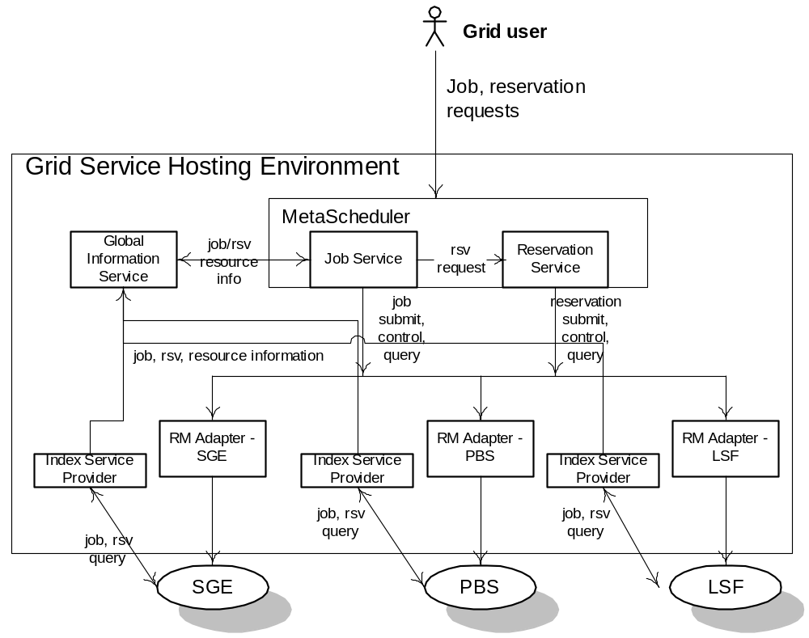
Figure 1 Program Execution Architecture and Services

Reservation Service
Reservation Service allows end users or a Job service to reserve resources under the control of a resource manager to guarantee their availability to run a job. The service allows reservations on any type of resource (e.g. hosts, software licenses, or network bandwidth). Reservations can be specific (e.g. provide access to host “A” from noon to 5pm), or more general (e.g. provide access to 16 Linux cpus on Sunday). Once a reservation is made, a Job service can send a job to a resource manager that is attached to the provided reservation. Some of the policy decisions made by the Reservation service for use with a RM include notions of who can make reservations (e.g. admins only), how many hosts a particular user or user group can reserve at a time, when reservations can be made (i.e. “blackout periods”), and what types of hosts can be reserved.

List of interfaces
The Reservation service provides the following interfaces:
- Manageability – define a set of service data that describes the details of a particular reservation, including resource terms, start time, end time, amount of the resource reserved and the authorized users
- Add Reservation – request a new reservation with a particular resource requirement, starting at a specific time for a given duration
- Delete Reservation – remove a reservation
The Reservation service makes use of information about the existing resource managers available, any policies that might be defined at the VO level, and will make use of a logging service to log reservations. It will use the RM Adapter interfaces to make reservations and to delete existing reservations.

Standard schema/document
OGSI-agreement language.

Underlying services
No underlying service is identified.

Related services
- Global Information Service – allows for the propagation of information between resource managers and the metascheduler. It also provides facilities for other services to persist their state data.
- Resource Manager Adapter Service (RM Adapter) – provides a Grid service interface which bridges between the Grid service protocol and a given resource manager (e.g. LSF or PBS). The interface to a Resource Manager Adapter Service is a composition of the interfaces provided by the Job Service and Reservation Service, since both the Job Service and the Reservation Service use the services of the RM Adapter.
- Persistent service – required for storing job, configuration and events.

Related standard
- OGSI-Agreement: defines fundamental mechanisms based on Agreement services, which represent an ongoing relationship between an agreement provider and an agreement initiator. The agreements define the behavior of a delivered service with respect to a service consumer. The Agreement will most likely be defined in sets of domain specific agreement terms (defined in other specifications), since the OGSI-Agreement specification is focused on defining the abstraction of the agreement and the protocol for coming to agreement, rather than on defining sets of agreement terms.
- OGSI-Agreement Job Terms and Reservation Terms

Owner WG
GRAAP: OGSI-Agreement
JSDL: Job Terms and Resource Reservation Terms

Just as an example, I pick up “Reservation Service,” instead of “Job Service.”

