WS-Agreement for Java (WSAG4J) is a generic implementation of the WS-Agreement protocol. It supports common functionality to create and monitor agreements in a generic way and enables users to quickly build and deploy WS-Agreement based services.
WSAG4J implements the Agreement Factory port type for the creation of agreements, and the Agreement State port type for monitoring the states of existing agreements. At the current state, WSAG4J does not support the Pending Agreement Factory port type and the Agreement Acceptance port type; this will be subject for a future release.

WSAG4J follows a declarative approach to support and manage the whole lifecycle of an agreement, starting from the definition of an agreement template, over the deployment of the templates in factories, to the management of the agreement itself. The main features of WSAG4J are listed below:

- Host multiple agreement factories within one WSAG4J engine
- Customizable persistence layer for Agreement Factory and Agreement instances
- Default implementation of persistence layer based on configuration file persistence
- Easy to use server and client side API
- Free configurable factory actions within one WSAG4J engine
- Definition of Agreement Templates based on XML files
- Dynamic template creation by using macros in template definition
- Dynamic agreement offer validation based on creation constraints
- Dynamic agreement guarantee evaluation and generation of accounting events
- Negotiation of agreement templates
- Support of WS-Security and WS-Policy

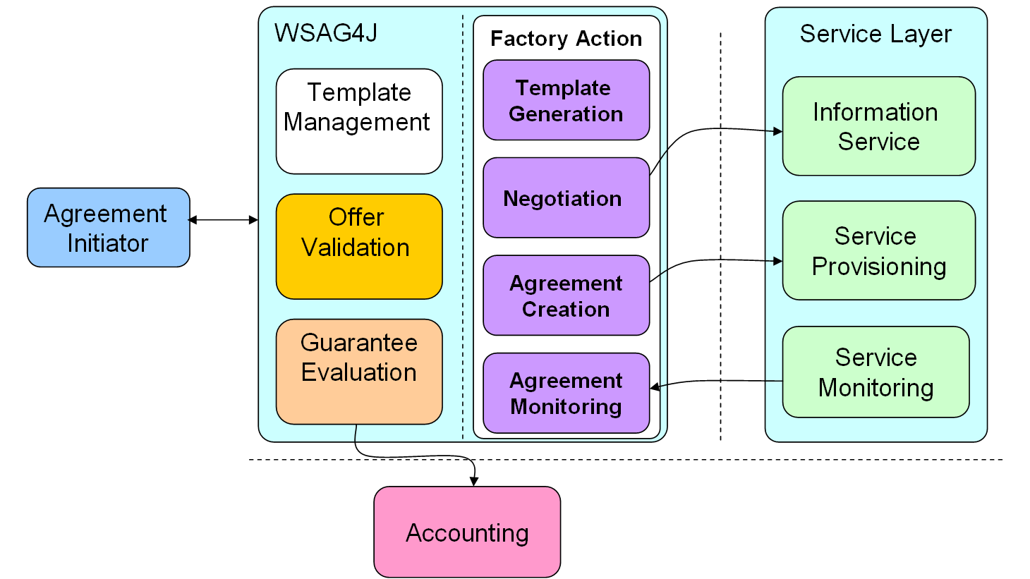

As already mentioned WSAG4J fosters the definition SLA templates and utilizes the information provided in the templates to validate agreement offer compliance at SLA creation time and monitor agreement compliance during SLA execution time.
Agreement template design
WSAG4J supports developers in designing SLA templates by allowing to publish templates in form of XML files rather than implementing them via an API. Furthermore, WSAG4J enables developers to dynamically generate SLA templates by using a macro language within the template definition files.
Since the developer defines the template as an XML document, the template files can easily be edited, and the developer does not need to implement agreement templates on API level, he can put its focus more on the design of the template rather than on the technical details and implementation details. Therefore, the level of entry for designing and implementing WS-Agreement based services is drastically lowered.

Agreement offer validation
WS-Agreement supports the definition of so called creation constraints as part of agreement templates. These creations constrains define how a valid agreement offer based on a specific template is constructed. On one hand this comprises the structure of the agreement offer, e.g. the content service description terms, the structure of a JDSL document contained in a service description term, and the elements that must be contained in this document. On the other hand creation constraints can define concrete values a specific element in an agreement offer may take, e.g. the minimum and maximum CPU speed of a compute system.
In case an agreement offer is created based on a template that defines a set of creation constraints, these constraints are automatically evaluated by the WSAG4J engine before the offer is passed to the associated agreement creation action. In that way, only agreements based on valid offers are created by a WSAG4J service.

Agreement guarantee evaluation
WSAG4J also provides automatic ways for guarantee evaluation. Similar to the validation of creation constraints, the definition of guarantee terms serves as foundation for the guarantee evaluation. WSAG4J poses certain best practices that must be obeyed, in order to evaluate guarantee terms successfully.

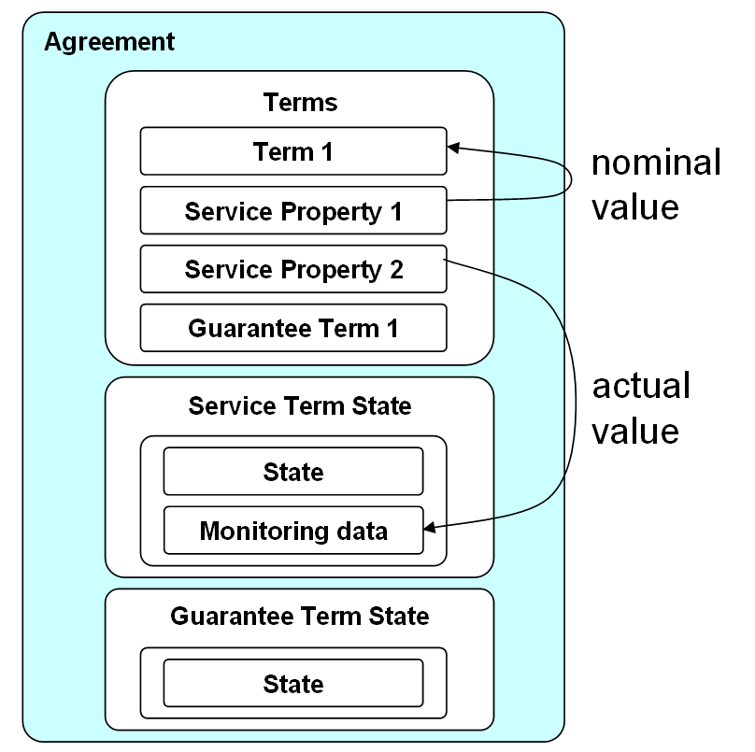
The basic principle for defining guarantee terms that can be automatically validated is to define guarantees only over measurable properties of an SLA. WS-Agreement supports the definition of properties via the ServiceProperties language element. A service property can be seen similar as a variable in a programming language. It binds a (property) name to a certain value of the agreement properties. This is done by referring this value via an XPath expression.

The agreement properties comprise data static data like agreement name, context and service terms, that were part of the agreement offer, and dynamic data such as the agreement state and the state of the different service and guarantee terms. Service term states usually comprise monitoring data that is periodically updated. In contrast to that, guarantee term states are automatically generated by the WSAG4J engine.

In WSAG4J we assume that guarantees define a relationship between a requested service level (nominal value) and a provided service level (actual value). In WS-Agreement this relationship is expressed in the service level objective (SLO) of a guarantee term. WSAG4J supports the flexible definition of service level objectives and guarantee terms. In order to define a SLO, the requested and a provided service levels (nominal and actual values) are exposed as service properties. The SLO then defines a relationship over these service properties using a simple expression language.

As the creation constraints, guarantee terms are defined at the design time of a SLA template. Once an SLA was created, the WSAG4J engine periodically evaluates the state of all guarantee terms that are part of this SLA. Furthermore, WSAG4J will account fulfillments and violations of guarantees.

Conclusion
WSAG4J is a generic framework, that support users in easily develop and run WS-Agreement based services. It implements basic mechanisms for creating valid SLAs and managing agreement compliance during runtime. It ships with its own web service stack and provides support for WS-Security and WS-Policy. Furthermore, a simple, action based programming model enables users to easily deploy new agreement templates with custom agreement creation and monitoring strategies in a WSAG4J server and the usage of custom persistence layers is supported.

