Summary:

Earth observation satellites are specifically designed to observe Earth from orbit, and intended for environmental monitoring, meteorology, and maps making. Each Earth Observation satellite brings on-board a series of instruments, i.e sensors intended to collect, save and transmit data about the Earth. Each instrument carries on different sensors apt to different observations. According to the way they collect data, sensors could be classified in two main groups: Radar sensors and Optical sensors.
Information about Earth Observation services, availability and applications is currently accessible only in a very scattered way through different mission operators, scientific institutes, service companies, data catalogues, etc. and request for EO images cannot be performed automatically since human interaction is often required.
Some providers have created web catalogues to allow users to request for archive images. Users have to log in and manually filling up a form, to request for images or products. Web catalogues usually shows a list of quick looks and information about all available images matching the request. Finally, user can select between the available images and confirm the purchase getting the EO image by e-mail, FTP, or DVD distribution.
Accordingly, only a limited community, knowing what to search for, is in a position to collect and compile the Earth Observation information. Easier and timely access to large quantities of primary data is a condition for delivering effective services. Therefore, the ARGUGRID platform is utilised in this test case in order to provide an easy and effective way for delivering EO images to a variety of users.
With the increasing availability of Earth Observation images, some new providers have appeared in the market, offering new implementations of common and new operations.
Some of this services are already provided by the image providers, but this new specialized services intends to improve the current ones, by using new algorithms, better auxiliary data or just faster processing. Simple examples include, clipping, format conversion, resizing, reprojection etc. services.

Customers/Actors

- Service Provider: Business that provides EO images and Clipping Services to customers over the network as web services
- Agents: Software intelligent agents that represent the service providers and the users for negotiation reasons
- Users: Customers that request EO image and clipping services

Scenario

The use case scenario describes the simple case where a user wants valid earth observation products for studying an oil spill caused by a disaster event. The user knows location and time of this oil spill.
Moreover the user desires to perform clipping operation to the ordered image so as to keep the data within the desired polygon for further calculation and processing.
The large number of satellites as well as clipping services complicates the decision. Moreover, a deep knowledge of the sensors and its characteristics is needed. A system with that knowledge, and able to select the best option, would be very appreciated in crises.
Using the ARGUGRID system, a non-expert user could get useful information in an easy and quick way.

All services (clipping and Earth Observation image acquisition) are offered as GRIA web services within the network and are represented by intelligent agents, capable of internal reasoning and argumentation as well as negotiation with other agents. The following figure represents the execution of the scenario and the following steps explain in detail the whole procedure.
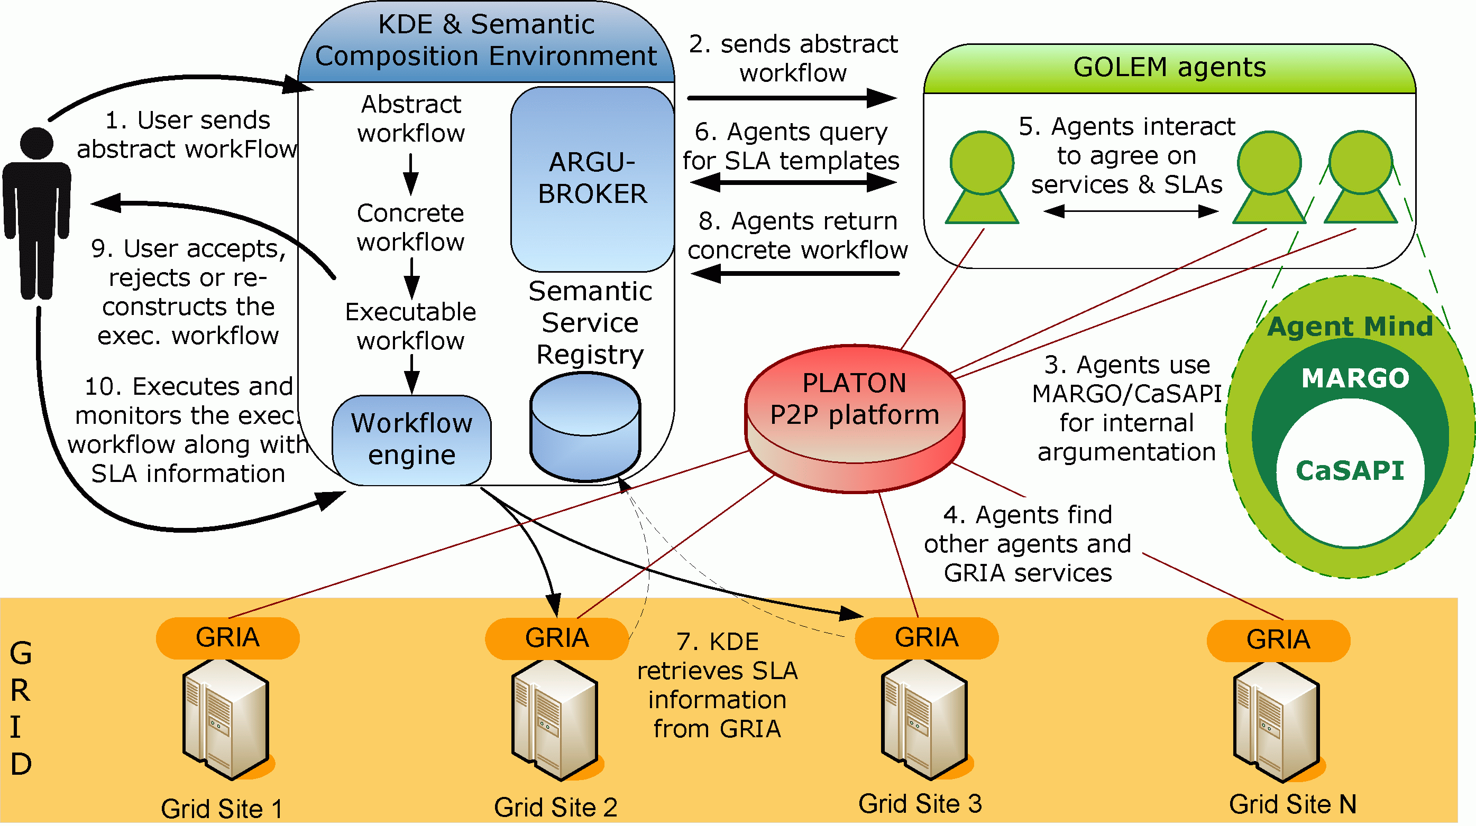

- The user uses the KDE Authoring Tool interface in order to submit an abstract workflow that reflects, at a high-level, the user requirements.
- The KDE ArguBroker delegates the abstract workflow to GOLEM software agents. The GOLEM agent representing the user will start finding which GRIA services should be used in order to derive a concrete workflow, to be executed on the Grid.
- To accomplish this, the GOLEM agent uses the MARGO argumentation engine for decision-making, which in turn uses the CaSAPI general-purpose argumentation engine. These are implemented within the mind of every GOLEM agent and work in a way to reason about services and make decisions, aiding the refinement process of the abstract workflow.
- To find out appropriate GOLEM agents that represent GRIA Grid service, GOLEM agents are given the capability to use the PLATON P2P platform, linking all available GOLEM agents and GRIA services in a virtual registry that can be queried. The GOLEM user agent discovers a set of GOLEM agents that can fulfil its goal requirements.
- Agents interact with each other in other to find appropriate services to use to satisfy their goals.
- Non functional properties, such as resolution of image, delivery time and cost of each service are stored in Service Level Agreements (SLAs) within the GRIA registries, and can be retrieved by the Semantic Registry. Agents after discovering a set of appropriate services, query the Semantic Registry to retrieve the SLA templates of the services.
- The Semantic Registry retrieves the SLA information from the GRIA registry residing in each GRIA node.
- Having carried out its mission, the GOLEM agent representing the user (i.e. the initial agent that received the abstract workflow from the KDE) will return back to the KDE the concrete workflow, constituted by a set of GRIA services (an image acquisition and a clipping service) to be executed in a certain manner/sequence. The agent also returns the negotiated SLAs of the services within the workflow.The KDE uses the capabilities of the ARGUBROKER component in order to produce an executable workflow, based on the concrete workflow received by the GOLEM Agent representing the user.
- At this point, an executable workflow with an associated set of SLAs is presented to the user, giving him the choice of either accepting the concrete workflow or rejecting it or deciding to modify the abstract workflow, in order to get a better solution. In the latter case, the abstract workflow will be given again as input to the KDE, repeating steps until the user either accepts or rejects the ARGUGRID executable workflow solution. In the case of acceptance, the system will follow step 9 below.
- The workflow engine within the KDE will use its workflow execution service to send the execution workflow, along with its related SLA information, for execution on the Grid infrastructure, running the GRIA Grid middleware. Upon successful execution of the final executable workflow, the user is informed and the execution results/data are returned back to the user in an FTP site where he can download the clipped image.

Functional requirements:

For the use case scenario to be considered successful, a concrete executable workflow needs to be returned to the user consisting of two services: one that orders an earth observation image from an oil spill territory and another that performs clipping to the first image, resulting to new one.

Preconditions:
- Different GRIA host machines that store the offered services along with their SLAs. Each service has to be wrapped as a GRIA service.
- Different machines containing GOLEM containers. Each GOLEM agent is equipped with the CASAPI argumentation engine and is assumed to have basic knowledge as defined by each use case scenario.
- A peer-to-peer platform, PLATON, runs as underlying middleware with each GOLEM container constituting a PLATON node.
- Set up of distributed Semantic Registries holding semantic information about the services, upon which the GOLEM agents query.
- KDE authoring tool interface, where the users enter to set their goals forming abstract workflows.

Non-functional requirements:

Security considerations:

Each user should be authenticated to use the ARGUGRID system. Moreover, the services offered at the GRIA sites need to grant access to the KDE execution engine, in order to call and execute them. This can be simply solved by use of the GRIA VO management system, the PBAC 2 mechanism.

Trust:

Models of trust are envisaged to be used in relation with the agent negotiation. These models may feed into the VO model, and it may be used to evaluate the effectiveness of the VOs and individual agents’ effectiveness in that VO. For example, an agent may ask another agent if it can deliver a service or if it knows of another who can reliably provide the service.

Involved resources:

The resources involved compose the whole ARGUGRID platform. Therefore we have:
- A Grid infrastructure consisting of different GRIA nodes.
- A peer-to-peer infrastructure.
- GOLEM containers of agents
- Semantic Registries
- KDE workflow authoring Tool and Semantic Composition Environment

Related work / Experience in the field:

Information about Earth Observation services, availability and applications is currently accessible only in a very scattered way through different mission operators, scientific institutes, service companies, data catalogues, etc. In general, to get an image of a specific area, a user should be subscribed to one of the image service providers or he should contact them either via e-mail or by phone call, as in the RadarSat image request and delivery workflow.
Even if what is described above, could help while understanding how image request works, it is necessary to underline that most of the providers, have subscribed to the “Charter On Cooperation To Achieve The Coordinated Use Of Space Facilities In The Event Of Natural Or Technological Disasters” (http://www.disasterscharter.org/charter_e.html).
According to it, the member agencies should provide a unified system of space data acquisition and delivery to those affected by natural or man-made disasters through Authorized Users. Each member agency has committed resources to support the provisions of the Charter and thus is helping to mitigate the effects of disasters on human life and property.

Moreover, as far as EO information providers are concerned, some European initiatives intend to provide European service industry with a more straightforward and cheaper access to basic data and products.
- GMES Services Element focuses upon the delivery of policy-relevant services to end-users, primarily (but not exclusively) from EO sources.
GMES (Global Monitoring for Environment and Security) is a joint initiative of the European Commission and European Space Agency, aimed at achieving an autonomous and operational capability in the exploitation of geo-spatial information services.
- EOMD (Earth Observation Market Development) aims to foster the use of Earth Observation based geo-information services within new market sectors. EOMD supports and funds the EO service industry to grow their business by attracting new clients and encouraging partnership building.
- DUE (Data User Element) mission is to encourage the establishment of a long-term relationship between user communities and Earth Observation. DUE is a programmatic component of the Earth Observation Envelope Programme (EOEP). EOEP is an optional programme of the European Space Agency, currently subscribed by 14 ESA Member States.
Providers can be divided in image providers and operations providers. The first group allow users to access to images and data from the satellites, while the second group process or transform the data provided by the first group.

References:

- L. Lymberopoulos, S. Bromuri, K. Stathis, S. Kafetzoglou, M. Grammatikou and S. Papavassiliou, “Towards a P2P Discovery Framework for an Argumentative Agent Technology assisted GRID”, CoreGRID workshop, June 2007, Crete, Greece
- D. Kollia, S. Kafetzoglou, M. Grammatikou and S. Papavassiliou, “Discovery of resources in a distributed Grid environment based on specific Service level Agreements (SLAs)”, INGRID 08 - 3rd International Workshop on Distributed Cooperative Laboratories: Instrumenting the GRID, April 2008, Ischia, Italy
- F. Toni, D. Gaertner, M. Grammatikou, S. Kafetzoglou, L. Lymberopoulos, S. Papavassileiou, M. Morge, S. Bromuri, J. McGinnis, K. Stathis, V. Curcin, M. Ghanem, L. Guo, “The ArguGRID platform: an overview”, GECON08 - 5th International Workshop on Grid Economics and Business Models, August 2008, Las Palmas, Canary Islands, Spain
- V. Curcin, M. Ghanem, Y. Guo, K. Stathis and F. Toni, “Building next generation Service-Oriented Architectures using argumentation agents”, Proceedings of the 3rd International Conference on Grid Services Engineering and Management (GSEM 2006), September 2006, Erfurt, Germany
- http://gs.mdacorporation.com/products/sensor/radarsat/rsiug98_499.pdf

