Agenda for OGSA-WG and fellow WG F2F meeting
- August 15 - 19 in San Francisco Bay Area -
Draft 5 (August 1, 2005)

Venue: Fujitsu facility in Sunnyvale
Address: H bldg, 1250E, Arques Avenue, Sunnyvale, CA94086
Directions to Fujitsu: http://tinyurl.com/69aof
Campus Map: http://www.fih.fujitsu.com/fih/about/contacts/hq2_fujitsu.pdf

Entrance Procedure:
All visitors will need to identify themselves at a front desk, show a picture ID and obtain a visitor badge before entering the meeting room.

Wi-Fi internet access is available at the meeting room. (Setup details will be provided on site.)

Local contact:
Ms. Yoko Stein, +1-408-530-4574

Meeting room:
Room 334 (Monday – Friday)
Meeting room 334 is in the main building (H bldg) and next to the cafeteria.

Room C (Tuesday morning, EGA and OGSA joint session)
Meeting room C is in the main building (H bldg).

Coffee and juice will be provided at the meeting room. Cafeteria is open for breakfast (7-9am) and Lunch (11:15am-1:30pm). It closes at 2:00pm.

Dial-in (by Freeconference.com, No toll free number):
Toll number: 1-323-785-4156

The pass code: 71815

Glance network:
Address: http://ogsa.glance.net
Pass code: MMDD (0815 for Aug. 15)

Contact:
1-312-399-3176 (Hiro’s mobile)
Accommodation:
The following hotel is recommended. It offers free internet access and large rooms (all non-smoking).
Corporate Inn Sunnyvale
805 E El Camino Real, Sunnyvale, CA 94087 United States
Phone: 408 220-1000
Fujitsu rate: 105 USD/night

The full hotel list where you can get Fujitsu rates is available
https://forge.gridforum.org/projects/ogsa-wg/document/sunnyvale-hotel-list/

Attendees List

Michael Behrens (R2AD, LLC)
Michel Drescher (Fujitsu)
Donal Fellows (University of Manchester)
Andrew Grimshaw (University of Virginia)
Marty Humphrey (University of Virginia)
Soonwook Hwang (NAREGI)
Hiro Kishimoto (Fujitsu)
William Lee (Imperial College)
Allen Luniewski (IBM)
Fred Maciel (Hitachi
Tom Maguire (IBM)
Steve McGough (Imperial College)
Dejan Milojicic (HP)
Mark Morgan (University of Virginia)
Takuya Mori (NEC)
Pramila Mullan (French Telecom)
Steven Newhouse (University of Southampton)
Manuel Pereira (IBM)
Darren Pulsipher (Xango)
Andreas Savva (Fujitsu)
Stuart Schaefer (Softricity)
Frank Siebenlist (ANL)
Ravi Subramaniam (Intel)
Steve Tuecke (Univa)
Jay Unger (IBM)
Andrea Westerinen (Cisco)
Pete Ziu (Northrop Grumman)

EGA (Aug. 16 morning)
Alan Clark (Novell)
Raj Kumar (HP)
Parviz Peiravi (Intel)
Paul Strong (Sun)

Telephone Bridge
Neil Chue Hong (EPCC)
Marvin Theimer (Microsoft)
Jem Treadwell (HP)

Apologies
Dave Berry (NeSC)
Fred Brisard (Computer Associates)
Mathias Dalheimer (Fraunhofer ITWM)
Abdeslem Djaoui (Rutherford Labs)
Ian Foster (ANL)
Chris Jordan (SDSC)

David Snelling (Fujitsu)
Chris Smith (Platform)
Meeting schedule at a glance
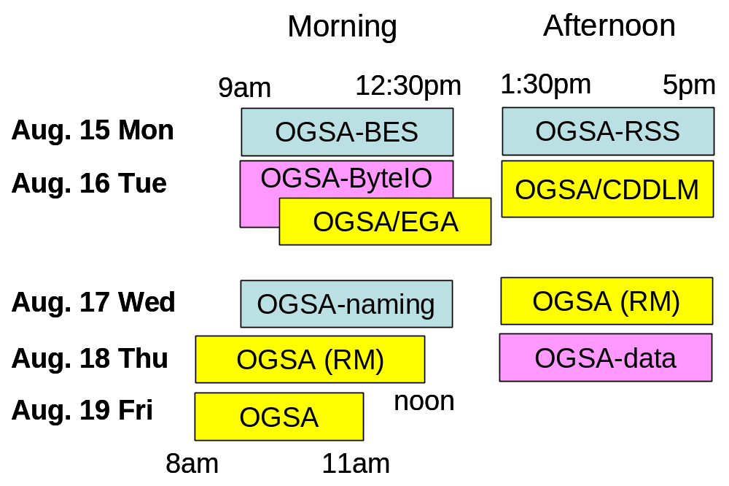
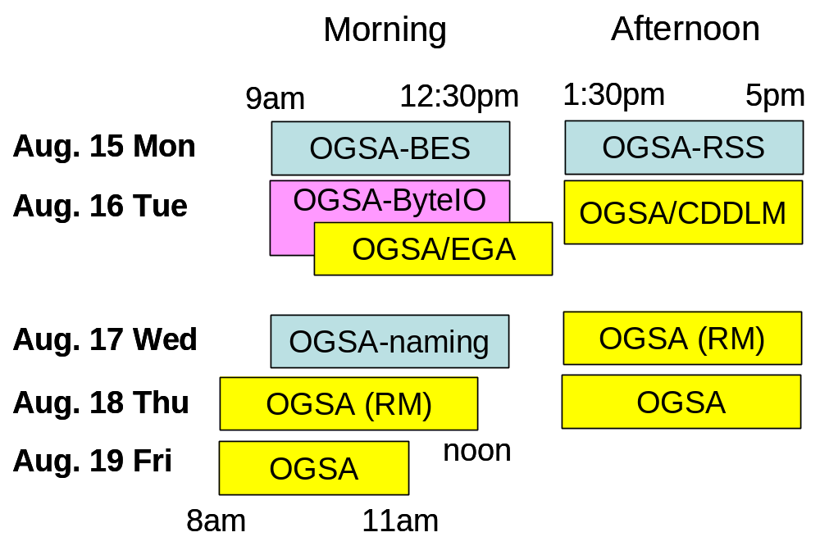
Aug. 15 (Mon), 9am ~ 12:30pm
OGSA-BES (Andrew, Steven, and Darren)

Andrew, Steven, and Darren will provide session agenda.

Aug. 15 (Mon), 1:30pm ~ 5pm
OGSA-RSS (Donal and Soonwook)

Donal and Soonwook will provide session agenda.

Aug. 16 (Tue), 9am ~ 12:30pm (1) [Parallel session]
OGSA-ByteIO (Mark and Neil)

Mark and Neil will provide session agenda.

Aug. 16 (Tue), 9am ~ 12:30pm (2) [Parallel session]
EGA and OGSA (Paul and Andrew)
Room C in Bldg H

Paul and Andrew will provide session agenda.

Aug. 16 (Tue), 1:30pm ~ 5pm
OGSA-WG and CDDLM-WG (Dejan and Hiro)

Dejan and Hiro will provide session agenda.

Aug. 17 (Wed), 9am ~ 12:30pm
OGSA-naming (Manuel and Andrew)

Manuel and Andrew will provide session agenda.
Aug. 17 (Wed), 1:30pm ~ 5pm
OGSA-WG #1 (Tom and Hiro)

Fred will provide more detailed session agenda.

1) Early discussion (10 min)
  - Note taker
  - Agenda bashing

2) Resource Modeling discussion I (90 min)

<break>

3) Resource Modeling discussion II (90 min)

Aug. 18 (Thu), 8am ~ noon
OGSA-WG #2 (Tom and Hiro)

Fred will provide more detailed session agenda.

1) Early discussion (10 min)
  - Note taker
  - Agenda bashing

2) Resource Modeling discussion III (90 min)

<break>

3) Resource Modeling discussion IV (90 min)

Aug. 18 (Thu), 1:30pm ~ 5pm
OGSA-WG #3 (Tom and Hiro)

1) Early discussion (10 min)
  - Note taker
  - Agenda bashing

2) OGSA-data architecture (60 min)
- Allen Luniewski explains current data architecture doc draft

<break>

3) TBD (60 min)

4) TBD (60 min)

Aug. 19 (Fri), 8am ~ 11am
OGSA-WG #4 (Tom and Hiro)

1) Early discussion (10 min)
  - Note taker
  - Agenda bashing

2) Architecture and glossary 1.5 (60 min)
  - Open issues, resolution process, schedule

3) OGSA-AuthZ discussion (30 min, if they can make it)
  - OGSA AuthZ attribute document review
  - OGSA AuthZ service review

<break>

4) GGF15 preparation and schedule (45 min)
  - GGF15 session plan
  - Next F2F (Oct 6 & 7)

5) Wrap-up

<Another agenda item candidates>

- OGSA-WG next step discussion
  - OGSA WSRF BP 1.0 interop

