Agenda for OGSA-WG and fellow WG F2F meeting
- October 6 - 7 at IBM/Lotus Cambridge -
Draft 08 (Oct. 5, 2005)

Location
IBM / Lotus Cambridge
1 Rogers Street,
Cambridge, MA 02142

Thursday October 6th 8:00 AM – 6:00 PM Room: 5th Floor 5003 (Breakout 5381)
Friday October 7th 8:00 AM – 3:00 PM Room: 3rd Floor 3003 (Breakout 6309)

Entrance Procedure:
All visitors will need to identify themselves at a front desk, show a picture ID and obtain a visitor badge before entering the meeting room.

Wi-Fi internet access may be available at the meeting room. (Setup details will be provided on site.)

Local contact:
<TBA>

Dial-in:
Toll number: +1 718 3541071 (New York)
+1 408 9616509 (San Jose)
The pass code: 4371991

Glance network:
Address: http://ogsa.glance.net
Pass code: MMDD (1006 for Oct. 6)

Contact:
1-312-399-3176 (Hiro’s mobile)

Walking or Taxi

It is about a 2 mile walk from Boston Park Plaza to IBM/Lotus, 1 Rogers Street, or about a 5 minute cab ride.

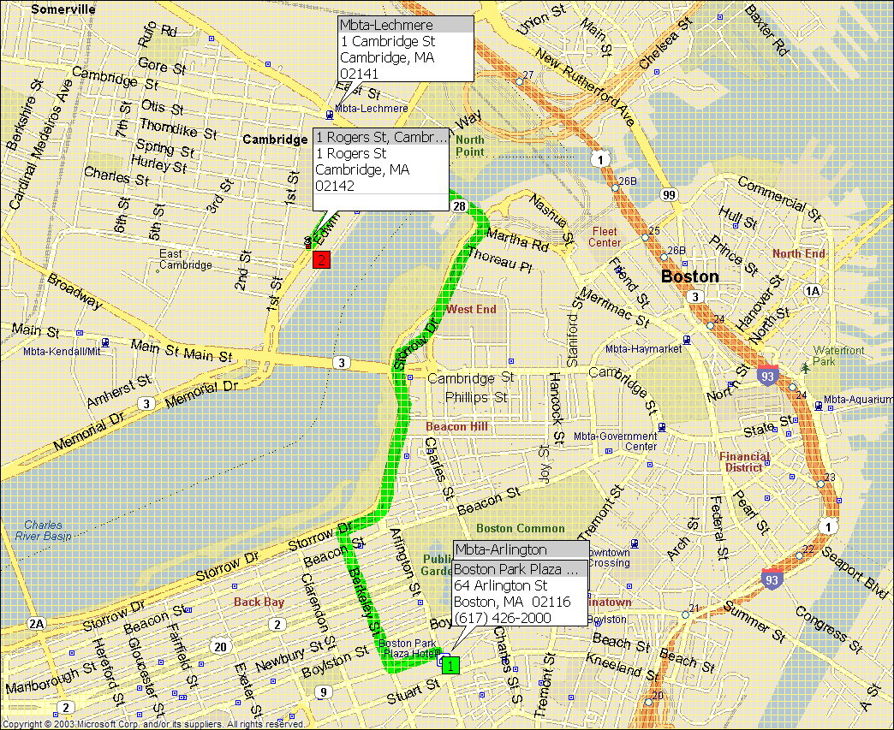

When walking you can cross the river at the Cambridge Street bridge and then along First Street to Rogers… this is shorter than walking all the way up to Science Center and around (the way a Taxi has to go … the green route pictured on the map)..
Public Transportation:

You can also take the Metropolitan Boston Transit Authority (MBTA), (Bostonian’s call it the “T”) Green line train from Arlington Station, about 2.5 blocks from the hotel to the Lechmere station (end of the line) which is also about 2.5 blocks from IBM Canbridge, 1 Rogers Street. You can actually walk thru the Cambridge Galleria Mall from the Lechmere Station toward Rogers Street. (See maps below). The fare for the “T” is $1.25.

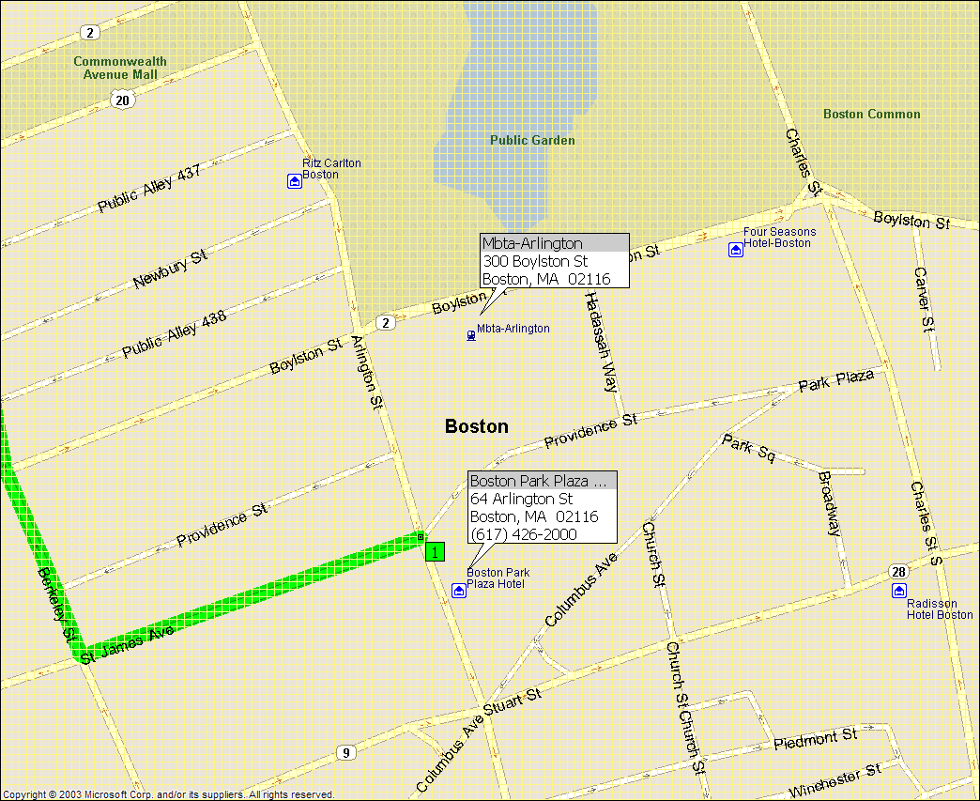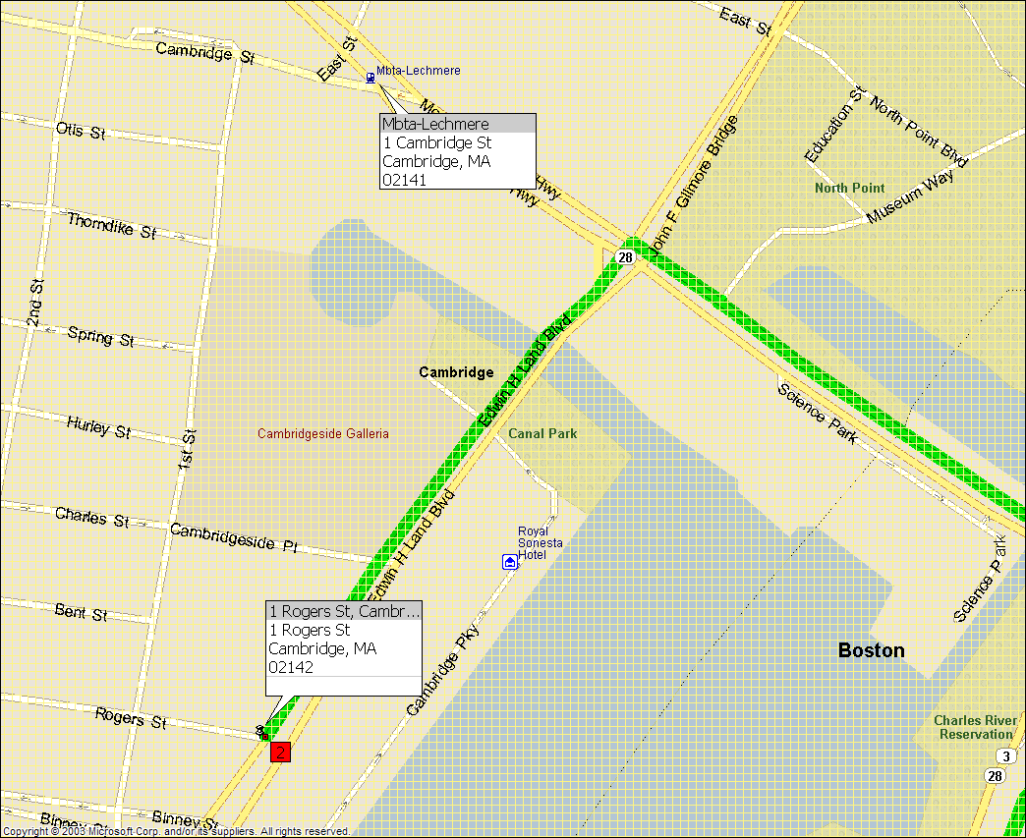

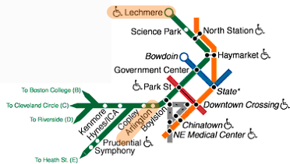
Attendees List

In Person
Hiro Kishimoto (Fujitsu)
Tom Maguire (EMC)
Andreas Savva (Fujitsu)
Andrew Grimshaw (University of Virginia)
David Snelling (Fujitsu)
Steven Newhouse (University of Southampton)
Mathias Dalheimer (Fraunhofer ITWM)
Ellen Stokes (IBM)
Abdeslem Djaoui (Rutherford Labs)
Dave Berry (NeSC)
Dejan Milojicic (HP)
Allen Luniewski (IBM)
Steve McGough (Imperial College)
Pete Ziu (Northrop Grumman)
Jun Tatemura (NEC)
Jim Pruyne (HP)
Steve Tuecke (Univa)
Michael Behrens (R2AD, LLC)
Chris Smith (Platform)
Steve Loughran (HP)
Takashi Kojo (NEC)
Toshiyuki Nakata (NEC)
Fred Maciel (Hitachi)
Jem Treadwell (HP)
Jay Unger (IBM)
Manuel Pereira (IBM)
Philipp Wieder (Forschungszentrum Jülich)
Ayla Debora (Universidade Federal de Campina Grande)
Stephen Davey (NeSC)
Stuart Schaefer (Softricity)
Donal Fellows (University of Manchester)
Andre Merzky (Free University Amsterdam)
Stephen Crouch (OMII, University of Southampton)
Sachiko Wada (Ascade)
Wolfgang Ziegler (University of Freiburg)
Srinivasan, Latha (HP)

Telephone Bridge
Mark Morgan (University of Virginia)
Andrea Westerinen (Cisco)
Ravi Subramaniam (Intel)

Apologies
Ian Foster (ANL)
Fred Brisard (Computer Associates)
Takuya Mori (NEC)
Frank Siebenlist (ANL)
Marvin Theimer (Microsoft)
Soonwook Hwang (NAREGI)
Michel Drescher (Fujitsu)

Making inquiries
Darren Pulsipher (Xango)
Neil Chue Hong (EPCC)

Meeting schedule at a glance

Day | Time | Agenda Item
Oct. 6  Thursday | 8-9:30am | EMS (1) WS-Agreement discussion
Oct. 6  Thursday | 9:30am-11am | EMS (2) CDDLM & ACS discussion (I)
Oct. 6  Thursday | 11am-12:30pm | EMS (3) CDDLM & ACS discussion (II)
Oct. 6  Thursday | 12:30-1:30pm | Lunch
Oct. 6  Thursday | 1:30-3pm | OGSA-naming session
Oct. 6  Thursday | 3:30-5pm | Resource Management, information/data model discussion
Oct. 6  Thursday | 5-6pm | OGSA-WG re-charter draft review
Oct. 7  Friday | 8-9:30am | OGSA-BES session
Oct. 7  Friday | 10-11:30am | OGSA-data session
Oct. 7  Friday | 11:30am-12:30pm | Lunch
Oct. 7  Friday | 12:30-2:30pm | Architecture & Glossary 1.5 review
Oct. 7  Friday | 2:30-3pm | Wrap-up and next step

Oct. 6 (Thu), 8 ~ 9:30am
EMS architecture discussion
With GRAAP-WG

Oct. 6 (Thu), 9:30 ~ 11am
EMS architecture discussion
With CDDLM-WG & ACS-WG (I)

Oct. 6 (Thu), 11am ~ 12:30pm
EMS architecture discussion
With CDDLM-WG & ACS-WG (II)

Oct. 6 (Thu), 1:30 ~ 3pm
OGSA-naming WG session (Andrew and Manuel)

- Discussion of OGSA guidelines and recommendations regarding the utilization of RNS and WS-Names

Oct. 6 (Thu), 3:30 ~ 5pm
OGSA Resource Management design team session (Fred, Ellen, and Andrea)
Information / data model discussion

- Review of the "Rules of Engagement" + "Guidelines" document. Ellen and Fred will write an outline of the document during GGF15.

- Discuss what set of information model profiles are needed for EMS (E.g., Container + Activities, Scheduling...). Work on profiles will start from one of these (quite possibly Container + Activities).

- Review of the "BES container profile" draft as an example

Oct. 6 (Thu), 5 ~ 6pm
OGSA-WG re-charter discussion (Tom and Hiro)

Oct. 7 (Fri), 8 ~ 9:30am
OGSA-BES WG session (Andrew, Steven and Darren)

Oct. 7 (Fri), 10 ~ 11:30am
OGSA-data WG session (Dave and Allen)

- Naming OGSA Data
What extra demands do data services place on the naming framework?

Oct. 7 (Fri), 12:30 ~ 2:30pm
OGSA Architecture & Glossary 1.5 review (Andreas and Jem)

Oct. 7 (Fri), 2:30 ~ 3pm
Wrap-up and next step discussion (Tom and Hiro)

