OGSA-Interested Party Survey (rev. 07)
Dec. 6, 2004
Information provided in a survey is not considered the official position of the stakeholder unless so stated. Further, even if information provided is the official position of the stakeholder the survey is not binding and does not imply any obligation on the stakeholder.
Grid scenarios present a number of significant challenges to end-users, application developers, and IT managers. OGSA will address these complex challenges by defining a set of standards that together, like the interlocking pieces of a puzzle, provide the foundation on which to build robust Grid applications and Grid management systems. Thus, OGSA will define the services, their interactions, and the design philosophy based on the community’s experiences, inputs, and feedback.
Provided answers are covered by the GGF IPR policy.
https://forge.gridforum.org/projects/helpdesk/document/IPR_Stmt
The purpose of this survey is to solicit input from all OGSA stakeholders in order to refine the OGSA roadmap document and OGSA version 2.0 architecture documents.
The OGSA roadmap document will define priorities for OGSA interfaces, based on community input, identify dependencies among interfaces, and describe community requirements for timing the definition of the OGSA interfaces. Thus we need your input to complete this process including:
- What specifications are most important for your activity?
- Which ones need to be done before the others?
- Which specifications are you ready to work on, or are already working on?
- Which specifications are you ready to use?
- Which specifications are more important than others for you? Or which areas have multiple competing specifications so hindering adoption?
The OGSA version 2.0 document will be a revised, more mature, version of the current OGSA version 1.0 document. It will still be an informative document, presented at the same abstract level as OGSA version 1.0. In addition, the OGSA-WG recognizes the need to provide normative descriptions of the architecture to the OGSA stakeholders in a timely fashion. Initially, however, such normative descriptions can address only parts of the architecture due to the scale of the work. If you are defining or implementing one or more OGSA related interfaces, please provide feedback including:
- What specifications are you defining or implementing?
- Do your interfaces satisfy OGSA requirements described in the version 1.0 document? Do they fit well in the OGSA version 1.0 capability framework?
- Do you have additional requirements for OGSA? Do you have other ideas, which should be a part of OGSA?
- Do you have the expertise to develop these specifications? Are you willing to work with the OGSA-WG to make these specifications part of OGSA, and hence define OGSA compliance?
This is the draft revision of OGSA-WG interested party survey template. Please use this template to describe your activity. The text in blue is explanation and should be deleted before answer submission.
If you have any comment or suggestion to improve this template, please send it to OGSA-WG mailing list (ogsa-wg@ggf.org).
Hiro Kishimoto (hiro.kishimoto@jp.fujitsu.com)

Name
OGSA stakeholder’s (e.g., party, project, activity, individual) name and web site URL (if any)
Anonymous submission is allowed but discouraged.

Outline

Category
Please check the most suitable categories with respect to this party.
Table 1 category of the party
Standards development group or research group (e.g. GGF WG/RG, OASIS TC, etc.)
Open source software development or distribution project (e.g. Globus, NMI, OMII, etc.)
Grid testbed or application project (e.g. TeraGrid, National Fusion Collaboratory, etc)
Commercial software and / or hardware vender
Grid user company
Other (please specify)

Description
Describe this party’s activity in 5-10 lines. Include goals, party size, supporting organizations, and pointers to related materials, if applicable.

Contact person
Name and email address of contact person for this party or survey submitter.

Schedule
Schedule, for example, the major release dates.

Synergy with OGSA

Role
Please check one or more suitable roles for the party.
Table 2 Table role of the party
Grid requirements gathering
High level architecture design
Low level architecture design
Specification (e.g. API) development
Grid software development
Grid operation
Other (please specify)

Area or capability
The following areas or capabilities (except Grid application) are defined in the OGSA version 1.0 document. If the party is working in these areas, please specify its “involvement” to the OGSA-WG activities and “role.”
For the Involvement column, please check one of the appropriate boxes: High – Mid – Low
- High means the party has attended OGSA F2F meetings, GGF sessions, and / or teleconference regularly
- Mid means the party has attended sessions or teleconferences a few times.
- Low means the party has not yet attended sessions or teleconference.
For the Role column, please check one or more box: HLA (High level arch design) – ASD (Actual specs development) – IMP (Implementation)
If the party is not working in any of these areas, please check the N/A column.
This information will help place the party in the following “role-involvement” chart. This chart is provided for information purposes and does not have to be edited.
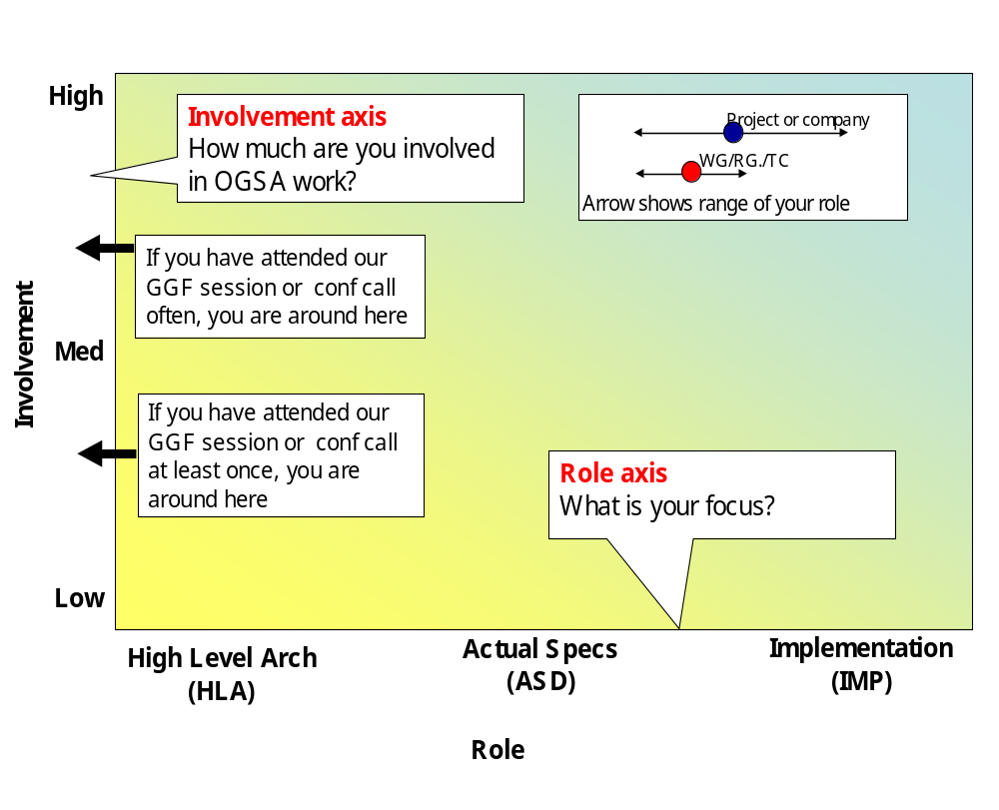
Fig 1 Role-involvement chart

Table 3 role-involvement table
Area | Involvement |  |  | Role |  |  | N/A
Area | High | Med | Low | HLA | ASD | IMP | N/A
Grid application
Execution management services
Data services
Resource management services
Security services
Self-management services
Information services
Naming service:
Infrastructure services

Input to OGSA
In order to synchronize OGSA and this party, your input is essential. Please read chapter 3 of the OGSA version 1.0 document and let us know your feedback with respect to each OGSA capability relevant to you. Does the current capability description align with your activity? If there are any conflicts and / or gaps, or the party has any general input for OGSA please check the appropriate box. Please provide additional description of the problems and any solution proposals.
In particular, if the party is developing actual specifications, which may eventually be identified as “OGSA compliant”, please provide a summary of each and expected dates for the following:
- Specification publication date
- Reference implementation release date
- Early adoption date
- Mainstream adoption date
If your feedback is not available at this moment but will be ready in the near future, please note its planned date.
If the party is not working on a capability (answered no at §3.2), please check N/A column.
Table 4 OGSA input table
Area | Conflicts, Gaps, Inputs |  | N/A
Execution management services | Conflicts
Execution management services | Gaps
Execution management services | Inputs
Data services | Conflicts
Data services | Gaps
Data services | Inputs
Resource management services | Conflicts
Resource management services | Gaps
Resource management services | Inputs
Security services | Conflicts
Security services | Gaps
Security services | Inputs
Self-management services | Conflicts
Self-management services | Gaps
Self-management services | Inputs
Information services | Conflicts
Information services | Gaps
Information services | Inputs
Naming service | Conflicts
Naming service | Gaps
Naming service | Inputs
Infrastructure services | Conflicts
Infrastructure services | Gaps
Infrastructure services | Inputs

Expected output from OGSA
The refinement of OGSA is likely to result in a set of documents, shown below in three tiers (see figure 2). Tier 1 includes the following “Root documents”:
- Roadmap version 1.0 document
- Architecture (OGSA version 2.0) document (Revision of OGSA document version 1.0)
- Glossary version 2.0 (Revision of OGSA Glossary document version 1.0)
Tier 2 includes the following “Design team documents”:
- Service Description describes the services in each capability using a combination of natural language and UML, listing the interfaces and operations defined by each service.
- Scenarios demonstrate how these services can implement the use cases, using a combination of natural language and UML.
Tier 3 consists of Expert WG documents. These documents provide a normative definition of the services using a mixture of WSDL and natural language. These should be GGF Recommendation documents or equivalents from other standards development organizations.
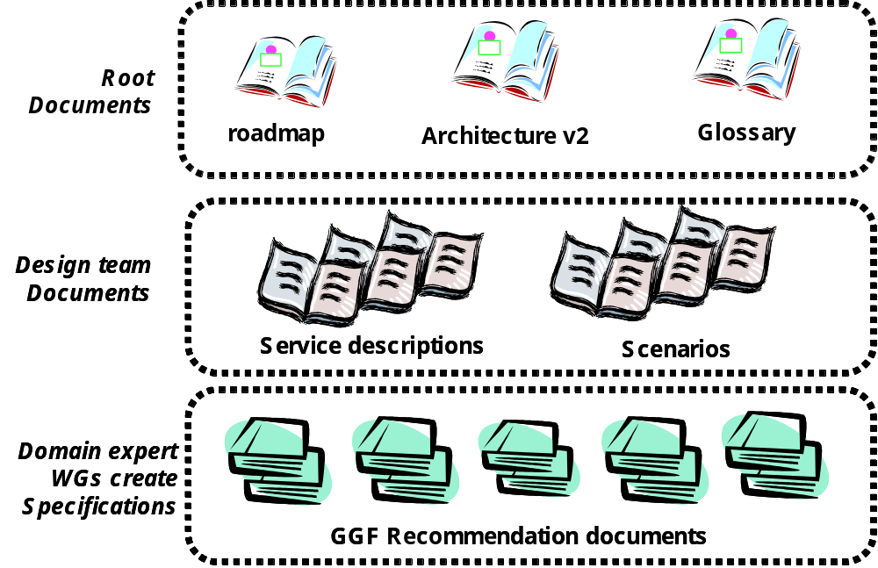
Fig 2 OGSA version 2.0 document structure
If the party is planning to develop and / or use any of the above documents, please check the appropriate box for each applicable area. For each checked box provide a delivery date that fits your schedule.
Because the document publication schedule is still under discussion, this is a hypothetical question; if the schedule is as follows, does it fit with your schedule?

Table 5 Hypothetical OGSA version 2.0 documents schedule
Document name |  | WG draft publication | Reference Implementation release
Roadmap document version 1.0 |  | GGF13 (‘05/3) | n/a
Architecture and glossary version 2.0 |  | GGF14 (‘05/6) | ‘05/11
Service descriptions  Scenarios | EMS | GGF14 (‘05/6) | ‘05/11
Service descriptions  Scenarios | Data Services | GGF14 (‘05/6) | ‘05/11
Service descriptions  Scenarios | Resource Mgmt | GGF15 (‘05/9) | GGF17 (‘06/6)
Service descriptions  Scenarios | Security services | GGF17 (‘06/6) | GGF19 (‘07/3)
Service descriptions  Scenarios | Self Management | GGF17 (‘06/6) | GGF19 (‘07/3)
Service descriptions  Scenarios | Information Services | GGF16 (‘06/3) | GGF18 (‘06/9)
Service descriptions  Scenarios | Naming Service | ‘04/12 | ‘05/11

Table 6 Spec development / use schedule
Area | Specifications and their schedule |  | N/A
Execution management services | Develop
Execution management services | Use
Data services | Develop
Data services | Use
Resource management services | Develop
Resource management services | Use
Security services | Develop
Security services | Use
Self-management services | Develop
Self-management services | Use
Information services | Develop
Information services | Use
Naming service | Develop
Naming service | Use
Infrastructure services | Develop
Infrastructure services | Use

General comments for OGSA
If the party has any general comments, not covered in any of the previous sections, please add them here.

https://forge.gridforum.org/projects/ogsa-wg/document/draft-ggf-ogsa-spec/en/19
In OGSA version 1.0 document, naming service is explained as a service under information capability.

