Application Use Cases

In order to understand “peer-to-peer” applications and their requirements, we provide a set of use cases that cover three of the more common peer-to-peer applications: pc grid computing, file sharing, and content delivery.

PC Grid Computing

The overall objective of PC Grid Computing is to leverage the unused processing power of desktop computers for non-desktop related activities. Such activities may include data services [farsite, oceanstore, avaki], compute services [entropia, ud, platform] or some combination. Here, we focus on compute services.

Figure 1 shows the overall architecture of a generalized PC Grid Computing system. There are three main actors: Users define jobs and decompose a job into a set of tasks that are submitted to the system; the Desktop Clients receive tasks from the system and manage their execution on the host machine; and finally the System Manager maintains resource and capability information regarding the desktop clients, maintains task resource requirements, schedules tasks to clients, and manages the overall fault tolerance and system behavior.

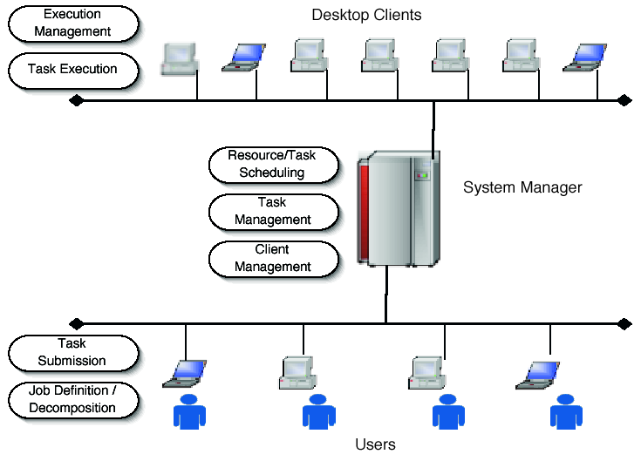
Figure 1: Generalized Architecture of a PC Grid Computing System.

We describe the following use cases:
- User submits Job,
- User Queries the System Manager for Status,
- Desktop Client Joins the System,
- Desktop Client Executes a Task,
- Job Completes and results are returned to the User,
- Desktop Client Leaves the System.

User submits Job

A user interfaces to the system through a desktop computer. This computer may or may not function as a execution resource (for the purposes of this document, we assume that it does not). There may be a single user (eg. seti@home), or a many users (we assume many users).

A job is a computational task that the user wishes to execute. A job is composed of a set of tasks, where each task is a single computational unit. Job decomposition may or may not be part of the PC Grid Computing system, and may range from trivial (eg. parameter sweep style jobs) to quite difficult.

The job is decomposed into a set of task descriptions, that includes all the information necessary to execute the task: command executables or locations where they can be found, input parameters, input files or their locations, required output files or their locations, and resource requirements. These task descriptions are sent to the System Manager for scheduling and the System Manager returns a unique job ID for that batch of tasks. The JobID can be used to query the System Manager for the job status.

Note: there may be a firewall or NAT between the User and the System Manager.

User Queries the System Manager for Status

Using the jobid returned by the System Manager for a previously submitted job, the user can query the system to determine the status of the set of tasks. The System Manager returns the job statistics (number of tasks completed, number of tasks currently being executed, number of tasks pending, number of errors, etc).

Note: there may be a firewall or NAT between the User and the System Manager.

Desktop Client Joins the System

When a new Desktop Client joins the system (that is, when the client installs the PC Grid Computing Client software), the software first determines the resource characteristics of the machine: laptop versus desktop, operating system and version, available RAM and disk, processor speed, etc. These resource characteristics are sent to the System Manager that records the characteristics of the machine, its current IP address and generates some unique client ID that is returned to the software.

The client ID is used for all future communications with the System Manager. Note: the client ID cannot be the IP address of the machine, since in this environment, IP addresses may change dynamically. By tagging all communication by a unique client id, the System Manager can identify client machines as their IP addresses change.

After receiving the client ID, the client and System Manager periodically communicate to ensure that the client is available.

Note: there may be a firewall or NAT between the Client and the System Manager.

Desktop Client Executes a Task

When the System Manager schedules a task for execution by allocating the task to an appropriate client. The client, through either a push or a pull mechanism, receives the task description and downloads the necessary files (input files, databases, executables, etc). The client then launches the task typically in some type of sandbox, where the client software can have tight control of the task’s execution.

The client software monitors the execution of the task, ensures that the task does not cause any interference with the desktop user and if so, kills or pauses the task.

The task may need to communicate with other tasks during its execution.

When complete, the a signal is sent to the System Manager that the task completed, and the resulting files (or locations) are copied to their external locations, as described in the task description.

If the desktop client is a laptop, it may disconnect from the network and continue to execute the task. When the task is complete, the client software waits until the network is available, then sends the notification to the System Manager. When disconnected, communication with other tasks is not possible and the task blocks.

If the desktop client is rebooted, the client software is automatically restarted and the task is either continued from a checkpoint file (if available) or restarted from the beginning. If tasks are communicating, then restarting a task due to failures must be done in such a way to ensure consistency and validity of the results.

Note: there may be a firewall or NAT between the client and the System Manager and between any two clients.

Job Completes and results are returned to the User

When the set of tasks are complete, the result files, and return codes are sent to the user’s desktop machine. Future queries of the task show the task as complete.

Desktop Client Leaves the System

A desktop client could leave the PC Grid Computing system for a number of reasons, both expected and unexpected. Expected leaves can occur when the software is uninstalled, or the machine is gracefully halted. Unexpected leaves can occur if the machine crashes or has a hard stop. In the first case, the client software can send a notification to the System Manager that the client machine will no longer be part of the PC Grid Computing system. In the latter case, the periodic communication to or from the System Manager will eventually detect that the machine is no longer responding.

File Sharing

File Sharing applications such as Napster and Gnutella are still the most popular peer-to-peer applications in the peer-to-peer space with on the order of millions of users (Napster alone had by some estimates over 57 million individual users). Figure 2 shows a generalized file sharing application. It consists of a number (perhaps millions) of Users and a System Directory. The users may belong to a number of different Groups, where each Group has a unique name. Users have files that they share with other members of groups to which they belong. Groups may be created dynamically by any user who is then identified as the “owner of the group”. The owner of the group can control the subsequent membership of that group. All users belong to the special group “allusers”. The System Directory maintains the list of groups, their owners and members, and some metadata of the files that are shared for every user and group. The System Directory allows users within a group to search for files of certain type or content. This directory is a logical entity. It may be implemented in either a centralized way with a single group that includes all users (eg. Napster), or in a distributed fashion (eg. Gnutella). We make no assumptions about implementation.

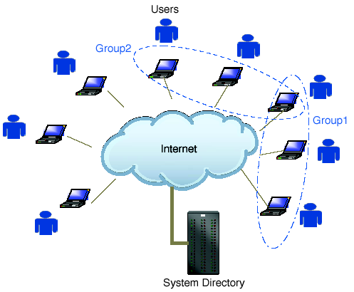
Figure 2: Generalized File Sharing Application

Use cases:
  - client joins the network and logs in
  - user creates a group among which file sharing is possible
  - client publishes files
  - client searches for and downloads files
  - client leaves the network

User Creates a New Group

Any user in the system may be able to create a new group. The user runs a client program on his or her desktop computer that connects to the system and authenticates the user. The user can then request a new group to be created with a particular group name. A group is created by the System Directory on behalf of the user who is then acknowledged as the “owner of the group”. A group has a group name and a group id. The name is arbitrary, but the group id is unique and assigned by the System Directory and returned to the user’s client program. The user is automatically added as the first member of that group.

The group name and id are stored on by the System Directory and are indexed so as to enable discovery by other users. Groups may be hidden or visable, and have open or closed enrollments, all defined by the user at the time the group is created. Visible groups can be discovered by other users not in the group, hidden groups can not. Open-enrollment groups allow any user to become a member automatically, closed-enrollment groups require approval from the owner.

User Joins a Group

In order to join a group, a user must either know the group id of the group he/she wishes to join, or search through the directory of visible group stored by the System Directory. The user then issues a join request to the System Directory.

If the requested group has an open enrollment policy, the user is automatically added. If it is closed, the user is marked as “wanting to join” and awaits approval from the owner of the group. Once given, the user is added to the membership.

Once a member of the group, the shared files that the user has on his desktop computer are indexed and their metadata are sent to the System Directory to allow other member of the group to discover them.

User Shares Files Within a Group

Once a user is a member of a group (and note that all users are members of the special group “allusers”), they can search for content (ie files) that are shared among all the members of that group.

Using the client program on the users desktop machine, the user contacts the System Directory with the search criteria. The System Directory returns to the user’s client program a list of member that have a related file and that are currently connected and logged into the system. The user’s client program can then contact the “peer members” directly and request a copy of the file of interest.

If the peer member disconnects or logs off, then the user’s client program must retry the transfer with a different peer member.

Note that most users are likely to have firewalls or NATs installed between themselves and the System Directory.

P2P Content Delivery

Peer-to-peer content delivery addresses the problem of delivery of large files from a single source server to multiple client destinations. In general, Content Delivery Networks (CDNs) (ref akamai) use specialized content caches located throughout the network to deliver common content such as large images, software updates, or streaming media. Doing so reduces the bandwidth bottleneck at the originating server and improves performance from the client’s perspective.

Peer-to-peer content delivery applications are based on the same idea, but instead of using specialized machines that serve as caches, they use the client’s themselves. Figure 3 shows the general idea: The Server originates the content that is delivered to the client on the right. Subsequently, the client on the left requests the same content from the server. Instead of pushing the content through the internet once again for the second client, a peer-to-peer content delivery network would redirect the file transfer to the first client who, after all, has an identical copy of the content. This redirection is seemless to the second client and the operation completes sooner (since the bandwidth within the enterprise is typically larger than the internet) and more cost effectively (since no bandwidth is used by the server).

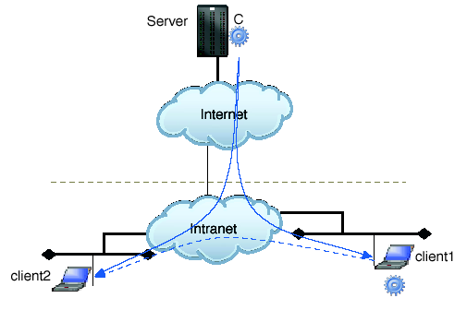
Figure 3: Peer-To-Peer Content Delivery

We consider the following use cases:
  - client1 retrieves the content file from server (no peer caches are available)
  - client 2 retrieves the content file from a peer cache at client1

Client Retrieves Content Directly from Server

For this example, the server holds the content file marked C and receives a request for C from client1. Client1 is situated within an intranet, perhaps a corporate network. The content may be a large file such as a streaming media file, or a software update. C has meta-data associated with it that describes the version information and is not updated by the clients (ie, the content is read only).

Client1 sends a request to the server for file C. They Peer-to-peer Content Delivery Network intercepts that request and determines that there are no peer caches that hold C. Therefore, the request is sent directly to the server who then send the file to the client.

When C is received by the client, the client software creates a peer cache at the client and stores both the content and metadata associated with the content. The P2PCDN is updated with client1’s new cached information.

Client Retrieves Content from Peer Cache

When Client2 requests content C from Server, the P2PCDN again intercepts the requests and determines that C is available from a nearby peer. The content request is redirected to client1 and C is retrieved. Client2 then also becomes a peer cache and the P2PCDN system is updated to reflect this cache for future requests.

