Policy Use Cases for Grid Systems
Status of This Memo
This memo provides information to the Grid community a set of Use Cases for Policies in the NPI Grid Architecture. This document is an informational document is does not define any standard or technical recommendation. Distribution is unlimited.
Copyright Notice
Copyright © Global Grid Forum (2003). All Rights Reserved.
Abstract

Contents
Policy Use Cases for Grid Systems 1
Abstract 1
1. Introduction 3
2. Areas of Policy Use 3
3. Policy Use Case Actors 4
3.1 User 4
3.2 Resource 4
3.3 Application 4
3.4 Security System 4
3.5 System Administrator 5
3.6 Application Integrator 5
3.7 Auditor 5
3.8 Capacity Planner 5
3.9 System Management Tools 5
4. Policy Use Cases 5
4.1 Administer Policies 5
4.1.1 Primary: Update an existing Policy 6
4.1.2 Create a new Policy 7
4.1.3 Delete an existing Policy 8
4.1.4 Deactivate an existing Policy 9
4.1.5 Activate an existing Policy 10
4.1.6 Get the Policy for a specific date. 11
4.2 Query for Policy Information 12
4.2.1 Primary: Query a specific policy 12
4.2.2 Select for query based on policy attribute 13
4.2.3 Simulate interaction of Jobs, Resources and Policies 14
4.3 Evaluate Impact of Policies 14
4.3.1 Primary: Evaluate current running jobs affected by a Policy 14
4.3.2 Evaluate finished jobs affected by a Policy 14
4.3.3 Evaluate pending jobs affected by a Policy 14
4.4 Monitor Resource Usage compliance 15
4.4.1 Primary: Notify User of Resources not in compliance 16
5. Security Considerations 17
6. Author Information 17
7. Glossary 17
8. Intellectual Property Statement 17
9. Full Copyright Notice 17
References 18

Introduction
The following are the detailed description of the use cases of a Grid system. Use cases are presented as UML sequence diagrams that illustrate message-based interaction between and among the Actors and a ‘black box’ Grid system. Use cases are extended with scenarios which describe in more detail as to how the system will react to an actor's input.
The messages listed below the sequence diagram use a numbering scheme that describes the message hierarchy not the sequence of steps, so there is no direct correspondence between the step numbers in the sequence diagram and the message numbers.
It is important to note that, at this stage of analysis and design, the message protocol flow is still under development. Responses to messages, acknowledgements (ack) for example, may seem to be missing or misplaced. These protocols will not be defined in this document but give other groups or organizations a starting point to build from.
This document is organized in the following way. First the areas that were considered when performing the Use Cases was addressed. Second a description of the actors of the system will be described. This helps define the boundary of the system for better definition. Lastly, the Use cases will be described, and the scenarios for each use case.

Areas of Policy Use
When performing the use case analysis of policies in the grid we specifically looked at the following areas that policy is used, defined, or managed.
- Scheduling policies
  - Jobs
    - Individual job or workflow can have a policy that limits the times that a job can run.
    - Individual job or workflow can be limited according to values of resources.
  - Users
    - A User can only run jobs at specific time
    - A User can only run jobs on specific
  - Resources
  - Groups of Users
  - Projects
  - Resource Sharing
- Security policies
  - Authentication
  - Authorization
  - Data integrity
  - Privacy
  - Non-repudiation, and
  - Access control
- Billing policies
  - Pricing and billing,
  - Cost of using a resource
- Reservation Policies
- Accounting Policies
  - Logging
  - Reporting usage
- Monitoring policies
- Performance policies
- Inter-cluster or grid services policies

Policy Use Case Actors

User
A User is a person who has an expressed need (i.e. one or more jobs) to access and use managed resources. Users are the primary actors, as their needs drive the requirement for applications to execute on resources. In general, the user is more interested in the beneficial results of Grid than the concepts and inner workings. It is the value of these beneficial results that funds all IT and Grid investment. Examples: Engineers, scientists, accountants, risk analyst, etc.

Resource
A resource is an atomic unit of supply within the Grid space. Resources can represent a tangible entity (e.g. a CPU or available disk space), derived value (e.g. CPU run queue length) or an intangible construct (e.g. state).
There are two primary modes of resource utilization: consumption and borrowing, and an additional mode: reference. Here are some examples:
- Consumption: As a job runs, CPU cycles, wall clock time and network bandwidth are used up in the process. These resources are not available to other jobs as the job runs and cannot be recovered for later use.
- Borrowing: A job runs using a floating software license, occupying memory and allocating files on temporary disk storage. At the end of the job these resources are returned for use by other jobs.
- Reference: A job requires a specific release of an operating system. As a resource the operating system release is not borrowed or consumed, just referenced.

Application
The Application is executed on external Resources by the Grid system. The Application will consume and borrow resources from the external Resources. Applications are another primary actor.
Examples: programs, build systems
This includes different classes of applications. This is the collection of all components to run a particular job or application.

Security System
The Security System is a standalone arbitrer of access control. Must provide reliable means of:
Identification – ability to uniquely identify a user (e.g. username)
Authentication – ability to confirm identification by something the user has or knows (e.g. security token, password)
Access Control – Allows or disallows an action (e.g. read, delete, submit) requested by an identified and authenticated user against a protected entity (e.g. a file).
The Security System needs to authenticate the User for access to the Grid system.
The Security System needs to arbitrate on Resource access requests.

System Administrator
This actor will be in charge of provisioning configuration, planned and ad hoc operations of the Grid system. This actor will also be in charge of diagnosis and recovery from abnormal situations. The System Administrator needs to have command and control of the Grid system.

Application Integrator
The Application Integrator provides services and software that glue the Grid system and Applications for the User together.

Auditor
An Auditor requires an independent stream of information about the Grid system usage to reconcile against guidelines and plans. The auditor’s output reports on actual system usage in reference to the policies that are in place to manage system usage.

Capacity Planner
The Capacity Planner requires historical information about supply and demand in order to make decisions (including performance and capacity projections) for hardware and software resources in the future.

System Management Tools
These are tools that require event flows and action from the Grid system. These includes change management, source management, problem tracking, and configuration management. System Management Tools will have passive (listening) and active (controlling) roles.

Policy Use Cases

Administer Policies
This use case describes the administration (add/change/delete) of policies. Policies are maintained within Grid on behalf of one or more Users.

Primary: Update an existing Policy
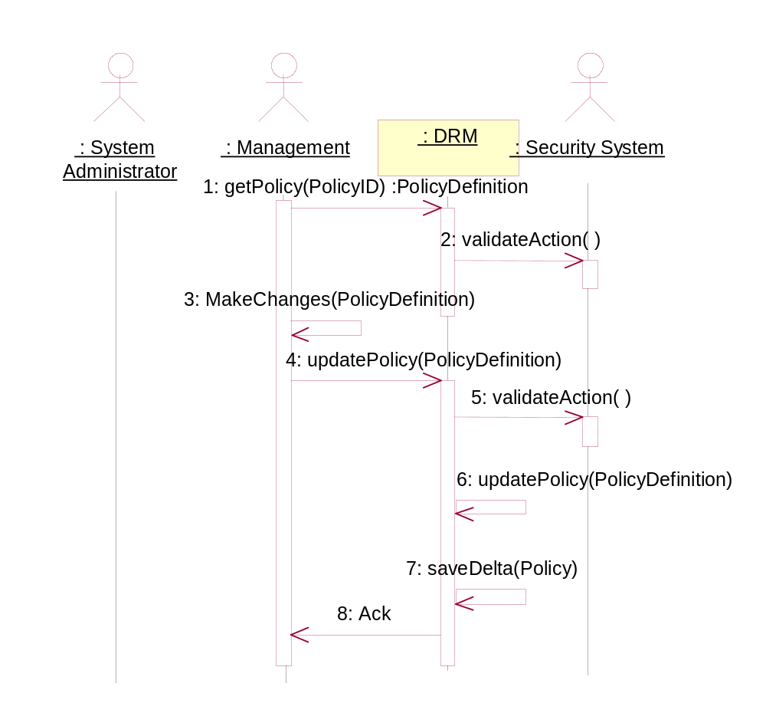
Sequence Diagram : Primary: Update an existing Policy

Grid must keep track of all changes to Policies and be able to recover the state of a Policy to a given point in time. This is necessary in order to be able to evaluate the impact of Grid decision behavior.

Messages
1. getPolicy(PolicyID) :PolicyDefinition [:Management-->:Grid]
1.1. validateAction( ) [:Grid-->:Security System]
Can this Management actor retrieve this Policy?
2. MakeChanges(PolicyDefinition) [:Management-->:Management]
3. updatePolicy(PolicyDefinition) [:Management-->:Grid]
The Grid implementor can control the number of Users changing a policy at the same time through a lock and unlock mechanism. This is a suggested function and will not be part of the standard.
3.1. validateAction( ) [:Grid-->:Security System]
Can this Management actor update this Policy?
3.2. updatePolicy(PolicyDefinition) [:Grid-->:Grid]
Only update the changes to the Policy definition compared to the existing Policy.
3.2.1. saveDelta(Policy) [:Grid-->:Grid]
We need to save the delta between the Policy and the new Policy definition. This will be used to maintain a full historical record of Policy changes.
In addition to a save delta action, a snapshot all of the policies may be required at regular intervals.
3.2.2. Ack [:Grid-->:Management]

Create a new Policy
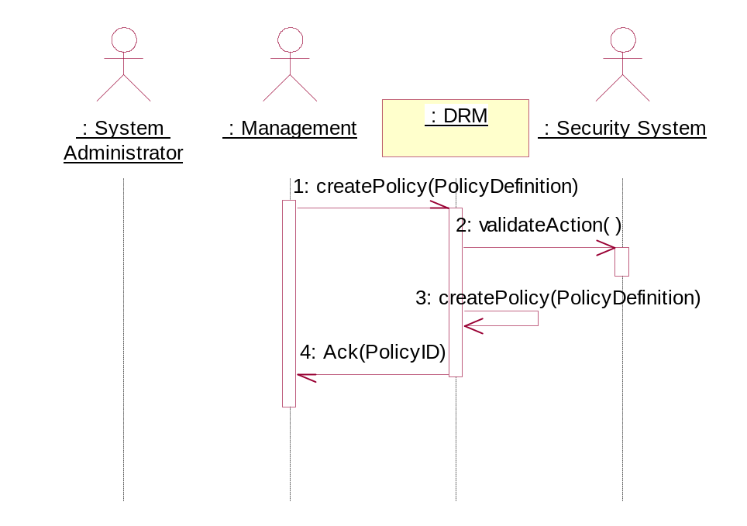
Sequence Diagram : Create a new Policy

Messages
1. createPolicy(PolicyDefinition) [:Management-->:Grid]
1.1. validateAction( ) [:Grid-->:Security System]
Can this Management actor add a Policy?
1.2. createPolicy(PolicyDefinition) [:Grid-->:Grid]
The Grid system will create the Policy according to the Policy Definition. The initial Policy state may be contained in the Policy definition.
1.3. Ack(PolicyID) [:Grid-->:Management]

Delete an existing Policy
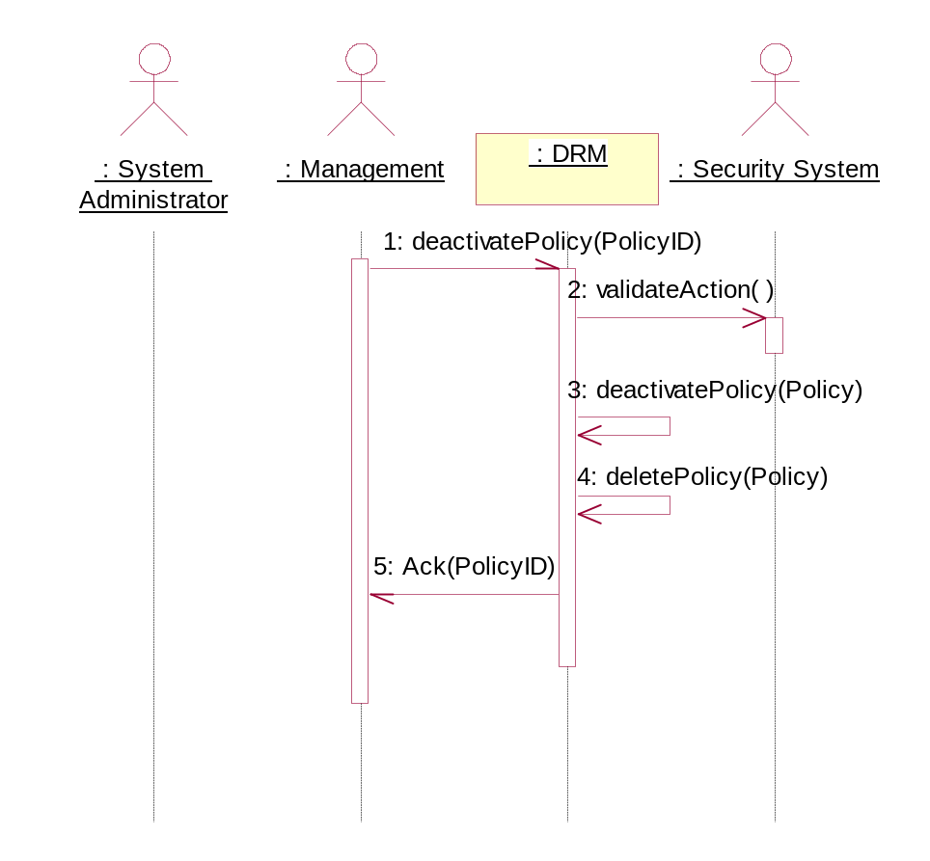
Sequence Diagram : Delete an existing Policy

Messages
1. deactivatePolicy(PolicyID) [:Management-->:Grid]
1.1. validateAction( ) [:Grid-->:Security System]
Can this Management actor delete this Policy
1.2. deactivatePolicy(Policy) [:Grid-->:Grid]
The Grid system will deactivate the Policy. Current running jobs will not be affected by the deactivation of a Policy.
1.3. deletePolicy(Policy) [:Grid-->:Grid]
This will delete a Policy from the Grid system.
1.4. Ack(PolicyID) [:Grid-->:Management]

Deactivate an existing Policy
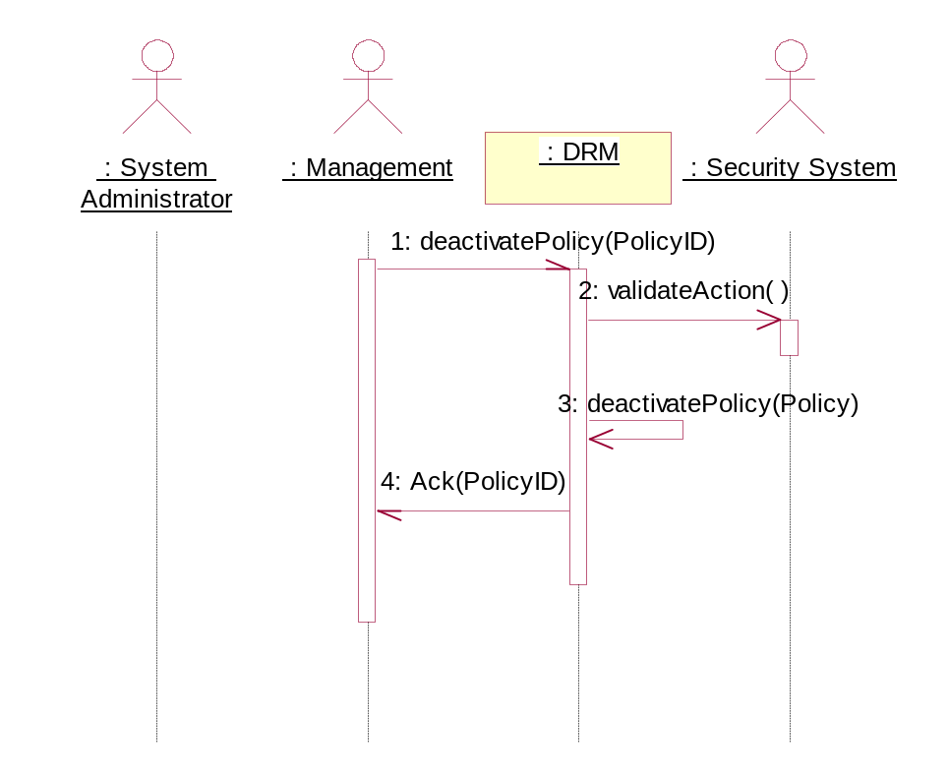
Sequence Diagram : Deactivate an existing Policy

Messages
1. deactivatePolicy(PolicyID) [:Management-->:Grid]
1.1. validateAction( ) [:Grid-->:Security System]
Can this Management actor deactivate this Policy?
1.2. deactivatePolicy(Policy) [:Grid-->:Grid]
The Grid system will deactivate the Policy. Current running jobs will not be affected by the deactivation of a Policy.
1.3. Ack(PolicyID) [:Grid-->:Management]

Activate an existing Policy
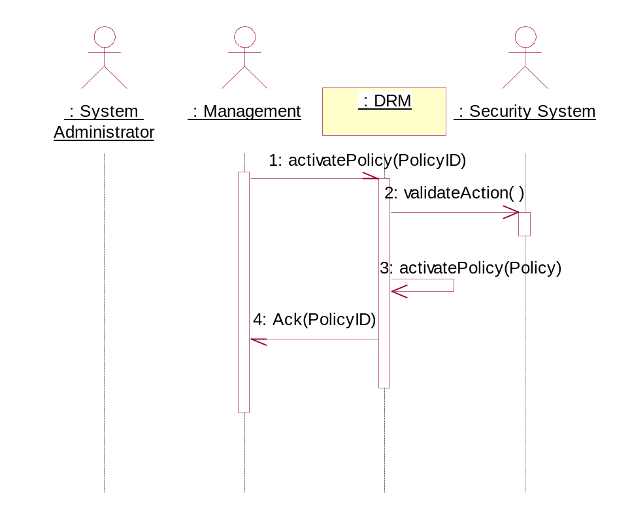
Sequence Diagram : Activate an existing Policy

Messages
1. activatePolicy(PolicyID) [:Management-->:Grid]
1.1. validateAction( ) [:Grid-->:Security System]
Can this Management actor activate this Policy?
1.2. activatePolicy(Policy) [:Grid-->:Grid]
The Grid system will activate the Policy.Current running jobs will not be affected by the activation of a Policy.
1.3. Ack(PolicyID) [:Grid-->:Management]

Get the Policy for a specific date.
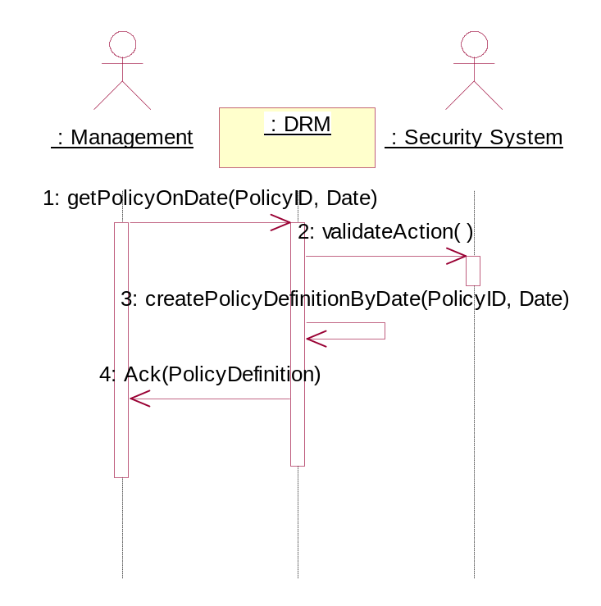
Sequence Diagram : Get the Policy for a specific date.
An actor may need to reconstitute a Policy definition for a specific date/time.

Messages
1. getPolicyOnDate(PolicyID, Date) [:Management-->:Grid]
1.1. validateAction( ) [:Grid-->:Security System]
Can this Management actor perform this action?
1.2. createPolicyDefinitionByDate(PolicyID, Date) [:Grid-->:Grid]
2. Ack(PolicyDefinition) [:Grid-->:Management]

Query for Policy Information

Primary: Query a specific policy
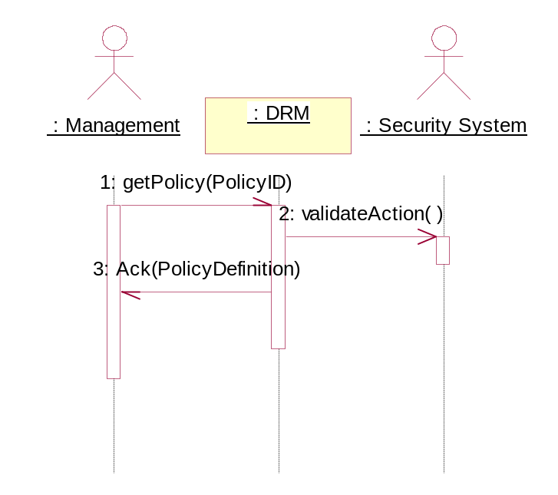
Sequence Diagram : Primary: Query a specific policy
Query a specific Policy by Policy name.

Messages
1. getPolicy(PolicyID) [:Management-->:Grid]
1.1. validateAction( ) [:Grid-->:Security System]
Can this Management actor retrieve this Policy?
1.2. Ack(PolicyDefinition) [:Grid-->:Management]

Select for query based on policy attribute
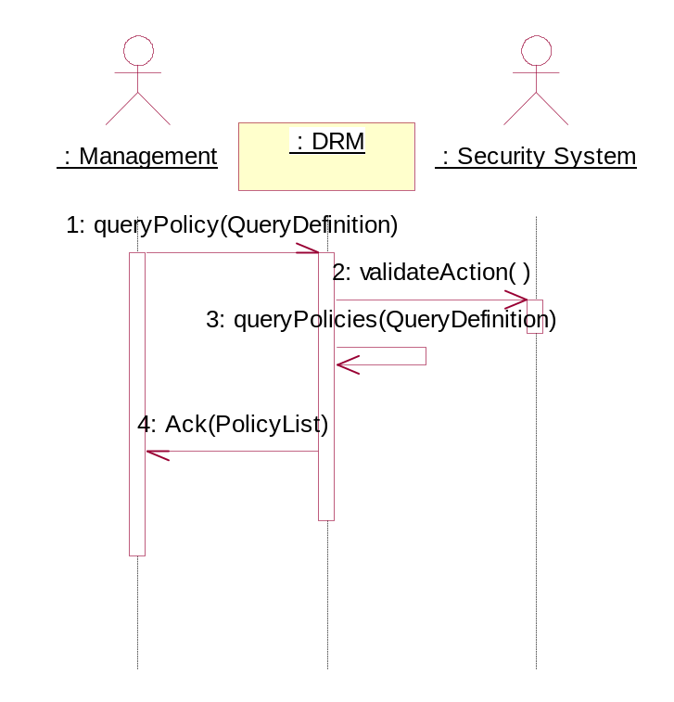
Sequence Diagram : Select for query based on policy attribute
- find all the policies that reference software license XYZ version 9
- find all policies that reference certain Users or Groups
- find all policies that reference certain Resources
- find all policies that are valid within a certain time frame
- find all policies that reference a certain instance for applying rules/policies e.g. queues, hosts…..
- list all policies that are administered by certain Users/Administrators/Groups

Messages
1. queryPolicy(QueryDefinition) [:Management-->:Grid]
1.1. validateAction( ) [:Grid-->:Security System]
Can this Management actor retrieve this Policy?
1.2. queryPolicies(QueryDefinition) [:Grid-->:Grid]
1.3. Ack(PolicyList) [:Grid-->:Management]

Simulate interaction of Jobs, Resources and Policies
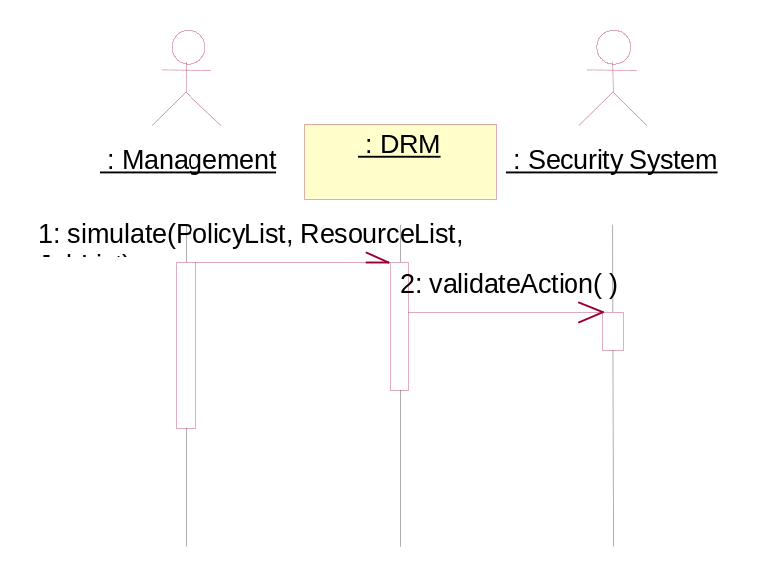
Sequence Diagram : Simulate interaction of Jobs, Resources and Policies

This function enables ‘what-if’ scenarios. This will not be a standard requirement.

Messages
1. simulate(PolicyList, ReourceList, JobList) [:Management-->:Grid]
1.1. validateAction( ) [:Grid-->:Security System]
Can this Management actor simulate these Policies?

Evaluate Impact of Policies

Primary: Evaluate current running jobs affected by a Policy

Messages
Messages for this sequence diagram have not yet been captured.

Evaluate finished jobs affected by a Policy

Messages
Messages for this sequence diagram have not yet been captured.

Evaluate pending jobs affected by a Policy

Messages
Messages for this sequence diagram have not yet been captured.

Monitor Resource Usage compliance
Monitor Resource utilization by jobs during execution. Warn, over-charge, or terminate if job exceeds allowed resources (e.g. mallocs too much memory, exceeds allowed storage, spawns too many processes, etc.). This use case relies on three fundamental functions:

1) Setting threshold (e.g. 100 M of memory, 25 processes) and action (e.g. warn, apply premium charge, terminate). This is a policy or the union of several policies - i.e. system limit may be 1500 M, limit for group A is 500 M, limit for program X is 250 M.

2) Monitoring events (as effectively as possible) to discover when thresholds have been exceeded. Grid overhead and scalability will be strongly affected by monitoring strategies. Indiscriminate polling will not scale.

3) Initiating and completing the specified action. Action may be internal or external. Completion may be trivial (e.g. action is sending a message) or may require confirmation and retry until complete (e.g. cancel job).

The interaction of these three functions needs to be managed for maximum efficiency. Duplicate monitor points need to be identified and consolidated. For example, threshold A is defined to monitor job X memory for accounting purposes and threshold B is defined to monitor job X memory to terminate at a specified limit. A single memory monitor point will serve both thresholds.

Primary: Notify User of Resources not in compliance
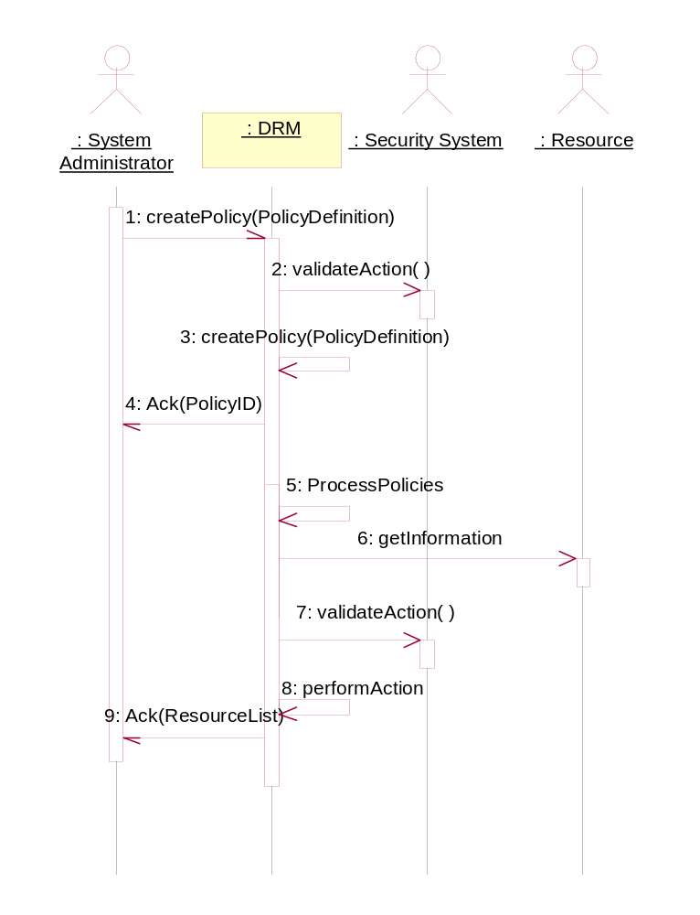
Sequence Diagram : Notify User of Resources not in compliance
Since a Grid system may not have complete control over a resource, the usage of that resource may not be in compliance with rules defined within the Grid system. This use case describes the function by which a Grid system can check for non-compliance.

Messages
1. createPolicy(PolicyDefinition) [:System Administrator-->:Grid]
1.1. validateAction( ) [:Grid-->:Security System]
Can this System Administrator request this action?
1.2. createPolicy(PolicyDefinition) [:Grid-->:Grid]
1.3. Ack(PolicyID) [:Grid-->:System Administrator]
2. ProcessPolicies [:Grid-->:Grid]
The Grid system will run the monitoring Policies based on the frequency defined in the Policy. It will then evaluate the rules accordingly.
2.1. getInformation [:Grid-->:Resource]
The rule for this Policy is to get information about the Resource and check if it meets a threshold value.
2.2. validateAction( ) [:Grid-->:Security System]
Can this Grid system perform this action?
2.3. performAction [:Grid-->:Grid]
2.3.1. Ack(ResoruceList) [:Grid-->:System Administrator]
If the threshold value is met then the Policy sends an acknowledgement to the User with the list of Resources above the threshold.

Security Considerations
This is a REQUIRED section.

Author Information
Contact information for authors.

Glossary
Recommended but not required.

Intellectual Property Statement
The GGF takes no position regarding the validity or scope of any intellectual property or other rights that might be claimed to pertain to the implementation or use of the technology described in this document or the extent to which any license under such rights might or might not be available; neither does it represent that it has made any effort to identify any such rights. Copies of claims of rights made available for publication and any assurances of licenses to be made available, or the result of an attempt made to obtain a general license or permission for the use of such proprietary rights by implementers or users of this specification can be obtained from the GGF Secretariat.
The GGF invites any interested party to bring to its attention any copyrights, patents or patent applications, or other proprietary rights which may cover technology that may be required to practice this recommendation. Please address the information to the GGF Executive Director.

Full Copyright Notice
Copyright (C) Global Grid Forum 2003. All Rights Reserved.
This document and translations of it may be copied and furnished to others, and derivative works that comment on or otherwise explain it or assist in its implementation may be prepared, copied, published and distributed, in whole or in part, without restriction of any kind, provided that the above copyright notice and this paragraph are included on all such copies and derivative works. However, this document itself may not be modified in any way, such as by removing the copyright notice or references to the GGF or other organizations, except as needed for the purpose of developing Grid Recommendations in which case the procedures for copyrights defined in the GGF Document process must be followed, or as required to translate it into languages other than English.
The limited permissions granted above are perpetual and will not be revoked by the GGF or its successors or assigns.
This document and the information contained herein is provided on an "AS IS" basis and THE GLOBAL Grid FORUM DISCLAIMS ALL WARRANTIES, EXPRESS OR IMPLIED, INCLUDING BUT NOT LIMITED TO ANY WARRANTY THAT THE USE OF THE INFORMATION HEREIN WILL NOT INFRINGE ANY RIGHTS OR ANY IMPLIED WARRANTIES OF MERCHANTABILITY OR FITNESS FOR A PARTICULAR PURPOSE."
References

