The goal of the Grid Scheduling Architecture Research Group (GSA-RG) is to define a scheduling architecture that supports cooperation between different scheduling instances for the allocation and coordination of required Grid resources for a scheduling request.

In this context, a scheduling instance is defined as a software entity that exhibits a standardised behaviour in respect to the interactions with other software entities (part of the GSA or external services) that cooperate to find, if it is possible, a solution to scheduling problems submitted by users, e.g. the selection and planning of resource allocations for a job.

The scheduling instance is the basic building block of a scalable, modular architecture for scheduling jobs/tasks/applications in Grids. Its main function is to find a solution to a scheduling problem that it receives from a generic input interface. To do so, it needs to interact with local resource management systems which typically control the access to the resources. If a scheduling instance can find a solution for a submitted scheduling problem, the generated schedule is returned through a generic output interface.

To solve a scheduling problem, a scheduling instance can exploit several options:

- it can try to solve the whole problem by itself interacting with local resource managers which it is able to interact with;

- if it can partition the problem in several sub-problems, it can try to:
  - if possible, solve some of the sub-problems;
  - forward the unsolved sub-problems to independent scheduling instances;
  - wait for potential solutions;
  - aggregate them to find a global solution to the original problem;

- if it can not partition the problem or can not find a solution, aggregating sub-problems solutions if possible, it has tow option:
- it can report back that it cannot find a solution;
- it can try to:
  - forward, the whole problem to another, different scheduling instance;
- wait for a solution, if the new instance can find one.

A generic Grid Scheduling Architecture will need to cover these behaviours, but actual implementations do not need to grant all of them. This model of operations is clearly modular, and permits to implement several scheduling infrastructures, like the ones depicted in the following examples.

Example 1: Enterprise Grids represent a scenario of commercial interest in which the available IT resources within a company are better exploited and the administrative overhead is lowered by the employment of Grid technologies. The resources are typically not owned by different providers and are therefore not part of different administrative domains.

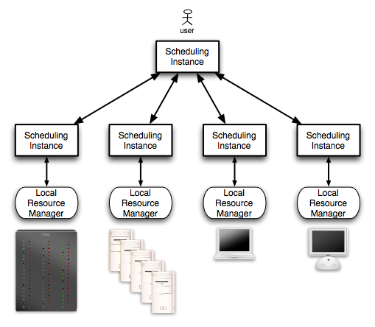
Figure 1. Example of a scheduling infrastructure for Enterprise Grids

In this scenario we have a centralized scheduling architecture; a central scheduling instance is the single access point to the whole infrastructure, and manages directly the scheduling instances that interact directly with the local resource managers. Every user must submit jobs to this centralized entity.
This architecture can guarantee scheduling decisions in short times, because it does not need to split the problem in sub-problems, or to aggregate the decisions, or to forward it to different scheduling instances.

Example 2: High Performance Computing Grids represent a scenario in which different computing sites, e.g. scientific research labs, collaborate for joint research. Here, compute- and/or data-intensive applications are executed on the participating HPC computing resources which are usually large parallel computers or cluster systems. The total number of participating sites in this Grid projects is commonly in the range of tens or hundreds, the available number of processing nodes is in the range of thousands. In this case the resources are part of several administrative domains, with their own policies and rules.

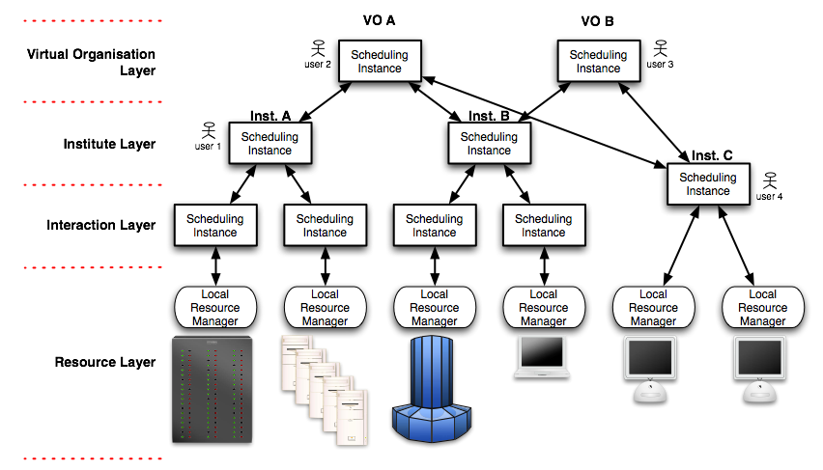

Figure 2. Example of a scheduling infrastructure for HPC Grids

In this scenario we have several institutes that share resources to build an HPC Grid. The institutes may organize their own resources in a centralized infrastructure, while the different institutes are connected through Virtual Organizations in a hierarchical way to build the individual VO scheduling architecture. Every instance on the institute layer can interact with instances in the relevant institute or the competent instance in the Virtual Organisation layer, depending on the user affiliation. The topology of the interactions is not constrained.
A user can submit jobs to the scheduling instances at institute or VO. The scheduling instances can split a scheduling problem in several sub-problems, or forward the whole problem to different scheduling instances in the same VO.
This infrastructure is fault tolerant, but the hierarchical behaviour can impose a serious performance limit if the number of institutes or VO grows.

Example 3: Global Grids might comprise all kinds of resources from single desktop machines to large scale HPC machines, which are connected through a global Grid network.

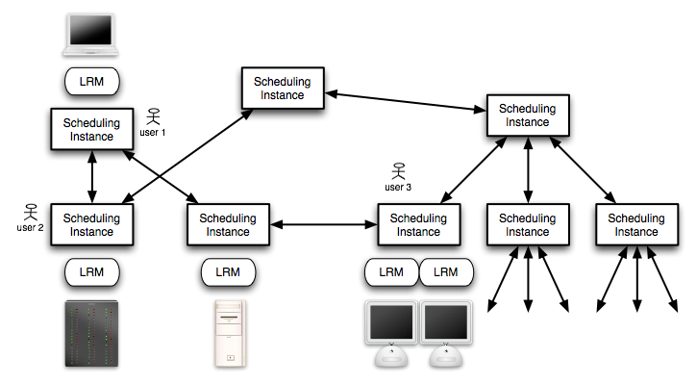

Figure 3. Example of a scheduling infrastructure for Global Grids

This scenario is the most general one, covering both the cases illustrated above and introducing a fully decentralized architecture. Every scheduling instance can accept jobs to be scheduled.
Like in P2P systems, the fault tolerance is high, but the time needed to find a solution to scheduling problems can be long and unpredictable.

From the previous examples, we can infer that a generic scheduling instance can exhibit the following proficiencies:

- ability to interact with local resource managers;
- ability to interact with external services that are not defined in the Grid Scheduling Architecture, like information, forecasting, submission, security and execution services;
- ability to receive a scheduling problem (from other scheduling instance or external submission services), calculate a schedule, and return a scheduling decision (to the calling instance or an external service);
- ability to split a problem in sub-problems, to receive scheduling decisions and to merge them into a new one;
- ability to forward problems to other scheduling instances.
However, an instance might exhibit only a subset of such abilities. This depends on its interactions with other instances/services and its expected behaviour (ability to split and/or forward problems).
If a scheduling instance is able to cooperate with other instances, it must exhibit the ability to send problems or sub-problems, depending on the case, and receive scheduling results; given one of such instance, we call higher level instances the ones that are able to directly forward a problem to that instance, and lower level instances the ones that are able to directly accept a problem from that instance. A single instance must acts as a decoupling barrier between the actions performed at higher and lower levels: it is concerned neither with the previous instances which the problem is flowed through (i.e. it has been submitted by an external service or forwarded by other instances as a whole problem or as a sub-problem), nor with the actions that the following instances will undertake to solve the problem. Every instance will need to know just the problem it has to solve and the source of the original scheduling problem that it is helping to resolve, to avoid potential forwarding issues.

From a component point of view, such abilities are expressed as interfaces. In general, the interfaces of a scheduling instance can be divided in two main categories: functional interfaces and non-functional interfaces. The former are necessary to enable the main behaviours of the scheduling instance, while the latter are concerned with the management the instance itself (creation, destruction, status notification, authorization, etc.).
We want to highlight that we considered only the functionalities that must be directly exploited to support a general scheduling architecture; for example, security services are from a function point of view not strictly needed to schedule a job, so they are considered external services or non-functional interfaces.

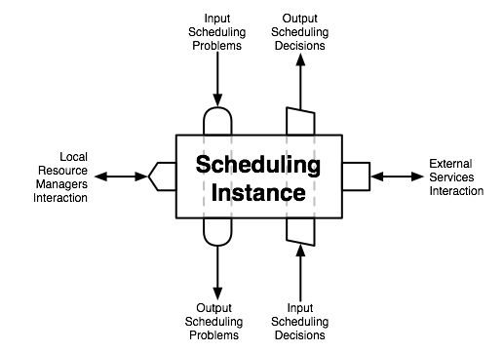

Figure 4. Scheduling Instance Functional Interfaces

The functional interfaces that a scheduling instance can expose are depicted in Fig. 4 and illustrated in the following:

- Input Scheduling Problems Interface: the methods of this interface are responsible to collect a description of a scheduling problem that must be solved, and start the scheduling process. This interface is not intended to accept jobs directly from users; rather an external submission service (e.g. portal or command line interface) can collect the scheduling problems described with a user-defined formalism, validate them and produce a neutral representation accepted as input by this interface. In this way, this interface is fully decoupled from external interactions and can be exploited to compose several scheduling instance as in the examples illustrated above, where an instance can forward a problem or submit a sub-problem to other instances using this interface.
Every scheduling instance must implement this interface.

- Output Scheduling Decisions Interface: the methods of this interface are responsible to communicate the results of the scheduling process started earlier with a problem submission. Like in the previous case, this interface is not intended to communicate the results directly to a user, rather to visualization/reporting service. Again, we can exploit this decoupling in a modular way: if an instance received a submission from another one, it must use this interface to communicate the results to the submitting instance.
Every scheduling instance must implement this interface.

- Output Scheduling Problems Interface: if an instance is able to forward a whole problem or partial ones to other scheduling instances, it needs the methods of this interface to submit the problem to lower level instances.

- Input Scheduling Decisions Interface: if an instance is able to submit problems to other instances, it must wait until a scheduling decision is produced from the one which the problem was submitted to. The methods of this interface are responsible for the communication of the scheduling results from lower level instances.

- Local Resource Managers Interface: the final goal of a scheduling process is to find an allocation of the jobs to the resources. It means that sooner or later the whole process has to interact with local resource managers to allocate the jobs to the resources. While some scheduling instances can be dedicated to the “routing” of the problems, others interact directly with local resource managers to find suitable schedules, and propagate the answers in a neutral representation back to the entity that submitted the scheduling problem.
Different local resource managers can require different interaction interfaces.

- External Services Interaction Interfaces: if an instance must interact with an entity that is neither a local resource manager nor another scheduling instance, it needs an interface that permits to communicate with that external service that is exploited by the scheduling architecture. For example, some instances may need to gain access to information, billing, security and/or performance predictor services.
Different external services can require different interaction interfaces.

It is not in the context of this work to define exactly these interfaces, their interactions and the relative communication protocols. Instead we are interested in showing how this basic block can be used to build a generic scheduling infrastructure and give information about the required functionalities and data necessary for this scheduling architecture.

