RISM-FMO Coupled Simulation

Summary
Analyzing multiscale and interdisciplinary problems is becoming increasingly important in nanoscience fields, in which a simulation couples complex physical phenomena in different spatial and temporal scales. For instance, in drug design, analyzing a target molecule’s electronic structure in a solvent involves extensive use of coupled simulation methodologies. The molecule’s electronic structure based on a molecular orbital method is combined with solvent distribution calculation using statistical dynamics for macro regions. The coupled simulation is expected to solve large-scale problems with a high degree of physical accuracy by combining simulation components associated with different kinds of physical models and numerical methods.
The requirements for such applications are;
- The underlying grid must coschedule multiple simulation code by discovering and coallocating appropriate computer resources in the grid.
- Coupled simulation code must exchange data effectively between the parallel components that are programmed with very different underlying physics, divergent styles of parallel programming, and varying data representations.
- The underlying grid must absorb such differences in an automated fashion—that is, the system should support semantic transformation between synonymous physical quantities in different representations.

Customers
Scientists in the Institute for Molecular Science (Okazaki, Japan), and Kyushu University (Fukuoka, Japan) are using this application. Scale depends on the size of problems (e.g. number of molecular). They are using geographically distributed inter-site systems. Many users are using RISM and FMO. However co-allocation job users are few.
The co-allocation function can be used not only for such complex simulation jobs but also for real time visualization jobs. Real time visualization job executes target calculation job and visualization job for its results simultaneously. User can easily know the progress of the calculation, and can evaluate the calculation results in real time. We think that many users will use co-allocation functionality for real time visualization.

Scenarios and applications
Figure 1 shows the scenario of RISM-FMO application. The RISM calculates solvent charge distribution and the FMO calculates electronic structure of molecular. The mediators between them transform meshes and transfer calculation results. These applications are communicating with GridMPI.
Figure 2 shows a RENKEI/NAREGI workflow of RISM-FMO application. Note that this workflow is simplified for demonstration and explanation. The actual workflows, which the scientists are using in their work, are more complex. The icon named RISMFM is the core-process of this workflow. This type of icon is called co-allocation job icon, and has hierarchical structure. In the RISMFM icon, resources for RISM, FMO, and mediator are co-allocated, and these applications are executed simultaneously. Figure 3 shows configuration of the RISMFM icon. The RISM is suited for SMP architecture and the FMO is suited for cluster systems.
The computing resources and the storage resources can be located in geographically distributed sites. However these resources should be in a same VO.
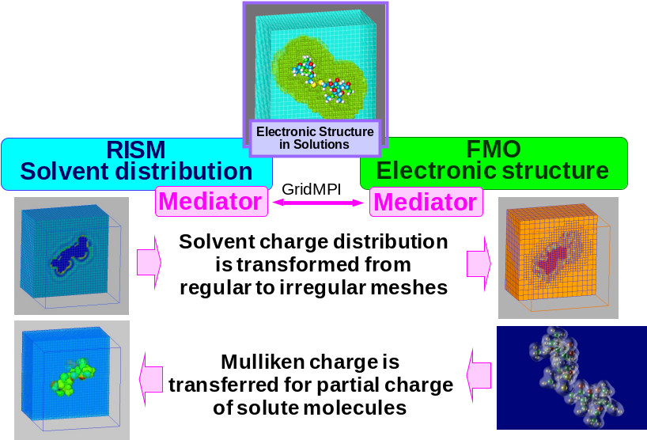
Figure 1 Scenario of RISM-FMO application

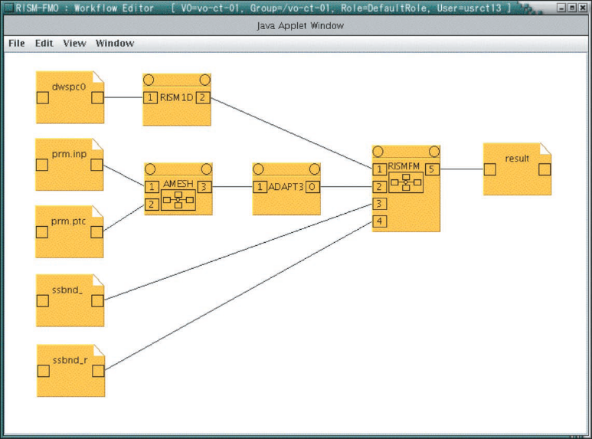
Figure 2 RISM-FMO job workflow

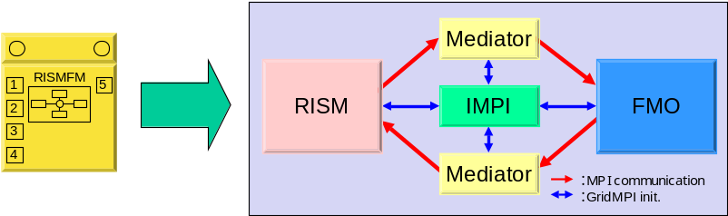

Figure 3 Configuration of the RISM-FMO icon

Involved resources and production Grid infrastructure
The RISM-FMO application has been run in a NAREGI infrastructure. It consists of resources in the Institute for Molecular Science (IMS), Kyushu University, Tokyo Institute of Technology, and National Institute of Informatics (NII). The RISM was run on a Power Architecture based big SMP system in IMS, and the FMO and mediators were run on Intel based large cluster systems in the other sites. The geometrical distance between Kyushu University and NII is the maximum distance in this infrastructure, around 900km.

Security considerations
Security is an important factor in the advanced science. It requires secure job submission; secure data transfer, trust credential delegation, space isolation with other jobs, and cleanup of temporally files and memories.

Performance considerations
Usually, the applications take long time for calculation. Therefore performance of grid services are not required. Computing power, and high band width and low latency network are required.

Usecase situation analysis and PGI expectations
For co-allocation jobs, the RENKEI/NAREGI computing resource (GridVM) supports the following functions.
- Advanced resource reservation
- Advanced reservation (scheduling) table advertisement
- GridMPI support
- Allocated worker nodes list advertisement (for each GridMPI activity)
We expect that the PGI supports above functionalities.

References
S Matsuoka, K Saga, and M Aoyagi, “Coupled-Simulation e-Science Support in the NAREGI Grid,” in Computer 41 (11), 2008.

Author information
Kazushige Saga <saga@grid.nii.ac.jp>

