GRID Transaction Management Research Group:
Report

Status of this Memo
This document provides information to the community regarding the use of transaction capabilities in a GRID environment. Distribution of this document is unlimited. This is a DRAFT document and continues to be revised.

Abstract
Successful realization of Grid environments may require the use of various transaction capabilities, such as transaction protocol engines and system and resources that can react to transaction stimulus (commands?). The aim of this interim report is to present the conclusions of the Transaction Management Research Group so far. The group is studying use case scenarios of both e-science and e-business applications. A companion Use cases documents describes transaction use cases for commercial infrastructure and application topics, scientific infrastructure and application topics, essential grid technologies, and working group use cases. The list of Grid use cases presented is necessarily incomplete. Also use cases are not described at the detail required for formal requirements. This report summarises the findings of the use case study, and draws tentative conclusions on ways of applying transaction concepts to the Grid environment. This includes an examination of some of the potential pitfalls and challenges in applying transactions capabilities in a typical Grid environment. It goes on to make recommendations for practical application of components, services and protocols.


GLOBAL GRID FORUM
office@gridforum.org
www.ggf.org

Full Copyright Notice
Copyright © Global Grid Forum (2005). All Rights Reserved.
This document and translations of it may be copied and furnished to others, and derivative works that comment on or otherwise explain it or assist in its implementation may be prepared, copied, published and distributed, in whole or in part, without restriction of any kind, provided that the above copyright notice and this paragraph are included on all such copies and derivative works. However, this document itself may not be modified in any way, such as by removing the copyright notice or references to the GGF or other organizations, except as needed for the purpose of developing Grid Recommendations in which case the procedures for copyrights defined in the GGF Document process must be followed, or as required to translate it into languages other than English.
The limited permissions granted above are perpetual and will not be revoked by the GGF or its successors or assigns.
This document and the information contained herein is provided on an "AS IS" basis and THE GLOBAL GRID FORUM DISCLAIMS ALL WARRANTIES, EXPRESS OR IMPLIED, INCLUDING BUT NOT LIMITED TO ANY WARRANTY THAT THE USE OF THE INFORMATION HEREIN WILL NOT INFRINGE ANY RIGHTS OR ANY IMPLIED WARRANTIES OF MERCHANTABILITY OR FITNESS FOR A PARTICULAR PURPOSE.

Intellectual Property Statement
The GGF takes no position regarding the validity or scope of any intellectual property or other rights that might be claimed to pertain to the implementation or use of the technology described in this document or the extent to which any license under such rights might or might not be available; neither does it represent that it has made any effort to identify any such rights. Copies of claims of rights made available for publication and any assurances of licenses to be made available, or the result of an attempt made to obtain a general license or permission for the use of such proprietary rights by implementers or users of this specification can be obtained from the GGF Secretariat.
The GGF invites any interested party to bring to its attention any copyrights, patents or patent applications, or other proprietary rights which may cover technology that may be required to practice this recommendation. Please address the information to the GGF Executive Director (see contact information at GGF website).
Contents
1 Introduction 4
2 The challenges of Transactions in a Grid Environment 6
3 Transactional Requirements 8
4 Overview of Current Transaction Protocols 11
5 Options Concept - Outline and Implementation Notes 37
6 Recommendations 42
7 References 43
8 Editor Information 44

Figures
Figure 1 A transaction tree 12
Figure 2 BTP components and sub-protocols 13
Figure 3 WS-C Coordinator - components and protocols 15
Figure 4 WS-C Two applications with their own coordinators 17
Figure 5 WS-C The usage of Endpoint References during registration 18
Figure 6 WS-AT Completion protocol 19
Figure 7 WS-AT 2PC protocol 20
Figure 8 WS-BA BusinessAgreementWithParticipantCompletion protocol 22
Figure 9 WS-BA BusinessAgreementWithCoordinatorCompletion protocol 22
Figure 10 WS-CAF Two-phase commit transactions 28
Figure 11 WS-CAF Transaction coordinator two-phase status transition 30
Figure 12 WS-CAF Coordinator-to-synchronization message exchanges 31
Figure 13 WS-CAF LRA example 33
Figure 14 WS-CAF Business processes and tasks 34

Introduction

Purpose of this document
The goal of this RG is to investigate how to apply transaction management (TM) techniques to Grid systems.

There are application areas that might not need transaction support, e.g. read only access to a data warehouse. A lot of other grid applications however would benefit from, if not require, transactional support. A common grid transaction service would contribute a useful building block for professional grid systems.

This research group is trying to identify and verify possible grid transaction approaches as well as potential technology to implement them. It focuses on finding the required solutions within existing specifications. For this purpose a close partnership with responsible groups handling the existing specifications is desired.

This Research Group provides a forum to track Grid transaction community activities and advise the Grid community on the application of TM technologies in Grid applications and infrastructure, to identify case studies and share good practice.

As an overall result of the research group there will be a set of information regarding transactional support in Grids to the GGF community.

The Projected Tasks in the TM-RG’s charter are:

1. Identify typical use cases of grid application scenarios involving transactional support.
2. Identify and document the requirements of TM within a Grid setting.
2. Identify appropriate existing transaction techniques and specifications that match these requirements.
3. Work out architectural approaches to integrate transactional support with other specifications, e.g. DAIS.
4. Provide a forum to discuss and share insights of Grid transaction management.
5. Work with other RG and WG (also outside of GGF) to both push Grid transactions, to offer a service of expertise and to ensure that TM meets the requirements of other Grid specifications

This document reports progress on meeting these goals and completing these particular tasks.

History of the group
The initial meeting was a birds-of-a-feather session about transactions in the grid, which took place at GGF10 on March 11th 2004 in Berlin. It was organized by a German group of people from universities and IBM. As a result of it was decided to found a research group in data area of GGF on transaction management. The group was initially chaired by Torsten Steinbach together with Jim Webber and Can Tuerker.

After agreeing on a group charter the team began to work on collecting use cases for transaction management in grid environment. The first results of this effort were presented by Jim Webber and Dieter Gawlick at the subsequent GGF11 in Honolulu on June 8th and 9th 2004. The next meeting at GGF12 in Brussels on September 22nd continued the presentation of these efforts by presenting the trip support and eDiaMoND use cases to the audience.

While the use case collection continued the group started another effort to educate its members on existing transaction specifications using web services. For this purpose a sequence of three dedicated telephone meetings was arranged to present WS-Coordination/AT/BA (Ian Robinson, IBM), WS-CAF (Malik Saheb, Arjuna) and BTP (Tony Fletcher, Choreology) to the group.

The following meeting at GGF13 in Seoul was chaired by Dieter Gawlick and served mainly to attract more interest from people from Asian and pacific hemisphere.

Through all this time the main work of the group was done via telephone conferences. Whenever possible the group met in a each second week on Wednesday by phone to organize the work and track action items.

The challenges of Transactions in a Grid Environment

Introduction
What is special about Grid environments with regard to transactions? We believe that transactions have to deal with a couple of problems that are unique or at least typical to such environments. Following are the most important properties of grid systems with regard to a transactional support.

- Resources are used very dynamically and with late binding. One can not tell which concrete resource is used at development time and usually not even at deployment time.

- Resources are shared very dynamically and to a large extent by multiple clients.

- A concrete resource can be integrated in and disintegrated from a grid very dynamically.

- There is typically no persistent legal relationship between client and resources. Instead ad-hoc legal relationships are established during runtime.

To investigate in detail what the concrete transactional requirements are the first work item of the group has been to perform a use case survey. Please refer to the use case document provided here:
<link to use case doc>

Transaction Categories
As one result of this work the group has identified four different categories of transactions in a grid in two groups:

Group 1: Information management patterns
Transaction Support for Information Dissemination
This group of transactions serves the purpose to reliably propagate data.

Transaction Support for Information Aggregation
This group of transactions serves the purpose to reliably aggregate data.

Group 2: Process management patterns
Process tracking (Coordination of Processes)
These transactions server the purpose of ensuring that business processes and workflows are completed in an ordered or contingent way.

Agreement negotiation and execution (Provisional-Final Negotiation)
This group of transactions coordinates the retrieval and confirmation of reservations or options. An example is the step-by-step reservation of a sequence of grid resources and then to atomically confirm all reservations.

Transactional Requirements

The Use Case document draws out a number of requirements on and for transaction capabilities. Many of these would apply to any transaction system though some may be more specific to transactions in a Grid environment. This section lists all the requirements to be found in the Use document in the order they are found there, rather than in any other logical order.

Requirements from Use Case document section 3 on "Distributed available-to-promise"

R1 Non-atomic outcomes: the client may not want the whole transaction to fail if one or more participants fail.
R2 Ability to apply business rules to participant failures, which may mean that the client must know the identity of each participant.

Requirements from Use Case document section 4 on "Supporting Long-Running Computations on the Grid"

R3 Results should not be released to the application as a whole until the sub-computation has completed, lest any partial failures become Byzantine faults in the system as a whole.
R4 For the localised failure case, the process needs to be split into sub-processes each of which can be restarted without prejudice in the event of a failure.

Requirements from Use Case document section 5 on "Financial Instrument Trading"

R5 No manual reconciliation will be required to repair transactional inconsistencies.
R6 Each interaction will be guaranteed to achieve not only reliable delivery of the message, but also reliable processing of the message.
R7 Each set of participants will agree on the outcome of their business transaction, that is, no case will arise where one party thinks a transaction succeeded and the other thinks it failed or doesn’t know the outcome.
R8 If a participant or network connection fails temporarily, when it comes back up, the participant will automatically recover and resynchronize with its counter-parties.
R9 A coordinating party such as the Trading Service will be able to monitor the state of all its interactions with all counter-parties.
R10 Each set of participants will be able to keep a reliable audit trail of each business transaction. (To meet both legal / regulatory requirements, and also to aid post transaction dispute resolution in a clear and fair manner.)

Additional requirements:
R11 Ability to handle many transactions simultaneously with a fast response time.
R12 Ability to support a variable number of participants in the transaction.
(In this case sellers and their credit providers.)
R13 Ability to support propagation of a transaction from one participant to another.
(In this case Buyer to Trading Service to Sellers to their credit providers.)
R14 Ability to be able to selectively cancel parts of a transaction while confirming other parts.
R15 Ability to be able to use commit / cancel mechanisms other than do the work then compensate if need to cancel.
R16 Ability for an ‘application’ to determine the desired outcome of the transaction, or parts thereof, and be informed of the actual result of the transaction.
R17 Ability to be able to signal and handle time limited offers.

Requirements from Use Case document section 6 on "Trip Support"

R18 Any support is assumed to be reliable and secure.
R19 Applications programmers should be able to provide this functionality without understanding the complexity of the underlying technology. They should have the perception that they do not need to deal with several users accessing the same resources at the same time.
R20 An important requirement is the support of options by resource managers. Business conflicts on resources are managed by business rules checking the compatibility of all outstanding options.
R21 Another requirement is auditing and tracking of options granted and their confirmations.

Requirements from Use Case document section 7 on "Credit Verification"

R22 Transaction developers need to be able to specify the pattern of application:
- Standard client/sever pattern. The completion of the commit request implies that any changed data are committed and recoverable. Data that are read from other transactions are committed but may not be recoverable.
- Messaging: The completion of the commit request implies that any changed data are committed and but may not be recoverable. Data that are read from other transactions are committed but may not be recoverable.
- Propagation: The completion of the commit request implies that data are committed but not necessarily recoverable. Data that are read from other transactions are committed and are recoverable.

Requirements from Use Case document section 8.4.1 on "GRID Resource Management - Contract or agreement negotiation"

R23 A negotiation transaction may require long, back-and-forth conversations between parties before preparation and commitment.
R24 These conversations may require application messages to be logged along with transaction signals for recovery.
R25 One party may conduct negotiations with several other parties simultaneously, confirming some and cancelling others.

Requirements from Use Case document section 8.4.2 on "GRID Resource Management - Resource allocation, deployment and scheduling"

R26 Ability to support reservation is a provisional promise, subject to eventual use or cancellation (or timed self-cancellation).
R27 Ability to reserve resources from many parties at the same time, confirming some and cancelling others.

Requirements from Use Case document section 8.4.3 on "GRID Resource Management - Resource billing and payment "

R28 Ability to provide alternative resources, such as a payment to compensate for familiar to provide a specified service or level of service.

Overview of Current Transaction Protocols
As a second task the group analyzed the existing protocols for performing transaction via web services. Following is a brief overview of these protocols.

OASIS Business Transaction Protocol (BTP)

References
The BTP specification is available from the OASIS standards organisation web site (http://www.oasis-open.org/apps/org/workgroup/business-transaction/document.php?document_id=9999 also check for a latter version at http://www.oasis-open.org/committees/documents.php?wg_abbrev=business-transaction). The slides on which this summary is based can be obtained from https://forge.gridforum.org/projects/tm-rg/document/BTP_Presentation/en/2

Principles
The Business Transaction Protocol (BTP) is aimed at appropriate transactionality for loosely-coupled systems where loosely-coupled implies autonomous, but cooperating systems that may be inter-enterprise (different owners) or intra-enterprise (linked applications with different purposes) or, of course a mixture of intra and inter enterprise systems. Thus a guiding principle of BTP is that the systems involved are autonomous, but agree to co-operate with each other according to the assigned meanings of the protocol messages. Thus the emphasis is on the messages their meanings and their allowed sequencing rather than the internal behaviour of each system.

In many respects BTP is a conventional distributed transaction coordination protocol and it uses the ‘presumed abort’ paradigm. The messages are defined and given meaning in their abstract form which uses natural language and this is the fundamental form. The BTP specification provides a realisation of the message set in XML and a standards binding to SOAP over HTTP so it is usable in a Web Services environment.

BTP distinguishes between protocol errors and protocol promises. So if a system receives a badly formed message or one that is not permitted for the state it is in then that is a protocol error and is signalled as such. However, if a system is commanded to ‘confirm’, it should respond with a ‘confirmed’ message as when it previously sent a ‘prepared’ message it was promising that it could either confirm or cancel at the superior’s request, but if it actually cancels and responds with a cancelled message that is permitted (even though not desired!) and not treated as a protocol error.

Another very important consequence of the autonomy of the participating systems principle is that the specification does not dictate how the participating systems achieve confirm or cancel. There are a number of well known methods of achieving confirm and cancel that include:
Do-Compensate (where prepare means do and log parameters to enable cancellation, cancel means use the log to reverse the work, and confirm means forget the log),
Validate-Do (where prepare means validate the requested actions and log parameters, confirm means do the requested work according to the logged parameters, and cancel means forget the log), and
Provisional-Final (where prepare means do the requested work but as mark pending and keeping a copy of the original, confirm means mark as final, cancel means delete the pending copy and revert to the originals.

Other variations, permutations and combinations are not prohibited! The choice depends on the requirements of the application using BTP and, of course the application developer. This means that different systems in the same distributed transaction may take different approaches, but equally their design may be coordinated so that each uses a method appropriate for the overall distributed application.

The Protocols
The Business Transaction Protocol organises the systems participating in a transaction into a traditional transaction ‘tree’ structure and the ‘outcome’ sub-protocol is run within this tree to coordinate the termination of the transaction. There are actually three other sub-protocols that make up BTP (four if you include propagation, that is tagging application messages to indicate they are part of a particular transaction).

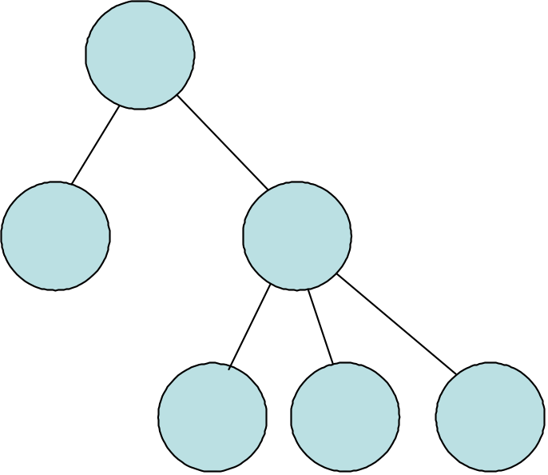

Figure 1 A transaction tree1

The initiation protocol is optional to implement and may be used to request new transaction context (or transaction identification) or associate a new one with an existing one. This context may be used to tag application messages so that they are known to be part of a particular transaction. Following the BTP principle of allowing application designers as much freedom as practicable, the use of this context is optional. If the application protocol can convey the semantics in some other way it is permitted to do so.

The enrolment sub-protocol is required and is the means of building the BTP engine tree. The application at one level of the tree sends an application message to the next level down which is tagged with a context or some other means of indicating it is part of a particular transaction. The receiving application can then use the enrolment sub-protocol back up the tree to enlist in the transaction.

The ‘control’ protocol is optional to implement and may be used by a lightweight BTP implementation (that is one not running the full outcome protocol state machine) to communicate with the top (or root) node of the tree to request partial or complete preparation of the tree, then confirmation or cancellation.

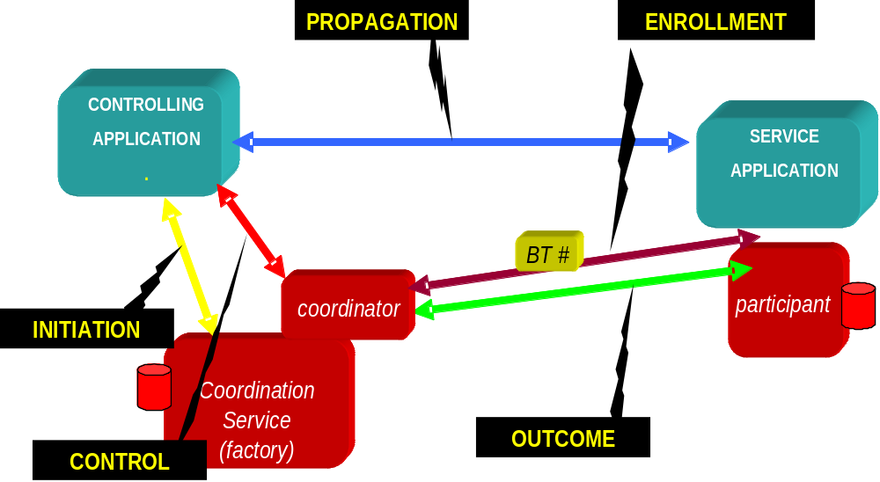

Figure 2 BTP components and sub-protocols2

Atoms and Cohesions
The top or controlling application wants a consistent result (if it does not then there may be little point in using a transaction protocol), but it may not always be necessary to include the work and results from all the participating systems, depending on the logic of the application. BTP copes with this situation by allowing the top node and each intermediate node in a transaction tree to be what it terms ‘cohesive’ or ‘atomic’. For a cohesive node its application will decide the final confirm set when it requests confirmation, prior to which it can tolerate or force exclusion without ending the entire transaction. For an atomic node every participant that enrols is in the final confirm set giving the ‘traditional’ transaction all or nothing characteristic – each node subordinate to this one has veto power. Note that once confirmation at a node has been initiated then the chosen confirm set is always internally atomic.

A complete transaction tree can be set up to be atomic throughout, which gives the distributed transaction the traditional all or nothing characteristics, so in this case either the whole transaction confirms, or if cancellation is requested or one of the participating nodes cancels then the whole transaction cancels (with the caveat that BTP allows heuristic decisions, that is broken promises which means that each individual node may have made its own decision independent of the others). Alternatively each node can be set up to be cohesive and then the application at each of these top and intermediate (i.e. non-leaf) nodes makes its own decision as to what it needs to do to respond to a confirm, including cancelling or confirming nodes in the tree immediately below it. And as might be expected, BTP supports the situation where there is a mix of atomic and cohesive nodes in a transaction tree.

Timed promises
BTP introduces a useful variation on the traditional two phase outcome protocol. It allows the prepare message going down tree (if one is used – it is an optional message in the protocol) to carry a ‘qualifier’ which indicates the minimum time a prepared promise should last for. The prepared message coming back up the tree may then carry a qualifier that indicates how long its prepared promise will last for and whether it is more likely to confirm or cancel if this time expires before it receives a confirm or cancel command. This can assist some application optimisations.

Extensibility
The XML form of the messages can be extended using the XML schema extensibility mechanisms. However, BTP includes an extension mechanism at the abstract message level as well that translates directly to the XML level and this is the qualifier mechanism. There are a few standard qualifiers specified in the BTP specification such as those for timed promises mentioned in sub section 4.1.5 on Timed promises. Users of BTP can specify additional qualifiers to suit their particular application.

Recovery
BTP specifies when the protocol engine has to record information (known as making a log record) for recovery purposes and a recovery algorithm. The aim is to ensure that a system can complete termination of outstanding transaction on recovery from a failure. Some form of recovery should be possible if the log record is intact, though not all situations can be dealt with (destruction of a system for instance!). BTP also supports application recovery even while in the active phase (that is while it is still performing its application work).

WS-Coordination / WS-AtomicTransaction and WS-Business Activity (WS-C/AT/BA)

References
This group of specification is a joint effort of BEA, IBM and Microsoft ((c)&#169; 2002-2004 BEA Systems, International Business Machines Corporation, Microsoft Corporation. All rights reserved). This section is based on the specifications available at http://www.ibm.com/developerworks/webservices/library/ws-transpec. A set of slides can be obtained from https://forge.gridforum.org/projects/tm-rg/document/WS-Coordination/en/1.

Principles
The Web Services Transactions specifications define mechanisms for transactional interoperability between Web services domains and provide a means to compose transactional qualities of service into Web services applications. The Web Services Transactions specifications describe an extensible coordination framework (WS-Coordination) and specific coordination types for:
- Short duration, ACID transactions (WS-AtomicTransaction)
- Longer running business transactions (WS-BusinessActivity)

WS Coordination
This specification describes a framework for a coordination service (or coordinator) which consists of these component services:
- An Activation service with an operation that enables an application to create a coordination instance or context.
- A Registration service with an operation that enables an application to register for coordination protocols.
- A coordination type-specific set of coordination protocols.
This is illustrated below in Figure 3.
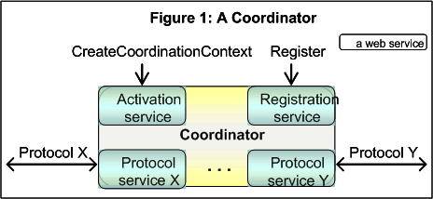

Figure 4 WS-C Coordinator - components and protocols4

Applications use the Activation service to create the coordination context for an activity. Once a coordination context is acquired by an application, it is then sent by whatever appropriate means to another application.

The context contains the necessary information to register into the activity specifying the coordination behavior that the application will follow.

Additionally, an application that receives a coordination context may use the Registration service of the original application or may use one that is specified by an interposing, trusted coordinator. In this manner an arbitrary collection of Web services may coordinate their joint operation.

Figure 5 illustrates how two application services (App1 and App2) with their own coordinators (CoordinatorA and CoordinatorB) interact as the activity propagates between them. The protocol Y and services Ya and Yb are specific to a coordination type, which are not defined in this specification.
- App1 sends a CreateCoordinationContext for coordination type Q, getting back a Context Ca that contains the activity identifier A1, the coordination type Q and an Endpoint Reference to CoordinatorA's Registration service RSa.
- App1 then sends an application message to App2 containing the Context Ca.
- App2 prefers CoordinatorB, so it uses CreateCoordinationContext with Ca as an input to interpose CoordinatorB. CoordinatorB creates its own CoordinationContext Cb that contains the same activity identifier and coordination type as Ca but with its own Registration service RSb.
- App2 determines the coordination protocols supported by the coordination type Q and then registers for a coordination protocol Y at CoordinatorB, exchanging Endpoint References for App2 and the protocol service Yb. This forms a logical connection between these Endpoint References that the protocol Y can use.
- This registration causes CoordinatorB to forward the registration onto CoordinatorA's Registration service RSa, exchanging Endpoint References for Yb and the protocol service Ya. This forms a logical connection between these Endpoint References that the protocol Y can use.
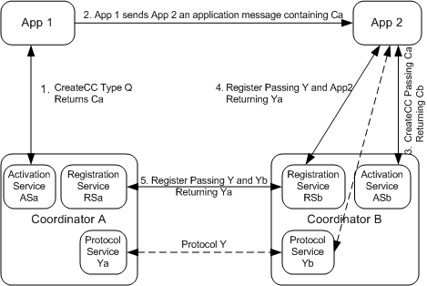

Figure 6 WS-C Two applications with their own coordinators6

Once an application has a coordination context from its chosen coordinator, it can register for the activity. The interface provided to an application registering for an activity and for an interposed coordinator registering for an activity is the same.

The requester sends:

Register
The syntax and semantics of this message are defined in Section 3.2.1.
The coordinator's registration service responds with:

Registration Response
The syntax and semantics of this message are defined in Section 3.2.2.
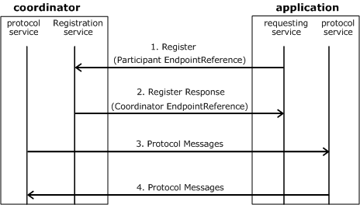

Figure 7 WS-C The usage of Endpoint References during registration7

In Figure 8, the coordinator provides the Registration Endpoint Reference in the CoordinationContext during the CreateCoordinationContext operation. The requesting service receives the Registration service Endpoint Reference in the CoordinationContext in an application message.

1.) The Register message targets this Endpoint Reference and includes the participant protocol service Endpoint Reference as a parameter.

2.) The RegisterResponse includes the coordinator's protocol service Endpoint Reference.

3. & 4.) At this point, both sides have the Endpoint References of the other's protocol service, so the protocol messages can target the other side.

WS AtomicTransaction
Atomic transactions have an all-or-nothing property. The actions taken prior to commit are only tentative (i.e., not persistent and not visible to other activities). When an application finishes, it requests the coordinator to determine the outcome for the transaction. The coordinator determines if there were any processing failures by asking the participants to vote. If the participants all vote that they were able to execute successfully, the coordinator commits all actions taken. If a participant votes that it needs to abort or a participant does not respond at all, the coordinator aborts all actions taken. Commit makes the tentative actions visible to other transactions. Abort makes the tentative actions appear as if the actions never happened. Atomic transactions have proven to be extremely valuable for many applications. They provide consistent failure and recovery semantics, so the applications no longer need to deal with the mechanics of determining a mutually agreed outcome decision or to figure out how to recover from a large number of possible inconsistent states.

Atomic Transaction defines protocols that govern the outcome of atomic transactions. It is expected that existing transaction processing systems wrap their proprietary mechanisms and interoperate across different vendor implementations.
The Atomic Transaction coordination context must flow on all application messages involved with the transaction.

Atomic Transaction adds the following semantics to the CreateCoordinationContext operation on the activation service.

- If the request includes the CurrentContext element, the target coordinator is interposed as a subordinate to the coordinator stipulated inside the CurrentContext element.
- If the request does not include a CurrentContext element, the target coordinator creates a new transaction and acts as the root.

A coordination context may have an Expires attribute. This attribute specifies the earliest point in time at which a transaction may be terminated solely due to its length of operation. From that point forward, the transaction manager may elect to unilaterally roll back the transaction, so long as it has not transmitted a Commit or a Prepared notification.
The specification defines the following protocols for atomic transactions.

- Completion: The completion protocol initiates commitment processing. Based on each protocol's registered participants, the coordinator begins with Volatile 2PC then proceeds through Durable 2PC. The final result is signaled to the initiator. The following diagram illustrates the protocol abstractly:
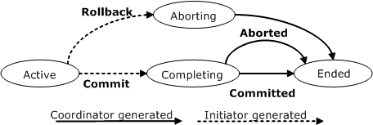
Figure 9 WS-AT Completion protocol9

- Two-Phase Commit (2PC): The 2PC protocol coordinates registered participants to reach a commit or abort decision, and ensures that all participants are informed of the final result. The following diagram illustrates the protocol abstractly:

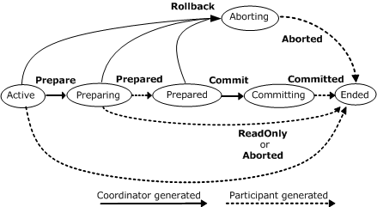
Figure 10 WS-AT 2PC protocol10

The 2PC protocol has two variants:

- Volatile 2PC: Participants managing volatile resources such as a cache should register for this protocol. Upon receiving a Commit notification in the completion protocol, the root coordinator begins the prepare phase of all participants registered for the Volatile 2PC protocol. All participants registered for this protocol must respond before a Prepare is issued to a participant registered for Durable 2PC. Further participants may register with the coordinator until the coordinator issues a Prepare to any durable participant. A volatile recipient is not guaranteed to receive a notification of the transaction's outcome.
- Durable 2PC: Participants managing durable resources such as a database should register for this protocol. After receiving a Commit notification in the completion protocol and upon successfully completing the prepare phase for Volatile 2PC participants, the root coordinator begins the Prepare phase for Durable 2PC participants. All participants registered for this protocol must respond Prepared or ReadOnly before a Commit notification is issued to a participant registered for either protocol.
A participant can register for more than one of these protocols by sending multiple Register messages.

WS Business Activity
This specification provides the definition of a business activity coordination type used to coordinate activities that apply business logic to handle business exceptions. Actions are applied immediately and are permanent. Compensating actions may be invoked in the event of an error. The Business Activity specification defines protocols that enable existing business process and work flow systems to wrap their proprietary mechanisms and interoperate across trust boundaries and different vendor implementations.
Business Activities have the following characteristics:
- A business activity may consume many resources over a long duration.
- There may be a significant number of atomic transactions involved.
- Individual tasks within a business activity can be seen prior to the completion of the business activity, their results may have an impact outside of the computer system.
- Responding to a request may take a very long time. Human approval, assembly, manufacturing, or delivery may have to take place before a response can be sent.
- In the case where a business exception requires an Activity to be logically undone, abort is typically not sufficient. Exception handling mechanisms may require business logic, for example in the form of a compensation task, to reverse the effects of a completed business task.
- Participants in a business activity may be in different domains of trust where all trust relationships are established explicitly.

This specification leverages WS-Coordination by extending it to support business activities. It does this by adding constraints to the protocols defined in WS-Coordination and by defining its own Coordination protocols.

Business activities support two coordination types and two protocol types. Either protocol type may be used with either coordination type.

The coordination types are atomic and mixed as identified by the following URIs:

http://schemas.xmlsoap.org/ws/2004/10/wsba/AtomicOutcome
http://schemas.xmlsoap.org/ws/2004/10/wsba/MixedOutcome
A coordinator for an AtomicOutcome coordination type must direct all participants to close or all participants to compensate. A coordinator for a MixedOutcome coordination type may direct each individual participant to close or compensate. All coordinators MUST implement the AtomicOutcome coordination type. Any coordinator MAY implement the MixedOutcome coordination type.

The Coordination protocols for business activities are summarized below with names relative to the wsba base name:
- BusinessAgreementWithParticipantCompletion: A participant registers for this protocol with its coordinator, so that its coordinator can manage it. A participant must know when it has completed all work for a business activity. Following is the BusinessAgreementWithParticipantCompletion abstract state diagram.
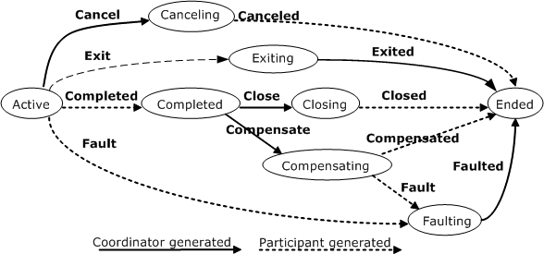
Figure 11 WS-BA BusinessAgreementWithParticipantCompletion protocol11

BusinessAgreementWithCoordinatorCompletion: A participant registers for this protocol with its coordinator, so that its coordinator can manage it. A participant relies on its coordinator to tell it when it has received all requests to perform work within the business activity. Following is the BusinessAgreementWithCoordinatorCompletion abstract state diagram.
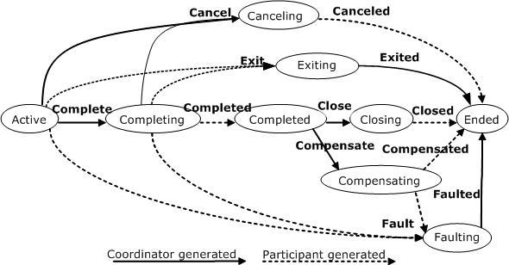
Figure 12 WS-BA BusinessAgreementWithCoordinatorCompletion protocol12

An overview of OASIS Web Service Composite Application Framework (WS-CAF)
The WS-CAF suite includes three specifications that can be implemented incrementally to address the range of requirements needed to support a variety of simple to complex composite applications:
- Web Service Context (WS-Context), a lightweight framework for simple context management.
- Web Service Coordination Framework (WS-CF), which defines the behavior of a coordinator with which Web services can register for context augmentation and results propagation, and on top of which can be plugged various transaction protocols.
- Web Services Transaction Management (WS-TXM), comprising three distinct protocols for interoperability across multiple transaction managers and supporting multiple transaction models (two phase commit, long running actions or compensation, and business process flows).
The overall aim of the combination of the parts of WS-CAF is to provide a complete solution that supports various transaction processing models and architectures. Implementations of WS-CAF can start small and grow to include more functionality over time. The emphasis of WS-CAF is to define supporting services required by Web services used in combination, including other specifications.

The parts of WS-CAF comprise a stack, starting from WS-Context, adding WS-CF, and finally WS-TXM to deliver the complete features and functionality required by composite applications. An implementation of WS-CAF can start with WS-Context for simple context management, and later add WS-CF for its additional context management features and context message delivery guarantees, and finally add WS-TXM for managing a variety of recovery protocols.

In the following sections we shall examine each of these specifications in more detail and show how they support the development of composite Web Service applications.

References
This group of specifications is currently being undertaken with OASIS (http://www.oasis-open.org/committees/tc_home.php?wg_abbrev=ws-caf ). A set of slides can be obtained from https://forge.gridforum.org/projects/tm-rg/document/WS-CAF/en/1

Context management
The WS-Context specification defines a context service that can be used by arbitrary Web Services to form composite applications. Contexts are first-class elements, i.e., the context information is represented as a Web Service, accessible via its URI. Contexts may flow implicitly (transparently to the application) with normal messages sent to participants/endpoints during Web Service execution.

WS-Context defines the notion of an activity to which the context is bound: the lifetime of the activity is the lifetime of the context. So, for example an activity can be used to model a session: all interactions on a session-oriented service in the scope of an activity will be uniquely and unambiguously tied to that activity through the context. An activity may also model a business process instance, a conversation and other concepts.
Where messages (either application messages, or WS-Context protocol messages themselves) require contextualization, the context is transported in a SOAP header block. The basic context structure is shown below.

<xsd:complexType name="ContextType">
<xsd:sequence>
<xsd:any namespace="##other" processContents="lax" minOccurs="0" maxOccurs="unbounded"/>
<xsd:element name="context-identifier" type=" tns:contextIdentifierType xsd:"/>
<xsd:element name="context-service" type="ref:ServiceRefType" minOccurs="0"/>
<xsd:element name="type" type="xsd:anyURI"/>
<xsd:element name=”context-manager” type=”ref:ServiceRefType” minOccurs=”0”/>
<xsd:element name="parent-context" type=”tns:ContextType” minOccurs="0">
</xsd:sequence>
<xsd:attribute name="timeout" type="xsd:int" use="optional"/>
<xsd:attribute ref=”wsu:Id” use=”optional”/>
</xsd:complexType>
The structure contains the following information:
- A mandatory context-identifier. This identifier can be thought of as a “correlation” identifier or a value that is used to indicate that a Web Service is part of the same activity.
- An optional context-service, which identifies the issuing authority responsible for generating the context.
- A mandatory URI that indicates the type of the protocol supported by the context, i.e., it indicates how the information within a context can be interpreted.
- An optional context-manager which can be used to get data associated with a context-identifier when the context is passed by reference (we shall describe this in the next section).
- An optional parent-context element containing some portion of the current context’s parent hierarchy.
- An optional timeout attribute, which indicates for how long the context information is valid; after this period has elapsed, the context is considered to be invalid.
- An optional wsu:Id attribute, which may be used to support signing or encrypting the context structure.
- The context can contain information from an arbitrary number of augmenter services. The context structure is extended via the extensibility xsd:any element present in the schema.
As you can see, by default all the context defines is a unique context identifier, the type of the context (e.g., transaction or security) and a timeout value (how long the context can remain valid). For example:

<ContextType> MyContext </ContextType>
<context-identifier>
www.webservicestransactions.org/example/Example
</context-identifier>
<logon>
<user-name> John Doe </user-name>
<password> ******** </password>
</logon>
<parent-context>
<database-name> SQL-DB </database-name>
<file-name> Index-S-file </file-name>
<display-address> PocketPc25 </display-address>
</parent-context>
<parent-context>
<transaction-type> BusinessProcess </transaction-type>
<transaction-mode> Required </transaction-mode>
</parent-context>
The example illustrates user information that obtains a security token and passes the token as a single sign-on feature for the composite application. In other words, the context could be provided as input to the first Web Service in a workflow. The first Web Service in the flow then could check the username and password (the asterisks are used to indicate opaque data in the example) and retrieve an authentication token to use in checking whether the user is authorized to access each subsequent Web Service in the flow. Such an authentication token would be placed back into the context data structure as an augmentation. For example:

<logon>
<user-name> John Doe </user-name>
<password> ******** </password>
<AuthToken> ******** </AuthToken>
</logon>
The AuthToken is added by the security system at the end of the username and password information upon execution of the initial Web Service in the flow. The context is a dynamic data structure; the results of a security sign on (or other operation pertinent to the contents of the context) would typically be added for propagation to the next Web Service in the flow. For example, a single sign on system bridging multiple security domains would add another token to the context.

Coordination
WS-CF builds upon the activity concept defined in WS-Context by narrowing the notion of an activity to that of an activity group: such a group contains members (participants) that will be driven through the same protocol. WS-CF says nothing about specifics of such coordination protocols and when or where participants may join and leave: this is left up to referencing specifications to define.

The group membership facilities are used to build and manage relationships between services. For example, an activity group can be used as the basic definition of a participant set in a coordination protocol. The group paradigm is central to coordination, whether it is coordinating the outcome of distributed transactions, security domains, replica consistency, cache coherency etc. Because WS-CF is meant to support a range of coordination protocols, each possessing different protocol messages and potentially different coordinator interfaces, WS-CF does not define how or when coordination occurs. This is left to referencing specifications, such as transactions.

The activity group is tied to an underlying WS-Context activity such that their lifetimes coincide. Web Services that wish to join or leave the group make use of the Registration Service; the membership of the group may also be obtained from the Registration Service.
The main components involved in using and defining the WS-CF are:
- A Registration service, which provides an interface for the registration of participants within a specific protocol.
- A Participant service, which defines the operation or operations that are performed as part of the protocol. It is possible to register participants that have no protocol specific callback operations.
- A Registration Context Type, which allows participants to join an activity group.
This specification allows group membership to be managed with reference to a specific context; the relationship between different contexts is defined by the WS-Context specification; specific protocols based on activity groups may support subgroups and interposed activities. Activity groups are particularly useful for structuring relationships in the kinds of coordination protocols found in transaction systems and data replication/consistency protocols for clustered services.

WS-CF extends the basic context structure defined in WS-Context:

<xs:complexType name="RegistrationContextType">
<xs:complexContent>
<xs:extension base="wsctx:ContextType">
<xs:sequence>
<xs:element name="registration-service" type="ref:ServiceRefType"/>
<xs:element name="sub-protocol" type="xs:anyURI" maxOccurs="unbounded"/>
<xs:element name="participant-service" type="ref:ServiceRefType" maxOccurs="unbounded"/>
<xs:any namespace="##other" processContents="lax" minOccurs="0"/>
</xs:sequence>
</xs:extension>
</xs:complexContent>
</xs:complexType>
When an activity is created, a corresponding activity group is started and the context is augmented to include the Registration Service Endpoint Reference (EPR). Whenever a recipient of the context wishes to enroll a participant service with the activity group, is sends an appropriate message (wscf:addParticipant) to the Registration Service, including the participant’s EPR. Upon successful registration, the wscf:participantAdded message is returned.

It is worth noting that WS-CF allows coordinator implementations to support a range of different protocols, i.e., a single EPR may support more than one coordination protocol. Each type of coordination protocol is uniquely identified by a xsd:URI and multiple instances may be supplied on the wscf:addParticipant message to ensure that the participant EPR is registered to participate in the associated protocol exchanges. All coordination messages are the responsibility of referencing specifications, such as those concerned with transaction management.

Figure 13 below shows an example flow of messages for a referencing specification using WS-CF:
- The application starts a new activity, which ultimately causes the issuing of a begin on the Coordination Service to demarcate the beginning of a transaction. This causes the Coordination Service to create a coordinator used to identify the activity instance and subsequently track the elements interested in the transaction outcome (i.e., the participants).
- The application issues a server method. Context information is appended to the message. The context is used at the target to recreate the execution environment. Having been passed a coordinator reference the target registers interest in the transaction outcome.
- The application terminates the activity and sends an appropriate referencing specification message to the Coordination Service. The coordinator sends the two-phase commit protocol (in this example) messages to each registered participant and returns the outcome to the application.
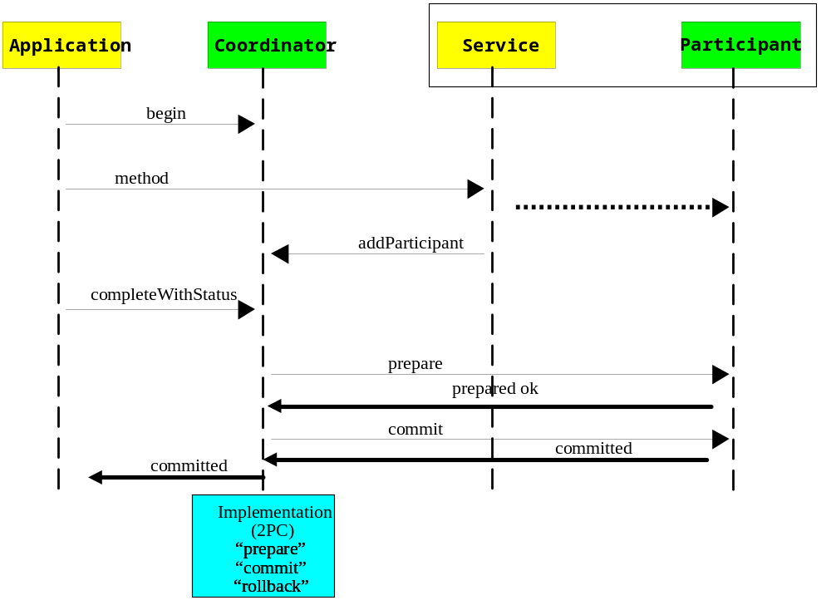
Figure 14 WS-CAF Two-phase commit transactions14

Transactions
WS-TXM provides models that are designed to accommodate multiple use-cases, from tightly-coupled intranet-based transactions (WS-ACID), through to Internet-scale long lived transactions (WS-LRA), to business-process oriented transactions (WS-BP). All of the WS-TXM protocols build on WS-CF and rely on it for membership services.
It’s important to note that this set of protocols is not meant to be complete. The intention is that if other models are developed to better suit different use cases, then those models should be added to WS-TXM.

WS-ACID
The WS-ACID specification defines a model based on traditional ACID transactions: it is assumed that all services provide ACID semantics and that any use of atomic transactions occurs in a trusted domain, over short durations. Within the scope of a WS-ACID transaction, services enroll transaction-aware resources, such as databases and message queues, as participants. When the transaction terminates, the outcome decision of the WS-ACID transaction is then propagated to each enlisted resource and the appropriate commit or rollback actions are taken by each.

To begin an atomic transaction, the client application firstly locates a WS-ACID coordinator. Once located, the client begins a transaction and this starts a WS-CF activity group as mentioned earlier. This will cause the creation of WS-ACID context, which is an augmented WS-CF context, containing the Registration Service EPR. This EPR can be used by services to enlist resources (such as databases) into the transaction.

After obtaining a transaction context from the coordinator, the client application then proceeds to interact with Web services to accomplish its business-level work. With each invocation on a business service, the client propagates the context, such that the each invocation is implicitly scoped by the transaction.

Each WS-ACID coordinator supports two protocols: the traditional two-phase commit (identified by the xsd:URI http://www.webservicestransactions.org/wsdl/wstxm/tx-acid/2pc/2003/03) and a synchronization protocol (identified by http://www.webservicestransactions.org/wsdl/wstxm/tx-acid/sync/2003/03).

The ACID transaction model supports the following optimizations:
- Presumed rollback: the transaction coordinator need not record information about the participants in stable storage until it decides to commit, i.e., until after the prepare phase has completed successfully.
- One-phase: if there is only a single participant involved in the transaction then there is no need for a prepare phase since consensus is implicit.
- Read-only: a participant that is responsible for a service that did not modify any transactional data during the course of the transaction can indicate to the coordinator during prepare that it is a read-only participant and it will be omitted from the second phase of the commit protocol.
Participants that have successfully passed the prepare phase are allowed to make autonomous decisions as to whether they commit or rollback. A participant that makes such an autonomous choice must record its decision in case it is eventually contacted to complete the original transaction. If the coordinator eventually informs the participant of the fate of the transaction and it is the same as the autonomous choice the participant made, then there is obviously no problem: the participant simply got there before the coordinator did. However, if the decision is contrary, then a non-atomic outcome has happened: a heuristic outcome, with a corresponding heuristic decision.

The possible heuristic outcomes are:
- Heuristic rollback: the commit operation failed because some or all of the participants unilaterally rolled back the transaction.
- Heuristic commit: an attempted rollback operation failed because all of the participants unilaterally committed. This may happen if, for example, the coordinator was able to successfully prepare the transaction but then decided to roll it back (e.g., it could not update its log) but in the meanwhile the participants decided to commit.
- Heuristic mixed: some updates were committed while others were rolled back.
- Heuristic hazard: the disposition of some of the updates is unknown. For those which are known, they have either all been committed or all rolled back.
Figure 15 illustrates the state transition for a WS-ACID coordinator and participant. If the WS-ACID transaction is instructed commit, then if there is only a single participant enrolled with the transaction there is no need for the coordinator to execute the two-phase protocol. As such, the coordinator begins the OnePhaseCommit protocol and either transits to the RolledBack or Committed state, depending upon the result returned by the participant.

If there are multiple participants enrolled with the transaction, the coordinator transits to the Preparing state and begins to execute the two-phase commit protocol by sending the prepare message to each participant. If all of the participants indicate that the services they represent performed no work (i.e., are read only) then the transaction is complete and the coordinator transits to the Committed state.

Any failures from a participant or indication that it cannot prepare cause the coordinator to rollback (move to the RollingBack state) and send rollback messages to all of the other participants. It then transits to the RolledBack state.
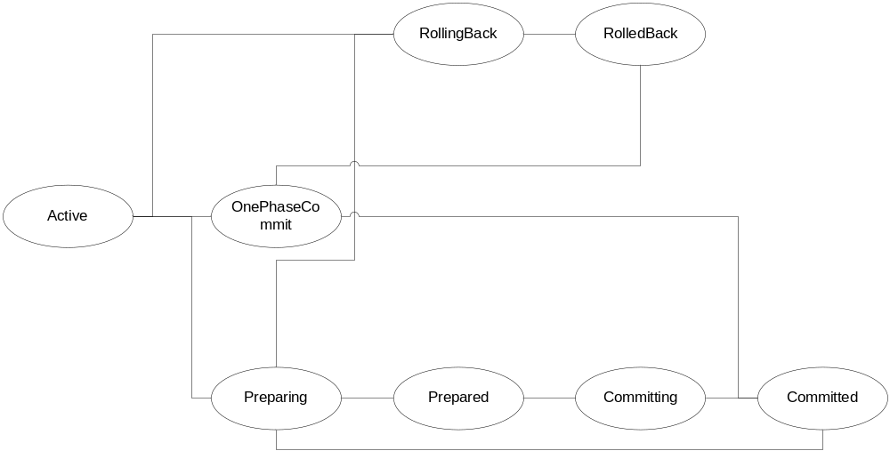
Figure 16 WS-CAF Transaction coordinator two-phase status transition16
Assuming all participants have prepared successfully, the transaction coordinator makes the decision as to whether to commit or rollback and must record sufficient information on stable storage to ensure this decision can be completed in the event of a failure. It is then in the Prepared state. When the coordinator starts the second phase of the commit protocol it is in the Committing state and ultimately moves to the Committed state.

Most modern transaction processing systems allow the creation of participants that do not take part in the two-phase commit protocol, but are informed before it begins and after it has completed. They are called Synchronizations, and are typically employed to flush volatile (cached) state, which may be being used to improve performance of an application, to a recoverable object or database prior to the transaction committing; once flushed, the data will the be controlled by a two-phase aware participant.

The message exchanges (ignoring the normal WS-CF coordinator-to-participant message exchanges, including failures) are illustrated in Figure 17:
- beforeCompletion: A Synchronization participant is informed that the coordinator it is registered with is about to complete the two-phase protocol and in what state, i.e., committing or rolling back. The failure of the participant at this stage will cause the coordinator to cancel if it is not already doing so.
- afterCompletion: A Synchronization participant is informed that the coordinator it is registered with has completed the two-phase protocol and in what state, i.e., committed or rolled back (via the associated Status). Any failures by the participant at this stage have no affect on the transaction.
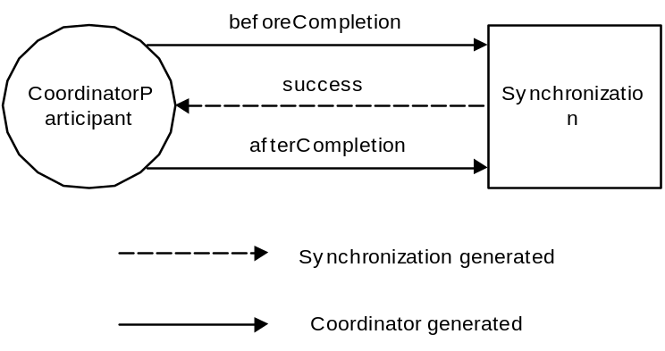
Figure 18 WS-CAF Coordinator-to-synchronization message exchanges18

WS-LRA
The long running action model (LRA) is designed specifically for those business interactions that occur over a long duration. Within this model, an activity reflects business interactions: all work performed within the scope of an application is required to be compensatable. Therefore, an application’s work is either performed successfully or undone. How individual Web services perform their work and ensure it can be undone if compensation is required, are implementation choices and not exposed to the LRA model. The LRA model simply defines the triggers for compensation actions and the conditions under which those triggers are executed.

As with most transaction models, LRA is concerned only with ensuring participants obey the protocol necessary to make an activity compensatable; semantics of the business interactions are not part of LRA model. Issues such as isolation of services between potentially conflicting activities and durability of service work are assumed to be implementation decisions. The coordination protocol used to ensure an activity is completed successfully or compensated is not two-phase and is intended to better model business-to-business interactions. Although this may result in non-atomic behavior for the overall business activity, other activities may be started by the application or service to attempt to compensate in some other manner.

Each LRA is tied to the scope of an activity. This means that when the activity terminates, the LRA coordination protocol will be automatically performed either to accept or compensate the work.

In the LRA model, each application is bound to the scope of a compensation interaction. For example, when a user reserves a seat on a flight, the airline reservation centre may take an optimistic approach and actually book the seat and debit the users account, relying on the fact that most of their customers who reserve seats later book them; the compensation action for this activity would obviously be to un-book the seat and credit the user’s account. Work performed within the scope of a nested LRA must remain compensatable until an enclosing service informs the individual service(s) that it is no longer required.

The context for the LRA protocol is shown below.

<xs:element name="context">
<xs:complexType>
<xs:complexContent>
<xs:extension base="wstxm:ContextType">
<xs:sequence>
<xs:element name="lra-id" type="xs:anyURI"/>
<xs:element name="coordinator-hierarchy">
<xs:complexType>
<xs:sequence>
<xs:element name="coordinator-location"
type="xs:anyURI" minOccurs="0"
maxOccurs="unbounded"/>
</xs:sequence>
</xs:complexType>
</xs:element>
</xs:sequence>
</xs:extension>
</xs:complexContent>
</xs:complexType>
</xs:element>
There is a caveat to this model though, where application services may not be compensatable (e.g. an application-level service that prints and mails cheques), or the ability to compensate may be transient. The LRA model allows applications to combine services that can be compensated with those that cannot be compensated Obviously by mixing the two service types the user may end up with a business activity that will ultimately not be undone by the LRA model, but which may require outside (application specific) compensation.

The LRA model defines a protocol actor called a Compensator that operates on behalf of a service to undo the work it performs within the scope of an LRA. How compensation is carried out will obviously be dependant upon the service; compensation work may be carried out by other LRAs which themselves have Compensators.

Let’s consider another example of a long running business transaction. The application is concerned with booking a taxi, reserving a table at a restaurant, reserving a seat at the theatre, and then booking a room at a hotel. If all of these operations were performed as a single transaction then resources acquired during booking the taxi (for example) would not be released until the top-level transaction has terminated. If subsequent activities do not require those resources, then they will be needlessly unavailable to other clients.

For example, Figure 19 illustrates how a travel agency application may be structured using this technique. LRA1 is used to obtain the taxi to the airport. The user then wishes to get the cheapest flight from three different airlines and so the agency structures each seat reservation (or booking, depending upon how the user feels) as a separate LRA. In this example, the airline represented by LRA2 gives a cost of $150 for the flight; while LRA2 is still active, the application starts LRA3, a new independent-level LRA to ask the next airline for a costing: LRA3 gives a value of $160 and so it is cancelled. Finally the travel agency starts LRA4 to check the other airline, which gives a value of $120 for the seat. Thus, LRA2 is cancelled and LRA4 is confirmed, with the result that the seat is bought. The travel agency then uses the same technique to select the cheapest travel insurance from amongst two options (using LRA5 and LRA6).
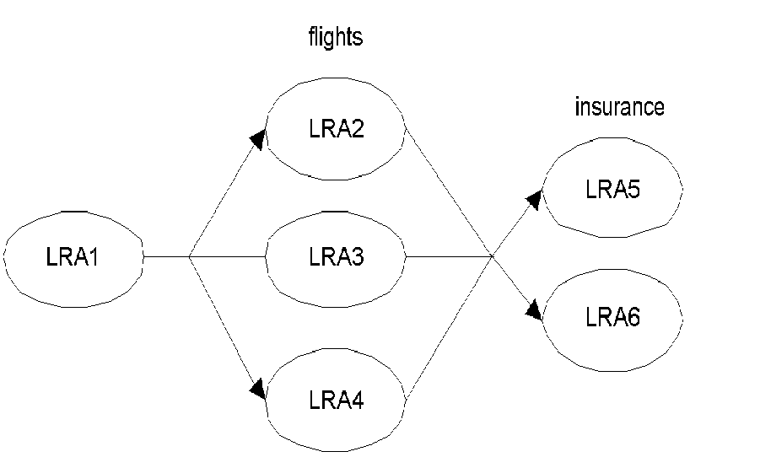
Figure 20 WS-CAF LRA example20

WS-BP
In the business process transaction model (BP model) all parties involved in a business process reside within business domains, which may themselves use business processes to perform work. Business process transactions are responsible for managing interactions between these domains. A business process (business-to-business interaction) is split into business tasks and each task executes within a specific business domain. A business domain may itself be subdivided into other business domains (business processes) in a recursive manner.

Each domain may represent a different transaction model if such a federation of models is more appropriate to the activity. Each business task (which may be modeled as a scope) may provide implementation specific counter-effects in the event that the enclosing scope must cancel. In addition, periodically the controlling application may request that the entire business domains checkpoint their state such that they can either be consistently rolled back to that checkpoint by the application or restarted from the checkpoint in the event of a failure.

An individual task may require multiple services to work. Each task is assumed to be a compensatable unit of work. However, as with the LRA model described earlier, how compensation is provided is an implementation choice for the task.

For example, consider the purchasing of a home entertainment system example shown in figure 21. The on-line shop interacts with its specific suppliers, each of which resides in its own business domain. The work necessary to obtain each component is modeled as a separate task, or Web service. In this example, the HiFi task is actually composed of two sub-tasks.
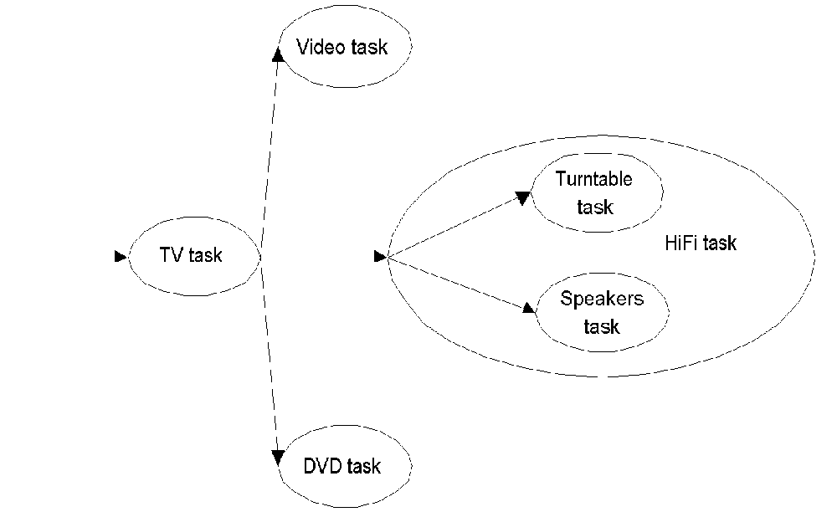
Figure 22 WS-CAF Business processes and tasks22
In this example, the user may interact synchronously with the shop to build up the entertainment system. Alternatively, the user may submit an order (possibly with a list of alternate requirements) to the shop which will eventually call back when it has been filled; likewise, the shop then submits orders to each supplier, requiring them to call back when each component is available (or is known to be unavailable).

The business process transaction model supports this synchronous and asynchronous interaction pattern. Business domains are instructed to perform work within the scope of a global business process. The business process has an overall manager that may be informed by individual tasks when they have completed their work (either successfully or unsuccessfully), or it may periodically communicate with each task to determine its current status. In addition, each task may make period checkpoints of its progress such that if a failure occurs, it may be restarted from that point rather than having to start from the beginning. A business process can either terminate in a confirmed (successful) manner in which case all of the work requested will have been performed, or it will terminate in a cancelled (unsuccessful) manner, in which case all of the work will be undone.

If it cannot be undone, then this fact must be logged. One key difference between the business process transaction model and that of traditional 2PC is that it assumes success, that is the BP model is optimistic and assumes the failure case is the minority and can be handled or resolved offline if necessary, or through replay/void/compensation, but not always automatically, often requiring human interaction.

Logging is essential in the BP model for replay, void, and compensation (attempts to “rollback” or restore the initial state). However, recovery may ultimately be the responsibility of a manual operator if automatic recovery/compensation is not possible. As we shall see, interposition plays a major role in the BP model to improve performance or to federate a distributed environment into separate domains. In fact user intervention is likely to be an important part of business process management, as is monitoring of every step. As such, although the protocols are described in terms of participant services, it is expected that in some cases implementations of participants will interact directly with operators. The asynchronous nature of the BP model allows arbitrary periods of time to elapse between requests and responses to assist in this type of interaction.

Each participant or subordinate coordinator is responsible for ensuring that sufficient data is made durable in order to complete the BP even in the event of failures. Recovering participants or coordinators use the recovery mechanisms defined in WS-CF to determine the current status of the BP and act accordingly. Interposition and check pointing of state allow the system to drive a consistent view of the outcome and recovery actions taken, but allowing always the possibility that recovery isn’t possible and must be logged or flagged for the administrator. In a large scale environment or in the presence of long term failures, recovery may not be automatic. As such, manual intervention may be necessary to restore an application’s consistency.

In order to participant within a business process transaction (BP model), each business domain is exposed as a single subordinate (interposed) coordinator, forming a parent-child relationship; the business domain is identified by the coordinator URI. The interposed coordinator is responsible for managing the domains participation within the overall business transaction. The internal implementation of a domain is not the responsibility of this specification. In order to perform work necessary for a business task a domain may use its own business process transaction, BP transactions, or some other infrastructure.

This specification does not define what constitutes a business domain, i.e., what collection of services are grouped into a single domain. Neither does it specify how or when interposition occurs on behalf of a given domain. For example, the first service that resides within a specific domain may be responsible for performing interposition. Or interposition may occur only when work is done that is to be controlled by the overall business process.

When and where to use interposition is a design decision. Typically there will be a business transaction manager (e.g., the root coordinator) that knows which systems have been updated or not (i.e., knows which systems have completed and with what status). It knows either because the participants have notified it of the completion and status, or because it asked for a response and did not get one. Or it knows some parts have finished with others still pending.

Unlike traditional transaction systems where recovery is typically automatic and required little or no user or application intervention, in a long running business process that executes over many disparate business domains, the hardest part is determining when a failure has occurred and what to do in such a situation. In the worst case, the error is logged and brought to the attention of an administrator. In the best case, the compensation or undo logic is executed, or some workaround is found through presenting the exception to the user and having the user choose another possible option.

Options Concept - Outline and Implementation Notes

Transaction support is designed to allow users to create, change, delete and access a set of records that are managed by one or more resource managers without dealing with failure and concurrency issues. Users only need to bundle a set of requests to a transaction. Specifying when a transaction starts and when a transaction is completed or should be aborted is all a user needs to do. A transaction manager coordinates the participating resource managers and ensures that these resources managers act coherently according to the transactional directives. The support of resource managers; providing locking to isolate user from each other and providing recovery, is a crucial part of this technology.

Existing (ACID) transaction management is designed for short running applications. Let us note the following properties apply:

- While a user updates a record no other user can do so at the same time.
- Once a modification becomes part of a transaction it cannot be dropped.
- A commit or abort applies to all resources that have been modified
- All intermediate results will be lost in case of a failure.

While these properties are acceptable for short running transactions they are perceived as serious shortcomings for long running transactions:

Business transactions (workflow) do not have the above listed limitations; however, they provide only recommendations on how to deal with the properties listed above, especially they depends on users to design and implement support for securing and dropping resources and making intermediate results recoverable. Usually, the idea is to just go ahead and do things as if there will go forward and compensate if this is not the case. Supporting compensation, however, has been proven to be difficult. Options are designed to overcome these complex issues.

Since transactions depend heavily on the functionality of resource managers there is a need for new technology called options. Options are designed to remove the properties listed above. Options can be managed through a set of operations. The management of options complements the management of data designed for short running transactions - SELECT (FOR UPDATE), INSERT, UPDATE, and DELETE.

The Functions of Options
Options are managed through the following set of operations:
- Find option – in response to a find option request a resource manager identifies a set of options satisfying the condition specified by the requestor. The information about the conditions for securing an option is part of the response. The find option request is optional and not required assuming the requestor understands which conditions have to be met to secure an option. A find option request is equivalent to a select request; however it takes secured options into account.
- Secure option – in response to a secure option request a resource manager secures one or more options. Once an option is secured the resource manager is committed to honor this option subject to the conditions specified as part of this option. A secure option request is like an update request; however, options allow multiple concurrent and competing requests. The secure request is optional and can be combined with a confirm request. Furthermore, a secure option request acts like an update request combined with phase 1 of a commit process. As a consequence, phase 1 and phase 2 of the commit process are not any longer bundled together; e.g., the classical commit logic has been extended.
- Drop option – in response to a drop option request the resource manager removes one or more secured but not yet confirmed options. A special case is to drop all options secured by one resource manager. The drop option request allows the selective invalidation an important extension of the classical resource management functionality. In the classical model a change could never be removed from a transaction.
- Confirm option – the response to a confirm option request is an acknowledgement that the request has been received (in time) and executed (or not and why not). In case of acceptance the requestor is subject to the conditions that are specified in the secure option request; e.g.; the requestor too is committed to honor the options according to the specified conditions. A confirm request acts like a phase 2 of a commit request for the selected set of secured options. If the confirm request is combined with a secure request it implies the processing of the actual request as well as phase 1 on 2 of the commit process. It is important to understand that the confirm request actually defines the scope of a transaction; e.g., the decision with option request belongs to a transaction and which does not is delayed as long as possible. Obviously classical transactions do not allow this; each resource manager request has to be executed in the context of a transaction.
- Cancel option – a requestor may (be forced to) cancel an option even after it has been confirmed. The requestor has to honor the obligations as specified in the option. The cancel option should not be confused with compensation.
- Modify option – a requestor may (be forced to) request a modification of a secured or confirmed option. The requestor has to honor the obligation as specified in the option. A modify request is typically followed by a secure and confirm request. The confirm request implicitly cancels the existing option.

Each single request represents a single classical transaction. Consequently, each interaction is recoverable. The interaction between the requestor and the resource manager will be based on the INFOD technology. INFOD provides a recoverable, auditable and non-reputable communication between requestor and resource managers.

A requestor does not need to confirm all secured options at once but is able to do so in multiple steps. Obviously; atomicity is lost.

So far, the discussion is focused on a series of request to a single resource manager. The Travel Use case, however, requires an atomic confirm request to multiple resource managers. This can be achieved by adding a coordinator. As part of the response to a find option request a resource manager specifies acceptable coordinator. Once a requestor has found the desired options, it will attempt to secure them. As part of this secure request the requestor has to specify which coordinator will be used in the confirm request. If a requestor likes to atomically confirm a set of options that are secured against multiple resource managers the requestor sends a confirm options request to the selected coordinator instead of to the various resource manager. The coordinator validates the request and notifies the individual resource managers as well as the requestor of the outcome. Consequently, a confirm request directed to a coordinator needs to reference previously successful secure options request.

The use of INFOD and the processing of options by resource managers ensure that each step is recoverable. Therefore, it is advisable the program representing the requestor is recoverable after each processing step. INFOD ensures that the request and responses are recoverable; it is the responsibility of the requestor (program) to save any additional data consistently with the INFOD data. Using classical transaction technology in the context of INFOD makes this easy.

Implementation Notes:

Modern resources managers provide support for extensibility. Extensibility allows the specification and implementation of new services, which complement the existing services. Using such a framework, one would create an option service. The option services would implement the various option requests for a set of collections or tables. The option services would access and changes these tables or collections using the basic access and manipulation services. However, the use of these basic services is exclusively reserved for the option service. Direct SQL or XML access would expose too much detail of the options implementation to the requestor and could lead to inconsistencies of the information associated to options.

The option service interacts with requestors using a modern messaging service: Once a request has arrived, the option service is activated. It starts a transaction, consumes a message, does the required processing, creates the response as a message and commits the transaction. This makes the service recoverable, auditable, and the communication non-reputable.

The option service consists of a core service, the one that understands the domain neutral logic and is complemented by a set of domain specific services. Theses domain services deal with the domain specific logic.

Scenarios
Find and Confirm Options – One Resource Manager

Find options – identify a set of options interaction with one resource manager

Confirm options – confirm all selected options

This scenario does not require a coordinator. It is equivalent to transaction classical non-distributed transaction and commit processing.

This scenario represents today’s state of the art in options technology. One looks for options and confirms them once the right once are found. There is rarely the possibility to secure options, there is no possibility to modify options, there is no possibility to confirm a subset of the options, there is no possibility to commit options against multiple service providers, and there is definitely no possibility for a non-reputable record of the communication.

Other Examples

To be added

Other Notes:

- One should add a set of functions tracking the delivery process for a more complete coverage of the use case; e.g.; once delivered an option cannot be changed or cancelled. This will not be discussed as of now

- Business transactions (workflow) do not have the limitations of ACID transactions; however, they provide only recommendations how to deal with the listed issues, especially they depend on users to design and implement a consumption support. Supporting consumption has been proven to be difficult.

- The option model eliminates need for compensation; compensation is far too hard to design and implement. Being based on secure and drop support the option model provides the functionality of a well-structured compensation model; e.g., it is guaranteed to work. Since the support for options is part of the functionality of resource manager application developers do not need to support this functionality any more.

- One could create functions on top of the basic services; such as waiting lists; e.g., inform interested parties that a conflicting secured option has been dropped. The notification could include a secured option.

Recommendations

- We recommend that a group picks up the use cases, refines them and adds new ones if necessary.

- We recommend that a group performs an analysis to see if the existing transactional specs are suitable for implementing the use cases.

- We recommend that a group studies the issues involved in using the current protocols described in section 4 and any other protocol developed to support Options (section 5) within a Grid environment. We envisage that this may mean using the complete protocol as specified, or a profile of the protocol, and may require the development of a specification for the mapping to the Grid infrastructure, as well as guidance and recommendations on use and implementation issues.

- We recommend that a group provides a reference implementation of the options model.
- A sample implementation is already being done by Joerg Seitter (joerg@data-grid.org) in the context of a Master thesis about the options model (supervised by Peter van Santen, Brunel University of London)
- The progress of this project can be tracked at http://www.seitter.net/optionsmodel

- We recommend that a group identifies a solution for recoverability/visibility issue (Credit Verification Use Case).

References

[1] "The Escrow Transactional Method", O'Neil, Patrick E., TODS, V 11, No 4 (December 1986), pp. 405-430.

[2] "Options Model Proposal", The GGF Transaction Management Research Group, http://forge.gridforum.org/projects/tm-rg/document/Options_Model_Proposal/en/1

Editor Information
Tony Fletcher, Choreology Ltd
68, Lombard Street, London EC3V 9LJ
Phone: +44 1473 729537 mobile: +44 7801 948219
Email: tony.fletcher@choreology.com or amfletcher@iee.org

Acknowledgements
We gratefully acknowledge the contributions made to this document by Torsten Steinbach, Mark Little, Dieter Gawlick, Bob Haugen, Tony Fletcher, GGF Working groups and all other members of the TM-RG working group members who discussed and reviewed the material.

End of Document

Nested transaction are able to do this in a very limited way; however, they have never been successful in commercial products
It is assumed that the user is familiar with the Use Case document, especially with section titled Trip Support
The coordination of multiple resource managers will be discussed later.
The resource manager may also be forced to cancel, we will ignore this case for now
The resource manager may also be forced to cancel, we will ignore this case for now
https://forge.gridforum.org/projects/infod-wg
This works only if there is at least one coordinator that is acceptable for all resource managers.
The details of the validation process will not be discussed here; but the basic idea is to check that the ‘understanding ‘ of the requestor and the resource manager for each resource to be confirmed match.

