Example

Description of the Example
In this section, we describe an example that considers the modeling of a managed system, its advertised capabilities and the expression of activity requirements. The managed system is modeled using the CIM information model, the advertised capabilities are described using the GLUE information model (draft 19 [REF]) and the activity requirements are expressed as XPath/XQuery expression on the GLUE-based XML rendering of the advertised capabilities.
Using the GLUE terminology, the example considers an administration domain ACME exposing a batch system to the Grid by using the BES interface. The batch system is locally managed by OpenPBS and is composed of two different subsets of nodes: 1) an old set of 50 machines based on Xeon and 1 GB RAM; 2) a new set of 100 machines based on Xeon. Two shares (fast and slow) are configured in order to access either the fast nodes or the slow nodes. The Virtual Organization VOA signs an agreement with the administration domain ACME in order to access the BES endpoint to run activities on the slow nodes. The Virtual Organization VOB signs an agreement with the administration domain ACME in order to access the BES endpoint to run activities on the fast nodes.

Diagram
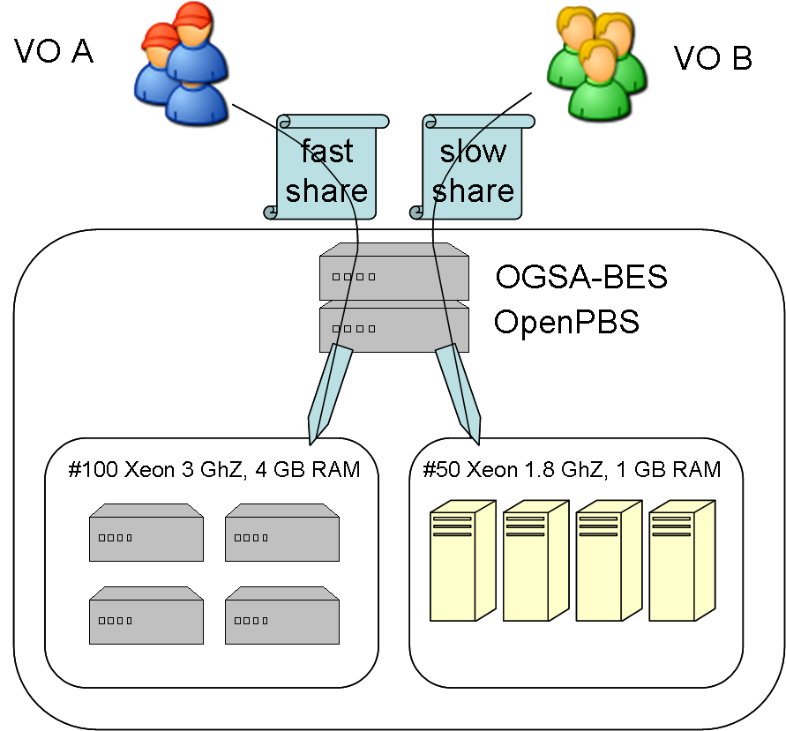

Example of XML Document compliant to GLUE 2.0 XSD rendering describing the example

<?xml version="1.0" encoding="UTF-8"?>
<glue:Grid xmlns:glue="http://GLUE2" xmlns:xsi="http://www.w3.org/2001/XMLSchema-instance"
xsi:schemaLocation="http://GLUE2 GLUE2.xsd">
<AdminDomain>
<ID/>
<ComputingService>
<ID>urn:acme:cs</ID>
<Name>ACME BES Endpoint</Name>
<Type>org.cs</Type>
<QualityLevel>production</QualityLevel>
<ComputingEndpoint>
<ID>urn:acme:cs:bes</ID>
<URL>https://bes.acme.com:7443/...</URL>
<Type>org.cs.bes</Type>
<QualityLevel>development</QualityLevel>
<SpecificationName>OGSA-BES</SpecificationName>
<SpecificationVersion>1.0</SpecificationVersion>
<HealthState>OK</HealthState>
<ServingState>production</ServingState>
<WSDL>http://someurl/ogsa-bes.wsdl</WSDL>
<AccessPolicy>
<Scheme>VOMS</Scheme>
<Rule>VO:VOA</Rule>
<Rule>VO:VOB</Rule>
</AccessPolicy>
</ComputingEndpoint>
<ComputingShare>
<LocalID>slow</LocalID>
<MappingPolicy>
<Scheme>VOMS</Scheme>
<Rule>VO:VOA</Rule>
</MappingPolicy>
<MaxWallTime>432000</MaxWallTime>
<!-- 5 days -->
<MaxCPUTime>432000</MaxCPUTime>
<MaxTotalJobs>50</MaxTotalJobs>
<MaxRunningJobs>500</MaxRunningJobs>
<MaxWaitingJobs>200</MaxWaitingJobs>
<MinWallTime>1000</MinWallTime>
<TotalJobs>40</TotalJobs>
<RunningJobs>30</RunningJobs>
<WaitingJobs>1</WaitingJobs>
<FreeJobSlots>1</FreeJobSlots>
</ComputingShare>
<ComputingShare>
<LocalID>fast</LocalID>
<MappingPolicy>
<Scheme>VOMS</Scheme>
<Rule>VO:VOB</Rule>
</MappingPolicy>
<MaxWallTime>432000</MaxWallTime>
<MaxCPUTime>432000</MaxCPUTime>
<MaxTotalJobs>50</MaxTotalJobs>
<MaxRunningJobs>500</MaxRunningJobs>
<MaxWaitingJobs>200</MaxWaitingJobs>
<MinWallTime>1000</MinWallTime>
<TotalJobs>40</TotalJobs>
<RunningJobs>30</RunningJobs>
<WaitingJobs>1</WaitingJobs>
<FreeJobSlots>1</FreeJobSlots>
</ComputingShare>
<ComputingResource>
<ID>urn:acme:cluster</ID>
<LRMSType>OpenPBS</LRMSType>
<LRMSVersion>3.0</LRMSVersion>
<Homogeneity>false</Homogeneity>
<ExecutionEnvironment>
<ID>urn:acme:xeon</ID>
<PhysicalCPUs>50</PhysicalCPUs>
<CPUVendor>Intel</CPUVendor>
<CPUModel>Xeon</CPUModel>
<CPUVersion>5150</CPUVersion>
<CPUClockSpeed>2660</CPUClockSpeed>
<MainMemorySize>4000000000</MainMemorySize>
<VirtualMemorySize>4000000000</VirtualMemorySize>
<OSName>ScientificLinux</OSName>
<OSVersion>4.0.5</OSVersion>
<SPECInt2000>51</SPECInt2000>
<ConnectivityIn>false</ConnectivityIn>
<ConnectivityOut>true</ConnectivityOut>
<NetworkInfo>infiniband</NetworkInfo>
</ExecutionEnvironment>
<ExecutionEnvironment>
<ID>urn:acme:pentium</ID>
<Total>50</Total>
<Used>0</Used>
<PhysicalCPUs>50</PhysicalCPUs>
<CPUVendor>Intel</CPUVendor>
<CPUModel>Pentium</CPUModel>
<CPUVersion/>
<CPUClockSpeed>3000</CPUClockSpeed>
<MainMemorySize>500000000</MainMemorySize>
<VirtualMemorySize>500000000</VirtualMemorySize>
<OSName>ScientificLinux</OSName>
<OSVersion>3.0.5</OSVersion>
<SPECInt2000>18</SPECInt2000>
</ExecutionEnvironment>
</ComputingResource>
<ComputingEndpoint_ComputingShare>
<ComputingEndpointID>urn:acme:cs:bes</ComputingEndpointID>
<ComputingShareID>fast</ComputingShareID>
</ComputingEndpoint_ComputingShare>
<ComputingEndpoint_ComputingShare>
<ComputingEndpointID>urn:acme:cs:bes</ComputingEndpointID>
<ComputingShareID>slow</ComputingShareID>
</ComputingEndpoint_ComputingShare>
<ComputingShare_ExecutionEnvironment>
<ComputingShareID>fast</ComputingShareID>
<ExecutionEnvironmentID>urn:acme:xeon</ExecutionEnvironmentID>
</ComputingShare_ExecutionEnvironment>
<ComputingShare_ExecutionEnvironment>
<ComputingShareID>slow</ComputingShareID>
<ExecutionEnvironmentID>urn:acme:pentium</ExecutionEnvironmentID>
</ComputingShare_ExecutionEnvironment>
</ComputingService>
</AdminDomain>
</glue:Grid>

Example of Queries

Query 1: Select the values of all local IDs of all computing shares
//ComputingShare/LocalID

Query 2: Select the IDs of all execution environments that:
- are part of a computing service on production level, and
- can provide 40 or more CPUs, and
- whose CPUs are of type Xeon

//ComputingService[QualityLevel eq "production"]//ExecutionEnvironment[PhysicalCPUs gt 39][lower-case(CPUModel) eq "xeon"]/ID

Query 3: Parameterized version of example 2.
XPath 2.0 allows to use variables in expressions, allowing to share and distribute XPath expressions that can be executed in any environment, and possibly shared by multiple installations.

Every XPath 2.0 compliant engine MUST be able to evaluate variables.
However, initialising variables with values is dependent on the XPath engine!

//ComputingService[QualityLevel eq $qlevel]//ExecutionEnvironment[PhysicalCPUs gt 39][lower-case(CPUModel) eq $cpuModel]/ID

