Global Grid Forum Documents and Recommendations: Process and Requirements

Status of This Memo

This memo provides information to the Grid community regarding the GGF document series processes. It does not define any standards or technical recommendations. Distribution is unlimited.

Copyright Notice

Copyright © Global Grid Forum (2001). All Rights Reserved.

Abstract

Among the most useful products of Global Grid Forum (GGF) efforts will be documents that provide information, guidance, or recommendations. This memo defines five types of GGF document and a set of development and review processes for these documents. The process borrows heavily from the Internet Engineering Task Force Request for Comments document process and is intended to complement that process.
Contents

Abstract 1
1. Introduction 2
2. GGF Documents 3
3. GGF Document Process 4
3.1 Grid Working Draft 4
3.2 Informational or Experimental GFDs 5
3.3 Community Practice GFDs 5
3.4 Recommendations Track GFDs 6
3.4.1 Proposed Recommendation 7
3.4.2 GGF Recommendation 7
4. Minimum Document Requirements 8
4.1 Specific GGF Document Formats 9
5. Variance and Appeals Processes 10
6. Security Considerations 10
Glossary 10
Author Contact Information 11
Acknowledgments 11
Intellectual Property Statement 11
Full Copyright Notice 11
Appendix A: Copyright Notices 12
Appendix B: Intellectual Property Rights and Notices 13
B-1. Contributions 13
B-2. Confidentiality Obligations 13
B-3. Rights and Permissions 13
B-3.1 Determination of Reasonable and Nondiscriminatory Terms 15
B-3.2 Notices 15
Appendix C: Document Process Flowcharts 15
C-1. Informational and Experimental Documents 16
C-2. Community Practice Documents 17
C-3. Recommendations Track Documents 18
References 19

Introduction

The Global Grid Forum (GGF) is a group of individuals engaged in research, development, deployment, and support activities related to high-capability distributed software systems, or “Grids.” The scope of the applications that motivate these activities is quite broad, including for example high performance processing applications, distributed collaborative environments, distributed data analysis, and remote instrument control. A defining characteristic is a perceived need for services beyond those provided by today’s commodity Internet.

The GGF intends to emulate, as appropriate, the Internet Engineering Task Force (IETF, www.ietf.org) and Internet Research Task Force (IRTF, www.irtf.org), and to support and complement the Internet Standards Process as outlined in [1][2][3].

During the two years since the GGF first met, approximately one hundred draft documents have been developed, varying widely in scope, intent, and quality. Some GGF documents have been submitted to conferences or journals, and others have been submitted to the Internet Engineering Task Force (IETF) as candidates for the Request for Comments (RFC) series. In many cases, however, we have seen and anticipate documents that are useful to the Grid community but are not necessarily appropriate in scope or topic for conferences, journals, or RFC publication. We thus believe it will be useful to initiate a GGF document series, similar to the RFC series, that will be persistent and will involve a clearly defined review processes tied to the intent and scope of the document.

To this end, we describe here a document series with several types of documents, each with a specific purpose and scope, along with a process by which documents are developed and included in the document series.

GGF Documents

One of the important GGF objectives is to produce high-quality documents that contribute to the process of designing, building, operating, or using Grids and Grid technologies. We anticipate GGF documents will fall into one of the following categories, modeled after the IETF’s RFC series. (Other document categories may become necessary at some point in the future.).

Grid Working Drafts (GWD), represent the final version of a draft document that has been submitted to the GGF editor to enter into the GFD review process.

Informational Documents (GFD-I), inform the community of an interesting and useful Grid-related technology, architecture, framework, or concept.

Experimental Documents (GFD-E), inform the community of the results of Grid-related experiments, implementations, or other operational experience.

Community Practice Documents (GFD-C), inform and influence the community regarding an approach or process that is considered to be widely accepted by consensus and practice in the Grid community.

Recommendations Documents (GFD-R), document a particular technical specification or a particular set of guidelines for the application of a technical specification. The recommendations documents are intended to guide interoperability and promote standard approaches.

A Grid Forum document may be designated as obsolete when it is superseded by another document. The obsolete designation clearly indicates that the document no longer reflects current thinking, but still recognizes the document’s contributions by allowing it to be referenced and consulted. A stronger designation of historical is used, primarily for technical specifications or specific recommendations, to indicate that the specification should no longer be used. In order to change a GFD status to historical, a GFD-I is necessary to explain the reasoning.

Recommendations documents follow a recommendations track that involves three states with increasingly rigorous requirements: Proposed Recommendation, Draft Recommendation, and Grid Recommendation.

A Proposed Recommendation (GFD-R-P) is analogous to a “Proposed Standard” in the Internet Standards Process:

A Proposed Standard specification is generally stable, has resolved
known design choices, is believed to be well-understood, has received
significant community review, and appears to enjoy enough community
interest to be considered valuable. However, further experience
might result in a change or even retraction of the specification
before it advances.

Usually, neither implementation nor operational experience is
required for the designation of a specification as a Proposed
Standard. However, such experience is highly desirable, and will
usually represent a strong argument in favor of a Proposed Standard
designation.”[ [1], Section 4.1.1, p. 12]

A Draft Recommendation (GFD-R.D) is analogous to a “Draft Standard” in the Internet Standards Process:

A specification from which at least two independent and interoperable
implementations from different code bases have been developed, and
for which sufficient successful operational experience has been
obtained, may be elevated to the "Draft Standard" level. For the
purposes of this section, "interoperable" means to be functionally
equivalent or interchangeable components of the system or process in
which they are used. If patented or otherwise controlled technology
is required for implementation, the separate implementations must
also have resulted from separate exercise of the licensing process.
Elevation to Draft Standard is a major advance in status, indicating
a strong belief that the specification is mature and will be useful.”
[ [1], Section 4.1.2, p. 13]

A Grid Recommendation (GFD-R) is analogous to an “Internet Standard” in the Internet Standards Process [1]. As with Internet Standards, a Grid Recommendation does not necessarily represent an exclusive solution (e.g., the FTP standard does not describe a unique solution for file movement, nor does the TELNET standard describe a unique solution for remote terminal emulation).

GGF Document Process

The process by which a document is designated as part of the GFD series consists of multiple levels of review along one of three separate process paths depending upon the type of document.

While a GFD may originate from within or outside of GGF, the review process will require some level of consensus within one or more working groups, research groups, or within the GGF more broadly.

It is recommended, but not required, that all documents be discussed within working groups or research groups prior to submission to the GGF editor for publication as a Grid Working Draft (GWD).

Authors may not participate in the review of their own documents. If a member of the prescribed review process is also an author, the relevant area director or GGF editor will designate an alternate.

Grid Working Draft

A Grid Working Draft (GWD) is used (a) to provide the broad community with a stable document for general review and comment and (b) to indicate that intellectual property considerations have, to the best of the author’s knowledge, been addressed and are noted in the document.

When a working group or research group has reached consensus that a draft should be submitted to become part of the GFD document series, and has addressed intellectual property considerations (see §), the document is submitted to the GGF editor to begin the review process. This review process is different for each type of document. The final version of the draft document that is submitted to the GGF editor will be designated as a GWD.

For documents not originating in GGF working groups or research groups, an author (or group of authors) may submit directly to the GGF editor. In these cases, depending on the type of document, the GGF editor may assign it for review by an existing working group or research group, or may require that a GGF working group or research group be given responsibility to develop consensus prior to submission to the GGF editor as a GWD.

To clarify the intent of a document, GWDs should be designated with a document type corresponding to GFD types:

GWD-I (candidate Informational GFD)
GWD-E (candidate Experimental GFD)
GWD-C (candidate Community Practice GFD)
GWD-R (candidate Recommendations track GFD)

Upon submission to the GGF editor for consideration as a GFD, the GWD version is “frozen” during the subsequent review and comment period.

A GWD must meet all minimum document format and content requirements outlined in §4, including copyright and intellectual property notices, prior to submission to the GFD document review process described below.

Informational or Experimental GFDs

Informational or Experimental GFDs may originate from outside the GGF, or they may originate from individuals or a group within the GGF.

If the document originates from a GGF group, the group chair(s) will submit the draft to the GGF editor as a GWD-I or GWD-E. The GGF editor will determine, in consultation with the relevant area directors, whether the document is appropriate for the GGF document series and, if so, will make the draft available for public comment and will announce its availability.

If the draft originates from an individual or non-GGF group, the GGF editor will either assign the document to an appropriate working group or research group for review or will ask the GFSG to review the document. Based on the results of these reviews, the document either will be made available for a 30-day public comment period or will be returned to the author(s) within a reasonable period of time.

At the end of the 30-day public comment period, based on recommendations from the GFSG, issues raised during the comment period, and any actions taken by the authors to address issues raised, the GGF editor will determine whether the document should be published as a GFD. Depending on the extent of the changes, the GGF editor may return the document without action, require a restart of the 30-day comment period, or determine that the changes are minor enough to proceed with publication immediately.

If the GWD-I or GWD-E is not recommended for publication as a GFD, the document is removed from the central GWD area.

Community Practice GFDs

A Community Practice document is intended to represent broad consensus across the Grid Community regarding a particular subject. As such, a fairly rigorous review is necessary to ensure that such consensus exists.

The chair(s) from the originating working group or research group will submit the GWD-C to the GGF editor to begin the review and comment process for publication as a GFD-C. The GGF editor will submit the GWD-C to the GFSG for a 15-day internal (GFSG) review period.

If the draft originates from an individual or non-GGF group, the GGF editor will either assign the draft to an appropriate working group or research group for review or will ask one or more GFSG members to review the draft. Based on the results of these reviews, the draft will either be submitted to the GFSG for a 15-day internal (GFSG) review or returned to the author(s) within a reasonable period of time

At the end of this 15-day review period the GGF editor will determine, based on consensus of the GFSG, whether the draft should proceed to a 60-day public comment period or be returned without further action.

If the consensus of the GFSG is that the GWD-C is a reasonable candidate for consideration as a GFD-C, the GGF editor will make the GWD-C available for a 60-day public comment period and will announce its availability. During the 60-day public comment period the GGF editor may request that the relevant area director(s) obtain one or more invited reviews of the document.

At the end of the 60-day public comment period, based on issues raised during the comment period and any actions taken by the authors to address issues raised, the relevant area director(s) will make a recommendation to the GGF editor and GFSG regarding the publication of the document as a GFD-C. The recommendation will include an overview of issues raised and the results of the invited review(s) if these were requested by the GGF editor. The review will focus on technical and intellectual quality of the document as well as the extent to which the work truly reflects community-wide practice and support.

Depending on the extent of the changes made as a result of the 60-day public comment period and GFSG review, the GGF editor may return the document for further work, require a restart of the 60-day comment period, or determine that the changes are minor enough to proceed with designation as a GFD-C immediately.

If the GWD-C is not recommended for publication as a GFD, the document is removed from the central GWD area.

In some cases (e.g., because of evolution in thinking or technology), a GFD-C may be replaced or updated. In these cases, the original GFD-C will be given obsolete status (GFD-C.O), and this will be noted in the status field of the title page of the document.

Recommendations Track GFDs

Recommendations track GFDs (GFD-R) give specific guidance regarding a particular subject, such as a technical specification or guidance regarding the application of technical specifications. These documents represent not only intellectual consensus within the Grid community but also reasonable assurance that the recommended approach is valid and useful.

Recommendations track GFDs will generally originate from within GGF working groups.

The recommendations track contains two status levels: Proposed Recommendation and Grid Recommendation (GFD-R-P and GFD-R). An obsolete designation is assigned a recommendation that has been superceded by a more recent recommendation or that is no longer under consideration as a recommendation. A historical designation is assigned to a recommendation to indicate that, because of current practice or technology, implementation is discouraged.

Proposed Recommendation

The chair(s) from the originating working group or research group will submit the Proposed Recommendation (GWD-R-P) to the GGF editor to begin the review and comment process for publication as a GFD-R-P. The GGF editor will submit the GWD-R-P to the GFSG for a 15-day internal (GFSG) review period.

If the draft originates from an individual or non-GGF group, the GGF editor will either assign the draft to an appropriate working group or research group for review or will ask one or more GFSG members to review the draft. Based on the results of these reviews, the draft will either be submitted to the GFSG for a 15-day internal (GFSG) review or returned to the author(s) within a reasonable period of time.

At the end of this 15-day review period the GGF editor will determine, based on consensus of the GFSG, whether the draft should proceed to a 60-day public comment period or be returned without further action.

At the end of this 15-day review period the GGF editor will determine, based on consensus of the GFSG, whether the document should proceed to a 60-day public comment period or be returned to the working group. If the GWD-R-P is returned to the working group, the relevant area director(s) will briefly summarize the reasoning of the GFSG, providing this summary to the GFSG and group chairs and/or authors.

If, based on the technical and intellectual quality of the draft, the consensus of the GFSG is that the GWD-R-P is a reasonable candidate for consideration as a GFD-R-P, the GGF editor will make the GWD-R-P available for a 60-day public comment period and will announce its availability. The GGF editor may also request that the relevant area director(s) obtain one or more invited reviews of the document.

At the end of the 60-day public comment period, based on issues raised during the comment period, any actions taken by the authors to address issues raised, and feedback from invited reviews (if these were requested), the relevant area director(s) will make a recommendation to the GGF editor and GFSG regarding the publication of the document as a GFD-R-P.

Depending on the extent of the changes made as a result of the 60-day public comment period and GFSG review, the GGF editor may require a restart of the 60-day comment period or may determine that the changes are minor enough to proceed with designation as a GFD-R-P immediately.

If the GWD-R-P is not recommended for designation as a GFD-R-P, the relevant area director(s) will briefly summarize the reasoning of the GFSG, providing this summary to the GFSG and group chairs and/or authors. The group and/or authors may elect to continue working on the draft to address issues raised in the 60-day comment period and/or GFSG review. If, after 6 months, the GFSG has not advanced the GWD-C to the 60-day public comment period, the GWD-C is removed from the central GWD area.

GGF Recommendation

Once a document is published as a GFD-R-P, a 24-month timer will begin during which period it is expected that operational experience will be gained will mean that at least two interoperable implementations (from different code bases and, in the case of licensed code, from two separate license agreements) must be demonstrated (if appropriate). The entire protocol or specification must be implemented in the interoperable implementations. The GFSG will determine whether interoperable implementations (or implementations in software at all) are necessary or whether operational experience can be gained in a more appropriate fashion.

A document must remain at the GFD-R-P level for a minimum of 6 months.

Within the 24-month period that begins with publication as a GFD-R-P, the operational experience must be documented in the form of one or more GFD-E documents. When the working group chairs determine that sufficient operational experience has been achieved and documented, they will submit a request, along with a summary of the GFD-R-P and the associated GFD-E documents, to the GFSG for review. The review will focus on the operational experience as it relates to verifying feasibility and utility of the GFD-R-P recommendations.

If the GFSG determines that the GFD-R-P has achieved sufficient operational experience to verify its feasibility and utility, a formal review will be conducted by the relevant Area Directors in cooperation with the GGF editor. This review must include at least 3 experts in the subject matter and context of the work, chosen from both within and outside of the GGF community. Depending on the subject matter, the GGF editor or GGF chair may also solicit formal review from relevant standards bodies (e.g., W3C or IETF).

This review will be conducted over a 4 month period during which the formal review will take place and further public comment will be invited and encouraged.

The formal review will provide input to the GFSG in determining whether the GFD-R-P should (a) remain at the same status level or (b) be moved to obsolete or historical status. In either case, the relevant area director(s) will briefly summarize the reasoning of the GFSG, providing this summary to the GFSG and group chairs and/or authors.

When a recommendations-track document has not reached the Grid Recommendation level but has remained at the same stage in the process (including GWD) twenty-four months, and every twelve months thereafter until the status is changed, the GFSG will review the viability of the effort responsible for that specification and the usefulness of the technology. Following each such review, the GFSG will approve termination or continuation of the development effort. At the same time the GFSG will decide to maintain the specification at the same maturity level or to move it to obsolete or historical status. This decision will be communicated to the GGF to allow the GGF community an opportunity to comment. This provision is not intended to threaten a legitimate and active working group effort, but rather to provide an administrative mechanism for terminating a moribund effort.

Minimum Document Requirements

Extensive formatting and content guidelines exist for RFC and Internet Draft documents (see http://www.ietf.org/ID.html and [4]). GGF document authors are strongly encouraged to follow these guidelines as applicable. At a minimum, each GGF document must contain the following information

- Document type: GWD-X or GFD-X, where X is one of several types including I (informational), E (experimental), P (Community Practice), or R (Recommendations track).
- Author name(s), affiliation(s), and contact information
- Date of the document (original date and revised date).
- Name of working group or research group (where applicable)
- Title of document
- Document URL
- 1-2 paragraph abstract
- Table of contents

Documents must contain a section with a summary of security considerations.

Copyright notices, as outlined in Appendix A: Copyright Notices, must be included in all documents.

Intellectual property notices, as outlined in Appendix B: Intellectual Property Rights and Notices, must be included in all documents.

Documents may be submitted in either ASCII text or PDF. In the case of PDF, an editable document source must also be submitted; acceptable source formats are Microsoft Word, Rich Text Format (RTF), or plain ASCII text.

Specific GGF Document Formats

The first page of the document must contain a header as follows, where items in <angle brackets> are required and items in [square brackets] are required only when applicable:

<document type > Author, Affiliation
[working group or research group name] [add’l authors]
[working group or research group URL(if applicable)] Document Date
[document URL)] [Revised Date]

Document Title

[Status: (used for Historical documents)]
[Replaces: <document(s)> (used for documents that supercede historical or obsolete documents)]

Document type is one of the following:

GWD-I (candidate Informational GFD)
GWD-E (candidate Experimental GFD)
GWD-C (candidate Community Practice GFD)
GWD-R (candidate Recommendations track GFD)

Once approved for publication as a GGF document, the document type will be changed by the GGF editor to the appropriate GFD type as follows:

GFD-I (Informational GFD)
GFD-E (Experimental GFD)
GFD-C (Community Practice GFD)
GFD-R-P (Proposed Recommendation)
GFD-R (Recommendation)

GFD-C or GFD-R documents may also be assigned “obsolete” or “historical” status, designated by appending an “O” or “H” to the document type (e.g., a document made obsolete as a GFD-R.D becomes a GFD-R.DO).

GFDs will also have a sequence number assigned by the GGF editor and appended to the document type.

All pages must have the primary author’s email address (where primary means the author who is designated as primary point of contact for comments) in the lower left and a page number in the lower right.

All pages after the first page must have <document type> in the upper left and the most recent revision date in the upper right.

The document must begin with a status statement, a copyright statement, and a 1-2 paragraph abstract followed by a table of contents. The copyright statement on the cover page should be simply “Copyright © Global Grid Forum (date). All Rights Reserved.” The full copyright statement (see Appendix A: Copyright Notices) must be included at the end of the document.

Sections must be outline numbered (1, 1.1, 1.1.1, etc.).

A glossary is highly recommended, particularly where many acronyms are used.

The document must include a section with author contact information including name, affiliation, and email address.

Variance and Appeals Processes

Because the GGF document process is new, some “debugging” may be needed during its initial stages. The GFSG will work with the GGF chair and GGF editor to determine whether at any point it is necessary to modify the process in general or vary the process for a particular case in order to make necessary progress.

At any given time disagreements may arise among GGF participants, including disagreement regarding decisions made as part of the GGF document process.

If an individual wishes to appeal the decision of a working group or research group chair, the appeal should be made to the relevant area director. If this does not resolve the problem, an appeal should be made to the GGF chair.

If an individual wishes to appeal the decision of the GGF Steering Group or GGF editor, the appeal should be made to the GGF chair.

If an individual wishes to appeal the decision of the GGF chair, the appeal should be made to any area director. The area director will first attempt to resolve the problem via communication with the GGF chair, and if necessary the area director may call for a vote of the GFSG.

Security Considerations

Security issues are not discussed in this document.

Glossary

Area Director: Senior individual with management responsibilities for a set of working groups and/or research groups organized as an “area.”
GFAC: Global Grid Forum Advisory Committee, consisting of the GGF chair and senior individuals from the GGF community.
GFD: Grid Forum Document. GFDs are persistent.
GGF editor: The GGF editor is responsible for management of the GFD process, in cooperation with the GFSG and the GGF secretariat.
GFSG: Global Grid Forum Steering Group, consisting of the GGF chair, GGF editor, area directors, and other senior individuals from the GGF community.
GGF: Global Grid Forum (see www.gridforum.org)
GGF Chair: The GGF chair is responsible for overall management of the GGF, in cooperation with the GFSG and GFAC.
GWD: Grid Working Document. GWDs are not persistent but exist as drafts for discussion.

Author Contact Information

Charlie Catlett
Argonne National Laboratory
9700 S. Cass Avenue
Argonne, IL 60439-4844
catlett@mcs.anl.gov

Acknowledgments

This document attempts to capture the recommendations of many members of the GGF steering group and working group chairs as well as the foundational work that is documented in the references. Several GGF leaders provided extensive review: Gail Pieper, Ruth Aydt, Ian Foster, Bill Johnston, and Jenny Schopf. Brian Carpenter and Scott Bradner, long-time contributors to the Internet Standards Process, also provided review as well as timely and insightful advice.

Intellectual Property Statement

The GGF takes no position regarding the validity or scope of any intellectual property or other rights that might be claimed to pertain to the implementation or use of the technology described in this document or the extent to which any license under such rights might or might not be available; neither does it represent that it has made any effort to identify any such rights. Copies of claims of rights made available for publication and any assurances of licenses to be made available, or the result of an attempt made to obtain a general license or permission for the use of such proprietary rights by implementers or users of this specification can be obtained from the GGF Secretariat.

The GGF invites any interested party to bring to its attention any copyrights, patents or patent applications, or other proprietary rights which may cover technology that may be required to practice this recommendation. Please address the information to the GGF Executive Director (see contacts information at GGF website).

Full Copyright Notice

Copyright (C) Global Grid Forum (2001). All Rights Reserved.

This document and translations of it may be copied and furnished to others, and derivative works that comment on or otherwise explain it or assist in its implementation may be prepared, copied, published and distributed, in whole or in part, without restriction of any kind, provided that the above copyright notice and this paragraph are included on all such copies and derivative works. However, this document itself may not be modified in any way, such as by removing the copyright notice or references to the GGF or other organizations, except as needed for the purpose of developing Grid Recommendations in which case the procedures for copyrights defined in the GGF Document process must be followed, or as required to translate it into languages other than English.

The limited permissions granted above are perpetual and will not be revoked by the GGF or its successors or assigns.

This document and the information contained herein is provided on an "AS IS" basis and THE GLOBAL GRID FORUM DISCLAIMS ALL WARRANTIES, EXPRESS OR IMPLIED, INCLUDING BUT NOT LIMITED TO ANY WARRANTY THAT THE USE OF THE INFORMATION HEREIN WILL NOT INFRINGE ANY RIGHTS OR ANY IMPLIED WARRANTIES OF MERCHANTABILITY OR FITNESS FOR A PARTICULAR PURPOSE."

Appendix A: Copyright Notices

GGF requires a copyright notice for several reasons. First, the copyright gives GGF the right to publish the whole document as-is in perpetuity. Second, the copyright allows others to republish the whole document as-is without obtaining permission (e.g. a document repository or mirror site). Third, the copyright permits translation of the whole document into other languages. Finally, the copyright permits the development of derivative works within the GGF process.

All other rights are retained by the authors.

The following copyright notice and disclaimer shall be included in all GGF documents (GWD or GFD):

"Copyright (C) Global Grid Forum (date). All Rights Reserved.

This document and translations of it may be copied and furnished to others, and derivative works that comment on or otherwise explain it or assist in its implementation may be prepared, copied, published and distributed, in whole or in part, without restriction of any kind, provided that the above copyright notice and this paragraph are included on all such copies and derivative works. However, this document itself may not be modified in any way, such as by removing the copyright notice or references to the GGF or other organizations, except as needed for the purpose of developing Grid Recommendations in which case the procedures for copyrights defined in the GGF Document process must be followed, or as required to translate it into languages other than English.

The limited permissions granted above are perpetual and will not be revoked by the GGF or its successors or assigns.

This document and the information contained herein is provided on an "AS IS" basis and THE GLOBAL GRID FORUM DISCLAIMS ALL WARRANTIES, EXPRESS OR IMPLIED, INCLUDING BUT NOT LIMITED TO ANY WARRANTY THAT THE USE OF THE INFORMATION HEREIN WILL NOT INFRINGE ANY RIGHTS OR ANY IMPLIED WARRANTIES OF MERCHANTABILITY OR FITNESS FOR A PARTICULAR PURPOSE."

Appendix B: Intellectual Property Rights and Notices

GGF intellectual property right management process is under development and is intended to mirror the intellectual property rights and procedures associated with the Internet Standards Process, as outlined in [1], Section 10. The section below is a modified excerpt from [1].

In all matters of intellectual property rights and procedures, the intention is to benefit the Grid community and the public at large, while respecting the legitimate rights of others.

B-1. Contributions

Contributions include verbal statements in GGF meetings, as well as written and electronic communications made at any time or place, which are addressed to
- the GGF plenary session
- any GGF working group or portion thereof
- the GFSG or any member thereof on behalf of the GFSG
- the GFAC or any member thereof on behalf of the GFAC
- any GGF mailing list, including any working group or research group list, or any other list functioning under GGF auspices
- the GGF editor or the GWD process

Statements made outside of a GGF meeting, mailing list, or other function that are clearly not intended to be input to an GGF activity, group, or function are not subject to these provisions.

By submission of a contribution, each person actually submitting the contribution is deemed to agree to the following terms and conditions on his or her own behalf, on behalf of the organization (if any) he or she represents, and on behalf of the owners of any propriety rights in the contribution. Where a submission identifies contributors in addition to the contributor(s) who provide the actual submission, the actual submitter(s) represent that each other named contributor was made aware of and agreed to accept the same terms and conditions on his or her own behalf, on behalf of any organization he or she may represent and any known owner of any proprietary rights in the contribution.

B-2. Confidentiality Obligations

No contribution that is subject to any requirement of confidentiality or any restriction on its dissemination may be considered in any part of the GGF document process, and there must be no assumption of any confidentiality obligation with respect to any such contribution.

B-3. Rights and Permissions

In the course of its work developing recommendations, GGF receives contributions in various forms and from many persons. To best facilitate the dissemination of these contributions, it is necessary to understand any intellectual property rights (IPR) relating to the contributions.

- Some works (e.g., works of the U.S. government) are not subject to copyright. However, to the extent that the submission is or may be subject to copyright, the contributor, the organization he or she represents (if any), and the owners of any proprietary rights in the contribution grant an unlimited perpetual, non-exclusive, royalty-free, worldwide right and license to the GGF under any copyrights in the contribution. This license includes the right to copy, publish, and distribute the contribution in any way and to prepare derivative works that are based on or incorporate all or part of the contribution, the license to such derivative works to be of the same scope as the license of the original contribution.

- The contributor acknowledges that the GGF has no duty to publish or otherwise use or disseminate any contribution.

- The contributor grants permission to reference the name(s) and address(es) of the contributor(s) and of the organization(s) he or she represents (if any).

- The contributor represents that contribution properly acknowledges major contributors.

- The contributor, the organization (if any) he or she represents, and the owners of any proprietary rights in the contribution agree that no information in the contribution is confidential and that the GGF and its affiliated organizations may freely disclose any information in the contribution.

- The contributor represents that he or she has disclosed the existence of any proprietary or intellectual property rights in the contribution that are reasonably and personally known to the contributor. The contributor does not represent that he or she personally knows of all potentially pertinent proprietary and intellectual property rights owned or claimed by the organization he or she represents (if any) or by third parties.

- The contributor represents that there are no limits to the contributor's ability to make the grants acknowledgments and agreements above that are reasonably and personally known to the contributor.

By ratifying this description of the GGF process, the GGF warrants that it will not inhibit the traditional open and free access to GGF documents for which license and right have been assigned according to the procedures set forth in this section, including GWDs and GFDs. This warrant is perpetual and will not be revoked by the GGF or its successors or assigns.

Where any patents, patent applications, or other proprietary rights are known, or claimed, with respect to any GGF document and are brought to the attention of the GFSG, the GFSG shall not advance the document without including in the document a note indicating the existence of such rights or claimed rights. Where implementations are required before advancement of a specification, only implementations that have, by statement of the implementers, taken adequate steps to comply with any such rights or claimed rights shall be considered for the purpose of showing the adequacy of the specification.

The GFSG disclaims any responsibility for identifying the existence of or for evaluating the applicability of any claimed copyrights, patents, patent applications, or other rights in the fulfilling of the its obligations as outlined in the previous paragraph and will take no position on the validity or scope of any such rights.

Where the GFSG knows of rights, or claimed rights, the GGF secretariat shall attempt to obtain from the claimant of such rights a written assurance that upon approval by the GFSG of the relevant GGF document(s), any party will be able to obtain the right to implement, use and distribute the technology or works when implementing, using, or distributing technology based upon the specific specification(s) under openly specified, reasonable, nondiscriminatory terms. The working group or research group proposing the use of the technology with respect to which the proprietary rights are claimed may assist the GGF Secretariat in this effort. The results of this procedure shall not affect advancement of document, except that the GFSG may defer approval where a delay may facilitate the obtaining of such assurances. The results will, however, be recorded by the GGF Secretariat and made available. The GFSG may also direct that a summary of the results be included in any GFD published containing the specification.

B-3.1 Determination of Reasonable and Nondiscriminatory Terms

The GFSG will not make any explicit determination that the assurance of reasonable and nondiscriminatory terms for the use of a technology has been fulfilled in practice. It will instead use the normal requirements for the advancement of GGF recommendations track documents to verify that the terms for use are reasonable. If the two unrelated implementations of the specification that are required to advance from Proposed Recommendation to Draft Recommendation have been produced by different organizations or individuals or if the "significant implementation and successful operational experience" required to advance from Draft Recommendation to Recommendation has been achieved the assumption is that the terms must be reasonable and, to some degree, nondiscriminatory. This assumption may be challenged during the open comment period.

B-3.2 Notices

The following IPR notice must be included in all GGF documents:

The GGF takes no position regarding the validity or scope of any intellectual property or other rights that might be claimed to pertain to the implementation or use of the technology described in this document or the extent to which any license under such rights might or might not be available; neither does it represent that it has made any effort to identify any such rights. Copies of claims of rights made available for publication and any assurances of licenses to be made available, or the result of an attempt made to obtain a general license or permission for the use of such proprietary rights by implementers or users of this specification can be obtained from the GGF Secretariat.

The GGF invites any interested party to bring to its attention any copyrights, patents or patent applications, or other proprietary rights which may cover technology that may be required to practice this recommendation. Please address the information to the GGF Executive Director.

Explicit statements about IPR should not be included in the document, because including a specific claim implies that the claim is valid and that the listed claims are exhaustive. Once a document has been published as a final GFD, there is no mechanism to effectively update the IPR information. Authors should instead provide the GGF secretariat with any explicit statements or potentially relevant claims.

Appendix C: Document Process Flowcharts

The following flowcharts summarize the processes described earlier in this document. In the case of ambiguity or conflict between the charts and the text, the text is considered to be the official process.

C-1. Informational and Experimental Documents
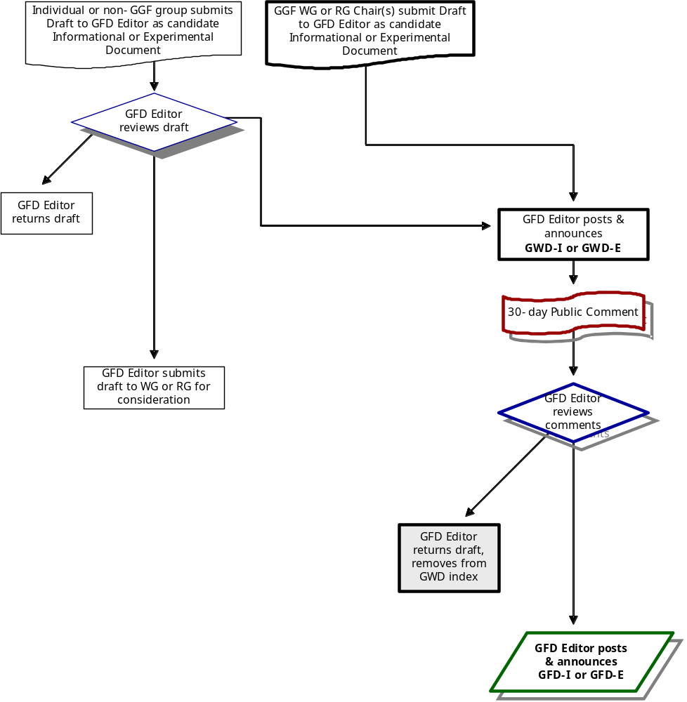

C-2. Community Practice Documents
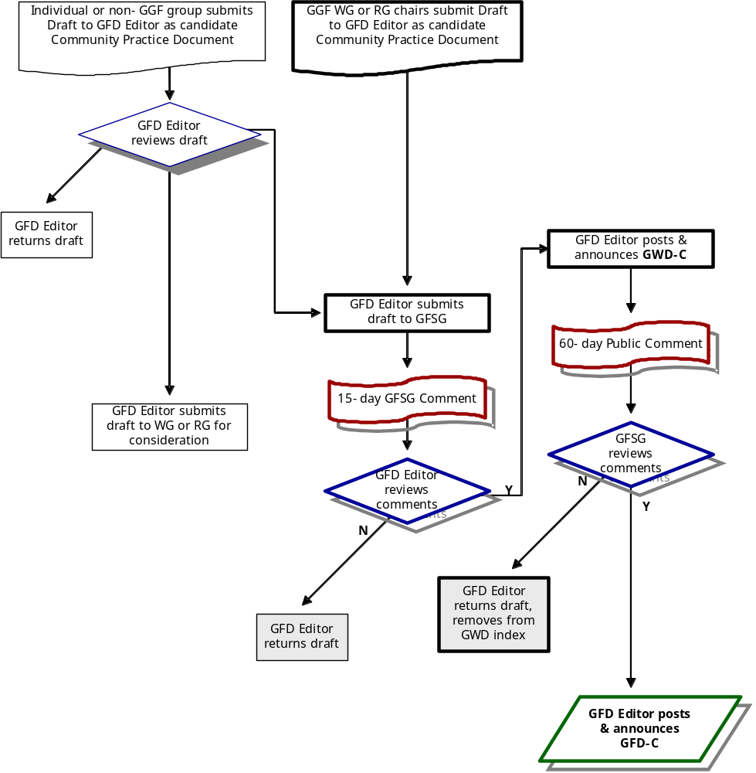

C-3. Recommendations Track Documents
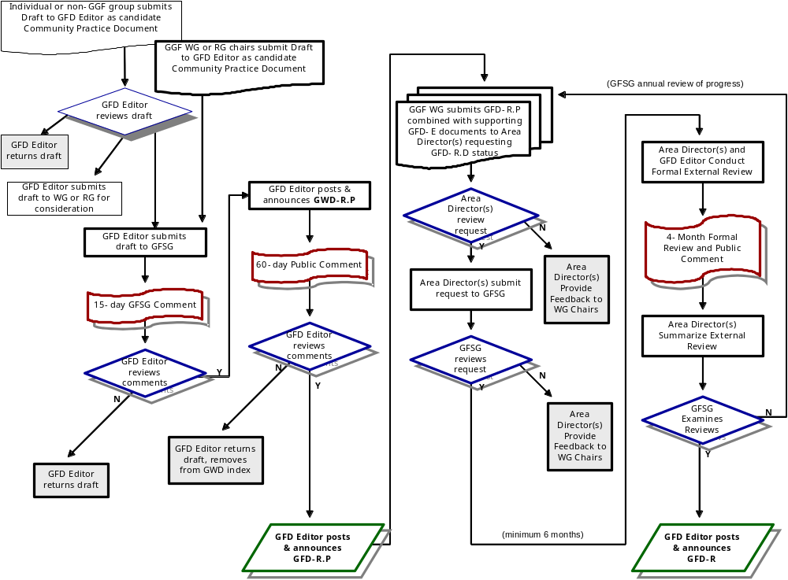

References

[1] Bradner, S., "The Internet Standards Process – Revision 3,” RFC 2026, October 1996.
[2] Bradner, S., "IETF Working Group Guidelines and Procedures," RFC 2418, September 1998.
[3] Weinrib, A., and Postel, J., “IRTF Research Group Guidelines and Procedures,” RFC 2014, October 1996.
[4] Postel, J., "Instructions to RFC Authors," RFC 1543, USC/Information Sciences Institute, October 1993.
[5] Catlett, C., Foster, I., and Johnston, W., “Global Grid Forum Structure,” October 2001.
[6] Catlett, C., Foster, I., and Johnston, W., “Global Grid Forum Management Structure and Processes,” October 2001.

