Experiences of Using Usage Record (UR) version 1.0

Status of This Document

This document provides information to the Grid community on experiences of using the Usage Record (UR) format recommendation version 1.0. It does not define any standards or technical recommendations. Distribution is unlimited.

Copyright Notice

Copyright © Open Grid Forum 2009. All Rights Reserved.

Abstract

For resources to be shared, sites must be able to exchange basic accounting and usage data in a
common format. This format must encompass both job level accounting and aggregate
accounting. The Usage Record (UR) Format describes a common format with which to exchange basic accounting and usage data over a grid instantiation.

This document describes experiences of using the Usage Record (UR) Format version 1.0 Recommendation across a number of infrastructures.

Contents

Abstract 1
1. Introduction 3
2. Process & Objectives 3
3. Survey Template 4
4. Identified Use Cases 4
4.1 APEL 4
4.2 DGAS 5
4.3 UNICORE Accounting System 8
4.4 SGAS 9
4.5 UAS 10
4.6 Gratia 11
4.7 ARCO 12
4.8 DEISA Accounting System 13
1. Security Considerations 14
2. Authors 14
3. Contributors 15
4. Intellectual Property Statement 15
5. Disclaimer 15
6. Full Copyright Notice 15
7. References 15

Introduction

For resources to be shared, sites must be able to exchange basic accounting and usage data in a
common format. This format must encompass both job level accounting and aggregate
accounting. The Usage Record (UR) Format describes a common format with which to exchange basic accounting and usage data over a grid instantiation.

This document describes experiences of using the Usage Record (UR) Format version 1.0 Recommendation across a number of infrastructures. The document is based on information returned from the experiences survey activity.

Process & Objectives

The process of gathering and consolidating the experiences is as follows:

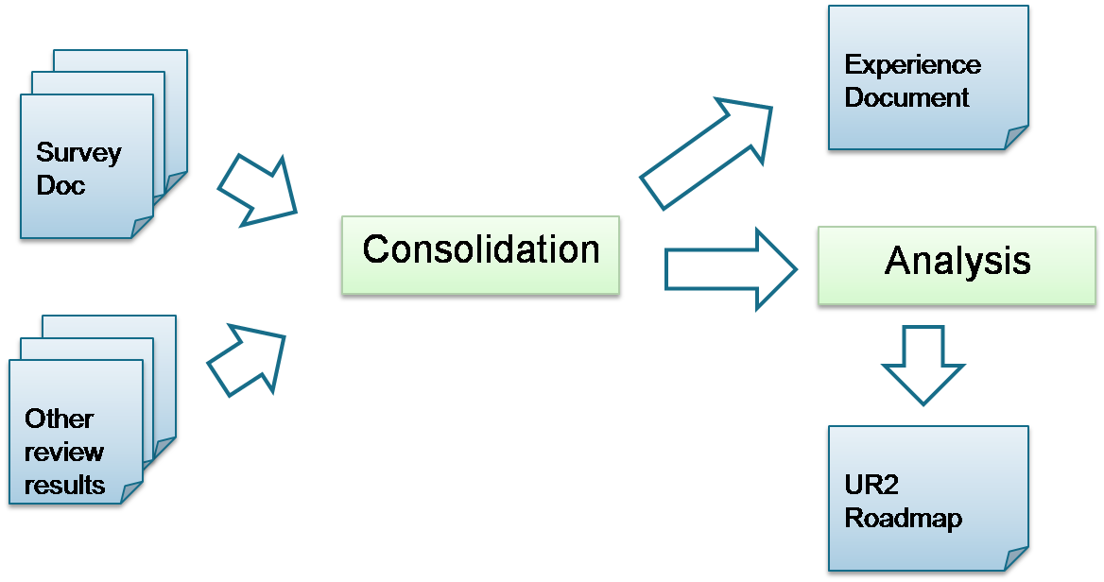

The artefacts and activities in the above process correspond to the following objectives:

- Survey doc/Other review results: from the results of the survey activity, and other sources, gather:
  - Use case collection – information concerning how UR1.0 is used.
  - Implementation status – the status of each of these infrastructures in their adoption of UR1.0
- Consolidation: from this gathered information, consolidate advanced requirements that have emerged into the Experiences Document.
- Experience Document [this document]:
  - Bring together the results from the consolidation activity
  - Provide guidance for how to progress towards UR2
  - Provide a reflective role for the RUS-WG activities.

Additionally, there is a parallel Analysis objective to produce an UR2 Roadmap from the consolidation activity and experiences. However, this is out of scope of this document [or is it?]

Survey Template
The survey template used to gather experiences with UR1.0 (available at http://forge.ogf.org/sf/go/artf6130?nav=1) was comprised of six parts:

- Project Description: overview of the project making use of UR1.0.
- Usage Metric Checklist: indication of which elements and attributes of the UR1.0 specification are produced and/or consumed.
- Extensions (if any): extensions to the specification that have been adopted to meet with additional requirements, and an indication of which extensions are considered important.
- Metering time: the times that usage records are generated e.g. at job start, job end, at points during the job, etc.
- High-level usage: details of what is done with usage records after generation.
- Recommendation to UR2 Roadmap: in which directions should the Usage Record evolve? e.g. summary records, aggregate records, improved execution/data/network accounting, etc.
- Feedback: opinions on any missing questions that should have been included in the survey.

Identified Use Cases

APEL

Overview

APEL (Accounting Processor for Event Logs), is the accounting system of WLCG, which uses URs for reporting usage statistics. Its key components are the Log Parser, which collates the information to create the records, R-GMA as the publishing protocol, and the Reporting Portal.

APEL Use Case

The use case for APEL is as follows:
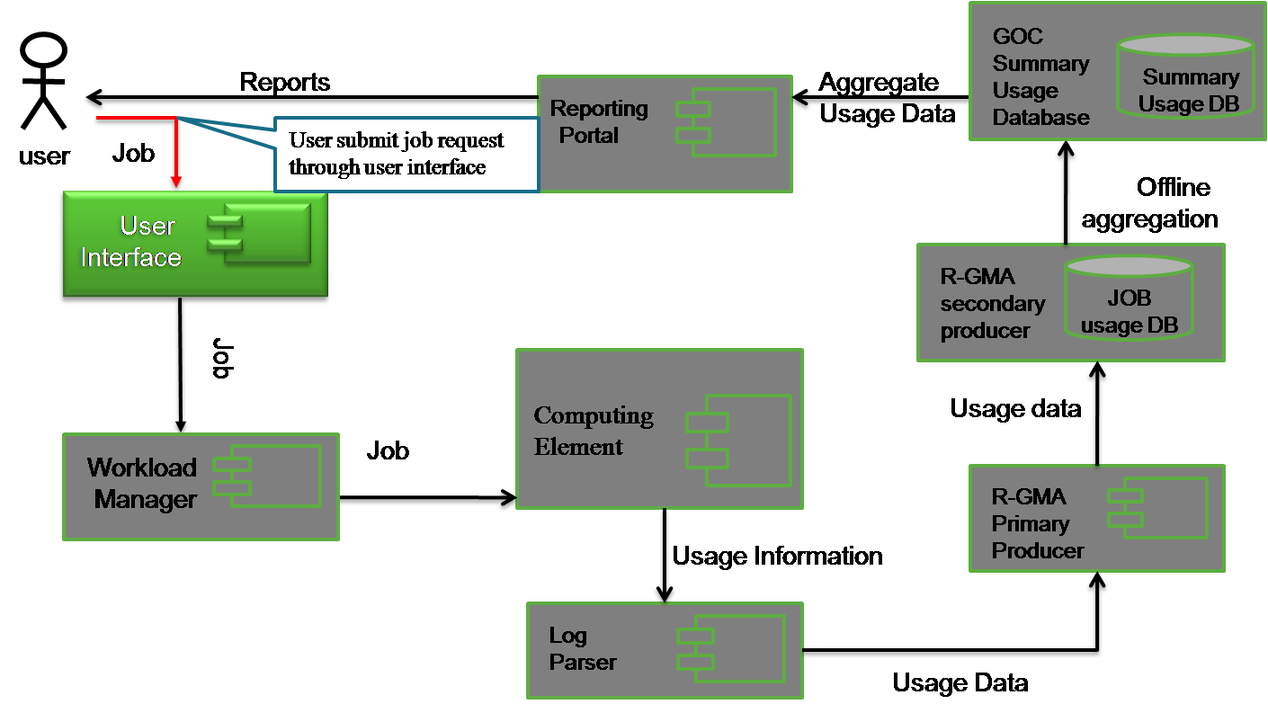

- User submits job request through the User Interface.
- The request is forwarded to the Workload Manager for scheduling.
- The job is scheduled to a particular Computing Element for execution.
- The APEL Log Parser is deployed at the Computing Element site to meter usage information periodically (e.g. once per day) by parsing LRMS log files and other relevant services.
- Pieces of usage information are gathered as a complete usage record and put into an R-GMA virtual database as a primary producer.
- Usage data are shipped into GOC/CCLRC’s persistent job usage database.
- An offline aggregation process usage records on per site, per VO, per month, per year basis into the GOC Summary Usage Database.
- User queries usage statistics through the Reporting Portal.

APEL Schema and UR

The Usage Schema adopted by APEL is as follows:

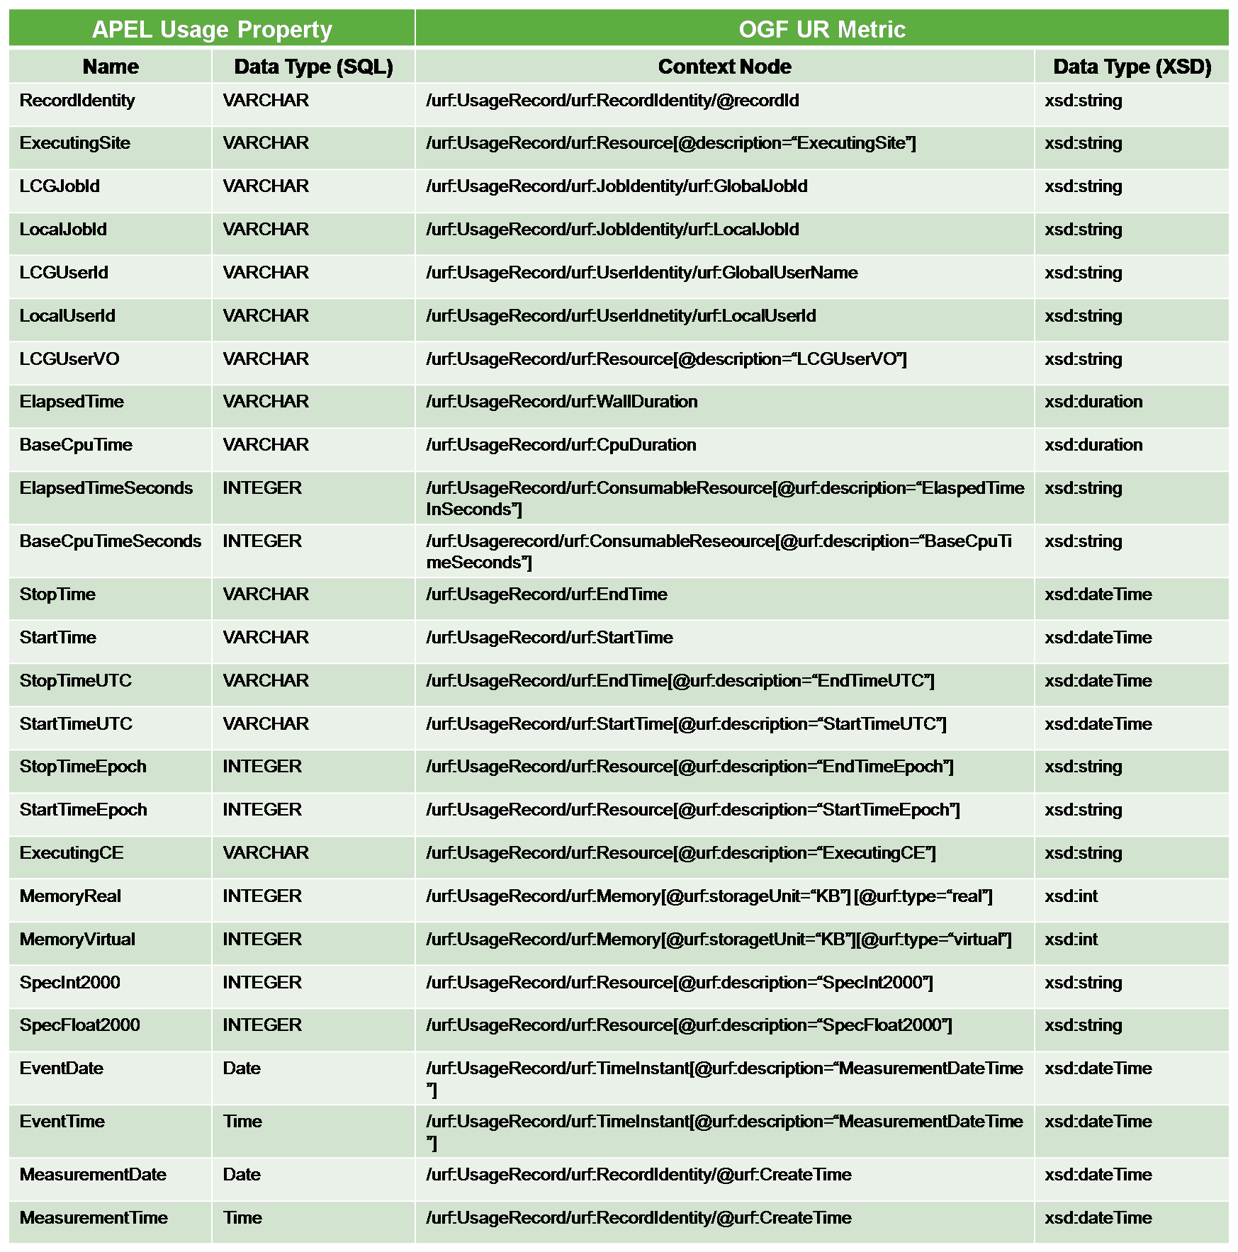

DGAS

Overview

The Distributed Grid Accounting System (DGAS), employed for example by INFN-Grid, D-Grid and Baltic Grid, was originally developed within the EDG and EGEE projects. Its key components are the Home Location Registers (HLRs), that can be hierarchically organized to store accounting information at different levels (e.g. for a site, a national grid, or a specific VO), the optional Price Authorities (PAs), that in a grid economic setting can be queried to obtain price quotations for resources, and the accounting sensors that collect raw accounting information from the Computing Elements (CEs) and are available for CEs based on different batch systems (PBS, LSF and a prototype version for Condor).

DGAS Use Case

DGAS has significantly evolved from its original structure and workflow [DGAS1]. The use case for the latest version DGAS is as follows:

- The grid user submits a job request to the grid's Resource Broker (RB), or metascheduler.
- The RB forwards the job to the appropriate CE.
- The accounting sensors, running as a daemon on the CE, collect the necessary information on resource usage shortly after job completion and sends the corresponding accounting record to the site's Primary (or First-level) HLR server (“Site HLR”), that manages the accounts of the CEs in its administrative domain.
- The Site HLR can forward accounting records to an optional layer of Second-level HLRs (“L2HLRs”) that in turn can forward them to higher-level HLRs (Note: HLRs beyond the primary level are denoted as L2HLRs although an arbitrary number of levels may be deployed). HLRs can also be configured to forward the accounting records of specific VOs to distinct L2HLRs such that VOs can collect the accounting information regarding their users on dedicated servers. This flexibility allows for the deployment of different hierarchical structures (e.g. allowing to have contemporaneously regional, national, grid-wide and/or VO-specific L2HLRs).
- Primary HLRs and L2HLRs may be queried by authorized users. Different authorization levels can be enforced for different HLR servers. For example: site administrators usually have access to all accounting information stored on their Site HLRs, grid users might be authorized to obtain information regarding their own jobs from L2HLRs but not from Site HLRs and VO administrators may access all information that has been forwarded to their VO-specific L2HLR, or to the VO-specific records on a national L2HLR server.
- An optional billing and charging system (not implemented by DGAS) can use accounting and pricing information provided by DGAS.

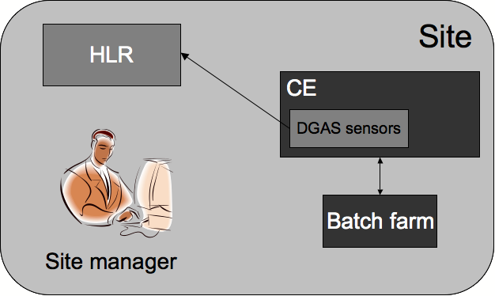
Figure 1: this figure depicts the basic architecture of the DGAS service. A set of sensors collecting records on the computing farm and a site-local server known as HLR which archives them on a RDBMS.

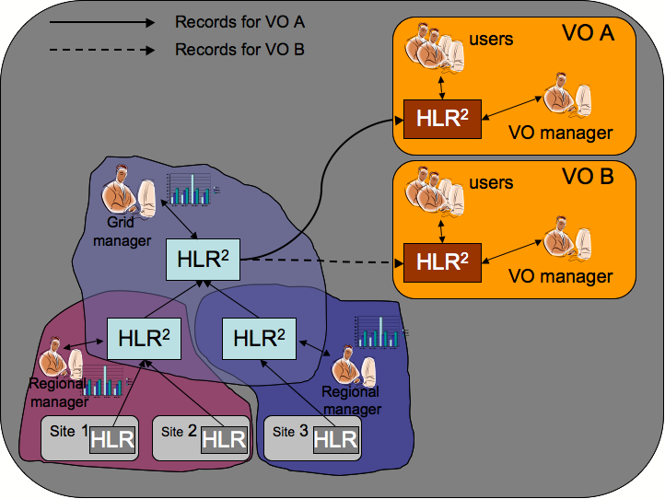
Figure 2: This workflow highlights DGAS’ capability to distribute copies of the records to all the involved entities. Sites archive their own copies of the URs. It is then possible to have sets of L2HLRs as desired. As an example, in this deployment scenario there are two L2HLR deployed on the regional grids, one generic-purpose L2HLR for the whole grid infrastructure and eventually two VO-Specific L2HLRs. It ha sto be highlighted that VO specific HLRs are optional part of the architecture, it is not required to VOs to deploy a 2LHLR.

DGAS Schema and UR

The usage information contained in a DGAS accounting record is as follows:

DGAS field | DGAS field type | UR field
dgJobId | varchar(160) | /urf:UsageRecord/urf:JobIdentity/urf:GlobalJobId
date | datetime | /urf:UsageRecord/urf:TimeInstant[@urf:description=”date”]
gridResource | varchar(160) | /urf:UsageRecord/urf:MachineName
gridUser | varchar(160) | /urf:UsageRecord/urf:UserIdentity/ds:KeyInfo
userFqan | varchar(255) | /urf:UsageRecord/urf:Resource[@urf:description=”UserFQAN”]
userVo | varchar(160) | /urf:UsageRecord/urf:Resource[@urf:description=”UserVO”]
remoteHlr | varchar(160) | /urf:UsageRecord/urf:Resource[@urf:description=”RemoteHLR”]
cpuTime | int(10) unsigned | /urf:UsageRecord/urf:CpuDuration
wallTime | int(10) unsigned | /urf:UsageRecord/urf:WallDuration
pmem | int(10) unsigned | /urf:UsageRecord/urf:Memory
vmem | int(10) unsigned | /urf:UsageRecord/urf:Swap
amount | smallint(5) unsigned | /urf:UsageRecord/urf:Charge
start | int(10) unsigned | /urf:UsageRecord/urf:StartTime
end | int(10) unsigned | /urf:UsageRecord/urf:EndTime
iBench | mediumint(8) unsigned | /urf:UsageRecord/urf:Resource[@urf:description=”IntBenchmark”]
iBenchType | varchar(16) | /urf:UsageRecord/urf:Resource[@urf:description=”IntBenchmarkType”]
fBench | mediumint(8) unsigned | /urf:UsageRecord/urf:Resource[@urf:description=”FloatBenchmark”]
fBenchType | varchar(16) | /urf:UsageRecord/urf:Resource[@urf:description=”FloatBenchmarkType”]
acl | varchar(160) | /urf:UsageRecord/urf:RecordIdentity/ds:KeyInfo
id | bigint(20) unsigned | /urf:UsageRecord/urf:RecordIdentity/@recordId
lrmsId | varchar(160) | /urf:UsageRecord/urf:JobIdentity/urf:LocalJobId
localUserId | varchar(32) | /urf:UsageRecord/urf:UserIdentity/urf:LocalUserId
localGroup | varchar(160) | /urf:UsageRecord/urf:Resource[@urf:description=”LocalUserGroup”]
endDate | datetime | /urf:UsageRecord/urf:EndTime
siteName | varchar(160) | /urf:UsageRecord/urf:Resource[@urf:description=”SiteName”]

Although DGAS has a custom interface and data representation format, recently a prototype for a Resource Usage Service (RUS) interface (for both server and clients, i.e. accounting sensors and user queries) has been developed for DGAS [DGAS2]. The Web Services-based RUS interface handles UR documents as defined by the OGF UR-WG that can then be translated into the DGAS custom data format. Note however that since the end of the funding project, DGAS-RUS work is on-hold.

UNICORE Accounting System

Overview

The UNICORE Accounting System is mainly for real-time job usage monitoring. It is deployed at a single specific site only, and in terms of Usage Record has no aggregation or summarization capability. The key components are the Usage Record Format (URF) Generator, which meters and composes usage records, The Resource Usage Service (RUS), and LLView, a usage monitoring application.

UNICORE Accounting System Use Case

The use case for the UNICORE Accounting System is as follows:

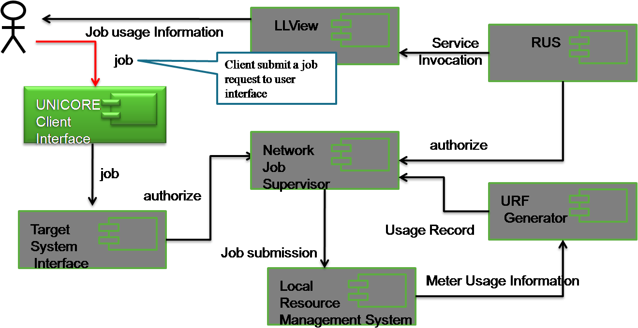

- The client submits a job request through the Client Interface.
- The job request is forwarded to the Target System Interface, which is one service of the UNICORE Atomic Services (UAS).
- The job description (JDL) is then passed to the Network Job Supervisor service to be parsed and interpreted. The NJS is also in charge of authorisation.
- If authorised, the NJS sends the parsed job request file to the Local Resource Management System for job submission.
- User can monitor submitted jobs through the LLView monitoring application.
- The LLView application invokes the RUS service, which is embedded within the UAS service, but at a higher level to other services.
- The RUS service then delegates the request to the Network Job Supervisor for authorisation.
- The Network Job Supervisor parses the RUS request into a usage record request and forwards it to the URF Generator.
- The URF Generator meters usage information of current executing jobs.

UNICORE Schema and UR

[Need more here!] UNICORE is URv1 compatible, extensions?

SGAS

Overview

SGAS (SweGrid Accounting System) is a Globus accounting component, widely deployed within Norway for economic accounting purposes. Its key components are the Job Account Reservation Manager for economic authorisation, the Bank Service, and the Logging and Usage Tracking Service which contains an RUS implementation for usage query.

SGAS Use Case

The use case for SGAS is as follows:

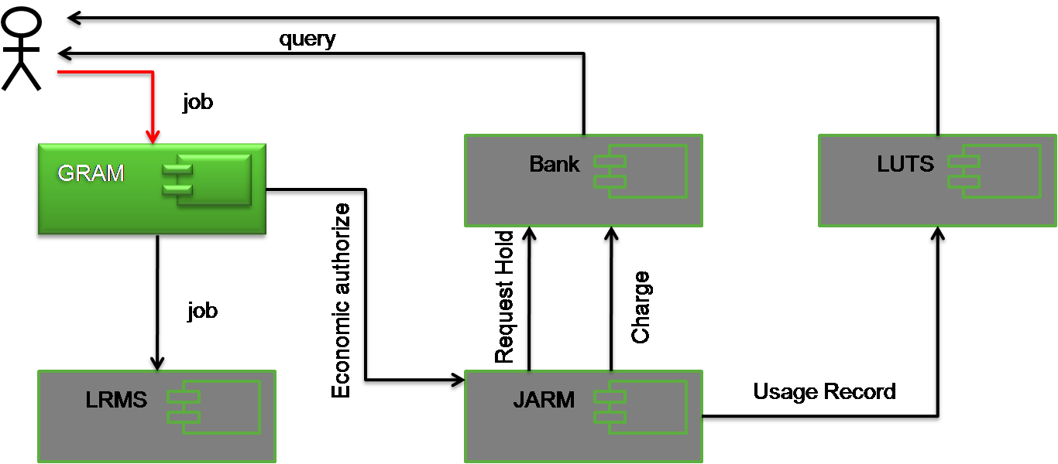

- The user submits a job request to the Globus Resource Allocation and Management (GRAM) service.
- Economic authorisation is then requested for the user from the Job Account Reservation Manager (JARM).
- The JARM requests authorisation from the Bank, which issues a time-limited reservation to run the job.
- If economic authorisation is given, GRAM submits the job to the Local Resource Management System (LRMS).
- Following execution, the JARM then sends the economic ‘charge’ to the Bank, and submits a completed usage record to the Logging and Usage Tracking Service (LUTS).
- The user is able to query both the Bank and LUTS for economic and usage records respectively.

SGAS Schema and UR

SGAS additionally supports the following extension to UR:

Extension | Description | OGF UR Mapping
VOName | Virtual Organization Name | /urf:UsageRecord/urf:Resource[@urf:description=“VOName”]

UAS

Overview

The UAS (User Accounting System) is used by the National Grid Service (NGS) in the UK, mainly for usage monitoring against allocated quotas on per-user basis. Its key components are the JDMDB module, which captures user/job mapping information by parsing Globus log files, Batch2UR which meters local resource usage, UR Generator, RUS and the User Accounting System (UAS) Portal.

UAS Use Case

The use case for UAS is as follows:

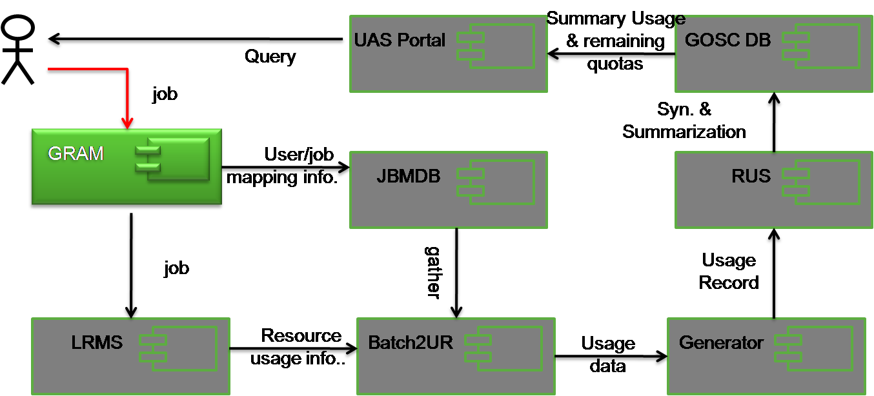

- The user submits a job request to the Globus Resource Allocation and Management (GRAM) service.
- GRAM informs the JBMDB about the user/job information.
- GRAM submits the job to the Local Resource Management System (LRMS).
- Batch2UR monitors the usage of the job on the LRMS, and together with user/job information retrieved from JBMDB, generates usage data.
- The UR Generator converts this usage data into usage records which are forwarded to the Resource Utilisation Service (RUS).
- The RUS stores usage records persistently in an Oracle relational database.
- Usage data are summarised into the Grid Operations Support Centre (GOSC) database through an Oracle synchronisation mechanism.
- Summary of use and remaining quotas can be retrieved by the UAS Portal on request.

UAS Schema and UR

The following extensions to the UR schema are supported:

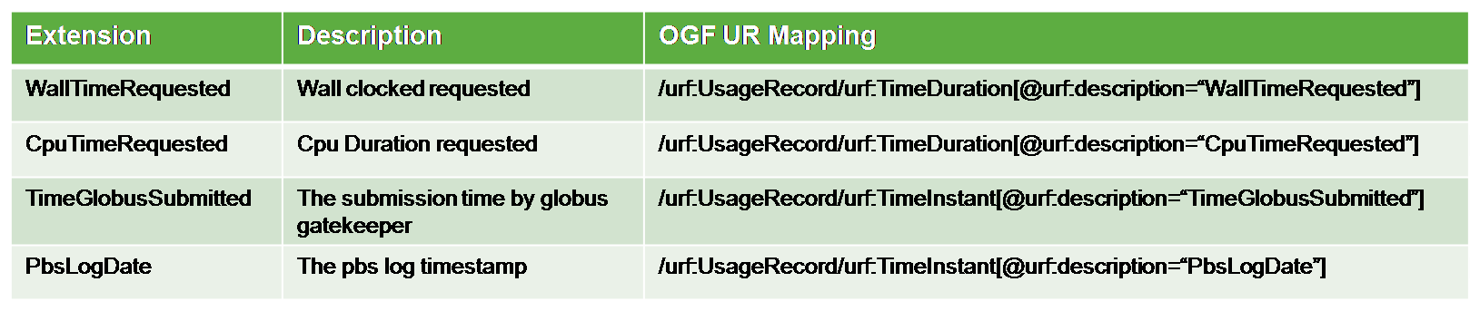

Gratia

Overview

Gratia is the accounting system used within the Open Science Grid (OSG), and is mainly used for usage reporting. Its key components are the Probe, which meters and generates usage record files, the Collector, which gathers usage records, and the Publisher, which is essentially a web portal.

Gratia Use Case

The use case for Gratia is as follows:

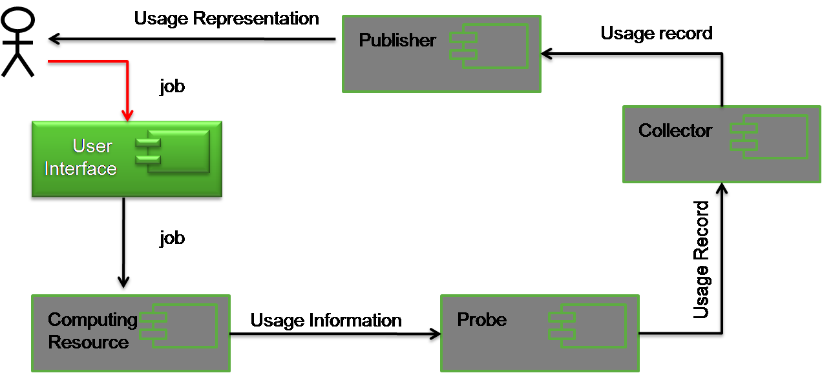

- The user submits a job through the User Interface.
- The job is submitted to the local Computing Resource.
- Usage information is gathered by Probe, converted into a usage record and sent to the Collector.
- The Collector gathers usage records and sends them on request to the Publisher web portal.
- The user can query usage via the Publisher web portal.

Gratia Schema and UR

The Gratia database model is as follows:

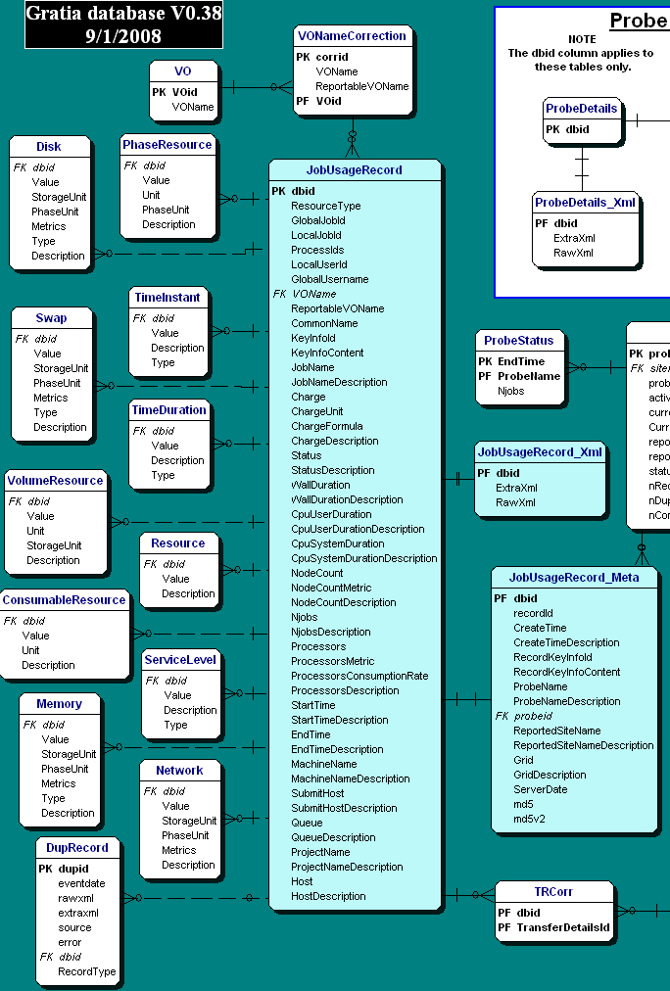

ARCO

Overview

ARCO (Accounting and Reporting Console) is specifically used within the Sun GridEngine, mainly for usage reporting. Its key components are the DBWriter, which meters resource usage and the Web-based Console tool, which is a graphical reporting portal.

ARCO Use Case

The ARCO use case is as follows:
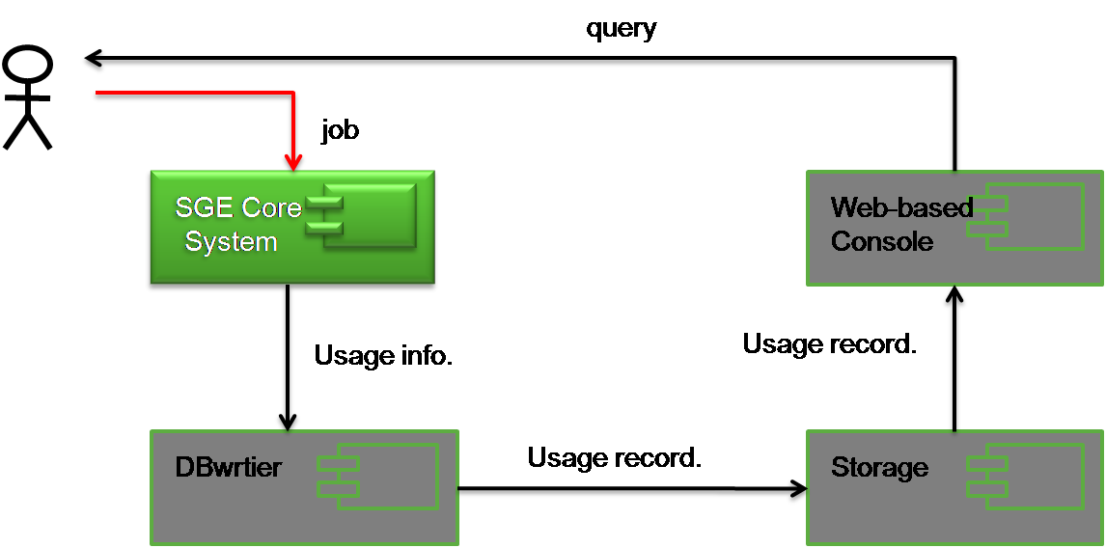

- The user submits a job to the Sun GridEngine (SGE) Core System.
- The Sun GridEngine (SGE) Core System executes the job on the local resource.
- The usage information is formatted into a usage record by the DBWriter and sent into Storage.
- Upon request from the user, the Web-based Console can retrieve usage records from Storage.

ARCO Schema and UR

The usage schema for UR adopted by ARCO is as follows:

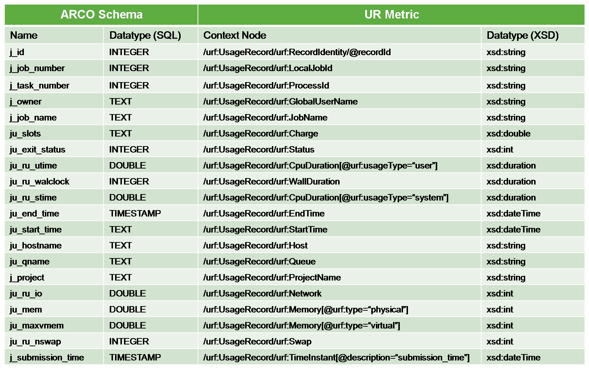

DEISA Accounting System

Overview

The DEISA [DEISA] infrastructure operates at a level higher than a single Grid infrastructure installation, being a consortium of a number of national supercomputing centres that each deploys a persistent, production quality, distributed supercomputing environment.

The DEISA accounting facilities comprise four key components: an accounting data provider, which pushes resource monitoring data into site-local native XML databases, an accounting information service that runs at every DEISA site and publishes this monitoring data, the User-Administration System (UAS), which is based on a distributed network of LDAP servers across all sites that synchronise their user account data between themselves periodically, and a DEISA Accounting Report Tool (DART) for inquiring these information services.

DEISA Accounting System Use Case

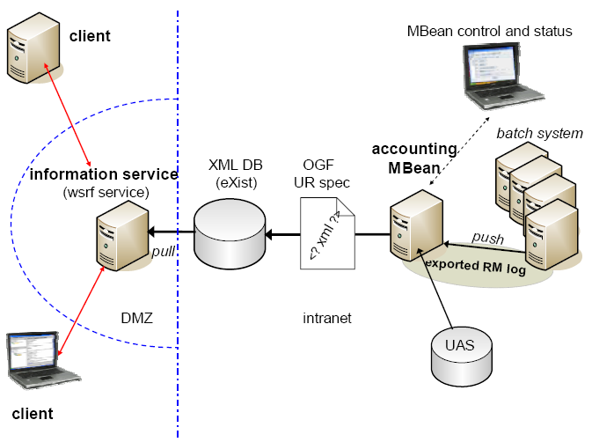

- A user submits a job to one of the DEISA sites, where a Grid infrastructure (e.g. UNICORE, Globus) submits that job to an underlying resource manager for execution.
- At an individual site, the DEISA accounting data provider reads the information from the proprietary log-files of the resource manager, adds missing property values from the UAS (e.g. project name, X.509 subject name), converts this into the UR format, and stores it locally within an eXist database. This is done at least once a day.
- Accounting information services that run at each DEISA site allow users, site accounting managers, project supervisors and the DEISA supervisor to retrieve their role-specific subset of UR information via the GUI client DART (DEISA Accounting Report Tool). This fetches the accounting data from the accounting information services on demand, and aggregates and filters the information according to the client’s role.

DEISA Accounting System Schema and UR

[info to be retrieved from http://www.ges2007.de/fileadmin/papers/jreetz/GES_paper105.pdf]

Security Considerations

Please refer to RFC 3552 [RESCORLA] for guidance on writing a security considerations section. This section is required in all documents, and should not just say “there are no security considerations.” Quoting from the RFC:

“Most people speak of security as if it were a single monolithic property of a protocol or system, however, upon reflection, one realizes that it is clearly not true. Rather, security is a series of related but somewhat independent properties. Not all of these properties are required for every application.

We can loosely divide security goals into those related to protecting communications (COMMUNICATION SECURITY, also known as COMSEC) and those relating to protecting systems (ADMINISTRATIVE SECURITY or SYSTEM SECURITY). Since communications are carried out by systems and access to systems is through communications channels, these goals obviously interlock, but they can also be independently provided.”

Authors

Steve Crouch, OMII-UK, University of Southampton, s.crouch@omii.ac.uk.
Donal Fellows, University of Manchester, donal.k.fellows@manchester.ac.uk.

Contributors

The authors gratefully acknowledge the contributions made to this experiences document by:

Intellectual Property Statement

The OGF takes no position regarding the validity or scope of any intellectual property or other rights that might be claimed to pertain to the implementation or use of the technology described in this document or the extent to which any license under such rights might or might not be available; neither does it represent that it has made any effort to identify any such rights. Copies of claims of rights made available for publication and any assurances of licenses to be made available, or the result of an attempt made to obtain a general license or permission for the use of such proprietary rights by implementers or users of this specification can be obtained from the OGF Secretariat.

The OGF invites any interested party to bring to its attention any copyrights, patents or patent applications, or other proprietary rights which may cover technology that may be required to practice this recommendation. Please address the information to the OGF Executive Director.

Disclaimer

This document and the information contained herein is provided on an “As Is” basis and the OGF disclaims all warranties, express or implied, including but not limited to any warranty that the use of the information herein will not infringe any rights or any implied warranties of merchantability or fitness for a particular purpose.

Full Copyright Notice

Copyright (C) Open Grid Forum 2009. All Rights Reserved.

This document and translations of it may be copied and furnished to others, and derivative works that comment on or otherwise explain it or assist in its implementation may be prepared, copied, published and distributed, in whole or in part, without restriction of any kind, provided that the above copyright notice and this paragraph are included on all such copies and derivative works. However, this document itself may not be modified in any way, such as by removing the copyright notice or references to the OGF or other organizations, except as needed for the purpose of developing Grid Recommendations in which case the procedures for copyrights defined in the OGF Document process must be followed, or as required to translate it into languages other than English.

The limited permissions granted above are perpetual and will not be revoked by the OGF or its successors or assignees.

References
Note that only permanent documents should be cited as references. Other items, such as Web pages or working groups, should be cited inline (i.e., see the Open Grid Forum, http://www.ogf.org). References should conform to a standard such as used by IEEE/ACM, MLA, Chicago or similar. Include an author, year, title, publisher, place of publication. For online materials, also add a URL. It is acceptable to separate out “normative references,” as IETF documents typically do. Some sample citations:

[DEISA] Johannes Reetz, Thomas Soddemann, Bart Heupers, Jules Wolfrat. “Accounting Facilities in the European Supercomputing Grid DEISA”. Proceedings of the German e-Science Conference 2007 (GES2007), Baden Baden, Germany, May 2-4, 2007
[DGAS1] Rosario M. Piro, Andrea Guarise, Albert Werbrouck. “An Economy-based Accounting Infrastructure for the DataGrid”. Proceedings of the 4th International Workshop on Grid Computing (GRID2003), Phoenix, Arizona (USA), November 17th, 2003.
[DGAS2] Rosario M. Piro, Michele Pace et al. “Tracing Resource Usage Over Heterogeneous Grid Platforms: A Prototype RUS Interface for DGAS”. Proceedings of the 3rd International Conference on e-Science and Grid Computing (eScience 2007), pp. 93-101, Bangalore, India, December 10-13, 2007.

