Web Services Agreement Negotiation Specification (WS-AgreementNegotiation)

Version 1.0

Authors (alphabetically):
Alain Andrieux, (Globus Alliance / USC/ISI)
Karl Czajkowski, (Globus Alliance / USC/ISI)
Asit Dan (IBM)
Kate Keahey, (Globus Alliance / ANL)
Heiko Ludwig (IBM)
Jim Pruyne (HP)
John Rofrano (IBM)
Steve Tuecke (Globus Alliance / ANL)
Ming Xu (Platform Computing)

Abstract
This document describes Web Services Agreement Negotiation Specification (WS-AgreementNegotiation),
a protocol for negotiation of agreements based on the WS-Agremeent specification.
Status
This document is a draft of the WS-Agreement Specification Negotiation from the Global Grid Forum (GGF). This is a public document being developed by the participants of the GRAAP Working Group (Grid Resource Allocation and Agreement Protocol WG) of the Scheduling and Resource Management (SRM) Area of the GGF.


GLOBAL GRID FORUM
office@ggf.org
www.ggf.org

Full Copyright Notice
Copyright © Global Grid Forum (2003, 2004). All Rights Reserved.
This document and translations of it may be copied and furnished to others, and derivative works that comment on or otherwise explain it or assist in its implementation may be prepared, copied, published and distributed, in whole or in part, without restriction of any kind, provided that the above copyright notice and this paragraph are included on all such copies and derivative works. However, this document itself may not be modified in any way, such as by removing the copyright notice or references to the GGF or other organizations, except as needed for the purpose of developing Grid Recommendations in which case the procedures for copyrights defined in the GGF Document process must be followed, or as required to translate it into languages other than English.
The limited permissions granted above are perpetual and will not be revoked by the GGF or its successors or assigns.
This document and the information contained herein is provided on an "AS IS" basis and THE GLOBAL GRID FORUM DISCLAIMS ALL WARRANTIES, EXPRESS OR IMPLIED, INCLUDING BUT NOT LIMITED TO ANY WARRANTY THAT THE USE OF THE INFORMATION HEREIN WILL NOT INFRINGE ANY RIGHTS OR ANY IMPLIED WARRANTIES OF MERCHANTABILITY OR FITNESS FOR A PARTICULAR PURPOSE.

Intellectual Property Statement
The GGF takes no position regarding the validity or scope of any intellectual property or other rights that might be claimed to pertain to the implementation or use of the technology described in this document or the extent to which any license under such rights might or might not be available; neither does it represent that it has made any effort to identify any such rights. Copies of claims of rights made available for publication and any assurances of licenses to be made available, or the result of an attempt made to obtain a general license or permission for the use of such proprietary rights by implementers or users of this specification can be obtained from the GGF Secretariat.
The GGF invites any interested party to bring to its attention any copyrights, patents or patent applications, or other proprietary rights which may cover technology that may be required to practice this recommendation. Please address the information to the GGF Executive Director (see contact information at GGF website).

Table of Contents

Web Services Agreement Negotiation Specification (WS-AgreementNegotiation) 1
Full Copyright Notice 2
Table of Contents 3
1 Introduction 3
1.1 Goals and Requirements 4
1.1.1 Requirements 4
1.1.2 Non-Goals 5
1.2 Notational Conventions 5
1.3 Namespace 5
2 Example Scenarios 6
2.1 Service Parameterization 6
3 Agreement Offer and Negotiability Constraints 7
4 Layered Service Model 8
5 Offer Types and Negotiation State 9
6 Port Types and Operations 10
6.1.1 Port Type wsan:NegotiationFactory 11
6.1.2 Port Type wsan:Negotiation 14
7 Common Use Cases 16
7.1 Agreement Negotiation 16
7.2 Agreement Renegotiation 16
8 Acknowledgements 17
9 References 17
Appendix 1 - Document Schema 18
Appendix 2 - WSDL 18
Appendix 3 - Example 18

- Introduction
- TODO make intro.
- […]

The creation of an agreement can be initiated by the consumer side or by the provider side. While simple scenarios for agreement creation may involve little or no negotiation, creation of an agreement through negotiation can involve numerous scenarios depending on the consumer or provider side acting as initiator, maintainer of negotiation state and finally maintainer of agreement state. This specification defines a core set of messages and resources modeling these states for supporting many usage scenarios.
[…]
An example scenario for agreement negotiation is described in section 4.
Section 5 specifies the structure of agreement negotiation offers and introduces negotiability constraints. Section 6 describes the layered service model. Section explains the state machine that governs commitment types in offers and commitment state in a negotiation. Section 7 introduces the port types and operations in the specification. Section 8 specifies the two use cases of agreement negotiation, namely, agreement negotiation in initial agreement creation and renegotiation of agreements, respectively.
  - Goals and Requirements
The goals of WS-AgreementNegotiation are to standardize the terminology, concepts and protocols for negotiation and renegotiation of agreements, including WSDL needed to express the message exchanges.

    - Requirements
In meeting these goals, the specification must address the following specific requirements:
- Must sit on top of the WS-Agreement stack based on the WS-Agreement specification: The WS-AgreementNegotiation protocol must sit as an optional negotiation layer on top of the WS-Agreement protocol stack.
- Must provide a simple negotiation state machine
- It must be possible to create agreements for services defined by any domain specific service description terms, such as job specification, data service specification, network topology specification and web service description language (WSDL). Service objective description will reference the elements defined in service description.Must use the WS-Agreement meta-language in order to express negotiation offers: Terms of negotiation offers must be expressed using the meta-language already defined in WS-Agreement (or domain-specific derivations thereof). Negotiability constraints must be expressed within the extensible framework for expressing constraints as it is defined in WS-Agreement.
- Must allow negotiation of existing agreements, and enable creation of negotiated agreements: It must be possible to start a negotiation based on an existing agreement. Alternatively, it must be possible to create a new agreement and start its negotiation in one shot.
- Must enable symmetry of protocol: A large number of negotiation scenarios are possible depending on whether a provider or consumer initiates agreement creation and/or negotiation, and also where the agreement and negotiation states are maintained. The basic messages defined in this document can be applied for modeling various usage specific scenarios.

- Relationship to other WS-* specifications: WS-AgreementNegotiation must be composable with other Web services specifications, in particular WS-Security, WS-Policy, WS-Federation, WS-Addressing, WS-Coordination, WS-ResourceProperties, WS-ResourceLifetime, Web Services for Remote Portals, and WS-ReliableMessaging and the WS-Resource framework [WS-Resource].
    - Non-Goals
The following topics are outside the scope of this specification:

- Define a negotiation protocol involving several parties simultaneously (although it must be possible to negotiate an agreement linked to a service provisioning that involves several parties)
- Any requirements for the agreement or service layer.

  - Notational Conventions
The keywords “MUST”, “MUST NOT”, “REQUIRED”, “SHALL”, “SHALL NOT”, “SHOULD”, “SHOULD NOT”, “RECOMMENDED”, “MAY”, and “OPTIONAL” in this document are to be interpreted as described in RFC 2119 [RFC 2119].

When describing abstract data models, this specification uses the notational convention used by the [XML Infoset]. Specifically, abstract property names always appear in square brackets (e.g., [some property]). When describing concrete XML schemas, this specification uses the notational convention of [WS-Security]. Specifically, each member of an element’s [children] or [attributes] property is described using an XPath-like notation (e.g., /x:MyHeader/x:SomeProperty/@value1). The use of {any} indicates the presence of
an element wildcard (<xsd:any/>). The use of @{any} indicates the presence of an
attribute wildcard (<xsd:anyAttribute/>).
  - Namespace
This is an XML or other code example:

http://www.ggf.org/namespaces/ws-agreementNegotiation (Code)

The following namespaces are used in this document:

Prefix | Namespace
wsag | http://www.ggf.org/namespaces/ws-agreement (temporary)
wsan | http://www.ggf.org/namespaces/ws-agreementNegotiation (temporary)
wsbf | http://www.ibm.com/xmlns/stdwip/web-services/WS-BaseFaults
wssg | http://www.ibm.com/xmlns/stdwip/web-services/WS-ServiceGroup
wsrp | http://www.ibm.com/xmlns/stdwip/web-services/WS-ResourceProperties
wsa | http://schemas.xmlsoap.org/ws/2003/03/addressing
xsi | http://www.w3.org/2001/XMLSchema-instance
wsdl | http://schemas.xmlsoap.org/wsdl/
xs/xsd | http://www.w3.org/2001/XMLSchema

- Example Scenarios
WS-Agreement covers a wide scope of application scenarios relating to the establishment of an agreement between a service provider and a service consumer. This is achieved by using a single format of document and a protocol comprising few states. The example below illustrates the use of WS-AgreementNegotiation for negotiating agreements.

  - Service Parameterization
In this scenario, the service contracted is an authentication and access control service. The service exposes an interface to register a new user, set an access control policy, manage a user’s passwords, authenticate a user and check a requested user action against the corresponding access control policy. In an access control environment, quality of service aspects such as response to for access verification and service availability is critical. Depending on particular needs, service consumers require different service quality levels and are prepared to pay differently for their quality of service requirements.
The service is very convenient for event organizers or other temporary projects. For example, sports events such as
an athletics meeting or a soccer tournament require access control services for a limited amount of time to a large and diverse group of constituents such as athletes, journalists, jurors, and spectators who access the event’s Web site or applications.
A service provider offers an agreement template describing the service and its guarantees, including the options available to the customer. The service description includes the WSDL of the service interface. Customer can choose among a service using Kerberos-based authentication or a proprietary authentication system. Furthermore, customers can choose how many users ID should be managed. Customers can add availability and response time guarantees to individual operations of the interface, e.g., to distinguish quality requirements for management and access control operations. For operation availability, customers choose between 95%, 98%, 99%, and 99.9%, defined as receiving an reply in 15 seconds. For average response time guarantees, customers choose between 0.5, 1 or 2 seconds, and set the number of operations per minute for which the response time goal must hold. Also, customers can set the time when the service will be available.
This template offers many options to service consumers. Service consumers send a completed offer to the service provider. Based on capacity limitations, the provider may accept the offer as is, reject the offer altogether or make a counter-offer. For example, if a service consumer asks for 1 sec response time for up to 1000 requests per minute, the provider might only have capacity for up to 500 requests and counter-proposes an agreement for 500 requests, maybe for a lower price, suggesting that the service consumer can buy the rest of the capacity from a different provider.
Once the agreement is accepted by both parties, the provider provisions the service and exposes status information on guarantee compliance to the user. The service consumer may shop for the remaining capacity needs at different providers.
In the course of the event, it may turn out that more or less capacity is needed. Hence, the service consumer wants to be able to renegotiate the agreement.

- Agreement Offer and Negotiability Constraints
An agreement negotiation offer MAY contain negotiability constraints.

In a negotiation offer, the negotiability constraint section specifies constraints that MUST hold true in any counter-offer. The specification of negotiability constraints in an offer does not state a promise that a replying offer fulfilling the constraints will be accepted. It is a voluntary disclosure of a preference to reduce the number of offers to be exchanged to agree or terminate a negotiation.

In the special case of creating an agreement and a corresponding negotiation endpoint at the same time (see the wsan:createNegotiatedAgreement operation in the port type section of this document), the initial negotiation offer is also the agreement creation offer. Therefore, the creation constraint section of a template, becomes negotiability constraints in the sense that the input negotiation offer MUST satisfy them.
  - TODO: adapt corresponding content description section in WS-Agreement to negotiation offer

- Layered Service Model

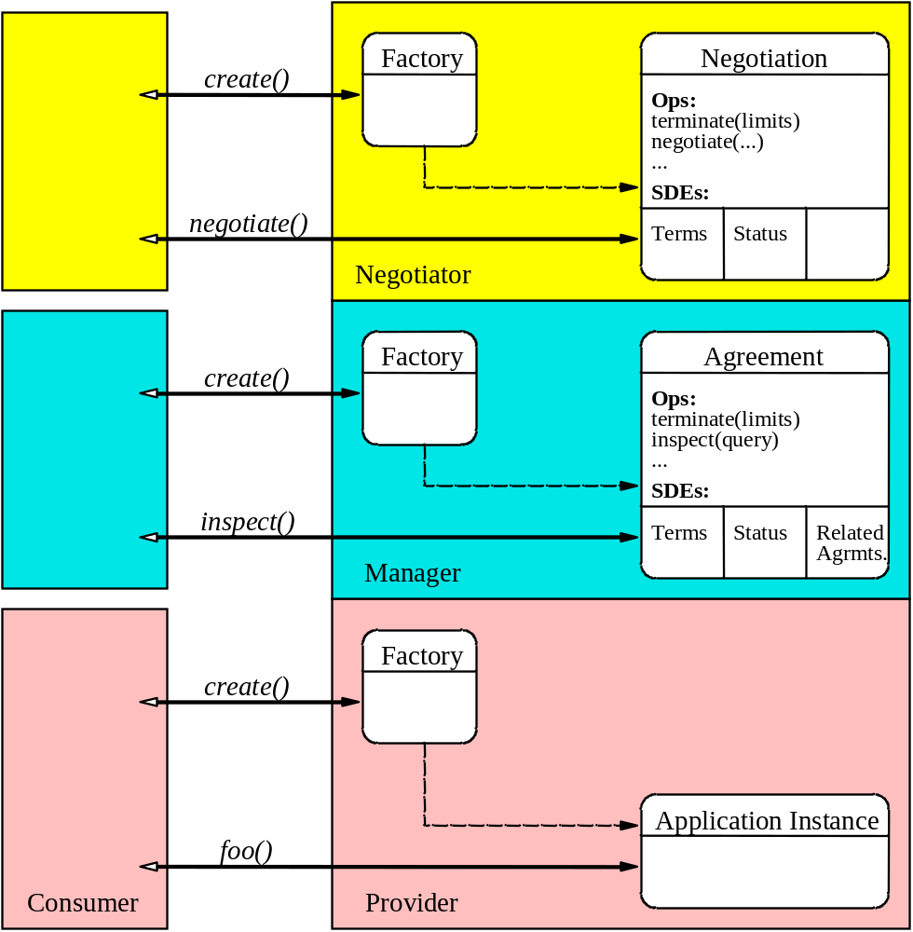
Figure 1: WS-AgreementNegotiation Conceptual Layered Service Model.

The WS-AgreementNegotiation specification provides an additional layer to the WS-Agreement conceptual model.

The negotiation layer provides a Web service-based interface for negotiating an agreement so that it eventually satisfies both negotiating parties and become observed, and for renegotiating existing agreements after they have been observed.
In this conceptual layering the agreement layer hides the service layer from the negotiation layer. It also decouples the negotiation model from the agreement and service provisioning layers, thus making it possible to swap different negotiation models independently of the agreement model and the service virtualization. In this way it is possible to use a different negotiation protocol than WS-AgreementNegotiation when appropriate.
WS-AgreementNegotiation specifies the following port types:
  - A negotiation port type exposes a negotiate operation that the initiator can call in order to negotiate the related agreement. Eventually negotiation leads to the agreement being observed (i.e. both parties commit to it). The operation can then be called again in order to renegotiate the agreement (if the implementation service permits it of course).
  - A negotiation factory exposes a negotiation service creation operation which takes an agreement EPR as a parameter. The operation creates a negotiation service related to that specific agreement. The only way for the initiator to modify the agreement is through the negotiation protocol exposed by the negotiation port type.

Offer Types and Negotiation State
There are six types of offer than can be provided to, or returned from negotiation operations in the WS-Agreement model. For simplicity, each offer type corresponds directly to a state in the negotiation state machine, as depicted in Figure 6.
Note: we define the responder as the party that is invoked by the initiator.

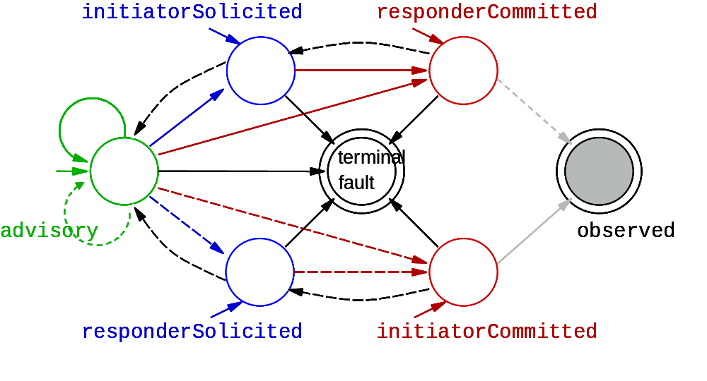Figure 2: Negotiation Protocol State Machine. The advisory start state is changed to solicited or committed by one of the parties sending an appropriate negotiation offer. The terminal observed state is reached by acceptance from one of the committed states. The terminal fault state is reached by explicit termination or by terminal faults. A synchronous continuing fault invalidates a state change implied by the faulted offer.

The offer is a suggestion to enter the state named in the offer. The offer type is encoded using the /@commitment attribute:
<offer commitment="offer type">
...
</offer>

The six message types are represented as follows:
- Advisory offers bear the wsan:advisory value and indicate no obligations or restrictions on further negotiation.
- Soliciting offers indicate no obligations but require that a counter-offer be committed. There are role-specific solicitation offer types:
  - Initiator-solicited offers are sent by the initiator and bear the wsan:initiatorSolicited value.
  - Responder-solicited offers are sent by the responder and bear the wsan:responderSolicited value.
- Committing offers indicates that the sender is obligated to the offer terms if the recipient decides to observe. There are role-specific commitment offer types:
  - Initiator-committed offers are sent by the initiator and bear the wsan:initiatorCommited value.
  - Responder-committed offers are sent by the responder and bear the wsan:responderCommited value.
- Accepting offers bears the wsan:observed value and indicates that the sender accepts the offer that has been committed by the recipient.
- Termination uses the underlying WS-RF termination mechanisms and indicates a destruction of all shared Negotiation, Agreement, or Renegotiation state. Third-party resolution, outside the scope of WS-Agreement, may still be used to resolve obligations from terminated Agreements.
- Rejection uses the underlying WS-RF fault mechanisms to signal rejection of an offer, without losing the shared state that existed prior to the rejected offer.
The protocol state machine and operation message requirements restrict the conditions and means by which these offers may be delivered. The protocol states are named according to offer type. Practically speaking, the state of the sender changes when he decides to send an offer of that type, and the state of the receiver changes when he processes a received offer of that type.
Issue 3: Faults are unavoidable in widely distributed systems; we do not wish WS-Agreement to be fragile in the face of such faults, so we include the rejection mechanism. Does there need to be a way to reject offers through an input message, in addition to the fault-response as an output message?

- Port Types and Operations
In this section we detail the wsan:NegotiationFactory and wsan:Negotiation port types.
Per the reuse principles of the WS-Resource Framework on which the Web service expression of this specification is based, interface reuse can be achieved by copying and pasting operation and resource definitions specified here. Designers can reuse the operations defined in the wsag:AgreementFactory and wsan:NegotiationFactory and compose them in their own specialized factories.

Every port type exposes a GetResourceProperty operation as defined in [WS-ResourceProperties]. This enables the port types to expose read-only resource properties. The GetMultipleResourceProperties operation enables retrieval of several resource properties in one request/response message exchange. The definition of these operations is identical to the one in [WS-ResourceProperties] and has not been repeated here.

Full WSDL definition of the port types can be found in Appendix.

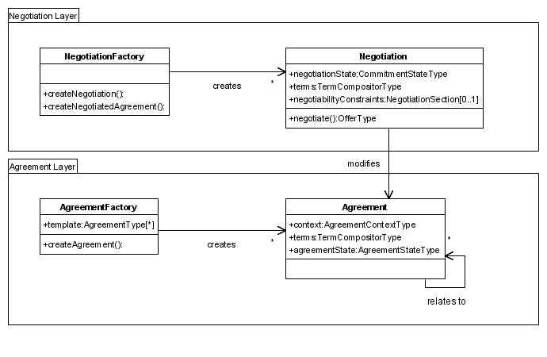
Figure 3: Port types in WS-Agreement and WS-AgreementNegotiation. In this diagram the ‘+’ sign indicates resource properties that are read-only accessible. Return types of the factory operations have not been mentioned in this diagram, for lack of space.
    - Port Type wsan:NegotiationFactory
      - Operation wsan:createNegotiation
The wsan:createNegotiation operation is used to generate a wsan:Negotiation related to a wsag:Agreement passed as input.

Input
Issue : Should we rename “input” messages as “request” messages to follow WSRF habits? I think I prefer input/output as it follows the WSDL naming. What we are using now is a mix: “input”/”response”.
The form of the wsan:createNegotiation input message is:

<wsan:createNegotiationInput>
<initiatorNegotiationEPR>
EPR1
</initiatorNegotiationEPR> ?
<existingAgreementEPR>
EPR2
</existingAgreementEPR>

</wsan:createNegotiationInput>

The contents of the input message are further described as follows:
/wsan:createNegotiationInput/initiatorNegotiationEPR
This optional element provides a contact point EPR1 where the invoked party can send messages pertaining to this stateful negotiation (this is applicable only in the case of a symmetric deployment of the wsan:Negotiation port type).
/wsan:createNegotiationInput/existingAgreementEPR
This is the contact point EPR2 of the existing wsag:Agreement to which the wsan:Negotiation to create MUST be related. This element MUST appear.

Result
The successful result of wsan:createNegotiation is the EPR of a newly created wsan:Negotiation.
The form of the response is:
<wsan:createNegotiationResponse>
<createdNegotiationEPR>
EPR3
</createdNegotiationEPR>

</wsan:createNegotiationResponse>
The contents of the response message are further described as follows:
/wsan:createNegotiationResponse/createdNegotiationEPR
This is an endpoint reference EPR3 to a wsan:Negotiation service where the initiator can send messages pertaining to this stateful negotiation. The wag:Negotiation MUST be related to the input wsag:Agreement at EPR2.

Faults
A fault response indicates that no wsan:Negotiation was created and may also indicate domain-specific reasons.
      - Operation wsan:createNegotiatedAgreement
The wsan:createNegotiatedAgreement operation is used to generate a wsag:Agreement and a wsan:Negotiation to negotiate it.

Input
Issue : Should we rename “input” messages as “request” messages to follow WSRF habits? I think I prefer input/output as it follows the WSDL naming. What we are using now is a mix: “input”/”response”.
The form of the wsan:createNegotiatedAgreement input message is:

<wsan:createNegotiatedAgreementInput>
<initiatorNegotiationEPR>
EPR1
</initiatorNegotiationEPR> ?
<initiatorAgreementEPR>
EPR2
</initiatorAgreementEPR> ?
<offer commitment="wsan:CommitmentType">
wsan:NegotiatedAgreementOfferType
</offer> ?
</wsan:createNegotiatedAgreementInput>

The contents of the input message are further described as follows:
/wsan:createNegotiatedAgreementInput/initiatorNegotiationEPR
This optional element provides a contact point EPR1 where the invoked party can send messages pertaining to this stateful negotiation. This is applicable only in the case of a symmetric deployment of the wsan:Negotiation port type.
/wsan:createNegotiatedAgreementInput/agreementEPR
This is the optional contact point EPR2 of an existing wsag:Agreement to which the wsan:Negotiation referenced by EPR1 MUST be related. This is applicable only in the case of a symmetric deployment of the wsag:Agreement port type.
/wsan:createNegotiatedAgreementInput/offer
This is the initial offer to start the negotiation with. If the offer is accepted a new wsag:Agreement EPR will be returned as well as the EPR of the new wsan:Negotiation. This offer must satisfy the agreement creation constraints expressed in one or more of the agreement templates advertised by the AgreementFactory (alternatively, a specialized NegotiationFactory could decide to advertise negotiation templates).
/wsan:createNegotiatedAgreementInput/offer/@commitment
This is the offer type of the agreement offer.

Result
The successful result of wsan:createNegotiatedAgreement is the EPRs of each of a newly created and related wsan:Negotiation and wsag:Agreement.
The form of the response is:
<wsan:createNegotiatedAgreementResponse>
<createdNegotiationEPR>
EPR3
</createdNegotiationEPR>
<createdAgreementEPR>
EPR4
</createdAgreementEPR>
<counterOffer commitment="wsan:CommitmentType">
wsan:NegotiationOfferType
</counterOffer> ?
</wsan:createNegotiatedAgreementResponse>

The contents of the response message are further described as follows:
/wsan:createNegotiatedAgreementResponse/createdNegotiationEPR
This is an endpoint reference EPR3 to a wsan:Negotiation service where the initiator can send messages pertaining to this stateful negotiation.
/wsan:createNegotiatedAgreementResponse/createdAgreementEPR
This is an endpoint reference EPR4 to a newly created wsag:Agreement service which terms can be negotiated by sending messages to EPR3.
/wsan:createNegotiatedAgreementResponse/counterOffer
This is the counter-offer. This element MAY appear, in which case the agreement MAY include extra negotiability constraints that the next offer sent by the initiator MUST comply with.
/wsan:createNegotiatedAgreementResponse/counterOffer/@commitment
This attribute specifies the offer type of the response offer. This attribute MUST appear in the counter-offer. The value is governed by the negotiation protocol state machine.

Faults
A fault response indicates that no wsan:Negotiation nor wsag:Agreement was created and may also indicate domain-specific reasons.
      - Resource Property wsan:entry
The wsan:NegotiationFactory port type can create new resource-qualified endpoint references to services (with associated resources) of port types wsan:Negotiation (beginning of a new negotiation in order to eventually reach an agreement). It may be desirable to expose in the interface the created services, for instance for monitoring clients to use. The wsan:NegotiationFactory port type is therefore modeled as a service group with respect to the [WS-ServiceGroup] specification, and records information about each service-resource pair it creates in a new wsan:entry resource property instance. The entry typically includes the EPR of the new qualified service and MAY contain optional information (see the WS-ServiceGroup specification for more information) that this specification does not define.
      - Resource Property wsan:membershipContentRules
This resource property is defined so as to assert the specific content of the wsan:entry resource property and is mandated by [WS-ServiceGroup].
The wsan:membershipContentRules resource property contains a set of wssg:MembershipContentRule elements that specify the intentional constraints on each member service of the service group (see resource property wsan:entry). Each wsgg:membershipContentRule specifies at least a port type that every member service in the service group must implement.
In the context of the wsan:NegotiationFactory, there must be one wsgg:membershipContentRule specifying wsan:Negotiation as the member port type.
The form of the wsan:membershipContentRules resource property is:
<wsan:membershipContentRules>
<wsgg:MembershipContentRule
MemberInterface="port type"
ContentElements="qnames"/> *
<wsgg:MembershipContentRule
MemberInterface="wsag:Agreement
ContentElements="qnames"/> +
<wsgg:MembershipContentRule
MemberInterface="port type"
ContentElements="qnames"/> *
</wsan:membershipContentRules>

See the [WS-ServiceGroup] specification for more information on the wsgg:MembershipContentRuleType.

    - Port Type wsan:Negotiation
      - Operation wsan:negotiate
The wsan:negotiate operation is used to send offers for purpose of negotiating the agreement represented by the wsag:Agreement that the wsan:Negotiation is related to.

Input
The form of the wsan:negotiate input message is:
<wsan:negotiateInput>
<offer commitment="wsan:CommitmentType">
wsan:NegotiationOfferType
</offer>
</wsan:negotiateInput>
The contents of the input message are further described as follows:

/wsan:negotiateInput/offer
The input agreement submitted as an offer for negotiation.
/wsan:negotiateInput/offer/@commitment
This is the offer type, which MUST be one of wsan:advisory, wsan:initiatorSolicited, wsan:responderSolicited, wsan:initiatorCommitted, wsan:responderCommited, or wsan:observed as governed by the protocol state machine depicted in Figure 6.

Result
The successful result of wsan:negotiate is any counter-offer:
<wsan:negotiateResponse>
<counterOffer commitment="wsan:CommitmentType">
wsan:NegotiationOfferType
</counterOffer>
</wsan:negotiateResponse>

The contents of the result message are further described as follows:
/wsan:negotiateResponse/counterOffer
This is the counter-offer. It MAY be nil, if the wsan:Negotiation wishes to return successfully without issuing a counter-offer. In that case, the wsan:Negotiation is in the state defined by the input offer. The agreement MAY include extra negotiability constraints that the next offer sent by the initiator MUST comply with.
/wsan:negotiateResponse/counterOffer/@commitment
This is the commitment type of the response offer. If the response offer is not nil, it MUST bear an offer type governed by the negotiation protocol state machine.

Faults
A continuing fault indicates that the wsan:Negotiation was unable to accept the input offer and the state remains unchanged from before the invocation. A terminal fault indicates that the wsan:Negotiation was unable to accept the offer and the wsan:Negotiation will terminate immediately.
      - Resource Property wsan:relatedAgreementEPR
The wsan:relatedAgreementEPR resource property is the contact point of the wsag:Agreement the wsan:Negotiation is related to, i.e. the wsag:Agreement that the wsan:Negotiation updates if its wsan:negotiate operation is successfully invoked. This resource property is of type wsa:EndpointReferenceType.
      - ResourceProperty wsan:terms
This resource property represents the current state of the terms being negotiated. The way to change them is to use the wsan:negotiate operation.
      - ResourceProperty wsan:negotiabilityConstraints
This resource property represents the negotiability constraints on the terms being currently negotiated.
      - Resource Property wsan:negotiationState
The wsan:negotiationState is the status of the negotiation with respect to the commitment of the negotiating parties to the current offer. It is governed by the negotiation protocol state machine (see Figure 6).

- Common Use Cases
In this section we present common usage patterns of the WS-AgreementNegotiation service model.
Note: the binding between the agreement and service layer being out of the scope of this specification, we omit the steps and operations that expose service layer services or application functionality. Suggestions include using the [WS-ServiceGroup] idiom to have the Agreement service expose the list of services it binds to.

  - Agreement Negotiation
In the case of agreement negotiation we want to create an Agreement and a Negotiation at once. The specialized

Negotiation Factory MAY compose the wsan:createNegotiatedAgreement operation defined in the canonical wsan:NegotiationFactory port type.

Process:
- The initiator calls the createAgreementAndNegotiation operation on the specialized Negotiation Factory service.
- The Factory service returns an EPR to an Agreement and an EPR to a Negotiation.
- The initiator calls the negotiate operation on the Negotiation service in order to change the current state of the agreement: the terms being negotiated or the commitment status. The Negotiation service either rejects the offer using a non-terminating i.e. continuing fault or accepts the offer and updates the state of the Agreement.
- Step 3 is repeated until one party decides to stop negotiation or both parties commit to the current offer. For example the Negotiation service can send a terminal fault, indicating unwillingness to accept any further message.
- Eventually both parties commit to an offer and the agreement becomes observed.
  - Agreement Renegotiation
In the case of renegotiation of an existing agreement, there SHOULD be an additional operation in the specialized Negotiation Factory port type for the initiator to obtain the EPR to a Negotiation service in case it lost the Negotiation EPR obtained when requesting creation of the agreement (agreement negotiation use case) or if it never requested a Negotiation in the first place (simple agreement creation use case – see [WS-Agreement]). Therefore, the specialized Factory MAY choose to compose an equivalent of the wsan:createNegotiation operation defined in the wsan:NegotiationFactory.

Process:
- The steps in the simple agreement creation use case or the steps in the negotiation use case are used here.
- The initiator calls the createNegotiation operation on the Factory in order to retrieve the EPR to a Negotiation service related to the agreement which EPR was supplied to the operation.
- Negotiation iterative process: Steps 3-5 of the negotiation use case are performed.

- Acknowledgements
This document is the work of the GRAAP Working Group GRAAP Working Group (Grid Resource Allocation and Agreement Protocol WG) of the Scheduling and Resource Management (SRM) Area of the GGF.
Members of the Working Group are (at the time of writing, and by alphabetical order): Alain Andrieux, (Globus Alliance / USC/ISI), Takuya Araki (ANL), Carl Czajkowski, (Globus Alliance / USC/ISI), Asit Dan (IBM), Kate Keahey (Globus Alliance / ANL), Chris Kurowski (PSNC), Heiko Ludwig (IBM), Jon MacLaren (University of Manchester), Steven Newhouse (London e-Science Centre), Steven Pickles (University of Manchester), Jim Pruyne (HP), John Rofrano (IBM), Volker Sander (*Forschungszentrum Jülich * ), Chris Smith (Platform Computing), Steve Tuecke (Globus Alliance / ANL), Alan Weissberger (NEC), Ming XU (Platform Computing), Wolfgang Ziegler (*Fraunhofer–Institute*).
Contributions of the following people are also acknowledged (alphabetically): Ian Foster (ANL), Robert Kearney (IBM), David Kaminsky (IBM), Carl Kesselman (ANL/USC/ISI), Miron Livny (University of Wisconsin), Jeff Nick (IBM), Ellen Stokes (IBM), John Sweitzer (IBM).
- References
[SOAP 1.2]
http://www.w3.org/TR/soap12-part1/
[URI]
T. Berners-Lee, R. Fielding, L. Masinter, "Uniform Resource Identifiers (URI): Generic Syntax," RFC 2396, MIT/LCS, U.C. Irvine, Xerox Corporation, August 1998.
http://www.ietf.org/rfc/rfc2396.txt
[WS-Agreement-old]
http://forge.gridforum.org/docman2/ViewProperties.php?group_id=71&document_content_id=358

[SNAP]
K. Czajkowski, I. Foster, C. Kesselman, V. Sander, S. Tuecke:
“SNAP: A Protocol for Negotiating Service Level Agreements and Coordinating Resource Management in Distributed Systems”
http://www.isi.edu/~karlcz/papers/snap-lncs-25370153.pdf
[WS-Addressing]
http://www.ibm.com/developerworks/webservices/library/ws-add/
[WS-Resource]
http://www.ibm.com/developerworks/library/ws-resource/ws-modelingresources.pdf
[WS-ResourceLifetime]
http://www.ibm.com/developerworks/library/ws-resource/ws-resourcelifetime.pdf
[WS-ResourceProperties]
http://www.ibm.com/developerworks/library/ws-resource/ws-resourceproperties.pdf
[WS-BaseFaults]
URL to specification when on-line
[WS-ServiceGroup]
URL to specification when on-line
[WS-Notification]
http://www.ibm.com/developerworks/library/ws-resource/ws-notification.pdf
[WS-Security]
http://www.ibm.com/developerworks/webservices/library/ws-secure/
[XML-Infoset]
http://www.w3.org/TR/xml-infoset/
[XML]
http://www.w3.org/TR/REC-xml
[XML-ns]
http://www.w3.org/TR/1999/REC-xml-names-19990114
[XPath]
http://www.w3.org/TR/xpath

- Document Schema

- WSDL

- Example

