Self-Management Services

Objectives

Self-management was conceived as a way to help reduce the cost and complexity of owning and operating an IT infrastructure. In such an environment, system components—from hardware such as desktop computers and mainframes to software such as operating systems and business applications—are self-configuring, self-healing, self-optimizing (These are detailed later in the section that talks about the basic attributes of self management).

These self-managing attributes suggest that the tasks involved in configuring, healing, optimizing the IT system can be initiated based on situations that the components themselves detect, driven by business needs, and that these tasks are performed by those same technologies. Collectively, these intuitive and collaborative characteristics enable enterprises to operate efficiently with fewer human resources, while decreasing costs and enhancing the organizations’ ability to react to change. For instance, in a self-managing system, a new resource is simply deployed and then optimization occurs. This is a significant shift from traditional implementations, in which a significant amount of analysis is required before deployment, to ensure that the resource will run effectively.

One of the main objectives of self management is to have service level attainment for a set of services (or resource depending on the taxonomy) – with as much automation as possible to reduce the costs and complexity of managing the system. In an operational environment, it is often necessary to control various aspects of the behavior of a solution component in a manner that cannot be determined a priori by the component developer. This is achieved in a self managing system through the deployment of policies to govern the behavior of system components derived from business objectives and the role is defined as a ‘Service Level Manager’. Service Level Managers are responsible for setting and adjusting policies, and then change the behavior of the managed resource or service in response to observed conditions in the system to ensure overall compliance with business objectives. SLMS (service level managers) are themselves managed by policies that are either embedded in its implementation or retrieved from other SLMS.

Thus composition and hierarchy are expected between different SLMS and that will significantly reduce the complexity of operation of the system and initial system design since you can build complex SLMS by involving simple SLMS in the process.

While the self management set of services/mechanisms are a significant part of the OGSA, its still at a preliminary stage of development and hence only some of the aspects of Self management is given below, with the understanding that more detailed analysis and architecture will come in later versions of this document.

Basic Attributes
The collection of attributes collectively needed for various stages of self management are given below. Their existence at a conceptual level is discussed below and not their actual binary existence (whether its files or database pieces or written in XML etc).

Service Level Agreement
Business as well as IT agreements between organizations or individuals that give the guidance as to the purpose and delivery objective of the service or resource that is being managed.

Policy
A Policy is used to govern the behavior of the service level manager and the manageable resources under its control. Policies governing the autonomic behavior are derived from service level agreements (SLAs), which are established, after possible negotiation, and deployed as part of a management context under which the manageable resources are used. Service level managers orchestrate real-time changes in the dynamic management infrastructure based upon policy which governs their behavior.

Service Level Manager Model
This provides the framework to instantiate and work with a SLMS such that which various SLMS, and human operators can interact and understand each other without having known about each other at the design time. There is an interface component to an SLMS model, as well as representation of an SLMS and its component management services (not the managed services) and control loops they form, and instantiation and maintenance of SLMS.

Example Scenarios
Self management capabilities are fundamental to the Grid. This section describes an example of how they can be used in the real world – a job level management. Similar concepts can be derived by seeing how self management works for an infrastructure level phenomenon (grid system management), security and so on.

Job Level management
The QoS required for executing a job is described in an SLA created when the IT business activity manager submits the job. The job must be executed so that it satisfies the agreement. At a later stage, the IT business activity manager renegotiates with the Job Manager to update the existing agreement. When the agreements are updated the resource requirements are recalculated and in the service level attainment loop, the provisioning steps are triggered as a result of changing conditions. After the provisioning step, it is assumed that the resources are in a ready state for the job to start, including starting executable resources such as application server or DBMS.
IT business activity manager can monitor the load and resource utilization of the provisioned resources using the Monitoring Service or the Metering Service. The IT business activity manager also can obtain the state of running job from the Job Manager.

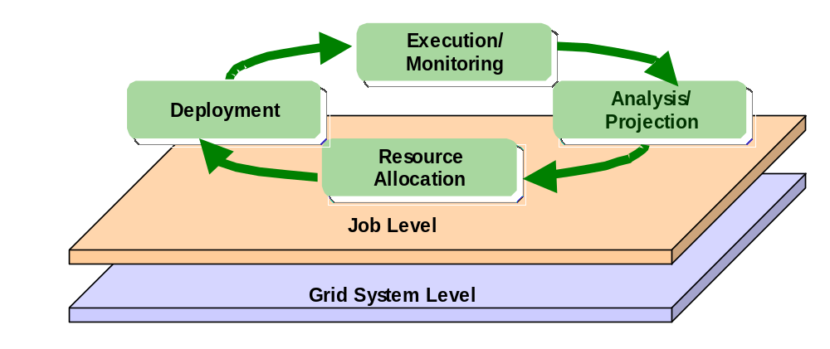

Functional Capabilities
Self Management is essentially self-configuration, self-healing, self-optimization. This shows the essential difference of self management with other OGSA categories – namely it is not just about the components that are involved in doing self management, but the method in which it is done – the “sauce” or the way in which the components interact , control loops are formed and systems behave intelligently based on environmental changes. These mechanisms that bring self management about can be described as follows.
- Self-configuring mechanisms adapt dynamically to changes in the IT system, using policies provided by the IT professional. Such changes could include the deployment of new components or the removal of existing ones, maybe due to a dramatic increase or decrease in the workload.
- Self-healing mechanisms can detect improper operations of and by the resources and services and initiate policy-based corrective action without disrupting the IT environment. The IT system as a whole becomes more resilient since the day-to-day operations are less likely to fail. Self healing has an angle of self protection included in it as well. This means that components can detect hostile behaviors as they occur and take corrective actions to make themselves less vulnerable. The hostile behaviors could include unauthorized access and usage, virus infection and proliferation, and denial-of-service attacks. These capabilities allow businesses to consistently enforce security and privacy policies.
- Self-optimizing mechanisms are able to tune themselves to the best efficiency to meet end-user or business needs. The tuning actions could mean reallocating resources to improve overall utilization or optimization by enforcing a Service Level agreement (business or IT agreements). Self-optimization helps provide a high standard of service for both the system’s end users and their customers. Self optimization makes use of self-configuration in its implementation.
It is important to note that the self-configuring, self-healing, self-optimizing attributes are not independent of one another. They work together to allow the ability to make changes to the configuration of one or more aspects of the IT system.

Towards achieving self management all the OGSA service categories are needed as those services and/or components are utilized by the self management apparatus. In addition some special functional requirements are called out in the following sections that are very important for self management, but may not be reflected in the same way in other OGSA service categories.

Service level management
This is basically the SLMS action described earlier in the objective section. This is an idea in self management. These activities are generally instances of a generic control loop pattern that may be used to control and adjust various service activities. The service level attainment activity is a cycle consisting of the following phases
- Monitoring: The SLMS receives and processes resource instrumentation through a monitoring component. Service execution and monitoring of resource utilization, for example, monitoring the load and utilization of resources, the running states of service components, and detecting faults. Such information is used as input to the Analysis phase. This might be made possible by using the monitoring services from the general Resource Management Category in OGSA.
- Analysis and Projection: Analysis is performed against the instrumentation to evaluate and determine compliance with its established policy and SLAs. The manager gets to know if resources are meeting QoS objectives and operating within defined policies. Analysis can also predict future resource behavior based on history and projection requirements. When system behavior is not consistent with overall goals, the manager evaluates alternative courses of action to effect changes in the set of configured resources in its sphere of influence and selects a plan of action in accordance with its configured policies.
- Execute (Actions): The manager then executes the plan, either by interacting with underlying managed resources, or by communicating with other managers responsible for other resources in the system. For example a workload manager may adjust priorities and process shares of task executing within a cluster of processors to meet service level objectives and policies. Or in cases where local action against a pool of resource is either impossible (in violation of policy or constrained) or ineffective a resource manager may “appeal” to other management functions to remedy the situation. For example a workload manager might make a provisioning request to add additional processors to a cluster.
This control loop executes continuously, assessing the current state of the system against the expressed service level objectives and making adjustments as necessary to bring the system into compliance. Other services are needed for these phases to happen like linkages to ‘capacity planning’, ‘entitlement of resources’, ‘problem and root cause analysis engine’, predictive analyzer ( analysis monitored data to predict future behavior ), etc.
A number of management components may be involved in service level attainment activities. The QoS and SLA requirements addressed by these management activities can be very varied - for e.g. relating to performance attainment such as processor capacity or utilization (workload management), or more qualitative objectives like security levels. Activities affect each other directly or indirectly. Because of all these the relationship and order of execution between these different management components in the control loops and service level managers should be fairly loose.

Policy and Model based Management
Service level managers orchestrate real-time changes in the dynamic management infrastructure based upon policy which governs their behavior. The intelligence in the self management is basically directed by the policies and models about the SLMS and the services that are being managed.

Entitlement
Entitlement is about negotiating with other resource holders (other SLMS, human operators, stored resource pools etc.) to obtain the right resources. This is also the place where different SLAs are compared to find out which resource need is more important. This is an earlier phase compared to resource reservation in which only the resource options are analysed , while in resource reservation the resource to the user is guaranteed.

Planning
Planning refers to calculating the optimum requirements of a service in terms of resources it needs. This can be at an initiation stage or due to some problem/root cause being identified, or due to a command from a higher level.

Capacity Management
Capacity management includes the actual actions relating to updating the current state and requirement of resources. It includes things like linking with inventory, asset management, moving the resources from the current location into the service domain, moving the resources from service domain into a storage area or to another domain etc.

Analytics

Problem and root cause analysis
Analysis of monitored data to find out the express issue and the root cause. Includes filtering capabilities, correlation etc.

Predictive analysis
Analyze monitored data to predict future behavior – this could be things like planning for future resource needs, or to predict future problems.

…

Properties

Quality of Service
Service Level Management components implement autonomic policy-based capabilities across multiple Quality of Service (QoS) dimensions of the management infrastructure. Key QoS dimensions include (but are not limited to): Availability, Security, and Performance. These cornerstone QoS dimensions are expressed in terms of measurable intent which can be captured in Service Level Agreements established between the service being provided and the users of the service. Availability might be measured in terms of “minutes of outage”. Desired security capabilities might be described as privileges provided by class of service for associated users. Performance characteristics could be specified in terms of well known throughput or response time objectives.

Performance
Gives the measures and metrics (quantifiable data about how the system is performing – e.g.: Cumulative CPU load factor) that go into computing the QOS metrics of a specified service.

Availability
Specifically denotes the metrics that show the failure rate of the service – of all types including the macro cases ( system crash ) and other less observable cases ( service didn’t deliver due to throughput drop and buffer flushing ).

Security
Security is becoming more and more important in the IT environment of the day. These measures talk about security violations, probability of security violations, identity management metrics (time to bring in a user, or delete one ...)

Interactions with the rest of OGSA
Self management is a vast area of grid systems of the future that it requires or interacts with almost all other aspects of grid systems. Some important services are given below as examples, but the more accurate statement at this juncture (this version of architecture document) is to say Self Management interacts with all the other services of OGSA.

Logging

Monitoring

Discovery

Provisioning

Resource Reservation

Security

Workflow

Composition

Resource Management ( Service and/or Resource Manageability Model )
This corresponds to having the representation of the service or resource that is being managed. The SLMS can read this information and can act on the intelligence in this, in response to a changing environment or a command from a higher level. Further details as to how best to model a service or resource needs to be done.

