Agenda for OGSA-WG and fellow WG F2F meeting
- February 17 at National Technical University of Athens -
Draft 03 (Feb. 11, 2006)

Location
National Technical University of Athens
Zografou Campus, Iroon Polytexneiou 9, 15780 Zografou
Multimedia Ampitheatre, the library building ground floor
February 17, Friday 9am-5pm

Direction from Divani Caravel Hotel
We will meet at hotel lobby 8:30am and take taxi to NTUA. It will take 20-25 minutes depending on traffic.

In case you prefer to use public transportation (it will take 30-45 minutes):
From “Evangelismos” station near by hotel, take line 3 metro to “Katehaki” station (4th stop). From “Katehaki” station, take bus number 242 to NTUA Administration Building. Bus departs 15 and 45 every hour from Metro station.
Library building is the next to the Administration Building.

The campus map and information on getting there.
http://www.ntua.gr/en_ntua/campus.htm
This is an external view of the building where the room is.
http://www.ntua.gr/en_ntua/pages/empn02_jpg.htm

Wi-Fi internet access is available at the meeting room. (Setup details will be provided on site.)

Local contact:
Konstantinos Dolkas
work phone +30-2107722546
mobile +30-6974899851
Dial-in:
Toll number: +1 718 3541071 (New York)
+1 408 9616509 (San Jose)
+81 (0)3 3570 8225 (Tokyo)
+44 (0)207 3655269 (London)
The pass code: 4371991

Glance network:
Address: http://ogsa.glance.net
Pass code: MMDD (1006 for Oct. 6)

Map

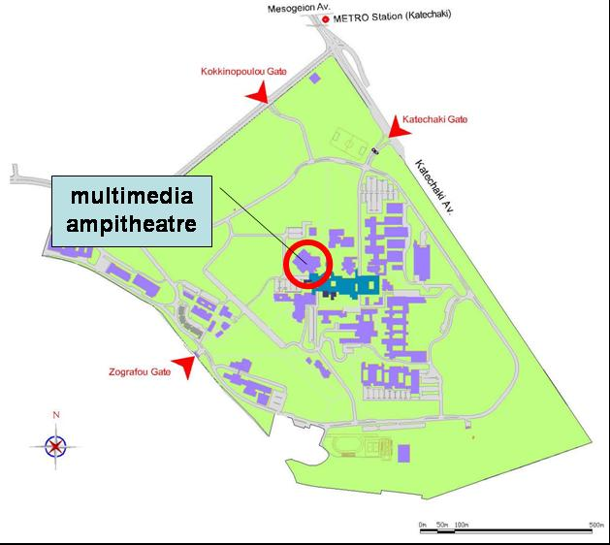
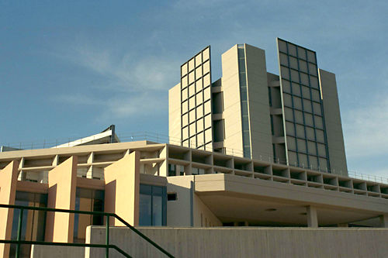
Attendees List

In Person
Hiro Kishimoto (Fujitsu)
Andreas Savva (Fujitsu)
Andrew Grimshaw (University of Virginia)
David Snelling (Fujitsu)
Steven Newhouse (University of Southampton)
Ellen Stokes (IBM)
Dave Berry (NeSC)
Dejan Milojicic (HP)
Steve McGough (Imperial College)
Mark Morgan (University of Virginia)
Fred Maciel (Hitachi)
Jem Treadwell (HP)
Keisuke Fukui (Fujitsu)
Darren Pulsipher (Ovoca)
Chris Jordan (SDSC)
Marvin Theimer (Microsoft)
Ravi Subramaniam (Intel)

Telephone Bridge
Michael Behrens (R2AD, LLC)

Apologies
Tom Maguire (EMC)
Allen Luniewski (IBM)
Pete Ziu (Northrop Grumman)
Chris Smith (Platform)
Ayla Debora (Universidade Federal de Campina Grande)
Donal Fellows (University of Manchester)
Neil Chue Hong (EPCC)
Frank Siebenlist (ANL)
Soonwook Hwang (NAREGI)

Making inquiries
Mathias Dalheimer (Fraunhofer ITWM)
Jun Tatemura (NEC)
Jim Pruyne (HP)
Steve Loughran (HP)
Takashi Kojo (NEC)
Toshiyuki Nakata (NEC)
Manuel Pereira (IBM)
Ian Foster (ANL)
Fred Brisard (Computer Associates)
Takuya Mori (NEC)
Philipp Wieder (Forschungszentrum Jülich)
Stephen Davey (NeSC)
Stuart Schaefer (Softricity)
Michel Drescher (Fujitsu)
Andre Merzky (Free University Amsterdam)
Stephen Crouch (OMII, University of Southampton)
Sachiko Wada (Ascade)
Wolfgang Ziegler (University of Freiburg)
Jay Unger (IBM)

Feb. 17 (Friday), 9am ~ 12:30pm

- Early Discussion (30 min)
  - Note taker
  - Role call and self introduction
  - Agenda bashing

- CDDLM and EMS joint session (90 min)
  - Doing a real example, e.g., BLAST, for CDL and JSDL could be useful as a next step.
  - Action:
      - Dejan(CDDLM) to provide a CDL for deploying and configuring BLAST
      - Steve/Andreas(JSDL) to provide a JSDL document for submitting a BLAST job

- Future meeting scheduling (30 min)
  - Finalizing April F2F date/location
  - Finalizing GGF17 B2B F2F meeting date/location

- EMS scenarios discussion with RSS WG (60 min)
  - Separation of EPS and CSG is not clearly required – suggest to RSS to remove CSG and let them make the call. And clearly define the added value of CSG.
  - EPS returns an ordered (by policy) list of (Activity Execution Candidates: <JSDL doc; EPR or path of BES container; rank (optional, numeric, extensible), …>.

Lunch at University cafeteria (12:30 – 1:30pm)

Feb. 17 (Friday), 1:30 ~ 5pm

- EMS scenarios discussion(60 min)
  - Follow up on workflow discussion and the possibility of doing a Job Manager BoF. Focusing on the API and not the language aspect is one choice but we need to figure out the model and define the scope of the activity first.

- Information model discussion (120 min)
  - BES container profile document review
  - Containers in OGSA document review
  - Information Modeling Guideline document review

- General discussion (30 min)
  - Architecture & Glossary 1.5 Editor Submission
  - OGSA communication discussion
  - Show time: your favorite video clips

Group dinner <TBD>

