Containers in OGSA

Status of This Memo
This document is in draft stage and should be considered as in flux. Distribution is unlimited.

Copyright Notice
Copyright © Global Grid Forum (2006). All Rights Reserved.

Abstract
This memo provides information to the Grid community on the information modeling of containers for OGSA (Open Grid Services Architecture). It defines the proposed container object for inclusion in DMTF’s Common Information Model. Specific containers, such as the Basic Execution Services container, are defined as profiles and described in a separate document. Distribution is unlimited.

Contents

1. Overview 3
2. The Container Model 3
3. UML 3
4. Discussion of the Model Elements 4
4.1 New Classes 4
4.2 New Associations 5
4.3 Properties Added to Existing Classes 5
4.4 Methods Added to Existing Classes 5
5. Managed Object Format (MOF) 5
6. XML 5
7. Security Considerations 5
8. Glossary 6
9. Author Information 6
10. Acknowledgements 6
11. References 6
12. Full Copyright and Intellectual Property Notices 6

Overview
The Container Model describes the managed objects and their relationships for defining the execution environment for activities in a grid. The CIMv2.10 final schema is the foundation for the development of this model. It is expected that this model will be folded into CIMv2.12 preliminary.
In this document we provide the container model in UML, DMTF CIM Managed Object Format (MOF), and suggest, as a strawman, an XML schema that could be used by OGSA-compliant Grid Services to exchange the information in the model presented. DMTF provides their XML representation via automatic conversion tool (MOF to CIM-XML, via CIM DTD).
The keywords “MUST”, “MUST NOT”, “REQUIRED”, “SHALL”, “SHALL NOT”, “SHOULD”, “SHOULD NOT”, “RECOMMENDED” and “MAY” used in this document are to be interpreted as described in [RFC2119].

The Container Model
OGSA defines a container as a collection of running entities and activities, e.g. services, jobs. A container may, for example, be a queuing service, a Unix host, a J2EE environment, or a collection of containers (a façade or a virtual organization of job containers). A container has resource properties that describe both static and dynamic information, e.g. OS version, types of executables allowed, policies, security, load, QoS information. A container implements some subset of the manageability interfaces of a Web Services Distributed Management (WSDM) manage resource. The container has various relationships to other resources. The container uses various services such as reservation services, logging services, information services, job management services, and provisioning services.
A single new class, Container, is defined as a subclass of the Collection class. While OGSA desires to define specific containers, there is no need to define subclasses of the Container class. Instead, the details of OGSA containers necessary for implementation and interoperability are defined by a profile. For example, OGSA needs a Basic Execution Services (BES) Container. The BES container is a container constrained by a profile and not a subclass of the Container class. The Container acts as an aggregator of the managed properties necessary for the use of the container through its various relationships with the ManagedElement class. In the BES context, the container aggregates and exposes attributes needed to make scheduling decisions.
The class added to CIMv2.12 experimental in support of the Container work is marked as ‘Experimental’ in the CIM MOF and as {E} in the UML diagram and appear in bold font for easier identification.
The model elements are discussed in a bit more detail in Section 4 following the presentation of the UML in Section 3. The ManagedObject Format (MOF) description is given in Section 5. (MOF is a textual rendering of UML, defined in the CIM Specification [CIMspec] published by the DMTF.) Section 6 offers a corresponding XML description.
Note: It is expected that additional CIM classes, attributes, and methods will be defined and need to be added to CIM as the specific container profile work progresses. These will be documented in similar fashion to the Container class either within this document or in a separate document.

UML
The figure below depicts the classes and properties of the container model. The new class with its attributes and methods are highlighted in red bold.
Question: do we need an attribute to denote the environment of container, such as whether the container is a queuing service, a J2EE hosting environment, a host (operating system based), etc?

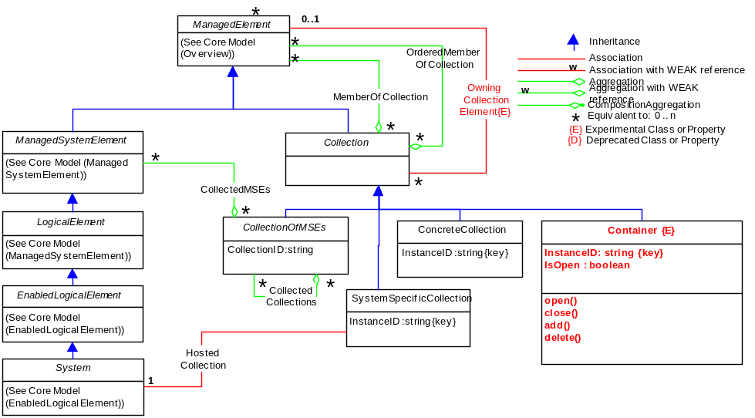
Figure 1: Container Model

Discussion of the Model Elements
This section describes the classes, associations, properties, and methods proposed to be added to CIM v2.12 experimental in support of a container model.

New Classes

Container
The Container class inherits from the CIM_Collection class. It is a concrete class meaning that it is instantiable without further subclassing. It is a collection of running entities and activities, e.g. services, jobs. A container may, for example, be a queuing service, a Unix host, a J2EE environment, or a collection of containers (a façade or a virtual organization of job containers). A container has resource properties that describe both static and dynamic information, e.g. OS version, types of executables allowed, policies, security, load, QoS information. A container implements some subset of the manageability interfaces of a Web Services Distributed Management (WSDM) manage resource. The container has various relationships to other resources. The container uses various services such as reservation services, logging services, information services, job management services, and provisioning services. Because this container class serves as an aggregator of other classes (attributes and methods) and can aggregat any ManagedElement (all classes in CIM are ManagedElements), the contents of a specific container are described by a profile.
Contents:
- InstanceID (required)
Within the scope of the instantiating Namespace, InstanceID opaquely and uniquely identifies an instance of this class.
- IsAcceptingNewActivities
A boolean attribute that defines the current ability of the container to accept new activities.
- Open
This operation moves the container into a state where it is open for requests. For example, within the context of the Basic Execution Services profile, this means the container can start accepting new activities, and the operation maps to ‘StartAcceptingNewActivities()’ interface.
- Close
This operation moves the container into a state where it is closed to requests. For example, within the context of the Basic Execution Services profile, this means the container stops accepting new activities, and the operation maps to ‘StopAcceptingNewActivities()’ interface.
- Add
This operation add requests to the container. For example, within the context of the Basic Execution Services profile, this means that a new activity is added to the container, and the operation maps to the ‘CreateActivity()’ interface.
- Delete
This operation changes and/or deletes requests within the container. For example, within the context of the Basic Execution Services profile, this means that a new or existing activity can be moved to the ‘suspended’ state within the container, and the operation maps to the ‘CreateSuspendedActivity()’ interface.

New Associations
None.

Properties Added to Existing Classes
None.

Methods Added to Existing Classes
None.

Managed Object Format (MOF)
The schema is described in Managed Object Format, defined in [CIMspec].
The MOF below reflects the UML diagram in this document. It is included to provide the details and descriptions necessary to understand the UML.
<insert MOF>

XML
An XML representation of Container as an XSD is being developed.

Security Considerations
This specification defines the model and XML Schema for containers. While the interactions of containers with its activities must be secured, the security details are outside the scope of this specification. Instead, it is assumed that security is addressed in specifications that define how this model and XML Schema are bound to specific communication protocols (such as [CIMOPS] or [OGSA]) and programming environments.

Glossary
<any terms we should list?>

Author Information
Ellen Stokes
IBM Corporation
11400 Burnet Rd
Austin, TX 78758
+1 512 838 0552
stokese@us.ibm.com

Acknowledgements
We are grateful to numerous colleagues for discussions on the topics covered in this document, in particular (in alphabetical order, with apologies to anybody we've missed): <list the names>.

References
[RFC2119] Bradner, Scott, "Key Words for use in RFCs to Indicate Requirement Levels", RFC 2119, http://www.ietf.org/rfc/rfc2119.txt
[CIM2.11final] DMTF CIM Schema, Version 2.10 Final, http://www.dmtf.org/standards/cim_schema_v210.php
[CIM2.12prelim] DMTF CIM Schema, Version 2.12 Experimental, http://www.dmtf.org/standards/cim_schema_v212.php
[CIMspec] DMTF, CIM Specification V2.2, http://www.dmtf.org/standards/documents/CIM/DSP0004.pdf
[CIMXML] DMTF, Representation of CIM in XML, http://www.dmtf.org/standards/documents/CIM/DSP0201.pdf
[BES] GGF, OGSA Basic Execution Service Specification, http://www.ggf.org/XXX.pdf
[BES Profile] GGF, OGSA Basic Execution Service Profile, http://www.ggf.org/XXX.pdf

Full Copyright and Intellectual Property Notices
Full Copyright Notice
Copyright © Global Grid Forum (2006). All Rights Reserved.
This document and translations of it may be copied and furnished to others, and derivative works that comment on or otherwise explain it or assist in its implementation may be prepared, copied, published and distributed, in whole or in part, without restriction of any kind, provided that the above copyright notice and this paragraph are included on all such copies and derivative works. However, this document itself may not be modified in any way, such as by removing the copyright notice or references to the GGF or other organizations, except as needed for the purpose of developing Grid Recommendations in which case the procedures for copyrights defined in the GGF Document process must be followed, or as required to translate it into languages other than English.
The limited permissions granted above are perpetual and will not be revoked by the GGF or its successors or assigns.
This document and the information contained herein is provided on an "AS IS" basis and THE GLOBAL GRID FORUM DISCLAIMS ALL WARRANTIES, EXPRESS OR IMPLIED, INCLUDING BUT NOT LIMITED TO ANY WARRANTY THAT THE USE OF THE INFORMATION HEREIN WILL NOT INFRINGE ANY RIGHTS OR ANY IMPLIED WARRANTIES OF MERCHANTABILITY OR FITNESS FOR A PARTICULAR PURPOSE."

Intellectual Property Statement
The GGF takes no position regarding the validity or scope of any intellectual property or other rights that might be claimed to pertain to the implementation or use of the technology described in this document or the extent to which any license under such rights might or might not be available; neither does it represent that it has made any effort to identify any such rights. Copies of claims of rights made available for publication and any assurances of licenses to be made available, or the result of an attempt made to obtain a general license or permission for the use of such proprietary rights by implementers or users of this specification can be obtained from the GGF Secretariat.
The GGF invites any interested party to bring to its attention any copyrights, patents or patent applications, or other proprietary rights which may cover technology that may be required to practice this recommendation. Please address the information to the GGF Executive Director.

This class is planned to be submitted to DMTF for inclusion in CIMv2.12 experimental.
Details of the BES profile are in [BES Profile] document.

