Grid Scheduling Use Cases

Status of this Memo
This document provides information to the community regarding the Grid scheduling use case scenarios used in the definition of a Grid Scheduling Architecture (GSA-RG). Distribution of this document is unlimited. This is a DRAFT document and continues to be revised.

Abstract
Grids will provide a large variety of complex services. The interactions of those services require an extensible and integrated resource management. Although such a coordinated scheduling of services is currently not readily available. Access to resources is typically subject to individual access, accounting, priority, and security policies of the resource owners. Those policies are typically enforced by local management systems. Therefore, an architecture that supports the interaction of independent local management systems with higher-level scheduling services is an important component for Grids. Further, user of a Grid may also establish individual scheduling objectives. Future Grid scheduling and resource management systems must consider those constraints in the scheduling process. Taking into account different policies is also important for the implementation of various economic and business models.
The goal of the Grid Scheduling Architecture research group (GSA-RG) is to define a scheduling architecture that supports cooperation between different scheduling instances for arbitrary Grid resources. Considered resources include network, software, data, storage and processing units. The research group will particularly address the interaction between resource management and data management. Co-allocation and the reservation of resources are key aspects of the new scheduling architecture, which will also include the integration of user or provider defined scheduling policies.
The group will begin with identifying a set of relevant use-cases based on experiences obtained by existing Grid projects. Then, it will determine the required components of a modular scheduling architecture and their interactions.


GLOBAL GRID FORUM
office@gridforum.org
www.ggf.org

Full Copyright Notice
Copyright © Global Grid Forum (2003). All Rights Reserved.
This document and translations of it may be copied and furnished to others, and derivative works that comment on or otherwise explain it or assist in its implementation may be prepared, copied, published and distributed, in whole or in part, without restriction of any kind, provided that the above copyright notice and this paragraph are included on all such copies and derivative works. However, this document itself may not be modified in any way, such as by removing the copyright notice or references to the GGF or other organizations, except as needed for the purpose of developing Grid Recommendations in which case the procedures for copyrights defined in the GGF Document process must be followed, or as required to translate it into languages other than English.
The limited permissions granted above are perpetual and will not be revoked by the GGF or its successors or assigns.
This document and the information contained herein is provided on an "AS IS" basis and THE GLOBAL GRID FORUM DISCLAIMS ALL WARRANTIES, EXPRESS OR IMPLIED, INCLUDING BUT NOT LIMITED TO ANY WARRANTY THAT THE USE OF THE INFORMATION HEREIN WILL NOT INFRINGE ANY RIGHTS OR ANY IMPLIED WARRANTIES OF MERCHANTABILITY OR FITNESS FOR A PARTICULAR PURPOSE.

Intellectual Property Statement
The GGF takes no position regarding the validity or scope of any intellectual property or other rights that might be claimed to pertain to the implementation or use of the technology described in this document or the extent to which any license under such rights might or might not be available; neither does it represent that it has made any effort to identify any such rights. Copies of claims of rights made available for publication and any assurances of licenses to be made available, or the result of an attempt made to obtain a general license or permission for the use of such proprietary rights by implementers or users of this specification can be obtained from the GGF Secretariat.
The GGF invites any interested party to bring to its attention any copyrights, patents or patent applications, or other proprietary rights which may cover technology that may be required to practice this recommendation. Please address the information to the GGF Executive Director (see contact information at GGF website).
Contents
1 Introduction 4
2 Application-Oriented Scheduling in the Knowledge Grid 5
2.1 Summary 5
2.2 Customers 6
2.3 Scenarios 6
2.4 Involved resources 7
2.5 Functional requirements 7
2.6 Workflow of Scheduling Process 7
2.7 Involved Scheduling Components/Services 7
2.8 Failure Considerations 7
2.9 Security Considerations 8
2.10 Accounting Considerations 8
2.11 Performance Considerations 8
2.12 Use case Situation Analysis 8
2.13 References 8
3 Editors Information 9

Introduction
One of the first milestones of the GSA-RG’s charter is the identification of relevant use-cases for Grid scheduling.
This document is a collection of the use case scenarios contributed by GSA-RG participants or solicited from others.
Based on this document the GGSA-RG will identify and specify common requirements to support the creation of Grid schedulers which serve the use-cases. This information will be used to identify components, services and protocols for a Grid scheduling architecture. Services and protocols from other GGF groups are considered as potential basic building blocks of such an architecture and will be used wherever possible.
Note, that it is not the task of the Research Group to define protocols or algorithms. Instead, the RG identifies the requirements for Grid scheduling, designs a suitable Grid scheduling architecture including existing services as well as currently missing components and their interaction.

Application-Oriented Scheduling in the Knowledge Grid

Summary
The Knowledge Grid (K-Grid) is an architecture built atop basic Grid middleware services that defines more specific services for the definition, composition, validation and execution of knowledge discovery applications over Grids, and for storing and managing discovered knowledge [1, 2]. The K-Grid Resource Allocation and Execution Management Service (RAEMS) is a service used by the Knowledge Grid to map applications onto available resources and to coordinate their execution. The K-Grid scheduler is part of the RAEMS; it can be seen as an “application agent” associated to each application to be executed. Indeed, the scheduler produces job assignments (along with timing constraints) for each application, with the goal of improving its performances, on the basis of knowledge or prediction about computational and I/O costs. Afterwards, it follows each application execution to adapt generated schedules to new information about job status and available resources. Moreover, since in realistic Grid applications it is generally infeasible to specify all the details of applications at composition time, the Knowledge Grid scheduler allows the definition and use of abstract hosts, i.e. hosts whose characteristics are only partially known, and that can be matched to different concrete ones [3].

Therefore, the main objectives of the scheduler are:
- Abstraction from computational and network resources in application composition. With the use of abstract hosts, users are allowed to disregard low-level execution-related aspects, and to concentrate more on the structure of their applications.
- Application performance improvement. Given a set of available hosts, schedules are generated trying to minimize applications’ completion times.

Besides the scheduler, the K-Grid’s RAEMS includes an Execution Manager, used to translate the output of the scheduling process into submissions to basic Grid services, and a Job Monitor that follows the execution of submitted jobs and notifies the scheduler about significant events occurred. Each K-Grid node has its own scheduler which is responsible for instantiating a new application agent for each scheduling request coming from the same or different nodes.

The architecture of the scheduler [4] comprises three main components (Fig. 1):
- Mapper. It computes schedules employing a scheduling algorithm and making use of resource descriptions and computational and I/O cost evaluations.
- Cost/Size Estimator. It builds the I/O and computational cost estimation functions. The CSE comprises data gathering modules collecting dynamic information about current and future availability and performance of resources, and estimation modules dealing with the actual construction of estimation functions, on the basis of the perceived status of resources w.r.t. time.
- Controller. It guides the scheduling activity by receiving abstract applications, requesting the corresponding schedules to the Mapper, and ordering the execution of scheduled jobs to the Execution Manager. The Controller also receives notifications about significant events occurred and re-schedules unexecuted parts of the application.
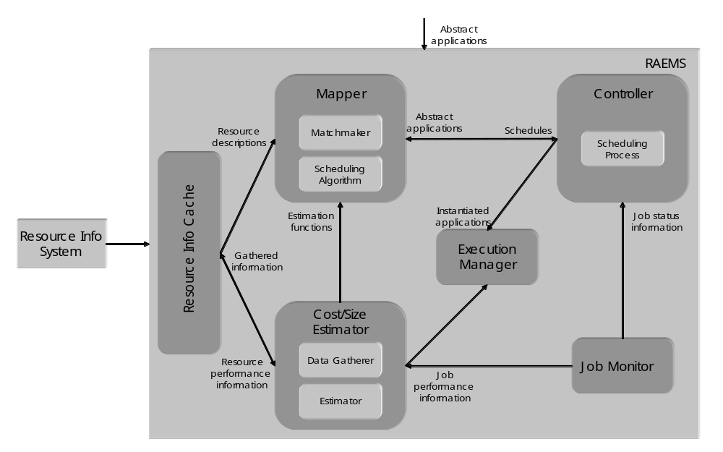
Figure 1. Scheduler architecture

The scheduler modules are extensible as they provide an open interface allowing to plug-in user-defined functionalities and behaviors. The scheduler can load modules implementing scheduling algorithms and matchmaking functionalities (in the Mapper), scheduling processes (in the Controller), and data gathering and cost estimation activities (in the Cost/Size Estimator). Each module can refer to its own description of resources. This makes the scheduler potentially useful in Grid frameworks different from the Knowledge Grid. For instance, cooperation among different schedulers could be implemented in the scheduling process, and resource and applications’ descriptions could be properly designed to include the needed information.

Customers
The target customers of the Knowledge Grid scheduler are mostly Grid users who want to perform knowledge discovery processes on Grids. However, since the scheduler is not tightly coupled with the Knowledge Grid architecture, its use can be seamlessly extended to other application domains.

Scenarios
- Application submission. The scheduler interprets user’s request and finds a suitable schedule for it by matching resource requirements with concrete resource descriptions, and trying to minimize the application completion time.
- Restart on failure. Both computation and communication jobs are automatically observed during the execution, and a re-scheduling policy can be implemented in the scheduler Controller.
- Extension. The scheduler can load modules implementing different functionalities, each of which can be based on a different way of characterizing resources.

Involved resources
The extensibility of the Knowledge Grid scheduler allows the use of virtually any kind of resource needed by the users; the only limitations are those of resource providers.

Functional requirements
- Information retrieval. The scheduler must be able to connect to external resource information services to retrieve data about (current and future) availability and performance of resources.
- Application parsing and validation. The scheduler must parse and validate the scheduling requests w.r.t. their structure and w.r.t. the actual possibility to instantiate them.
- Resource preselection. The available resources must be preliminarily filtered to retain only those actually usable for the application.
- Scheduling. The scheduler must support a scheduling process, i.e., the sequence of actions to be taken in coincidence with particular events, and a scheduling algorithm, defining the way in which jobs are assigned to resources.
- Failure management. The scheduling process must be dynamic with re-scheduling, i.e., the scheduler is invoked initially and then, during application executions, it is invoked again as a consequence of significant events occurred, to re-schedule unexecuted parts of the application.
- Extensibility. It must be possible to extend the scheduler funtionalities with personalized ones based on different application scenarios and Grid structures.

Workflow of Scheduling Process
For each application to be scheduled, the scheduler instantiates a different Controller. Moreover, the following logical steps are performed:

- The Cost/Size Estimator gathers data about characteristics and performances of available resources and builds the cost estimation functions (this step can be done offline).
- The Matchmaker selects resources usable to execute the jobs composing the application, using information coming from the Resource Information Cache.
- The Mapper evaluates a certain set of possible schedules, using information coming from the Estimation modules of the Cost/Size Estimator, and chooses of the one minimizing the completion time.
- The Controller requests job execution to the Execution Manager.
- The Controller waits for job status notifications from the Job Monitor or new information about availability and performance of resources and adapts the schedule to such changes.

Involved Scheduling Components/Services
Based on the general Grid scheduling architecture as defined in October, 2002 GSA document, the following services are involved in the activity of the Knowledge Grid scheduler:
- Data and Network Management services;
- Job Supervisor service;
- Information service (static and forecasted).

Failure Considerations
The Knowledge Grid scheduler handles job failures as described in Section 2.3.

Security Considerations
Security in the Knowledge Grid scheduler is demanded to other Knowledge Grid services; it is essentially based on GSI.

Accounting Considerations
Accounting in the Knowledge Grid scheduler is demanded to other Knowledge Grid services.

Performance Considerations
The Knowledge Grid scheduler caches resource information and strongly indexes them in order to obtain the data access performance needed during the scheduling activity. In addition, due to the inherent intractability of the scheduling problem to be dealt with, one of the most important requirements of the scheduling heuristics is a suitable effectiveness/efficiency tradeoff.

Use case Situation Analysis
We have designed a complete scheduling model and implemented the architecture described in Section 2.1 for its support. The scheduler is currently within the context of the Knowledge Grid, but its structure and openness prove suitable for more general scheduling scenarios. The study of suitable scheduling heuristics for different kinds of applications and Grids is currently underway.

References
1. The Knowledge Grid Lab. http://dns2.icar.cnr.it/kgrid/.
2. M. Cannataro and D. Talia. The Knowledge Grid. Communications of the ACM, 46-1, 2003.
4. M. Cannataro, A. Congiusta, A. Pugliese, D. Talia, P. Trunfio. Distributed data mining on Grids: services, tools, and applications. IEEE Transactions on Systems, Man, and Cybernetics: Part B (TSMC-B). To appear.
3. A. Pugliese and D. Talia. Application-oriented scheduling in the Knowledge Grid: a model and architecture. International Conference on Computational Science and its Applications (ICCSA), 2004.

Editors Information
Andrea Pugliese, Domenico Talia
DEIS-University of Calabria
Via P. Bucci, 41/C, Rende (Italy)
{apugliese,talia}@deis.unical.it

