OGF  Category: Community Practice  Grid and Virtualization Working Group  http://forge.gridforum.org/sf/projects/gridvirt-wg | Editors:  Wolfgang Reichert, IBM  Erol Bozak, SAP  July 2007

Grid and Virtualization – Use Cases

Status of This Memo

This memo provides information to the Grid community regarding server virtualization technology. It does not define any standards or technical recommendations. Distribution is unlimited.

Copyright Notice

Copyright © Open Grid Forum (2007). All Rights Reserved.

Abstract

This document defines the use cases wherein the grid infrastructure is seen participating in an virtualized system infrastructure. The use cases are described from the application point of view and benefit rather than from a technical infrastructure perspective.

The EGA Reference Model is taken as base architecture. The use cases are described in the terminology of this model.

Introduction
A virtualization platform (like a hypervisor or virtual machine) provides functions and capabilities which allow to decouple virtual systems and virtual resources from their physical representation. Although a virtual system may behave like a physical system, there is not necessarily a direct or permanent relationship between a virtual system and the physical host system.

Virtualization is designed to be transparent. This means that all previously known grid scenarios apply to virtual systems as well. Nevertheless, the concept of virtualization introduces new capabilities. They allow for additional use cases. These new use cases are described here.

In this document the use cases are arranged by virtualization capabilities. Each section is dedicated to one virtualization capability. The respective use cases are described and related to the Enterprise Grid Alliance Reference Model.

The reference model has been published by the Enterprise Grid Alliance (EGA) consortium with the purpose of defining a common context in terms of enumerating and classifying the set of components to be managed within an enterprise grid. See http://www.gridalliance.org.

For terms and definition used within this document refer to the adjoining paper “Grid and Virtualization – Terminology” at http://forge.gridforum.org/sf/projects/gridvirt-wg.

The Enterprise Grid Alliance Reference Model
EGA defines an enterprise grid as a collection of interconnected (networked) grid components under the control of a grid management entity.

The grid component is a super class of object from which all of the components that are managed within an enterprise grid are descended or derived. This may include, but is not necessarily limited to –
- Traditional resources such as servers, network switches, routers, SAN switches, disk arrays and so forth.
- Applications or services such as databases, an ERP service, an online bookstore etc.
- Everything in between which could be considered to be a meta-resource or a component of a service.

The Grid Management Entity (GME) is that logical entity that manages –
- The grid components.
- The relationships between various grid components.
- Their life cycles.

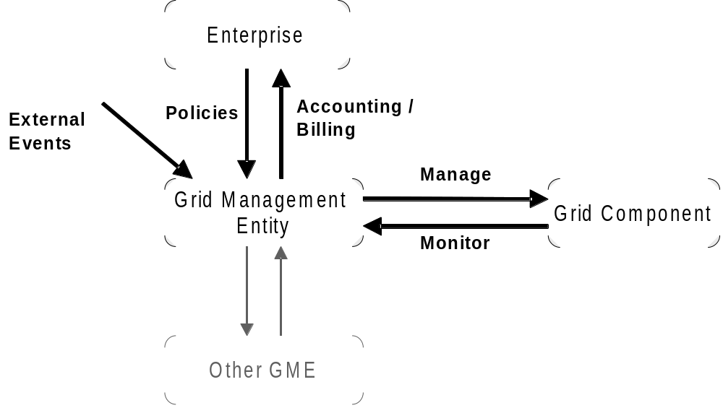
Illustration 1: The role of the Grid Management Entity (GME)
The GME is logically distinct from the managed grid components. All management functionality resides in the GME.
A grid component is monitored and managed by exactly one GME. A GME may communicate with other GMEs. GMEs may build up a hierachical system of GMEs. Management commands/policies/events propogate top down thru the GMEs, whereby each GME applies the action accordingly to its own grid component(s).
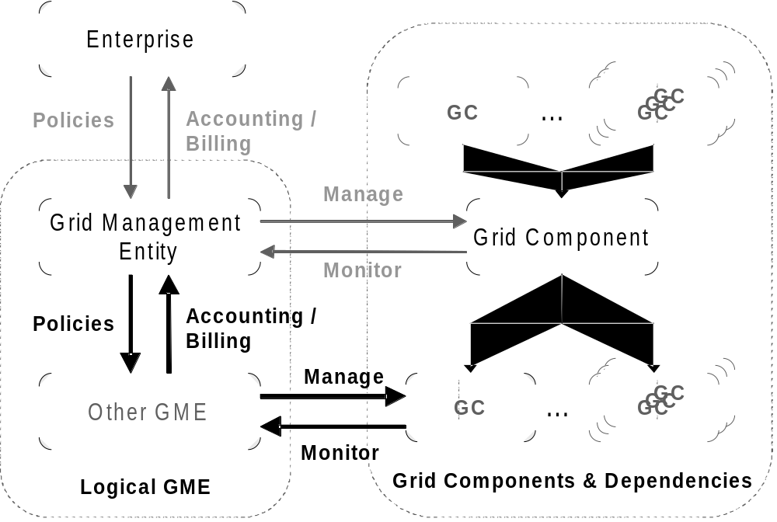
Illustration 2: Hierarchy of grid components and grid management entities

Introducing virtualization in the model
In the case of virtualization the Host System can be considered a grid component. The respective management entity is the Virtualization Platform (e.g. Hypervisor, VM) which implements the monitoring and management functions.

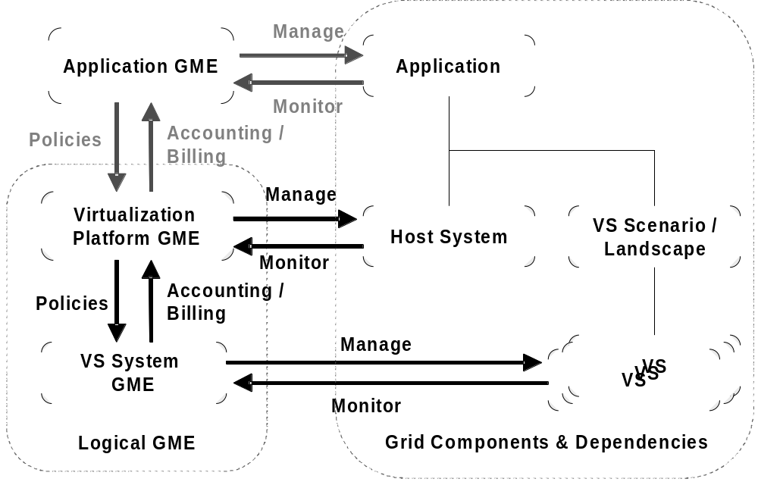
Illustration 3: Virtual Systems in the EGA Model
An important conclusion w.r.t. the communication paths is derived from this model:

An application never triggers any actions directly with the host system. Nor does the host system inform any applications directly about system changes. Rather all communication is done between the GMEs. Each GME then decides whether an event or a policy change shall result in an action on the owned grid component(s).

Service Level Management
The GME is responsible for applying the service level agreements within its scope.

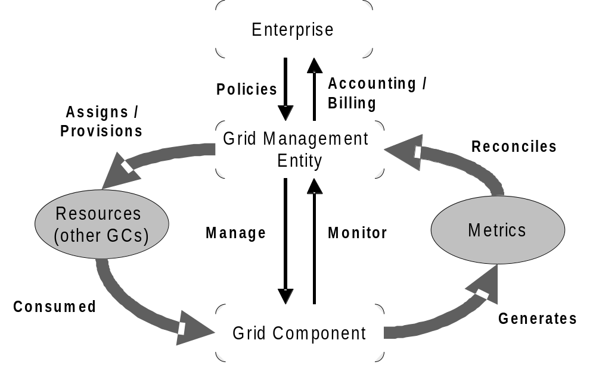
Illustration 4: Service Level Management

Migration of virtual systems during runtime
Some virtualization platforms (e.g. IBM System p/i, VMware, XEN) support live migration of a virtual system to another physical server. This happens transparently to the applications which run on the virtual system.

Use Cases

Power saving
The resource manager may pool virtual systems to a reduced number of physical systems in order to save power.

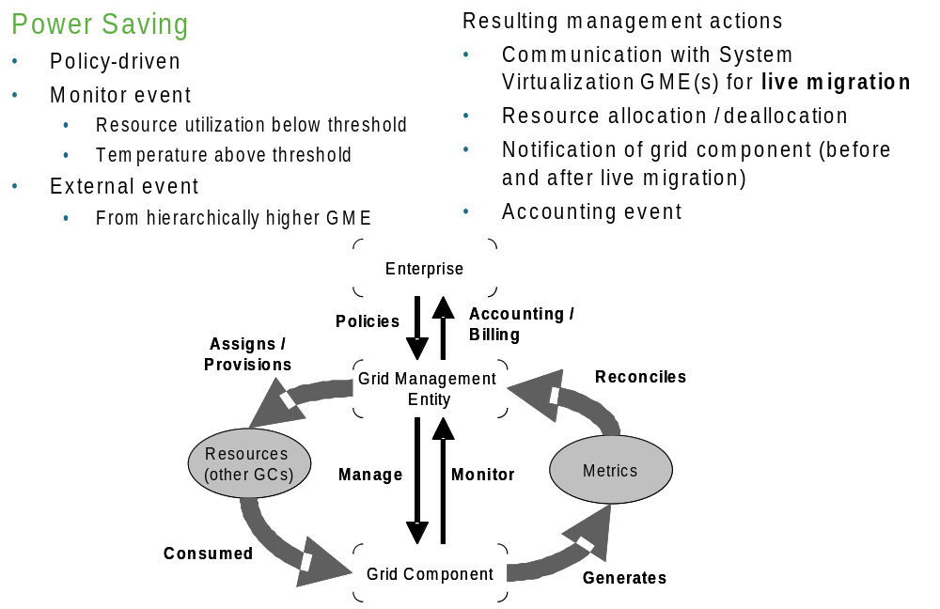

(Planned) maintenance
The physical system as well as the hypervisor could require maintenance activities to be performed (e.g. install patch, hw upgrade or driver etc.). The running job could be migrated to other machines without downtime.

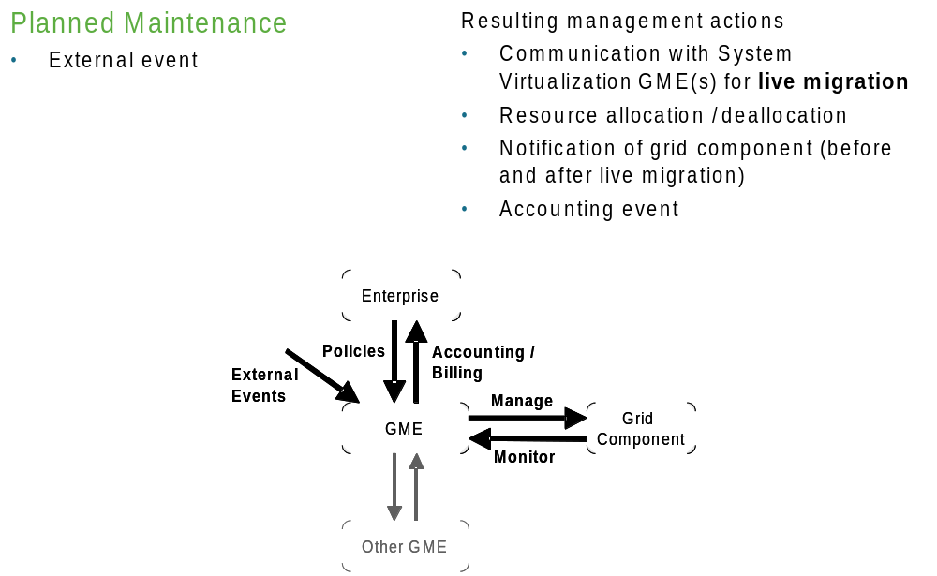

Changing capacity requirements
During runtime the job may require additional capacity (e.g. CPU capacity, Memory capacity, I/O bandwidth). If the underlying physical system is not able to serve the requirements the resource manager may migrate the job / virtual system to another physical system that fulfills the capacity requirements.

Changing capacity offering / availability
Capacity availability may change in the environment because of recently freed resources by the completed jobs or additional physical systems may be introduced. In these situations the resource manager may decide to utilize available capacity for the running jobs through migration.

Dynamic Resizing

Changing capacity requirements
During runtime the job may require additional capacity (e.g. CPU capacity, Memory capacity, I/O bandwidth etc.). If the underlying physical system is able to serve the requirements more capacity for the job / virtual system can be provided locally on the same physical system.

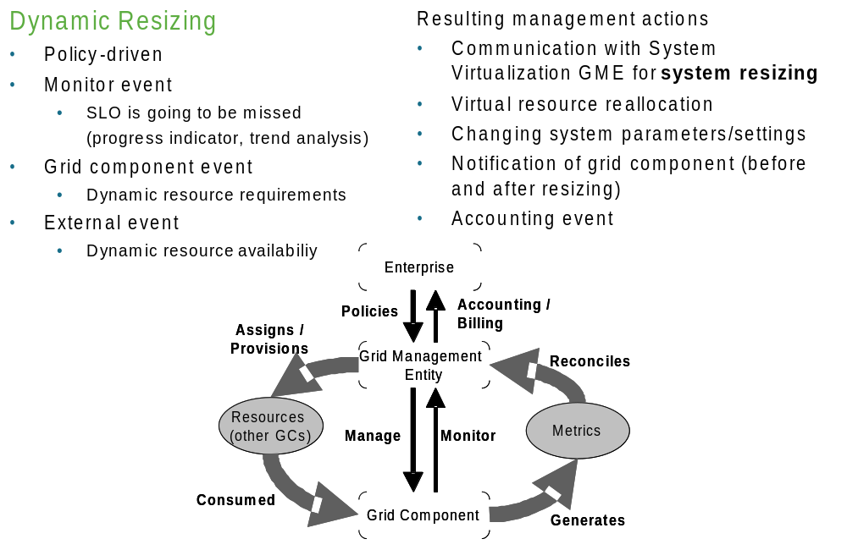

Changing capacity offering / availability
Capacity availability may change in the physical system (e.g. CPU capacity, Memory capacity, I/O bandwidth etc.) because of recently freed resources by the completed jobs. In these situations available capacity can be utilized for the running jobs.

Snapshotting

Stateful cloning
The execution of a job may require costly preparation steps, e.g. retrieving data from the backend, which might be common to all jobs of an activity / application. Rather than doing the preparation separately for each job one (or the first) job can be snapshotted after the preparation and the state can be cloned and distributed.

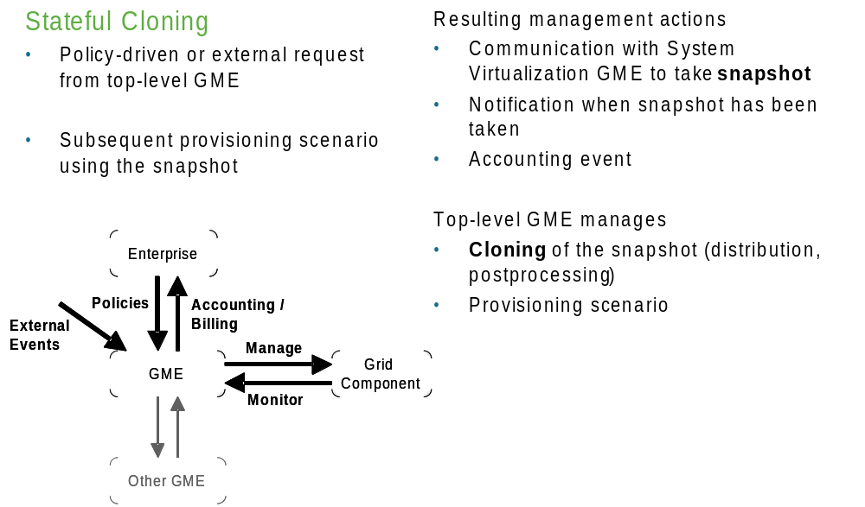

Protecting (long running) jobs from software or hardware failures
By providing recovery points that can be re-activated (long running) jobs can be restarted at a certain persisted state potentially on a different physical system.

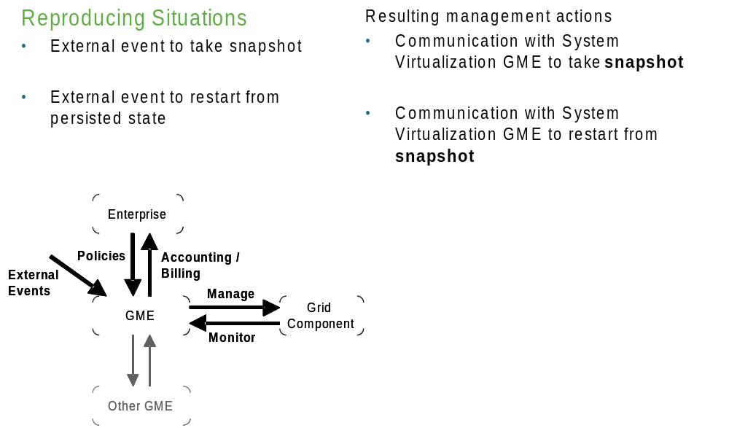

Reproducing situations
For purpose of diagnosis (error or performance analysis etc.) the user may repetitively re-run the same job from a certain persisted state.

Isolation

Metering of job resource consumption
For the purpose of accounting and billing, metering via the virtualization platform provides more accurate data.

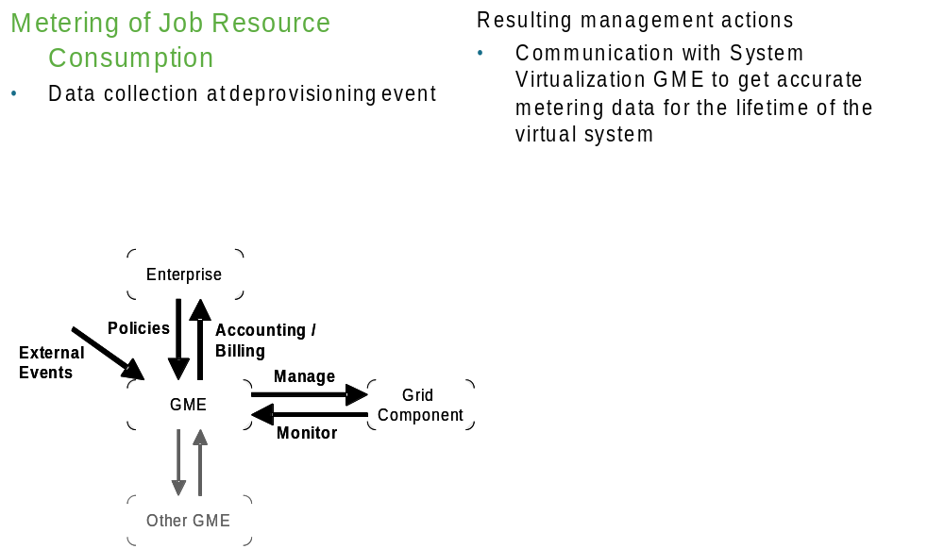

Resource consumption control
Through isolation the amount / degree of resource consumption can be controlled and leveled, i.e. greedy jobs can be controlled.

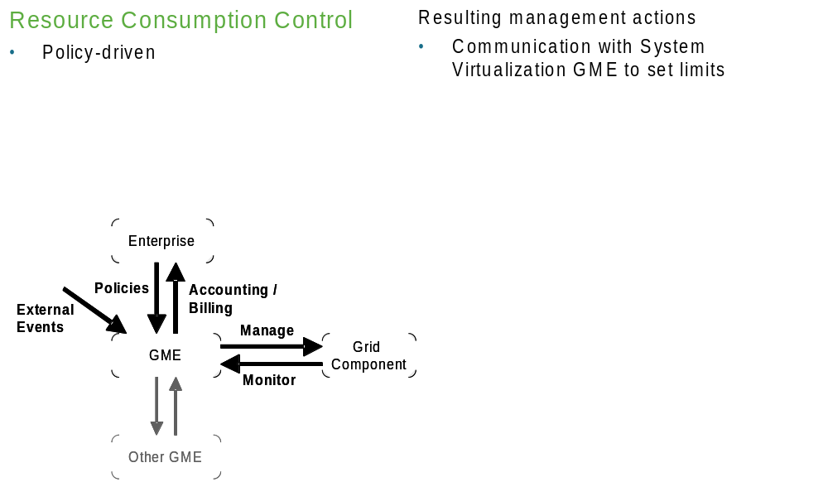

Provisioning Scenarios
Standard grid provisioning scenarios are extended in a virtual system environment:
Rather than searching for and allocating resources for the job resources can be “created” on demand.
Available physical systems and resources can be divided into smaller parts as needed. The provisioning manager needs to understand the additional capabilities. We expect that over time the trend will be to run every workload in its own virtual environment (e. g. LPAR, Container). The software stack is created as needed and the system is cleaned up afterwards.

This has several advantages as listed below.

Protection against malware
To protect jobs from other jobs that may fail and consequently impact other jobs from proper execution the jobs may be executed isolated in dedicated virtual systems. The hypervisor ensures that a malfunctioning virtual system does not impact other parties.

Avoiding conflicts
Jobs may require certain resources from the system to be allocated statically, e.g. a certain port number. To resolve conflicts between different jobs the jobs may be executed isolated in virtual systems while sharing physical resources.

Ensuring security
To protect the job from spyware the job can be executed in its own dedicated and certified virtual system. The system is cleaned up after the job has completed.

Emulating an environment for legacy jobs
Legacy applications / jobs may require certain physical resources or a certain runtime environment (e.g. operating system). In this situation a virtual system may emulate the legacy environment.

