GWD-I | T. Goss-Walter, Deutscher Wetterdienst
 | Dr. S. van den Berghe, Fujitsu Labs of Europe
Category: Informational
 | Initial Release: May 2003
Individual Posting | Last Revision: July 2003

Grid Security Interoperation
UNICORE & Globus

Status of This Memo

This memo provides information to the Grid community. Distribution is unlimited.

Document Version: 1.2

Copyright © Global Grid Forum (2003). All Rights Reserved.

Abstract
This paper is meant to inform the GGF community about the newly developed UNICORE to Globus interface realized by the GRIP project. GRIP not only develops an interface to allow UNICORE jobs to run on Globus hosts, but also makes sure that job and data security is still guaranteed.
This paper bases upon [Goss1] and [Goss2] and it is assumed that the reader has carefully read through both documents and understood the information provided there.
Due to the different security models of UNICORE and Globus there are several aspects which this document highlights and outlines solutions for.
Besides technical aspects of UNICORE and Globus security it also summarizes how overall security could be achieved taking into account that security also depends on contractual agreements between users and providers. Considering Security Interoperation between UNICORE and Globus Service Level Agreements and nondisclosure agreements play an essential role especially for commercial applications.
The GRIP project links together the worlds of UNICORE and Globus. Both grids have been designed and set up independently, so they implement different security concepts.
This document first describes the job process flow starting at a user’s client where jobs are created, passing the various firewalls and networks, traversing the UNICORE gateway and aiming at target computers located at Globus enabled UNICORE High Performance Computing Centers.
The UNICORE as well as the Globus architecture rely on Public Key Infrastructures. Both PKI models are different in certain points.
In GRIP more than one Certificate Authority is involved when submitting a job from the UNICORE sphere into the Globus world as Globus makes use of so-called Proxy Certificates. Proxy Certificates are a sensitive security aspect of Globus and thus of GRIP.
PKI security is essential in GRIP and builds the base for overall job security in UNICORE, Globus and the UNICORE-to-Globus interface.
The various steps a job takes are analyzed with regards to reliability, data integrity and confidentiality. Thereby, the main focus again is on PKI aspects like in the previous documents [Goss1], [Goss2].
Having described the process flow considering the security implications of the systems involved, the weak points within this chain of information processing are outlined.
Finally, the major aspects of this analysis are summarized in the last chapter.

Contents

1 Process Flow 5
1.1 The Client Site 6
1.1.1 Proxy Certificates in Globus 7
1.2 The Internet 7
1.3 The Globus-enabled UNICORE Site 8
1.4 The TSI and the Globus Host 9
2 The Public Key Infrastructure 12
2.1 The UNICORE PKI 12
2.2 The Globus PKI 12
2.3 The Client PKI 13
2.4 Globus Gatekeeper 13
2.5 CA Security 13
3 Reliability, Availability, Integrity and Confidentiality 14
3.1 Availability and Reliability 14
3.2 Integrity 14
3.3 Confidentiality 15
4 Security Interoperation 16
4.1 Further Improvements 16
5 Summary 17
6 Bibliography 18
7 Appendix A : Glossary 19
8 Appendix B : Security Considerations 20
8.1 Author Information 20
8.2 Intellectual Property Statement 20
8.3 Full Copyright Notice 20
9 Change History 22

Change History

Process Flow
This chapter describes the flow of a UNICORE Abstract Job Object (AJO) from the user to a target host running Globus. Several computing and networking components need to interwork in order to securely create, transfer and execute a user’s job. The overall architecture is outlined in Figure 1.
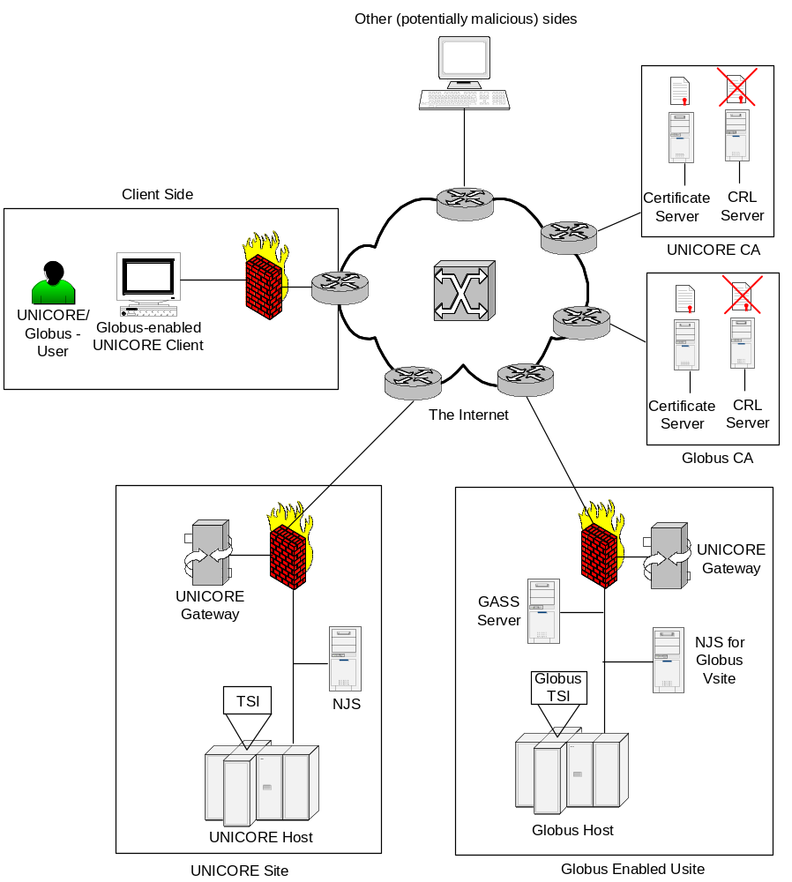
Figure 1

The following components have to be considered when evaluating overall system security:
- Client (user) site
- Internet
- Globus enabled Usite (Usite with optional Vsites)
- Globus target system
- Certificate Authorities

The Client Site
A client site normally consists of
- a client computer (workstation, PC),
- the Intranet of the company, institution or user’s home office and
- a firewall with dedicated gateways (mail gateway, http gateway, etc.).
A client site can be divided into an application and a security part. The major component is the (Globus enabled) client workstation where the application program(s) are executed. It also represents the most sensitive component of the client site’s security infrastructure.
The client site’s firewall protects the Intranet from direct attacks from the Internet. However, there are still ways for hackers from outside the Intranet to gain access to the client computer, e.g. through malicious web applets or e-mail viruses. Also, internal attacks play a significant role in Intranet security. According to security studies more than 70% of hacking attacks are originated from a company’s Intranet [MetaGroup].
A Globus enabled client workstation maintains several security sensitive objects:
- private key of the user’s UNICORE certificate
- private key of the user’s Globus certificate
- access control to the user’s PC or workstation (e.g. password file or Single-Sign-On client)
- (sensitive) application data
The UNICORE and Globus certificates’ private keys are highly sensitive objects. Intruders who get hold of those keys are able to submit jobs on behalf of the user. Special care has to be taken to protect the keys either through very good pass phrases or by using smart card storage media. In particular, the Globus certificate’s private key is stored as a pass phrase protected plain file in PKCS#1 format. In contrast, UNICORE uses a password protected JAVA keystore to protect the user’s private key [HCH1].
Access passwords and key pass phrases become useless if the computer itself has been hacked. So, care has to be taken to protect the client from virus, web and other kinds of malicious attacks. A Trojan horse placed on the client system scanning for passwords and application data undermines further security steps within the process flow.
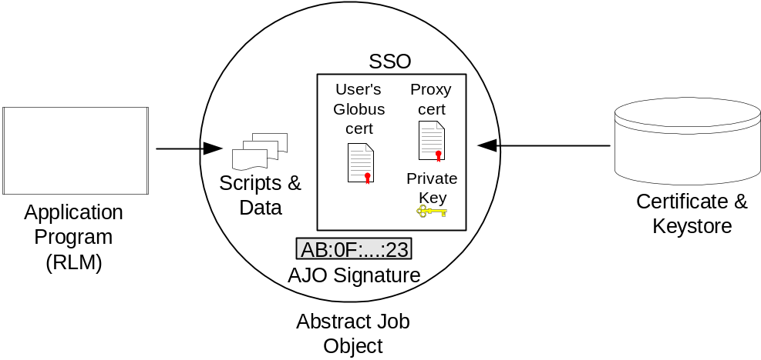
Figure 2
The relevant output of the user’s client is the extended Abstract Job Object as outlined in Figure 2. Besides the payload (scripts and data) the Globus enabled AJO contains a Site Specific Security Object (SSO) which consists of the user’s Globus certificate (public key), the newly created proxy certificate, signed with the user’s Globus certificate’s private key, and the unencrypted private key in PKCS#1 encoding belonging to the proxy certificate.

Proxy Certificates in Globus
Proxy Certificates in Globus are used by the Globus gatekeeper process to act on behalf of the client, i.e. the Globus user (Certificate Delegation). In contrast to the private key belonging to the Globus user certificate, the proxy certificate’s private key is unencrypted. This eases the use of the certificate because no password has to be entered and it also allows for Single-Sign-On. A proxy certificate may also be used to sign another proxy certificate [Globus].
A proxy certificate contains the identity of the original (physical) user and is marked as a proxy by adding “ /CN=proxy” to the common name field. However, a Globus site may only trust a proxy certificate if the whole certificate chain is validated bottom-up. For this purpose a Globus site has to validate
- proxy certificate n with proxy certificate n-1,
- proxy certificate 1 with the Globus user certificate,
- the Globus user certificate with the Globus CA n certificate,
- The Globus CA n certificate with the Globus CA n-1 certificate and
- the Globus CA 1 certificate with the top level root certificate.
According to the rules defined by the Globus Security Infrastructure (GSI) working group of GGF a Globus site should validate the whole certificate chain before trusting a proxy certificate and thus have to have access to all certificates within the chain.
The AJO is signed with the user’s UNICORE private key. The extended AJO is much more sensitive than a normal UNICORE AJO, because it contains the unencrypted private key of the proxy certificate. Data transfers across the Internet therefore have to use SSL connections. UNICORE already uses SSL connections in order to protect those network links. Thus, the required level of security is guaranteed without additional changes.
A further step in increasing security could be to encrypt the SSO with the target NJS’s certificate. This ensures that the private key can only be read by the target NJS [HCH2].

The Internet
The grid makes use of Internet connections to transfer jobs and data between client sites and HPCs as well as among HPCs.
Both UNICORE and Globus use SSL connections for all job and data transfers. Security of SSL connections depend on four factors:
- protection of the (asymmetric) private key used to decrypt the symmetric key when setting up the SSL connection
- strength of the asymmetric encryption (1024 bit should be minimum)
- strength of the symmetric encryption (128 bit should be minimum)
- validity period of the symmetric key (the shorter the more secure)
In plain UNICORE the required SSL encryption quality is determined by the confidentiality of the AJO payload. In Globus enabled UNICORE the encryption quality of SSL connections across the Internet must be high enough to protect the Globus proxy certificate’s private key which is submitted along with the AJO.
Intruders who get hold of the SSO are able to submit their own, potentially malicious jobs into Globus. This highly affects the system integrity of Globus HPCs.
To increase HPC security all Globus proxy certificates are only valid for a short time period (typically 12 hours).
Figure 3 summarizes the relevant security components of an SSL connection.
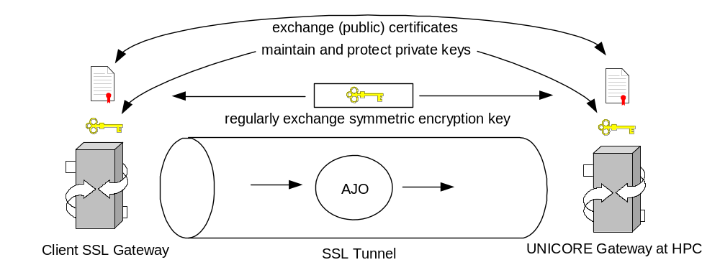
Figure 3
The UNICORE gateway maintains a gateway certificate together with the corresponding private key, while the client site holds its user certificate and private key. The public certificates are mutually exchanged between client and UNICORE site. The client site’s certificate is authenticated at the NJS (for further details see [Goss1]).

The Globus-enabled UNICORE Site
Like in plain UNICORE the UNICORE gateway of a Globus enabled Usite terminates the incoming SSL connection from a client site or from another HPC. It should log all incoming connections, so that security breaches can be traced back if necessary. The UNICORE gateway already logs incoming connections, so that possible intruders can be traced back if required.
The gateway then forwards the AJO to the Network Job Supervisor (NJS). Forwarding can be done unencrypted or by using an SSL connection again. For large Intranets SSL encryption should be chosen to protect the AJO from Intranet internal security breaches.
The Globus enabled target NJS has to perform the following steps:
- Decrypt the SSO with its private key which belongs to its NJS certificate. This step only applies if the SSO has been encrypted by the client computer.
- Verify the signature of the AJO with the user’s public certificate.
- Authorize the user according to the UUDB.
- Deconstruct the AJO and incarnate (Globus: ground) the component tasks according to the Incarnation Database (IDB) into executable scripts.
- Forward UNICORE sub-jobs to other UNICORE sites if required. Those sub-jobs are signed with the NJS’s private key and contain the job and the user’s original certificate.
Please note that Globus sub-jobs may be created by the Globus parent job, but are handled differently than UNICORE sub-jobs. Globus sub-jobs are not distributed by the NJS, but by the Globus target system.
From a security perspective the Globus enabled NJS plays a major role as it validates the integrity of an AJO, authorizes users and submits UNICORE sub-jobs to other HPCs. Furthermore, it receives the private key belonging to the Globus proxy certificate. The NJS does not store, but only forwards those proxy credentials. However, care has to be taken that no malicious software modules can be loaded onto the NJS server in order to ensure integrity and confidentiality of proxy credentials passing through.
So, the NJS has to be located in a secure environment and must not be accessible by malicious hackers. For this purpose, it should not be equipped with unnecessary software like SMTP, HTTP and FTP daemons and the corresponding client tools.
The NJS forwards the prepared scripts to the Globus TSI which represents the interface to the target host. The TSI may either run on the target host, on the machine the NJS is running on or on a separate workstation. Separating the TSI from the target host environment makes it possible to leave the target site unchanged. Practically, especially for security reasons, administrators of HPCs won’t permit to install additional interface software like the TSI on their machines, so the separated TSI architecture has been chosen by the GRIP project.
Figure 4 summarizes theesensitive components for the NJS.
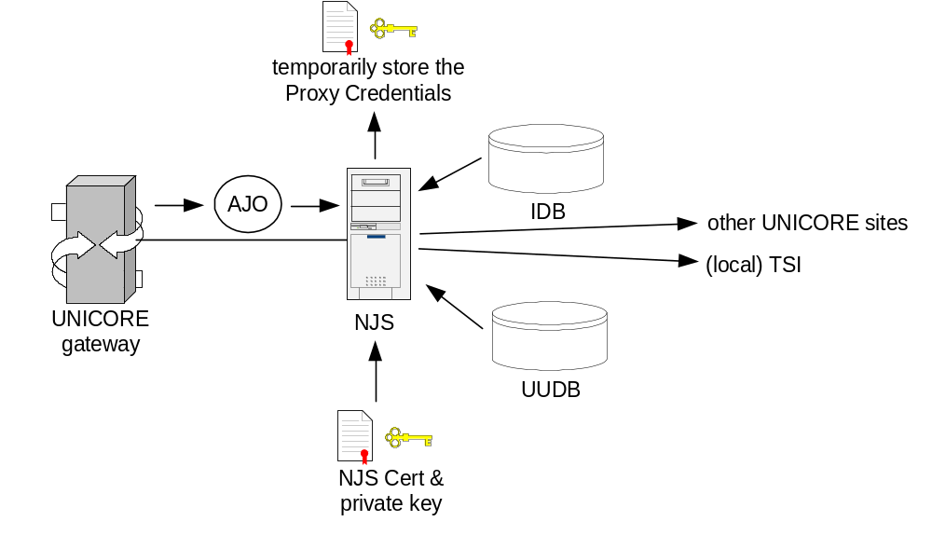
Figure 4
In contrast to the gateway which does not touch the AJO’s signature, the NJS has to extract the different components, job, data and proxy credentials.
So, the NJS has full access to the job, the data and to the proxy credentials which are sent along with the AJO.
A malicious hacker who gains control of the NJS could submit potentially malicious jobs to Globus hosts during the proxy certificate is valid.
Although, he could submit UNICORE and Globus jobs towards the local TSI, he wouldn’t be able to access a different NJS, because each NJS validates the AJO signature against the user’s certificate. As the user’s private key is not known by the NJS, a hacker would need to break into the user’s client workstation first to gain access to other NJS’ and to submit UNICORE jobs to other UNICORE sites. As Globus does not make use of signed jobs it is much more vulnerable in this regard.
The typical UNICORE and GRIP architecture demands the NJS server to be located in a secured environment protected by firewalls and other security measures (secure facility, protection against internal hackers, etc.) to protect the server against break-ins.

The TSI and the Globus Host
The TSI is a software module that may run on either the target host or any other workstation “behind” the NJS and represents the interface between NJS and the execution environment.
In UNICORE the TSI receives the job to be executed and the data to be processed. The output is stored into the user’s workspace, i.e. the user’s UNICORE account.
Besides job scripts and data the Globus TSI also receives the proxy credentials, i.e. the proxy certificate and the private key, from the NJS.
In contrast to UNICORE where sub-jobs are part of the AJO a user submits to a target host, Globus supports dynamic job creation out of a master process. So, a Globus job needs to have access to the proxy credentials in order to log into other Globus hosts and to submit sub-jobs and data on behalf of the user. If the TSI does not run on the target host, which is most likely for most installations, the proxy credentials have to be forwarded to the Globus host to allow the primary job for creating Globus sub jobs and for transferring data using GridFTP.
Because the NJS already decrypts the SSO, it has to be made sure that the data transfer between NJS and TSI is well protected. In case NJS and TSI are located on different machines it is recommended to use an authenticated, certificate based SSL connection between NJS and TSI. The NJS can use its own NJS certificate while the TSI needs another certificate. This is a new requirement in GRIP which is part of the security measures taken by the project.
In case the TSI does not run on the target host or at least within the secured environment of the target site, an encrypted data connection between TSI and target host is mandatory, especially if the proxy credentials are forwarded to the Globus target host. For this purpose Globus makes use of SSL connections to protect all data transfers from and to target systems.
To establish the SSL connection both TSI and Globus host may use their already installed server certificates.
Figure 5 summarizes the most relevant security architectural components.
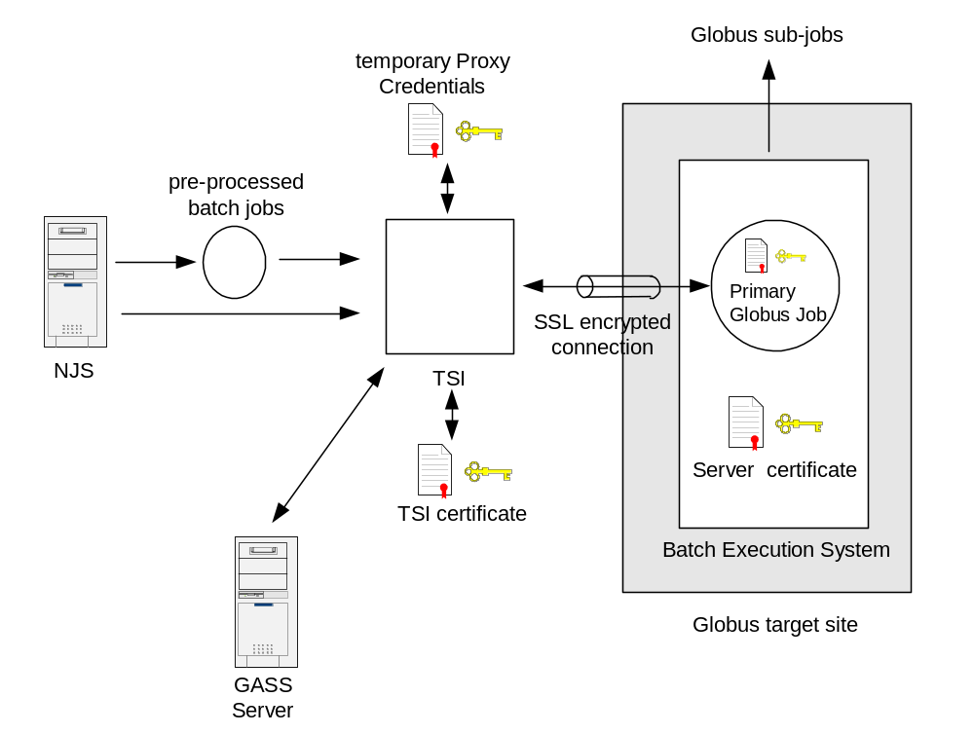
Figure 5
Other solutions which simplify TSI maintenance but keep a distinct level of security are currently being investigated [HCH2].
The GASS server is used as the UNICORE file store, so that the Globus job manager can transfer files to and from the GASS server. It serves as a data managing server for job execution. While handling of stdout and stderr are done automatically via the GASS server, all other files have to be transferred manually [HCH2].
In terms of security there are four very sensitive objects around the TSI which need to be well protected from intruders:
- Proxy credentials (proxy certificate and private key) which are received and forwarded by the TSI. So, the TSI must be as well secured as the NJS (see 3.3 for further information about the NJS).
- The Globus host itself is sensitive because all data including the user’s batch job(s) are easily accessible to third parties having appropriate administrative rights on that machine.
It has to be made sure that unnecessary software like web browsers, e-mail clients, etc. are removed from the host to give hackers as little chance as possible to gain access to the machine.
- The Globus host uses an own host certificate to establish SSL connections to other (Globus) hosts and user clients and thus have to have the appropriate private key stored within the file system.
- The GASS server which stores job data must also be well protected from third parties.
While the proxy certificate is valid a Globus job may dynamically create sub-jobs and submit them to other Globus hosts. Although, dynamic job creation might be an advantage for large jobs, the security impact might be huge:
- The user has to make sure that all hosts to which sub-jobs might be sent are reliable. So, a user must be aware of the Globus host architecture and needs to be able to evaluate the security level of each affected Globus target host before he submits his main job.
Those requirements might lower the advantage of the Single-Sign-On concept using proxy certificates in Globus.
- A security breach within the primary Globus host can enable intruders to manipulate a user’s job so, that it creates sub-jobs and sends them together with relevant data to foreign Globus systems.
In contrast to UNICORE, Globus jobs are not signed with the user’s own private key, so that a secondary Globus host cannot prove job integrity.
- Proxy certificates are signed with the user’s private key. A secondary Globus site could read user information from the proxy certificate and its signature.
Globus hosts should validate the signature against the user’s certificate to empower system administrators to detect evil users. If the signature is not validated, Globus jobs could run almost anonymously on Globus hosts.
Signature validation requires access to the whole certificate chain (see 3.1.1). So, a Globus site has to receive all relevant certificates together with the job or requires access to a global certificate repository (CAS Project [Globus]).
- Proxy certificates can be manipulated on the NJS server and the TSI or Globus host. As both the certificate as well as the private key are submitted in a package, an intruder could manipulate those credentials when he gains access to either of the two systems.
Because Globus jobs are not signed, tracking down users according to the submitted proxy certificates is not 100% reliable.

The Public Key Infrastructure
Both the UNICORE and the Globus security concept heavily depend upon Public Key Infrastructures (PKIs).
As GRIP combines UNICORE and Globus at least two PKIs are required. In fact at least four Certificate Authorities are involved:
- UNICORE PKI
- Globus PKI
- Client PKI
- Globus Gatekeeper PKI

The UNICORE PKI
The UNICORE PKI issues certificates for users, gateways, NJS’, and in GRIP also for TSIs. During the UNICORE and UNICORE Plus project phases a centralized PKI with one Certificate Authority was used. Now, UNICORE develops towards a distributed PKI with multiple CAs following the concept of Virtual Organizations.
Without loss of generality we assume that a centralized PKI will be used. In the GRIP project that is the case for Deutscher Wetterdienst who has set up its own CA and registered it with the Globus test site at the University of Manchester.
The UNICORE CA offers a Certificate Revocation List (CRL) for certificate validation. UNICORE certificates are needed for each UNICORE user, for the UNICORE gateway, the Globus enabled NJS and, this is special to GRIP, for the Globus enabled TSI.
Further information about the GRIP PKI can be found in [Goss2].

The Globus PKI
Globus certificates are issued from Globus CAs. Like in UNICORE there are user and server certificates. A Globus user may apply for a certificate at the Globus CA by e-mail at ca@globus.org and receive his Globus user certificate as well as his private key via e-mail. This complies with a VeriSign Class 1 certificate as there is no formal authentication process unlike in UNICORE where a user has to show up at a Registration Authority and show her ID card. However, other Globus CAs do utilize different, far more secure authentication mechanisms complying to VeriSign Class 2 and Class 3 certificates.
The new GridPMA working group [GridPMA] of GGF tries to gather CA certificates, CPs and CPS’ of different Globus CAs to summarize and to make those information available to the community.
Like the UNICORE CAs each Globus CA also issues a Certificate Revocation List. Currently, Globus does not support seamless CRL checking in a CA hierarchy. Thus, a flat PKI architecture should be used to guarantee a secure PKI environment.
To prevent a user from using any Globus resource at any time it is sufficient to remove the appropriate entry from the resource's grid map file [Globus] which is similar to UNICORE where a user is removed from the UUDB.
In GRIP each user requires a Globus user certificate. Also, a Globus target host needs Globus server certificates in order to establish authenticated SSL connections to other Globus sites.

The Client PKI
Each Globus enabled UNICORE client is equipped with a Globus proxy certificate plugin. Before a job may be submitted to a Globus target system a proxy certificate has to be created by the plugin. The proxy certificate is signed with the private key of the Globus user certificate.
This makes the proxy plugin become an individual CA (so-called Proxy CA) with the Globus CA as its superordinate CA.
The Proxy CA does not issue a CRL because proxy certificates are only valid for a short time period (typically 12 hours).

Globus Gatekeeper
Furthermore, a proxy certificate is allowed to sign further proxy certificates. This makes the Globus gatekeeper process become an additional CA as the gatekeeper may issue and sign subordinate proxy certificates if permitted.
Like the initial proxy certificate all depending proxy certificates are also valid for a limited time period (typically 12 hours). All Proxy CAs abandon the option to issue Certificate Revocation Lists.

CA Security
Each CA has to well protect its private key(s) which it signs customer certificates with. This also applies to Proxy CAs which issue proxy certificates. Professional CAs like the UNICORE and Globus CA use dedicated servers not connected to external networks and free from unnecessary software to store their own private keys and to sign customer certificates on. Furthermore, those CAs also follow dedicated Certificate and Security Policies.
In contrast to professional CAs a Proxy CA runs on a normal client workstation or supercomputing host not following such very strict Certificate and Security Policies. They are normally attached to the company’s or any other organization’s Intranet and mostly run additional tools like e-mail or other communications programs.
A user of a Globus-enabled UNICORE client must be aware of running a highly sensitive CA on her machine which needs to be very well protected from intruders and third parties. The best protection is to store the private key of the Globus user certificate as well as the private key of the UNICORE user certificate on a PIN protected smart card.
At least both private keys must be protected by good pass phrases. In case of a soft keystore, the client should not be used for Internet browsing, e-mail reception or any other unnecessary communications processes.
In GRIP overall CA security is as strong as the weakest CA in use. A very secure UNICORE CA could not balance a weak Globus CA and vice versa. Due to the Globus proxy certificate plugin running on the client, overall security also heavily depends upon protection of the user’s PC, resp. workstation.

Reliability, Availability, Integrity and Confidentiality
Grid users have certain demands for availability and reliability of computing resources as well as for data integrity and confidentiality. These are mostly contractual claims which especially commercial users have to arrange with their target computing sites by negotiating appropriate Service Level Agreements (SLAs).

Availability and Reliability
A grid network is aimed to provide reliable computing power to the users. To achieve maximum reliability and availability the number of accessible target HPCs could be chosen so, that the users’ requirements for computing power and storage capabilities are satisfied even if one or more HPCs in the grid are down or busy.
Furthermore, Service Level Agreements (SLA) can stipulate certain requirements and thus guarantee dedicated levels of availability, reliability, security and other target values required by the customer. This might be interesting especially for commercial users.
The GRIP project is another step in increasing the available computing power and data storage capabilities by making Globus resources available to UNICORE users.
Both UNICORE and Globus are currently developing resource brokers to dynamically assign computing resources to UNICORE and Globus jobs. However, users still need accounts on the target systems for authorization. In UNICORE each site verifies the received and signed jobs according to the well-known user certificates while in Globus the target sites rely on proxy certificates. However, those proxy certificates are also directly linked to well-known user certificates.

Integrity
While availability and reliability can be assured by SLAs and enough potential target HPCs, data integrity is an immanent feature of the security model of each grid.
In UNICORE each AJO is signed with the user’s private key, so that each target site can validate the job’s integrity by decrypting the signed hash and comparing it to the re-hashed AJO. This guarantees data integrity from the user client up to the target host. Even data integrity of sub-jobs is guaranteed as they are re-signed by using the primary NJS’s private key.
However, a user cannot make sure that her jobs won’t be manipulated on the target machine(s) just before execution. Again, SLAs have to be made to ensure distinct trust levels between users and HPC administration(s).
Globus jobs are not signed, so guaranteeing data integrity in Globus is much more difficult than in UNICORE. Like in UNICORE Globus also uses SSL connections to submit jobs from users to hosts and among hosts. Because sub-jobs may be created during runtime, a secondary Globus host might receive malicious jobs with manipulated proxy certificates.
In GRIP a modified NJS decodes the AJO, removes the signature and together with the TSI creates appropriate Globus jobs. So, data integrity through signed AJOs can only be assured between user and NJS server. The link between NJS, TSI and Globus host is critical in this architecture. To protect the data on that link an authenticated SSL connection is used. Authentication is guaranteed by using dedicated NJS and TSI server certificates. The public certificates have to be mutually exchanged between NJS and TSI, so that a one-to-one trust relationship is established.

Confidentiality
Confidentiality is similar in both Globus and UNICORE. Both grids use SSL connections to transfer jobs and data. To guarantee confidentiality at UNICORE and Globus target sites nondisclosure agreements and SLAs have to be signed by the persons in charge.
The same applies to Globus-enabled UNICORE sites.

Security Interoperation
The most sensitive point in Globus enabled UNICORE is the creation, storage and transmission of the proxy certificate.
This makes the whole chain from the client workstation to the Globus target host much more sensitive to hacker attacks than in plain UNICORE.
Both the Globus-enabled NJS server and the Globus TSI are normally located within an HPC. The responsible system administrators having the appropriate security know how are able to well protect those systems from direct attacks (hacker attacks from the external or internal network) and indirect attacks (web applets, e-mail viruses).
The users’ client workstations equipped with the Globus proxy certificate plugin on the other hand are not as easy to manage. As stated above (see chapter 4) each Globus-enabled client carries a Proxy CA, so extreme care has to be taken to protect the permanent private keys (UNICORE user certificate’s private key and Globus user certificate’s private key) as well as the temporary proxy certificate’s private key from
- direct hacker attacks,
- attacks through web applets and ActiveX programs,
- virus attacks and
- Trojan horses trying to scan passwords and pass phrases from the keyboard.
In a sensitive environment UNICORE and Globus users should use smart cards to store their permanent private keys.
However, as Globus makes use of temporary proxy certificates, those keys cannot be stored on smart cards and remain unencrypted within the file system of the client workstation and, at least temporarily, on the target host(s).
So, even while using smart card technology the client workstation still has to be well protected against third parties. This can only be achieved by an adequate sense of responsibility of the user. He has to avoid any kind of unnecessary (communications) software. Furthermore, he has to protect the client from any unauthorized physical or non-physical access.
Appropriate nondisclosure agreements and Service level Agreements can guarantee a certain level of security in terms of chapter 5 for the HPC target hosts.

Further Improvements
While smart card technology would improve keystore security, dealing with two different user certificates would still mean security degradation. The more certificates and private keys a user has to protect the higher is the risk to loose integrity for at least one of them.
According to [HCH1] generating proxy certificates out of existing UNICORE user certificates would technically be possible. Globus host administrators would have to accept user certificates issued by other CAs when validating proxy certificates’ signatures. However, this could mean additional administrative efforts for Globus administrators.
The concept of Virtual Organizations in UNICORE and the similar concept in Globus allow for well-defined trust relationships around dedicated CAs.

Summary
Security interoperation plays an important role in GRIP as the GRIP project links together both security models of UNICORE and Globus.
Although, both security models rely on Public Key Infrastructures, they differ in certain points. While UNICORE uses signed job objects for guaranteeing data integrity, individual user certificates for authentication and a pre-defined sub-job structure, Globus does not make use of job and data signing. For highly dynamic job creation, brokerage and data transfers (GridFTP) Globus relies on proxy certificates.
The GRIP project combines both grid worlds and thus have to link together both security models. Major changes had to be made within the TSI to translate a UNICORE AJO into Globus scripts. Furthermore, NJS and TSI need to log the UNICORE user into the Globus host by using a proxy certificate which the NJS receives from the user’s client workstation.
Guaranteeing a secure handling of proxy certificates is a major issue in GRIP. Intruders getting hold of proxy credentials would be able to run Globus jobs on behalf of the user (impersonation). The most critical point is the (unencrypted) proxy certificate’s private key which needs to be transferred along with the certificate itself.
Proxy credentials are needed by the Globus host in order to allow for dynamic job creation, job submission to other Globus hosts, job monitoring and file transfer (GridFTP) on behalf of the user.
For confidentiality both models make use of SSL connections to transfer data across insecure internal (Intranet) and external (Internet) networking connections.
PKI security depends on protection of private keys. UNICORE utilizes a password protected JAVA keystore at the client site while Globus uses PKCS#1 encoded private keys (plain files which are password protected). Smart card technology would heavily improve the security of the keystore of both UNICORE and Globus. However, proxy certificates’ private keys may not be protected by pass phrases because they are intended for Single-Sign-On technology.
On the HPC site security measures are mostly hidden to the user. Although, system security of gateways, NJS servers and hosts are indispensable for overall security, UNICORE and Globus users require binding agreements defining system availability, reliability and confidentiality. Such agreements have to be written down in Service Level Agreements and nondisclosure agreements.
HPCs on the other hand have to make sure that users follow their rules and regulations for which they also may have to sign certain contracts.
Finally, UNICORE users have to be aware of the different security models when submitting jobs into Globus. However, the current security measures, which consequently make use of SSL connections in order to guarantee data confidentiality, guarantee an appropriate level of security, which is equivalent to pure Globus security.
A major prerequisite for PKI based security is to accurately check the whole certificate chain bottom-up, especially in Globus which utilizes proxy certificates for Single-Sign-On. However, as proxy certificates are submitted along with their private keys, intruders might much more easily compromise Globus security.
Overall security in GRIP is equivalent to Globus security. All sensitive connections are SSL protected and handling of proxy certificates is similar to that of Globus. So, accessing Globus resources through UNICORE using GRIP technology is as secure as using plain Globus, but far more flexible by having access to both worlds of UNICORE and Globus through the same client.

Bibliography

[HCH1] Hans-Christian Hoppe, Thomas Kentemich, Dr. David Snelling:
Interoperability Software Requirements Specification
May 2002
GRIP, Deliverable D2.1a, IST-2001-32257
[HCH2] Hans-Christian Hoppe, T. Kentemich, Dr. D. Snelling, P. Wieder:
Specification of interoperability modules
August 2002
GRIP, Deliverable D2.1b, IST-2001-32257
[Goss1] Torsten Goss-Walter, Reinhard Letz:
An Analysis of the UNICORE Security Model
October 2002
Global Grid Forum
[Goss2] Torsten Goss-Walter, Reinhard Letz:
The GRIP PKI and Certificate Policy
March 2003
Global Grid Forum
[UNICORE] http://www.unicore.org

[Globus] http://www.globus.org

[GRIP] http://www.grid-interoperability.org

[GGF] http://www.gridforum.org

[GridPMA] http://www.gridpma.org

[MetaGroup] http://www.metagroup.com

Appendix A : Glossary
AJO | Abstract Job Object
CA | Certifying Authority
CP | Certificate Policy
CPS | Certificate Practice Statement
CRL | Certificate Revocation List
GASS | Global Access to Secondary Storage
GCP WG | Grid Certificate Policy Working Group
GGF | Global Grid Forum
GridPMA | Grid Policy and Management Authority
GRIP | Grid Interoperability Project
HPC | High Performance Computing Center
IDB | Incarnation Database
NJS | Network Job Supervisor
PKI | Public Key Infrastructure
RA | Registration Authority
SLA | Service Level Agreement
SSL | Secure Socket Layer
SSO | Site Specific Security Object
TSI | Target System Interface
U-CA | UNICORE CA
U-Site | UNICORE-Site
UUDB | UNICORE User Database
V-Site | Virtual Sites (within a U-Site)

Appendix B : Security Considerations

Author Information
Torsten Goss-Walter | Deutscher Wetterdienst  Kaiserleistrasse 44  63067 Offenbach  Germany | Torsten.Goss-Walter@dwd.de
Dr. Sven van den Berghe | Fujitsu Laboratories of Europe  Hayes, Middlesex, UB4 8FE  United Kingdom | s.vandenberghe@fle.fujitsu.com

Intellectual Property Statement

The GGF takes no position regarding the validity or scope of any intellectual property or other rights that might be claimed to pertain to the implementation or use of the technology described in this document or the extent to which any license under such rights might or might not be available; neither does it represent that it has made any effort to identify any such rights. Copies of claims of rights made available for publication and any assurances of licenses to be made available, or the result of an attempt made to obtain a general license or permission for the use of such proprietary rights by implementers or users of this specification can be obtained from the GGF Secretariat (see contacts information at GGF website).

The GGF invites any interested party to bring to its attention any copyrights, patents or patent applications, or other proprietary rights which may cover technology that may be required to practice this recommendation. Please address the information to the GGF Executive Director.

Full Copyright Notice

Copyright (C) Global Grid Forum (2003). All Rights Reserved.

This document and translations of it may be copied and furnished to others, and derivative works that comment on or otherwise explain it or assist in its implementation may be prepared, copied, published and distributed, in whole or in part, without restriction of any kind, provided that the above copyright notice and this paragraph are included on all such copies and derivative works. However, this document itself may not be modified in any way, such as by removing the copyright notice or references to the GGF or other organizations, except as needed for the purpose of developing Grid Recommendations in which case the procedures for copyrights defined in the GGF Document process must be followed, or as required to translate it into languages other than English.

The limited permissions granted above are perpetual and will not be revoked by the GGF or its successors or assigns.

This document and the information contained herein is provided on an "AS IS" basis and THE GLOBAL GRID FORUM DISCLAIMS ALL WARRANTIES, EXPRESS OR IMPLIED, INCLUDING BUT NOT LIMITED TO ANY WARRANTY THAT THE USE OF THE INFORMATION HEREIN WILL NOT INFRINGE ANY RIGHTS OR ANY IMPLIED WARRANTIES OF MERCHANTABILITY OR FITNESS FOR A PARTICULAR PURPOSE."

Change History
Date | Comment | Author
04/30/03 | Document structure | T. Goss-Walter
05/12/03 | Initial Release | T. Goss-Walter
05/14/03 | Published for review on BSCW | T. Goss-Walter
05/27/03 | Changes according to TSI requirements | T. Goss-Walter
07/07/03 | Document reviewed by Fujitsu | S. van den Berghe
07/09/03 | Document updated according to review | T. Goss-Walter
10/01/03 | Minor updates according to running project | T. Goss-Walter
10/31/03 | Minor updates according to running project | T. Goss-Walter

Currently, Globus 2 does not fully support hierarchical PKIs (CA chain). This is due to insufficient CRL validation.
Globus jobs are not signed at all. Due to the Single-Sign-On concept using proxy certificates “user-oriented” job signing is not possible. User oriented job signing would require the user’s private key.
Technically, it is possible to use the same PKI in UNICORE and Globus. However, it must be possible to deal with separate PKIs to allow for maximum compatibility.
There are also secure online CAs. However, those CAs will not be considered in this document.
The only changes made to the NJS were to handle proxy certificates.

