Access

Information Dissemination in the Grid Environment

Status of This Memo

This memo provides information to the Grid communities. The intention is to define a standard. Distribution is unlimited.

Copyright Notice

Copyright © Global Grid Forum (2002). All Rights Reserved.

Abstract

Grids applications must be able to access, manage and share data in a timely fashion at a very large scale and potentially across organizational boundaries. Challenges arise from the number and variety of involved parties, the size of the data, the number of recipients (consumers) of each data element and the geographical distance. Critical data must be protected while providing efficient access to and distribution of these data with the required Quality of Service (QoS).

“Information Dissemination” (INFOD) addresses these requirements. INFOD supports timely and efficient data dissemination of customized information mainly based on consumer’s needs. It is assumed that the data to be disseminated are created in response to an event. Therefore, a key objective is to disseminate data as soon as it becomes available.

The outline of the paper is as follows. First we provide a short introduction of INFOD – a more detailed introduction along with Use Cases can be found in [INFODU]. Second we define the INFOD information that is kept and managed in registries. Then we describe in detail the operations that are introduced to support the new functionality. Finally, we discuss security, describe an UML profile of INFOD, and provide the XML schema and WSDL, as well as a Glossary.

Note: Upgrades are planned in preparation of GGF14. In addition, the functionality introduced in this document will eventually be packaged as 3 related specification documents. This follows the standard Web services practice of having small composable specifications, and makes the functional layering of the total specification more apparent to readers.

Contents

Abstract 1
1. Introduction 4
1.1 Goals 5
1.2 Non-Goals 6
1.3 Items to follow-up on 6
2. The INFOD Resources, Messages and Registration Manager 7
2.1 The INFOD Resources: INFOD Entities and INFOD Artifacts 7
2.2 The INFOD Resource: The Sections 7
2.2.1 INFOD Resource: Core Section 8
2.2.2 INFOD Resource: Constraint Section 9
2.2.3 INFOD Resource: Scheduling Section 10
2.2.4 INFOD Resource: Policies Section 10
2.2.5 INFOD Resource: Processing Section 11
2.3 The INFOD Messages 11
2.4 The INFOD Registration Manager 12
3. Interfaces 13
3.1 Overview 13
3.1.1 The INFOD Interfaces 13
3.1.2 The INFOD Interfaces’ operations 14
3.1.3 Scenarios with INFOD Publisher, Consumer and Registration Manager 15
3.1.4 Scenarios with INFOD Disseminator 16
3.2 The INFOD Registration Manager Interface 18
3.2.1 Creating a Subscription 18
3.2.2 Altering a Subscription 21
3.2.3 Dropping Subscription 22
3.2.4 Accessing Subscription metadata 23
3.2.5 Creating a Publication 24
3.2.6 Altering a Publication 26
3.2.7 Dropping Publication 28
3.2.8 Accessing Publication metadata 28
3.2.9 Creating a Consumption 29
3.2.10 Altering a Consumption 32
3.2.11 Dropping Consumption 33
3.2.12 Accessing Consumption metadata 34
3.2.13 Creating Dissemination 35
3.2.14 Altering a Dissemination 37
3.2.15 Dropping Dissemination 39
3.2.16 Accessing Dissemination metadata 40
3.2.17 Creating Subscriber 41
3.2.18 Altering Subscriber 41
3.2.19 Dropping Subscriber 41
3.2.20 Creating Publisher 41
3.2.21 Altering Publisher 41
3.2.22 Dropping Publisher 41
3.2.23 Creating Disseminator 41
3.2.24 Altering Disseminator 41
3.2.25 Dropping Disseminator 41
3.2.26 Creating Consumer 41
3.2.27 Altering Consumer 41
3.2.28 Dropping Consumer 41
3.3 The NotifyUpdate Interface (optional) 41
3.3.1 Publishing Metadata Updates 41
3.4 The INFOD Disseminator Interface 42
3.4.1 Disseminator Interface 42
3.5 The INFOD Consumer Interface 43
3.5.1 Consumer Interface 43
4. Security Considerations 44
4.1 Securing the Message Communication between the INFOD Services 44
4.2 Message Encryption and Data Privacy Requirements 45
4.3 Integration with authorization model 45
5. Appendix I – UML 45
6. Appendix II – XML Schema 46
7. Appendix III – WSDL 1.1 46
8. Appendix IV – Vocabulary Management 46
9. Appendix V – Transactions Management 47
Author Information 48
Glossary 49
Intellectual Property Statement 51
Full Copyright Notice 52
References 52

Introduction

Information Dissemination (INFOD) allows data sources to share data with the appropriate entities that eventually consume it in a timely fashion.

State changes cause events to be generated and events cause messages to be generated and sent to the entities that eventually consume them.

States
Events
Messages
Filters
Consumptions

Figure 1 – INFOD Base Model

INFOD uses the term publisher to reference the entity that creates messages, consumer to reference the entity that eventually consumes the message and subscriber to reference the entity matching publishers’ data with consumers needs. INFOD allows publishers, subscribers and consumers to influence what is considered an event, what message gets published and who the consumers are. Disseminators can be used as intermediaries between publishers and consumers. Disseminators are designed to provide efficient asynchronous distribution of messages as well as indirection between publishers and consumers; i.e., publishers do not need to know the target consumers and nor the consumers the publishers. Publishers and consumers might use the services of multiple disseminators. A message might need to pass through more than one disseminator.

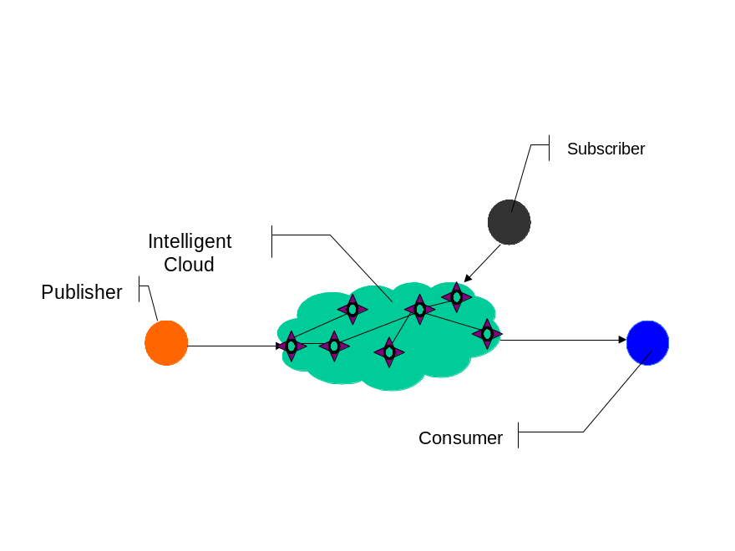
Figure 2 - INFO Elements

Messages are typically disseminated from publishers to consumers. However, publishers (or disseminators) can also alert consumers of the existence of data and consumers can retrieve these data at their convenience.

Publications, dissemination and consumptions are the artifacts that execute the actions directed by publishers, subscribers, disseminators and consumers. A publication specifies and makes available for discovery and delivery a particular set of messages, events, and/or states. A subscription specifies which messages are to be delivered to which consumers. A dissemination specifies a mechanism by which messages are propagated from producer to consumers. A consumption specifies the mechanism by which particular messages are applied by consumers.

The INFOD Registration Manager manages the information about publishers and publications, subscribers and subscriptions, disseminators and dissemination and consumers and consumptions. However, this information might be cached as required; subscription support will ensure up-to-date information.

The delivery of messages is only meaningful if there is a shared understanding between publisher and consumer of the content. A prerequisite for this common understanding is a vocabulary management. Furthermore, messages may contain sensitive information only to be delivered to consumers with the right and need to know; the consumers may only be willing to receive message from qualified resources. Identity management provides this functionality. INFOD considers vocabulary and identity management as core services.

A more detailed discussion about the INFOD model and Use Cases can be found in [INFODU]. It is assumed that the reader has some familiarity with [INFODU].

Goals

In meeting its goals, the INFOD specification must explicitly address the following requirements:

- Subscribers must be able to select publishers of interest: Subscriber must be able to specify which publishers are of interest to consumers. If subscribers use filters to identify publishers they must be able to request confirmation of eligible publishers. Furthermore, subscribers must be able to request notification if the list of eligible publishers changes.
- Subscribers must be able to select messages of interest: Subscribers must be able to specify which messages are of interest to which consumers.
- Publishers must be able to select consumers: Publishers must be able to specify eligible consumers as well as the appropriate consumers for each message.
- Subscribers must be able to use vocabulary management to select messages of interest: Subscribers must be able to specify which messages are of interest without explicitly defining a specific (set of) publisher(s). Subscribers must be able limit the selection of publishers.
- Subscribers may be able to specify which messages should be published in response to an event: If publishers expose events subscribers must be able to specify which events are of interest and which message should be created in response to an event.
- Subscribers may be able to define what is considered a single event: If publishers expose states subscribers must be able to define what is considered an event and what message should be created in response to an event. Events may be based on the expiration of time. Events can be based on any retained or future state.
- Subscribers must be able to correlate events to form new (composite) events: Subscribers must be able to combine events to create new events. Composite events may be created in response to messages, events, and state changes.
- Consumers must be able to specify dynamically how and when messages are received: Consumers should be able to specify the distribution channel for receiving messages based on message content, their own status as well as external factors, such as time of day. Additionally, consumers may request notifications about the existence of a message as well as reminders they have not consumed these messages in time. Furthermore, consumers must be able to specify the reaction(s) in response to a message.
- Consumers must be able to limit the messages received: Consumers must be able to specify which messages can be delivered.
- Consumers may be able to retrieve past messages: Consumers must be able to access past messages.
- Publishers, consumers and subscribers must be able to specify QoS requirements: QoS requirements relate to security, performance, scalability, reliability, transactional publications and consumptions, exactly once propagation to one or more consumers as well auditing and tracking.
- Publishers, subscribers and consumers may be known to Identity Management: In case that security is of importance, Identity Management will be used to verify information about publishers, subscriber and consumers.
- It must be possible to use multiple filters: Filters are used to select messages, publishers, subscribers and disseminators. It must be possible to specify multiple filters; INFOD will ensure proper composition.

Non-Goals

The following requirements are outside the scope of the INFOD specifications:

Specification of vocabulary management: INFOD depends on vocabulary management. INFOD assumes the existence of a vocabulary management services. Detailed requirements will be developed in consultation with the OGSA team since it is assumed that vocabulary management is an important service for the majority Grid services.

Specification of identity management: INFOD depends on identity management. INFOD assumes the existence of a identity management services. Detailed requirements will be developed in consultation with the OGSA team since it is assumed that identity management is an important service for the majority Grid services.

Synchronization of registries: INFOD does not provide methods of synchronizing registries. Users may do so by using INFOD technology. Synchronization of registries may become a use case once the specifications reach a mature state.

Discovery services: The Registry Management does not support discovery. A discovery service would require the ability to support vocabularies transformation.

Negotiation services: INFOD services may support a wide variety of QoS requirements. INFOD does not specify how to negotiate a QoS selection, neither for a single nor for a set of competing services.

Optimization services: Filters are used to identify events, select events, and/or to select consumers. In many cases, various components (publishers, disseminators and consumers) can apply/process these filters. INFOD does not attempt to identify which component(s) are optimal in a specific context. However, it provides the means for optimization.

Items to follow-up on

The following items are not described in this version of the INFOD specifications and will be addressed later:

Operations: information to control the operations like start, stop, pause and resume that apply to INFOD resources are not specifically addressed in this version of the specifications. The OGSA profile or other resource management service will be used to describe such requirements.

Resource Management: topics like the naming, versoning and change management of resources is not part of the INFOD scope yet some specific components are expected by the INFOD model, in particular: time of a change, a reference to an identity to record responsibility for the change, time when a version becomes valid, time when a version expires, a schedule when this version is valid, etc.

Factoring of this specification into related specification documents: the proposed factoring is as follows, from simple to more complex scenarios:
- Information Dissemination from publishers to consumers, allowing subscribers to subscribe on behalf of 3rd party consumers
- Information Dissemination with one or more disseminators, but without propagation requirements between disseminators (disseminators do not talk to each other yet provide decoupling of publishers/subscribers/consumers interaction)
- Information Dissemination with one or more disseminators and with possible propagation between disseminators (delivery of the ‘intelligent cloud’ of figure 2 above).

The INFOD Resources, Messages and Registration Manager

This section formally introduces the INFOD resources, the INFOD messages and then describes how these resources and messages are defined in, and used by, the INFOD Registration Manager.

Please note:

The names of the vocabulary are subject to changes
The detailed specifications are provided in 6, Appendix II titled XML Schema.

The INFOD Resources: INFOD Entities and INFOD Artifacts

There are two types of INFOD resources:

INFOD Entities: subscribers, publishers, disseminators, consumers
INFOD Artifacts: subscriptions, publications, disseminations, consumptions

The description of each of these resources shows a high level of similarity. The INFOD model exploits this similarity by defining a common structure to describe any INFOD resource. This common structure is divided into five sections, which are described in detail below.

The INFOD Resource: The Sections

Each INFOD resource contains a set of components, which are grouped into the following sections:

A core section, common across all resources; describes the basic properties of entries

A constraint section, optional and/or applicable to either INFOD entities only, INFOD artifacts only or both; describes the properties, vocabularies and filters of entries

A scheduling section, optional and/or applicable to either INFOD entities only, INFOD artifacts only or both; describes schedules for dissemination (in particular for propagation, the dissemination of data between two different INFOD disseminators) and notification (the dissemination of data from a disseminator to a consumer)

A policies section, optional and/or applicable to either INFOD entities only, INFOD artifacts only or both; describes operational characteristics associated with the resource

A processing section, optional and/or applicable to either INFOD entities only, INFOD artifacts only or both; describes procedures that may affect message creation, transformation, composition and consumption

INFOD Resource: Core Section

The core section is mandatory for every INFOD resource but not all components of the core are mandatory, as outlined below.

Here is the list of components of the Core section:

INFOD_Type

Specifies the type of this entry
The following values are valid and imply an entity: Publisher, Subscriber, Consumer, Disseminator
The following entries are valid and imply an artifact: Publication, Subscription, Consumption, Dissemination
Valid for both INFOD entities and INFOD artifacts
Mandatory component. Only one value allowed

INFOD_Identifier

Uniquely specifies the URI of this entry
Note1: A reference to the relevant OGSA specification will be added
Note2: also specifies a reference to an entry in an Identity Management service, in particular for supporting security policies. A reference to the relevant OGSA specification will be added.
Valid for both INFOD entities and INFOD artifacts
Mandatory component (for non-‘create’ operations). Only one value allowed

INFOD_Name

Specifies a descriptive name for this entry
Note: A reference to the relevant OGSA specification will be added
Valid for both INFOD entities and INFOD artifacts
Zero or one value allowed

INFOD_Resource_Reference

Specifies the relationship between one INFOD resource and other INFOD resources
There are three types of INFOD Resource references due to the relationship between INFOD resources:

Specification of a relation between an artifact and its entities; which artifact is related to which entities. It is important that the types between source and targets match: E.g., a publication has to reference publishers.

Specification of a relation between entities and artifacts; which entity is related to which artifacts. It is important that the types between source and targets match: E.g., a publisher has to reference publications.

Specification of a relation between artifacts themselves; in particular, between dissemination and publication/consumption. There is the notion of local or home dissemination. Certain functions can only be used with the home dissemination; e.g., transactional support. Additionally, the home dissemination provides some functions such as retention, auditing and tracking and non-repudiation.

A filter has to reference INFOD_Identifiers, by either explicitly specifying URIs and/or implicitly using a filter against properties and/or vocabularies of these identities. Additionally, a keyword uniquely is needed to define the type of relationship.
Valid for both INFOD entities and INFOD artifacts
Zero or more values allowed – depends on the resource type

INFOD Resource: Constraint Section

The constraints section optional and valid for every INFOD resource. The INFOD model associates no semantics to the entries in the constraint section of INFOD resource definitions.

Here is the list of components of the constraint section:

INFOD_Descriptions

Describes the resource (role or artifact) using a vocabulary registered in a vocabulary service. This allows other resources (artifacts or roles) to decide if this resource is of interest/acceptable to them.
Valid for both INFOD entities and INFOD artifacts
Zero or more values allowed

INFOD_Vocabularies

Specifies which vocabularies this INFOD resource supports.
Valid only for INFOD artifacts
One or more values allowed (for artifacts)

INFOD_Filters

Filters allow this INFOD resource to specify which other resources (related artifacts and roles) qualify for interaction in the context of INFOD; filters reference the properties of other resources – see Table 1 below. Information dissemination is only possible if/when all filter conditions from all artifact and roles involved in an interaction are met. Filters can reference message vocabularies.
Vocabulary management defines what filters can be used against which vocabularies, how filters can be combined, and how filters can reference information from other vocabularies.
A filter has to reference INFOD_Identifiers, by either explicitly specifying URIs and/or implicitly using a filter against properties and/or vocabularies of these identities.
Valid for both INFOD entities and INFOD artifacts
Zero of more values allowed

Table 1 - Selection of Filters
Resource Type →  Target  ↓ | Publisher  Publication | Subscriber  Subscription | Consumer  Consumption | Disseminator  Dissemination
Publisher  Publication | N/A | Y | Y | Y
Subscriber  Subscription | Y | N/A | Y | Y
Consumer  Consumption | Y | Y | N/A | Y
Disseminator  Dissemination | Y | Y | Y | Y

INFOD Resource: Scheduling Section

The scheduling section is optional and valid for every INFOD resource.

Here is the only component of the scheduling section:

INFOD_Schedule

Specifies the scheduling activity policies for INFOD artifact resources
Only valid for INFOD artifact resources
Zero or more values allowed (for artifacts)
Examples for scheduling include: dissemination between INFOD disseminators (also called ‘propagation’) to specify when propagation should take place (e.g., immediate, during times, depending on load) and under which condition streaming should be enabled; dissemination from an INFOD disseminator to a consumer (also called ‘Notification’) to specify when notification should take place and what consumption and protocol could/should be used, etc.
Note: A reference to a scheduling language is needed and will be added
Note: More details will be added.

INFOD Resource: Policies Section

This section is optional and valid for every INFOD resource.

Here is the only component of the policy section:

INFOD_Policies

Specifies the (operational) policies that are supported or required INFOD by entity or artifact resource
Valid for both roles and artifacts, although mostly used for artifact resources
Zero or more values allowed
Examples for policies include: transactions, recoverability, security, query support, retention, auditing, non repudiation, best effort, at least/most/exactly once delivery, timely delivery, fair delivery, ‘atomic’ delivery to multiple recipients, propagation scheduling and protocols, etc.
Note: A reference to a policy language may be needed
Note: More details will be added.

INFOD Resource: Processing Section

The processing section is optional and valid for every INFOD resource.

Here is the only component of the processing section:

INFOD_Processing

Specifies procedures for specifying either message creation, transformation, composition and/or consumption, for that INFOD resource
Valid only for artifacts
Zero or more values allowed
Note: More details will be added.

The INFOD Messages

INFOD messages consist of request messages (for example to create a new publication in an INFOD Registration Manager) or response messages.

INFOD request and response messages are further divided into metadata messages (for example, create a new publication) and data messages (for example, getdata).

Each INFOD message consists of the following components:

INFOD_Header

A header section, mandatory, common across all INFOD messages; describes basic
properties of messages (creation time, length, etc.)

INFOD_Manifest

A manifest section, optional; describes information controlling the dissemination and
processing of the message (INFOD model specific); the manifest may then
be subclasses as either:

INFOD_MManifest

A manifest for metadata update response messages

INFOD_DManifest

A manifest for data response messages (user data)

INFOD_Payload

A payload section, mandatory; contains the data part of the message; the payload may then
be composed of one or many of the following sub-components, among others:

INFOD_StatusInfo

Part of an INFOD metadata response message payload; provides detailed description of the result of the INFOD operation

INFOD_Query

Part of an INFOD metadata request message payload; provides query expression on INFOD resources and/or vocabulary

INFOD_QueryResult

Part of an INFOD metadata response message payload; provides detailed description of the result of the INFOD query operation

The INFOD Registration Manager

The INFOD Registration Manager is designed to manage all INFOD resources, all INFOD entities and artifacts.

INFOD Registration Managers depends on the support of a vocabulary management service. It is highly recommend that readers are familiar with the use of the term vocabulary management in the context of INFOD. This subject is discussed in Appendix IV titled Vocabulary Management.

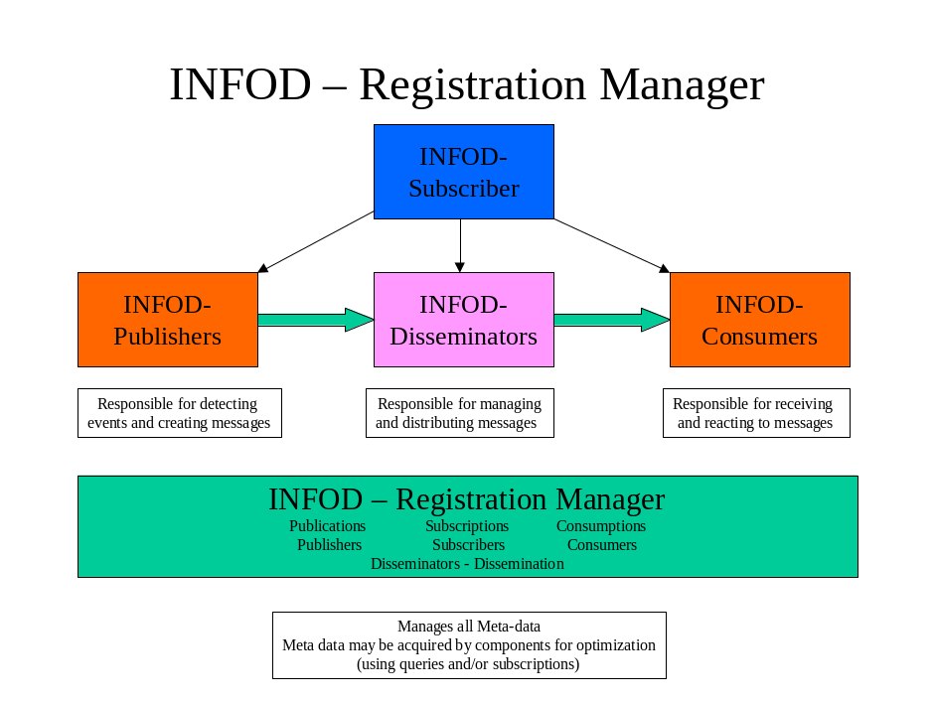
Figure 3 - INFO Registration Manager

The INFOD Registration Manager manages INFOD resources through a common interface, namely the Registration Manager interface, described in more detail in section 3 below. That interface allows operations like Create, Alter, Drop of resources that include all artifacts and roles, namely publications, subscriptions, consumptions, disseminations and publishers, subscribers, consumers and disseminators.

Interfaces

Section 2 above introduced the major INFOD entities from which INFOD roles can be derived: the INFOD Registration Manager, the INFOD Publisher, the INFOD Consumer and the INFOD Disseminator. This section defines the interfaces for each of these roles.

Note that the INFOD Subscriber, also an INFOD role, doesn’t have a specific interface because it does not expect to process any INFOD messages. Its interaction is limited to requesting services from an INFOD Registration Manager.

Overview

This section quickly summarizes the various interfaces available in the INFOD model. Each interface’s messages and operations are described in detail in following sections.
This section also provides a few typical INFOD scenarios, to provide some context on how to use INFOD interfaces.

The INFOD Interfaces

The table below introduces the INFOD interfaces for the various INFOD roles.

INFOD Role | Available Interface | Description
Registration Manager | RegistrationManager Interface | Manages publications, subscriptions, disseminations, consumptions, publishers, subscribers, disseminators and consumers
Publisher | none | Publishers need not implement any interface; other than the NotifyUpdate interface that is available for all INFOD roles
Receiver of Update Notifications when INFOD resources are updated | NotifyUpdate Interface (optional) | If implemented, allows the publisher, disseminator or consumer to receive updates made to any INFOD resource in a Registration Manager
Consumer | Consumer Interface | Manages who, what and how messages are consumed
Disseminator | Disseminator Interface | Acts as a producer of events and messages for consumers or other disseminators

The INFOD Interfaces’ operations

The table below lists the operations supported by the various interfaces defined in the table above.

INFOD Interface | Operations
RegistrationManager Interface | CreateINFODResource  AlterINFODResource  DropINFODResource  getData(XX)  where XX is one of publication, subscription, dissemination, consumption, publisher, subscriber, disseminator or consumer
NotifyUpdate Interface | MPublish
Consumer Interface | Consume/Receive
Disseminator Interface | DPublish  getDataforBrowse  getDataforConsumption

Notes:

- XML schemas are not included in this section but will be provided in Appendixes.
- Messages that are disseminated between INFOD-Disseminators require more stringent policies than messages that are disseminated to consumers. These (propagation) policy requirements will be defined at a later time.

Scenarios with INFOD Publisher, Consumer and Registration Manager

This scenario supports point-point models where publishers either know of, or find out (through dynamic queries) the consumers to publish the information to. The difference between the diagrams provided below lie in how the INFOD publisher finds out about the updated consumer information.

In this first diagram, the INFOD publisher queries the consumption information to determine whether/where to publish its data.

Note: in the diagrams below, the term ‘INFOD Registry’ refers to the INFOD Registration Manager’.

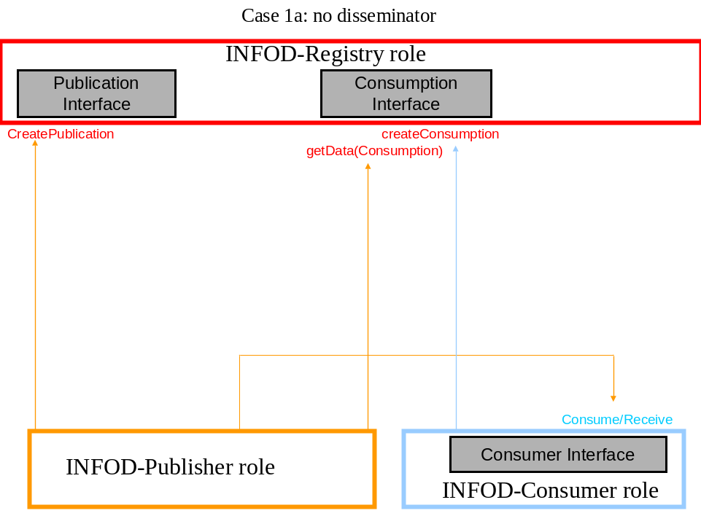

In this second diagram, the INFOD publisher implements the NotifyUpdate interface to be notified of updates about consumptions of interest to again determine whether/where to publish its data.

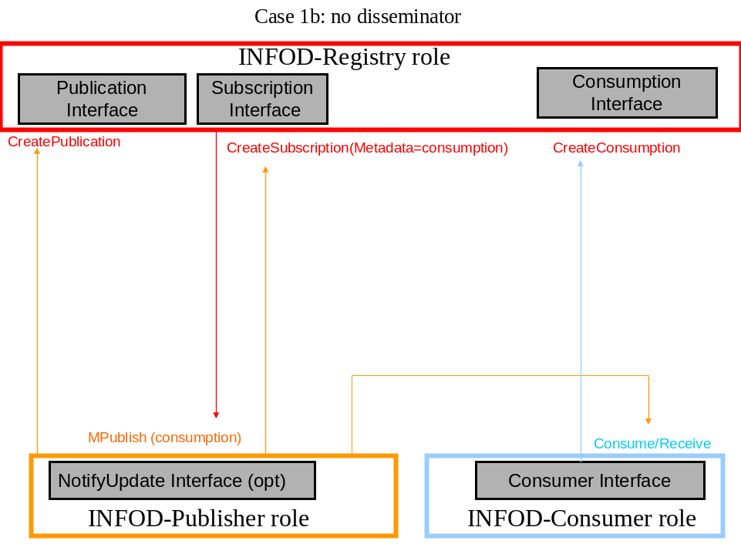

Scenarios with INFOD Disseminator

This scenario supports models where publishers are decoupled from consumers and thus introduces the INFOD Disseminator. The difference between the diagrams provided below lie in how the data is disseminated to the consumer.

Note: in the diagrams below, the term ‘INFOD Registry’ refers to the INFOD Registration Manager’.

In this first diagram, the INFOD disseminator pushes the data to the INFOD consumer.

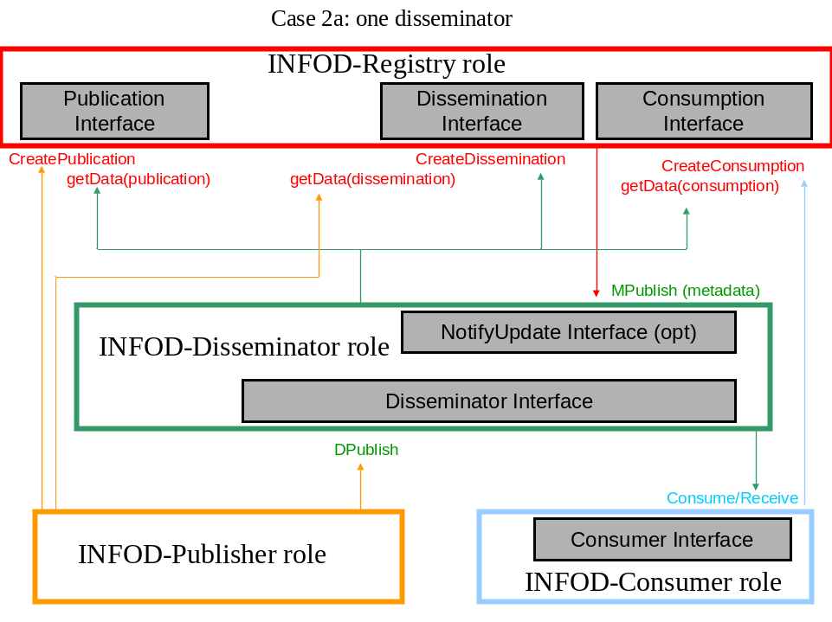

In this second diagram, the INFOD consumer pulls data from the INFOD disseminator.

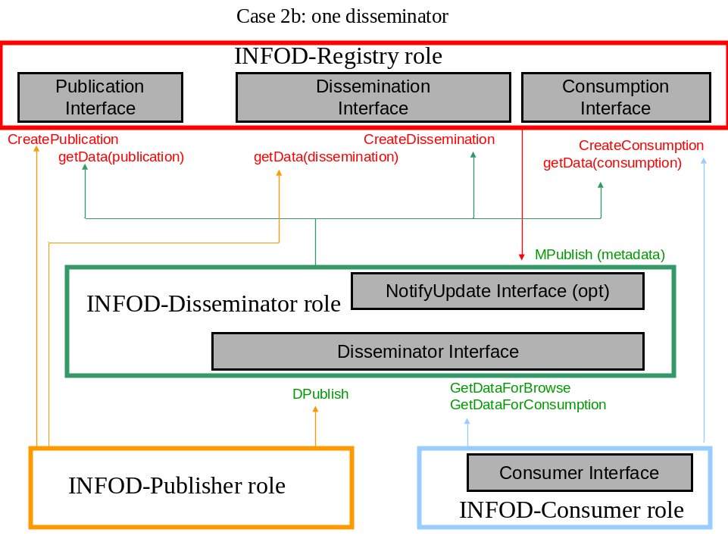

The INFOD Registration Manager Interface

The INFOD Registration Manager manages the INFOD resources defined in section 2. Its interface
defines a standard set of message exchanges to describe how to create, alter and drop these resources in the Information Dissemination store. These common set of operations consist of:
  - createINFODResource
  - alterINFODResource
  - dropINFODResource

Each of these operations act upon a common set of components as previously described in section Error: Reference source not found.

The remainder of this section describes in detail the various combinations of operations for the INFOD RegistrationManager interface, providing some examples and context for each INFOD resource. It includes:
  - creating a publication, altering a publication, dropping a publication, accessing a publication metadata
  - creating a consumption, altering a consumption, dropping a consumption, accessing a consumption
  - creating a subscription, altering a subscription, dropping a subscription, accessing a subscription metadata
  - creating a dissemination, altering a dissemination, dropping a dissemination, accessing a dissemination metadata
  - creating a publisher, altering a publisher, dropping a publisher, accessing a publisher metadata
  - creating a consumer, altering a consumer, dropping a consumer, accessing a consumer metadata
  - creating a subscriber, altering a subscriber, dropping a subscriber, accessing a subscriber metadata
  - creating a disseminator, altering a disseminator, dropping a disseminator, accessing a disseminator metadata

Creating a Subscription

The CreateINFODResource operation is used by an INFOD subscriber to register its interest in INFOD messages generated by INFOD publications (which may or may not already exist at the Registration Manager at subscription time; that is, publications are allowed to be created dynamically).

As part of the processing of a CreateINFODResource request message for a subscription, the INFOD RegistrationManager MUST create a subscription resource representing the subscription.

The components of the createINFODResource request message for creating a subscription are provided in the table below:

createINFODResource Request Message Components for a publication | Component Type as defined in Section Error: Reference source not found | Component Value
Core components:
INFODResourceType  Mandatory. Only one | INFOD_Type | ‘Subscription’
INFODResourceIdentifier  Zero value allowed | INFOD_Identifier | null
INFODResourceName  Zero or one value allowed | INFOD_Name | Nickname for subscription
INFODResourceReferences  One or more values allowed | INFOD_Resource_Reference | Required entry:  Subscriber <subscriber list>
Constraints component:
INFODResourceDescriptions  Zero of more values allowed | INFOD_Descriptions | Terms that describe the subscription – may be queried
INFODResourceVocabularies  Mandatory. Only one. | INFOD_Vocabularies | The vocabulary of the publication of interest to the subscription definition
INFODResourceFilters  Zero or more values allowed | INFOD_Filters | Ex may include:  Publication <publication list>  Consumption <consumption list>
Scheduling component:
INFODResourceSchedule  Zero or more values allowed | INFOD_Schedule | Policy terms describing scheduling information
Policies component:
INFODResourcePolicies  Zero value allowed | INFOD_Policies | null
Processing component:
INFODResourceProcessing  Zero value allowed | INFOD_Processing | null

Details about each component follow:

The INFODResourceType should be set to ‘Subscription’.
The INFODResourceIdentifier should be set to ‘null’ as this is a ‘create’ operation.
The INFODResourceName is an optional name to associate to the subscription to create.

The INFODResourceReferences needs to include provenance information, and thus it is required to have an entry for the subscriber information.

The INFODResourceDescriptions is an optional component that associates descriptive terms to the particular subscription instance. If such properties are defined, publishers, subscribers, disseminators and consumers may then query across different subscriptions to determine which subscription best fits their needs.

The INFODResourceVocabularies is a component that defines either:
- the publication for which data filters or procedures may be specified. This is required for pub/sub scenarios where subscription specifications refer to specific publications (for example, topic names)
- the publication that they implicitly define (this is the case where the subscription implicitly defines a publication)
Note that subscriptions do not have vocabularies, rather they inherit (or implicitly define) the vocabulary of the publications they are based upon (or implicitly define).

The INFODResourceFilters is an optional component that defines selection criteria for the subscription. The subscription filters may for example include:

- Publication <data filter against publication vocabulary>: if present, the filter determines the data of interest for the subscription. In this case the filter is against a publication vocabulary (or defines one, for implicit publications)
- Publication <publication list>: if present, the subscription is limited to expressions against a particular set of publications; this is a more general list than the previous list which specifically targets a publication vocabulary
- Publisher <publisher list>: if present, the subscription is limited to expressions against a particular set of publishers
- Consumption <consumption list>:if present, the subscription is limited to a particular set of consumptions (for example only send data to machines that are within a known network)
- Consumer <consumer list>: if present, the publication is limited to a particular set of consumers to publish its data to (for example, only send data to people in a particular department)

The INFODResourceSchedule is an optional component that defines scheduling requirements for the subscription.

The INFODResourcePolicies should be null. There is no operational characteristics associated with subscriptions.

The INFODResourceProcessing is an optional component that associates a subscriber-provided procedure to specify how to transform the data of interest. Such procedure may be used to manipulate the message format from the original publication message format (vocabulary).

If the INFOD Registration Manager accepts the createINFODResource request message for a subscription, it must respond with a createINFODResource response message.

The component of the createINFODResource response message for creating a subscription is provided in the table below:

createINFODResource Response Message Component for a subscription | Component Type as defined in Section Error: Reference source not found | Component Value
INFODResourceIdentifier  One value returned | INFOD_Identifier | URI for the newly created subscription

Instead of the createINFODResource response message, the INFOD Registration Manager may also send the following faults in response to a createINFODResource request message:

- User not authorized to create a subscription at this Registration Manager

Altering a Subscription

The alterINFODResource operation is used by an INFOD subscriber to modify the subscription definition.

The components of the alterINFODResource request message for altering a subscription are provided in the table below:

AlterINFODResource Request Message Components for a publication | Component Type as defined in Section Error: Reference source not found | Component Value
Core components:
INFODResourceType  Mandatory. Only one | INFOD_Type | ‘Subscription’
INFODResourceIdentifier  Mandatory. Only one | INFOD_Identifier | URI of the subscription resource
INFODResourceName  Zero or one value allowed | INFOD_Name | Nickname for subscription
INFODResourceReferences  Zero or more values allowed | INFOD_Resource_Reference
Constraints component:
INFODResourceDescriptions  Zero of more values allowed | INFOD_Descriptions | Terms that describe the subscription – may be queried
INFODResourceVocabularies  Zero or more values allowed | INFOD_Vocabularies | Publication Vocabulary
INFODResourceFilters  Zero or more values allowed | INFOD_Filters
Scheduling component:
INFODResourceSchedule  Zero or more values allowed | INFOD_Schedule
Policies component:
INFODResourcePolicies  Zero value allowed | INFOD_Policies | null
Processing component:
INFODResourceProcessing  Zero value allowed | INFOD_Processing | Null

Details about each component were provided in the ‘Creating Subscription’ section.
Any component provided when altering a subscription implies a replace of the original value.

The component of the alterINFODResource response message for altering a subscription is provided in the table below:

AlterINFODResource Response Message Component for a subscription | Component Type as defined in Section Error: Reference source not found | Component Value
INFODResourceAlterStatusInfo  Mandatory. Only one | INFOD_StatusInfo | Summary of changes

The INFODPublicationAlterStatus provides a summary of the updates made to the referenced subscription resource at the appropriate Registration Manager.

Instead of the alterINFODResource response message, the INFOD Registration Manager may also send the following faults in response to an alterINFODResource request message:

- User not authorized to alter a subscription at this Registration Manager
- Subscription does not exist at the particular Registration Manager

Dropping Subscription

The dropINFODResource operation is used by an INFOD subscriber to drop the metadata associated with the subscription. .

The components of the dropINFODResource request message for dropping a subscription are provided in the table below:

dropINFODResource Request Message Component for a publication | Component Type as defined in Section Error: Reference source not found | Component Value
INFODResourceType  Mandatory. Only one | INFOD_Type | ‘Subscription’
INFODResourceIdentifier  Mandatory. Only one | INFOD_Identifier | URI of the subscription resource

There is no response message associated with a dropINFODResource request message for a subscription.

However, the INFOD Registration Manager may send the following fault in response to a dropINFODResource request message for a subscription:

- Subscription doesn’t exist at the particular Registration Manager
- User not authorized to do the drop operation

Accessing Subscription metadata

The getData operation is typically used by an INFOD subscriber, publisher, disseminator or consumer to retrieve metadata about subscribers, publishers, disseminators, consumers, subscriptions, publications, consumptions and/or disseminations at a given Registration Manager.

Components of the getData request message are as follows:

getData Request Message Component for a subscription | Component Type as defined in Section Error: Reference source not found | Component Value
INFODResourceType  Mandatory. Only one | INFOD_Type | ‘Subscription’
INFODQueryExpression  Mandatory. Only one | INFOD_Query | Query expression on that publication metadata

If the INFOD Registration Manager accepts the getData request message for a subscription, it must respond with a getData response message.

The component of the getData response message for a subscription is:

getData Response Message Component for a subscription | Component Type as defined in Section Error: Reference source not found | Component Value
INFODMetaDataQueryResult  Mandatory  Only one | INFOD_QueryResult | Query result

Instead of the getData response message, the INFOD Registration Manager may also send the following fault in response to a getData request message for a subscription:

- Empty result set for the query
- User not authorized to do the query operation at the Registration Manager

Creating a Publication

The CreateINFODResource operation is used by an INFOD publisher to define the data that it is able to publish. Note however that some publications may be created by consumers, when these publications are generated by some event composition or event correlation.

As part of the processing of a CreateINFODResource request message for a publication, the INFOD RegistrationManager MUST create a publication resource representing the publication.

The components of the createINFODResource request message for creating a publication are provided in the table below:

createINFODResource Request Message Components for a publication | Component Type as defined in Section Error: Reference source not found | Component Value
Core components:
INFODResourceType  Mandatory. Only one | INFOD_Type | ‘Publication’
INFODResourceIdentifier  Zero value allowed | INFOD_Identifier | null
INFODResourceName  Zero or one value allowed | INFOD_Name | Nickname for publication
INFODResourceReferences  One or more values allowed | INFOD_Resource_Reference | Required entry:  Publisher <publisher list>
Constraints component:
INFODResourceDescriptions  Zero of more values allowed | INFOD_Descriptions | Terms that describe the publication – may be queried
INFODResourceVocabularies  Zero or more values allowed | INFOD_Vocabularies | Vocabulary that may be queried to determine the structure of the publication message
INFODResourceFilters  Zero or more values allowed | INFOD_Filters | Ex may include:  Disseminator <disseminator list>  Consumption <consumption list>
Scheduling component:
INFODResourceSchedule  Zero value allowed | INFOD_Schedule | null
Policies component:
INFODResourcePolicies  Zero or more values allowed | INFOD_Policies | Policy terms that may further constraint operational characteristics of the publication
Processing component:
INFODResourceProcessing  Zero value allowed | INFOD_Processing | null

Details about each component follow:

The INFODResourceType should be set to ‘Publication’.
The INFODResourceIdentifier should be set to ‘null’ as this is a ‘create’ operation.
The INFODResourceName is an optional name to associate to the publication to create.

The INFODResourceReferences needs to include provenance information, and thus it is required to have an entry for the publisher information. This is because a publication may be defined solely by its provenance information.

The INFODResourceDescriptions is an optional component that associates descriptive terms to the particular publication instance. If such properties are defined, subscribers, disseminators and consumers may then query across different publications to determine which publication best fits their needs.

The INFODResourceVocabularies is an optional component that defines the structure of the message payload. If such vocabularies are defined, subscribers, disseminators and consumers may then express their interest by defining queries against the vocabulary.

The INFODResourceFilters is an optional component that defines selection criteria for the publication. The publication filters may for example include:

- Subscriber <subscriber list>: if present, the publication is limited/targeted to a particular set of subscribers (for example, do not allow subscribers that are not part of a given company to subscribe to that publication)
- Disseminator <disseminator list>: if present, the publication is limited/targeted to a particular set of disseminators to publish its data to (for example, workload management)
- Consumption <consumption list>: if present, the publication is limited to a particular set of consumptions to publish its data to (for example only send data to machines that are within a known network)
- Consumer <consumer list>: if present, the publication is limited to a particular set of consumers to publish its data to (for example, only send data to people in a particular department)

The INFODResourceSchedule should be null when creating a publication. Scheduling doesn’t apply to publication artifacts.

The INFODResourcePolicies is an optional component that defines operational constraints for the publication. This may include:
- whether a message is limited to single record (a record that was changed and that was of interest) or whether a message will include all records that were changed in the context of a single transaction (and of interest)
- whether to notify interested parties any time the publication definition changes (essentially defining an implicit subscription to the publication metadata)
- etc.

The INFODResourceProcessing should be null as the publisher already provides the structure of the data it publishes through its vocabulary.

If the INFOD Registration Manager accepts the createINFODResource request message for a publication, it must respond with a createINFODResource response message.

The component of the createINFODResource response message for creating a publication is provided in the table below:

createINFODResource Response Message Component for a publication | Component Type as defined in Section Error: Reference source not found | Component Value
INFODResourceIdentifier  One value returned | INFOD_Identifier | URI for the newly created publication

Instead of the createINFODResource response message, the INFOD Registration Manager may also send the following faults in response to a createINFODResource request message:

- User not authorized to create a publication at this Registration Manager

Altering a Publication

The alterINFODResource operation is used by an INFOD publisher to modify the metadata associated with the data that it is able to publish. Note however that some publications may be created by consumers, when these publications are generated by some event composition or event correlation and so may be altered by the same consumers.

The components of the alterINFODResource request message for altering a publication are provided in the table below:

AlterINFODResource Request Message Components for a publication | Component Type as defined in Section Error: Reference source not found | Component Value
Core components:
INFODResourceType  Mandatory. Only one | INFOD_Type | ‘Publication’
INFODResourceIdentifier  Mandatory. Only one | INFOD_Identifier | URI of the publication resource
INFODResourceName  Zero or one value allowed | INFOD_Name | Nickname for publication
INFODResourceReferences  Zero or more values allowed | INFOD_Resource_Reference
Constraints component:
INFODResourceDescriptions  Zero of more values allowed | INFOD_Descriptions | Terms that describe the publication – may be queried
INFODResourceVocabularies  Zero or more values allowed | INFOD_Vocabularies | Vocabulary that may be queried to determine the structure of the publication message
INFODResourceFilters  Zero or more values allowed | INFOD_Filters | Ex may include:  Disseminator <disseminator list>  Consumption <consumption list>
Scheduling component:
INFODResourceSchedule  Zero value allowed | INFOD_Schedule | Null
Policies component:
INFODResourcePolicies  Zero or more values allowed | INFOD_Policies | Policy terms that may further constraint operational characteristics of the publication
Processing component:
INFODResourceProcessing  Zero value allowed | INFOD_Processing | Null

Details about each component were provided in the ‘Creating Publication’ section.
Any component provided when altering a publication implies a replace of the original value.

The component of the alterINFODResource response message for altering a publication is provided in the table below:

AlterINFODResource Response Message Component for a publication | Component Type as defined in Section Error: Reference source not found | Component Value
INFODResourceAlterStatusInfo  Mandatory. Only one | INFOD_StatusInfo | Summary of changes

The INFODPublicationAlterStatus provides a summary of the updates made to the referenced publication resource at the appropriate Registration Manager.

Instead of the alterINFODResource response message, the INFOD Registration Manager may also send the following faults in response to an alterINFODResource request message:

- User not authorized to alter a publication at this Registration Manager
- Publication does not exist at the particular Registration Manager

Dropping Publication

The dropINFODResource operation is used by an INFOD publisher to drop the metadata associated with the data that it is not going to publish anymore. Note however that some publications may be created by consumers, when these publications are generated by some event composition or event correlation and so may be dropped by the same consumers.

The components of the dropINFODResource request message for dropping a publication are provided in the table below:

dropINFODResource Request Message Component for a publication | Component Type as defined in Section Error: Reference source not found | Component Value
INFODResourceType  Mandatory. Only one | INFOD_Type | ‘Publication’
INFODResourceIdentifier  Mandatory. Only one | INFOD_Identifier | URI of the publication resource

There is no response message associated with a dropINFODResource request message for a publication.

However, the INFOD Registration Manager may send the following fault in response to a dropINFODResource request message for a publication:

- Publication doesn’t exist at the particular Registration Manager
- User not authorized to do the drop operation

Accessing Publication metadata

The getData operation is typically used by an INFOD subscriber, publisher, disseminator or consumer to retrieve metadata about subscribers, publishers, disseminators, consumers, subscriptions, publications, consumptions and/or disseminations at a given Registration Manager.

Components of the getData request message are as follows:

getData Request Message Component for a publication | Component Type as defined in Section Error: Reference source not found | Component Value
INFODResourceType  Mandatory. Only one | INFOD_Type | ‘Publication’
INFODQueryExpression  Mandatory. Only one | INFOD_Query | Query expression on that publication metadata

If the INFOD Registration Manager accepts the getData request message for a publication, it must respond with a getData response message.

The component of the getData response message for a publication is:

getData Response Message Component for a publication | Component Type as defined in Section Error: Reference source not found | Component Value
INFODMetaDataQueryResult  Mandatory  Only one | INFOD_QueryResult | Query result

Instead of the getData response message, the INFOD Registration Manager may also send the following fault in response to a getData request message for a publication:

- Empty result set for the query
- User not authorized to do the query operation at the Registration Manager

Creating a Consumption

The CreateINFODResource operation is used by an INFOD consumer to register consumption information to an INFOD Registration Manager.

The INFOD model allows consumer information to be provided at different levels: at the subscription level, at the publication level or directly through the Consumption Interface.

As part of the processing of a CreateINFODResource request message for a consumption, the INFOD RegistrationManager MUST create a consumption resource representing the consumption.

The components of the createINFODResource request message for creating a consumption are provided in the table below:

createINFODResource Request Message Components for a consumption | Component Type as defined in Section Error: Reference source not found | Component Value
Core components:
INFODResourceType  Mandatory. Only one | INFOD_Type | ‘Consumption’
INFODResourceIdentifier  Zero value allowed | INFOD_Identifier | null
INFODResourceName  Zero or one value allowed | INFOD_Name | Nickname for consumption
INFODResourceReferences  One or more values allowed | INFOD_Resource_Reference | Required entry:  Consumer <consumer list>
Constraints component:
INFODResourceDescriptions  Zero of more values allowed | INFOD_Descriptions | Terms that describe the consumption – may be queried
INFODResourceVocabularies  Zero or more values allowed | INFOD_Vocabularies | Enables the consumption to advertize the vocabulary that it supports
INFODResourceFilters  Zero or more values allowed | INFOD_Filters | Ex may include:  Publisher <publisher list>
Scheduling component:
INFODResourceSchedule  Zero value allowed | INFOD_Schedule | null
Policies component:
INFODResourcePolicies  Zero or more values allowed | INFOD_Policies | Policy terms that may further constraint operational characteristics of the consumption
Processing component:
INFODResourceProcessing  Zero or one value allowed | INFOD_Processing | A procedure that describes transformations or processes that may need to be executed on the data after it is received

Details about each component follow:

The INFODResourceType should be set to ‘Consumption’.
The INFODResourceIdentifier should be set to ‘null’ as this is a ‘create’ operation.
The INFODResourceName is an optional name to associate to the consumption to create.

The INFODResourceReferences needs to include provenance information, and thus it is required to have an entry for the consumer information. If no other component is provided, the provenance information defines the consumption.

The INFODResourceDescriptions is an optional component that associates descriptive terms to the particular consumption instance. If such properties are defined, publishers and disseminators may then query across different consumptions to determine which consumptions are eligible.

The INFODResourceVocabularies is an optional component that defines the structures of the message payload that it supports.

The INFODResourceFilters is an optional component that defines selection criteria for the consumption. The consumption filters may for example include:

- Publication <publication list>: if present, the consumption is limited/targeted to a particular set of publications (for example, only consume publications that have to do with new car information for a particular brand)
- Publisher <publisher list>: if present, the consumption is limited/targeted to a particular set of publishers (for example, do not allow publishers that are not part of a given company ‘s approved list of publishers)
- Disseminator <disseminator list>: if present, the consumption is limited to a particular set of disseminators to consume its data from (for example, if a non-approved disseminator sends data to that consumption, the operation will fail)
- Subscriber <subscriber list>: if present, the consumption is limited to a particular set of of data to consume, filtered by whom subscribed to it on behalf of the consumer (for example, do not consume data that has been subscribed to by subscribers that belong to a particular company)

The INFODResourceSchedule should be null when creating a publication. Scheduling doesn’t apply to publication artifacts.

The INFODResourcePolicies is an optional component that defines operational constraints for the consumption. This may include:
- whether to notify interested parties any time the consumption definition changes (essentially defining an implicit subscription to the consumption metadata)
- directives on when and how to trigger the consumption which is necessary in environments where the consumer needs to dynamically update that information for disseminators and possibly publishers to use
- etc.

The INFODResourceProcessing is an optional component that associates a consumer-provided procedure to the particular consumption instance. If such procedure is defined, it is executed after the data is received.

If the INFOD Registration Manager accepts the createINFODResource request message for a consumption, it must respond with a createINFODResource response message.

The component of the createINFODResource response message for creating a consumption is provided in the table below:

createINFODResource Response Message Component for a consumption | Component Type as defined in Section Error: Reference source not found | Component Value
INFODResourceIdentifier  One value returned | INFOD_Identifier | URI for the newly created consumption

Instead of the createINFODResource response message, the INFOD Registration Manager may also send the following faults in response to a createINFODResource request message:

- User not authorized to create a consumption at this Registration Manager

Altering a Consumption

The alterINFODResource operation is used by an INFOD consumer to modify the metadata about how and when the data is to be consumed.

The components of the alterINFODResource request message for altering a consumption are provided in the table below:

AlterINFODResource Request Message Components for a consumption | Component Type as defined in Section Error: Reference source not found | Component Value
Core components:
INFODResourceType  Mandatory. Only one | INFOD_Type | ‘Consumption’
INFODResourceIdentifier  Mandatory. Only one | INFOD_Identifier | URI of the consumption
INFODResourceName  Zero or one value allowed | INFOD_Name | Nickname for consumption
INFODResourceReferences  One or more values allowed | INFOD_Resource_Reference
Constraints component:
INFODResourceDescriptions  Zero of more values allowed | INFOD_Descriptions | Terms that describe the consumption – may be queried
INFODResourceVocabularies  Zero or more values allowed | INFOD_Vocabularies | Vocabulary supported by the consumption
INFODResourceFilters  Zero or more values allowed | INFOD_Filters
Scheduling component:
INFODResourceSchedule  Zero value allowed | INFOD_Schedule | null
Policies component:
INFODResourcePolicies  Zero or more values allowed | INFOD_Policies | Policy terms that may further constraint operational characteristics of the consumption
Processing component:
INFODResourceProcessing  Zero or more values allowed | INFOD_Processing

Details about each component were provided in the ‘Creating Consumption’ section.
Any component provided when altering a consumption implies a replace of the original value.

The component of the alterINFODResource response message for altering a consumption is provided in the table below:

AlterINFODResource Response Message Component for a consumption | Component Type as defined in Section Error: Reference source not found | Component Value
INFODResourceAlterStatusInfo  Mandatory. Only one | INFOD_StatusInfo | Summary of changes

The INFODPublicationAlterStatus provides a summary of the updates made to the referenced consumption resource at the appropriate Registration Manager.

Instead of the alterINFODResource response message, the INFOD Registration Manager may also send the following faults in response to an alterINFODResource request message:

- User not authorized to alter a consumption at this Registration Manager
- Consumption does not exist at the particular Registration Manager

Dropping Consumption

The dropINFODResource operation is used by an INFOD consumer to drop the metadata associated with the data that it is not going to receive anymore.

The components of the dropINFODResource request message for dropping a consumption are provided in the table below:

dropINFODResource Request Message Component for a consumption | Component Type as defined in Section Error: Reference source not found | Component Value
INFODResourceType  Mandatory. Only one | INFOD_Type | ‘Consumption’
INFODResourceIdentifier  Mandatory. Only one | INFOD_Identifier | URI of the publication resource

There is no response message associated with a dropINFODResource request message for a consumption.

However, the INFOD Registration Manager may send the following fault in response to a dropINFODResource request message for a consumption:

- Consumption doesn’t exist at the particular Registration Manager
- User not authorized to do the drop operation

Accessing Consumption metadata

The getData operation is typically used by an INFOD subscriber, publisher, disseminator or consumer to retrieve metadata about subscribers, publishers, disseminators, consumers, subscriptions, publications, consumptions and/or disseminations at a given Registration Manager.

Components of the getData request message are as follows:

getData Request Message Component for a consumption | Component Type as defined in Section Error: Reference source not found | Component Value
INFODResourceType  Mandatory. Only one | INFOD_Type | ‘Consumption’
INFODQueryExpression  Mandatory. Only one | INFOD_Query | Query expression on that consumption metadata

If the INFOD Registration Manager accepts the getData request message for a consumption, it must respond with a getData response message.

The component of the getData response message for a consumption is:

getData Response Message Component for a consumption | Component Type as defined in Section Error: Reference source not found | Component Value
INFODMetaDataQueryResult  Mandatory  Only one | INFOD_QueryResult | Query result

Instead of the getData response message, the INFOD Registration Manager may also send the following fault in response to a getData request message for a consumption:

- Empty result set for the query
- User not authorized to do the query operation at the Registration Manager

Creating Dissemination

The CreateINFODResource operation is used by an INFOD disseminator to register dissemination information to an INFOD Registration Manager.

As part of the processing of a CreateINFODResource request message for a dissemination, the INFOD RegistrationManager MUST create a dissemination resource representing the dissemination.

The components of the createINFODResource request message for creating a dissemination are provided in the table below:

createINFODResource Request Message Components for a dissemination | Component Type as defined in Section Error: Reference source not found | Component Value
Core components:
INFODResourceType  Mandatory. Only one | INFOD_Type | ‘Dissemination’
INFODResourceIdentifier  Zero value allowed | INFOD_Identifier | null
INFODResourceName  Zero or one value allowed | INFOD_Name | Nickname for dissemination
INFODResourceReferences  One or more values allowed | INFOD_Resource_Reference | Required entry:  Disseminator <disseminator list>
Constraints component:
INFODResourceDescriptions  Zero of more values allowed | INFOD_Descriptions | Terms that describe the dissemination - may be queried
INFODResourceVocabularies  Zero or more values allowed | INFOD_Vocabularies | Enables the dissemination to advertize the vocabulary that it supports
INFODResourceFilters  Zero or more values allowed | INFOD_Filters | Ex may include:  Consumer <consumer list>
Scheduling component:
INFODResourceSchedule  Zero value allowed | INFOD_Schedule | null
Policies component:
INFODResourcePolicies  Zero or more values allowed | INFOD_Policies | Policy terms that may further constraint operational characteristics of the dissemination
Processing component:
INFODResourceProcessing  Zero or one value allowed | INFOD_Processing | A procedure that describes transformations or processes that may need to be executed on the data during dissemination

Details about each component follow:

The INFODResourceType should be set to ‘Dissemination’.
The INFODResourceIdentifier should be set to ‘null’ as this is a ‘create’ operation.
The INFODResourceName is an optional name to associate to the dissemination to create.

The INFODResourceReferences needs to include provenance information, and thus it is required to have an entry for the disseminator information.

The INFODResourceDescriptions is an optional component that associates descriptive terms to the particular dissemination instance. If such properties are defined, publishers and consumers may then query across different consumptions to determine which disseminations are eligible.

The INFODResourceVocabularies is an optional component that defines the structures of the message payload that the dissemination supports.

The INFODResourceFilters is an optional component that defines selection criteria for the dissemination. The dissemination filters may for example include:

- Publisher <publisher list>: if present, the dissemination is limited/targeted to a particular set of publishers (for example, do not allow publishers that have not garanteed certain data integrity requirements)
- Publication <publication list>: if present, the dissemination is limited/targeted to a particular set of publications (for example, a dissemination will only disseminate data pertaining to a certain type of publications)
- Subscriber <subscriber list>: if present, the dissemination is limited/targeted to a particular set of subscribers (for example, do not allow subscribers that are not part of a given company to subscribe to that publication)
- Consumption <consumption list>: if present, the dissemination is limited to a particular set of consumptions to publish its data to (for example only send data to machines that are within a known network)
- Consumer <consumer list>: if present, the dissemination is limited to a particular set of consumers to publish its data to (for example, only send data to people in a particular department)

The INFODResourceSchedule should be null when creating a dissemination. Scheduling doesn’t apply to dissemination artifacts.

The INFODResourcePolicies is an optional component that defines operational constraints for the dissemination. This may include:
- policy terms that control how data is replicated between disseminators
- whether to notify interested parties any time the dissemination definition changes (essentially defining an implicit subscription to the consumption metadata)
- etc.

The INFODResourceProcessing is an optional component that associates a disseminator-provided procedure to the particular dissemination instance. If such procedure is defined, it is executed after the data is received and before it is sent out.

If the INFOD Registration Manager accepts the createINFODResource request message for a dissemination, it must respond with a createINFODResource response message.

The component of the createINFODResource response message for creating a dissemination is provided in the table below:

createINFODResource Response Message Component for a dissemination | Component Type as defined in Section Error: Reference source not found | Component Value
INFODResourceIdentifier  One value returned | INFOD_Identifier | URI for the newly created dissemination

Instead of the createINFODResource response message, the INFOD Registration Manager may also send the following faults in response to a createINFODResource request message:

- User not authorized to create a dissemination at this Registration Manager

Altering a Dissemination

The alterINFODResource operation is used by an INFOD disseminator to modify the metadata about how and when the data is to be disseminated.

The components of the alterINFODResource request message for altering a dissemination are provided in the table below:

AlterINFODResource Request Message Components for a disemination | Component Type as defined in Section Error: Reference source not found | Component Value
Core components:
INFODResourceType  Mandatory. Only one | INFOD_Type | ‘Dissemination’
INFODResourceIdentifier  Mandatory. Only one | INFOD_Identifier | URI of the dissemination
INFODResourceName  Zero or one value allowed | INFOD_Name | Nickname for dissemination
INFODResourceReferences  One or more values allowed | INFOD_Resource_Reference
Constraints component:
INFODResourceDescriptions  Zero of more values allowed | INFOD_Descriptions | Terms that describe the dissemination – may be queried
INFODResourceVocabularies  Zero or more values allowed | INFOD_Vocabularies | Vocabulary supported by the dissemination
INFODResourceFilters  Zero or more values allowed | INFOD_Filters
Scheduling component:
INFODResourceSchedule  Zero value allowed | INFOD_Schedule | null
Policies component:
INFODResourcePolicies  Zero or more values allowed | INFOD_Policies | Policy terms that may further constraint operational characteristics of the dissemination
Processing component:
INFODResourceProcessing  Zero value allowed | INFOD_Processing | null

Details about each component were provided in the ‘Creating Dissemination’ section.
Any component provided when altering a dissemination implies a replace of the original value.

The component of the alterINFODResource response message for altering a dissemination is provided in the table below:

AlterINFODResource Response Message Component for a dissemination | Component Type as defined in Section Error: Reference source not found | Component Value
INFODResourceAlterStatusInfo  Mandatory. Only one | INFOD_StatusInfo | Summary of changes

The INFODPublicationAlterStatus provides a summary of the updates made to the referenced dissemination resource at the appropriate Registration Manager.

Instead of the alterINFODResource response message, the INFOD Registration Manager may also send the following faults in response to an alterINFODResource request message:

- User not authorized to alter a dissemination at this Registration Manager
- Dissemination does not exist at the particular Registration Manager

Dropping Dissemination

The dropINFODResource operation is used by an INFOD disseminator to drop the metadata associated with a particular dissemination.

The components of the dropINFODResource request message for dropping a dissemination are provided in the table below:

dropINFODResource Request Message Components for a dissemination | Component Type as defined in Section Error: Reference source not found | Component Value
INFODResourceType  Mandatory. Only one | INFOD_Type | ‘Dissemination’
INFODResourceIdentifier  Mandatory. Only one | INFOD_Identifier | URI of the dissemination resource

There is no response message associated with a dropINFODResource request message for a dissemination.

However, the INFOD Registration Manager may send the following fault in response to a dropINFODResource request message for a dissemination:

- Dissemination doesn’t exist at the particular Registration Manager
- User not authorized to do the drop operation

Accessing Dissemination metadata

The getData operation is typically used by an INFOD subscriber, publisher, disseminator or consumer to retrieve metadata about subscribers, publishers, disseminators, consumers, subscriptions, publications, consumptions and/or disseminations at a given Registration Manager.

Components of the getData request message are as follows:

getData Request Message Components for a dissemination | Component Type as defined in Section Error: Reference source not found | Component Value
INFODResourceType  Mandatory. Only one | INFOD_Type | ‘Dissemination’
INFODQueryExpression  Mandatory. Only one | INFOD_Query | Query expression on that dissemination metadata

If the INFOD Registration Manager accepts the getData request message for a dissemination, it must respond with a getData response message.

The component of the getData response message for a dissemination is:

getData Response Message Component for a dissemination | Component Type as defined in Section Error: Reference source not found | Component Value
INFODMetaDataQueryResult  Mandatory  Only one | INFOD_QueryResult | Query result

Instead of the getData response message, the INFOD Registration Manager may also send the following fault in response to a getData request message for a dissemination:

- Empty result set for the query
- User not authorized to do the query operation at the Registration Manager

Creating Subscriber

Altering Subscriber

Dropping Subscriber

Creating Publisher

Altering Publisher

Dropping Publisher

Creating Disseminator

Altering Disseminator

Dropping Disseminator

Creating Consumer

Altering Consumer

Dropping Consumer

The NotifyUpdate Interface (optional)

The NotifyUpdate interface defines a standard set of message exchanges to allow INFOD publishers, disseminators or consumers to be notified when updates are made to INFOD resources in an INFOD Registration Manager.

A lightweight INFOD publisher will typically not implement that interface and will publish its data to INFOD disseminators, letting the disseminator filter the appropriate messages based on subscription and consumption information. In that case, the INFOD disseminator may decide to implement the NotifyUpdate interface to keep up with INFOD Registration Manager metadata updates. In the case of more complex publishers however, the NotifyUpdate interface may be implemented to enable the publishers to specifically target which messages to send to which consumers, without having to rely on an INFOD disseminator.

The NotifyUpdate interface has only one operation, Mpublish, a ‘metadata updates’ publish operation.

The Mpublish operation delivers metadata changes, ie updates to INFOD resources. To actually create a subscription for such notification, an INFOD_policy needs to be defined for the INFOD resources that are of interest. This can be done either during the createINFODResource operation or through an alterINFODResource operation for that resource.

Publishing Metadata Updates

The Mpublish operation delivers one or more metadata update message to the NotifyUpdate interface of the INFOD role that implements it. This may be a publisher (receiving updates from an INFOD disseminator) or a disseminator (receiving updates from an INFOD Registration Manager).

Components of the MPublish response message are as follows:

MPublish Response Message Components | Component Type as defined in Section Error: Reference source not found | Component Value

No response is expected from the receiver of the metadata update (INFOD publisher or INFOD disseminator) upon receipt of this message.

The INFOD Disseminator Interface

The interfaces for the INFOD Disseminator define a standard set of message exchanges to describe an information dissemination disseminator. The disseminator provides an intermediary between publishers and consumers, delivers distribution functions and sends messages to consumers.

There is only one interface defined for the Disseminator , namely the:
- Disseminator Interface

The remainder of this section describes in detail the operations defined for that interface.

Note:

The INFOD disseminator references most of the resources in the INFOD Registration Manager and thus typically needs mechanisms for synchronizing with these resources’ updates. So INFOD Disseminator roles may either implement part of the INFOD Registry to be able to manage directly the various INFOD resources or may decide to implement the NotifyUpdate interface.

Disseminator Interface

The INFOD Disseminator interface’s operations are limited to actual data distribution and data movement operations. Operations like ‘subscribe’ are not part of that interface (rather, they are provided by the INFOD registry interfaces).

The operations supported by the Disseminator interface are as follows:
- Dpublish
- GetDataForConsumption
- GetDataForBrowse

The remainder of this section describes the operations in detail.

3.3.1.1 Dpublish

An INFOD publisher sends the Dpublish message to an INFOD disseminator in order to deliver one of more INFOD message(s).

Components of the DPublish response message are as follows:

DPublish Response Message Components | Component Type as defined in Section Error: Reference source not found | Component Value

No response is expected from the INFOD disseminator upon receipt of this message.

3.3.1.2 GetDataForConsumption, GetDataForBrowse

In response to a GetDataForConsumption or GetDataForBrowse message, the INFOD disseminator returns the data that satisfies the consumer subscription and/or publication specifications. The difference between GetDataForConsumption and GetDataForBrowse, like their name indicates, is that the former is a destructive read whereas the latter is not to allow new consumers to receive messages that other consumers have already read.

Note:

The INFOD disseminator policies that support this type of functionality MAY be available at the INFOD Registration Manager where the disseminator registered itself.

Components of the GetDataForConsumption or GetDataForBrowse request message are as follows:

getDataForConsumption or getDataForBrowse Request Message Components | Component Type as defined in Section Error: Reference source not found | Component Value

The response of the GetDataForConsumption or GetDataForBrowse request message is a GetDataForConsumption response message or a GetDataForBrowse response message, with the following components:

getDataForConsumption or getDataForBrowse Response Message Components | Component Type as defined in Section Error: Reference source not found | Component Value

Instead of the INFODGetDataResponse message, the INFOD disseminator may also send the following faults in response to a GetDataForConsumption or GetDataForBrowse request message:

- User not authorized to browse or to consume from this disseminator

The INFOD Consumer Interface

The INFOD Consumer only has one interface, the consumer interface. An INFOD disseminator or an INFOD publisher sends INFOD messages to INFOD consumers using the consumer interface.

Consumer Interface

The consumer interface allows for efficient consumption by defining messages that include INFOD-specific information (such as publication metadata) in addition to the application-specific message content.

There is only one operation provided by the consumer interface, the Consume/Receive operation.

3.4.1.1 Consume/Receive

An INFOD publisher or disseminator MAY send the Consume/Receive message to the INFOD consumer in order to deliver one or more INFOD messages.

Components of the Consume/Receive request message are as follows:

Consume/Receive Request Message Components | Component Type as defined in Section Error: Reference source not found | Component Value

No response is expected from the INFOD consumer upon receipt of this message.

Security Considerations

This section of the document details the security aspects of the INFOD services. It categorizes the requirements in three classes:

- Securing the message communication between the INFOD services
- Message encryption and data privacy requirements
- Integration with authorization model

Securing the Message Communication between the INFOD Services

An INFOD operating environment consists of a set of publishers, consumers, disseminators and registries. All the above service components operate in different security domains and require “long-term” secure communication of messages. Additionally, as the INFOD services operate in a web services environment it is imperative that such communications use SOAP as the base communication protocol. SOAP based communication between services can be secured by using the mechanisms described by the WS security specification [WSS]. Although, the use of WS-Security provides the mechanisms to accommodate multiple security tokens and encryption technology, it remains limited to providing a secured point-to-point communication mechanism on a message level. However, INFO-D services need to build upon this security mechanism to describe the security context under which they could sustain long running exchanges of messages. A communication session between the two entities such as publisher and disseminator or disseminator and consumer serves as the basis for establishing the security context. Establishing a security context between system entities allows secured messaging on the session level and reduces the synchronization overheads required to obtain it on per-message basis. WS-Secure Conversation [WSC] provides the mechanism for maintaining such long-term contexts for message exchange.

The INFOD model RECOMMENDS the establishment of the following contexts:

Publisher – Registry secured context, with Registry as the context security token creator.
Publisher – Disseminator secured context, with Disseminator as the context security token creator.
Disseminators-Disseminators secured context, with either Disseminator as the context security token creator. Note that this is the only context with multiple communicating entities, all the remaining are one-to-one contexts.
Disseminator-Registry secured context, with Registry as the context security token creator.
Consumer-Disseminator secured context, with Consumer as the context security token creator.

Authentication remains a crucial aspect of formation of a secured conversation. Hence, the specification identifies the objects that create the secured context. It is envisaged that an INFOD-Registry will provide services to multiple publishers/consumers/disseminators and controls the access to this shared state. Hence, it is imperative to have the INFOD-Registry act as the authenticator for other services. Similarly, a publisher controls the dissemination of the messages and hence is deemed responsible for establishing the context with the disseminators. However, in case of multiple disseminators the information flow happens to be bidirectional and a request may be initiated by either of the disseminators. As a set of disseminators cooperate to disseminate messages, a shared security context is recommended. In future, it is envisaged that in the latter versions INFOD may introduce mechanisms for mutual authentication based on trust mechanisms.

Message Encryption and Data Privacy Requirements

INFOD advocates the use of mutual filtering techniques to provide smart dissemination of the messages. Mutual filtering requires the disseminators to be able to interpret the contents of the messages being routed. As INFOD isolates a publisher from a consumer and DOES NOT require either the publishers or the consumers to authenticate the either, secured point-to-point communication becomes a non-issue. INFOD services provide security verification mechanisms to compensate for its inability to provide a point-to-point secured communication between the publishers and consumers.

<Any concerns for privacy issue>
<To be completed>

Integration with authorization model

Access control mechanisms for management of publication, subscription and consumption artifacts rely on the authentication mechanisms to authorize the access to the resources. Only authorized principals are allowed to register the publications, publish messages, create and manage the subscription, initiate and manage the consumption process. It is recommended that the authorization model should provide a fine grained control, preferably at the level of the evaluation context/ topics. Authorization models can be divided into two categories:

Access model for INFOD resources
Access model for INFOD messages

Access models for the INFOD resources enforce the policies to allow restricted access to creation, deletion, and invocation of methods on service interfaces. Access models for resources can be maintained individually by each of the INFOD services as they are directly associated with the state maintained by the service. For example, an access model of INFOD registry resources controls the process of publicizing a publication and remains solely responsible for enforcing the related access policies.

Access model for INFOD messages allows association of the dynamic authorization policies that control the access to the contents and the routing of the messages. Candidate examples include a publisher restricting dissemination of messages to a restricted list of consumers. Dynamic authorization policies may be propagated as a part of the secured conversation context and will need to be enforced by each participant that shares the context.

Appendix I – UML

To be added

Appendix II – XML Schema

The intention is to derive the XML schema from the INFOD UML Profile using an UML toolset.

Appendix III – WSDL 1.1

The intention is to derive the WSDL representation from the INFOD UML Profile using an UML toolset.

Appendix IV – Vocabulary Management

All available resources and services (publishers, publications, subscription, etc.) are treated in a uniform manner. They are all manipulated through a resource abstraction. The characteristics and capabilities of a resource are described using terms in one or more vocabularies. The vocabularies are used to support the creation, organizing and manipulation of terms, and the discovery of resources using queries where vocabulary terms act as meta-variables.

Each term in a vocabulary has a name, one or more values, and the type of its value or values. Each term must have a name that is unique within its vocabulary. This uniqueness can be achieved by different means depending on the type of the vocabulary. For example, if an XML schema defines the vocabulary, terms form a hierarchy where their uniqueness, for local terms, is defined by their names and their positions in the hierarchy.

The set of values that can be associated with a particular term form its data type. Some terms, however, do not have data types, and, correspondingly, do not have values associated with them. Such terms name groups of particular instances (pen, table, etc.) Some vocabularies, XML schemas, for example, have data types associated with each term. Data types allowed for a particular vocabulary form the data type model of this vocabulary. The data type model should be flexible and extensible in order to handle query-matching operations in type-specific ways.

Vocabularies are resources themselves. They are described and can be discovered like any other resource. It is important to note that they are described using terms in other vocabularies.
Vocabularies can be extended dynamically by adding new terms. New vocabularies can be created dynamically. Any application (publisher, for example) should be able to create a new vocabulary resource.

Functionally, the following operations should be allowed on vocabularies:
- Create, or register, a vocabulary
- Extend a vocabulary with new terms
- Extend the data type system of a vocabulary
- Create a description of a resource (publisher, publication, vocabulary, etc.) in a particular vocabulary. In the case of XML schemas, such descriptions are XML documents or XPath expressions valid in a particular XML schema.
- Create a query in the corresponding query language such XQuery or SQL
- Validate a resource description or a query in the corresponding vocabulary, or vocabularies.
- Discover a resource (propagation, matching, etc.)
- Process erroneous or incomplete descriptions and queries. Such processing may result in the retrieval or dissemination of partial information or in the rejection of the description or query

INFOD requires support for categorization, e.g.; the ability to create topic spaces from data. This support has to be flexible and dynamic allowing a variety of presentations as well as rich filter support.

Furthermore, INFOD requires support for expressions. It must be possible to make expressions as part of vocabularies, have expressions reference (other) vocabularies and use filters that reference expressions as well as non-expressions

Text previously in Dependencies

Sharing of resources across organizational boundaries is a fundamental aim of OGSA. This requires a common vocabulary if different organizations are to interoperate. Grid resources are not limited to storage devices, processing nodes or networks but cover any entity that can be “identified” or addressed, including consumer information systems like in the news, entertainment and education domains, event types, subscriptions, etc….
A vocabulary is a list of terms that have an unambiguous definition. The same term should not be used to mean different concepts in the same context. If different terms are used to mean the same thing then all but one preferred term should be listed as synonyms or aliases. The meaning of terms might be specified to some degree and in some way either formally in a machine processable semantic language or through some out of band mechanism (agreement between people). Vocabularies help structure, classify, model and or represent the concepts and relationships pertaining to some subject matter of interest to some community. Since the Grid is widely distributed, a vocabulary should support “joins” of information from different data sets and searches based on Topics (subjects), descriptions, queries or filters.

Having one single agreed vocabulary in OGSA is unrealistic because as new communities are spawned new, previously unheard of vocabularies might be needed. Allowing for dynamic creation of vocabularies will ensure that OGSA will continue to expand into areas we have not even thought about yet. For service-to-service communication semantic interoperability requires the use of a machine processable semantics language.

INFOD could be targeted at a larger number of current and future OGSA use cases, if vocabulary management is pushed down to the infrastructure level in OGSA. Having a common vocabulary management would also benefit other areas of OGSA such as common resource management model.

Things to work on:

Vocabulary support classifications and expressions as data

Appendix V – Transactions Management

Note: It is assumed that the reader is familiar with the two stages during transaction commit processing – visibility and recoverability. Whatever the situation is, data must be visible before they can be accessed by another (later) transaction. However, there are varying needs for recovery.

INFOD assumes that messaging is the communication mechanism of choice. Transactional publications and consumptions require that the Dpublish and GetDataForConsumption interfaces are used within a transaction. This implies that the referenced INFODDisseminator has to be (part of) a resource manager. In many cases access to and manipulation of non-INFOD data has to occur in the same transaction as the INFOD operations. If the INFODDisseminator and the non-INFOD data reside in different resource managers, there is no problem. Distributed 2PC will properly handle the situation – the cost is a performance penalty. However, if the INFODDisseminator and the non-INFOD data reside in the same resource manager two problems arise:

- Propagation will not work properly (recovery as not guaranteed).
- The execution of transactions that publish and/or consume messages is not optimized

The problem arises because transactional programs cannot specify their requirement for recoverability; the default is that data can be read or updated by a (later) transaction even if they have been (just) modified by a transaction that is not yet recoverable. Propagation, however, requires that only recoverable data are made available. Moreover, a commit request does not return unless the transaction is recoverable. Obviously, there is no need to add this delay if programs use messages for external communication.

This leads to the following requirements:

Applications need to be able to specify whether data have to be recoverable when accessed – the default is that recovery is not required
Applications need to be able to specify whether all changes have to be recoverable before returning from commit – the default is recovery is required.

Note: The following function may become integral part of INFOD dissemination.

(Time Sensitive) Exactly Once Delivery to Multiple Consumers

Let us assume that an application uses messages to interact with services. These applications may go through the following phases:

Specify what is of interest and send a request. This request will be send to one more services based on specification expressed by filters that contained in the message.
Get option from product providers who meet conditions are interested in providing an option – an option is a firm offer for a limited amount of time.
Repeat this process until all required options are obtained.
Confirm all options - atomically.

If there are several product providers it must be ensured that the (option) confirmation messages reach all providers in time. To ensure this a mutually agreed upon arbitrator has to be determined. Such an arbitrator acts like a commit coordinator. The requestor sends one message to the arbitrator and the arbitrator confirms that the message is received in time and notifies the services.

The trip Use Case in [INFODU] exemplifies the requirements in detail.

Author Information

Vijay Dialani
IBM Corporation
Almaden Research Center
650 Harry Road,
San Jose, CA 95120-6099
1 (408) 927 1406
vdialani@us.ibm.com

Abdeslem Djaoui
Rutherford Appleton Laboratory
Chilton
Didcot
Oxon
OX11 0QX
U.K.
44 1235 445481
A.Djaoui@rl.ac.uk

Steve Fisher
Rutherford Appleton Laboratory
Chilton
Didcot
Oxon
OX11 0QX
U.K.
44 1235 445493
S.M.Fisher@rl.ac.uk

Dieter Gawlick
Oracle Corporation
500 Oracle Parkway
Redwood Shores
CA 94065
1 (650) 506 8706
dieter.gawlick@oracle.com

Christopher Kantarjiev
Oracle Corporation
500 Oracle Parkway
Redwood Shores
CA 94065
1 (650) 607 5521
chris.kantarjiev@oracle.com

Cecile Madsen
IBM Silicon Valley Laboratory
555 Bailey Avenue
San Jose, CA 95141
1 (408) 463 2578
madsen@us.ibm.com

Susan Malaika
17 Skyline Drive, Project 994,
Hawthorne, NY 10532
1 (914) 784 5262
malaika@us.ibm.com

Shailendra Mishra
Oracle Corporation
500 Oracle Parkway
Redwood Shores
CA 94065
1 (650) 506 9123
shailendra.mishra@oracle.com

Glossary

Auditing
The process an INFO-D service uses to detect and record security and provenance related events, such as an attempt to create, access, or delete objects such as publisher, subscription, topics and messages. The records of such events are securely stored and are only available to service manager.

Browse
An iteration based data enumeration technique used for fetching a single item from an identifiable set of items. A browse operation on the INFO-D registry permits the selection of a subset of publishers/consumers/vocabulary information and allows fetching of these items individually.

Consumer
The final recipient of the information messages generated as a result of the publish/subscribe process sustained by the INFO-D services.

Consumption
The process of delivery of information messages from the publishers to consumer and subsequent acknowledgement of receipt.

Event
A causal and temporal occurrence of “state of interest” observed by an INFO-D publisher. [Do we need the event taxonomy mentioned here?]

Expression
An expression is a declarative language (SQL/XML) based representation of the event algebra supported by the service.

Evaluation
A contextual validation process of a list of expressions for a given a set of events.

Filtering
A mechanism to describe and identify a subset of events, messages from a list of events and messages.

Message
A contextual representation of an event, a message includes event and related data items.

Mutual filtering
A coordination mechanism used to match the expression of interest in data items with their respective publications.

Non-repudiation
Non-repudiation (in case of INFO-D) is the ability of the service to uniquely identify the causal ordering of actions undertaken by each object with respect to origination, management and propagation of events.

Notification
The process by which the occurrence of a “state of interest” is signaled from the observer of the state to the list recipients interested in such a state change is referred as Notification.

Operational Characteristics
(I have no idea, ask Dieter)

Propagation
Propagation is the process of communicating the list of messages assimilated from different disseminators to the list of desired consumers.

Publication
A publication is an objects expression to advertise its ability to observe, correlate and report the changes in the state of the “object(s) of interest”.

Publish/Subscribe
A mechanism used to express common interest in an entity and share information about its attributes. This mechanism requires a publisher to advertise its capability to provide a set of information attributes about the entity and the subscriber expresses its interest in a subset of the specified attributes.

Publisher
An object capable of having a publication is referred as a publisher.

Subscriber
A subscriber is the object that identifies the “object of interest”, specifies the correlation between its various “states of interest”, determines the evaluation contexts for the above correlations and specifies the structure of the intended messages generated from such evaluations.

Schema
A schema is a structured representation of object(s), their attributes and object relations.

Spam
Spam is an uncoordinated gossip based greedy protocol for dissemination of messages between publishers/consumers.

Topic
A topic is a uniquely identified evaluation expression.

Tracking
Tracking is a system capability for identification of the changes effected by object(s) on the state of other object(s).

Vocabulary
A shared definition used by publishers and consumers to communicate the “objects of interested” and the capability to identify their certain “states of interest”.

Intellectual Property Statement

The GGF takes no position regarding the validity or scope of any intellectual property or other rights that might be claimed to pertain to the implementation or use of the technology described in this document or the extent to which any license under such rights might or might not be available; neither does it represent that it has made any effort to identify any such rights. Copies of claims of rights made available for publication and any assurances of licenses to be made available, or the result of an attempt made to obtain a general license or permission for the use of such proprietary rights by implementers or users of this specification can be obtained from the GGF Secretariat.

The GGF invites any interested party to bring to its attention any copyrights, patents or patent applications, or other proprietary rights which may cover technology that may be required to practice this recommendation. Please address the information to the GGF Executive Director.

Full Copyright Notice

Copyright (C) Global Grid Forum (date). All Rights Reserved.

This document and translations of it may be copied and furnished to others, and derivative works that comment on or otherwise explain it or assist in its implementation may be prepared, copied, published and distributed, in whole or in part, without restriction of any kind, provided that the above copyright notice and this paragraph are included on all such copies and derivative works. However, this document itself may not be modified in any way, such as by removing the copyright notice or references to the GGF or other organizations, except as needed for the purpose of developing Grid Recommendations in which case the procedures for copyrights defined in the GGF Document process must be followed, or as required to translate it into languages other than English.

The limited permissions granted above are perpetual and will not be revoked by the GGF or its successors or assigns.

This document and the information contained herein is provided on an "AS IS" basis and THE GLOBAL GRID FORUM DISCLAIMS ALL WARRANTIES, EXPRESS OR IMPLIED, INCLUDING BUT NOT LIMITED TO ANY WARRANTY THAT THE USE OF THE INFORMATION HEREIN WILL NOT INFRINGE ANY RIGHTS OR ANY IMPLIED WARRANTIES OF MERCHANTABILITY OR FITNESS FOR A PARTICULAR PURPOSE."

References

To be added

[INFODGGF12] pointer to our previous draft
[INFODU] pointer to GGF13 Use Case doc
[LIBERTY] Reference to Liberty group
[SAML] Reference to OASIS specifications
[TRANS_USE] Transaction Use Cases In particular section 4, ‘Credit Verification’, Requirement R18.
[WS-BrokeredNotification] http://docs.oasis-open.org/wsn/2004/09/wsn-WS-BrokeredNotification-1.3-draft-01a.pdf

[WSN] http://docs.oasis-open.org/wsn/2004/06/wsn-WS-BaseNotification-1.3-draft-01.pdf

[WSS] http://www.oasis-open.org/committees/download.php/5531/oasis-200401-wsssoap-message-security-1.0.pdf

[WSC] ftp://www6.software.ibm.com/software/developer/library/ws-secureconversation.pdf

