Information Dissemination in the Grid Environment

Status of This Memo

This memo provides information to the Grid Data Access and the Grid Data Replication communities. It does not define any standards or technical recommendations. Distribution is unlimited.

Copyright Notice

Copyright © Global Grid Forum (2002). All Rights Reserved.

Abstract

Data Grids are distributed environments where applications access, manage and distribute data in a timely fashion at a very large scale and potentially across organizational boundaries. Challenges arise from the number and variety of involved parties, the size of the data, the number of recipients (consumers) of each data element and the geographical distance. Data Grids need to protect the critical data while providing efficient access to and distribution of these data with the required Quality Of Service (QOS).

“Information Dissemination” - here after known as INFOD and formerly known as the “Grid Data Distribution” (GDD) - answers these requirements. INFOD supports timely and efficient data dissemination of customized information mainly based on consumer’s needs. It is assumed that the data to be disseminated are created in response to an event. Therefore, a key objective is to disseminate data as soon as it becomes available.

The outline of the paper is as follows. First we provide a short introduction of INFOD – a more detailed introduction along with use cases can be found in [INFODU]. Second we define the INFOD information that is kept and managed in registries. Then we describe in detail the operations that are introduced to support the new functionality. Finally, we discuss security, describe an UML profile of INFOD, and provide the XML schema and WSDL, as well as a Glossary.

Note: This is an early draft of a significant re-write of INFOD. This re-write was dictated by changes in its context (e.g., OGSA). The reader is advised to check for updates. The next update is planned for March 4, 2005. More upgrades are planned on a monthly schedule. These additional upgrades will be available on the website of the INFOD work group.

Contents

Abstract 1
1. Introduction 3
1.1 Requirements 4
1.2 Non-Goals 5
2. The INFOD Registry 5
2.1 Vocabulary Management 6
2.2 Identity Management 6
2.3 Publications 7
2.4 Producers 8
2.5 Consumptions 9
2.6 Subscriptions 10
3. Interfaces 11
3.1 Interfaces defined for the Registry 12
3.1.1 Publication Interface 12
3.1.2 Consumption Interface 14
3.1.3 Subscription Interface 15
3.2 Interfaces defined for the Publisher (optional) 17
3.2.1 NotifyUpdate Interface 17
3.3 Interfaces defined for the Disseminator 17
3.3.1 Producer Interface 18
3.3.2 Subscription Interface 19
3.3.3 NotifyUpdate Interface 19
3.4 Interfaces defined for the Consumer 19
3.4.1 Consumer Interface 19
4. Security Considerations 19
5. Open Issues/Questions/Work-to-do 19
6. Appendix I – UML 20
7. Appendix II – XML Schema 20
8. Appendix III – WSDL 1.1 20
9. Appendix IV – Vocabulary Management 20
10. Appendix V – Identity Management 21
Author Information 21
Glossary 22
Intellectual Property Statement 23
Full Copyright Notice 24
References 24

Introduction

Information Dissemination (INFOD) allows data sources to share the ‘right’ data with the ‘right’ recipients in a timely fashion. Events are noticed by data sources, which cause a message to be generated and sent towards a recipient. The message generation and delivery may be subject to some filters along the delivery path.
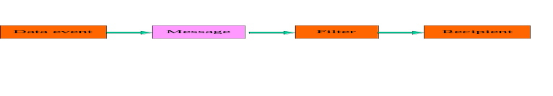

INFOD uses the term publisher to describe the sources of data (messages) and consumer for the recipients of data (messages). INFOD allows publishers and/or consumers to control which data are published and how and to whom it is distributed. Producers provide not only efficient asynchronous distribution of data but also provide indirection between publishers and consumers; i.e., publishers do not need to know the target consumers and nor the consumers the publishers. In the majority of cases it is assumed that publishers and consumers will interact with different producers. Various propagation methods will be used to disseminate information between producers.

Data are typically disseminated from publishers to consumers. However, publishers (or producers) can also alert subscribers of the existence of data and consumers can pull these data at their convenience.

Publications and consumptions are the artifacts that direct the actions of publishers and consumers. A publication specifies and makes available for discovery a particular set of data (messages) for subscription by a consumer. A consumption specifies the context in and mechanism by which particular data (messages) are applied by a consumer, once they have been delivered or pulled.
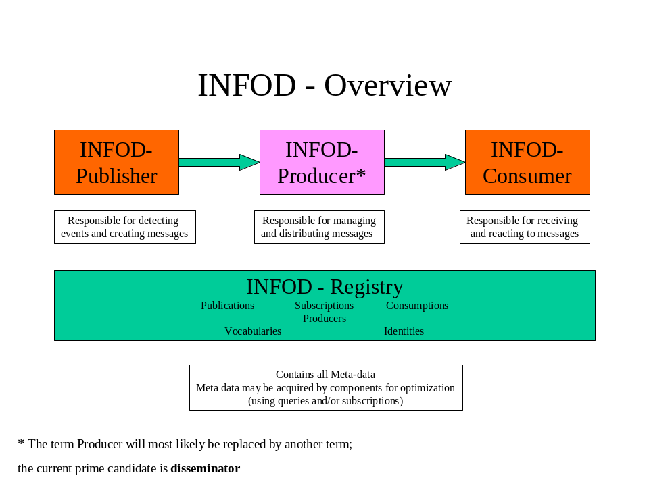
The information about publications, consumptions, subscriptions and producers is kept in INFOD-registries. However, performance and scalability requirements may dictate that INFOD components cache INFOD-registry information about other INFOD components as needed.

INFOD depends on vocabulary support to specify its components as well as the structure of the data that are disseminated and Identity Management system to specify its principals.

A more detailed discussion about the INFOD model and use cases can be found in [INFODU]. It is assumed that the reader some familiarity with [INFODU].

Requirements

In meeting its goals, the INFOD specification must explicitly address the following requirements:

- Publishers must be able to select/limit message consumption: Publishers must be able to specify for each message which consumers should/are eligible to receive a message. To do this, publishers may query and/or reference the registry information about consumers and/or subscriptions.
- Consumers must be able to select messages of interest: Using subscriptions, consumers must be able to specify which messages are of interest and which other consumers should/are eligible to see a message. To do this, consumers may query and/or reference the registry information about vocabularies, e.g., XML schema or SQL objects, publications and/or consumers.
- Consumers must not be limited by publisher-specified classifications in selecting messages: Publishers and producers may organize publications based on hierarchical name spaces (often called topics). However, the use of hierarchical name spaces should be the exceptions, the preferred method is the use of vocabularies.
- Consumers must be able to define what is considered an event: Using subscriptions, consumers must be able to specify what is considered an event and which message is created in response to an event. This includes events that are based on the expiration of time as well as those events that happened in the past. To do this, consumers may query and/or reference the registry information about publications, and consumers. Note: It is assumed that not all producers or publishers offer consumers’ the option to define events.
- Consumers must be able specify which messages should be published in response to an event: Using subscriptions, a consumer must be able to specify which message should be created in response to an event. To do this, consumers may query and/or reference the registry information about publishers. Note: It is assumed that not all producers or publishers offer consumers the option to define which messages are published in response to an event.
- Consumers must be able to combine events and/or messages to new (composite) events: Using subscriptions, consumers must be able to combine messages and events to create new events. To do this, consumers may query and/or reference the registry information about publishers and publications and specify correlations between messages from the one or several as well as constraints between messages.
- Consumers must be able to specify how and when messages are received: Consumers should be able to specify the distribution channel for receiving messages based on message content, their own status as well as external factors, such as time of day. Additionally, consumers may request notifications about the existence of a message as well as reminders they have not consumed these messages in time. Furthermore, consumers must be able to specify the reaction(s) in response to a message.
- Consumers must be able to limit which messages are received: Consumers must be able to specify which messages can be delivered. To do this, consumers may query and/or reference the registry information about vocabularies, publishers and/or producers.
- Consumers must be able to retrieve past messages (and events) on request: Consumers must be able to access past messages. To do this, consumers can query and/or reference the registry information about vocabularies, publishers and producers.
- Publishers and consumers must be able to specify QOS requirements: Publishers, producers and consumers must be able to specify minimal QOS requirements relating to reliability, transactional behavior, auditing and tracking as well as security.

Non-Goals

The following requirements are outside the scope of the INFOD specifications:

- Defining a model for vocabularies: INFOD depends on vocabulary management. This subject, however, has to be solved by the OGSA team for all Grid services and is therefore not part of the INFOD specifications.
- Defining identities: INFOD depends on identity management. This subject, however, has to be solved by the OGSA team for all Grid services and is therefore not part of the INFOD specifications.
- Synchronization of registries: INFOD does not provide methods of synchronizing registries. Users are highly encouraged to do so by using INFOD technology. Synchronization of registries may become a use case once the specifications reach a mature state.
- Discovery services: While registries are used to direct and control INFOD services, there is no provision for supporting discovery. A useful discovery service would require the ability to support vocabularies transformation – ontology’s.
- Negotiation services: INFOD services may support a wide variety of QOS requirements. INFOD does not specify how to negotiate a QOS selection, neither for a single nor for a set of competing services.
- Optimization services: Filters are used to identify events, select events, and/or to select consumers. In many cases, various components (publishers, producers and consumers) can apply/process these filters. INFOD does not attempt to identify which component(s) are optimal in a specific context. However, it provides the means for optimization.

The INFOD Registry

All INFOD resources (components) are defined and managed in registries. Here is a list of the resources:

- Vocabularies – Vocabularies describe the structure of data. Vocabularies are expressed in the context of meta-language such as XML Schema or SQL Objects, which also provides the language (XQUERY and SELECT/DML respectively) for access and manipulation of data instances. The ability to support hierarchical name spaces (topic spaces) and expressions or queries (as data) is an important INFOD requirement.
- Identity Management – Identity management is used to define and identify the various actors, such as publishers and consumers. Identity Management also ensures that its principals have access to only that information that they are entitled to see. It is important to note that vocabularies may be used to customize Identity management to each environment.
- Publishers – Publishers detect events and report about these events by publishing messages. Publishers may publish unconditionally and/or may react to consumers needs assuming consumers are entitled to be notified.
- Publications – Publications are the concrete representation/description that drive the actions of one or more publishers: the specific vocabulary and conditions under which an event will be reported (or a message will be sent).
- Producers - producers manage messages; notify consumers and forward (propagate) messages to other producers. On request, producers retain messages for auditing, tracking and non-repudiation.
- Consumers – Consumers are the recipients of messages. Recipients can receive information based on their own requests, the request of other consumer or the interest of publishers.
- Consumption – Consumptions describe the (security) context and explicit action to be taken when a message is received from a publisher (by the consumer).
- Subscriptions – Subscriptions are used to identify the interest in messages. The interest is expressed with filters (queries and expressions) against one or more vocabularies. Publishers may allow subscriptions to specify what should be published in reaction to an event or even what an event is in reaction to a state change.

Vocabulary Management

The INFOD registry uses Vocabulary Management to define the structures of resources and the language that can be used to find resource instances.

The INFOD team considers Vocabulary Management a fundamental building block for registries and assumes that it – the Vocabulary Management - will become part of the OGSA specification. Since this is – not yet – the case INFOD provides an informal description in Appendix IV titled Vocabulary Management.

Any resource will include the INFODCore. Some of the following information should be part of the generic Vocabulary Management or inherited from OGSA specifications [OGSA].

Identity:

Reference to an identity

Resource Type

Values are: TBD

Resource Type Version

Version of this resource type

Resource Instance Version

Version of this instance

Resource identification:

Identification

Operational Characteristics

Values are: TBD

Identity Management

INFOD supports timely and efficient data dissemination of customized information mainly based on consumers’ needs. It is important for consumers to know the identity of the publishers to judge the value and correctness of information, while publishers need to know the identity of the consumers to ensure that information is disseminated only to those consumers that are entitled to receive it.

Publishers and consumers will be represented as principals in Identity Management systems; all INFOD resources will reference at least one identity.

Identity Management provides a basic set of properties, such as names, signature and labels. INFOD assumes that Identify Management uses Vocabulary Management as an extensibility mechanism. This allows the selection of publishers, publications, consumption as well as consumers in a way that is meaningful for a specific context; e.g. identify the required policies.

The INFOD team considers Identity Management to be a fundamental building block for registries and assumes that it – the Identity Management - will become part of the OGSA specification. Since this is – not yet – the case INFOD provides an informal description in Appendix V titled Identity Management.

Publications

The publication resources are managed by the Create/Alter/DropPublication operations.

INFODPublicationBase

INFODCoreVocabulary
The value for the ResourceType is: Publication
Transaction – message may only be created in the context of a transaction
This requires that the producer supports transactions
Encryption – message may only be delivered when encrypted
Auditing – messages may need to be retained
Non-repudiation – messages may require signed receipt

INFODPublicationProperties – one or more

Specifies vocabularies that describe the publication. This allows producers and consumers to decide if this publication is of interest/acceptable to them.

INFODPublicationVocabularies – one or more

Specifies vocabularies that describe the data and/or events that are available from this publication.

The vocabularies may represent the message and their payloads.

INFODPublicationProducerFilter – optional

Publications may specify a default producer by filtering the information contained in INFODProducerBase and/or INFODProducerProperties.

This (default) producer can be overridden for each message. INFOD will specify the scope of each filter specifications as well as the conflict resolution policy.

INFODPublicationConsumptionFilter – optional

Publications determine which message should be delivered to which consumption/consumer. To do this, publications can reference vocabularies related to consumption/consumers. Message/event instance information may be referenced in these filters; e.g., a bill goes to the payee that is specified in the instance.

Publications may choose to accept or ignore subscriptions; subscriptions act as default consumer selections and can become part of the selection specified in publications. This allows both publications and subscriptions to be used to determine what information will be delivered to whom. This model provides mutual filtering; e.g. a message is only delivered if the publisher is willing to share the data and the consumer is interested in the data. A side effect is fine-grained security that is able to react to the current situation of the consumer.

If no filter is specified – neither in the publish request nor in the publication specification - the selection specification of the producer will be used.

Producers

The producer resources are managed by the Create/Alter/DropProducer operations.

INFODProducerBase

INFODCoreVocabulary
The value for the ResourceType is: Producer
Transaction – transaction support can be enabled for publications and/or consumption
Propagation – propagation provides best effort, at least once, at most once, exactly once
Encryption – messages can be encrypted
Auditing – messages can be retained
Non-repudiation – notification/propagation can require signed receipts

INFODProducerProperties – optional

Specifies vocabularies that describe the producer. This allows publications, producers and consumers to decide if this producer is of interest/acceptable to them.

INFODProducerVocabularies – one or more

Specifies vocabularies that describe the messages supported by this producer.

There will be a standard part, INFODMessageHeader containing information about the publisher, the publication, the time of the message creation etc. followed by the structure of the payload. The structure of the payload is typically identical with the structure(s) defined by INFODPublicationVocabularies. However, the payload could be defined through a different vocabulary. This is especially the case if transformation and procedures are used to change the original message structure and/or content.

An important part of INFODMessageHeader is the information related consumer selection. This information comes from the publications in the form of list of consumers/consumptions and/or expressions and/or from the subscriptions. Depending on the specification, for each consumer/consumption the information about the message delivery has to be kept according to the specifications.

INFODProducerConsumerFilter – optional

Producers determine which message should be delivered to which consumer. To do this, producers can use vocabularies related to consumers. Message/event instance information may be referenced in these filters; e.g., a bill goes to the payee that is specified in the instance.

Producers may choose to accept or ignore subscriptions; subscriptions act as default consumer selections and can be combined with the selection of producers. By doing this, both publications and subscriptions are used to determine what information will be delivered to whom. This model provides mutual filtering; i.e., a message is only delivered if the producer is willing to share the data and the consumer is interested in the data. A side effect is fine-grained security that is able to react to the situation of the consumer.

Note that consumer vocabularies may contain expressions. These expressions may be treated as subscriptions.

This selection specification will be used if no selection criteria have been provided by the publication.

Consumptions

The consumption resources are managed by the Create/Alter/DropConsumption operations.

INFODConsumptionBase

INFODCoreVocabulary
The value for the ResourceType is: Subscription
Transaction – message may only be consumed in the context of a transaction
This requires that the publication and producer supports transactions
Encryption – message may only be delivered when encrypted
Auditing – messages may need to be retained
Non-repudiation – messages may require signature

INFODConsumptionProperties – one or more

Specifies one or more vocabularies that describe the consumption. This allows publications, producers and consumers to decide if this consumption is of interest/acceptable to them.

INFODConsumptionProcedure – optional

Consumptions may specify how messages should be processed. Such a procedure will be described through the INFODMessageConsume vocabulary. INFOD allows procedures to be stateful, transactional and recoverable.

If there is no INFODConsumptionProcedure vocabulary, the consumption cannot be externally controlled.

INFODConsumptionFilter – optional

Referencing the respective vocabularies the consumption can specify which messages are acceptable from which publications and/or producers. The content of messages can be referenced in the filter specification for publications and producers.

This allows users to specify protection against messages with unwanted content and/or from unwanted publication and/or producers.

INFODConsumptionNotification – optional

Consumers may specify when messages should be notified and which consumption should be used. This specification can be based on the message content, the time of days as well as the current ‘status’ of the consumer. Such a notification will be described through the INFODMessageNotification vocabulary.

Subscriptions

The subscription resources are managed by the Create/Alter/DropSubscription operations.

INFODSubscriptionBase

INFODCoreVocabulary
The value for the ResourceType is: Subscription
Transaction – message may only be created in the context of a transaction
This requires that the publication and producer supports transactions
Encryption – message may only be delivered encrypted
Auditing – messages may need to be retained
Non-repudiation – messages may require signature

INFODSubscriptionProperties – one or more

Specifies vocabularies that describe the subscription. This allows publications, producers and consumers to decide if this subscription is of interest/acceptable to them.

INFODSubscriptionDataFilter – one or more

Specifies an expression against one or more vocabularies.

If a referenced vocabulary represents messages, the INFODSubscriptionDataFilter defines whether any new message is of interest; otherwise INFODSubscriptionDataFilter defines events. An event filter can be used to specify composite events – events being triggered by the existence of multiple events or messages that when correlated show a certain pattern/constraint. Additionally the filter can be used to define constraint on publishers, publications and producers.

INFODSubscriptionDataFilter does not specify which component needs to evaluate the filter since this is highly dependent on implementation choices and operational characteristics. In some cases, especially for composite events, multiple components will be involved in the filtering of events. Any part of an INFODSubscriptionDataFilter that specifies an event has to be evaluated by the publications.

INFODSubscriptionProcedure – optional

Publications may allow subscriptions to specify which message should be created when a filter becomes true. Such a procedure will be described through the INFODMessageCreate vocabulary.

INFOD allows procedures to be stateful, transactional and recoverable. The INFODSubscriptionDataFilter may allow the specification of the message creation.

INFODSubscriptionProducerFilter – optional

Subscriptions determine which message should be published to which producer. To do this, subscriptions can use vocabularies related to producers. Message/event instance information may be referenced in these filters.

INFODSubscriptionConsumptionFilter - optional

Subscriptions determine which message should be delivered to which consumption/consumer. To do this, subscriptions can use vocabularies related to consumption/consumers. Message/event instance information may be referenced in these filters.

Interfaces

The interfaces that are introduced in the Information Dissemination model are shown in the picture below.

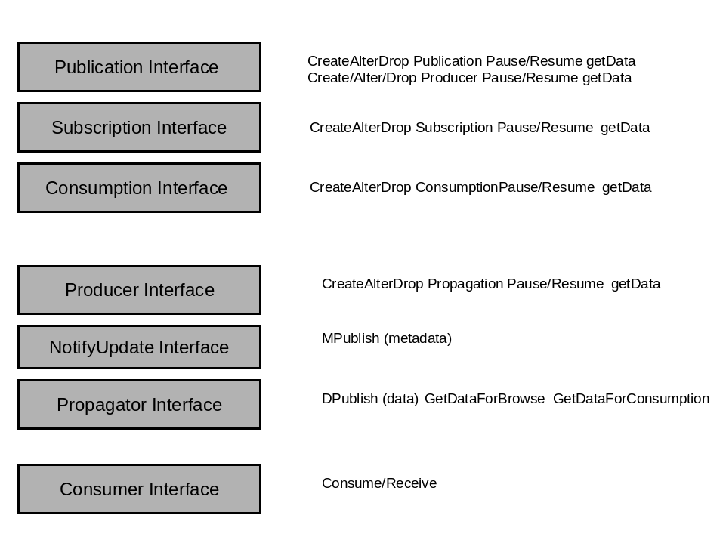

The INFOD interfaces may be composed and implemented by the various roles introduced by the INFOD model, namely the Registry, Publisher, Disseminator(*) and/or Consumer, as shown in the picture below.

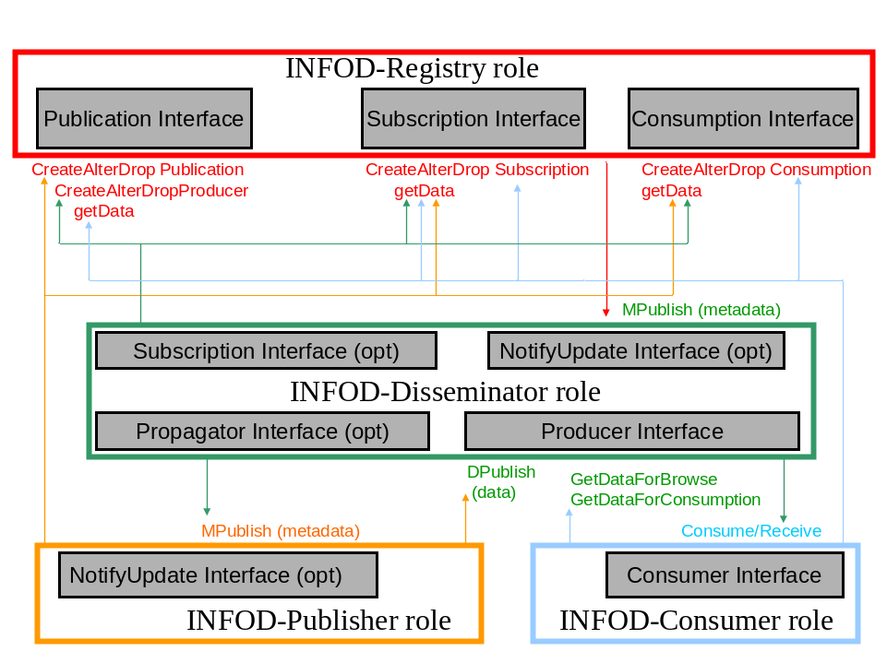

(*) Notes – Please Read:

- For the remainder of section 3 (except for headings), the ‘Disseminator’ role is currently still referred to as a ‘Producer’. The name change will occur later and will not affect the Producer interface (which will retain the Producer name).
- INFOD-Disseminators will disseminate messages between each using propagation. This interface will be defined at a later time.

Interfaces defined for the Registry

The INFOD Registry (role) interfaces define a standard set of message exchanges to describe an information dissemination store. The store acts not only as a typical registry (look up functions) but also as a service manager that owns and manages the necessary resources for information dissemination. These resources consist of Publications, Producers, Subscriptions, and Consumptions, as defined in section 2. The INFOD-Registry interfaces thus consist of:
- Publication Interface
- Subscription Interface
- Consumption Interface

The remainder of this section describes in detail the various interfaces and the operations
they support.

Publication Interface

The publication interface owns the publication and producer resources and manages information about publishers, publications and producers. Its operations are described below.

3.1.1.1 CreatePublication

The CreatePublication message is typically used by an INFOD publisher to define the data that it is able to publish.

Publications that define specific event composition or event correlation may be created by consumers.

As part of the processing of a CreatePublication request message, the INFOD Registry MUST create a Publication resource representing the Publication.

The format of CreatePublication request message is:
<xml format to be provided later>

Components of message are:
- INFODPublicationPublisherInfo
- INFODPublicationProperties (opt)
- INFODPublicationVocabularies (opt)
- INFODPublicationProducerFilter (opt)
- INFODPublicationConsumptionFilter (opt)

More description of each component is as follows:

The publisher info provides provenance information and is therefore required.
The publication properties are optional and allow attributes to be defined for that publication,
that consumers or producers may query.
The publication vocabularies define the structure of the message payload.
The producer filter allows publications to be targeted for specific producers only.
Finally, the publication consumer filter allows publications to be targeted for specific consumers only.

If the INFOD Registry accepts the CreatePublication request message, it must respond with a
CreatePublicationResponse message of the following form:
<xml format to be provided later>

Components of the message are:

- INFODPublicationReference

The components of the CreatePublication response message are further described as follows:
The INFODPublicationReference provides a reference to newly created publication resource at the appropriate registry.

Instead of the CreatePublicationResponse message, the INFOD Registry may also send the following faults in response to a CreatePublication request message:

<to be provided later >

3.1.1.2 AlterPublication

3.1.1.3 DropPublication

3.1.1.4 CreateProducer

The CreateProducer message is used by an INFOD producer to register itself to an INFOD registry.

As part of the processing of a CreateProducer request message, the INFOD registry MUST create a producer resource representing the producer.

The format of CreateProducer request message is:
<xml format to be provided later>.

Components of message are:
- INFODProducerProperties (opt)
- INFODProducerVocabularies (at least one)
- INFODProducerConsumerFilter (opt)

More description of each component is as follows:

The producer properties are optional and allow attributes to be defined for that producer, so
that publishers and consumers may query it.
The producer vocabularies define the structure of the message payload that are supported by
the producer. Note that this may not always be the same as the original publication vocabulary (if transforms are applied for example).
Finally, the producer consumer filter allows a producer to target specific consumers only.

If the INFOD Registry accepts the CreateProducer request message, it must respond with a CreateProducerResponse message of the following form:
<xml format to be provided later. Components of the message are:>

- INFODProducerReference

The components of the CreateProducer response message are further described as follows:
The INFODProducerReference provides a reference to newly created producer resource at the appropriate registry.

Instead of the CreateProducerResponse message, the INFOD Registry may also send the following faults in response to a CreateProducer request message:
<to be provided later>

3.1.1.5 AlterProducer

3.1.1.6 DropProducer

3.1.1.7 GetData

Consumption Interface

The consumption interface owns the consumption resources and manages information about consumptions and consumers. Its operations are described below.

3.1.2.1 CreateConsumption

The CreateConsumption message is used by an INFOD consumer to register consumption information to an INFOD Registry.

The INFOD model allows consumer information to be provided in many different ways: at the subscription level, at the publication level or directly through the Consumption Interface.

As part of the processing of a CreateConsumption request message, the INFOD Registry MUST create a Consumption resource representing the consumption.

The format of CreateConsumption request message is:
<xml format to be provided later>.

Components of message are:

- INFODConsumptionConsumerInfo
- INFODConsumptionProperties (opt)
- INFODConsumptionProcedure (opt)
- INFODConsumptionFilter (at least one)
- INFODConsumptionNotification (opt)

More description of each component is as follows:

The consumption consumer info provides provenance information and is therefore required.
The consumption properties are optional and allow attributes to be defined for that consumption, so producers may query it.
The consumption procedure defines how messages will be consumed, whereas the consumption
filter allows additional filtering operations to be executed at the consumer end; finally, the consumption notification defines the type of scheduling activity that will trigger the consumption.

If the INFODRegistry accepts the CreateConsumption request message, it must respond with a CreateConsumptionResponse message of the following form:
<xml format to be provided later>.

Components of the message are:

- INFODConsumerReference

The components of the CreateConsumption response message are further described as follows:
The INFODConsumptionReference provides a reference to newly created consumption resource at the appropriate registry.

Instead of the CreateConsumptionResponse message, the INFOD Registry may also send the following faults in response to a CreateConsumption request message:
<to be provided later>

3.1.2.2 AlterConsumption

3.1.2.3 DropConsumption

3.1.2.4 GetData

Subscription Interface

The subscription interface owns the subscription resources and manages information about subscriptions and subscribers. Its operations are described below.

3.1.3.1 CreateSubscription

An INFOD producer or an INFOD consumer sends a CreateSubscription message to an INFOD Registry (or an INFOD producer if it implements that Subscription interface) in order to register its interest for INFOD messages related to one or more publications, which may or may not already exist at the Registry; that is, the CreateSubscription operation allows publications to be created dynamically.

As part of the processing of a CreateSubscription request message, the INFOD Registry (or the INFOD producer if it implements that Subscription interface) MUST create a subscription resource representing the subscription. Sending two identical CreateSubscription request messages to an INFOD Registry (or the INFOD producer if it implements that Subscription interface) will result in the creation of two subscription resources.

The format of the CreateSubscription message is:
<xml format to be provided later>

Components of message are:
- INFODSubscriptionSubscriberInfo
- INFODSubscriptionProperties (opt)
- INFODSubscriptionDataFilter
- INFODSubscriptionProcedure (opt)
- INFODSubscriptionProcedureFilter (opt)
- INFODSubscriptionConsumptionFilter (opt)

More description of each component is as follows:

The subscriber info provides provenance information and is therefore required.
The subscription properties are optional and allow attributes to be defined for that subscription,
so that publishers, producers or consumers or producers may query.
<more later on other parms, as they are being reworked>

If the INFOD Registry (or the INFOD producer if it implements that Subscription interface) accepts the CreateSubscription request message, it must respond with a
CreateSubscriptionResponse message of the following form:
<xml format to be provided later>.

Components of the message are:

- INFODSubscriptionReference

The components of the CreateSubscription response message are further described as follows:
The INFODSubscriptionReference provides a reference to newly created subscription resource at the appropriate registry.

Instead of the CreateSubscriptionResponse message, the INFOD Registry (or the INFOD producer if it implements that Subscription interface) may also send the following faults in response to a CreateSubscription request message:
<to be provided later >

3.1.3.2 AlterSubscription

3.1.3.3 DropSubscription

3.1.3.4 GetData

Interfaces defined for the Publisher (optional)

The INFOD publisher (role) interface defines a standard set of message exchanges to allow INFOD publishers to be notified of INFOD registry changes of interest. The interface it supports is the NotifyUpdate interface.

An INFOD publisher typically will not implement such interface and rather publish data
to INFOD producers, leaving the INFOD producer the tasks of filtering messages of relevance based on subscription and consumption information. In the case of complex publishers however, that interface allows publishers to target more specifically which messages to publish.

The remainder of this section describes in detail the operations that the NotifyUpdate interface supports.

NotifyUpdate Interface

The NotifyUpdate interface has only one operation, Mpublish, a metadata publish operation.

3.2.1.1 Mpublish

An INFOD producer MAY send the Mpublish message to the INFOD publisher in order to deliver one or more metadata update messages.

Note: an INFOD registry MAY also send the Mpublish message to the INFOD producer in order to deliver one or more metadata update messages.

The format of the Mpublish message is:
<xml format to be provided later>.

Components of message are:
<to be provided later>
<more description of each component to be provided later>

No response is expected from the INFOD publisher (or the INFOD producer) upon receipt of this message.

Interfaces defined for the Disseminator

The INFOD Producer (role) interfaces define a standard set of message exchanges to describe an information dissemination producer. The producer provides an intermediary between publishers and consumers, delivers distribution functions and sends messages to consumers. The INFOD producer therefore references most of the resources in the INFOD Registry and thus needs mechanisms for synchronizing these resources. The interfaces defined for the Producer are thus:
- Producer Interface
- Subscription Interface (optional – in that case, subscription resources are managed directly by the INFOD producer)
- NotifyUpdate Interface (optional – in that case, the INFOD producer is notified of updates to resources relevant to it)
- Propagator Interface (optional) – for communication between different INFOD producers

The remainder of this section describes in detail the various interfaces and the operations
these interfaces support.

Producer Interface

The INFOD Producer interface’s operations are limited to actual data distribution and data movement. Operations like ‘subscribe’ are not part of that interface (rather, they are provided by the INFOD registry interfaces). The operations supported are described below.

3.3.1.1 Dpublish

An INFOD publisher sends the Dpublish message to an INFOD producer in order to deliver one of more INFOD message(s). The format of the Dpublish message is:
<xml format to be provided later.Components of message are:>

- PublisherINFODReference (address of the INFODRegistry together with identifier for Publisher combination)
- data

<more description of each component to be provided later>

No response is expected from the INFOD producer upon receipt of this message.

3.3.1.2 GetDataForConsumption, GetDataForBrowse

In response to a GetDataForConsumption or GetDataForBrowse message, the INFOD producer returns the data that satisfies the consumer subscription and/or publication specifications. The difference between GetDataForConsumption and GetDataForBrowse, like their name indicates, is that the former is a destructive read whereas the latter is not so allows new consumers to receive messages that other consumers already read.

The INFOD producer policies MAY be available at the INFOD Registry where the producer registered itself.

The format of the GetDataForConsumption or GetDataForBrowse request message is:
<xml format to be provided later>.

Components of message are:
<to be provided later>
<more description of each component to be provided later>

The response of the GetDataForConsumption or GetDataForBrowse request message is a message of the following form:
<xml format to be provided later.

Components of the message are:

- Data…

The contents of the GetDataForConsumption or GetDataForBrowse response are further described as follows:
<to be provided later>

Instead of the GetDataResponse message, the INFOD producer may also send the following faults in response to a GetDataForConsumption or GetDataForBrowse request message:
<to be provided later >

Subscription Interface

That interface has already been defined in section 3.1.3

NotifyUpdate Interface

That interface has already been defined in 3.2.1.

Interfaces defined for the Consumer

The INFOD Consumer (role) interfaces consist of a single interface named the consumer interface. The INFOD producer sends INFOD messages to INFOD consumers using the consumer interface.

Consumer Interface

The consumer interface allows for efficient consumption by defining messages that include INFOD-specific information (such as publication metadata) in addition to the application-specific message content.

The operation provided by the consumer interface is the Consume/Receive operation.

3.4.1.1 Consume/Receive

An INFOD producer MAY send the Consume/Receive message to the INFOD consumer in order to deliver one or more INFOD messages. The format of the Consume/Receive message is:
<xml format to be provided later>

Components of message are:
<to be provided later>
<more description of each component to be provided later>

No response is expected from the INFOD consumer upon receipt of this message.

Security Considerations

To be added

Open Issues/Questions/Work-to-do

- Propagation has to be added to the registry and the interfaces
- Resources specify filters referencing other resources. Resource owners must be able to specify which (part of) filters can be overwritten and which not.
- The following vocabularies have to be specified
- INFODMessageHeader – specifies common part used by various message
- INFODMessageCreate – specification of messages as created by publishers
- INFODMessagePropagate - specification of messages as created by propagated from producers to producers
- INFODMessageNotification - specification of messages as created by producers
- INFODMessageConsume – specification of consumptions by consumers
- INFOD requires the following transaction support, which is not yet in any specifications – add reference
- For propagation – read data must be recoverable
- For commit – wait for recoverable is not needed
This support is only needed if transactional behavior does not lead to distributed 2 PC.
- Vocabulary support
- Support of classifications
- Support of expressions as data
- Can publisher and consumer communicate directly?
- INFODConsumptionNotification description is very confused.
- Terminology
- Producer or Agent (?) or?

Appendix I – UML

To be added

Appendix II – XML Schema

To be added

Appendix III – WSDL 1.1

To be added

Appendix IV – Vocabulary Management

All available resources and services (publishers, publications, subscription, etc.) are treated in a uniform manner. They are all manipulated through a resource abstraction. The characteristics and capabilities of a resource are described using terms in one or more vocabularies. The vocabularies are used to support the creation, organizing and manipulation of terms, and the discovery of resources using queries where vocabulary terms act as meta-variables.

Each term in a vocabulary has a name, one or more values, and the type of its value or values. Each term must have a name that is unique within its vocabulary. This uniqueness can be achieved by different means depending on the type of the vocabulary. For example, if an XML schema defines the vocabulary, terms form a hierarchy where their uniqueness, for local terms, is defined by their names and their positions in the hierarchy.

The set of values that can be associated with a particular term form its data type. Some terms, however, do not have data types, and, correspondingly, do not have values associated with them. Such terms name groups of particular instances (pen, table, etc.) Some vocabularies, XML schemas, for example, have data types associated with each term. Data types allowed for a particular vocabulary form the data type model of this vocabulary. The data type model should be flexible and extensible in order to handle query-matching operations in type-specific ways.

Vocabularies are resources themselves. They are described and can be discovered like any other resource. It is important to note that they are described using terms in other vocabularies.
Vocabularies can be extended dynamically by adding new terms. New vocabularies can be created dynamically. Any application (publisher, for example) should be able to create a new vocabulary resource.

Functionally, the following operations should be allowed on vocabularies:
- Create, or register, a vocabulary
- Extend a vocabulary with new terms
- Extend the data type system of a vocabulary
- Create a description of a resource (publisher, publication, vocabulary, etc.) in a particular vocabulary. In the case of XML schemas, such descriptions are XML documents or XPath expressions valid in a particular XML schema.
- Create a query in the corresponding query language such XQuery or SQL
- Validate a resource description or a query in the corresponding vocabulary, or vocabularies.
- Discover a resource (propagation, matching, etc.)
- Process erroneous or incomplete descriptions and queries. Such processing may result in the retrieval or dissemination of partial information or in the rejection of the description or query

INFOD requires support for categorization, e.g.; the ability to create topic spaces from data. This support has to be flexible and dynamic allowing a variety of presentations as well as rich filter support.

Furthermore, INFOD requires support for expressions. It must be possible to make expressions as part of vocabularies, have expressions reference (other) vocabularies and use filters that reference expressions as well as non-expressions

Appendix V – Identity Management

To be added

Author Information

Vijay Dialani
IBM Corporation
???
()
Vkd00r@ecs.soton.ac.uk

Abdeslem Djaoui
Rutherford Appleton Laboratory
Chilton
Didcot
Oxon
OX11 0QX
UK
A.Djaoui@rl.ac.uk

Steve Fisher
Rutherford Appleton Laboratory
Chilton
Didcot
Oxon
OX11 0QX
UK
S.M.Fisher@rl.ac.uk

Dieter Gawlick
Oracle Corporation
500 Oracle Parkway
Redwood Shores
CA 94065
(650) 506 8706
dieter.gawlick@oracle.com

Christopher Kantarjiev
Oracle Corporation
500 Oracle Parkway
Redwood Shores
CA 94065
(650) 607 5521
chris.kantarjiev@oracle.com

Cecile Madsen
IBM Silicon Valley Laboratory
555 Bailey Avenue
San Jose, CA 95141
(408) 463 2578
madsen@us.ibm.com

Susan Malaika
17 Skyline Drive, Project 994,
Hawthorne, NY 10532
(914) 784 5262
malaika@us.ibm.com

Shailendra Mishra
Oracle Corporation
500 Oracle Parkway
Redwood Shores
CA 94065
(650) 506 9123
shailendra.mishra@oracle.com

Glossary

To be added

Browse

Auditing

Consumer

Consumption

Event

Expression

Evaluation

Filtering

Message

Mutual filtering

Non-repudiation

Notification

Operational Characteristics

Propagation

Publication

Publish/Subscribe

Publisher

Subscriber

Schema

Spam

Topic

Tracking

Vocabulary

Intellectual Property Statement

The GGF takes no position regarding the validity or scope of any intellectual property or other rights that might be claimed to pertain to the implementation or use of the technology described in this document or the extent to which any license under such rights might or might not be available; neither does it represent that it has made any effort to identify any such rights. Copies of claims of rights made available for publication and any assurances of licenses to be made available, or the result of an attempt made to obtain a general license or permission for the use of such proprietary rights by implementers or users of this specification can be obtained from the GGF Secretariat.

The GGF invites any interested party to bring to its attention any copyrights, patents or patent applications, or other proprietary rights which may cover technology that may be required to practice this recommendation. Please address the information to the GGF Executive Director.

Full Copyright Notice

Copyright (C) Global Grid Forum (date). All Rights Reserved.

This document and translations of it may be copied and furnished to others, and derivative works that comment on or otherwise explain it or assist in its implementation may be prepared, copied, published and distributed, in whole or in part, without restriction of any kind, provided that the above copyright notice and this paragraph are included on all such copies and derivative works. However, this document itself may not be modified in any way, such as by removing the copyright notice or references to the GGF or other organizations, except as needed for the purpose of developing Grid Recommendations in which case the procedures for copyrights defined in the GGF Document process must be followed, or as required to translate it into languages other than English.

The limited permissions granted above are perpetual and will not be revoked by the GGF or its successors or assigns.

This document and the information contained herein is provided on an "AS IS" basis and THE GLOBAL GRID FORUM DISCLAIMS ALL WARRANTIES, EXPRESS OR IMPLIED, INCLUDING BUT NOT LIMITED TO ANY WARRANTY THAT THE USE OF THE INFORMATION HEREIN WILL NOT INFRINGE ANY RIGHTS OR ANY IMPLIED WARRANTIES OF MERCHANTABILITY OR FITNESS FOR A PARTICULAR PURPOSE."

References

To be added

[INFODGGF12] pointer to our previous draft

[INFODU] pointer to GGF13 Use Case doc

[TRANS_USE] Transaction Use Cases In particular section 4, ‘Credit Verification’, Requirement R18.

[WS-BrokeredNotification] http://docs.oasis-open.org/wsn/2004/06/wsn-WS-BrokeredNotification-1.2-draft-01.pdf

