NextGRID Graphical Animations Use Case

Introduction
This use case is based on the Digital Media use case described in the NextGRID project deliverable, P7.4.1.
Nowadays, almost all films and commercials use computer graphics animations to implement the special effects that the artists want to depict on the screen. Designers can use several software applications for creating 3D scenes like 3D Studio Max and Maya. These applications can build a 3D environment or just a single scene and render it. The large number of objects, textures, light sources and effects, like shiny surfaces and fog, is a factor that limits the design of a scene due to the increased computational effort. The best solution is to combine the summed power of many single PCs to accomplish the job with the existing software, thus combining the advantages of a powerful computer cluster with the “single PC” way.
The designer develops the job on a single PC with the client’s instructions followed as well as possible to ensure that the final result is the expected one. A close online collaboration between the client and the designer is required in order to obtain results close to the client’s needs.
KINO, a leading producer of TV commercials and films in Greece, anticipates this novel business model can be supported by a Grid enabled rendering infrastructure that can handle not only the in-house production of urgent jobs and small jobs, but also large tasks with a task based negotiation. This negotiation, on the outsourcing of large tasks, has such parameters as the deadline, the complexity of the task, the number of frames and the total computational time needed.

Actors
In this use case the actors are the Designers, Reviewers and the Bosses. The Designer has submitted animation rendering jobs to the Grid, and the Designer and Reviewers are interested in knowing when those jobs have been finished.
The Designer and Reviewer 1 want to be informed as soon as each animation is completed.
Reviewer 2 is currently out of the office and needs to be paged when each animation is completed, and will then return to the office to view the messages that have been sent.
Boss 1 wants to know which Designers are available between certain dates.
Boss 2 wants to be notified if any of the animations from this particular designer have not been completed by a certain deadline.
The Publisher is the Rendering Service.
The INFOD Registry manages the vocabularies and subscriptions etc.

Reviewers
INFOD Registry
Stored Animations
Submit jobs.

Designers
Bosses
3D Rendering Services
Publishers
Consumers
Subscribers (and Consumers)
Subscriptions
Figure 1: Diagram showing actors and services.

Scenarios
In these scenarios the designer submits jobs (i.e. animated scenes to be rendered) to the rendering service (compute cluster). On submitting the rendering job parameters such as time limit, complexity, number of frames in the scene, type of rendering software to use, data transport protocol etc, may all be specified. But how the job is submitted to the rendering service and the animation data transport are outside the scope of this document.
These scenarios will just concentrate on the notification of job completion to the designer and reviewers, within the INFOD framework.
It is also assumed that the Rendering Services have already been created and registered in the INFOD Registry.

Vocabularies
The first stage is to define the appropriate vocabularies for the Animators, Reviewers, Bosses & Rendering Services community:

Rendering Service Vocabulary Components | Comment
Organisation_Name | Name of the organisation hosting the rendering service.
Organisation_Location | Address of the organisation hosting the rendering service.
Organisation_Email | General e-mail address of organisation.
Organisation_Website | URL.
BBB_rating | A number between 1 and 5.
Security_Policy | Security policy.
Other …
Table 1: Media Organisation Vocabulary.

Rendering Service Vocabulary Components | Comment
Service_Name | Name of rendering service.
Service_Address | URL.
Service_Organisation | The organisation hosting the rendering service – see Organisation Vocabulary.
Rendering_Software | List of rendering software products available, e.g. 3D Studio Max, Maya.
Pricing_Model | Pricing model for rendering animations.
Other …
Table 2: Rendering Service Vocabulary.

Designer Vocabulary Components | Comment
Employee_Name | Name of the animator/designer, reviewer or boss.
Employee_Email | E-mail address.
Employee_Type | Designer, Reviewer or Boss.
Rendering_Software | List of rendering software products that they are trained in. [Probably not applicable for Reviewer or Boss types.]
Employee_Organisation | Name of the organisation or company that they work for – see Organisation Vocabulary.
Hourly_Rate | Hourly rate, for example for designing animations.
Availability | Dates and times when the employee is available.
Other …
Table 3: Employee Vocabulary.

Animation Vocabulary Components | Comment
Designer_Name | Name of the designer that submitted the animation for rendering.
Rendering_Job_Name | Name for the submitted rendering job.
Project_Name | Name of the project (e.g. film or commercial perhaps).
Number_of_Scenes | Number of scenes to be rendered (i.e. some measure of the complexity of the animation).
Rendering_Software | Rendering software used, e.g. 3D Studio Max or Maya etc.
Job_Time_Limit | Maximum completion time for the rendering job.
Job_Start | Actual start time for the rendering job.
Job_End | Actual end time for the rendering job.
Job_Status | Status of the rendering job, e.g. Accepted, Rejected, Submitted, Started, Completed, Reviewed, Passed, Failed, Exceeded Time Limit.
Animation_EPR | Location (EPR) of the resulting stored animation.
Other …
Table 4: Animation Vocabulary.

Subscriptions
The next stage is to create relevant subscriptions:
Subscription Entity  INFOD Component | Values
INFOD_Type | Subscription
INFOD_Name | Find a Rendering Service
INFOD_Description | Watch available Rendering Services
INFOD_Data_Constraint | Rendering_Service_Inventory: SHOW (Service Name, Organisation, Website) FOR Rendering_Software = 3D Studio Max
INFOD_Property_Constraints | Rendering Service Organisation: BBB_Rating > 2
 | Consumers: Default
INFOD_Schedule | Default
INFOD_Policies | Default
INFOD_Processing | None
Table 5: Designer finding a rendering service subscription.

Subscription Entity  INFOD Component | Values
INFOD_Type | Subscription
INFOD_Name | Find completed animations
INFOD_Description | Watch for completed animations
INFOD_Data_Constraint | Rendering_Jobs_Inventory: SHOW (Rendering_Job_Name, Animation_EPR) FOR Designer Name = designer, Project = Toy Story 3, Status = Completed
INFOD_Property_Constraints | None
 | Consumers: Default
INFOD_Schedule | Default
INFOD_Policies | Default
INFOD_Processing | None
Table 6: Designer monitoring animation jobs subscription.

Subscription Entity  INFOD Component | Values
INFOD_Type | Subscription
INFOD_Name | Find animations for review
INFOD_Description | Watch for animations requiring review
INFOD_Data_Constraint | Rendering_Jobs_Inventory: SHOW (Designer Name, email, job name, Animation_EPR) FOR Project = Toy Story 3, Status = Completed
INFOD_Property_Constraints | None
 | Consumers: Default
INFOD_Schedule | Default
INFOD_Policies | Default
INFOD_Processing | None
Table 7: Reviewers monitoring animation jobs subscription.

Subscription Entity  INFOD Component | Values
INFOD_Type | Subscription
INFOD_Name | Find a designer.
INFOD_Description | Watch for available designers.
INFOD_Data_Constraint | Employee_Inventory: SHOW (Name, Email) FOR Type = Designer, Rendering_Software = 3D Studio Max, Hourly rate < x £ per hour, Availability ∩ [25/12/2005:27/12/2005] = true
INFOD_Property_Constraints | Employees Organisation:  BBB_Rating > 3
 | Consumers: Default
INFOD_Schedule | Default
INFOD_Policies | Default
INFOD_Processing | None
Table 8: Boss watching for available designers subscription.

Joining the media community
Each appropriate Boss needs to enrol themselves and the Designers and Reviewers that they manage into the INFOD Registry. They (or an Administrator at one of the organisations) also need to add the relevant vocabularies and subscriptions.
- Boss (or Organisation Admin) registers the vocabularies with the INFOD Registry.
- Rendering Service adds itself as a Publisher, with a policy defined to ensure that the Rendering Service is notified if any new associations are added that relate to animation job subscriptions and consumers.
- Boss adds himself into the INFOD Registry as a Subscriber.
- Boss adds their Designers and Reviewers as Consumers, identifying designer and reviewer from roles and job characteristics.
- Boss adds the relevant Subscriptions to the INFOD Registry.
- Boss creates Associations between the Subscription entities and the Consumer entities. The Rendering Service (Publisher) will be informed that this new association has been created.

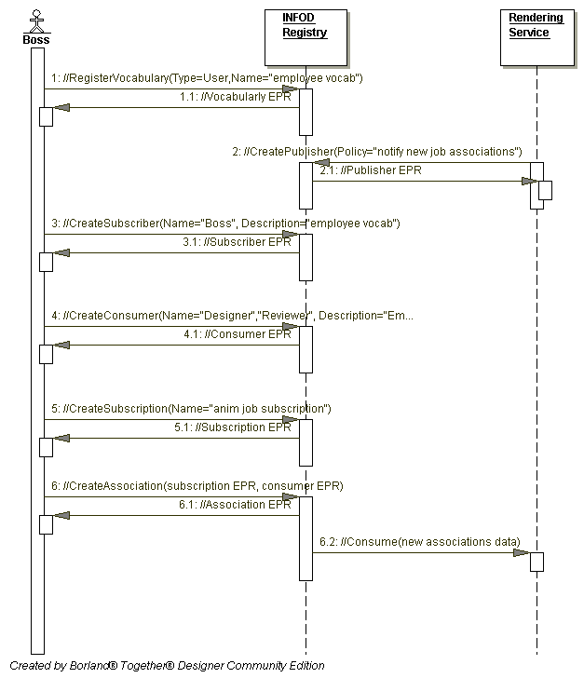
Figure 2: Scenario sequence diagram for the Boss.

Designer and Reviewer Subscription
Designer and Reviewer 1 want to be informed as soon as each animation is completed.
Note that the steps in italics take place outside of the INFOD framework.
- Designer submits an animation job to the Rendering Service, which adds the job to its inventory.
- The job completes (i.e. Job Status = “Completed”) and the rendered animation is stored by the Rendering Service.
- The Rendering Service examines the associated subscriptions.
- The Rendering Service generates messages for the relevant consumers.

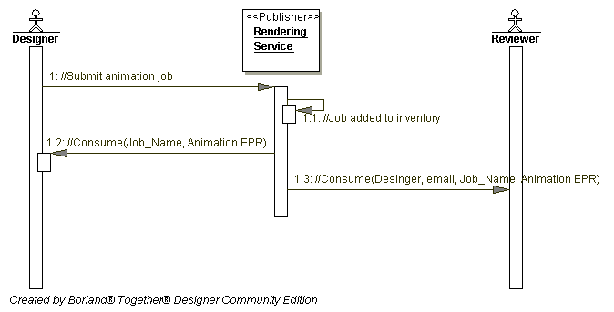
Figure 3: Scenario sequence diagram for Designer & Reviewer 1.

Security
Security would be very important for a film that is currently in production say. As well as the need to authenticate the identities of designers, reviewers & rendering services, one may also want job submission data and returned animations (MPEGs) to be encrypted.
But it is assumed that no additional security requirements would be needed beyond the security common to the entire set of scenarios.

Performance
Response times of around a few seconds would be required but this is unlikely to be outside the typical performance requirements common to many of the use cases.

Requirements Implied
- This should be a bulleted lists of requirements
- The requirements should be added by using the cross-reference entry on the insert menu and requesting the full text of the paragraph. This will ensure that any changes to the precise wording or numbering of the requirements will not give any problems. However this can only be done when the Use Case is pasted into the main document.

R0 | Subscribers must be able to select publishers of interest | Designers acting as subscribers define the constraints on the Rendering Services acting as publishers.
R1 | Subscribers must be able to select messages of interest | N/A
R2 | Publishers must be able to select consumers of interest | Publishers filter interested consumers by specifying constraints.
R3 | Publishers and subscribers must be able to use vocabulary management to select messages | The animation vocabulary is used to specify the message content.
R4 | Subscribers may be able to specify the messages to be published in response to an event | By defining what information is of interest, designers specify what message should be published when animation jobs are completed.
R5 | Subscribers may be able to define an event by querying one data source | Bosses for example by selecting specific designers can specify events. The activation of the subscriptions is the first event. Other events occur if the solution set has changed; i.e., a new matching designer has arrived, an animation job has changed status, or a rendering service is not any longer available.
R6 | Subscribers may be able correlate events to form composite events by querying multiple data sources | N/A
R7 | Consumers must be able to specify dynamically how and when messages are received | N/A
R8 | Consumers may be able to limit the messages received | N/A
R9 | Consumers may be able to retrieve past messages on request: Publishers, Subscribers and Consumers | The (home) disseminators of the publishers retain the message for future auditing.
R10 | Publishers, Subscribers and Consumers must be able to define QoS | Publisher use (home) disseminator to enable auditing
R11 | Publishers, Subscribers, and Consumers may have Identity Management | Identity management is used to support the security requirements
R12 | Filters must be able to be composed | Publishers (Rendering Services), consumers (designers, reviewers & bosses) and subscriptions specify constraints referencing each other information. The combined effect of these filters is evaluated to identify publishers.

