Minutes NSI-WG conf call 25 Nov 2009
Attendees:
John Vollbrecht
Tomohiro Kudoh
Inder Monga
Guy Roberts
Chin Guok
Joan Antoni Garcia
Jerry Sobieski
Gigi Karmous-Edwards

Discussed slides provided by John Vollbrecht (see below)

Slide 1: NSA should not include transport resources
Slide 3: shows example only, this should not be taken as an architectural specification – the interface external to the NSI does not form part of the specification, so is alluded to only, but does not form part of the NSI architecture. This led to a discussion about which messages belong on the NSI – some additional messaging for example for topology exchange are possible, but not defined here.
Slide 4: general agreement that this reflects the sequence.
Slide 7: discussion of how 2 phase commit works in tree model compared with chain model. More details to be provided by Tomohiro Kudoh.

Slide 1:
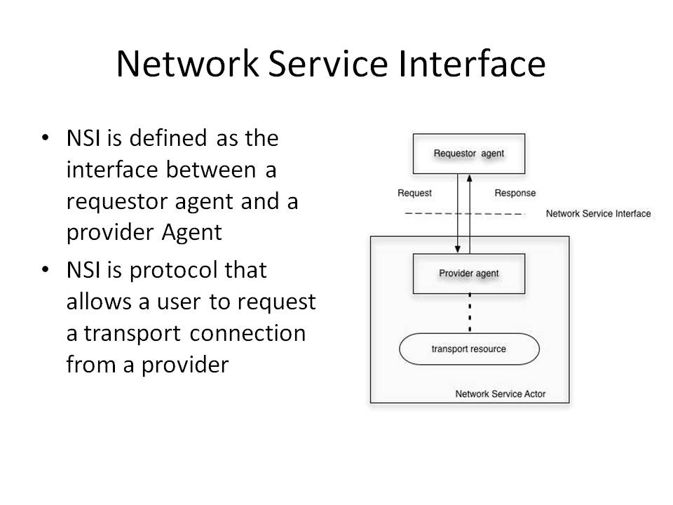

Slide 2:
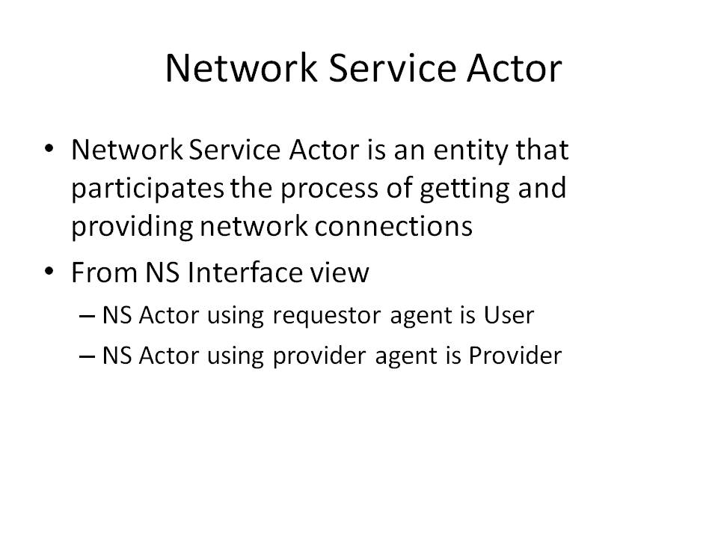

Slide 3:
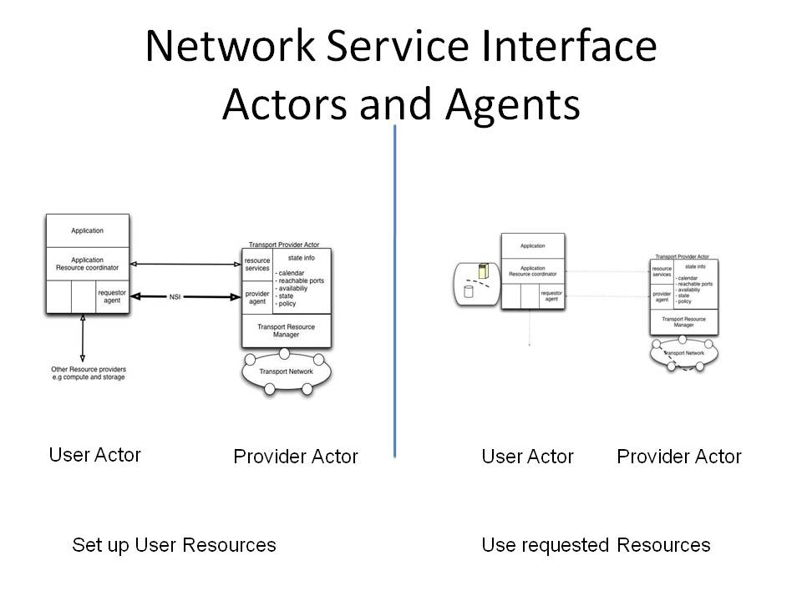

Slide 4:
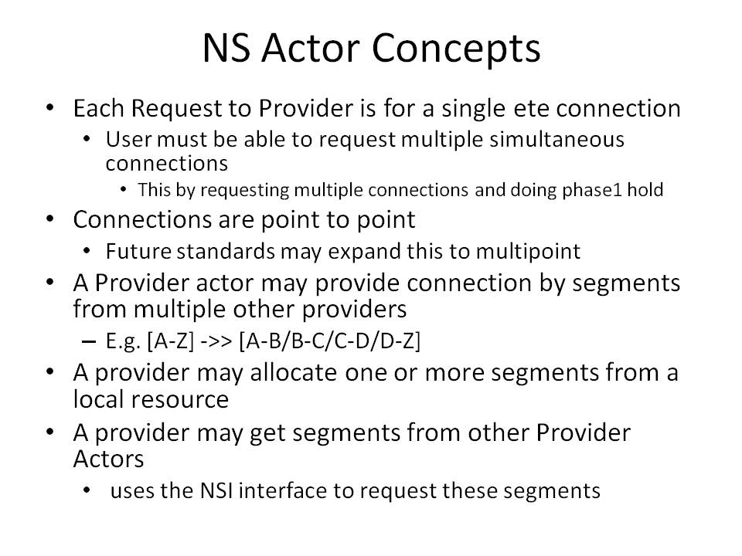

Slide 5:

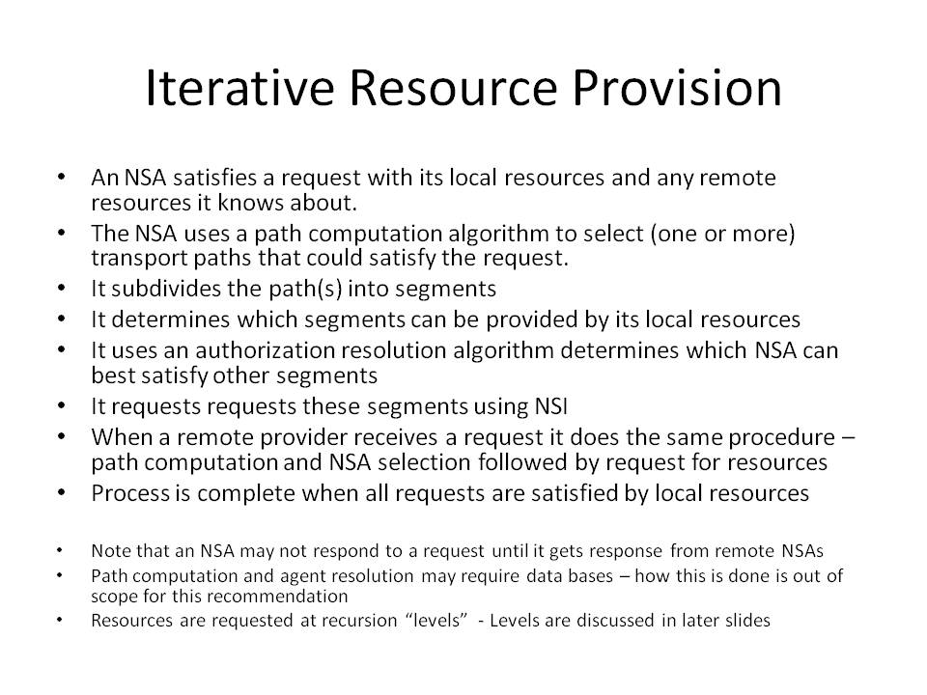

Slide 6:
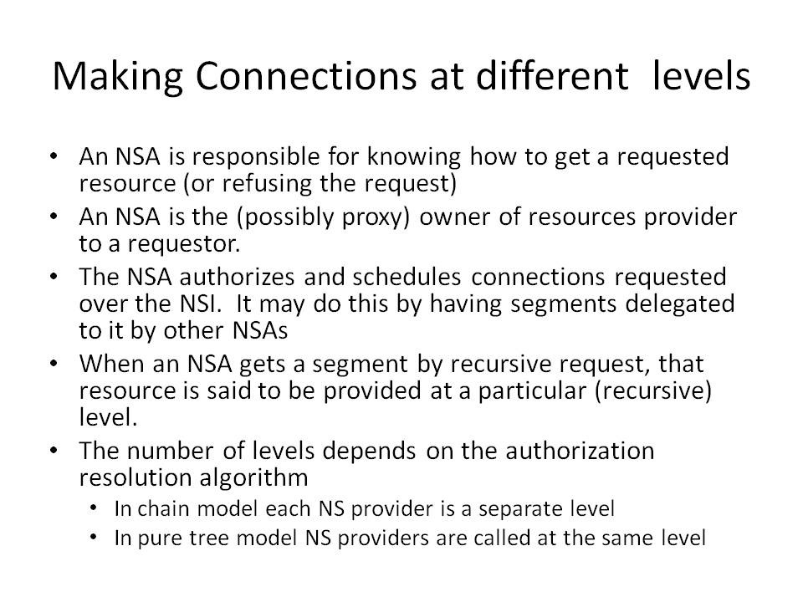

Slide 7:
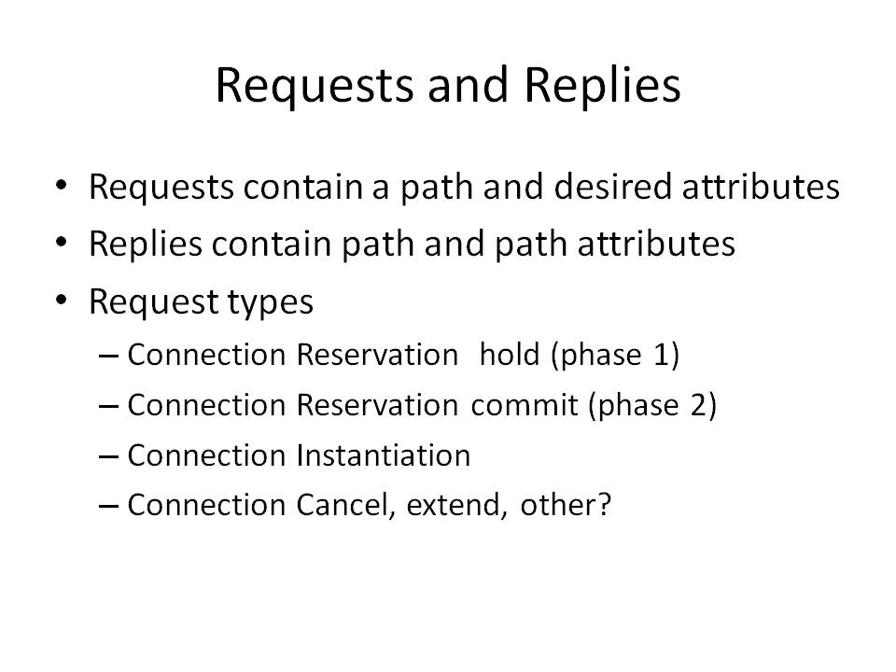

Slide 8:
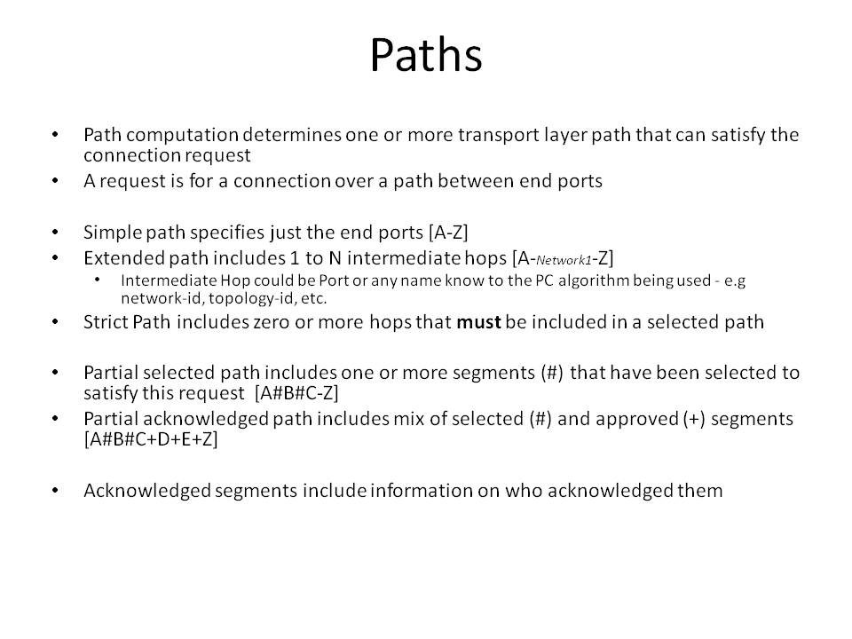

Slide 9:

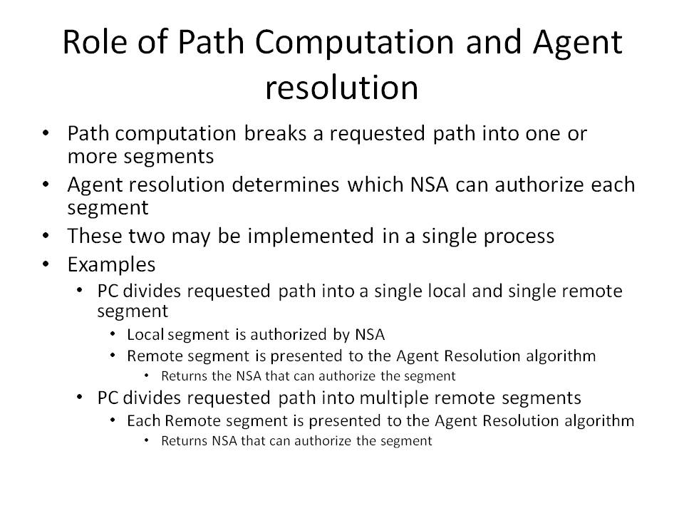

Slide 10:
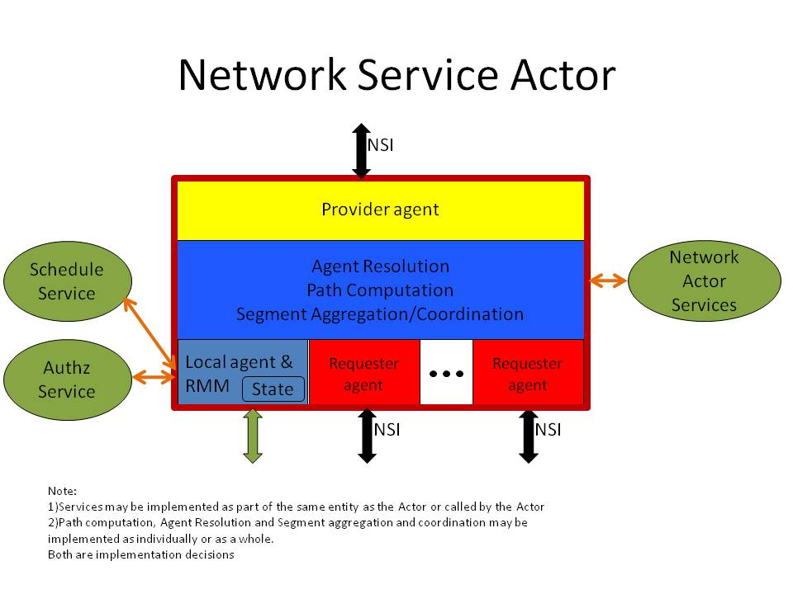

Slide 11:
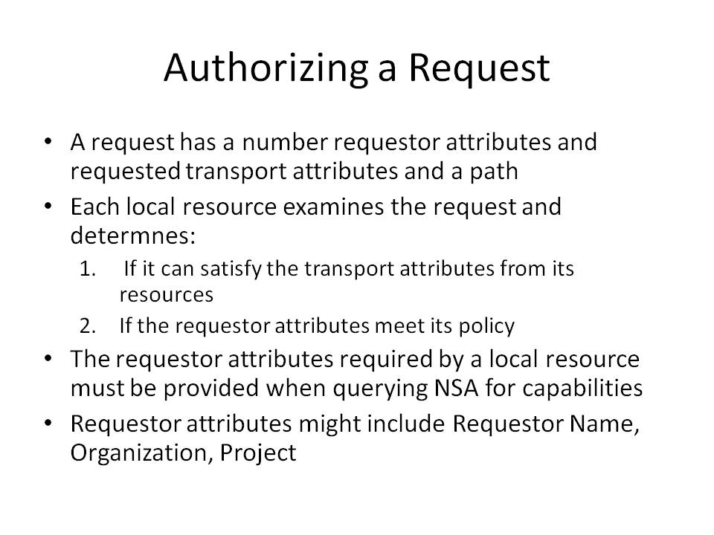

Slide 12:
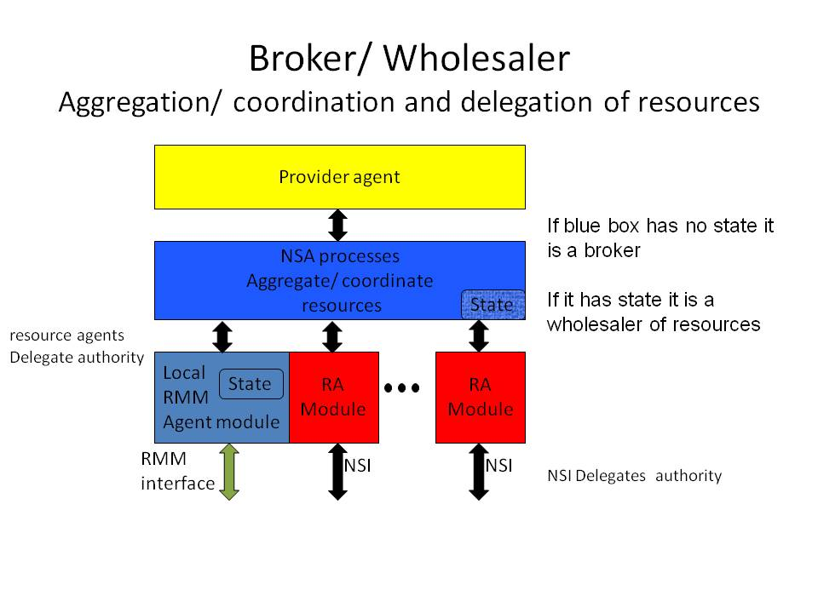

Slide 13:
