NSI Issue 8

Section 1 below is input from NML wg to start discussion with NSI to come up with a unified network model with NSI. Discussion will be continued at Catania. From Freek Dijkstra and Jeroen van der Ham.

Section 2 is a discription of Ethernet use case that should be able to use whatever naming we come up with – from Chin Guok

In the Misc arch issues folder is a PDF from Aaron Brown with a proposed description of a model of for how NSI nework elements fit together. I can’t copy it to this doc, but I think it should be discussed with this.

In my mind this is perhaps the most important issue to get resolved in order to make progress on the rest of the document. (jrv)

Naming of Endpoints and Connections
The NML-WG is working hard on its first schema. This is not completely finished yet, but the group has converged on a naming convention for the most important elements.
Below is a brief overview of the terms of the NML-WG schema.

- Node is a general term to describe any kind of node or device in a network topology.
- Port is associated with a Node to connect it to the network. A Node can have multiple ports.
[In NSI terminology as of now this would be a network termination point]
- Link connects two Ports together. (This is described as a group of two uni-directional links)

The items above are the main Network Elements. Below is a list of other things that are defined as groups of Network Elements. However, these groups are also Network Elements themselves, so they can be contained in themselves. For example a Path can contain another Path.

- Path is an ordered list of Network Elements, describing a path through the network. This need not be a completely detailed description of the whole route through the network.
[In NSI current terminology this is almost a connection. However it doesn’t seem to have resources associated with it. It also doesn’t seem to have time duration associated with it]
[Also, it does not have a concept of path (or connection) segments which are concatenated to create an ete path]
- Topology is a set of connected Network Elements describing a network topology, for example the description of Netherlight is a topology.
- Domain is a group of Network Elements. The Domain can be of different types, describing its role in the provisioning process. This is based on the terminology of the Stitching Framework [1].
[A domain seems close to a Network Service in NSI. question – how does the NSI concept of Network Service Agent fit – does each NS domain have an agent?]

  - User Domain A terminating domain where the users system resides
[is there a concept of an end-user that has no domain (or agent)?
  - Linking Domain A domain that is part of the path
[provides a segment]
  - Source Domain The first domain that realizes the provisioning request
[I would think this should be one end device of a connection/path]
  - Destination Domain The last domain that realizes the provsioning request.

Finally, the NML group also has a class Service in the schema, which aims to describe services that can be provided by Nodes. However, the definition of this class, and its intended usage have not completely crystalized yet.

Naming Convention
The NML group has not yet reached consensus on how to name instances of resources. The NML group does have agreed on the fact that an identifier must be a URI, and that it should contain some information about where it is defined.
Currently there are three proposals on the table:

- NURN: urn:ogf:network:domain=example.net:[ODSC]
- URL: http://www.example.net/network#[ODSC]
- URN: urn:ogf:example.net:[ODSC]
or urn:glif:example.net:[ODSC]
or urn:nml:example.net:[ODSC]
or urn:glif:network:example.net:[ODSC]

Where ODSC stands for “opaque domain specific chunk”. This part of the identifier is determined by the network itself, and does not provide any meaning other than identifying a resource.

Meanwhile, the GLIF community will soon start to use lightpath identifiers [2]. The Source Domain creates a lightpath identifier. It contains a DNS-like name of the Source Domain, followed by a local-identifier part, for example:
[I would think that the name could be created by any agent that has a unique identifer. Using source domain may be difficult if the source domain is different than the requestor for the circuit.]

- Identifier: example.org:2161le.

[1]: GEANT2, JRA3: Deliverable DJ3.5.3: Report on Testing of Technology Stitching, http://www.geant2.net/upload/pdf/GN2-07-066v5-DJ3-5-3-Report_on_Testing_of_Technology_Stitching.pdf
[2]: GLIF Tech WG: Global Lightpath Identiﬁers Naming Scheme
http://www.glif.is/list-archives/tech/msg00116.html

NSI Architecture Definition Example

The NSI architecture taxonomy aims to define terms and definitions that are future looking. However the concepts should also encompass technologies and implementations of today. The follow diagram (Figure 1.) is a simplified example of a network deployment using current technology and serves as an example of how the NSI architecture definitions can be used to label existing services.
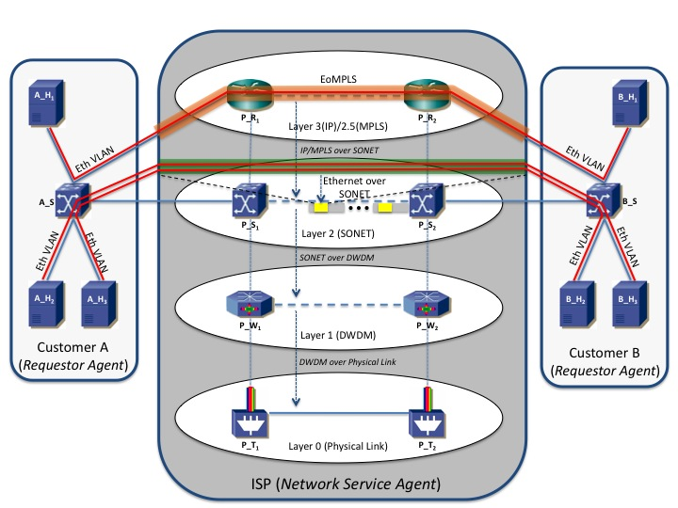
Figure 1. Example of existing network architecture

The following are example uses of the NSI architecture definitions:

- P_T₁ and P_T₂ are transponders connected physically by fiber optics (layer 0). P_T₁ <-> P_T₂ is defined as a ?

- P_W₁ and P_W₂ are DWDM gear connected by a wave (layer 1) over the physical link P_T₁ <-> P_T₂. P_W₁ <-> P_W₂ is defined as a ?

- P_S₁ and P_S₂ are switches connected by a SONET path (layer 2) over the DWDM wave P_W₁ <-> P_W₂. P_S₁ <-> P_S₂ is defined as a ?

- P_R₁ and P_R₂ are MPLS (layer 2.5) enabled routers that are IP (layer 3) connected over the SONET path P_S₁ <-> P_S₂. P_R₁ <-> P_R₂ is defined as a ?

- ISP provides an Ethernet VLAN service between customer A and B. This service will transit Ethernet packets with a specific VLAN ID from A_S to B_S over an EoMPLS path between P_R₁ and P_R₂. The EoMPLS connection A_S <-> P_R₁ <-> P_R₂ <-> B_S is defined as a ?

- A_H₁ and B_H₁ are connected over an Ethernet VLAN which utilizes the EoMPLS connection A_S <-> P_R₁ <-> P_R₂ <-> B_S. A_H₁ <-> B_H₁ is defined as a ?

- ISP also provides an Ethernet service between customer A and B. This service transits Ethernet packets (regardless of VLAN ID) between A_S and B_S by framing the Ethernet packets over the SONET path between via P_S₁ and P_S₂. The Ethernet connection A_S <-> P_S₁ <-> P_S₂ <-> B_S is defined as a ?

- A_H₂ and B_H₂ are connected over an Ethernet VLAN which utilizes the Ethernet connection A_S <-> P_S₁ <-> P_S₂ <-> B_S. A_H₂ <-> B_H₂ is defined as a ?

- A_H₃ and B_H₃ are connected over an Ethernet VLAN which shares the Ethernet connection A_S <-> P_S₁ <-> P_S₂ <-> B_S with A_H₂ and B_H₂. A_H₃ <-> B_H₃ is defined as a ?

