Network Services Interface: An Interface for Requesting Dynamic Inter-datacenter Networks

Tomohiro Kudoh^{*1}, Guy Roberts^{*2}, Inder Monga^{*3}
*1: National Institute of Advanced Industrial Science and Technology (AIST)
ITRI, AIST Tsukuba Central 2, 1-1-1 Umezono Tsukuba, Ibaraki 305-8568, Japan
t.kudoh@aist.go.jp
*2: Delivery of Advanced Network Technology to Europe (DANTE)
*3: Energy Sciences Network (ESnet)

Abstract: The Network Services Interface Working Group in the Open Grid Forum [1] has been working to define an open interface standard to enable interoperability between dynamic circuit services, which can be used for inter-datacenter networking.
OCIS codes: (000.4930) Other topics of general interest

1. Introduction
The inter-cloud has been gathering widespread attention in recent years. With the trend towards Big Data, the federation of data and services provided by different clouds is becoming key to developing new services. To facilitate these new services, the efficient transfer of data between clouds is becoming more important, and reliable network bandwidth between datacenters is critical to achieving a stable high performance service. The partition of an inter-datacenter network from other traffic is also an important requirement, however, in general, little progress has been made towards developing the wide area network as a manageable, shared resource.

Fig. 1. Inter-datacenter network

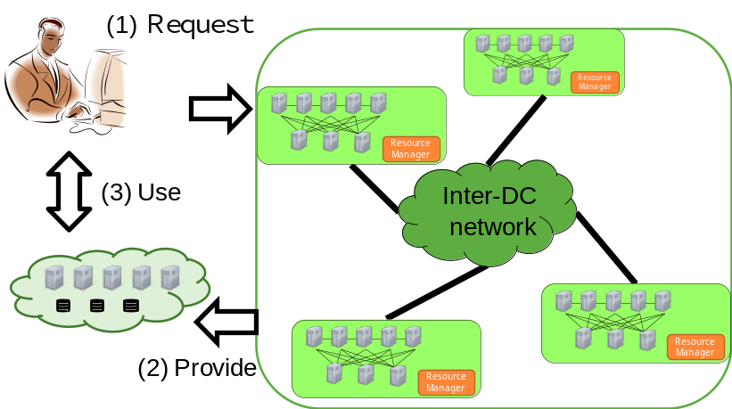

During the last decade, R&E networks around the world have been working on the challenge of delivering dynamic circuit services directly to applications that require bandwidth and service quality guarantees, which cannot be easily provided by conventional best-effort IP networks. To effectively deploy dynamic circuit services, providers require automated management systems that can dynamically provision circuits based on user requests. If such circuit services become available, an efficient inter-cloud infrastructure can be realized, as shown in Fig. 1.
Formed in 2008, the Open Grid Forum (OGF) Network Services Interface Working Group (NSI-WG) has been working on the standardization of an interface to request such circuits. The scope of this standardization effort not only includes a user-to-network provider interface, but also a provider-to-provider interface. Currently, usage is targeted at Research and Education (R&E) providers, as well as commercial providers, and NSI could eventually be implemented in home/retail networks as deployment progresses.
The NSI-WG has published a Network Service Framework document that defines a framework for the NSI protocol [2, 3], over which many network services can be offered. It defines several key architectural elements: the Network Service Interface (NSI), the NSI Protocol, the Network Service Agent (NSA), the Network Services, and an abstracted inter-network Topology. Currently, NSI-WG is working to finalize version 2.0 of the Connection Service document, in which a service architecture and protocol for end-to-end circuit provisioning interface is described. Complementary services, such as a Topology Service and a Discovery Service, are being standardized to support the NSI Connection Service.
2. Key features of NSI
In the NSI architecture, each provider’s network is managed by an NSA, and the NSI Connection Service protocol is the service interface between NSAs. An NSA can take on the role of a requester, a provider, or both. Multiple NSAs can be used to build up a hierarchy of requesters and providers. Requests can be propagated through this hierarchy of NSAs using a tree or chain workflow. The NSI framework identifies a circuit end point with a Service Termination Point (STP) identifier. STPs are conceptual entities, and by combining the concepts of NSAs and STPs, a mapping between a “service topology” and an abstract representation of multi-layer physical topology can be realized.
Using the NSI Connection Service, a reservation of an end-to-end connection can be requested with a designated start-time and end-time, two end points and several technology-specific parameters such as bandwidth (Fig.2). The NSI-CS supports the concept of both an auto-start and manual-start. In either case, the use of an explicit provisioning message is required. The behavior of auto-start or manual-start corresponds to whether the provisioning message is received before or after the start time of the reservation.

Fig. 2. NSI Connection Service overview

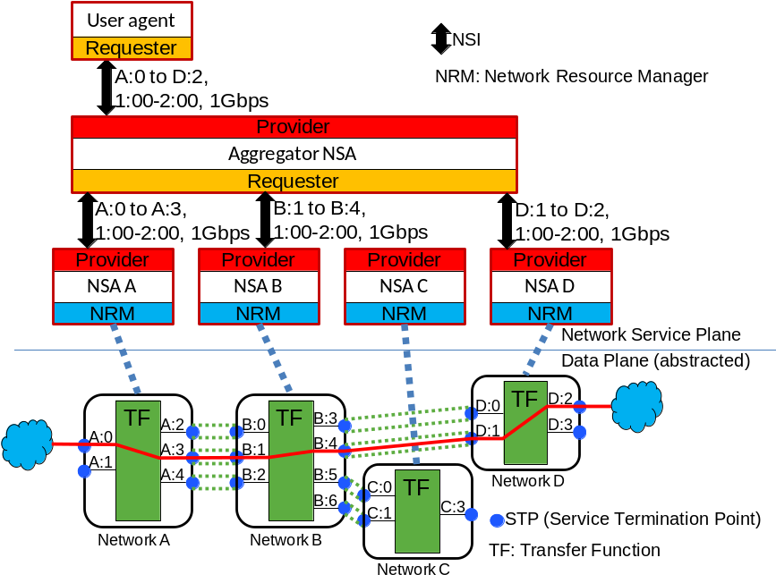

3. Inter-cloud resource management and NSI
By providing a wideband network with guaranteed bandwidth between data centers, a distributed virtual infrastructure (DVI) can be realized, which is composed of resources delivered by multiple data centers [4]. In a DVI, an inter-cloud network provided dynamically by NSI is connected to intra-datacenter network. Since there will be multiple tenants of cloud services in a data center, multiple virtual networks will be formed inside an intra-datacenter network. It is important that these virtual networks are properly connected to inter-datacenter networks; consequently, inter-datacenter resource management becomes important, indeed a number of research results have been reported on this issue. For example, AIST has been developing the GridARS inter-cloud resource management framework [5]. GridARS constructs a virtual infrastructure over multiple domains, based on advance reservation. GridARS consists of a Discovery Service, which collects static resource information, a Resource Management Service, which schedules and co-allocates appropriate resources, a Provisioning Service, which constructs a virtual infrastructure for the resources at a reserved time and a Monitoring Service, which collects resource usage information of each user’s virtual infrastructure and provides it to the user. GridARS manages inter-datacenter network using the NSI-CS protocol.

Fig. 3. Inter-datacenter resource management and NSI

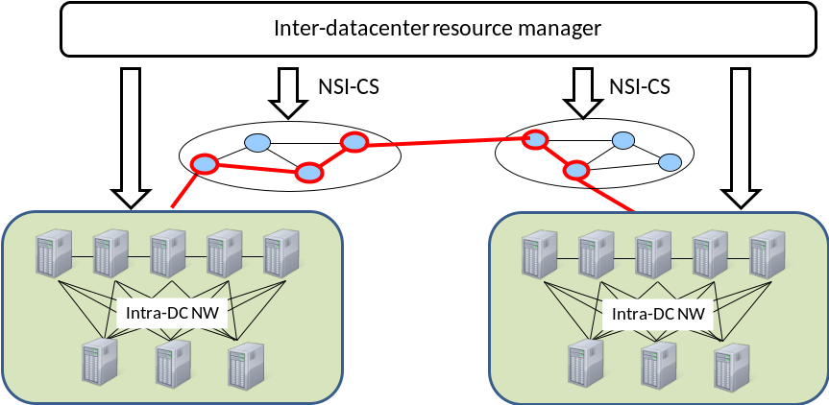

4. NSI v2.0 implementations
Following NSI-CS v1.0 defined in 2011, the NSI-WG has defined NSI-CS protocol v2.0, which has additional functionalities and robustness. AutoBAHN (GÉANT), DynamicKL (KISTI), G-lambda (AIST), G-lambda (KDDI R&D Labs), OpenNSA (NORUnet), OpenDRAC (SURFnet), OSCARS (ESnet) (in alphabetical order) have developed reference implementations of NSA, and deployment of NSI-CS will start at R&E networks around the world in 2013.

5. Conclusions
The NSI Connection Service protocol has been developed to allow dynamic service networks to inter-operate in a multi-provider environment. Version 2.0 of the NSI protocol is now being finalized and is to be demonstrated at Supercomputing 2012. This paper has shown how the NSI v2.0 can be used as a key building block for the delivery of distributed virtual infrastructures.

6. References

[1] http://www.ogf.org/.

[2] Guy Roberts, Tomohiro Kudoh, Inder Monga, Jerry Sobieski, John Vollbrecht, “Network Services Framework,” Open Grid Forum Document GFD.173, http://www.gridforum.org/documents/GFD.173.pdf .

[3] Radek Krzywania, Joan Antoni Garcia-Espin, Chin Guok, Jeroen van der Ham, Tomohiro Kudoh, John MacAuley, Joe Mambretti, Inder Monga, Guy Roberts, Jerry Sobieski, Alexander Willner, “Network Service Interface – gateway for future network services,” Terena Networking Conference 2012, https://tnc2012.terena.org/core/presentation/30

[4] Inder Monga, Eric Pouyoul, Brian Tierney, “Dynamic creation of end-to-end virtual networks for science and cloud computing leveraging OpenFlow/Software Defined Networking,” Terena Networking Conference 2012, https://tnc2012.terena.org/core/presentation/51

[5] Atsuko Takefusa, Hidemoto Nakada, Tomohiro Kudoh, Yoshio Tanaka, Satoshi Sekiguchi, “GridARS: An Advance Reservation-based Grid Co-allocation Framework for Distributed Computing and Network Resources,” Proc. 13th Workshop on Job Scheduling Strategies for Parallel Processing (LNCS 4942), pp. 152-168 , 2007

