OGSA™ EMS Architecture Scenarios

Version 1.0 (draft 009008)

Status of This Memo
This document provides information to the community on the scenarios used to refine the OGSA™ EMS architecture. This is an early draft and is still in flux. It does not define any standards or technical recommendations. Distribution is unlimited.

Copyright Notice
Copyright © Global Grid Forum (2006). All Rights Reserved.

Trademarks
OGSA is a trademark of the Global Grid Forum.

Abstract
…

Contents
1 Introduction 3
2 Fundamental Job Execution 3
2.1 Direct Job Execution 3
2.2 Indirect Job Execution 4
2.3 Job Termination 5
3 Selected Job Execution 6
4 Deployment and Configuration 9
4.1 Deploying an Application 9
4.2 An Application Using ACS 13
5 Data Types in Scenarios 13
5.1 Job 13
5.2 JobStatus 14
5.3 Activity 14
5.4 ActivityStatus 14
5.5 Activity Execution Candidate 14
6 Security Considerations 14
7 Glossary 14
Appendix A. Running a BLAST (Basic Local Alignment Search Tool) job 17
A.1. JSDL Document Submitted to the Job Manager 17
A.2. CDL Document retrieved by JM to prepare for deployment 18
A.3. CDL Document submitted by JM to DS 20
A.4. CDL document after DS has finished deployment 20
A.5. JSDL Document submitted to the BES Instance 20
Appendix B. August 2005 Interim Meeting Sequence Diagrams (TO BE DELETED) 23
B.1. BLAST Diagram from ’05 Aug F2F 23
B.2. 3-tier Diagram from ’05 Aug F2F (TO BE DELETED) 24
B.3. Server consolidation Diagram from ’05 Aug F2F (TO BE DELETED) 25

Introduction
The OGSA EMS architecture has been under discussion for many years. In its entirety it is, quite rightly, a complex set of interdependent services. However, not all of these services are required to perform simpler operations within the EMS space. This document provides a set of scenarios that build upon each other to move towards the full EMS architecture. It is proposed that this roadmap be used to drive the factorisation and capability of the services and interactions within the complete EMS architecture.
Initially, we should focus on the fundamental job execution scenarios as these are well understood and in common use in Grid infrastructures such as EGEE and OSG. Once these have been established activity can move in parallel focussing on:
- Configuration and Provisioning
- Resource Allocation by Agreement

Fundamental Job Execution
One scenario builds on top of another.

Direct Job Execution
Using an established BES Container a client (user) contacts the BES and starts an activity within the container as described within a simple JSDL document. Progress is monitored directly by the user from the client machine.
Requirements: BES and JSDL specifications.
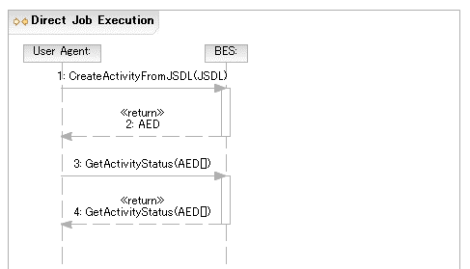

Indirect Job Execution
To enable more sophisticated EMS scenarios it is important that the user can delegate decision making and control to a user ‘agent’ – the Job Manager. The user contacts the job manager, specifying the job, which is then executed on an established BES container. Once the activity is established it is monitored by the Job Manager.
Requirements: Job Manager interface.

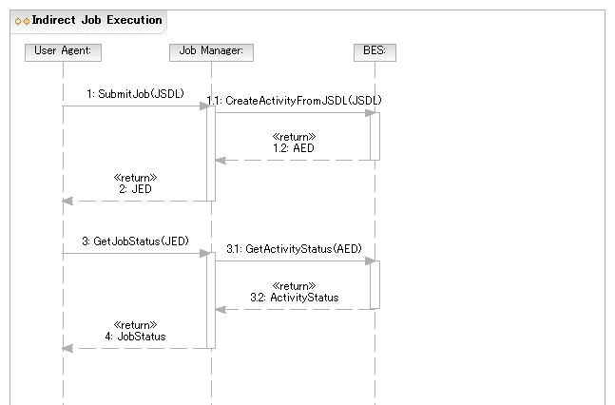

Job Termination
The simplest case of job control (not full job management) returning to JM at the end of the job

Normal Termination of Job
…

Job killed by User Agent

…

Selected Job Execution
In this scenario a simple POSIX application (BLAST) needs to be deployed to support an activity that is to be initiated within a BES container. In this scenario the BES instance has not been determined at submission time.
The Job Manager uses the Resource Selection Service (RSS) to select a BES instance. Internally, the RSS may use a simple selection algorithm (e.g., number of pre-defined BES instances to round-robin the job request from the job manager to one of these interfaces; or could obtain and select BES instances using a service registry (information service). With a defined selection language the RSS implementation can be more sophisticated by allowing a user defined selection policy to be applied to the available services in the registry.
[NB: This (and other steps) should be converted to a UML diagram once agreed.]
- The User Agent submits a JSDL document (which requires the BLAST application) to the JM requesting that the job (as specified by the JSDL document) be executed. The BES instance on which the job is to be executed is not specified.
- The JM queries the Execution Planning Service (EPS) for a list of candidate execution plans for the job, and uses the first plan returned.
- For the purposes of this scenario the first plan returned is considered to be the best choice.
- A plan is made up of at least a JSDL document and a reference to a BES container.
- For the purposes of this scenario, it is assumed that the execution plan does not specify a BES container that already has the BLAST application located on it, and that the application has to be installed so that the job (as described by the JSDL document) can be successfully executed.
- Note that the EPS may have returned an alternate (refined) JSDL document to use instead of the one originally submitted. This is to allow the rewriting of things such as abstract resources (such as one identifying the abstract name of some sequence database) into a set of requirements for making that resource available at the suggested BES container (e.g. by extending the set of DataStaging elements, or by providing an appropriate CDL document).
- Because the application is not installed (as per assumption above) the candidate execution plan includes a CDL suitable for making the application available on that BES container. This will have already identified a suitable BLAST binary for the platform in question.
- It is up to the implementation of the EPS to query whatever Information Service (IS) that is necessary to provide the candidate execution plans as described.
- For the purposes of this scenario we assume the CDL document has a number of ‘lazy elements’, i.e., it is a ‘template’.
- Later scenarios will refine this discovery step further, for example, by detailing an interaction with an ACS repository.
- The CDL document template MAY have some of its ‘lazy elements’ filled in by the JM using information retrieved from some IS.
- For example, the name of the resource (host) on which to deploy may be defined as a lazy element. The JM knows the BES container and may have a specific requirement from the user to execute the job on a specific resource (host).
- The JM queries the Information Service (IS) to discover a DS that can deploy to the platform hosting the BES instance.
- In the simplest case the DS is located on the platform hosting the BES instance or there is some other well known (pre-configured) relationship.
- The DS MAY act as a proxy for deployment on nodes OTHER than the one it is running on.
- The DS MUST advertise (somewhere in a currently unspecified manner) which nodes it is capable of deploying stuff onto, e.g., front end node for a cluster.
- If this fails, the next best execution plan (from those provided in step above) is chosen instead as a failover option, or if there are no other plans left, the job execution overall fails.
- The CDL document (which may still contain lazy elements) is then passed to the DS that can deploy to the platform hosting the BES instance.
- The DS MUST complete the remaining lazy elements in the CDL document. For example, the name of the resource (host) on which to deploy may be defined as a lazy element. If the JM has no specific requirement on which resource to deploy it may leave the element as lazy for the DS to decide. [CDDLM example.]
- If this fails, the next best execution plan (from those provided in step above) is chosen instead as a failover option, or if there are no other plans left, the job execution overall fails.
- The DS returns an EPR to the JM providing a reference to the installed software.
- The IS entry related to the resource is updated with the location of the BLAST application by the JM.
- This prevents the removal of the resource as ‘something’—the BLAST application—is ‘using’ it.
- The JM can use the EPR from the DS to find the defined environment variables to be pulled back in order to refine the JSDL document. This is effectively an operation to retrieve relevant chunks of the XML deployment tree (i.e. the instantiated CDL document) back to the JM for insertion into JSDL document.
- The complete JSDL document is then sent to the BES instance on that platform.
- If this fails, the next best execution plan (from those provided in step above) is chosen instead as a failover option, or if there are no other plans left, the job execution overall fails.
- The IS entry related to the BLAST application is updated with the information that the BES Activity now has an ‘interest’ in the application.
- If another BES Activity uses this BLAST application and performs this registration it will prevent un-deployment of the BLAST application even if the initial activity has completed.
- The BES Activity completes successfully.
- The interest of the BES Activity in the BLAST application is removed from the IS.
- If no other activities are registering an interest in the BLAST application on this resource then the undeploy operation MAY be invoked on the Deployment Service to remove this BLAST application from the resource.
- The application may remain installed for some period of time if it is expected that it may be re-used.
- If the BLAST application is removed then its entry in the IS is also removed.
- The User Agent is informed that the job is complete.

Following 2 sequence diagrams will be replaced
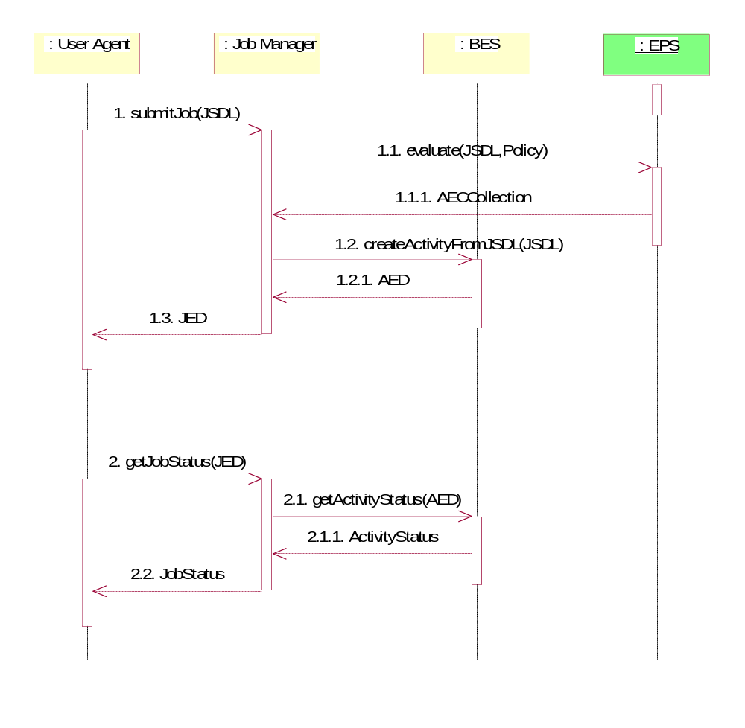
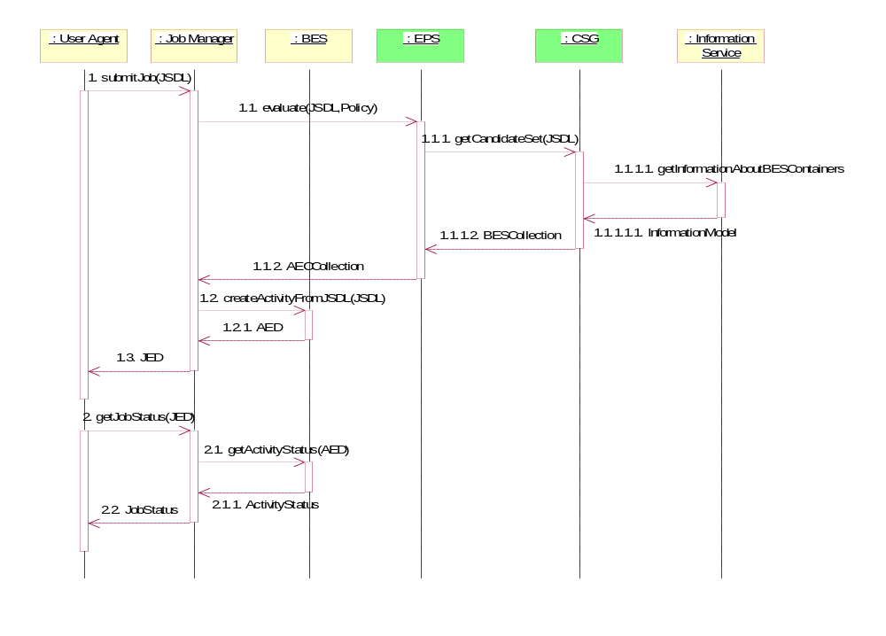

Deployment and Configuration

Deploying an Application

In this scenario a simple POSIX application (BLAST) needs to be deployed to support an activity that is to be initiated within a BES container. In this scenario the BES instance has already been determined and no BLAST application resides on that platform.
- The User Agent submits a JSDL document (which requires the BLAST application) to the JM requesting that the job (as specified by the JSDL document) be sent to a specific BES instance.
  - For the purposes of this scenario the BES instance is specified as an argument to the submission operation and is outside the JSDL document.
- The JM queries the Information Service (IS), or the platform directly, to discover if the specified BES instance resides on a resource which already has the BLAST application.
- For the purposes of this scenario it is assumed that an empty set is returned meaning that the specified BES instance does not have the BLAST application located on it. The BLAST application has to be installed so that the job (as described by the JSDL document) can be successfully executed.
- A BLAST binary suitable for the platform on which the BES instance resides is discovered from an IS and a CDL document describing its deployment requirements is retrieved.
- For the purposes of this scenario we assume the CDL document has a number of ‘lazy elements’, i.e., it is a ‘template’.
- Later scenarios will refine this discovery step further, for example, by detailing an interaction with an ACS repository.
- The CDL document template MAY have some of its ‘lazy elements’ filled in by the JM using information retrieved from some IS.
- For example, the name of the resource (host) on which to deploy may be defined as a lazy element. The JM knows the BES container and may have a specific requirement from the user to execute the job on a specific resource (host).
- The JM queries the Information Service (IS) to discover a DS that can deploy to the platform hosting the BES instance.
- In the simplest case the DS is located on the platform hosting the BES instance or there is some other well known (pre-configured) relationship.
- The DS MAY act as a proxy for deployment on nodes OTHER than the one it is running on.
- The DS MUST advertise (somewhere in a currently unspecified manner) which nodes it is capable of deploying stuff onto, e.g., front end node for a cluster.
- The CDL document (which may still contain lazy elements) is then passed to the DS that can deploy to the platform hosting the BES instance.
- The DS MUST complete the remaining lazy elements in the CDL document. For example, the name of the resource (host) on which to deploy may be defined as a lazy element. If the JM has no specific requirement on which resource to deploy it may leave the element as lazy for the DS to decide. [CDDLM example.]
- The DS returns an EPR to the JM providing a reference to the installed software.
- The IS entry related to the resource is updated with the location of the BLAST application by the JM.
- This prevents the removal of the resource as ‘something’—the BLAST application—is ‘using’ it.
- The JM can use the EPR from the DS to find the defined environment variables to be pulled back in order to refine the JSDL document. This is effectively an operation to retrieve relevant chunks of the XML deployment tree (i.e. the instantiated CDL document) back to the JM for insertion into JSDL document.
- The complete JSDL document is then sent to the BES instance on that platform.
- The IS entry related to the BLAST application is updated with the information that the BES Activity now has an ‘interest’ in the application.
- If another BES Activity uses this BLAST application and performs this registration it will prevent un-deployment of the BLAST application even if the initial activity has completed.
- The BES Activity completes successfully.
- The interest of the BES Activity in the BLAST application is removed from the IS.
- If no other activities are registering an interest in the BLAST application on this resource then the undeploy operation MAY be invoked on the Deployment Service to remove this BLAST application from the resource.
- The application may remain installed for some period of time if it is expected that it may be re-used.
- If the BLAST application is removed then its entry in the IS is also removed.
- The User Agent is informed that the job is complete.

Missing bits:
- May be multiple things that need to be deployed for the activity
- And deployed things may be cached for later re-use or cleanup.

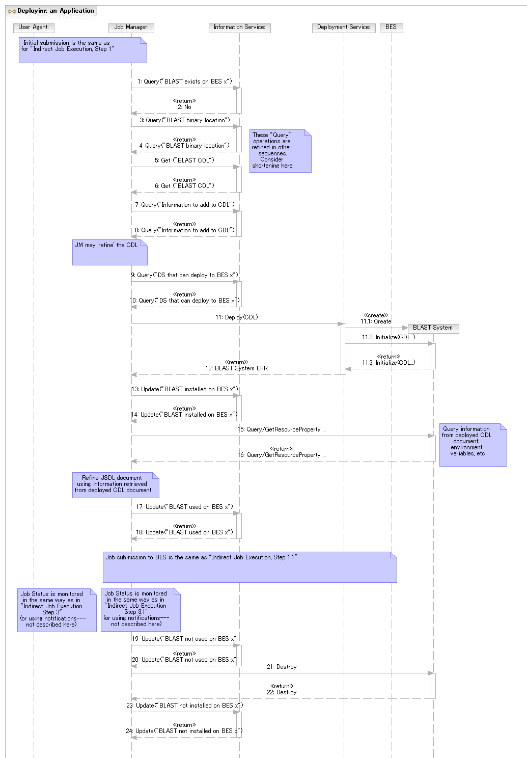
Figure 1 Deploying an Application

Deploying

an Application Using ACS
In this scenario a simple POSIX application (BLAST) needs to be deployed to support an activity that is to be initiated within a BES container. In this scenario the BES instance has already been determined and no BLAST application resides on that platform.
- The User Agent submits a JSDL document, which requires the BLAST application, to the JM. The BES container is specified as an argument to the submission operation. (see previous scenarios)
- The JM determines that the BES container does not have BLAST. (see previous scenarios)
- It is assumed that an Application Archive (AA) that contains all information required to install and configure BLAST is already registered in an Application Contents Services (ACS) Repository in the system.
- Note that an AA instance is addressable by an EPR.
- For simplicity, it is assumed that there is a single ACS repository in the system.
- The JM uses the contents of the JSDL ApplicationName element to search for a matching AA in the ACS Repository using the LookupArchives operation. The EPR of the AA describing the matching BLAST application is returned.
- It is also possible for the AA EPR to be provided as part of the submission (e.g., inside the JSDL document).
- For simplicity it is assumed that name matching between ApplicationName and AA is sufficient.
- In scenarios using the EPS this search-and-match is done by the EPS.
- The JM uses the AA GetContents operation to retrieve the CDL document describing the BLAST deployment requirements.
- For the purposes of this scenario we assume the CDL document has a number of ‘lazy elements’, i.e., it is a ‘template’. (see previous scenarios)
- The CDL document template MAY have some of its ‘lazy elements’ filled in by the JM using information retrieved from some IS. (see previous scenarios)
- The JM queries the Information Service (IS) to discover a DS that can deploy to the platform hosting the BES instance. (see previous scenarios)
- The CDL document (which may still contain lazy elements) is then passed to the DS that can deploy to the platform hosting the BES instance. (see previous scenarios)
- There is behind-the-scenes interaction between the DS and the ACS Repository. For example, the DS retrieves the binary corresponding to the BLAST application from the ACS Repository.
- The DS returns an EPR to the JM providing a reference to the installed software. (see previous scenarios)
…remaining steps as in previous scenarios…

Data Types in Scenarios

Job
Job Endpoint Descriptor (JED)
A Job should have some operation to get the current activities.

JobStatus
This is the status of the Job. This has not been defined yet. But should be defined by the Job Manager group.

Activity
Activity Endpoint Descriptor (AED)
This is defined in the BES specification.

ActivityStatus
This is the ActvityStatus and is defined in the BES specification.

Activity Execution Candidate
This contains a JSDL document, EPR or path of a BES Container, Rank = Number Optional
<ActivityExecutionCandidate>
<JSDL Document/>
<BES EPR/>
<Rank/>?
<CDL Document/>
<DeploymentService EPR/>
<xsd:any/>*
</ActivityExecutionCandidate/>+

Security Considerations
…
Editor Information
…
Contributor
…
Acknowledgements
…

Glossary
For the purposes of this document we define:
- Life Cycle: Both provisioning and deployment actions have a life cycle – they are created, used, and eventually destroyed. A mechanism is needed for activities to ‘register’ their use and interest in a particular activity. Before an activity is destroyed there have to be no outstanding references. [Look at EGA provisioning state model.]
- Provisioning: The instantiation of an environment on a resource (i.e. a deployment activity) that may be used by more than one activity. Generally these deployments are ‘heavyweight’ in that they may take substantial time to instantiate. Provisioning actions may be triggered by a specific activity (e.g. following a manual job submission) or as a result of general response (as defined by a policy) to the state of current resources in the system.
  - For example, “if my available free RHEL4 resources have dropped to 5%, dynamically provision new nodes until the total free nodes have increased to 15%.”
- Deployment: The instantiation of an environment on a resource to meet the needs of a specific activity such as a submitted job. This is generally a ‘lightweight’ action in that may just provide a binary, dataset, etc., onto the resource. Once used by the specified activity that environment may be removed immediately; or left as part of a ‘cache’ to be cleaned up or reused at a later date. (A ‘keep alive’ model might be needed in the latter case.)
  - For example, an activity wants to run Gaussian: download and install the required version for this platform.
- Activity: The smallest part of possibly a larger sequence of activities generated from a single submitted job.
- Job Manager (JM): The entity that accepts a ‘job’ (defined by a JSDL document) from the user agent. The JM coordinates further invocations and interactions with other elements of the EMS architecture.
- JSDL: Job Submission Description Language (GFD.56)
- Deployment Service (DS): The entity that accepts a ‘deployment’ action (defined by a CDL document) to instantiate an environment on the resource to support a BES job. The DS provides the bootstrapping for all deployment/provisioning actions. (GFD.69)
- CDL: Configuration Description Language
- CDL document template: A CDL document that still contains unresolved type references, e.g., lazy elements. (Note that this is not a CDDLM defined term. It is used for convenience.)
- Basic Execution Service (BES): The entity that accepts a JSDL document and instantiates an Activity. BES does not do provisioning/deployment.
Full Copyright Notice
Copyright © Global Grid Forum (2006). All Rights Reserved.
This document and translations of it may be copied and furnished to others, and derivative works that comment on or otherwise explain it or assist in its implementation may be prepared, copied, published and distributed, in whole or in part, without restriction of any kind, provided that the above copyright notice and this paragraph are included on all such copies and derivative works. However, this document itself may not be modified in any way, such as by removing the copyright notice or references to the GGF or other organizations, except as needed for the purpose of developing Grid Recommendations in which case the procedures for copyrights defined in the GGF Document process must be followed, or as required to translate it into languages other than English.
The limited permissions granted above are perpetual and will not be revoked by the GGF or its successors or assigns.
This document and the information contained herein is provided on an "AS IS" basis and THE GLOBAL GRID FORUM DISCLAIMS ALL WARRANTIES, EXPRESS OR IMPLIED, INCLUDING BUT NOT LIMITED TO ANY WARRANTY THAT THE USE OF THE INFORMATION HEREIN WILL NOT INFRINGE ANY RIGHTS OR ANY IMPLIED WARRANTIES OF MERCHANTABILITY OR FITNESS FOR A PARTICULAR PURPOSE.
Intellectual Property Statement
The GGF takes no position regarding the validity or scope of any intellectual property or other rights that might be claimed to pertain to the implementation or use of the technology described in this document or the extent to which any license under such rights might or might not be available; neither does it represent that it has made any effort to identify any such rights. Copies of claims of rights made available for publication and any assurances of licenses to be made available, or the result of an attempt made to obtain a general license or permission for the use of such proprietary rights by implementers or users of this specification can be obtained from the GGF Secretariat.
The GGF invites any interested party to bring to its attention any copyrights, patents or patent applications, or other proprietary rights which may cover technology that may be required to practice this recommendation. Please address the information to the GGF Executive Director (see contact information at GGF website).

References
…
- Running a BLAST (Basic Local Alignment Search Tool) job
  - JSDL Document Submitted to the Job Manager
According to the scenario above the JSDL document MUST contain at a minimum:
- The application name
Highlighted text indicates portions that may need refinement or have linkage to CDL.

<?xml version="1.0" encoding="UTF-8"?>
<jsdl:JobDefinition
xmlns:jsdl="http://schemas.ggf.org/jsdl/2005/11/jsdl"
xmlns:jsdl-posix="http://schemas.ggf.org/jsdl/2005/11/jsdl-posix"
xmlns:xsi="http://www.w3.org/2001/XMLSchema-instance"
xsi:schemaLocation="http://schemas.ggf.org/jsdl/2005/11/jsdl jsdl.xsd
http://schemas.ggf.org/jsdl/2005/11/jsdl-posix jsdl-posix.xsd">
<jsdl:JobDescription>
<jsdl:JobIdentification>
<jsdl:JobName>Blast1</jsdl:JobName>
<jsdl:Description>Blast query number 1</jsdl:Description>
<jsdl:JobProject>BlastProject</jsdl:JobProject>
</jsdl:JobIdentification>
<jsdl:Application>
<jsdl:ApplicationName>BlastN</jsdl:ApplicationName>
<jsdl:ApplicationVersion>2.2.13</jsdl:ApplicationVersion>
<jsdl:Description>BlastN performs nucleotide similarity
searching</jsdl:Description>
<jsdl-posix:POSIXApplication>
<!-- EXECUTABLE LOCATION NOT KNOWN YET -->
<jsdl-posix:Argument>-p</jsdl-posix:Argument>
<jsdl-posix:Argument>blastn</jsdl-posix:Argument>
<jsdl-posix:Argument>-d</jsdl-posix:Argument>
<jsdl-posix:Argument>est</jsdl-posix:Argument>
<jsdl-posix:Argument>-T</jsdl-posix:Argument>
<jsdl-posix:Argument>T</jsdl-posix:Argument>
<jsdl-posix:Input filesystemName="HOME">
sequences1.txt</jsdl-posix:Input>
<jsdl-posix:Output filesystemName="HOME">
sequences1.html</jsdl-posix:Output>
<jsdl-posix:Error filesystemName="HOME">
sequences1.err</jsdl-posix:Error>
<jsdl-posix:WorkingDirectory filesystemName="HOME">
blastqueries</jsdl-posix:WorkingDirectory>
<!--ENVIRONMENT TO BE INSERTED BY JM POST DEPLOYMENT-->
<!--Limits to be defined based on what the user is allowed-->
<jsdl-posix:UserName>csmith</jsdl-posix:UserName>
<jsdl-posix:GroupName>bio</jsdl-posix:GroupName>
</jsdl-posix:POSIXApplication>
</jsdl:Application>
<jsdl:Resources>
<!--Once the host is determined it is included here-->
<jsdl:FileSystem name="TMP">
<jsdl:FileSystemType>temporary</jsdl:FileSystemType>
<jsdl:Description>Well-known ‘name’ for temporary space that
does not necessarily persist after the job terminates.
</jsdl:Description>
<jsdl:DiskSpace>
<jsdl:LowerBoundedRange>10737418240.0</jsdl:LowerBoundedRange>
</jsdl:DiskSpace>
<!--Detailed setup to be provided by a CDL document.
Some values may be added here when refining.-->
</jsdl:FileSystem>
<jsdl:FileSystem name="HOME">
<jsdl:FileSystemType>normal</jsdl:FileSystemType>
<jsdl:Description>Chris's home directory</jsdl:Description>
<!--Detailed setup to be provided by a CDL document.
Some values may be added here when refining.-->
</jsdl:FileSystem>
<jsdl:ExclusiveExecution>true</jsdl:ExclusiveExecution>
<jsdl:TotalCPUCount>
<jsdl:Exact>1.0</jsdl:Exact>
</jsdl:TotalCPUCount>
</jsdl:Resources>
<jsdl:DataStaging>
<jsdl:FileName>blastqueries/sequences1.txt</jsdl:FileName>
<jsdl:FilesystemName>HOME</jsdl:FilesystemName>
<jsdl:CreationFlag>overwrite</jsdl:CreationFlag>
<jsdl:Source>
<jsdl:URI>
http://csmith.otherhost.com/blastqueries/sequences1.txt
</jsdl:URI>
</jsdl:Source>
</jsdl:DataStaging>
<jsdl:DataStaging>
<jsdl:FileName>blastqueries/sequences1.html</jsdl:FileName>
<jsdl:FilesystemName>HOME</jsdl:FilesystemName>
<jsdl:CreationFlag>overwrite</jsdl:CreationFlag>
<jsdl:Target>
<jsdl:URI>
http://csmith.otherhost.com/blastqueries/sequences1.html
</jsdl:URI>
</jsdl:Target>
</jsdl:DataStaging>
<jsdl:DataStaging>
<jsdl:FileName>blastqueries/sequences1.err</jsdl:FileName>
<jsdl:FilesystemName>HOME</jsdl:FilesystemName>
<jsdl:CreationFlag>append</jsdl:CreationFlag>
<jsdl:Target>
<jsdl:URI>
http://csmith.otherhost.com/blastqueries/sequences1.err
</jsdl:URI>
</jsdl:Target>
</jsdl:DataStaging>
</jsdl:JobDescription>
</jsdl:JobDefinition>
  - CDL Document retrieved by JM to prepare for deployment
The initial CDL template retrieved by the JM.
Add text that it is based on “BasicPosixComponent” not shown here.
<?xml version="1.0" encoding="UTF-8"?>
<cdl:cdl
targetNamespace="http://cddlm.org/component-model-example"
xmlns="http://cddlm.org/component-model-example"
xmlns:cdl="http://www.gridforum.org/namespaces/2005/02/cddlm/CDL-1.0"
xmlns:cmp="http://www.gridforum.org/cddlm/components/2005/02"
xmlns:bpc="http://www.gridforum.org/ogsa/BasicPosixComponent/2006/06"
xmlns:xsd="http://www.w3.org/2001/XMLSchema">
<cdl:system>
<Blast cdl:extends="bpc:PosixApplication">
<cdl:documenation>
Configuration data for BLAST binariy deployment.
</cdl:documenation>
<BlastApp cdl:extends="bpc:Application">
<Binary type="tar"> http://blast.app.com/blast.tar </Binary>
<UserName> csmith </UserName>
<GroupName> hpc </GroupName>
<Mode> 755 </Mode>
</BlastApp>
<TmpFileSystem cdl:extends="bpc:FileSystem">
<cdl:documenation>
Configuration data for temporary file system.
</cdl:documenation>
<FileSystemType>temporary</FileSystemType>
<DiskSpace>
<LowerBoundedRange>10737418240</LowerBoundedRange>
</DiskSpace>
</TmpFileSystem>
<HomeFileSystem cdl:extends="bpc:FileSystem">
<cdl:documenation>
Configuration data for home file system.
</cdl:documenation>
<FileSystemType>normal</FileSystemType>
<MountSource>server.acme.com:/home/csmith</MountSource>
<MountPoint>/home/csmith</MountPoint>
</HomeFileSystem>
<DataBaseFileSystem cdl:extends="bpc:FileSystem">
<cdl:documenation>
Configuration data for formatted database file system.
</cdl:documenation>
<FileSystemType>normal</FileSystemType>
<MountSource>server.acme.com:/db/ncbiblast</MountSource>
<MountPoint>/db/ncbiblast</MountPoint>
</DataBaseFileSystem>
<PATH cdl:extends="bpc:EnvironmentVariable"/>
<cdl:documenation>
Proper value of PATH environment variable will be available after
deployment.
</cdl:documenation>
<TMPDIR cdl:extends="bpc:EnvironmentVariable"/>
<cdl:documenation>
Proper value of TMPDIR environment variable will be available after
deployment.
</cdl:documenation>
</Blast>
</cdl:system>
</cdl:cdl>
  - CDL Document submitted by JM to DS
The CDL template after the JM has (possibly) added some values, e.g., hostnames.
Assume for now that this is identical to the one in A.2
  - CDL document after DS has finished deployment
The completely resolved CDL document (no lazy elements).
This one is needed.
  - JSDL Document submitted to the BES Instance
The final, refined, JSDL document submitted to BES for execution. Refinements of the initial document are highlighted.

<?xml version="1.0" encoding="UTF-8"?>
<jsdl:JobDefinition
xmlns:jsdl="http://schemas.ggf.org/jsdl/2005/11/jsdl"
xmlns:jsdl-posix="http://schemas.ggf.org/jsdl/2005/11/jsdl-posix"
xmlns:xsi="http://www.w3.org/2001/XMLSchema-instance"
xsi:schemaLocation="http://schemas.ggf.org/jsdl/2005/11/jsdl jsdl.xsd
http://schemas.ggf.org/jsdl/2005/11/jsdl-posix jsdl-posix.xsd">
<jsdl:JobDescription>
<jsdl:JobIdentification>
<jsdl:JobName>Blast1</jsdl:JobName>
<jsdl:Description>Blast query number 1</jsdl:Description>
<jsdl:JobProject>BlastProject</jsdl:JobProject>
</jsdl:JobIdentification>
<jsdl:Application>
<jsdl:ApplicationName>BlastN</jsdl:ApplicationName>
<jsdl:ApplicationVersion>2.2.13</jsdl:ApplicationVersion>
<jsdl:Description>BlastN performs nucleotide similarity
searching</jsdl:Description>
<jsdl-posix:POSIXApplication>
<jsdl-posix:Executable>/usr/local/bin/blastall
</jsdl-posix:Executable>
<jsdl-posix:Argument>-p</jsdl-posix:Argument>
<jsdl-posix:Argument>blastn</jsdl-posix:Argument>
<jsdl-posix:Argument>-d</jsdl-posix:Argument>
<jsdl-posix:Argument>est</jsdl-posix:Argument>
<jsdl-posix:Argument>-T</jsdl-posix:Argument>
<jsdl-posix:Argument>T</jsdl-posix:Argument>
<jsdl-posix:Input filesystemName="HOME">
sequences1.txt</jsdl-posix:Input>
<jsdl-posix:Output filesystemName="HOME">
sequences1.html</jsdl-posix:Output>
<jsdl-posix:Error filesystemName="HOME">
sequences1.err</jsdl-posix:Error>
<jsdl-posix:WorkingDirectory filesystemName="HOME">
blastqueries</jsdl-posix:WorkingDirectory>
<jsdl-posix:Environment name="PATH">
/usr/bin:/usr/local/bin:/usr/local/bio/bin
</jsdl-posix:Environment>
<jsdl-posix:Environment name="TMPDIR" filesystemName="TMP"/>
<jsdl-posix:WallTimeLimit>60</jsdl-posix:WallTimeLimit>
<jsdl-posix:FileSizeLimit>1073741824</jsdl-posix:FileSizeLimit>
<jsdl-posix:CoreDumpLimit>0</jsdl-posix:CoreDumpLimit>
<jsdl-posix:DataSegmentLimit>32768
</jsdl-posix:DataSegmentLimit>
<jsdl-posix:LockedMemoryLimit>8388608
</jsdl-posix:LockedMemoryLimit>
<jsdl-posix:MemoryLimit>67108864</jsdl-posix:MemoryLimit>
<jsdl-posix:OpenDescriptorsLimit>16
</jsdl-posix:OpenDescriptorsLimit>
<jsdl-posix:PipeSizeLimit>512</jsdl-posix:PipeSizeLimit>
<jsdl-posix:StackSizeLimit>1048576</jsdl-posix:StackSizeLimit>
<jsdl-posix:CPUTimeLimit>30</jsdl-posix:CPUTimeLimit>
<jsdl-posix:ProcessCountLimit>8</jsdl-posix:ProcessCountLimit>
<jsdl-posix:VirtualMemoryLimit>134217728
</jsdl-posix:VirtualMemoryLimit>
<jsdl-posix:ThreadCountLimit>8</jsdl-posix:ThreadCountLimit>
<jsdl-posix:UserName>csmith</jsdl-posix:UserName>
<jsdl-posix:GroupName>bio</jsdl-posix:GroupName>
</jsdl-posix:POSIXApplication>
</jsdl:Application>
<jsdl:Resources>
<jsdl:CandidateHosts>
<jsdl:HostName>cluster1</jsdl:HostName>
</jsdl:CandidateHosts>
<jsdl:FileSystem name="TMP">
<jsdl:FileSystemType>temporary</jsdl:FileSystemType>
<jsdl:Description>Well-known ‘name’ for temporary space that
does not necessarily persist after the job terminates.
</jsdl:Description>
<!--Mount point could also be defined in the initial JSDL
Added here because this value may be needed to construct
full paths for other elements.-->
<jsdl:MountPoint>/tmp</jsdl:MountPoint>
<jsdl:DiskSpace>
<jsdl:LowerBoundedRange>10737418240.0</jsdl:LowerBoundedRange>
</jsdl:DiskSpace>
</jsdl:FileSystem>
<jsdl:FileSystem name="HOME">
<jsdl:FileSystemType>normal</jsdl:FileSystemType>
<jsdl:Description>Chris's home directory</jsdl:Description>
<!--Mount point could also be defined in the initial JSDL
Added here because this value may be needed to construct
full paths for other elements.-->
<jsdl:MountPoint>/home/csmith</jsdl:MountPoint>
</jsdl:FileSystem>
<jsdl:ExclusiveExecution>true</jsdl:ExclusiveExecution>
<jsdl:TotalCPUCount>
<jsdl:Exact>1.0</jsdl:Exact>
</jsdl:TotalCPUCount>
</jsdl:Resources>
<jsdl:DataStaging>
<jsdl:FileName>blastqueries/sequences1.txt</jsdl:FileName>
<jsdl:FilesystemName>HOME</jsdl:FilesystemName>
<jsdl:CreationFlag>overwrite</jsdl:CreationFlag>
<jsdl:Source>
<jsdl:URI>
http://csmith.otherhost.com/blastqueries/sequences1.txt
</jsdl:URI>
</jsdl:Source>
</jsdl:DataStaging>
<jsdl:DataStaging>
<jsdl:FileName>blastqueries/sequences1.html</jsdl:FileName>
<jsdl:FilesystemName>HOME</jsdl:FilesystemName>
<jsdl:CreationFlag>overwrite</jsdl:CreationFlag>
<jsdl:Target>
<jsdl:URI>
http://csmith.otherhost.com/blastqueries/sequences1.html
</jsdl:URI>
</jsdl:Target>
</jsdl:DataStaging>
<jsdl:DataStaging>
<jsdl:FileName>blastqueries/sequences1.err</jsdl:FileName>
<jsdl:FilesystemName>HOME</jsdl:FilesystemName>
<jsdl:CreationFlag>append</jsdl:CreationFlag>
<jsdl:Target>
<jsdl:URI>
http://csmith.otherhost.com/blastqueries/sequences1.err
</jsdl:URI>
</jsdl:Target>
</jsdl:DataStaging>
</jsdl:JobDescription>
</jsdl:JobDefinition>

- August 2005 Interim Meeting Sequence Diagrams (TO BE DELETED)
  - BLAST Diagram from ’05 Aug F2F
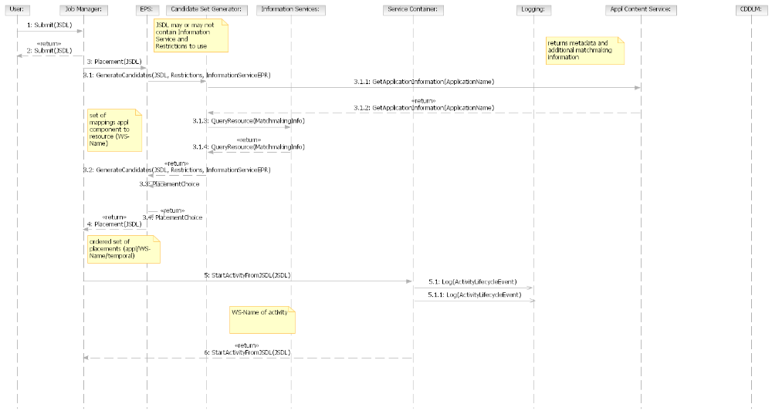
  - 3-tier Diagram from ’05 Aug F2F (TO BE DELETED)

Summary
Start designated job and deploy and configure its application and related data & container in advance if necessary
Actors
Timer, IT business activity manager
Main flow
- Actor asks GRID to start job
- If necessary, GRID deploys and configures application and container
- GRID returns result (success or fail)

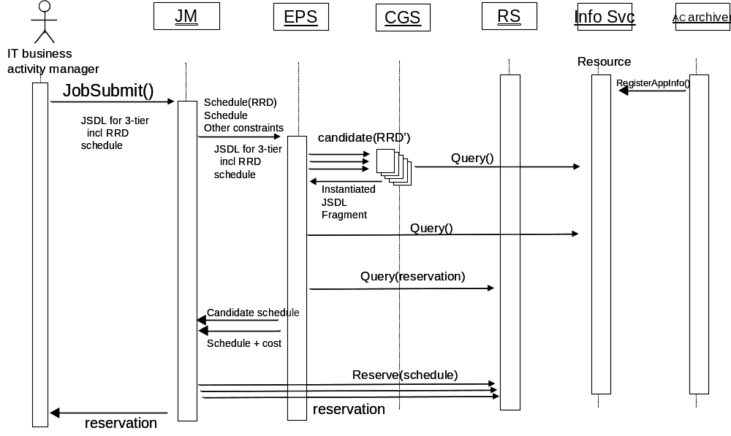
  - Server consolidation Diagram from ’05 Aug F2F (TO BE DELETED)

