EMS Architecture Composition Roadmap

Version 0.7

Status of This Memo
This document is in draft stage and should be considered as in flux. Distribution is unlimited.

Copyright Notice
Copyright © Global Grid Forum (2004-2006). All Rights Reserved.

Abstract
…

Contents
1 Motivation 4
2 Fundamental Job Execution 4
2.1 Direct Job Execution 4
2.2 Indirect Job Execution 5
2.3 Selected Job Execution 6
2.4 Job Termination 7
2.5 Dynamic Activity Placement Selection 8
3 Deployment and Configuration 9
3.1 An Application 9
3.2 A BES Instance 9
3.3 An Application Using ACS 9
3.4 A BES Instance Using ACS 11
3.5 Using a Deployment Estimation Service 11
Add time predictions to provision 3.1 and 3.2 (possibly by some deadline) using a deployment estimation service (perhaps based on historical data, etc, but how the estimation is done is out-of-scope.) Possibly requiring reservations. The EPS should talk to the DES to help develop the ranks for the AEC document. 11
[3.5 assumes that the 'level' of the BES container is pre-determined and fixed. See below.] 11
3.6 Determine dynamically the optimal level of 'BES container' in the system and provision containers appropriately depending on workload, etc 12
4 Data Types in Scenarios 13
4.1 Job 13
4.2 JobStatus 13
4.3 Activity 13
4.4 ActivityStatus 13
4.5 Activity Execution Candidate 13
5 Allocation 13
6 Accounting 13
7 Data 13
8 Integrated EMS Architecture 13
9 Appendix A: BLAST Diagram from ’05 Aug F2F 15
10 Appendix B: 3-tier Diagram from ’05 Aug F2F 16
11 Appendix C: Server consolidation Diagram from ’05 Aug F2F 17

Motivation
The OGSA EMS architecture has been under discussion for many years. In its entirety it is, quite rightly, a complex set of interdependent services. However, not all of these services are required to perform simpler operations within the EMS space. This document provides a set of scenarios that build upon each other to move towards the full EMS architecture. It is proposed that this roadmap be used to drive the factorisation and capability of the services and interactions within the complete EMS architecture.

Initially, we should focus on the fundamental job execution scenarios as these are well understood and in common use in Grid infrastructures such as EGEE and OSG. Once these have been established activity can move in parallel focussing on:
- Configuration and Provisioning
- Resource Allocation by Agreement

Fundamental Job Execution

One scenario builds on top of another.

Direct Job Execution
Using an established BES Container a client (user) contacts the BES and starts an activity within the container as described within a simple JSDL document. Progress is monitored directly by the user from the client machine.
Requirements: BES and JSDL specifications.
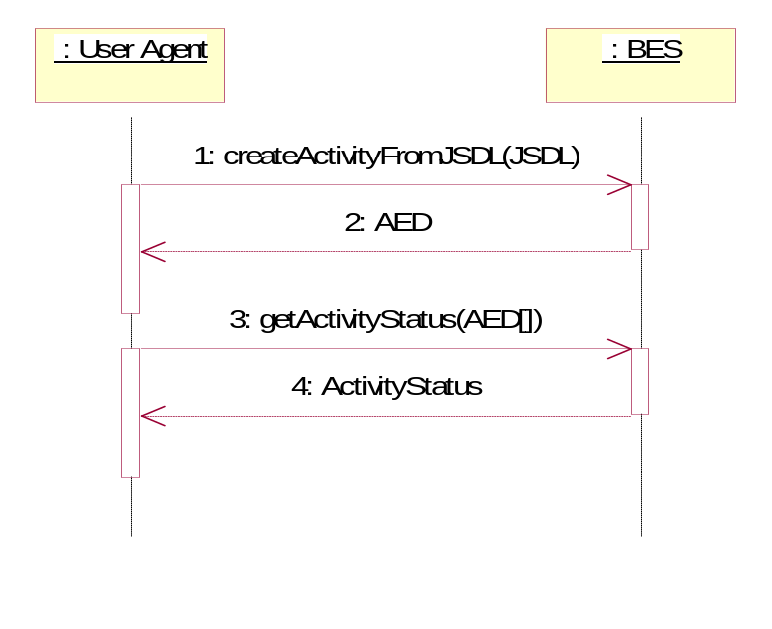

Indirect Job Execution
To enable more sophisticated EMS scenarios it is important that the user can delegate decision making and control to a user ‘agent’ – the Job Manager. The user contacts the job manager, specifying the job, which is then executed on an established BES container. Once the activity is established it is monitored by the Job Manager.
Requirements: Job Manager interface.

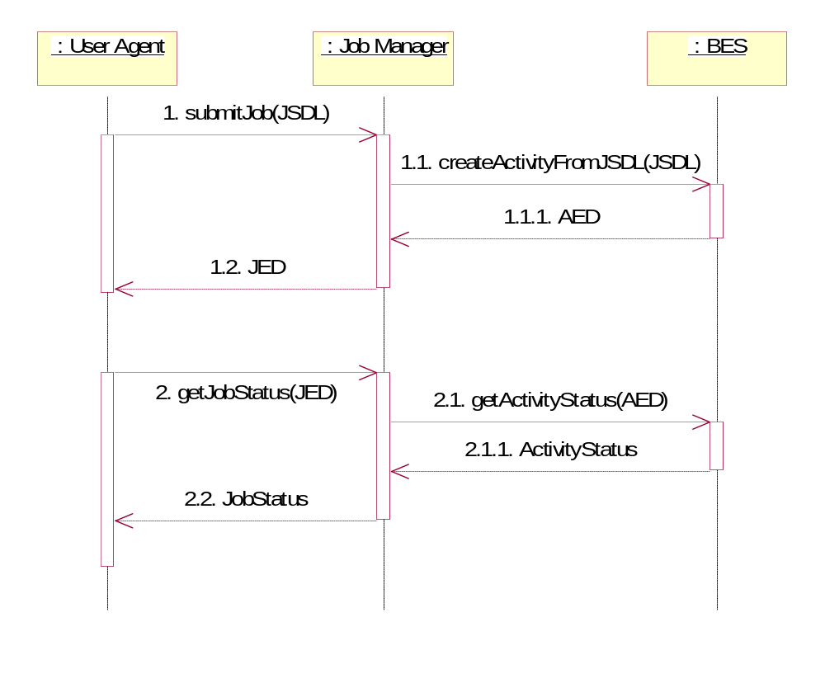

Selected Job Execution
Through the job manager the Resource Selection Service (RSS) is used to select a BES instance. Internally, the RSS uses a simple selection algorithm (e.g. number of pre-defined BES instances to round-robin the job request from the job manager to one of these interfaces.
Note: Activity Endpoint Descriptors are not exposed outside of the EMS architecture. A Job Endpoint Descriptor will be passed back to the User Agent from the Job Manager.
Requirements: RSS interface.

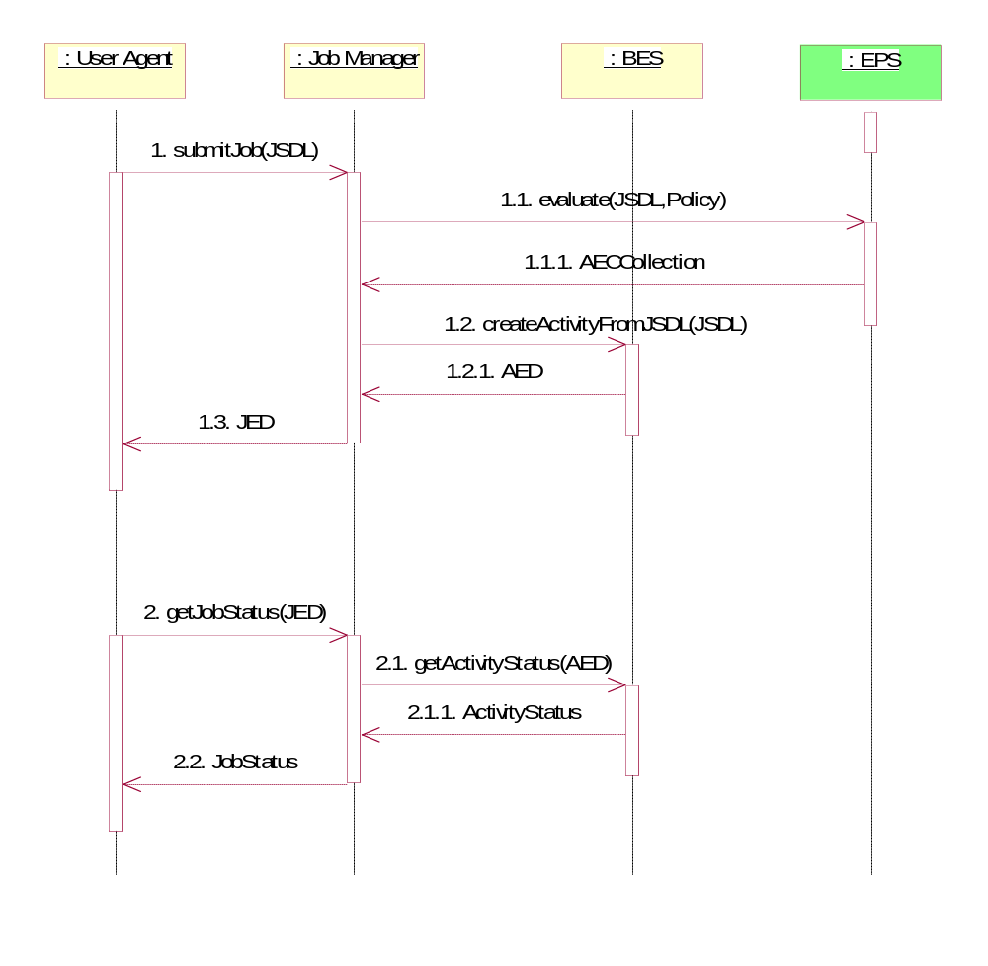

The User Agent submits an abstract JSDL document (i.e. one that is not tied to a specific resource) to the Job Manager receiving in return a WS-Name that can be used to query the status at a later date, The Job Manager contacts the Execution Planning Service (EPS) specifying the policy that must be used to select the ‘best’ resource specified within the JSDL abstract document. The JSDL document provides criteria to select the appropriate resource. In this example the EPS selects a BES from a number of existing pre-defined BES instances according to the ordering policy. The ordering policy expresses the desirability of one BES instance over another. It returns a concrete JSDL document that can be passed to a specific BES instance for execution.

Assumptions: WS-Agreement is not used. The EPS is a ‘black box’ in this example encapsulates other components of the RSS architecture. The activity started by BES ends cleanly at some point in the future. Pre-requisites: Established User Agent, Job Manager, BES and EPS instances. Requirements: EPS interface.

Todo: JSDL group to define what might be blank in an abstract JSDL document. (This was answered during the Nov 2 OGSA-WG call. Delete if the text below is acceptable.)

In the simplest case a JSDL document that does not specify a particular resource (host) for execution, as mentioned above. A more abstract case is that of specifying only an Application (ApplicationName and possibly ApplicationVersion) and the needed input and output data files; and leaving the rest up to the system.
With respect to resource selection and taking the choice of an operating system (OS) as an example, if the OperatingSystem element is defined then only that specific OS can be used. If the OperatingSystem element is not defined then any OS may be used. No alternatives are expressible. JSDL elements that accept numeric values do, however, accept ranges of values. For example, a JSDL document may specify that 3-5 CPUs and 2-4 GBytes of memory are required. There is no mechanism, however, to express a preference for a specific combination of resources, for example, that more memory is better than more CPUs. The expectation is that JSDL should be combined with some other language to provide this kind of more flexible descriptions. (WS-Agreement is one option but the assumption stated above is that it is not used.)

Ian’s comment: I would be concerned if there was an attempt to incorporate this as a primitive. As the brief and far-from-comprehensive list above shows, there are many different resource selection strategies that may be applied, and these strategies may be applied in many different ways and in different places.

Job Termination
The simplest case of job control (not full job management) returning to JM at the end of the job

Normal Termination of Job

Job killed by User Agent

Activity dies unexpectedly

Job Manager restarts the Job

Job Manager does not restarts the Job

Job Manager Terminates Job based on Policy. Any or all activities should be terminated

Dynamic Activity Placement Selection
Instead of using a static pre-defined list of BES instances these service interfaces will be obtained and selected from a service registry (information service). With a defined selection language the RSS implementation can be more sophisticated than in 2.3 allowing a user defined selection policy to be applied to the available services in the registry.
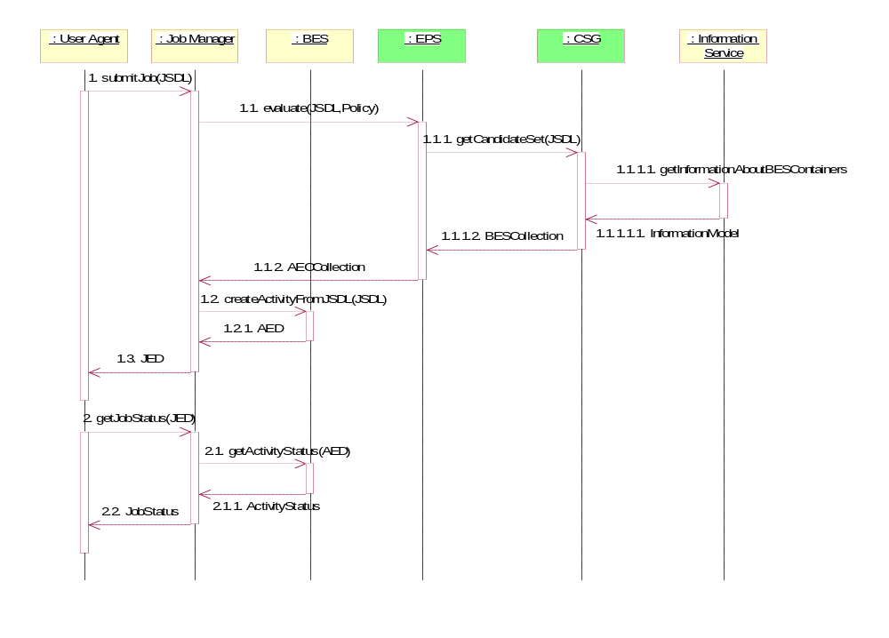

Requirements: Information/Data model to represent the service and a selection language.

The state of art – EGEE & OSG & Naregi.

Deployment and Configuration

An Application
Deploy an application on/so that an existing BES container can be used to invoke it. (The application can then be used to instantiate a BES activity.

[Assumes that the 'level' of the BES container is pre-determined and fixed.]

A BES Instance
Use CDDLM to provision a BES container and to configure it so that it appears in a registry instance and then becomes available for selection by the RSS in 2.4.
Requirements: CDDLM document and provisioning service.

[Assumes that the 'level' of the BES container is pre-determined and fixed.]

An Application Using ACS
Use the ACS model to obtain the application archive (with the deployment and configuration information) and instantiate it on a container (through BES?).
(Otherwise the same as for section 3.1)

Inititiate the process through provisioning?

Dejan: In a summary, we plan to leave the things as is, with the current specs on both sides unchanged. At the moment, they are closest to the option 2 (communication through data services). However, see also discussion below, which implies the interactions between ACS and CSG, even though it only relates to the data/information path between ACS and CSG and instead it is really about future services that CDDLM may offer. CSG interaction with ACS has not been discussed within ACS group, it is ambiguous and we believe that this was really the core of this whole controversy about the relationship between ACS, CDDLM, and CGS. It is about how CSG can obtain the information about the resource requirements and deployment time from the deployment descriptions, which is the topic of the next two items.

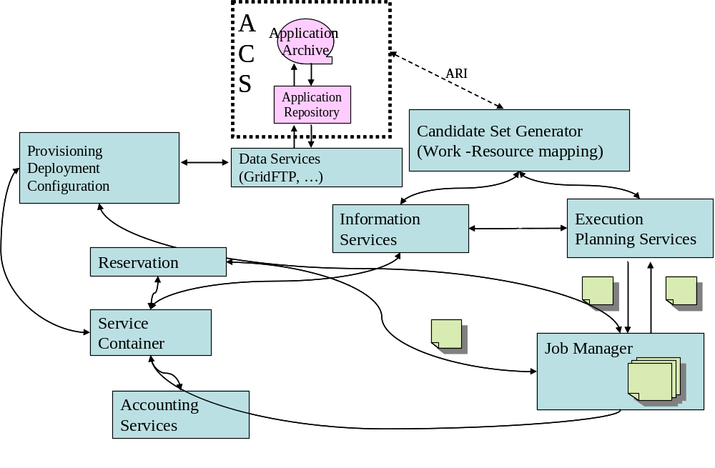
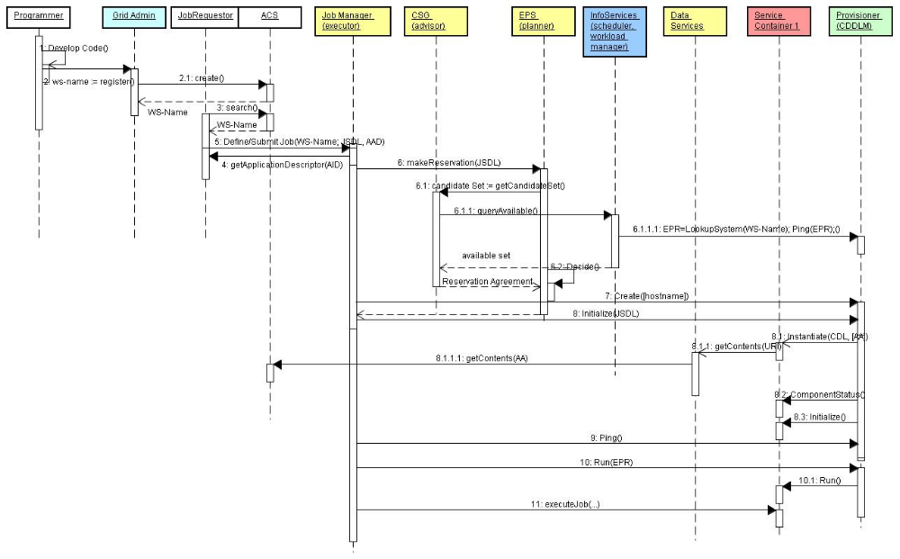
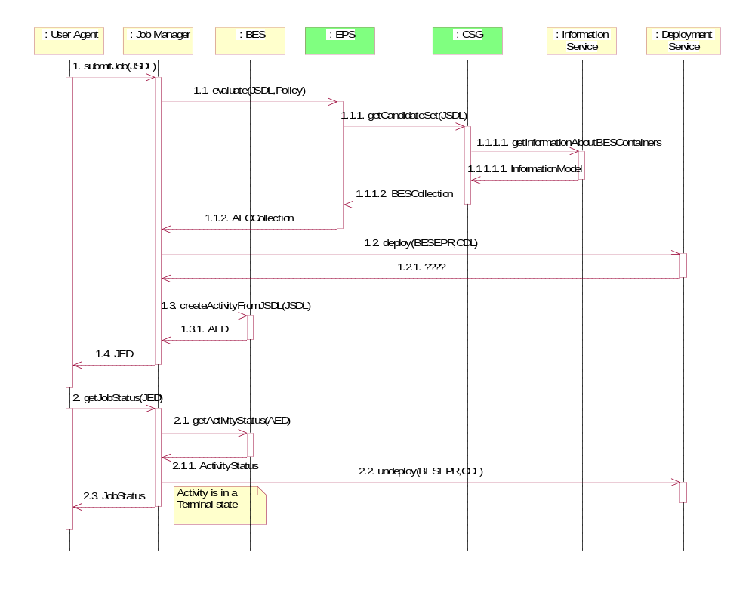

A BES Instance Using ACS
Use the ACS model to obtain deployment and configuration information and provision a BES container instance. (Otherwise the same as for section 3.1)

Using a Deployment Estimation Service

Add time predictions to provision 3.1 and 3.2 (possibly by some deadline) using a deployment estimation service (perhaps based on historical data, etc, but how the estimation is done is out-of-scope.) Possibly requiring reservations. The EPS should talk to the DES to help develop the ranks for the AEC document.

[3.5 assumes that the 'level' of the BES container is pre-determined and fixed. See below.]

How to estimate the deployment time?

Dejan: It is not possible, it could only be a hint. History is better source of this information. We could potentially, (from hints) resolve CDL by obtaining for each component the predicted deployment time, then from component graph calculate compound estimate (e.g. add times where components are serialized, return max where components are parallel, etc.). We will continue to explore these options.

We do not plan to support this sort of functionality in the existing specs; we may want to support it in versions 2.0, or if it is urgently required, we can address it in a separate spec. This could be something called "Deployment Estimates Services" (DES). This will heavily depend on this information provided as a part of the CDL. These Deployment Estimates Services can also address the resource requirements, by having a similar run through the tree and adding up the resource required. .

In addition to these offline services, we can provide the statistics about the run-time deployment time, by collecting time of the deployment of each component as well as overall time. These times can then be matched against the estimate times. Again, we do not plan to support this in the current versions of specs, but rather in the second versions or in separate specs.

[From Nov. 7 minutes]
- Agreed that this is not a high-priority item at the moment.
- Defining the interface and not detailing how the estimation is carried out is a reasonable first step. (Estimation could be history based and also involve some prediction when deployment requests are received for the first time.)
- Should this be a simple interface receiving a CDL fragment or one that unwinds a bigger CDL tree? For example, ask for estimates for deploying a CDL tree made of (A,B,C,D) (and considering deployments may be done in parallel) or ask separately for each A,B,C,D part?
- Also in the more complex form what should happen if there is history for deploying B,C,D but not A.
- Agreed that initially this interface may be very simple: either returns an estimate for whatever CDL (simple or complex) it receives; or "don't know"

Determine dynamically the optimal level of 'BES container' in the system and provision containers appropriately depending on workload, etc
[Version 1 of the document could just cover scenarios 3.1-3.5 and discuss 3.6 as future work. Otherwise need to breakdown 3.6 further.]

Where do we stop in expanding the tree (e.g. at the OS provisioning?) and how do we mark this?

Dejan: CDDLM (and CDL) are transparent to this. This is more matter of the policy and best practices. If further required, we can take this offline with Jay and come up with a proposal.

- Deployment versus provisioning requirements
(Or, where to 'cut' the CDL tree. Above the 'cut' point is deployment---assumed to be a relatively 'light' operation---and below is provisioning---assumed to be more heavy-weight.)
- Deciding the cut point is orthogonal to CDDLM---it is policy or best practices and is therefore a system choice
- Information (metadata) to help in making the choice could be added to the CDL as mark up
- CDDLM implementations have walked the tree fairly far down (to the hardware) for deployment
- CDL may be sufficient to express both deployment and provisioning. But it is an open issue if these two activities can, or should be unified in this way in OGSA. In particular CDL may not be going to the full extent of supporting costing, etc., that maybe needed to address all requirements
- Resources beneath the cut point can be considered as pre-provisioned: they either exist or they don't. They are not going to be deployed themselves; but they can be used to deploy on.
- Which resource to choose for deployment? It is the choice of the EMS architecture (EPS, CSG) and not of CDDLM.
- Discussion on how CDL may be viewed as a hierarchy of scripts; and that one could have a history of costs associated with each node. In other words the tree could be decorated with other information (cost, etc, as metadata)

- JSDL and CDL relation and can one cover the requirements for the other
- A JSDL submission may be associated with a deployment description or request, and the deployment portion could be described in CDL. [I.e., CDL could be a more specific application sub-type in a JSDL document.]
- JSDL is not intended to describe the configuration of the software that will be used by the job. The aim is to describe things at a higher level. There may be similarities between the languages (perhaps around resource description) but it does not mean that one language can, or should, replace the other because they serve different purposes.
- Jay wants to pursue the issue further among a smaller group of people.

Data Types in Scenarios

Job
Job Endpoint Descriptor (JED)
A Job should have some operation to get the current activities.

JobStatus
This is the status of the Job. This has not been defined yet. But should be defined by the Job Manager group.

Activity
Activity Endpoint Descriptor (AED)
This is defined in the BES specification.

ActivityStatus
This is the ActvityStatus and is defined in the BES specification.

Activity Execution Candidate
This contains a JSDL document, EPR or path of a BES Container, Rank = Number Optional
<ActivityExecutionCandidate>
<JSDL Document/>
<BES EPR/>
<Rank/>?
<CDL Document/>
<DeploymentService EPR/>
<xsd:any/>*
</ActivityExecutionCandidate/>+

Allocation
Allocation (i.e. reservation) scenarios using an agreement infrastructure.

Accounting
Accounting scenarios based around RUS?

Data
Replica space
Populating abstract JSDL with file locations

Integrated EMS Architecture
By bringing the scenarios described in section 2-5 together we will have defined and demonstrated integration of a significant fraction of the OGSA EMS architecture.

Risks: Effective demonstration of these services will require the interfaces to have been defined and implementations to have been provided.
Continual redesign

Provisioning Service: Will fill the gaps in the requirements by deploying and provisioning to fill gaps.

Who talks to who?:
Peer to peer around the job manager
Or is there a hierarchy? Job manager -> RSS -> provisioning (for example)

Need to learn from existing experience from implementations to build new standards.

Sequence diagram.

Paper design (or architecture) vs. implementation

Actions:
- Sequence diagram (from early stage)
- Architectual

Appendix A: BLAST Diagram from ’05 Aug F2F
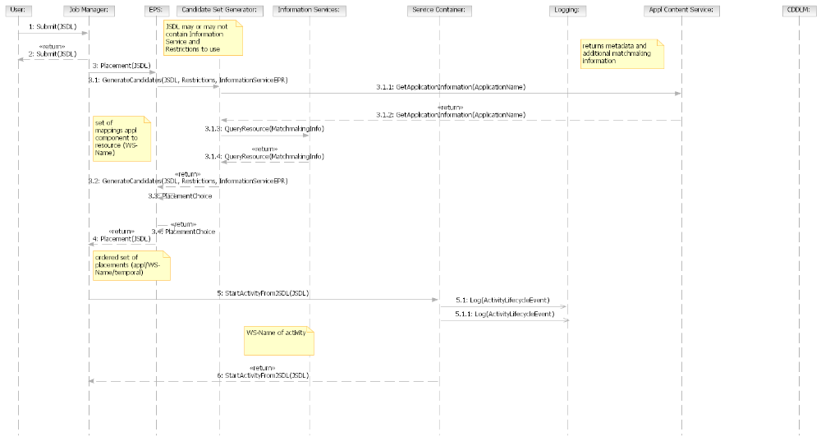

Appendix B: 3-tier Diagram from ’05 Aug F2F

Summary
Start designated job and deploy and configure its application and related data & container in advance if necessary
Actors
Timer, IT business activity manager
Main flow
- Actor asks GRID to start job
- If necessary, GRID deploys and configures application and container
- GRID returns result (success or fail)

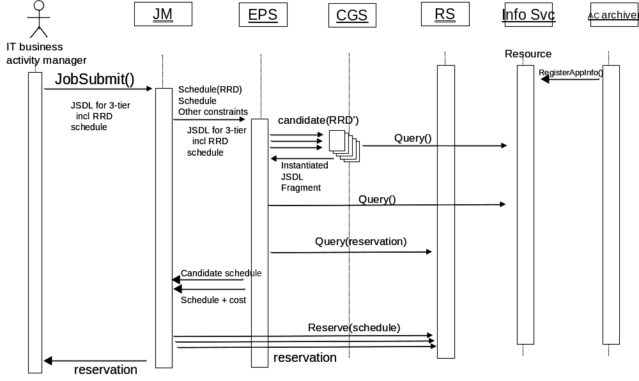

Appendix C: Server consolidation Diagram from ’05 Aug F2F

