Defining the Grid: A Roadmap for OGSA™ Standards
Version 1.1

Status of This Document
This document provides information to the Grid community regarding the roadmap of the Open Grid Services Architecture (OGSA). It does not define any standards or technical recommendations. Distribution is unlimited.
This document contains schedule information for work being carried out by multiple OGF working groups and external organizations. The document will be updated periodically to reflect schedule changes.
Copyright Notice
Copyright © Open Grid Forum (2004-2006). All Rights Reserved.

Trademark
Open Grid Services Architecture and OGSA are trademarks of the Open Grid Forum.

Obsoletes
This document obsoletes GFD-52 [ROADMAP1].

Abstract
The Open Grid Forum (OGF) has embraced the Open Grid Services Architecture (OGSA) as the blueprint for standards-based grid computing. “Open” refers to the process used to develop standards that achieve interoperability. “Grid” is concerned with the integration, virtualization, and management of services and resources in a distributed, heterogeneous environment. It is “service-oriented” because it delivers functionality as loosely coupled, interacting services aligned with industry-accepted Web service standards. The “architecture” defines the components, their organizations and interactions, and the design philosophy used.
While much progress has been made with OGSA, there remains a lack of clarity concerning exactly what OGSA is, who defines it, what will be defined when, and who is contributing to its development. This informational document answers these questions by providing a snapshot of the evolving OGSA space and an explanation of the direction chosen by OGSA-WG and OGF.

Contents
1. Introduction 3
2. OGSA: Process, Specifications, Profiles, and Software 4
2.1 OGSA Requirements 5
2.2 OGSA Profiles 5
2.3 OGSA Branding 6
3. OGSA Informational Document Schedule 7
3.1 OGSA Architecture Version 1.5 7
3.2 OGSA Glossary Version 1.5 7
3.3 OGSA ByteIO Use-Cases Version 1.0 7
3.4 OGSA Data Architecture Version 1.0 8
3.5 Naming Issues in Distributed Systems Version 1.0 8
3.6 OGSA EMS Architecture Scenarios Version 1.0 9
4. OGSA Normative Document Schedule 9
4.1 OGSA ByteIO Interface Document Version 1.0 10
4.2 OGSA Basic Execution Services Interface Document Version 1.0 11
4.3 Job Submission Description Language Specification Version 1.1 12
4.4 Resource Namespace Service Specification Version 1.0 13
4.5 WS-Naming Specification Version 1.0 14
4.6 Application Content Service Specification Version 1.0 15
4.7 WS-Agreement Specification Version 1.0 16
4.8 Attributes Used in OGSA Authorization Version 1.0 17
5. OGSA Recommended Profile Schedule 18
5.1 OGSA WSRF Basic Profile Version 1.0 18
5.2 OGSA Security Profile 1.0 – Secure Channel 19
5.3 OGSA Basic Security Profile 1.0 – Anonymous Channel 20
5.4 Future Profiles 21
6. OGSA Informational Profile Schedule 22
7. Collaboration with Other Organizations 22
7.1 Liaisons 22
7.2 Standards Development Organizations Collaboration on Networked Resources Management (SCRM) 22
8. Open-Source Software Projects 23
9. Security Considerations 25
Editor Information 25
Contributors 25
Acknowledgments 25
10. Intellectual Property Statement 25
11. Disclaimer 26
12. Full Copyright Notice 26
References 26
Appendix A. Summary of Referenced Specifications & Profiles 28
Appendix B. Web Services Context 29

Introduction
The Open Grid Forum (GGF) has embraced the Open Grid Services Architecture (OGSA) as the blueprint for standards-based grid computing. “Open” refers to the process used to develop standards that achieve interoperability. “Grid” is concerned with the integration, virtualization, and management of services and resources in a distributed, heterogeneous environment. It is “service-oriented” because it delivers functionality as loosely coupled, interacting services aligned with industry-accepted Web service standards. The “architecture” defines the components, their organizations and interactions, and the design philosophy used.
OGF’s OGSA Working group (OGSA-WG) has completed several major work products:
- The OGSA Use Cases document [OGSA Use Cases] describes a set of use cases from a range of enterprise and scientific settings, intended as a source of requirements for OGSA services.
- The Open Grid Services Architecture, Version 1.5 document (also called OGSA Architecture 1.5 in this document) [OGSA Arch] collates requirements for an Open Grid Services Architecture and identifies a large number of service interfaces that may be required to meet those requirements.
The completion of these documents leads to the question: what is the path by which OGSA will now be further developed and defined? An answer to this question is important to a variety of people:
- Many OGF participants have accepted the notion that OGSA can serve as an overarching architectural framework for different OGF activities. They now want to understand what this framework implies for their work.
- Developers and users want to know “what they can expect when” in terms of standards, so that they can make plans for product developments and technology acquisitions.
- There are one or more high-level architectural working groups such as OGSA-Data, which are responsible for significant components of the OGSA architecture. It is important for the members of these groups and others to understand the overall OGSA document framework and schedule.
In response to these and other pressures, we are moving quickly to fill out the OGSA definition and produce a set of normative specifications that define in great detail what it means to be OGSA-compliant. However, we must also be aware of a number of other factors:
- The broad importance of Grid and the tight alignment of OGSA with Web services means that further work on OGSA cannot proceed as a purely OGF activity, but must rather be viewed as one (hopefully important) input to a larger process aimed at defining service-oriented solutions to distributed computing problems.
- As in any standardization process, we need to be careful not to standardize prematurely, i.e., standardize without adequate experience and/or buy-in from its eventual users. These issues are particularly important in the case of OGSA, due to the particularly large gap between our ambition and experience.
- While the OGSA design teams have considered a variety of use cases we expect that there will always be important existing perspectives that have not yet been considered, and new use cases will continue to develop with the overall Grid standards infrastructure. We expect the consideration of use cases to be an ongoing process.
- The OGSA Architecture 1.5 covers a broad technical scope, and to date only a relatively small part of the subject matter has been addressed in normative or informational documents. Given the need for careful management of the process, the work must be undertaken in stages. Consequently we expect that it will take several years to develop normative documents that cover all of OGSA’s capabilities.
These considerations motivate this document, which seeks to clarify the role of OGSA and the steps required to refine its definition by addressing the following issues:
- With a view to clarifying the important standards maintained outside of the context of OGSA and OGF, we provide a brief overview of important standards related to service-oriented architectures in general, and which provide an important underpinning to many of the normative specifications which will be produced by OGSA and related working groups. Basic information on the relevance of these standards to OGSA work is provided.
- With a view to clarifying the process by which OGSA definition may proceed, we recommend a process by which technical specifications developed within or outside OGF can be identified as meeting OGSA requirements. The selection and combination of element specifications that are required to achieve interoperability are described in chapter 2.
- With a view to identifying factors that might help prioritize work on OGSA, we identify dependencies among different OGSA interfaces and the interfaces that appear needed within different deployment and application scenarios. The schedule of the first set of informational documents, normative documents, and profiles is described in chapters 3 through 6.
- With a view to identifying external constraints on OGSA, we review major relevant standardization activities external to OGF. We discuss both past activities that have produced specifications on which OGSA can build, and current and planned activities that may contribute to, and/or constrain, OGSA’s evolution. The collaborations among major standards development organizations are outlined in chapter 7.
- With a view to illustrating the breadth of interest in OGSA across the grid community, we describe in chapter 8 a range of open-source software projects that are actively engaged in implementing grid components and applications based on OGSA and related specifications. These projects are yielding valuable experience that enables their participants to contribute to the further development of OGSA.

OGSA: Process, Specifications and Profiles, and Software
We distinguish between the OGSA architectural process, OGSA specifications and profiles, and OGSA software: all of these are important to maintain coherence around OGSA and grid standards. These three areas are:
- OGSA is first and foremost an architectural process, managed by the OGSA-WG, which works to collect requirements, evaluate the maturity of specifications, and produce periodic updates to the following OGSA informational documents:
- A set of informational OGSA Use Case documents list end-user application scenarios that are thought to be relevant to OGSA design.
- The Open Grid Services Architecture [OGSA Arch] [OGSA Glossary] identifies framework, taxonomy, and functionality that should be provided to address use case requirements.
- Service Description documents, which are written and maintained by the appropriate domain-expert working groups or design teams, describe the services in the area in natural language, listing the interfaces and operations defined by each service.
- Scenario documents, also written by domain-expert working groups or design teams, demonstrate how these services can implement the use cases, using a combination of natural language and UML.
- Guideline documents, written by OGSA-WG, define concepts and methods in specific area in order to explain how to write OGSA specifications in each area. OGSA profile definition [OGSA Profile Definition] and modeling guideline are such guideline documents.
- An OGSA Roadmap, this document, expresses OGSA-WG views on the likely future evolution of OGSA to address unmet requirements and/or respond to technology evolution.
We emphasize that these informational documents are intended to provide guidance to OGSA designers, but are not binding on current or future versions of normative OGSA documents.
- OGSA specifications and profiles are normative documents. A specification documents the precise technical requirements, typically including interfaces, protocols and behaviors, for a conforming hardware or software component. An OGSA Profile identifies a set of broadly adopted normative technical specifications that collectively capture current understanding of what software must do to operate and manage interoperable grid environments. In developing such normative documents, OGSA-WG is informed by, and aligned with, user experiences with software that implements the relevant specifications. When this document mentions “OGSA” in any normative sense, it refers to such normative documents.
See section 2.2 for further discussion of OGSA Profiles.
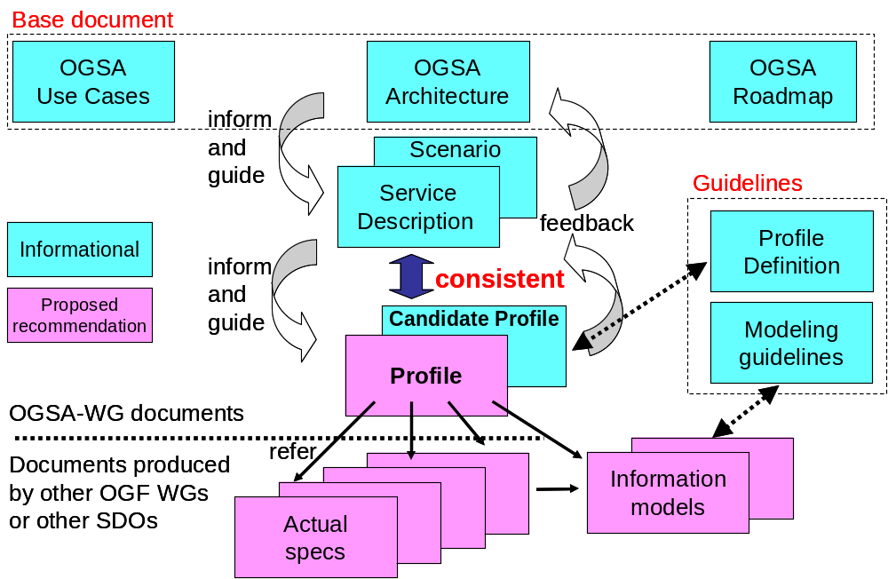
- OGSA software adheres to OGSA normative specifications and profiles, and thus enables customers to deploy grid solutions that interoperate even when based on different open-source or commercial software vendors’ implementations.
Table 2-1 OGSA documents and their structure
Table 2-1 Shows the structure of whole OGSA documents, especially the relationship among high-level informational documents, profiles, and actual proposed recommendation specifications.
At the time of writing, we have several OGSA informational document, specifications and profiles.. We do not yet have any OGSA-compliant software implementations or OGSA compliance tests. (See section 2.3 for more details.)
OGSA documents will evolve over time. Thus, any discussion of OGSA must always be qualified with a version number: e.g., “This software is compliant with OGSA WSRF Basic Profile 1.0,” or “OGSA WSRF Basic Profile 1.0 addresses X, Y, and Z in the OGSA Architecture 1.5.”

OGSA Requirements
OGSA requirements are derived from the study of use cases that are felt to be relevant to OGSA’s goals of service-oriented infrastructure and grids. Such use cases and the requirements are derived from OGF members at large.

OGSA Profiles
OGSA, in the normative sense, is defined by a set of specifications and OGSA Recommended Profiles (also referred to simply as “OGSA Profiles” in this document). The term profile is adopted from the WS-Interoperability (WS-I) organization, which has defined a Basic Profile 1.1 [WS-I BP 1.1] as a foundation for Web services interoperability, and also other profiles such as the Basic Security Profile [WS-I BSP 1.0] and Basic Attachments Profile [WS-I AP 1.0] that build on the Basic Profile.
An OGSA Profile, like a WS-I Profile, references a set of technical specifications and prescribes the ways in which those specifications should be implemented and used in order to perform various classes of operation in an interoperable fashion. However, the OGSA Profile is different from WS-I Profile in the sense that OGSA defines feature-rich combinable functionalities while WS-I Profile defines infrastructure-level specifications.
Individually and collectively, the specifications that are combined in an OGSA Profile:
- Address important end-user requirements, such as those described in the OGSA Use Case and Architecture documents;
- Are specified at a level sufficient to enable the development of interoperable implementations;
- Complement the other specifications contained in this and other OGSA Profiles;
- Have implementation experience; and
- Have been adopted—i.e., are already in use by, or have a high degree of expectation that they will soon be in use by, numerous technology providers and consumers.
OGSA Profiles are thus concerned above all with documenting acceptable practice and enabling interoperability, rather than with prescribing practice for the future.
In addition, OGSA Profiles seek to fill apparent gaps in the specifications. For example, the OGSA Security design team has created an XML Schema fragment to include a service's public credential in an endpoint reference (EPR), and the OGSA WSRF Basic Profile team has specified a number of resource property elements that a client can expect to find—e.g., ResourcePropertyNames.
We expect that various OGSA Profiles will be defined over time, each independently versioned. We propose in this document an initial set of such profiles, some of which might be augmented with extension profiles for more advanced functionality.
This approach of defining multiple independent profiles is important because as OGSA grows, no single vendor is likely to implement everything. Profiles allow vendors to claim unambiguously conformance to relevant portions of OGSA. For example, a scheduler vendor might claim conformance to the OGSA Basic Execution Management Profile 1.0, but not to the OGSA Basic Data Profile 1.0.
We use the term OGSA Recommended Profile to assure potential implementers that all of the normative documents—specifications or other profiles—referenced by the Profile meet certain criteria of status and community adoption, as described in the OGSA Profile Definition document [OGSA Profile Definition].
We will also define OGSA Informational Profiles, which do not yet meet the criteria required to be OGSA Recommended Profiles, but which are meant to inform the development of technical specifications that might be referenced by OGSA Recommended Profiles in the future. An important task of the OGSA-WG is thus, periodically, to identify and document in revised OGSA Profiles the sets of specifications that meet the criteria outlined above, and to revise the Informational documents based on the latest specifications and community views.
OGSA Recommended and Informational Profiles may be developed either by the OGSA-WG or by domain-expert working groups, but it is important to note that they must adhere to OGF’s OGSA branding guidelines, which are discussed in section 2.3.
Members of the OGSA-WG will also engage in development of specifications within appropriate working groups (not within the OGSA-WG itself), as well as in coordination and promotion activities aimed at bringing other specifications to the point where they are ready for inclusion in future versions of relevant OGSA Profiles.
The OGSA Profile Definition document outlines how to write Recommended and Informational Profiles that describe collections of specifications and their interactions, and defines the criteria to be used in determining the status and adoption levels of the underlying specifications.

OGSA Branding
Given the requirement for consistency across OGSA specifications and other documents, OGF defines in [OGSA-Related Naming Guidelines] the criteria to be used in determining whether to brand entities such as working groups and documents with an OGSA prefix.
The OGSA normative documents are expected to be implemented by multiple open-source software (OSS) projects and commercial software vendors. Authors of OGSA Software may claim one of three levels of agreement with the OGSA normative documents:
- A claim to implement a specification or profile is a statement of “best effort” to satisfy the requirements of the specification. There are no test mechanisms to guarantee the correctness of the implementation.
- A claim of conformance to a specification or profile is a statement of intent to interoperate with other conformant implementations. Two or more implementations may test their conformance by testing how well they interoperate. A conformance claim mechanism as defined in the profile should be used to communicate conformance.
- A claim of compliance would imply acceptance by a set of OGSA Compliance Tests. At the time of writing no such tests exist.
We may expect that OGSA compliance tests will be developed that define the practical criteria that must be satisfied for a software system to be called “OGSA-compliant.” Until such a suite is available, claims of OGSA compliance should not be made.

OGSA Informational Document Schedule
This chapter provides the development schedule of OGSA-related informational documents. Informational documents include Use Case documents, Architecture documents, Service Description documents, Scenario documents, and guideline documents.
Documents described in this chapter are OGF Informational Documents (GFD-I), as defined in [OGF Documents].

OGSA Architecture Version 1.5
This document provides a high-level OGSA definition by focusing on requirements and the scope of important capabilities required to support Grid systems and applications in both eScience and eBusiness. The capabilities described are Execution Management, Data, Resource Management, Security, Self-Management, and Information. Version 1.5 was released in September 2006 as GFD.80 and obsoletes OGSA Architecture Version 1.0 (GFD.30).

Development Schedule
Changes to this document will be made by OGSA-WG. At the time of writing, there is not a well-defined schedule for the next version of the document.

Related Documents
This document will refer to the OGSA Profile documents, and many other documents produced by OGSA-WG, by other OGF working groups, and by other standards development organizations.
OGSA Glossary versions will continue to be published as a companion document.

OGSA Glossary Version 1.5
The OGSA Glossary provides definitions of key terms used in the OGSA Architecture and in related documents. Version 1.5 was released in September 2006 as GFD.81, along with the OGSA Architecture 1.5. This version obsoletes OGSA Glossary Version 1.0 (GFD.44).
The Glossary will continue to be updated to include terms that are required as a result of changes made in the OGSA Architecture, and will be released in conjunction with new versions of that document. Existing terms will be reviewed and revised where appropriate, and outstanding tracker items will be resolved.

Development Schedule
Changes to this document will be made by OGSA-WG. When the OGSA Architecture document schedule is determined, the OGSA Glossary will follow roughly the same schedule.

Related Documents
This document is a companion to the OGSA Architecture 1.5 document.

OGSA ByteIO Use-Cases Version 1.0
The purpose of this document is to identify the requirements for the OGSA ByteIO interface. It is expected that the use cases will include reading from and writing to a binary file, reading the results of certain DAIS queries and reading data from a sensor, among other scenarios. The intention is that existing APIs, such as the POSIX API, should map easily to the ByteIO Web service interface.

Development Schedule
The OGSA ByteIO working group (ByteIO-WG) is now developing this document.
Milestone | Date
First draft available | June 2005
Ready for public comment review | November 2006
GFD-I publication | May 2007
Table 3-2 OGSA ByteIO use-case 1.0 document schedule

Related Documents
This use-case document is intended to be an input to the normative OGSA ByteIO interface document.

OGSA Data Architecture Version 1.0
The purpose of this document is to describe an overall data architecture for OGSA. It will identify message patterns and interfaces that form part of that architecture. Where possible, it will use existing specifications to form appropriate parts of this architecture, liaising with the groups defining those specifications to encourage them to fit into the overall OGSA picture. Where existing specifications are not available, the document will point out the need for work by other OGF working groups to fill the gaps. The document will not define detailed specifications; these are for other specifications.

Development Schedule
The OGSA Data Architecture working group (OGSA-D) is now developing this document.
Milestone | Date
First draft available | June 2005
Ready for public comment review | January 2007
GFD-I publication | May 2007
Table 3-3 OGSA Data Architecture 1.0 document schedule

Related Documents
This document will make extensive cross-references to other specifications, including WS-DAI, Storage Resource Management (SRM), ByteIO, Data Access and Integration (DAIS), Data Format Description Language (DFDL), GridFTP, Message Transmission Optimization Mechanism (MTOM), SOAP with Attachment (SwA), Resource Namespace Service (RNS), and WS-Naming.

Naming Issues in Distributed Systems Version 1.0
Naming in distributed systems has a rich history and literature, and the basics are very well understood. Traditional distributed systems often have a three-layer naming scheme. Human names such as paths or attributes are mapped to abstract names, which are then mapped to some form of address.
The purpose of this document is to provide background on naming in distributed systems, and the motivation and requirements for naming in OGSA.

Development Schedule
The OGSA-Naming WG developed an early draft of this document while the working group was a design team of the OGSA-WG, and is continuing to develop it for publication.
Milestone | Date
First draft available | June 2005
Ready for public comment review | December 2006
GFD-I publication | June 2007
Table 3-4 OGSA Naming Issues in Distributed Systems 1.0 document schedule

Related Documents
This document is informational only. It does not depend on any other specifications, although it refers to, for example, WS-Addressing, DNS, SGNP, WSRF, and JXTA.

OGSA EMS Architecture Scenarios Version 1.0
The OGSA EMS architecture in its entirety is, quite rightly, a complex set of interdependent services. However, not all of these services are required to perform simpler operations within the EMS space. This document describes a set of scenarios starting from fundamental job execution, and also including resource selection, deployment, and simple interactions with data services. The focus is on describing how already published, or close to completion, specifications can be leveraged.

Development Schedule
The OGSA working group (OGSA-WG) is now developing this document.
Milestone | Date
First draft available | July 2006
Ready for public comment review | October 2006
GFD-I publication | December 2006
Table 3-5 OGSA EMS Architecture Scenarios 1.0 document schedule

Related Documents
This document will make extensive cross-references to other specifications, including Job Submission Description Language (JSDL), Basic Execution Service (BES), Configuration Description Language (CDL), Application Contents Service (ACS), Resource Selection Services (RSS), and Resource Namespace Service (RNS).

Naming Mechanisms and their support in DMI
Although initially OGSA-DMI will focus on file movement, where possible we intend to design for general data movement. A significant aspect of this will be how data is named, and represented during communication with the service. In this document we will discuss existing naming systems and specify what will be supported by OGSA-DMI.

Development Status
The OGSA-Data Movement Interface working group (OGSA-DMI-WG) is now developing this document.

Milestone | Date
First draft available | March 2007
Ready for public comment review | November 2007
GFD-I publication | March 2008
Table 3-7 Naming Mechanisms and their support in DMI document schedule

Related Documents
This document is conceptually related to the Naming Issues in Distributed Systems document, and will reference the WS-Naming specification being developed by the OGSA-Naming working group, as well as the Resource Namespace Service specification being developed by the Grid File Systems Working Group. It will also reference underlying specifications developed by external entities, such as WS-Addressing.

HPC Job Scheduling: Base Case and Common Cases
This document describes the set of use cases for batch job scheduling of scientific/technical applications, also broadly referred to as the core high performance computing (HPC) use case. A simple base case is defined that we expect to have universally implemented by all batch job scheduling clients and schedulers. Additional "Common Cases" are enumerated, which are anticipated to be applicable to at least two but not all batch job scheduling clients and schedulers.

Development Status
The OGSA-HPC Profile working group (OGSA-HPCP-WG) is now developing this document.

Milestone | Date
First draft available | May 2006
Ready for public comment review | July 2006
GFD-I publication | April 2007
Table 3-8 HPC Job Scheduling: Base Case and Common Cases document schedule

Related Documents
This document will be used as a set of requirements for the forthcoming OGF proposed recommendation entitled "OGSA HPC Profile"

OGSA Normative Document Schedule
This chapter provides the development schedule for OGSA-related normative specifications. These documents are the products of domain-expert working groups other than OGSA-WG. The OGSA Profiles reference these documents.
Documents described in this chapter will initially be published as OGF Proposed Recommendations (GFD-R.P), as defined in [OGF Documents]. For each document we provide schedule information and a summary of referenced specifications, including status and adoption levels as defined in the OGSA Profile Definition document [OGSA Profile Definition]. Note that specifications that are considered to be at a foundation level for Web services are not included in the specification summaries.

OGSA ByteIO Interface Document Version 1.0
Various OGSA design team, research, and working groups have identified a need for a simple interface for reading and writing sequences of bytes to and from various sources. This interface document specifies a minimal Web service interface for this functionality. The resultant interface will fit into the overall architecture, and the OGSA ByteIO working group will liaise with other OGF groups, especially the OGSA, GFS, GSM, DAIS, InfoD and SAGA working groups, and also with active projects such as OGSA-DAI, Globus, NextGrid and WSRF.Net.

Development Schedule
The OGSA ByteIO working group (ByteIO-WG) is now developing this document.
Milestone | Date
First draft available | June 2005
Ready for public comment review | August 2006
GFD-R.P publication | Jan. 2007
Table 4-9 OGSA ByteIO interfaces 1.0 document schedule
An experience document which describes interoperability test among two or more implementations based on this interface will also be produced, and is planned to be available in October, 2007.

Referenced Specifications
This interface should be based on the OGSA WSRF Basic Profile 1.0 [OGSA WSRF Basic Profile]. The following table shows the referenced specifications and their status and adoption levels.
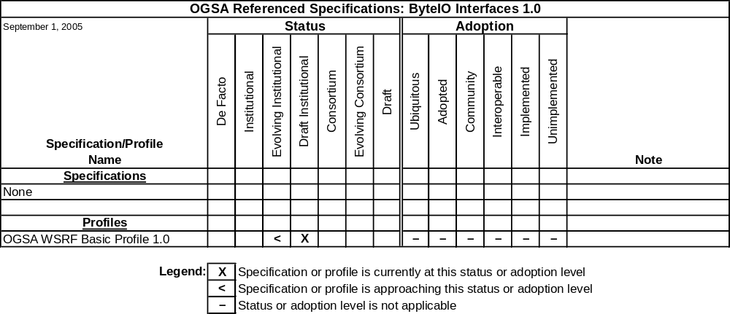
Table 4-10 OGSA ByteIO Interfaces 1.0 referenced specifications

Expected Use
The Basic Data profile, to be developed by the OGSA Data working group, is expected to reference this specification.

OGSA Basic Execution Services Interface Document Version 1.0
OGSA Basic Execution Services Working Group (BES-WG) is concerned with the interfaces (port types, resource properties, etc.) of service containers as defined in the OGSA Architecture document. Recall that service containers are execution environments in which other services—including legacy applications—execute. They (service containers) represent execution in the grid. A service container may represent a single processor, a virtual processor, a hosting environment such as .Net, a supercomputer, or a cluster managed by a queue management system such as LSF, PBS, or SGE. Service containers are one part in the overall EMS architecture (also described in OGSA Architecture).

Development Schedule
The OGSA Basic Execution Services Working Group (BES-WG) is now developing this document.
Milestone | Date
First draft available | June 2005
Ready for public comment review | October 2006
GFD-R.P publication | June 2007
Table 4-11 BES Interfaces 1.0 document schedule

Referenced Specifications
This specification should be based on WS-Naming 1.0, JSDL 1.0, RNS 1.0, and OGSA WSRF Basic Profile 1.0 [OGSA WSRF Basic Profile]. The following table shows the referenced specifications and their status and adoption levels.
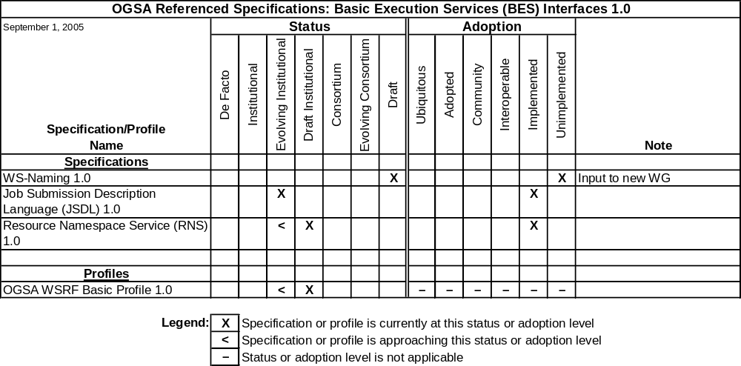
Table 4-12 BES Interfaces 1.0 referenced specifications

Expected Use
BES is at the “base” of the EMS architecture.

Job Submission Description Language Specification Version 1.1
The Job Submission Description Language (JSDL) is a language for describing the submission requirements of computational jobs. The JSDL specification defines a normative XML schema. No submission API is defined and no assumptions are made about how a JSDL document may be submitted to a job execution system.
In OGSA, JSDL is expected to be combined with the work of other groups: WS-Agreement (GRAAP-WG), Basic Execution Service (BES-WG), etc.

Development Schedule
The JSDL 1.0 specification has been published as GFD-R-P.056 in November 2005.
The JSDL working group (JSDL-WG) is now developing JSDL 1.1. This is a maintenance release and is not expected to introduce substantial new functionality.
Milestone | Date
First draft available | November 2006
Ready for public comment review | January 2007
GFD-R.P publication | June 2007
Table 4-13 JSDL 1.1 specification schedule
The JSDL-WG is also planning the next major release of the specification, JSDL 2.0. A detailed schedule is not available at this time.
An experience document which describes interoperability tests between two or more implementations based on the JSDL specification may also be produced.

Referenced Specifications
JSDL 1.1 references the Common Information Model (CIM) version 2.9 and ISO/IEC 9945:2003 (POSIX v3).
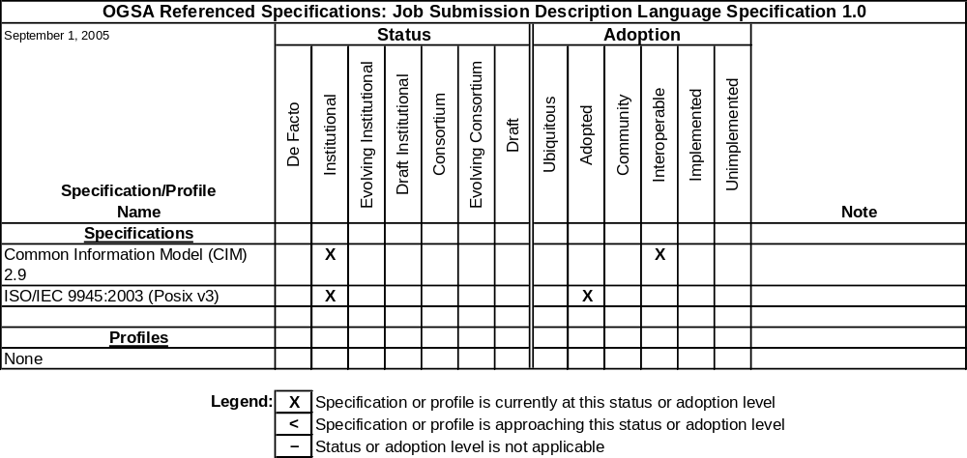
Table 4-14 JSDL 1.1 referenced specifications
Note that implementations of these two specifications are not required to implement JSDL.

Expected Use
The BES 1.0 is using JSDL 1.0 for the definition of the submission interface and is also expected to use JSDL 1.1. The OGSA HPC Profile WG is profiling JSDL 1.0 with a focus on interoperability.

Resource Namespace Service Specification Version 1.0
Various OGSA design team, research, and working groups, including the Grid File System Working Group (GFS-WG), have identified a need for a simple namespace service to accommodate a wide variety of grid applications. This service can be employed to manage the namespace of federated and virtualized data, services, or effectively any resource capable of being referenced in a grid/web service environment, with a particular emphasis on hierarchically managed names that may be used in human interface applications.
The RNS specification describes the operations, resource properties, and semantics of the namespace service. The resultant Web service will fit into the overall architecture, providing a core feature of OGSA.

Development Schedule
The GFS-WG has finalized the recommendation draft of the RNS specification for public comment and submission to the OGF editor. Ownership will transition to the OGSA-Naming WG after the document has been published as a proposed recommendation.
Milestone | Date
First draft available | November 2004
Ready for public comment review | September 2006
GFD-R.P publication | April 2007
Table 4-15 RNS specification 1.0 document schedule
The RNS specification document is based on a previously posted specification document for Virtual Filesystem Directory Services (VFDS) and was first made available in June of 2004.

Referenced Specifications
RNS exists in the context of the OGSA three-level naming scheme—it makes use of WSRF, WS-Notification, WS-Naming, and WS-Addressing.
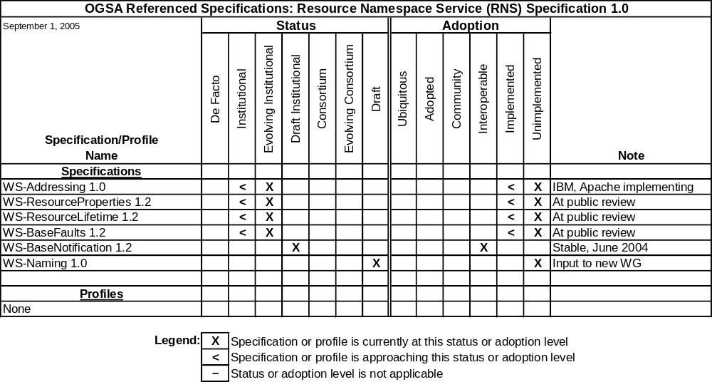
Table 4-16 RNS 1.0 referenced specifications
Note that a future revision of RNS is expected to reference the OGSA WSRF Basic Profile.

Expected Use
Naming is ubiquitous in OGSA. Thus many documents, including OGSA Architecture 1.5 and OGSA Data Architecture 1.0 may refer to RNS names in one context or the other. Also, multiple normative specifications, including The Grid File System Profile being developed by the GFS-WG, are expected to reference this specification.

WS-Naming Specification Version 1.0
The WS-Naming Specification describes a standard naming scheme that allows endpoints in a distributed system to be referred to in a high-level, abstract way. WS-Naming builds on the WS-Addressing specification, and extends it in such a way that neither Web service clients nor Web service endpoints need to be aware of the extension, and are free to fail to generate or understand the WS-Naming elements. In such a case, the normal WS-Addressing behavior still works exactly as described in that specification. If Web service clients or Web service endpoints are aware of this extension, they can attempt to locate a resilient address even if the peer has failed or encounters communication failures.

Development Schedule
The OGSA-Naming WG is now developing this specification.
Milestone | Date
First draft available | June 2005
Ready for public comment review | November 2006
GFD-R.P publication | June 2007
Table 4-17 WS-Naming 1.0 document schedule

Referenced Specifications
This specification is based on WS-Addressing, and is combinable with the OGSA WSRF Basic Profile 1.0.
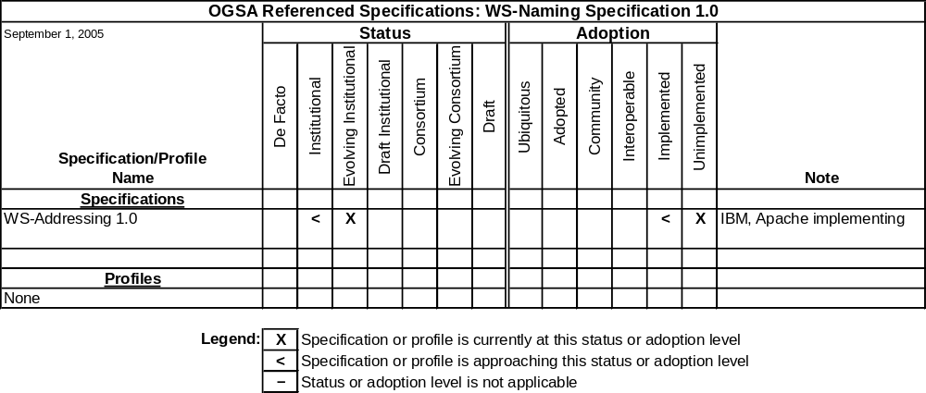
Table 4-18 WS-Naming Specification 1.0 referenced specifications

Expected Use
This specification is expected to be used by OGSA and many other documents, including OGSA Architecture 1.5 OGSA Data Architecture 1.0, RNS 1.0, and BES 1.0.

Application Contents Service Specification Version 1.0
The grid community currently manually creates and manages grid application content consisting of executables, scripts, and data. The Application Content Service (ACS) specification specifies a set of Web services that provide a way to archive components for stable storage and retrieval within a standardized format. This allows grid applications and their data to be packaged, stored, and then referenced over time as needed across domains.
ACS does not interpret or execute information in the contents; rather it just manages the contents for use by other OGSA services.

Development Schedule
The Application Content Service Working Group (ACS-WG) has completed this specification and it has been published as GFD-R-P.073. The next version of the specification has undergone some early discussions, but at the time of writing there is no well-defined schedule for publication.

Referenced Specifications
This specification will refer to OGSA WSRF Basic Profile 1.0 and the Installable Unit Deployment Descriptor (IUDD) specification being developed by the OASIS SDD-TC. Either RNS or WS-Naming may be utilized by ACS, since application archives can be referenced externally.
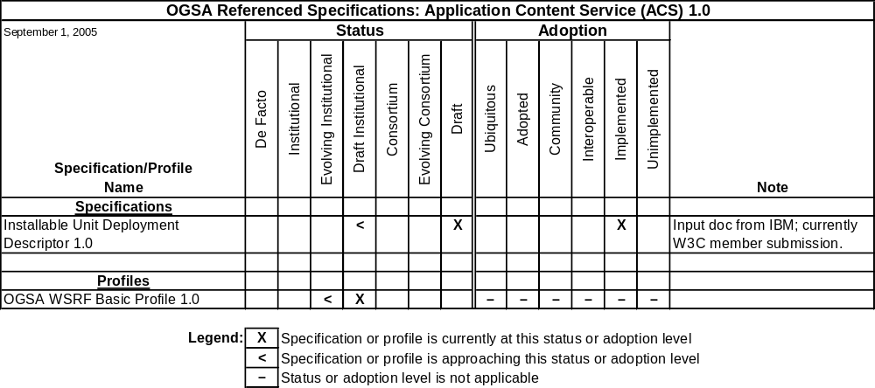
Table 4-19 ACS 1.0 referenced specifications

Expected Use
Since ACS provides an API to an archive for applications and data, it is anticipated that job management and advanced execution specifications would use the application archive interface. Thus future EMS architecture documents and advanced EM profiles may refer to the ACS specification. Also, since the application archive may include multiple component types, including configuration description and job control flow, future versions of the XML-CDL specification may be combinable with the ACS specification.
Given that ACS and IUDD are complementary, IUDD will refer to ACS in order to cover grid scenarios.

WS-Agreement Specification Version 1.0
This specification defines the Web Services Agreement Specification (WS-Agreement), a Web services protocol for establishing agreement between two parties, such as between a service provider and a consumer. WS-Agreement uses an extensible XML language for specifying the nature of the agreement, and agreement templates to facilitate discovery of compatible agreement terms.

Development Schedule
This specification went through public comment review in December 2004 and January 2005 and received a significant amount of very valuable feedback. This document is expected to be published in April 2007.
Milestone | Date
First draft available | August 2004
Ready for public comment review | June 2005
GFD-R.P publication | November 2006
Table 4-20 WS-Agreement 1.0 document schedule

Referenced Specifications
WS-Agreement normatively refers to WS-ResourceProperties and WS-Addressing.
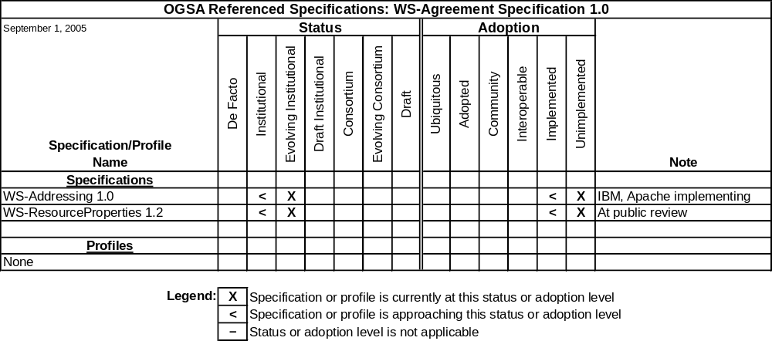
Table 4-21 WS-Agreement Specification 1.0 referenced specifications

Expected Use
In OGSA, it is expected that WS-Agreement 1.0 may be used in conjunction with JSDL. The OGSA EMS design team may define a Basic EMS profile referring to WS-Agreement 1.0, and in the future WS-Agreement may be used by other OGSA Profiles, including the proposed OGSA Basic Execution Management Profile.

Attributes Used in OGSI Authorization Version 1.0
This specification specifies elements and vocabulary for expressing attributes to be used in the context of OGSA authorization. The intention of defining standard formats and meanings (vocabulary) for these assertions is to facilitate interoperability between issuers of attribute assertions and the authorization services that consume them. This specification also defines profiles for using Security Access Markup Language (SAML) attribute assertions and X.509 attribute certificates as the standard OGSA attribute assertions.

Development Schedule
The OGSA Authorization working group (OGSA-Authz-WG) has now completed work on this document and it has been published as GFD.57.
The OGSA-Authz-WG is now re-chartering to define the next step of their standardization activities. As a result of the re-chartering discussion, the working group plans to revise the document to adopt the latest versions of the SAML specifications, which have themselves been revised and are available now.

Referenced Specifications
This document is based on the Assertions and Protocols for the OASIS Security Assertion Markup Language (SAML) V1.1 specification [SAML-core-1.1] and RFC 3281—An Internet Attribute Certificate Profile for Authorization [RFC-3281]. The following table shows the referenced specifications and their status and adoption levels.
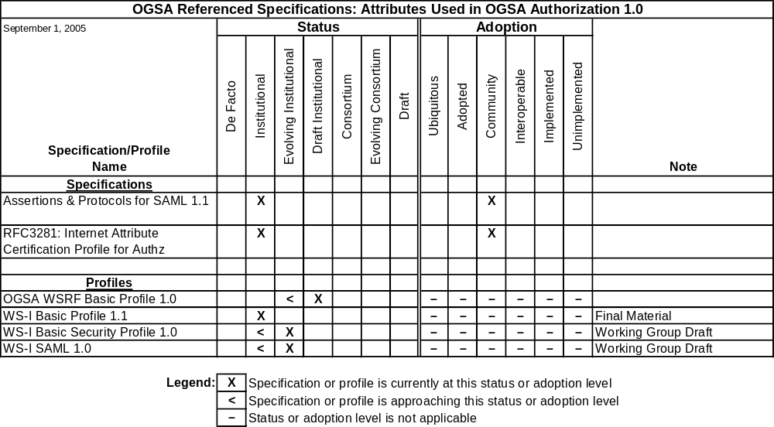
Table 4-22 Attributes Used in OGSA Authorization 1.0 referenced specifications

Expected Use
Future OGSA Security Profile, to be developed by the OGSA-WG Security design team, is expected to reference future version of this specification.

Data Movement Functional Specification
This document defines operations, inputs, outputs, and the underlying semantics for a service that can provide data movement services. These definitions are in the form of an abstract description, not actual code, XML, WSDL, etc.

Development Schedule
The OGSA-Data Movement Interface working group (OGSA-DMI-WG) is now developing this document.

Milestone | Date
First draft available | March 2007
Ready for public comment review | November 2007
GFD-I publication | March 2008
Table 4-23 OGSA-DMI Data Movement Functional Specification document schedule

Related Documents
This document forms part of the OGSA and OGSA-Data Architectures, and as such will be directly or indirectly referenced by future versions of both the OGSA Architecture and OGSA Data Architecture documents

Data Movement Transport Protocols and their use in DMI
The data movement service will be transport protocol agnostic. However, to be effective, it must be able negotiate an acceptable protocol between the endpoints, and provide protocol specific information in a standard, extensible way. This document will describe how this negotiation will take place, how extensibility will be achieved, and list the initial set of protocols and their interfaces.

Development Schedule
The OGSA Data Movement Interface working group (OGSA-DMI-WG) is now developing this document,

Milestone | Date
First draft available | March 2007
Ready for public comment review | November 2007
GFD-R.P publication | March 2008
Table 4-24 Data Movement Transport Protocols document schedule

OGSA Recommended Profile Schedule
This chapter provides the development schedule of OGSA Profile documents. These documents will be created by OGSA-WG or other domain-expert working groups. Profile documents described in this section should follow the guidelines set forth in the OGSA Profile Definition document [OGSA Profile Definition].
Documents described in this chapter will initially be published as OGF Proposed Recommendations (GFD-R.P), as defined in [OGF Documents]. For each document we provide schedule information and a summary of referenced specifications, including status and adoption levels as defined in the OGSA Profile Definition document [OGSA Profile Definition]. Note that specifications that are considered to be at a foundation level for Web services are not included in the specification summaries.

OGSA WSRF Basic Profile Version 1.0
The Profile is intended for use when implementing services that are concerned with distributed resource management, grid computing, or for other purposes that involve the modeling and management of stateful entities. These services frequently can benefit from the use of interfaces and behaviors defined in the WS-Addressing, WS-Resource Framework, and WS-Notification families of specifications.

Development Schedule
The OGSA-WG has completed work on Version 1.0 of this profile and it has been published as GFD.72. At the time of writing, there is not a well-defined schedule for release of any subsequent versions.

Referenced Specifications
This profile is based on the WS-I Basic Profile 1.1, WS-Addressing, WS-ResourceProperties, WS-ResourceLifetime, WS-BaseNotification, and WS-BaseFaults. The following table shows the referenced specifications and their status and adoption levels.
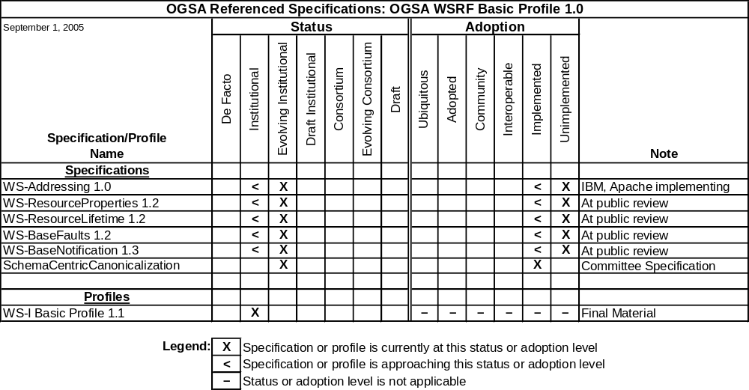
Table 5-25 OGSA WSRF Basic Profile 1.0 referenced specifications

Expected Use
This profile is expected to be the foundation for numerous specifications and profiles being developed by OGSA-WG and other working groups, including ByteIO, Application Content Service (ACS), and Basic Execution Services (BES).

OGSA Basic Security Profile 1.0 – Core
The Profile is intended for use in conjunction with OGSA WSRF Basic Profile Version 1.0 in order to ensure security of services that are concerned with distributed resource management, grid computing, or for other purposes that involve the modeling and management of stateful entities.
The Profile defines binding of key information to Endpiont References which may be used to associate and exchange key information of services. The Profile is intended to be used at least another security profile such as OGSA Security Profile 1.0 - Secure Channel.

.Development Schedule
The OGSA-WG is now developing this profile.
Milestone | Date
First draft available | September 2005
Ready for public comment review | February 2006
GFD-R.P publication | November 2006
Table 5-26 OGSA Basic Security Profile 1.0 – Core document schedule

Referenced Specifications
This profile is based on the WS-I Basic Security Profile 1.0, TLS, HTTP over TLS, and SAML. The following table shows the referenced specifications and their status and adoption levels.
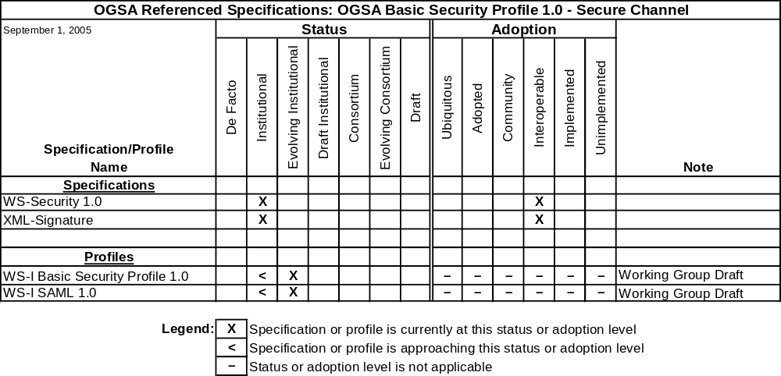
Table 5-27 OGSA Basic Security Profile 1.0 – core referenced specifications

Expected Use
This profile is expected to be the foundation for numerous specifications and profiles being developed by OGSA-WG and other working groups, including ByteIO, ACS, and BES.

OGSA Security Profile 1.0 – Secure Channel
The Profile is intended for use when implementing services that are concerned with distributed resources in a grid computing environment with secure authenticated communication channel for their interactions.

Development Schedule
The OGSA-WG is now developing this profile.
Milestone | Date
First draft available | September 2005
Ready for public comment review | February 2006
GFD-R.P publication | November 2006
Table 5-28 OGSA Security Profile 1.0 –Secure Channel document schedule

Referenced Specifications
This profile is based on the OGSA Basic Security Profile Core, WS-I Basic Security Profile 1.0, TLS, HTTP over TLS, and SAML.
Table 5-29 OGSA Basic Security Profile 1.0 – Secure Channel referenced specifications

Expected Use
This profile is expected to be the foundation for numerous specifications and profiles being developed by OGSA-WG and other working groups, including ByteIO, ACS, and BES.

WS-I Basic Profile Rendering of Data Movement Functional Specification
This document provides explicit WSDL, schema, etc,, that defines a WS-I Basic Profile Rendering of the data movement functional specification.

Development Schedule
The OGSA Data Movement Interface working group (OGSA-DMI-WG) is now developing this profile.

Milestone | Date
First draft available | September 2007
Ready for public comment review | May 2008
GFD-R.P publication | September 2008
Table 5-30 OGSA WS-I Basic Profile Rendering of Data Movement Functional Specification document schedule

Referenced Specifications
OGSA-DMI WG is working on identifying referenced specification.

WS-RF Basic Profile Rendering of Data Movement Functional Specification
This document provides explicit WSDL, schema, etc,, that defines a WS-RF Basic Profile Rendering of the data movement functional specification.

Development Schedule
The OGSA Data Movement Interface working group (OGSA-DMI-WG) is now developing this profile.

Milestone | Date
First draft available | September 2007
Ready for public comment review | May 2008
GFD-R.P publication | September 2008
Table 5-31 OGSA WS-RF Basic Profile Rendering of Data Movement Functional Specification document schedule

Referenced Specifications
OGSA-DMI WG is working on identifying referenced specification.

OGSA HPC profile
This document describes how a particular set of specifications are composed in order to solve some basic use cases around the use of HPC systems. For example, the use case of how to submit an executable job to run on a compute cluster..

Development Schedule
The OGSA-HPC profile working group (OGSA-HPCP-WG) is now developing this profile.

Milestone | Date
First draft available | August 2006
Ready for public comment review | December 2006
GFD-R.P publication | May 2007
Table 5-32 OGSA HPC Profile schedule

Referenced Specifications
This profile is based on the OGSA BES 1.0 and JSDL 1.0
Need table

OGSA Informational Profile Schedule
This chapter is intended to provide the development schedule of OGSA Informational Profile documents. These documents will be created by OGSA-WG or by other domain-expert working groups.
There are no plans to develop any informational profiles at present.

Collaboration with Other Organizations

Liaisons
In order to keep effective and productive communication and solve technical issues with concerted efforts, OGF as a whole or individual working groups maintain liaisons with other standards development organizations and with industry organizations.
Table 7-33 shows OGSA-related liaisons and their goals.

Organization | OGSA-WG Liaison | Goals
DMTF | Fred Maciel | Research how to apply the CIM model in OGSA resource management.
Table 7-33 OGSA liaisons and their goals

Standards Development Organizations Collaboration on Networked Resources Management (SCRM)
In addition to one-to-one liaison relationships both at the OGSA-WG level, explained in the previous section, and institutional level, major standards development organizations (SDOs) form a round table style, cross-institutional technical working group which will create a technologies and specifications landscape document and sort out terminology and taxonomy about Web service based management of networked resources. Such SDOs are including but not limited to DMTF, IETF, ITU-T, OASIS, OGF, SNIA, TMF, and W3C,This activity is called “Standards Development Organizations Collaboration on Networked Resources Management,” or SCRM (pronounced “scrum”). SCRM-WG is a regular OGF WG in the liaison area but this does not mean OGF will lead the SCRM work: OGF will provide an infrastructure for SCRM-WG, but the domain experts participating on behalf of the SDOs will equally contribute to and promote the SCRM work.
In May 2006, SCRM-WG released the online reference guide of specifications and standards for the management of networked resources. The wiki is available to anyone through OGF’s web site. Developed in wiki form, the information will be continuously updated by professionals throughout the world. Experts and institutions interested in adopting or researching these technologies are encouraged to submit additional information as appropriate. The SCRM-WG will maintain the integrity and legitimacy of information posted to this wiki.

Open-Source Software Projects
OGSA is expected to be implemented by multiple open-source software (OSS) projects and commercial software vendors. In this section we describe some of the projects whose work is contributing to OGSA in some significant way.
The Globus Toolkit (Globus) is an example of a major OSS grid project. The Globus Alliance is contributing to the development of OGSA by supporting the design and implementation of open-source software that implements specifications detailed in OGSA Profiles, and the participation of the implementers of that software in relevant standards processes. With its current version, GT4, based on early implementations of WSRF and WS-Notification and including implementations of all relevant security standards, Globus provides a comprehensive software infrastructure that allows developers and users to work with OGSA concepts now. Additional standards will be incorporated into future versions of the toolkit as they evolve.
The Globus Consortium is a group of companies with a common interest in promoting the development and adoption of the Globus Toolkit for commercial use. Consortium participants also have a strong interest in standards in general, and in OGSA in particular.
The Grid Research team at the University of Virginia (UVA) is committed to implementing several pieces of the OGSA Roadmap described here. Specifically, UVA will implement open versions of ByteIO, BES, RNS, and the WS-Naming specifications.
The Business Grid Computing Project (BG) is based on the OGSA Architecture specification. It is developing several services using specifications described in this Roadmap. In particular, BG will make available as open source software implementations of the Application Contents Service, JSDL, and WS-Agreement. BG intends to use the OGSA WSRF Basic Profile 1.0.
NextGrid is an EU-funded project to develop an architecture for next-generation grids that will enable their widespread use. The project is taking the OGSA WSRF Basic Profile and also many OGSA use cases as input to its architecture. NextGrid provided initial input to the OGSA Profiles, providing the normative basis in terms of both strategy and content, and will continue to feed architectural ideas into the development of OGSA.
The National Research Grid Initiative (NAREGI) is a Japanese national e-science grid project aiming at developing a computational infrastructure for supporting scientific and engineering research. One of the primary goals of the NAREGI Project is to contribute to the OGF standardization activities. NAREGI has been interested in, participated in, and, where possible, given feedback to numerous OGF working groups and research groups. Amongst the various groups, NAREGI has recently placed high emphasis on the OGSA-WG activities, being the first project or group to implement the EMS architecture described in the OGSA Architecture, in its alpha incarnation of the software stack that was released in 1Q 2005. Future plans will have NAREGI contribute to and provide reference implementations for Basic Execution Services (BES), Resource Selection Services (RSS), and Application Contents Service (ACS).
The Open Middleware Infrastructure Institute (OMII), located at the University of Southampton, is funded by the UK e-Science Core program. Its open-source distribution of Web services comprises services that are implementing current and emerging OGF- and OGSA-based standards, such as DAIS within the OGSA-DAI project, and JSDL and BES within the GridSAM projects. Both of these initiatives are funded through OMII's managed program.
The UniGrids Project will develop a Grid Service infrastructure compliant with the Open Grid Services Architecture (OGSA), and based on the Web Service Resource Framework (WSRF) and the UNICORE Grid software. The guiding principle of the project will be both to adopt and to influence standards in key project areas. The first version of Unicore/GS (the software developed by the UniGrids project) implements WSRF, WS-Addressing and JSDL. The second version of Unicore/GS will additionally implement OGSA-BES and provide support for WS-Security, SAML Authorization, and WS-Notification.
The Gridbus Project at the University of Melbourne is a major OSS project focused on the design and development of service-oriented, utility computing grid technologies. The Gridbus project has designed and implemented an open-source version of Grid Service Broker (GSB), a grid workflow management system, GridBank (grid authorization, authentication, and accounting services), an SLA-based facility for allocation of grid resources, and a .NET-based enterprise grid manager.
All of these technologies either currently support or are committed to supporting interfaces that are compliant with specifications from OGF and other bodies. Gridbus makes use of WSRF-compliant technologies in its development of advanced grid services. The project contributes to and provides reference implementations of GSB, with interfaces conforming to the JSDL and Portlets specifications; the GridBank database conforms to Resource Usage Record (RUR); its access interfaces conform to WSRF; and its workflow management system interfaces conform to the Business Process Execution Language (WS-BPEL) specification. Release of the various components under development is planned for late 2005.

Security Considerations
Although this document does not have any specific security considerations, security requirements related to OGSA are covered in OGSA Security Profiles and related specifications.

Editor Information
Christopher Jordan
San Diego SuperComputer Center
Email: ctjordan@sdsc.edu
Hiro Kishimoto
Fujitsu Laboratories
Email: Hiro.Kishimoto@jp.fujitsu.com

Authors
Jem Treadwell
Hewlett-Packard
Email: Jem.Treadwell@hp.com

Contributors
We gratefully acknowledge the contributions made to this document by Michael Behrens, Rajkumar Buyya, Dave Berry, Stephen Davey, Abdeslem Djaoui, Dona Dickinson, Ian Foster, Andrew Grimshaw, Mark Linesch, Allen Luniewski, Tom Maguire, Mark Morgan, Takuya Mori, Steven Newhouse, Manuel Pereira, Kazushige Saga, Andreas Savva, David Snelling, Steve Tuecke, and Peter Ziu.

Acknowledgments
We are grateful to numerous colleagues for discussions on the topics covered in this document, and to the people who provided comments on the public drafts. Thanks in particular to (in alphabetical order, with apologies to anybody we have missed) Mathias Dalheimer, Donal Fellows, Olegario Hernandez, Satoshi Itoh, Fred Maciel, Steve McGough, Toshiyuki Nakata, Jim Pruyne, Ravi Subramaniam, and Jay Unger.

Intellectual Property Statement
The OGF takes no position regarding the validity or scope of any intellectual property or other rights that might be claimed to pertain to the implementation or use of the technology described in this document or the extent to which any license under such rights might or might not be available; neither does it represent that it has made any effort to identify any such rights. Copies of claims of rights made available for publication and any assurances of licenses to be made available, or the result of an attempt made to obtain a general license or permission for the use of such proprietary rights by implementers or users of this specification can be obtained from the OGF Secretariat.
The OGF invites any interested party to bring to its attention any copyrights, patents or patent applications, or other proprietary rights which may cover technology that may be required to practice this recommendation. Please address the information to the OGF Executive Director.

Disclaimer
This document and the information contained herein is provided on an “As Is” basis and the OGF disclaims all warranties, express or implied, including but not limited to any warranty that the use of the information herein will not infringe any rights or any implied warranties of merchantability or fitness for a particular purpose.

Full Copyright Notice
Copyright (C) Open Grid Forum (2004-2006). All Rights Reserved.
This document and translations of it may be copied and furnished to others, and derivative works that comment on or otherwise explain it or assist in its implementation may be prepared, copied, published and distributed, in whole or in part, without restriction of any kind, provided that the above copyright notice and this paragraph are included on all such copies and derivative works. However, this document itself may not be modified in any way, such as by removing the copyright notice or references to the OGF or other organizations, except as needed for the purpose of developing Grid Recommendations in which case the procedures for copyrights defined in the OGF Document process must be followed, or as required to translate it into languages other than English.
The limited permissions granted above are perpetual and will not be revoked by the OGF or its successors or assignees.

References
[OGF Documents] Catlett, C.: Global Grid Forum Documents and Recommendations: Process and Requirements. OGF, revised April 2002. http://www.ogf.org/gf/docs/?final
[OGSA Arch] Foster, I., Kishimoto, H., Savva, A., Berry, D., Djaoui, A., Grimshaw, A., Horn, B., Maciel, F., Siebenlist, F., Subramaniam, R., Treadwell, J. and Von Reich, J.: The Open Grid Services Architecture, Version 1.5. Open Grid Forum, Lemont, Illinois, U.S.A., GFD-I.080, July 2006. http://www.ogf.org/gf/docs/?final
[OGSA Glossary] Treadwell, J. (ed.) Open Grid Services Architecture Glossary of Terms, Version 1.5. Open Grid Forum, Lemont, Illinois, U.S.A., GFD-I.081, July 2006. http://www.ogf.org/gf/docs/?final
[OGSA Profile Definition] Maguire, T. and Snelling, D.: OGSA Profile Definition Version 1.0. Open Grid Forum, Lemont, Illinois, U.S.A., GFD-I.059, January 2006. http://www.ogf.org/gf/docs/?final.
[OGSA-Related Naming Guidelines] Kishimoto, H.: OGSA related working group research group and specification naming guideline, version 1.0. GGF, May 2005.
https://forge.gridforum.org/projects/ggf-editor/document/OGSA_related_working_group_research_group_and_specification_naming_guideline/en/1.
[OGSA Use Cases] Foster, I., Gannon, D., Kishimoto, H. and Von Reich, J. (eds.): Open Grid Services Architecture Use Cases. GGF OGSA Working Group (OGSA-WG), GFD-I.029, October 2004. http://www.ogf.org/gf/docs/?final.
[OGSA WSRF Basic Profile] Foster, I., Maguire, T. and Snelling, D.: OGSA WSRF Basic Profile 1.0. GGF OGSA Working Group (OGSA-WG), 2005, forthcoming in the GGF document series, 2005. http://www.ogf.org/gf/docs/?final.
[SAML-core-1.1] Eve Maler, Prateek Mishra and Rob Philpott (ed.), Assertions and Protocols for the OASIS Security Assertion Markup Language (SAML) V1.1, OASIS Standard, 2 September 2003, http://www.oasis-open.org/committees/download.php/3406/oasis-sstc-saml-core-1.1.pdf
[RFC-3281] S. Farrell and R. Housley, RFC 3281 - An Internet Attribute Certificate Profile for Authorization, http://www.apps.ietf.org/rfc/rfc3281.html.
[WS-I AP 1.0] WS-I Attachments Profile 1.0:
http://www.ws-i.org/Profiles/AttachmentsProfile-1.0-2004-08-24.html .
[WS-I BP 1.1] WS-I Basic Profile 1.1: http://www.ws-i.org/Profiles/BasicProfile-1.1.html,
[WS-I BSP 1.0] WS-I Basic Security Profile 1.0:
http://www.ws-i.org/Profiles/BasicSecurityProfile-1.0-2005-01-20.html,
[ROADMAP1] Defining the Grid: A Roadmap for OGSA™ Standards v 1.0:
http://www.ogf.org/gf/docs/?final .
- Summary of Referenced Specifications & Profiles
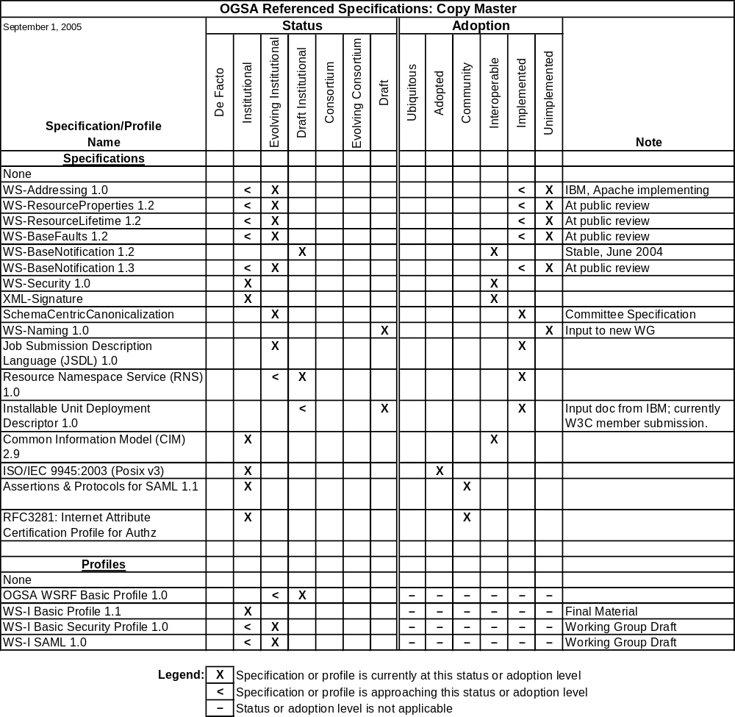
Note: This table and all similar tables in this document are copied directly from the OGSA-WG tracking database. Lines labeled “None” have no significance in this copy and may be ignored.
- Web Services Context
One of the most important changes to the overall distributed grid architecture model in recent years has been the adoption of web services as a foundation for method invocation and data exchange over a network. These services are built upon well known web service standards and provide access to grid resources using XML messages communicated typically using the HTTP/1.1 protocol. XML Schema provides a common typing system which combined with Web Services Description Language (WSDL) provide the building blocks to exchange information across disparate systems.
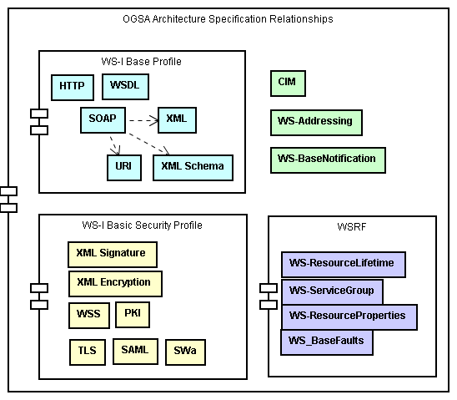
The evolving web service specifications cover many different functional areas to include messaging content, transport, security, transactions, metadata, and workflow. Since individually, these specifications may be interpreted and combined in ways which inhibit interoperability, key web service specifications have been composed together with guidelines to form profiles. The Web Services-Interoperability Organization (WS-I) has published the WS-I Basic Profile and the Basic Security Profile (BSP). OASIS has published the WS-Resource Transfer Framework (WSRF) which adds the notion of state to web services which can be remotely accessed and monitored.
Figure 1 - Container Relationship of standards and specifications
OGSA builds on this modular non-proprietary foundation to define specifications which enable grid systems to interoperate and to share resources between organizational boundaries, defining a standardized grid service infrastructure. OGSA ties these web service specifications together in order to describe distributed grid systems using the taxonomy and modeling principles defined in the Common Information Model (CIM) published by the Distributed Management Task Force (DMTF).
OGSA publishes this combination of evolving web service standards and OGF developed specifications as OGSA profiles, establishing the definition of a standardized interoperable grid system.
OGSA recognizes that it is important to track the evolution of web service standards and evaluate their impact periodically upon the OGSA Architecture as well as the grid community as a whole. This roadmap helps to serve that purpose by maintaining an enumeration of web service dependencies and depicting their statuses in tables and graphics.
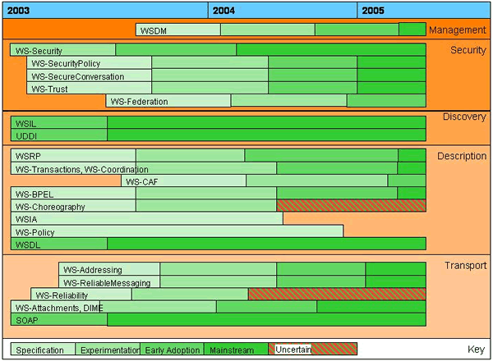

http://forge.ggf.org/sf/wiki/do/viewPage/projects.scrm-wg/wiki/HomePage
Globus Alliance: http://www.globusalliance.org
Virginia Center for Grid Research: http://www.cs.virginia.edu/~vcgr/standards/main.html
Business Grid Computing Project: http://www.ipa.go.jp/about/english/project/grid.html (English), https://www.ipa.go.jp/software/bgrid/index.html (Japanese)
NextGrid Project: http://www.nextgrid.org
NAREGI Project: http://www.naregi.org/index_e.html (English), http://www.naregi.org (Japanese)
Open Middleware Infrastructure Institute (OMII): http://www.omii.ac.uk/
UniGrids project: http://www.unigrids.org
Gridbus project: http://www.gridbus.org/intro.html
http://roadmap.cbdiforum.com/reports/protocols/

