Defining the Grid:
A Roadmap for the Open Grid Services Architecture

Table of Contents
1 Introduction 1
2 Open Grid Services Architecture: Goals and Status 2
3 The Standards Landscape 3
4 OGSA Definition Process 3
5 Dependencies and Priorities 4

Introduction
The Global Grid Forum (GGF)’s Open Grid Services Architecture working group (OGSA-WG) has recently completed two major work products. The OGSA Use Cases document describes a set of use cases from a range of enterprise and scientific settings, intended as a source of requirements for OGSA services. The OGSA Version 1 document collates requirements for an Open Grid Services Architecture and identifies a large number of service interfaces that may be required to meet those requirements.
The completion of these two documents leads to the question: what is the path by which OGSA should now be further developed and defined? An answer to this question is important to a variety of people.
- Many GGF participants have bought into the notion that OGSA can serve as an overarching architectural framework for different GGF activities. They now want to understand what this framework implies for their work.
- Developers and users want to know “what they can expect when” in terms of standards, so that they can make plans for product developments and technology acquisitions.
- Arguably the credibility of OGSA, GGF, and Grid as a whole depends in part on a coherent answer to this question.
These and other pressures encourage the view that we must move quickly to fill out the OGSA definition and produce a set of normative specifications that define in great detail what it means to be OGSA compliant.
However, before rushing into this task, we must also be aware of a number of other factors:
- The broad importance of Grid and the tight alignment of OGSA with Web services means that further work on OGSA cannot proceed as a purely GGF activity, but must rather be viewed as one (hopefully important) input to a larger process aimed at defining service-oriented solutions to distributed computing problems.
- As in any standardization process, we need to be careful not to standardize prematurely, i.e., standardize without adequate experience and/or buy in from its eventual users. These issues are particularly important in the case of OGSA, due to the particularly large gap between our ambition and experience.
- While the OGSA design team has worked hard and considered a variety of use cases, the team remains relatively small. It would seem likely that there are important perspectives that have not yet been considered.
- The human resources available to work on OGSA activities are small, certainly far fewer than are needed to do justice to the full spectrum of issues described in OGSA Version 1.
These considerations motivate this document, which seeks to clarify the role of OGSA and the steps required to refine its definition by addressing the following three issues.
- With a view to identifying external constraints on OGSA, we review major relevant standardization activities external to GGF. We discuss both past activities that have produced specifications on which OGSA can build, and current and planned future activities that may contribute to, and/or constrain, OGSA’s evolution.
- With a view to identifying factors that might help prioritize work on OGSA, we identify dependencies among different OGSA interfaces and the interfaces that appear needed within different deployment and application profiles.
- With a view to clarifying the process by which OGSA definition may proceed, we recommend a process by which technical specifications developed within or outside GGF can be identified as meeting OGSA requirements.

Open Grid Services Architecture: Goals and Status
A few brief words on goals and status, referring to other documents for details of course. An outline for now.
- Overarching goals.
  - Produce a broadly applicable and adopted framework for distributed system integration, virtualization, and management.
  - Produce an integrated, strongly coherent, and interoperable architecture for inter- and intra- grid systems.
  - Provide guidance for other groups to produce normative specifications for the development of the architecture.
- Documents produced.
  - “Open Grid Services Architecture Use Cases”
  - “The Open Grid Services Architecture, Version 1.0”
    - “Resource management in OGSA” (by CMM-WG)
  - “Open Grid Services Architecture: Glossary of Terms”
- Design teams
  - Data
  - Execution Management
  - Security
  - Resource management
  - Self-management
  - Information (OGSA logging)
  - Naming
- Coordination among related WG/RGs
- Relationships with other standards bodies (DMTF, OASIS WSDM)

The Standards Landscape
The roles of GGF, OASIS, W3C, DMTF, WS-I, IETF. Products that may be expected from each of these groups in the coming 1-2 years, and their relevance to OGSA. Approaches that may be taken to facilitate coordination.
The following are a few rough notes that may be relevant.
There are many places where bilateral coordination has worked, e.g. Web Services Distributed Management (WSDM)/Common Management Model (CMM), but there is still a lot of potential for conflict, e.g. Notification and Eventing.
Several low hanging pieces of fruit were identified: Notification, Web Services for Management eXtension (WMX), Data Center Markup Language (DCML), Naming, Reliable Messaging, Workflow (Web Services Composite Application Framework (CAF)/Web Services Business Process Execution Language (BEPL)), Code footprint vs. minimal functionality, common data model, policy models/languages (constraints and capabilities), provisioning and deployment (Solution Installation Schema, Configuration Description, Deployment, and Lifetime Management (CDDLM)).
Mechanisms for coordination: Work registers, the concept of a "profile", the need for an architecture in order to identify gaps and overlaps.

OGSA Definition Process
The process by which we see OGSA being further refined is shown in Figure 1.
A key issue is that the “top down” and “bottom up” worlds are to be coordinated as follows:
- OGSA-WG is concerned with defining requirements and overall architecture: the lighthouse towards which others may steer.
- WGs within GGF or other bodies may (hopefully will!) be formed to develop specifications that speak to requirements identified by OGSA-WG.
- The steps by which a technical specification may become identified as “OGSA compliant” remains to be clearly defined. A key requirement might be identification as a “recommendation” in the sense that there are two or more interoperable implementations.

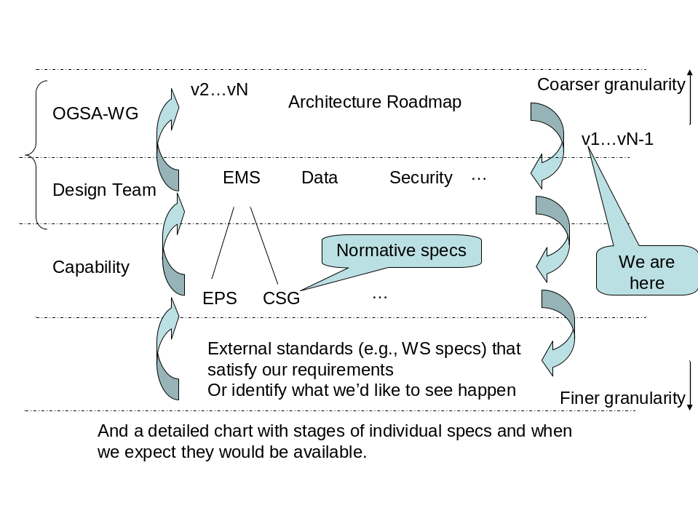
Figure 1. OGSA definition process

Dependencies and Priorities
Discuss priorities and dependencies between OGSA components.

