The Open Grid Services Architecture, Version 1.0

Status of this Memo
This document provides information to the community regarding the specification of the Open Grid Services Architecture (OGSA). Distribution of this document is unlimited. This is a DRAFT document and continues to be revised.

Abstract
Successful realization of the Open Grid Services Architecture (OGSA) vision of a broadly applicable and adopted framework for distributed system integration, virtualization, and management requires the definition of a core set of interfaces, behaviors, resource models, and bindings. This document, produced by the OGSA working group within the Global Grid Forum (GGF), provides a first, and necessarily preliminary and incomplete, version of this OGSA definition. The document specifies the scope of important services required to support Grid systems and applications in both e-science and e-business, identifies a core set of such services that are viewed as essential for many systems and applications, and specifies at a high-level the functionalities required for these core services and the interrelationships among those core services. The document also lists existing technical standards and standard definition activities within GGF, OASIS, W3C, and other standards bodies that speak to required OGSA functionality, and identifies priority areas for further work.


GLOBAL GRID FORUM
office@ggf.org
www.ggf.org

Full Copyright Notice
Copyright © Global Grid Forum (2002, 2003). All Rights Reserved.
This document and translations of it may be copied and furnished to others, and derivative works that comment on or otherwise explain it or assist in its implementation may be prepared, copied, published and distributed, in whole or in part, without restriction of any kind, provided that the above copyright notice and this paragraph are included on all such copies and derivative works. However, this document itself may not be modified in any way, such as by removing the copyright notice or references to the GGF or other organizations, except as needed for the purpose of developing Grid Recommendations in which case the procedures for copyrights defined in the GGF Document process must be followed, or as required to translate it into languages other than English.
The limited permissions granted above are perpetual and will not be revoked by the GGF or its successors or assigns.
This document and the information contained herein is provided on an "AS IS" basis and THE GLOBAL GRID FORUM DISCLAIMS ALL WARRANTIES, EXPRESS OR IMPLIED, INCLUDING BUT NOT LIMITED TO ANY WARRANTY THAT THE USE OF THE INFORMATION HEREIN WILL NOT INFRINGE ANY RIGHTS OR ANY IMPLIED WARRANTIES OF MERCHANTABILITY OR FITNESS FOR A PARTICULAR PURPOSE.

Intellectual Property Statement
The GGF takes no position regarding the validity or scope of any intellectual property or other rights that might be claimed to pertain to the implementation or use of the technology described in this document or the extent to which any license under such rights might or might not be available; neither does it represent that it has made any effort to identify any such rights. Copies of claims of rights made available for publication and any assurances of licenses to be made available, or the result of an attempt made to obtain a general license or permission for the use of such proprietary rights by implementers or users of this specification can be obtained from the GGF Secretariat.
The GGF invites any interested party to bring to its attention any copyrights, patents or patent applications, or other proprietary rights which may cover technology that may be required to practice this recommendation. Please address the information to the GGF Executive Director (see contact information at GGF website).
Contents
1 Introduction 6
2 Functional Requirements 7
2.1 Basic Functionality 8
2.2 Security 9
2.3 Resource Management 9
2.4 System Properties 11
3 Infrastructure Assumptions 12
4 Capabilities 13
4.1 Program Execution Services 13
4.1.1 Conceptual Frameworks 14
4.1.2 WS-Agreement Based Scheduler Instantiation 16
4.1.3 Instantiation with “Broker Service” 19
4.2 Data Services 20
4.3 Resource Management Services 21
4.4 Security Services 21
4.5 Self-Management Services 23
4.6 Problem Determination Services 23
4.7 Service-level Attainment Services 23
5 Services 23
5.1 Reference Renewal 23
5.1.1 Services 24
5.1.2 Dependencies 24
5.1.3 Standardization 24
5.2 Virtual Organizations 24
5.2.1 Services and schema 25
5.2.2 Dependencies 27
5.2.3 Standardization 27
5.3 Service Groups and Discovery Services 27
5.3.1 Services and schema 28
5.3.2 Dependencies 28
5.3.3 Related Standardization 29
5.4 Choreography, Orchestration, and Workflow 29
5.4.1 Services and schema 29
5.4.2 Dependencies 29
5.4.3 Standardization 29
5.5 Transactions 30
5.5.1 Services and schema 30
5.5.2 Dependencies 30
5.5.3 Standardization 30
5.6 Metering Service 30
5.6.1 Services and schema 31
5.6.2 Dependencies 31
5.6.3 Standardization 31
5.7 Deployment 31
5.7.1 Services and schema 31
5.7.2 Dependencies 32
5.7.3 Standardization 32
5.8 Application Contents Service 32
5.8.1 List of detailed services 33
5.8.2 Standard schema/document 33
5.8.3 Dependencies 36
5.8.4 Related services 36
5.8.5 Standardization 36
5.9 Fault Management 36
5.9.1 Services and schema 36
5.9.2 Dependencies 36
5.9.3 Standardization 36
5.10 Problem Determination 36
5.10.1 Services and schema 36
5.10.2 Dependencies 37
5.10.3 Standardization 37
5.11 Information and Monitoring Service 37
5.11.1 Services 39
5.11.2 Dependencies 42
5.11.3 Standardization 44
5.12 Logging Services 44
5.12.1 Requirements 44
5.12.2 Services and schema 45
5.12.3 Dependencies 45
5.12.4 Standardization 45
5.13 Messaging and Queuing 45
5.13.1 Services 45
5.13.2 Dependencies 45
5.13.3 Standardization 45
5.14 Event 45
5.14.1 Services and schema 45
5.14.2 Dependencies 45
5.14.3 Standardization 45
5.15 Policy and Agreements 45
5.15.1 Services and schema 45
5.15.2 Dependencies 45
5.15.3 Standardization 45
5.16 Base Data Services 45
5.16.1 Services and schema 45
5.16.2 Dependencies 45
5.16.3 Standardization 45
5.17 Other Data Services 45
5.17.1 Services and schema 45
5.17.2 Dependencies 45
5.17.3 Standardization 45
5.18 Discovery Services 45
5.18.1 Services and schema 45
5.18.2 Dependencies 45
5.18.3 Standardization 45
5.19 Job Agreement Service 45
5.19.1 Services and schema 45
5.19.2 Dependencies 45
5.19.3 Standardization 45
5.20 Reservation Agreement Service 45
5.20.1 Services and schema 45
5.20.2 Dependencies 45
5.20.3 Standardization 45
5.21 Data Access Agreement Service 45
5.21.1 Services and schema 45
5.21.2 Dependencies 45
5.21.3 Standardization 45
5.22 Queuing Service 45
5.22.1 Services 45
5.22.2 Dependencies 45
5.22.3 Standardization 45
5.23 WS-Agreement 45
5.23.1 Services and schema 45
5.23.2 Dependencies 45
5.23.3 Standardization 45
5.24 Web Services Distributed Management 45
5.24.1 Services and schema 45
5.24.2 Dependencies 45
5.24.3 Standardization 45
6 Security Considerations 45
7 Editor Information 45
8 Contributors 45
References 45

Introduction
Grid systems and applications aim to integrate, virtualize, and manage resources and services within distributed, heterogeneous, dynamic “virtual organizations” [6, 7]. The realization of this goal requires the disintegration of the numerous barriers that normally separate different computing systems within and across organizations, so that computers, application services, data, and other resources can be accessed as and when required, regardless of physical location.
Key to the realization of this Grid vision is standardization, so that the diverse components that make up a modern computing environment can be discovered, accessed, allocated, monitored, accounted for, billed for, etc., and in general managed as a single virtual system—even when provided by different vendors and/or operated by different organizations. Standardization is critical if we are to create interoperable, portable, and reusable components and systems; it can also contribute to the development of secure, robust, and scalable Grid systems by facilitating the use of good practices.
In this document, we present an Open Grid Services Architecture (OGSA) that addresses this need for standardization by defining, within a service-oriented architecture, a set of core interfaces and behaviors that address key concerns in Grid systems. These concerns include such issues as: How do I establish identity and negotiate authentication? How is policy expressed and negotiated? How do I discover services? How do I negotiate and monitor service level agreements? How do I manage membership of, and communication within, virtual organizations? How do I organize service collections hierarchically so as to deliver reliable and scalable service semantics? How do I integrate data resources into computations? How do I monitor and manage collections of services?
In our presentation, we first identify required capabilities for Grid systems and then translate those capabilities into a coherent set of components that collectively define OGSA. First, in §2, we provide an abstract definition of the set of problems that OGSA is intended to address. This analysis is based on requirements, technical challenges, previous experience, and the state of the art in related work. The abstract rendering is not constrained by any assumptions about the underlying infrastructure, but rather is intended to frame the “Grid” discussion and define solutions.
Next, in §3, we describe infrastructure assumptions that constrain our development of the OGSA design. In particular, we explain how OGSA both builds on, and is contributing to the development of, the growing collection of technical specifications that form the emerging Web services (WS) architecture [2].
In §4, we present a rendering of the required functionality into service definitions.
In §5, we provide descriptions of specific services, making clear where existing service specifications can be used unchanged and where modified or new service specifications are needed. We also describe the current state of any work underway to define such extensions and/or definitions.
This document, a product of the Global Grid Forum’s OGSA working group, defines OGSA version 1. The OGSA working group is likely to release revisions of this document in the future as our understanding of OGSA’s purpose and form, and the details of specific components, evolves.

Functional Requirements
This definition of OGSA version 1 is driven by a set of functional requirements, which themselves are informed by the use cases listed in Table 1 and described in a companion document [5]. These use cases do not constitute a formal requirements analysis, but have provided useful input to the definition process.
Table 1: OGSA Use Cases
Use case | Summary
Commercial Data Center (CDC) | Data centers will have to manage several thousands of resources, including servers, storage, and networks, while reducing management costs and increasing resource utilization.
Severe Storm Modeling | Enable accurate prediction of the exact location of severe storms based on a combination of real-time wide area weather instrumentation and large-scale simulation coupled with data modeling.
Online Media & Entertainment | Delivering an entertainment experience, either for consumption or interaction.
National Fusion Collaboratory (NFC) | Defines a virtual organization devoted to fusion research and addresses the need of software developed and executed by this community based on the application service provider model.
Distributed Query Processing | A service-based distributed query processor supporting the evaluation of queries expressed in a declarative language over one or more existing services.
Grid Workflow | Workflow is a convenient way of constructing new services by composing existing services. A new service can be created and used by registering a workflow definition to a workflow engine.
Grid Resource Reseller | Inserting a supply chain between the Grid resource owners and end users will allow the resource owner to concentrate on their core competence, while end users can purchase resources bundled into attractive packages by the reseller.
Inter Grid | Extends the CDC use case by emphasizing applications that are not really grid enabled and are difficult to change, mixed grid and non grid data centers, grid across multiple companies, and generic concepts of utility computing.
Interactive Grids | Compared to the online media use case, this use case emphasizes a very high granularity of distributed execution (thread-based, or even procedure-based, depending on the customer scenarios).
Grid Lite | Extends the use of grids to small devices: PDAs, cell phones, firewalls etc. It identifies essential grid services that enable the device to be part of a grid.
Virtual Organization Grid Portal | A VO gives its members access to various computational, instrument-based data and other types of resources. A portal provides an end-user view of the collected resources available to the members of the VO.
Persistent Archive | Preservation environments handle technology evolution by providing abstraction layers to manage mappings between old and new protocols, software and hardware systems, while maintaining authentic records.
Mutual Authorization | Refines the CDC and NFC use cases by introducing the scenario of the job submitter authorizing the resource on which the job will eventually execute.
Resource Usage Service | The Resource Usage Service facilitates the mediation of resource usage metrics produced by applications, middleware, operating systems, and physical resources in a distributed, heterogeneous environment.

Analysis of the use cases and other relevant input lead us to identify both important and apparently broadly relevant characteristics of Grid environments and applications, and functionalities that appear to have broad relevance to a variety of application scenarios. We summarize our findings in the following.

Basic Functionality
A first set of basic functions are fundamental to almost every use case.
Discovery and brokering. Mechanisms are required for discovering and/or allocating services, data, and resources with desired properties. For example, in the National Fusion Collaboratory use case, clients need to discover network services before they are used, and service brokers need to discover hardware and software availability, in order to identify codes and platforms that can meet client needs.
Monitoring. Many systems and applications require a global, cross-organizational view of resources and assets for project and fiscal planning, troubleshooting, and other purposes. Users want to monitor their applications as they run, and resource or service owners need to expose certain state so that users of those resources or services may manage their usage by monitoring the exposed state information.
Notification and messaging. Notification and messaging are critical in the dynamic scenario of the Severe Storm Prediction use case. It is completely event driven.
Metering, accounting, and billing. Applications and schemas are required for metering, auditing and billing. For example, in the IT Infrastructure and Management use case, the metering function records usage and duration, especially of licenses; the auditing function audits usage and the application profile on the machine; and the billing function bills the user based on metering.
Data sharing. Data management and sharing are common and important Grid applications. Mechanisms are required for accessing and managing data archives, for caching data and managing its consistency, for indexing and discovering data and metadata, and so on.
Deployment. Mechanisms are commonly required for deploying data and/or executables to the hosting environment used to execute a job or service.
Virtual organizations. The need to support collaborative VOs introduces a need for VO creation and management mechanisms, including group membership services. For example, in the Commercial Data Center use case, the commercial grid system creates a VO in a data center that provides IT resources to the job upon the customer job request. Depending on the customer’s request, the commercial grid system will negotiate with another remote such system and create a VO across the commercial data center. Such a VO can be used to achieve the necessary scalability and availability.
Policy. It is important to be able to represent policy at multiple stages in hierarchical systems, with a view to automating the enforcement of policies that might otherwise be implemented as organizational processes or managed manually. Several attributes should be handled as policy. An error and event policy guides self-controlling management, including failover and provisioning. From the low-level policies that govern how the resources are monitored and managed to high-level policies that govern how business processes such as billing are managed, there may be policies at every level of the infrastructure. High-level policies are sometimes decomposable into lower-level policies. For example, in the Commercial Data Center use case, policies may include SLAs, security, scheduling, and brokering.
Grouping and aggregation of services. Composing services using existing services is a core requirement. There are two main types of composition techniques: selection and aggregation. Selection involves choosing to use a particular service amongst many services with the same operational interface (e.g., select the fastest MP3 encoder). Aggregation involves orchestrating a functional flow (workflow) between services. For example, the output of the accounting service is fed into the rating service to produce billing records. One other basic function required for aggregation services is to transform the syntax and/or semantics of data or interfaces.

Security
Grids introduce a rich set of security requirements, of which we highlight just a few here.
Authentication and authorization. These are fundamental requirements in essentially every use case. For example, in the Commercial Data Center use case, the commercial Grid system authenticates the customer and authorizes the submitted request when the customer submits a job request. In the Online Media and Entertainment use case, related issues of digital rights management and key management arise.
Multiple security infrastructures. Distributed operation implies a need to interoperate with and manage multiple security infrastructures. For example, in the Online Media and Entertainment use case, a player may buy an EverQuest character on eBay and pay for it via his PayPal account. To support single sign-on a game developer may want to use a 3rd party authentication and authorization service, identify a mapping service, etc.
Isolation. Numerous use cases involve multiple nontrusting parties sharing the same resource, in which case strong isolation among the different parties is essential. For example, in the Commercial Data Center use case, isolation of customers in the same commercial data center is a crucial requirement, while in the Online Media and Entertainment use case, isolation among content offerings has to be ensured. In addition, several securities related services are required:
Perimeter security solutions. Many use cases require applications to be deployed on the other side of firewalls from their intended clients. Inter-Grid collaboration often requires crossing institutional firewalls. We need standard, secure mechanisms that can be deployed to protect institutions while also enabling cross-firewall interaction. This is a problem, for example, in the Fusion Collaboratory use case.
Encryption. For example, the IT Infrastructure and Management use case needs encryption of communication traffic—at the very least for the payload.
Certification. A trusted party certifies that a particular service has certain semantic behavior. For example, a company might only use e-commerce services certified by “Yahoo shopping.”
Intrusion detection and protection.

Resource Management
Resource management is another area in which we identify multiple cross-cutting requirements, encompassing service level agreement (SLA) negotiation, provisioning, and scheduling for a variety of resource types and activities.
Provisioning. Computer CPUs, applications, licenses, storage, networks, and instruments are all Grid resources that require provisioning. We need a framework that allows the provisioning of different resource types and for different purposes in a uniform, consistent manner.
Resource virtualization. Dynamic provisioning implies a need for resource virtualization mechanisms that allows resources to be transitioned flexibly to different tasks as required—for example, when bringing more Web servers on-line as demand exceeds some threshold.
Optimization of resource usage while meeting cost targets (e.g., to deal with finite resources). Mechanisms to manage conflicting demands from various organizations, groups, projects and users and implementing a fair sharing of resource and access to Grid.
Transport management. For applications that require some form of real-time scheduling, it can be important to be able to schedule or provision bandwidth dynamically for data transfers or in support of the other data sharing applications. For example, in the National Fusion Collaboratory use case, reliable transport management is essential to provide required end-to-end QoS.
Usage models that provide for both batch and interactive access to resources.
Support for the management and monitoring of resource usage and the detection of SLA or contract violations by all relevant parties. Also conflict management is necessary, to resolve different management disciplines which may conflict in their optimization objectives (availability goals vs. performance goals for example). Note: this is not a conflict between users or organizations.
CPU scavenging is an important tool for an enterprise or VO to use to aggregate computing power that would otherwise go to waste. OGSA should provide service infrastructure that allows for the creation of applications that use scavenged cycles. For example, consider a collection of desktop computers running software that supports integration into processing and/or storage pools managed via systems such as Condor, United Devices, and DataSynapse. Issues here include maximizing security in the absence of strong trust.
Scheduling of service tasks. Long recognized as an important capability for any information processing system, scheduling becomes extremely important and difficult for distributed Grid systems. For example, dynamic scheduling is an essential component in the Severe Storm Prediction use case. Compute resources must be provisioned on-demand to satisfy the need to complete a forecast on time.
Load Balancing. In many applications it is necessary to make sure deadlines are met, or resources are used uniformly. These are both forms of load balancing that must be made possible by the underlying infrastructure. For example, in the Commercial Data Center use case, monitoring job performance and adjusting allocated resources to match the load and fairly distributing end users’ requests to all the resources are necessary. For example, in the Online Media and Entertainment use case, the amount of workload is a direct result of how many concurrent online game players are being hosted on a game server, which can vary greatly in response to changing conditions.
Resource Reservation. This functionality may be required to execute the application on reserved resources. For example, in the Commercial Data Center use case, the commercial Grid system decides when to start the request processing based on the customer’s request, interpreting the job specification description language in which the request is written, and checking if the customer has the right to perform the request.
Logging. Processes like obtaining/deploying application programs might be logged, and the information might be used for accounting. This functionality is represented as “metering and accounting.” For example, in the Severe Storm Prediction use case, logging is required in order to understand what happened in the last “storm” so that performance can be optimized later.
Workflow management. Many applications can be wrapped in scripts or processes that require licenses and other resources from multiple sources. Applications coordinate using the file system or based on events. For example, in the National Fusion Collaboratory use case, a network service is a workflow of multiple components, including remote execution, input data transfer, and output data transfer.
Pricing.
Agreement-based interaction. The Fusion project requires agreement-based interaction capable of specifying and enacting agreements between clients and servers (not necessarily human), and then composing those agreements into higher-level end-user structures.

System Properties
We note a number of issues that arose in multiple scenarios but that are best thought of as desirable system properties rather than functions.
Fault tolerance. In distributed systems, failure must be considered a natural behavior, and failure recovery mechanisms must be an essential component of any design. Support is required for fail-over, load redistribution, and other techniques used to achieve fault tolerance. For example, in the Service-Based Distributed Query Processing use case, fault tolerance is important for long running queries that may return large amounts of data, while in the Severe Storm Prediction use case, fault tolerance is critical to ensure that a forecast is obtained in a timely manner. In the Commercial Data Center use case, the remote backup data center must be able to take over application systems if the primary data center becoming unavailable.
ITF: Should we think in terms of types of fault tolerance? Is “intrusion detection and recovery” a type? What about problem determination?
The self-healing capabilities of resources, services and systems are required. Significant manual effort should not be required to monitor, diagnose and repair faults. Ability to integrate intelligent self-aware hardware such as disks, networking devices etc. ITF: Not sure this adds much—or maybe it needs to be reworded???
Strong monitoring for defects, intrusions, and other problems. Ability to migrate attacks away from critical areas. ITF: Does this belong here???
Legacy application management. Legacy applications are often too valuable to give up and too complex to rewrite, and thus a Grid infrastructure must allow them to continue to be used.
Automated administration. It is important that we be able to codify and automate the normal practices used to administer the environment. The goal is that systems should be able to self-organize and self-describe to manage low-level configuration details based on higher-level configurations and management policies specified by administrators. ITF: Does this need to be reworded???
Support for heterogeneous platforms. Some use cases involve highly constrained and/or homogeneous environments that may well motivate specialized OGSA profiles. However, it is clear that, in general, Grid environments tend to be heterogeneous and distributed, encompassing a variety of operating systems (e.g., Unixes, Linux, Windows, and/or embedded systems), hosting environments (e.g., J2EE, .NET), and devices (e.g., computers, instruments, sensors, storage systems, databases, networks).
Support for heterogeneous mechanisms. Grid software must often also interoperate with a variety of distinct implementation mechanisms for core functions such as security.
Support for heterogeneous policies. Geographically distributed environments often feature varied usage, management, and administration policies (including policies applied by legislation) that must be honored and managed.
Support for heterogeneous application structures. A wide variety of application structures are encountered, and must be supported by other system components, including both single-process and multi-process (both local and distributed) applications covering a wide range of resource requirements; flows, i.e., multiple interacting applications that can be treated as a single transient service instance working on behalf of a client or set of clients, and/or workloads comprising potentially large numbers of perhaps heterogeneous applications.
Scalability. While by no means a universal requirement, various of the use cases require that underlying services scale to high numbers of entities, numbers of users, and/or performance levels.
Evolvability. TBD.

Infrastructure Assumptions
Our goal in defining the Open Grid Services Architecture is to define a coherent and integrated set of components that collectively address the requirements identified above within the context of a service-oriented architecture. We must necessarily make assumptions about the underlying infrastructure on which we build if we are to make concrete statements about higher-level services. There are many examples of specifications that tried to be too abstract and did not achieve their goal. For example, CORBA 1.1 failed to achieve interoperability because service names depended on implementation. Thus, just as the designs of TCP, DNS, and other higher-level TCP protocols and services are informed by the properties of the IP substrate on which they build, so our design of OGSA is influenced by our choice of underlying mechanisms. In this section, we list and to some extent justify those choices.
The primary assumption is that work on OGSA both builds on, and is contributing to the development of, the growing collection of technical specifications that form the emerging Web services (WS) architecture [2]. Indeed, OGSA can be viewed as a particular profile for the application of core WS standards. We may this choice because of a strong belief in the merits of a service-oriented architecture and our belief that the Web services architecture is the most effective route to follow to achieve a broadly adopted, industry standard service-oriented rendering of the functionality required for Grid systems.
This choice of Web services as an infrastructure and framework means that we assume that OGSA systems and applications are structured according to service-oriented architecture principles, and that service interfaces are defined by the Web Services Description Languages (WSDL). For now, we assume WSDL v1.1, with a move to WSDL 2.0 planned once that latter specification is finalized. We also assume XML as the lingua franca for description and representation (although recognizing that other representations may be required in some contexts, for example when performance is critical) and SOAP as the primary transport binding for OGSA services. In addition, we seek to develop service definitions that are consistent with the interoperability profiles defined through the WS Interoperability (WS-I) process.
While thus working within a Web services framework, we do not take it as a given that Web services standards as currently defined meet all Grid requirements. In some cases, existing specifications may require modification or extension. Thus, OGSA architects have been involved in the definition of WSDL 2.0 and in the review of WS-Security and related specifications, and we identify in this document other areas in which extensions to existing specifications are desirable. In other cases, Grid requirements motivate the introduction of entirely new service definitions.
One key area in which Grid requirements motivate extensions to existing specifications is security. Security issues arise at various layers of the OGSA infrastructure. We use WS-Security standard protocols to permit OGSA service requests to carry appropriate tokens securely for purposes of authentication, authorization, and message protection. End-to-end message protection is required by some scenarios addressed by the OGSA infrastructure, and thus OGSA must also provide for higher-level protection mechanisms such as XML encryption and digital signatures in addition to, or in place of, point-to-point transport-level security, such as TLS and IPSec. In addition to message-level security, an interoperable and composable infrastructure needs security components themselves rendered as services. There are various efforts underway to specify service definitions for these security services. For example, an OGSA authorization service may use the proposed WS-Agreement standard along with evolving OASIS standards SAML and XACML to express security assertions and access control description. When and where appropriate, OGSA will adopt, or define those security services.
A key area in which Grid requirements have motivated new specifications—specifications that have relevance beyond Grid scenarios—is in the area of state representation and manipulation. In particular, we assume that we have available as building blocks the interfaces and behaviors defined by the WS Resource Framework (WSRF), the recently proposed refactoring of the Open Grid Services Infrastructure (OGSI) [9]. WSRF defines an approach to modeling, accessing, and managing state; to grouping services; and to expressing faults. These mechanisms (defined after a 18-month design process within the GGF OGSI-WG) all have a fundamental role to play in constructing Grid systems. In addition, WSRF is being strongly considered for use in a variety of resource modeling and systems management standards efforts, such as the OASIS WSDM Technical Committee. Thus, OGSA-related standards that build on WSRF are likely to be well positioned for composition with efforts from these standards bodies.
Finally, we assume notification/eventing capabilities such as those defined within the recently proposed WS-Notification specifications. These specifications, derived like WSRF from OGSI, define notification mechanisms that build on WSRF mechanisms to support subscription to, and subsequent notification of changes to, state components. (WS-Eventing specification provides similar mechanisms, but does not yet connect to WSRF.)

Capabilities
The infrastructure elements just described provide powerful building blocks for stateful service-oriented systems. In particular, WSDL allows us to define service interfaces in a standard manner, facilitating service discovery and the creation of interoperable systems. WSRF mechanisms for representing and managing state have broad applicability, allowing us for example to define visible state for purposes of monitoring, create and manage transient stateful entities such as policies, and (with WS-Notification support) subscribe to and deliver notifications of changes to this state. WS-Security provides a basis for authentication.
However, these infrastructure elements certainly do not address all of the requirements identified in Section 2. Thus, we now turn to OGSA proper and describe the capabilities that are provided by its various components. We divide its functions into four broad groups: core, data, program execution, and resource management services.

Program Execution Services
Presumably needs to be shortened.
Program execution services enable applications to have coordinated access to underlying VO resources, regardless of their physical location or access mechanisms. When an application utilizing the Grid makes use of more than one physical resource during its execution, Program Execution middleware maps the resource requirements of the user application to the multiple physical resources that are required to run that application. The Program Execution services are the key to making VO resources easily accessible to end-users, by automatically matching the requirements of a Grid application with the available resources, while staying within the conditions that the VO has specified with the underlying resource managers.
Interoperability is the key to building up a Program Execution Services infrastructure. In order to allow the higher order constructs such as Program Execution to work with the lower level resource managers, there must be agreement on how these entities will interact with each other, even though the lower level resource managers might be very different from each other, in function and in interface. In order to meet the requirement for interoperability, standards are required which define the interfaces through which resource managers are accessed and managed. Additionally, there is a requirement that the services representing the resource managers act using standard semantics, so that the behavior of the resource manager is predictable to the scheduler.
OGSA-based Grid environments may be composed of many different, interacting services. Each such service may be subject to different policies on how to manage the underlying resources. In order to deal with the complexities of large collections of these services, there need to be mechanisms for Grid service management and the allocation of resources for applications. One such mechanism is defined through the proposed WS-Agreement interface [4]. The specification document for WS-Agreement describes it as “… the ability to create services and adjust their policies and behaviors based on organizational goals and application requirements.” WS-Agreement defines the Agreement-based Service Management model, which is specified as a set of WSRF-compliant portTypes allowing clients to negotiate with management services in order to manage services or other legacy applications.

Conceptual Frameworks
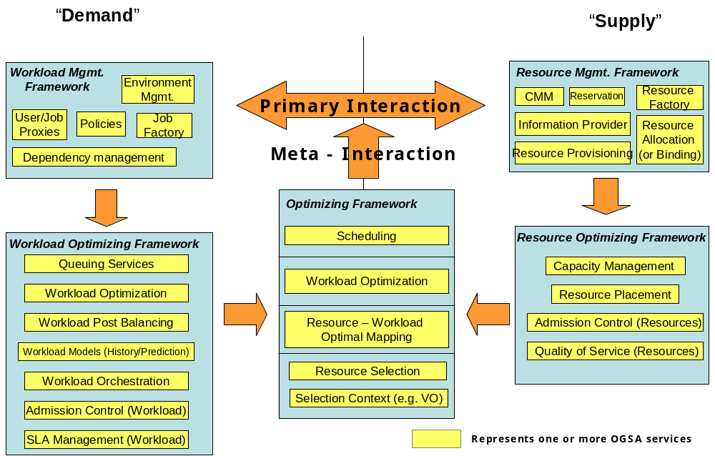
Workload realization is the general set of use cases that take workload requests and map them to appropriate resources within the Grid that can realize these workloads. Services manage and co-ordinate access to and consumption of geographically distributed resources by workloads realized on those resources.
Figure 1: Grid Frameworks - Execution
The overall conceptual architecture can be visualized as shown in Error: Reference source not found. Workload realization (or execution) can be visualized as a mapping between “demand” in the form of workloads and “supply” in the form of the available Grid resources. In a fundamental scenario, the system has to map the demand to the supply and provide the mechanism to realize these workloads on the resources. This primary mode can be augmented with other services, mechanisms and capabilities that provide alternate modes of interaction, including optimization of the mapping and scheduling a temporal and topological execution profile. In addition, other services manage and enforce the service level agreements with the user, and still other services tweak the resources and manage the available capacity to ensure that a desired quality of service is delivered. The alternate modes are not core to the execution framework, but can be added to augment the efficacy and efficiency of the overall system.
Services that belong to the Resource Optimization Framework are focused on the optimization of the supply side of the mapping. This can be done by admission control, resource utilization monitoring and metering, capacity projections, resource provisioning and load balancing across equivalent resources, and negotiation with workload optimization and/or management services to migrate workloads onto other resources so as to maximize resource utilization.
Services that belong to the Workload Optimization Framework are focused on the demand side of the mapping. These services may queue requests to prevent resource saturation and manage relative request priorities, or may perform post-balancing by migrating workloads to appropriate resources, depending on the potential to be penalized or rewarded for missing or exceeding SLAs respectively.
Services in the Optimizing Framework are focused on resolving any contentions that the myopic views of the respective resource or workload optimization frameworks may create. These services arbitrate and modulate the primary interactions either in an ‘in-band’ or an ‘out-of-band’ manner.
The term “resources” is used in its most general sense, and can include virtualized physical resources such as CPU, storage, memory, and/or virtual resources such as software licenses or data. As shown by Error: Reference source not found, workloads are composite entities that have multiple levels of “execution entities”: workloads are made up of jobs which in turn are made up of tasks which in turn are made up of tasklets. Each of these composite entities has a manager.
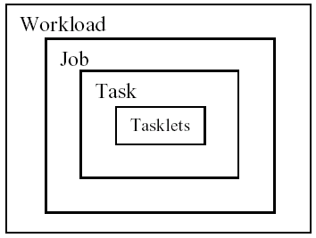
Figure 2: Workload, Job, Task, and Tasklet
A possible set of interactions among services to execute workloads are shown in Error: Reference source not found. The services can be at multiple levels in the Grid and can be composed of other services or service groups.
Figure 3: Service interactions for workload execution (partial enumeration)
A physical organization of the services and one of the possible collaboration scenarios is shown in Error: Reference source not found.

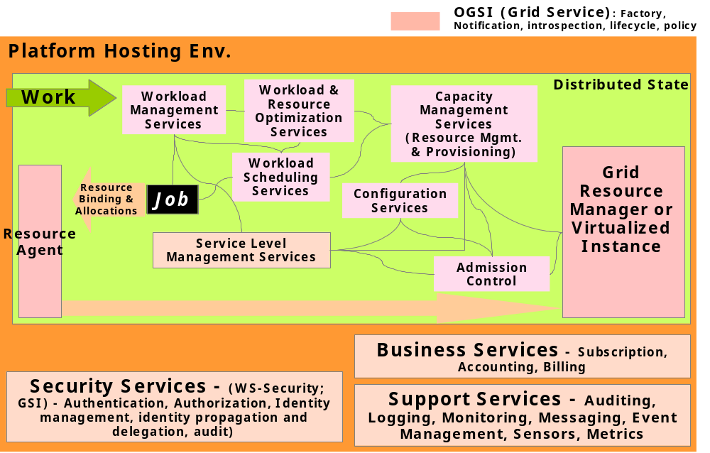
Figure 4: Example Grid execution service interaction

WS-Agreement Based Scheduler Instantiation
To put it in concrete terms, a user who wants to submit a compute job to run on a cluster would have their service client contact a job management service and negotiate a set of agreements that ensure that the job has access to required CPUs, memory, storage space, etc.
WS-Agreement defines fundamental mechanisms based on Agreement services, which represent an ongoing relationship between an agreement provider and an agreement initiator. The agreements define the behavior of a delivered service with respect to a service consumer. The Agreement will most likely be defined in sets of domain specific agreement terms (defined in other specifications), since the WS-Agreement specification is focused on defining the abstraction of the agreement and the protocol for reaching agreement, rather than on defining sets of agreement terms.
Referring back to the job submission example, the client might contact a job management service, which implements the AgreementFactory interface, with creation parameters that say “my job must have a software license for application X, would like to have 8 CPUs, and would like to have 4 Gbytes of RAM.” If the job management service couldn’t provide the software license (the “must have”), the agreement terms would be rejected. If it could provide all of the terms, an Agreement service instance representing the job resources would be created. If, because of available resource constraints, the job management service couldn’t fulfill the terms of the original creation parameters, but could supply either 4 CPUs and 4 Gbytes of RAM, or 8 CPUs and 2 Gbytes of RAM, the job management service could create an AgreementOffer which included two potential agreements: “app X, 4 CPUs, 4 Gbytes” and “app X, 8 CPUs, 2 Gbytes”, one of which the client could choose (because CPUs and memory were terms subject to counter-offers).
By defining various sets of terms for representing different types of resources available within the VO, Community Schedulers can be written which can negotiate with resource managers for the use of the underlying resources on behalf of the user community.
Program Execution services utilize WS-Agreement portTypes both for its client interface and for its interface to underlying resources, with the goal of allowing hierarchical VO deployment – e.g., one Community Scheduler talks to another Community Scheduler-based resource conglomeration. Another key aspect of agreement is to consider the constraints of the service provider based on Service Level Agreements in a business context, and their reflection in underlying resource manager policies. Not all constraints are based simply on the availability or unavailability of resources. Some are management policy specified, based on pricing, usage, higher priorities, and the like.
Error: Reference source not found shows the services required for Program Execution, which services include:
- Agreement Factory Service – create agreement services based on domain specific terms such as job, reservation and data access terms.
- Job Agreement Service – creates, monitors and controls compute jobs.
- Reservation Agreement Service – guarantees that resources are available for running a job.
- Data Access Agreement Service – staging the required application and data.
- Queuing Service – provides a service through which administrators can customize and define scheduling policies at the VO level, and/or at the different resource manager levels.
- Index Service – allows for the propagation of information between resource managers and the metascheduler.
Program Execution services can be flexibly composed to offer a whole spectrum of time-to-result QoS types, ranging from online/interactive to batch with specific or no turn-around time requirements:
- Online/interactive jobs can be sent by the Job Agreement service to the Resource Managers (RMs) immediately, without getting queued.
- Batch jobs will be queued by the Queuing services and dispatched to RMs later. The jobs with specific turn-around time may use the available reservations made with the RMs at specific times so that their deadlines can be met. The jobs with no specific turn-around time can be queued at the VO level or at the backend RM level, until the required resource is available, or can backfill the existing reservations without delaying the start time of the more time-critical jobs.
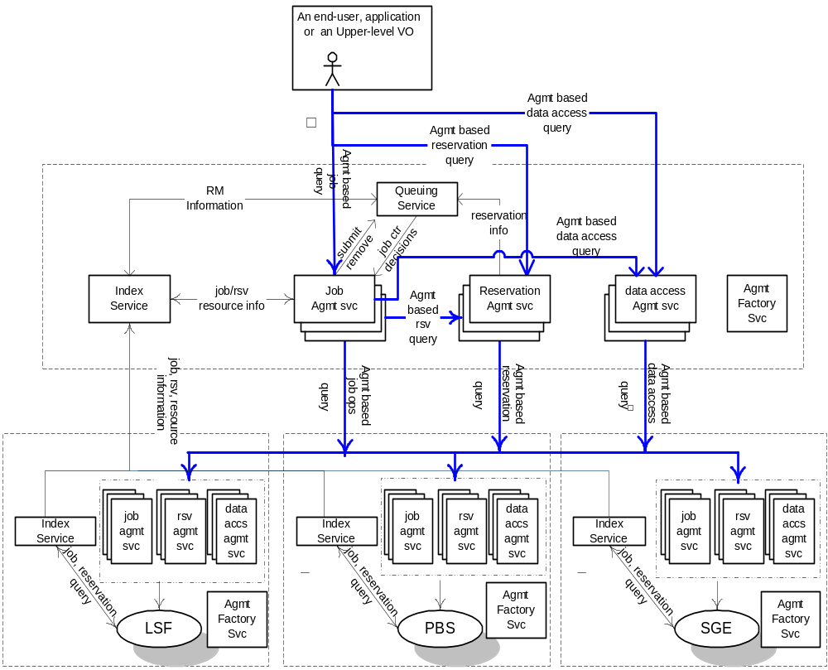
Figure 5: An Instantiation of Program Execution Architecture and Services

Instantiation with “Broker Service”
The Program Execution services must support the types of jobs. After a submitted job-request has been accepted, a broker service is used to select the resources (including the hosting environment) that are necessary to execute the job. [JT: First sentence in this para needs revision.]
After the pre-processing is completed successfully the requester is given a unique reference to the agreement. If necessary resources cannot be allocated, an error should be returned. Otherwise, the agreement can be used to query for information about the job as well as to control it – e.g., to modify job requirements or to cancel the job request.
The submitter can provide the following attributes or terms when submitting a job request.
- The service, program, or workflow that should be instantiated.
- The starting time of the job, including how long the job will execute.
- Resources, including data, needed by the job. (Resource descriptions could be given in XML.)
- User information.
- SLA information, including priority.
- Application startup script.
When the specified job start time arrives the scheduler must arrange for the job to start executing. If a startup script was specified then the script should be executed. A job may have its resources increased or decreased by the scheduler. Changes in resource allocation must be acknowledged synchronously. When a job terminates, the Program Execution services must carry out the following processing:
- Inform the client of the job’s final status.
- Release the resources allocated to the job by the hosting environment.
- Delete the job from the scheduler’s database.
The scheduling service is responsible for starting and managing all submitted jobs. Each job has a pre-determined start time, but priority and SLA attributes may cause it to be changed. The job state may be retrieved at any time.
Once the resource reservation period has finished then the job must be stopped and the resources used by the job must be returned to the resource management service. Jobs may be temporarily suspended or migrated based on the SLA (priority) associated with each job. Jobs with high priority are executed first.
Scheduling and resource reservation information associated with each job is kept in stable storage so that it is not lost in the event of failure. The scheduling service allows writing and reading of the scheduling data.
Resource reservation information is updated by the resource management service. In addition accounting information, such as which resources were used by the job, and for how long, is also recorded in the database.
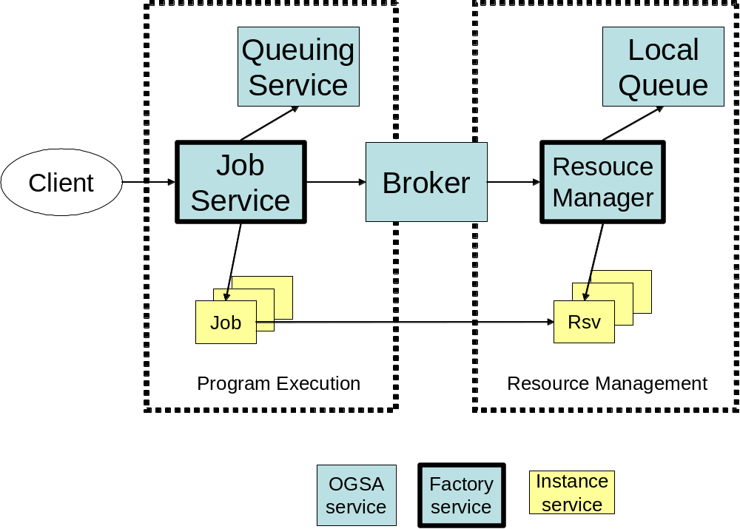
Figure 6: Program Execution with Broker

Data Services
The scale, dynamism, autonomy, and distribution of data sources in Grid environments can lead to significant complexity in data access and management. A variety of interfaces need to be defined to aid developers and users in the management of this complexity. In addition to basic data access interfaces and common resource models for storage and data management systems, these interfaces need to address the need for various transparencies, including heterogeneity, location, naming, distribution, replicas, ownership, and data access costs. Data virtualization services aimed at providing these transparencies can include federated access to distributed data, dynamic discovery of data sources based on content, dynamic migration of data for workload balancing, and schema management. In implementing such services, we need to take into account the wide variety of different data types, such as flat file data, streaming media, and relational data that require different approaches to management. Further, different applications require different forms of support – e.g., some applications cannot be modified and require transparent access via file systems, while others need explicit management of data locality and replication.
These considerations suggest a role for wide variety of potential data management interfaces, including data caching (resolving a file handle to a flat file into a data stream); data replication; data access, via mechanisms for accessing wide range of data types, including flat files, RDBMS, and streaming media; file and DBMS services and possibly federated data management services that are used as part of a vertical utility Grid; data transformation and filtering; schema transformation (allowing different data, service and policy schema to be reconciled so that the services can interact correctly); and Grid storage services, which allow direct access to storage throughout the Grid.

Resource Management Services
Service orchestration. These interfaces provide ways to describe and manage the choreography of a set of interacting services.
Administration. Standard interfaces for such tasks as software deployment, change management, and identity management.
Provisioning and resource management. Negotiation of service level agreements and dynamic resource allocation and re-distribution consistent with SLA policy, including mechanisms that allow clients and workflows to acquire access to resources and services at a particular (future) time.
Reservation and Scheduling Services. Reservation Services provide the mechanism to make resource reservations at a particular time and for a particular duration. Scheduling Services provide the mechanism to schedule tasks according to their priorities.
Deployment Services. Deploy necessary software (OS, middleware, applications) and data into the hosting environment.

Security Services
OGSA security architectural components must support, integrate, and unify popular security models, mechanisms, protocols, platforms, and technologies in a way that enables a variety of systems to interoperate securely. A preliminary OGSA Security Architecture document, developed within GGF’s OGSA-Sec working group seeks to address these goals in a manner consistent with the security model that is currently being defined for the Web services framework. An associated OGSA Security Roadmap document enumerates the security related specifications that will be needed to ensure interoperable implementations of the OGSA Security Architecture.
The security of a Grid environment must take into account the security of various aspects involved in a service invocation, as depicted in Figure 2 and discussed in the following.
As discussed in §Error: Reference source not found, a Web service can be accessed over a variety of protocol bindings. Given that bindings deal with protocol and message formats, security functions such as confidentiality, integrity, and authentication fall within the scope of bindings and thus are outside the scope of OGSA proper.
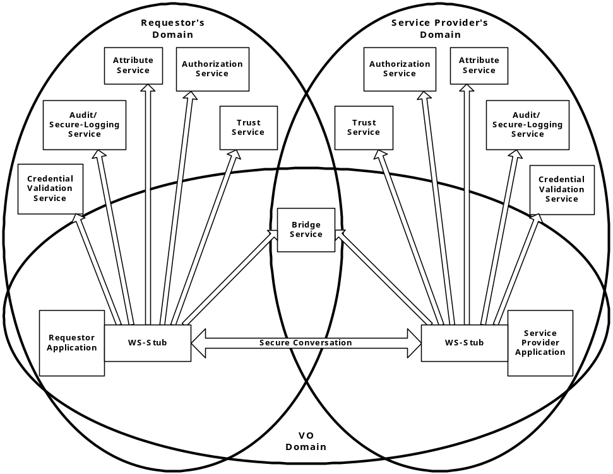
Figure 7: Security services in a virtual organization setting
Each participating end point can express the policy it wishes to see applied when engaging in a secure conversation with another end point. Policies can specify supported authentication mechanisms, required integrity and confidentiality protection, trust policies, privacy policies, and other security constraints. When invoking services dynamically, end points may need to discover the policies of a target service and establish trust relationships dynamically. (See §5.15 for more discussion of policy.)
Once a service requester and a service provider have determined each other’s policies, they can establish a secure channel over which subsequent operations can be invoked. Such a channel should enforce the mutual agreed qualities of protection, including identification, confidentiality, and integrity. The security model must provide a mechanism by which authentication credentials from the service requester’s domain can be translated into the service provider’s domain and vice versa.
This translation is required in order for both ends to evaluate their mutual access policies based on the established credentials and the quality of the established channel.
OGSA’s security model must address authentication, confidentiality, message integrity, policy expression and exchange, authorization, delegation, single logon, credential lifespan and renewal, privacy, secure logging, assurance, manageability, firewall traversal, and security at the WSRF layer. We can expect that existing and evolving standards will be adopted or recognized in the Grid security model.
Error: Reference source not found shows relationships between a requester, a service provider and many of the security services. Note that both requester and service provider are always subject to the security policies dictated by their respective administrative domains. Furthermore, a VO can have its own security policy that can enable the sharing of the submitted resources, but the associated rights will always be capped by the overruling resource-local policy. For many Grid applications, the resource owners and the individual requesters will not “know” each other as they live in different administrative domains while their interactions are dynamically discovered and brokered by scheduler services and such. This implies that trust has to be dynamically established through introductions, and the concept of the VO as a bridge is seen as an important tool to build these dynamic trust relationships.
All security interfaces used by a service requester and service provider need to be standardized within OGSA. Compliant implementations will be able to make use of existing services and defined policies through configuration. Compliant implementations of a particular security related interface would be able to provide the associated and possibly alternative security services.

Self-Management Services

Problem Determination Services

Service-level Attainment Services
Provisioning

Services
We now provide a more detailed description of required OGSA functionality. In each subsection, we first introduce a specific functionality that must be supported, and then present the following detailed information:
- A rendering of the functionality in terms of a detailed list of services. This sub-section lists interfaces provided by this service.
- The dependencies associated with these services, including both (a) services (infrastructures) extended by this service, and (b) services used by this services (peer services)
- Any standardization activities that bear on the required functionality. Any relevant existing standards or standardization efforts will be specified in this sub-section, along with information about the working group(s) within GGF and/or other standards bodies that have taken responsibility for developing technical specifications.

Reference Renewal
WSRF defines a naming scheme in which services and WS-Resources are referenced by WS-Addressing endpoint references. The WS-Addressing specification has not yet been submitted to a standards body, and thus completion of WSRF specifications within OASIS may change this dependency on WS-Addressing. However, we can safely assume that some scheme with similar properties will be retained.
Typically, Web service endpoint references are constructed by an authoritative source of the addressing information. An endpoint reference made available to a client represents a copy of the addressing information that may, at some point, become incoherent due to changes introduced by the authoritative source that effects the endpoint location. (For example, the associated service or WS-Resource may be relocated.) Thus, the WSRF WS-RenewableReferences specification defines a scheme by which endpoint references can be decorated with assertions providing the information needed to renew the endpoint reference in the event the reference becomes invalid. These assertions may direct a client to a service that implements the ReferenceResolver interface. Such a service is called a resolver service.

Services
A variety of different resolver service implementations may be provided to enable features such as transparent service instance migration, fault-tolerance through transparent fail-over, high availability through mirroring, and advanced security through fine-grained access control on name resolution. All these features come with some associated cost, and their applicability will therefore depend on the application itself.
Something about registration?

Dependencies
Endpoint reference renewal is a sensitive operation, which could be subject to access control policy and integrity protection, in which case the associated security services must be integrated with the resolution and registration operations.

Standardization
No standards or standardization activities bear upon the reference renewal function. A number of naming services and protocols can be leveraged to implement reference renewal functionality, including the Handle System [1, 8] and the scheme implemented in GT3.

Virtual Organizations
The “Virtual Organization” construct can serve an important purpose within Grid systems that span multiple administrative domains, by supplying a context that associates users, their requests, and a set of resources. These contexts can be depended on by services as a type of reliable assertion of identity, as for example when a particular user or resource is a member of a particular VO. VO contexts also permit the providers of Grid resources to associate appropriate policy and agreements with the resources they contribute to the Grid. Users and requests that are then associated with the VO are able to exploit those resources in a way that is consistent with those policies and agreements.
VO management functions provide for creating a new VO; associating entities such as users and groups with a VO; defining user roles (administration, configuration, use etc.) within a VO; associating services (encapsulated resources) with a VO; and for attaching agreements and polices to a VO as a whole or to individual services within a VO. Creation of a VO requires a mechanism by which the “VO context” is referenced and associated with user requests. A WS-Resource can be used for this purpose.
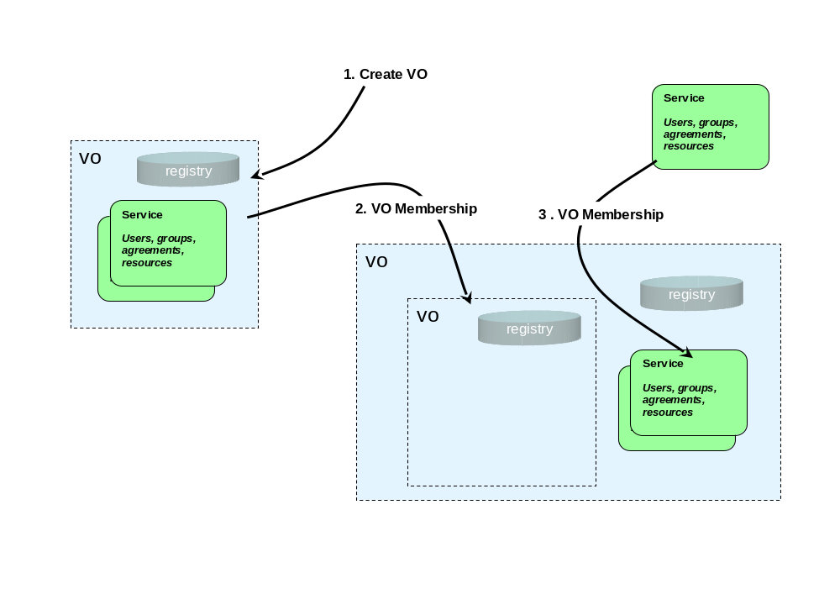
Figure 8: VO creation and membership

Services and schema
VOs can either be stand-alone or combined in a hierarchical containment structure that supports modeling the collection of resources in grids as a set of nested contexts.
VO creation and management. It is expected that VOs will be represented in OGSA as WS-Resources. Thus: (1) The factory pattern is employed to create new VOs. The Create VO operation establishes a new WS-Resource representing the new VO and returns a reference to that WS-Resource that can be used to direct requests to the new VO, and as a context identifier in the requests (made by users or other services) that are related to a particular VO. (2) WSRF lifetime management functions are used to manage the VO’s lifetime. VO Management mechanisms can exploit WSRF soft-state management to establish an initial “time to live” for the new VO, which may be updated as resources, users, groups, and polices join and/or leave the VO. An explicit operation may also be provided to destroy a VO. When a VO is eliminated, all relationships embodied by that VO are also eliminated. Though interfaces to create new VOs (factories) should be provided, a default VO in a given grid implementation may be extant (without explicit creation), may serve as a “root container,” and may depend on external means (such as DNS names or configuration files) for discovery of its address.
Relationship to Policies. As with other “factory” interfaces, policies (modeled as Agreements) may be used to specify the requirements for creation of a VO. These policies may contain information that describes how the VO responds to specific requests and how it behaves under specific conditions. The specific components (terms) of these policies (Agreements) may affect both the operation of the VO itself and, indirectly, the behavior of entities that are related to the VO. For example some policies might establish restrictions for membership of entities in the new VO, such as requiring resources and users to support a particular security or authorization mechanism to be able join the VO.
In addition to the policies established by Agreements used in VO creation, additional policy templates (Agreements) themselves might be “related” to VOs by the membership mechanism described above. These policies might be applied either as requirements as or defaults to requests that carry a “context” of the VO in the “terms” of their Agreements.
VO Membership Services. A VO may support a set of operations for managing the relationships of other entities to the VO. This membership operation can be used to add or delete a relationship of any entity (including an already extant VO) to a VO. Once again, the services for managing VOs can build upon the general mechanism for grouping services (WSRF Service Groups), and one or more of these collections may be used as a mechanism for maintaining associations of users, groups, resources and policies with the VO.
In particular, in addition to recording the relationship of an entity to the VO, these membership functions may also update state data related to a VO by storing context information (probably the VO reference) in an element associated with the service that represents the entity. Since entities (VOs, users, resources, policies) may be related to more than one VO, these “back pointers” are actually lists of the VOs with which the entities are associated. The service implementing a VO may also subscribe to events or notifications, to enable it to monitor the states of entities related to a VO so that it can update its information if entities are destroyed, either explicitly or automatically, by life-cycle functions. Refer to Figure 9 for an illustration of a VO structure.
As with many such structures, it is difficult to guarantee the consistency of both the primary registry entries and the “back pointers.” While the information in the VO Registry is considered authoritative, the “back pointer” information in the service data of members of the VO is only contingently consistent, and should be verified by any service that requires authoritative evidence of membership for functions such as security, trust or authorization.
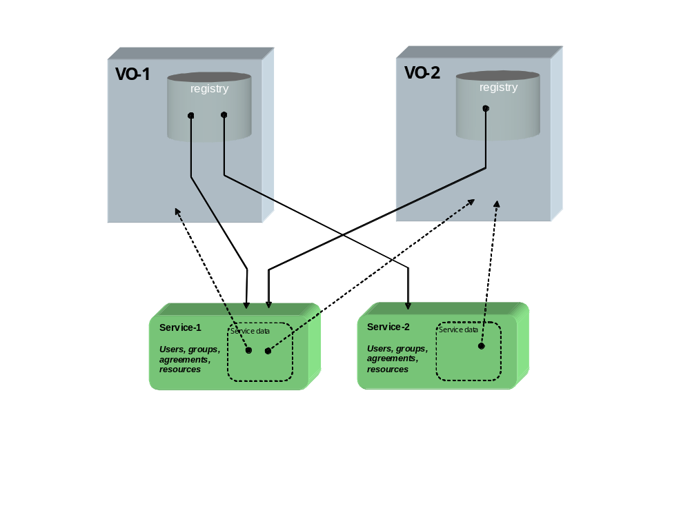
Figure 9: VO membership and “back pointers”
VO Registries –VO Registries enumerate the “population” of entities that are related to a VO. The specific nature of different sorts of entities and their relationship to the VO can be recorded in the registry as a set of attributes in one or more indices. VO Registries permit support for queries against the membership of the VO that will allow resource managers to discover these relationships. For example, a management component such as a scheduler might execute a query against one of these service groups to retrieve a list of a particular class of resources that are available as elements of a VO.
The Membership Service described above acts to maintain the registry of all the entities that are related to VOs. When new relationships between extant entities (including VOs) are made using the Membership Services, entries for them will be added to these indices. These registries can also be maintained by exploiting the general mechanism for state change propagation (WS-Notification) to permit “pruning” of these indices when entities change their relationship to VOs. The content model for these indices should contain information that will allow both people and programs using and managing the grid to discover VOs that are of interest to them. Specifically, some type of index of attributes for VOs should be implemented that can contain general information that records things such as externally readable names for the VO, the purpose the VO was created to serve, the organization that is responsible for its management, etc.

Dependencies
VO Services as described above rely heavily on the Service Group/Collection mechanism supplied by WSRF. They may also utilize the soft-state life-cycle mechanism and notifications to bind the relationships between VOs and the entities that compose them, and to maintain consistency of the registries with the state of the actual services that represent those entities.
VO Services also rely on the WS-Agreement framework to define a general mechanism for management of VOs. A specific set of Agreement terms will have to be defined that will be particular to policies that control the management of the VO Creation and Membership Services. These will include terms that may define roles with respect to the VO management (e.g., what requesters are permitted to add to, change, or delete relationships of other entities to the VO). They might also include terms that will enforce requirements for adherence to particular functional policies (e.g., security, privacy or trust methods, metering, auditing or accounting mechanisms, and resource usage limitations).

Standardization
WSRF
WS-Agreements
OGSA Working Group

Service Groups and Discovery Services
The WS-Addressing endpoint references used by WSRF to refer to services can be used to realize a two-level naming scheme, with HandleResolver services renewing endpoint references when required. However, endpoint references are not intended to contain semantic information, and indeed may be viewed for most purposes as opaque. Thus other entities (both humans and applications) need other means for discovering services with particular properties, whether relating to interface, function, availability, location, policy, or other criteria.
Traditionally in distributed systems this problem is addressed by creating a third-level “human-readable” or “semantic” name space that is then mapped (bound) to abstract names (in our case, endpoint references) via registry, discovery, metadata catalog, or other similar services. It is important that OGSA defines standard functions for managing such name spaces, as otherwise services and clients developed by different groups cannot easily discover each other’s existence and properties. These functions must address the creation, maintenance, and querying of name mappings. Two types of such semantic name spaces are common—naming by attribute, and naming by path.

Services and schema
Attribute naming schemes associate various metadata with services and support retrieval via queries on attribute values. A registry implementing such a scheme allows service providers to publish the existence and properties of the services that they provide, so that service consumers can discover them. We envision special purpose registries being built on the base service group mechanisms provided by the WSRF definition. In other words, an OGSA-compliant registry is a concrete specialization of WS-ServiceGroup.
A ServiceGroup is a collection of entries, where each entry is a WS-Resource implementing the ServiceGroupEntry interface. There is a ServiceGroupEntry for each service in the group (i.e., for each group member). Each ServiceGroupEntry contains a serviceLocator for the referred-to service, and information (Content) about that service. The content element is an XML element advertising some information about the member service. The type of the Content element conforms to one of the QName elements in the ContentModelType resource property of the ServiceGroup interface.
It is the content model of the service group definition that suggests the concrete type and specific use of the registry being offered. The content model of the serviceGroupEntry for a given service group is published in the service data of the service group. The content model is the basis on which search predicates can be formed and executed against the service group, using the findServiceData operation. In other words, it is the content model that forms the basis of the registry index upon which registry searches can be executed. It is envisioned that many application-specific, special-purpose registries will be developed.
It is also envisioned that many registries will inherit and implement the notificationSource interface so as to facilitate client subscription to register state changes. Again, specific state change subscriptions will be possible through the advertisement of the registry-specific service group content model of the service group on which the registry is built.
As stated earlier, we envision many application-specific registry implementations being defined. Whether or not one or more general-purpose registry types should be defined and adopted as part of OGSA is to be determined.
Path naming or directory schemes (as used, for example, in file systems) represent an alternative approach to attribute schemes for organizing services into a hierarchical name space that can be navigated. The two approaches can be combined, as in LDAP. Directory path naming can be accomplished by defining a PathName Interface that maps strings to WS-Addressing endpoint references. Thus a string such as “/data/genomics_dbs/mouse” could map to an endpoint reference that might deliver portions of the mouse genome, and perhaps also do BLAST searches against the mouse genome. Similarly, “/applications/biology/genomics/BLAST” could map to a GSH that has Interfaces for executing BLAST.
The interface will have methods to insert, lookup, and delete <string, endpoint reference> pairs, and will in essence be a simple table. It is expected that path_name services will be “chained” together, so that evaluation of a path may involve traversing several path_name services, forming a directed graph. This can be used to link disjoint namespaces into namespace cliques.

Dependencies
TBD.

Related Standardization
TBD.

Choreography, Orchestration, and Workflow
TBD: Intro.

Services and schema
OGSA should extend these interfaces to provide a rich set of behaviors (and associated operations and attributes) for business process management, by working either with external groups, with GGF groups, or with both. The following aspects are candidates. If the first is addressed, the others will be greatly simplified.
- Working through relationship between services as used on Grid scenarios and business processes so that we do not have redundancy of closely-related concepts
- Definition of choreography, orchestration and workflow for the Grid, allowing web services to be part of such flows, as well as services (with service data, notification, service collections, transient lifecyles, etc.
- Scheduling, quality of service, exception handling and policy applied to Grid flows; security, provisioning and resource management too.
- Management and monitoring of Grid flows; management and monitoring using Grid flows; change management for Grid flows (as in OASIS WSDM group).

Dependencies
- Definition of a job flow, including associated policies
- Assignment of resources to a Grid flow instance
- Scheduling of Grid flows (and associated Grid services)
- Execution of Grid flows (and associated Grid services)
- Common context and metadata for Grid flows (and associated services)
- Management and monitoring for Grid flows (and associated Grid services)
- Failure handling for Grid flows (and associated Grid services); more generally, managing the potential transience of Grid services
- Business transaction and coordination services. [Jeff Nick: First, it is difficult to identify what is Grid-unique here, versus general purpose distributed workflow and scheduling. Second, we must be careful not to reinvent WS-Transaction and WS-Coordination, but rather leverage those specifications.]

Standardization
As mentioned above, see http://xml.coverpages.org/bpm.html as well as the OASIS WSDM group. Related works includes WS-Choreography/WSCI, Web Services Business Processes/BPEL4WS, WS-CAF, BPMI/BPML, ebXML BPSS and more.
This item may cross the boundaries of many GGF groups, rather than being the province of a single group. The general issue of what a Grid flow is and how Grid flows relate to business processes may have to be addressed by OGSA, so that we avoid redundancy and proliferation.

Transactions
Transaction services are important in many Grid applications, particularly in industries such as financial services and in application domains such as supply chain management. However, transaction management in a widely distributed, high latency, heterogeneous RDBMS environment is more complicated than in a single machine room with a single vendor’s software. Traditional distributed transaction algorithms, such as two-phase distributed commit, may be too expensive in a wide area Grid, and other techniques such as optimistic protocols may be more appropriate. At the same time, different applications often have different characteristics and requirements that can be exploited when selecting a transaction technique to use. Thus, it is unlikely that there will be a “one size fits all” solution to the transaction problem.

Services and schema
TBD

Dependencies
TBD

Standardization
Transaction services are also being closely examined in the Web services community. For example, WS-Transactions has been recently “proposed” [3]. This initiative should be tracked closely.

Metering Service
Different Grid deployments may integrate different services and resources and feature different underlying economic motivations and models. However, regardless of these differences, it is a quasi-universal requirement that resource utilization can be monitored, whether for purposes of cost allocation (i.e., charge-back), capacity and trend analysis, dynamic provisioning, Grid-service pricing, fraud and intrusion detection, and/or billing. OGSA must address this requirement by defining standard monitoring, metering, rating, accounting, and billing interfaces. These interfaces can use or extend those defined by Web Services Distributed Management (WSDM), which provides access to basic resource performance and utilization instrumentation. For example, an operating system might publish counter values corresponding to the state of system activities such as CPU utilization, memory usage, disk and tape I/O activity, network usage, etc. While these interfaces do not provide the values needed for metering and accounting directly (since, for instance, they are not directly related to the consumers), they can provide basic monitoring data to be used by the metering and accounting services.
We address metering in this subsection, and rating, accounting, and billing in the sections that follow.
A service may consume multiple resources, and a resource may be shared by multiple service instances. Ultimately, the sharing of underlying resources is managed by middleware and operating systems. All modern operating systems and many middleware systems have metering sub-systems for measuring resource consumption (i.e., monitored data) and for aggregating the results of those measurements. For example, all commercial Unix systems have provisions for aggregating prime time and non-prime time resource consumption by user and command.
A metering interface provides access to a standard description of such aggregated data (metering serviceData). A key parameter is the time window over which measurements are aggregated. In commercial Unix systems, measurements are aggregated at administrator-defined intervals (cron entry), usually daily, primarily for the purpose of accounting. On the other hand, metering systems that drive active workload management systems might aggregate measurements using time windows measured in seconds. Dynamic provisioning systems use time windows somewhere between these two examples.
Several use cases require metering systems that support multi-tier, end-to-end flows involving multiple services. An OGSA metering service must be able to meter the resource consumption of configurable classes of these types of flows executing on widely-distributed, loosely-coupled server, storage, and network resources. Configurable classes should support, for example, a departmental charge-back scenario where incoming requests and their subsequent flows are partitioned into account classes determined by the department providing the service. The metering of end-to-end flows in a Grid environment is somewhat analogous to the metering of individual processes in a traditional OS. Since traditional middleware and operating systems do not support this type of metering, additional functions must be accommodated by OGSA. In addition to traditional accounting applications, it is anticipated that end-to-end resource consumption measurements will play an important role in dynamic provisioning, and in pricing services.
Finally, in addition to metering resource consumption, metering systems must also accommodate the measurement and aggregation of application-related (e.g., licensed) resources. For example, a service might charge consuming services a per-use fee. The metering service must be able to support the measurement of this class of service (resource) consumption.

Services and schema
TBD.

Dependencies
A very important construct to be supported for metered usage is the context which serves as the correlator for resource consumption associated with a particular application or user.
Resource Usage service, Logging service.

Standardization
TBD. Note about accounting, billing, rating.
The GGF RUS-WG.
The GGF GESA-WG defines services that use the metering service.

Deployment
Computer CPUs, applications, licenses, storage, networks, and instruments are all Grid resources that require installation, deployment and provisioning. Other new resource types will be invented and added to this list. OGSA needs a framework that allows resource provisioning to be done in a uniform, consistent manner.

Services and schema
[Jeff Nick: Lots of work to be done here. This section clearly reads on the CMM resource services, rendering resource types as services, with port type operations for various management disciplines, including install. What do we consider the difference between installation and provisioning? I might assert that not all provisioned resources are installed…i.e., they may exist a priori and be dynamically assigned for a particular use, which is a form of provisioning.
Another key service behavior with respect to provisioning is agreement. Yet another would be policy assertion and constraints.]

Dependencies
TBD

Standardization
TBD.

Application Contents Service
In order to install and operate complex systems such as three-tier systems more efficiently and automatically it is necessary to specify and manage as a unit a lot of different application-related information. The Application Contents Service provides central management of such application information. Contents include deployment contents such as program binaries and configuration data, descriptions of the hardware resources typically required by each component, and also various elements such as descriptions of procedures for lifecycle management and management policies typically applied to the running system. Systems may already have a history of correct operation, including performance validation. Such information should also be included as part of the application information since it can be used by the Grid system to provide more predictable operation.
In this section a job refers to the service created by the Job Manager possibly as a result of a user submitting a job description document. The application is a logical unit of content and configuration data that may be referred to by a job description as a short-hand method of specifying a well known and tested configuration that can be used to instantiate the desired job. A number of job descriptions may refer to the same application and therefore a number of jobs using the same application content may be instantiated at the same time. There is typically no interaction between the Application Contents Service and the Job or Job Manager after the application content has been used to instantiate the job.
Application and job have different lifecycles and are used by different actors. Consider for example the scenario of a business activity manager (CDC use case) executing a job at a data center. Before the business activity manager can submit the job the application must be developed. The skills and responsibilities needed for these various steps are different and are carried out by different actors.
- An Application Provider develops the various programs and also prepares items such as configuration data and descriptions of procedures that are required to execute programs correctly. Then the Application Provider collects these application contents, puts them into a deployable format and registers them with the Grid system.
- A Business activity manager submits the job description document and creates the job. The Business activity manager monitors job status, changes parameters if necessary, and handles failures. The Business activity manager does not need detailed knowledge of the applications nor the skill to describe things such as low level configuration and procedures to deploy, start, or stop programs. But the Business activity manager must understand the function of application and have the skills for using the tools provided by the Grid system.
The information that defines an application is used by various OGSA services. There may also be some information that is shared by multiple services, or information that may have to be updated at a later stage, e.g., when a new version of the application is developed. The application provider could submit the appropriate information to each OGSA service separately but would then have to manage changes of application contents directly. The purpose of the Application Contents Service is to remove the burden of content management from the application provider.
Application Contents Service
OGSA Services
Application Contents
Management
Application Contents
Access

Deployment Service
Access
Configuration Service
Notification

Registration
Patch

Discover
Application provider

Verification Service

Application Contents repository
Note: The list of services is informational.

Figure 10: Application Contents Service
Figure 10 illustrates the Application Contents Service. The application provider registers and updates the application contents through the Application Contents Management interface. The Application Contents Service also exposes the Application Contents Access interface to various OGSA services that use application contents.

List of detailed services
The following interfaces are defined:
- Application Contents Management Interface to provide a means for the application provider to manage application contents. This interface would include, for example, the ability to register or delete application contents (“Registration”), search for content that has been registered (“Discovery”), and update application contents (“Patch”). It is expected that versioning is supported. That is, registered application contents are not overwritten, but instead updates are stored as differences.
- Application Contents Access Interface to allow various OGSA services to access application contents. OGSA services can also receive notifications when application contents changes.

Standard schema/document
An Application Archive Format that can describe an application in a single file would simplify registering new application content and moving application content between sites. The Application Archive Format is similar in spirit to the ear format of J2EE. In the J2EE world, if an application server follows the J2EE specifications then, regardless of the vendor, it can execute applications contained in ear files within the scope of the J2EE specifications. In addition to interoperability, reasons that archive specifications such as ear have been widely accepted include ease of use, the ability to add signatures, and ease of productization. So, in the Grid world as well, the provision of a basic format for registering applications with the Application Contents Service can accelerate the growth of services.
At this time we cannot list all the necessary elements that define an application. Before determining the different elements that make up an application it is first necessary to determine the OGSA services that use application contents. The following are some possible elements of application contents based on existing data center management systems:
- Application Structure Description
This description defines the logical structure of the application. It corresponds to the Configuration Description (CD) of the CDDLM-WG.
- Deployment Contents
The deployment contents, such as class files or configuration data, that will be loaded on the appropriate hosting environment at deployment time.
- Configuration Parameters for Application
These parameters are used to configure the application. They must be specified at deployment time so that the application runs properly. This information is included in the CD of the CDDLM-WG.
- Configuration Parameters for Hosting Environment
These parameters are used to configure hardware resources, the OS or middleware. This information is included in the CD of the CDDLM-WG.
- Procedures for Lifecycle Management
Such procedures define how to initialize, start and terminate the application. Checkpointing and restarting procedures may also be defined. The procedures may take a variety of forms, e.g., scripts or workflows. They are deployed to the appropriate location, e.g., hosting environment, as part of job instantiation. The procedures are executed when there is a change in the job lifecycle state. The job lifecycle state is now under discussion in CDDLM-WG and OASIS WSDM-TC.
- Management Policies
These are policies that should be followed when an event, such as a failure or a load change, occurs. The policies are registered with the appropriate service, e.g., the fault management service, as part of job instantiation. A policy is applied when the specified event occurs to the job.
- Verification descriptions
Resource descriptions (possibly expressed as constraints) that are known to support correct operation of the application. The descriptions can be used by the appropriate services to verify that the resources allocated when instantiating a job do in fact provide the environment needed to execute the job.
- TBD: Health-check procedures: determine whether the instantiated job is in the expected operational state. Stored in ACS and registered with appropriate service as part of job instantiation.

Example of Application Structure Description
Example Application Structure for a 3 tier system:

Web

LB
EJB
DB
Web

...
web component group

<ASLogicalStructure>
<as name="ASWeb3Tier">
<as name="ASWeb">
<flow/> defines the procedure to deploy, start, stop or remove the job component.
<flow name="..." value="..." portTypeName="..."/>
<as name="LeafASLB">
<flow name="..." value="..." portTypeName="..."/>
</as>
<as name="LeafASWeb">
<scalability scalable="true">
<function>loadbalancer</function>
</scalability>
<flow name="..." value="..." portTypeName="..."/>
<software type="web" name="petstoreWeb" value="petstore.ear">
<version major="1" minor="1" revision="2"/>
</software>
</as>
</as>
<as name="ASEJB" xsi:type="struct:EJBASType">
...
</as>
<as name="ASDB" xsi:type="struct:DBASType">
...
</as>
<flow name="..." value="..." portTypeName="..."/>
</as>
</ASLogicalStructure>

Example of Verified Resource Description
For Web Server:
Number of Hosts: 3
Disk: 30 ~ 60GByte
CPU: Pentinum(R)III, 1130MHz
Memory: 256 MByte ~
OS: Red Hat Enterprise Linux AS, ver. 2.1
Web Container: Java(TM) 2 Platform, Enterprise Edition Application Server, ver. 1.4

<numberOfHosts wsa:count="3"/>
<host>
<allDisk unit="Gbyte">
<minimum wsa:amount="30"/>
<maximum wsa:amount="60"/>
</allDisk>
<CPUDescription>
<CPUType wsa:string="Pentium(R) III"/>
<CPUClock unit="MHz">
<minimum wsa:amount="1130"/>
</CPUClock>
</CPUDescription>
<physicalMemorySize unit="Mbyte">
<minimum wsa:amount="256"/>
</physicalMemorySize>
<OSType wsa:string="Red Hat Enterprise Linux AS"/>
<OSVersion wsa:string="2.1"/>
<WebContainerName wsa:string="Java(TM) 2 Platform, Enterprise Edition Application Server"/>
<WebContainerVersion wsa:string="1.4"/>
</host>
.....

Example of Management Policies
Below is a sample policy that defines the procedure to be followed when the MachineFailure event at level 5 occurs.

<eventPolicyRule>
<policyRuleName>ReplaceWebServerOnMachineDown</policyRuleName>
<eventTypeID>
<notificationID>MachineFailure</notificationID>
<level>5</level>
</eventTypeID>

<jobFlowDefinition>
ReplaceWebServerOnMachineDown.far.xml
</jobFlowDefinition>
<jobOperationName>ReplaceWebServerOnMachineDown</jobOperationName>
<jobPortNamespaceURI>http://..../JobFlowManager</jobPortNamespaceURI>
<jobPortLocalPart>JFIPortType</jobPortLocalPart>
</eventPolicyRule>

Dependencies
Notification interface to provide notification of changes of application contents.
Data Services.

Related services
CDDLM: Deployment Service
OGSA: Job and Job Manager.
Other related services (mainly PE).

Standardization
TBD

Fault Management

Services and schema
TBD

Dependencies
TBD

Standardization
TBD.

Problem Determination

Services and schema
TBD

Dependencies
Log services and trace services.

Standardization
TBD.

Information and Monitoring Service
An important system component in many Grid scenarios is an information and monitoring service that can provide both static and dynamic information about the state of resources, services, and applications. This information can be used for such tasks as fault detection, performance analysis, and job scheduling.
In defining
It is observed that certain types of information change with greater frequency, but no attempt is made here to distinguish between an information service and a monitoring service.
For grid monitoring, an accepted architecture within the GGF is the Grid Monitoring Architecture (GMA) that has been submitted as an informational document by the Performance Working Group within the Information Systems and Performance Area of the GGF. The Information and Monitoring Service described here is derived from GMA.
The Grid Monitoring Architecture, shown in Figure 1, consists of three components: consumers, producers and a directory service that is referred to as a registry here to avoid any implied structure. Producers describe the type and structure of information they want to make available. Consumers perform queries to find out what type of information is available and locate producers that provide such information. Once the consumer’s query is satisfied and the information source is known, then the consumer can contact the producer to obtain the relevant data.

event publication information
Consumer
Producer
event publication information
Directory
Service
events
Figure 1: Grid Monitoring Architecture components, reproduced from “A Grid Monitoring Architecture”, a GWD-I (Informational) document from the GGF Performance Working Group (GWD-Perf-16-3).

As explored within the OGSA Use Cases document, the Information and Monitoring Service is required so that a user can either produce or consume information. The OGSA Information and Monitoring Service is derived from the GMA in that it describes consumers and producers but not a registry. The publication and discovery of consumers, producers and event information is provided by additional related OGSA services. (The passing of information from producer to consumer is considered part of a future OGSA notification service that should provide both push and pull models of notification.) Therefore, for an Information and Monitoring Service two sets of operations are considered, the Client/Consumer and Client/Producer operations, as shown in Figure 2.
Consumer
Producer
Client/Consumer operations
Client/Producer operations
Figure 2: Information and Monitoring Service

By standardizing the interface to an Information Monitoring Service and using other standard OGSA services, such as mediation, registration and discovery, an inter-operable OGSA grid Information and Monitoring Service can be built.
ITF: I like the way that we develop requirements here, but also wonder how we relate this to the use cases. Presumably not all of these requirements will apply to every application.
General requirements:
- Fresh and archived data should be handled in a uniform manner.
- The system should associate each measurement with the time when it was made and with the originator or the information
- The information system should not impose limits in the number of contributing nodes.
- There must be no single points of failure.
- Partial network failures should have minimal impact. The system should recover once the network is back.
Producers
- A user must be able to publish data (via a Producer) even if the type of this data is not previously known to the system.
- When registering a Producer it must be possible to specify via an arbitrary predicate what partition of the information is available from that Producer. This is known as the partitioning predicate.
- It shall not be possible to publish data of a type that is not consistent with a type definition already registered within that VO.
- It shall not be possible for a Producer to publish data that are inconsistent with its partitioning predicate.
- Producers may offer varying qualities of service.
Consumers
- A user must be able to locate all Producers of information within the VO and determine their partitioning predicates.
- A Consumer should be able to obtain information from a Producer on a one off basis.
- A Consumer should be able to obtain a stream of new information as and when it becomes available from a Producer.
- Any query should be answerable by a Consumer though the information it needs is widely scattered throughout the system.
Security
- It must be possible to restrict knowledge of the existence of Producers of information to specific authorised users. If the user is not aware of what Producers exist, they do not know there are resources to which they are not allowed access. This makes it much harder for the attacker.
- A Producer must be able to restrict read access to information to specific authorised users. Access must be controllable at a fine level of granularity.
- A Producer must be able to restrict the publishing of information to specific authorised users. We need control over who is permitted to place information into the system. This is both to avoid being flooded with information from a faulty program or from a hacker and also to avoid the publishing of misleading information.

Services

Producer
A producer service provides the ability to put events or data into the Information and Monitoring Service. A client must first specify the information they will make available to the Grid, where the type and structure of that information should be well defined. Expected behavior is that the producer service would then inform a registry of the existence of the producer and of the type and structure of information it makes available, thereby allowing for discovery.
The producer may have certain properties and policies; similarly a client may wish to specify a policy describing the required properties of a producer. This could include how the information is held (e.g., using an associated back-end repository), or higher-level service properties such as retention periods, guarantee of delivery and persistency.
A client, using the OGSA Information and Monitoring Service, will instantiate a producer instance to enable it to regularly publish events. During the creation of a producer instance issues such as producer properties, policies and agreements are addressed through future OGSA mechanisms, such as factory, agreement and policy. The creation process will verify that the events are not inconsistent with a recognized description or schema using the OGSA Event or Schema services. The client/producer will then be ready to produce events.
There may be a requirement to relate the lifetime of a producer to an expected frequency of published events. The producer will then refresh its lifetime after each publication. If the producer fails to publish further information before an agreed time, then it times out and destroys itself.
It is assumed that mechanisms to alter properties and/or change policies and agreements will be defined elsewhere in the OGSA platform services. These mechanisms would include checking the status of the producer for information such as subscribed consumers and events currently available.

Producer Properties
It must be possible to request, discover and alter the properties of a producer. These properties include:
- Security Policy.
- Type and structure of information produced.
  - Expected frequency of publication of this information.
- Registry service end-point.
- Consumers currently connected.
  - Indication of what consumers are consuming (not necessarily all information produced).
  - Lifetime of association between consumer and producer.
- Retention policy for information.
- Persistence of information.
- Quality of delivery from producer to consumer.
- OGSA Schema/Event services used.

It is yet to be decided which properties of a producer will be mutable.

List of interfaces
The Producer Service provides the following operations:
- Publish – make a single event or set of events available to a consumer. This needs to be extensible to provide for different implementations with different underlying structures. There should be a common base directly related to OGSA Events described elsewhere. These events could be tuples of information, for example <event_name, event_measurement, event_time>. The mechanism that allows tuples to be published should also allow the publishing of a query expression, such as XUpdate or SQL (e.g., “INSERT INTO newTable (42,’John’,’Doe’,’Y’)”). A producer should be able to accept multiple events simultaneously for publishing.

Consumer Service
A Consumer Service provides the ability to consume events from the Information and Monitoring Service. Similar to a producer, the creation of a consumer instance should allow the specification of both consumer and producer properties, such as the type of data to be consumed, policies and agreements through recognized OGSA mechanisms, such as factory, agreement and policy.
Several types of applications have been identified that incorporate a consumer:
- Archiver – aggregate and store event data in long-term storage for later retrieval or analysis. An archiver could also act as a producer when data is retrieved from storage (see the joint consumer/ producer description below).
- Real-time monitor – collect monitoring data in real time for use by online analysis tools.
- Overview monitor – collect events from several sources and use the combined information to make a decision that could not be made on the basis of data from one producer. For example, one might trigger a call to the system administrator's pager at 2:00 am if greater than 10% of servers are down.
The expected behavior for a consumer is that OGSA Event and Schema services will be used to verify the request for data to be consumed. A registry/mediator service could then be used to locate suitable producers to contact. The consumer can then use OGSA notification services to subscribe to the producer and obtain the relevant data.
The creation of a consumer should be extensible, similar to a producer, with the ability to publish and support additional query languages such as SQL and XPath. A consumer could be created by specifying events of interest using OGSA Event services, or a supported query could be specified to further refine the events returned through predicates defined in the query expression, for example, “where cpuLoad > 0.5”.

Consumer Properties
It must be possible to request, discover and alter the properties of a consumer. These properties include:
- Security Policy.
- Type and structure of information consumed.
- Effectively the query expression, if appropriate.
- Registry service end-point.
- Mediator/Query Planner service address.
- Producers currently connected.
  - Indication of what producers are producing (not necessarily all information required).
  - Lifetime of association between consumer and producer.
- Retention policy for information.
- Amount of information currently available.
- Persistence of information.
- Consumer state (i.e., Is the current query executing?).
- Quality of delivery from producer to consumer.
- OGSA Schema/Event services used.
- Requested properties that a producer must contain.
It is yet to be decided which properties of a consumer will be mutable.

List of interfaces
The Consumer Service provides the following operations:
- GetEvents – retrieve a single event or set of events. The format returned should be extensible to allow for events to be returned in a format corresponding to the query specified at creation time. For example, ResultSet for SQL and Document for XPath.
- QueryOnce – executes the query or retrieves events specified within the Information and Monitoring Service. The operation completes when the query has finished or after the first set of events have been returned. If asynchronous, then a GetEvents operation must be subsequently called to retrieve the events.
- StartQuery – starts the execution of the query or starts to retrieve the events from the Information and Monitoring Service. This operation results in streams of relevant events arriving at the consumer, where these events can then be consumed by the client. Should allow a query to be run against information for a specified period in time, whether (a) in the past, for example against archive data; (b) in the present, for example against application data; or (c) in the future, for example against batch-run overnight data.
- The ability to satisfy a query for a specified period in time would depend upon the retention policies of relevant producers.
- StopQuery – stops the consumer service. Effectively stops the previous subscription operation. No fresh events will arrive at the consumer service.
- GetProducers – returns the list of producers that satisfy the Consumer’s query. The user is then free to contact any of the producers directly to retrieve events, using one the other Consumer methods.

Joint Consumer/Producer (Aggregators, Filters)
In addition, consumers and producers could be combined to provide many other services. Examples of these services include event filtering (via mediation, as described by the OGSA Distributed Logging platform service), caching, and intermediate processing of raw data as requested by a consumer. For example, a scheduling consumer might request that a prediction model be applied to the CPU load measurement history from a particular compute resource, and be notified only if the predicted load falls below a specified threshold, indicating that the resource is ready to accept new tasks. A consumer would be used to collect the CPU load measurements and the prediction model is applied to the measurement data. Any resulting events can then be made available to the Information and Monitoring Service through a producer service.
Issues of scalability can be partially addressed by a joint consumer/producer, similar to an aggregator, connecting to producers of similar information and providing one source for all this information to a consumer. This aggregator can ensure that primary producers do not get overloaded.

Dependencies
The Consumer and Producer services require certain services and schema, interact with peer services and could be used by further OGSA platform services.

Underlying Services
Consumer
Producer
Distributed Logging
Mediation*
Query Planning
Registry*
Schema*
Events
Notification
OGSI
Security
Data Access
Agreement
Policy
Metering
Scheduling
Potential Clients
Peer Services
Information & Monitoring Services
Management
* No current OGSA activity.
Figure 3: Relationship of Information and Monitoring Service to other OGSA services.

Client Services
The Information and Monitoring Service is seen as providing consumer and producer interfaces to client OGSA platform services to eliminate the duplication of behavior between those services.
- Scheduling – cannot take place without information concerning the current state of resources. Scheduling could make use of consumers to gain a view of the current state of resources. Scheduling could also use producers to publish scheduling events.
- Metering – for tracking resource utilization for cost allocation (i.e., charge-back), capacity and trend analysis, dynamic provisioning, Grid-service pricing, fraud and intrusion detection, and billing.
- Distributed logging – for logging events to help with problem analysis. This makes use of services for decoupling (i.e., separating) logging artifact creation from logging artifact consumption, using producers and consumers respectively. Filtering and aggregation (using a joint consumer/producer) can control the amount of data generated and stored by the Information and Monitoring Service.

Peer Services
To provide an Information and Monitoring Service, the producer and consumer services described above will need to interact with other OGSA services:
- Mediation and Query Planning: to find producers that can satisfy a consumer’s request (i.e., query) for information. Aims to balance completeness, complexity and performance, due to many producers each capable of providing partial results.
- Registry: to group together producers and consumers, most importantly it should record the schema and/or predicate of information that clients produce or wish to consume. A registry provides a repository so that a request for producers capable of satisfying a query can be discovered. Special purpose registries are envisioned being built on Service Groups provided by the WS-ServiceGroup.
- Schema/Events: services and standards for events and event descriptions should exist. This enables a consumer to discover possible events it can consume and the validation of query requests and the information produced. The use of recognized standards for events enables these events to be compared and related between potentially different sources within a VO. The possibility should exist to extend the schema temporarily to include user-defined events.

Dependencies
The consumer and producer services will build on underlying OGSA services:
- WS-ResourceProperties – defining the service’s interfaces and service data. Service state and metadata – for representing and accessing state data and metadata from a service instance.
- Notification – notification mechanisms or an extension of them could be used to pass events from producers to consumers.
- Agreement – allow negotiation for consumers and/or producers fulfilling certain criteria.
- Policy – allow consumers and/or producers to express the properties they possess.
- Data Access – if a consumer or producer is required to be persistent, then it could use the OGSA Data Access and Integration Services (DAIS) to enable this persistence.
- Security – for authenticating and authorizing consumers and producers so that information can be exchanged between them.
- Management – consumers and producers should extend OGSA management to allow service control, such as the starting, stopping and cleanup of a service.

Standardization
The GGF Performance Working Group has defined a Grid Monitoring Architecture (GWD-Perf-16-3) that bears upon the issues discussed here.

Logging Services
The OGSA Logging Services serve as an intermediary between log artifact producers and log artifact consumers. Producers write log artifacts that may or may not be read at a later time by consumers. Several Grid usage scenarios require logging services. These scenarios include those based on problem determination, metering resource consumption, failure recovery, transaction processing, and security. The logging requirements generated by these usage scenarios are summarized in the following section.

Requirements
Jan 8 Action Item: Hiro to add “Requirements” subsection to template … BH
Services that consume log artifacts place a number of requirements on the OGSA Logger Services. These requirements are described in the following subsections.

Legacy Logger Systems
To ensure the general acceptance of the basic log semantics and to enable the exploitation of existing implementations, the OGSA Logger Services should support key features found in existing logging implementations [ref:POSIXLogging, ref:LINUXLogging, ref:NTEvents, ref:zOSLoggerSystem. ].

Persistency
One of the basic goals of any logging system is to provide a mechanism to persist log records. The retention period for a log record should be determined by consumer requirements. For example, in a real-time monitoring application, data may become irrelevant in a very short amount of time. Data for an auditing program may be needed months or even years after it was generated. Some applications are best served by circular logs. Other applications depend on persistent log records to recover their state in case of failure. As discussed in §5.12.1.14, the OGSA Logger Services should support a variety of persistency QoSs (e.g., circular logs, logs with policy-specified record retention periods).

Support for Sequential Writes
The OGSA Logger Services should support sequential writes at the granularity of an individual record, with each record representing one log artifact. Writes always append a record to the end of a log stream. Byte-level access is not required.

Stateful Read Cursor
The OGSA Logger Services should permit consumers to sequentially access the records in a log stream using a stateful cursor that is not invalidated by producer writes or reads from other consumers. The system should provide an efficient mechanism to position the cursor using the record timestamp or the record GUID.

Ordering of Log Records
Logs are frequently used to record a time-ordered sequence of events. At a minimum, the OGSA Logger Services should, for a given write connection, permit consumers to efficiently read (time-stamped) records in the same order that they were originally written. As discussed in §, other implementations may choose to provide stricter ordering requirements.

Standard Schema for Log Records
A standard, structured log artifact schema facilitates the effective intercommunication amongst disparate applications. In some cases, such as when performance is paramount and interoperability is not a concern, less structured artifacts are more appropriate. The OGSA Event (§ogsadraft10-6.15) is designed to accommodate varying degrees of structure and should be used as the basis for the structured log artifact.

Decoupling of Producers from Consumers
The ultimate usage of a log artifact (e.g., audit, system management, problem determination) should be determined, potentially at runtime, by the log artifact consumer not the log artifact producer. The OGSA Logger Services should enable the decoupling of the log artifact producer from the log artifact consumer. This requirement is closely related to the requirement expressed in §5.12.1.8.

Broker
The OGSA Logger Services should support mechanisms that permit: (1) multiple producers to write records into log stream and (2) multiple consumers to read records from a log stream. Furthermore, the system should be able to coordinate concurrent reads and writes. This is a fundamental behavior supported by all production OS logger systems. This requirement is closely related to the requirement expressed in 5.12.1.7.

Filtering
Frequently the quantity of logging data generated is much greater then the quantity of data actually consumed. To reduce resource consumption, the OGSA Logger Services should provide filter mechanisms for both read and write operations. A filter on the write operation avoids the cost of storing the record.

Merged Log
Some use cases (e.g., a high-performance, merged log for a clustered system) require that the logger system exploit underlying, hardware-assisted merge mechanisms. These merge mechanisms (e.g., mainframe hardware which permits parallel computation) permit multiple producers operating in separate OS images to concurrently and efficiently write to a common (merged) log stream. The OGSA Logger Services should support the exploitation of hardware-assisted merge mechanisms.

Synchronous and Asynchronous Write Semantics
Some consumers require that every record written by a producer be reflected in the log or explicitly informed otherwise (e.g., transactional logs, metering for billing). Producers supporting this requirement must acknowledge every write. Some producers may choose to wait (i.e., block) on an acknowledgment from the Logger before executing any additional logic. Other producers may choose to continue execution, obtain the acknowledgement using a callback mechanism, and then deal with failure using separate recovery / notification logic. Finally, other consumers do not require any acknowledgement (e.g., fire and forget for non-critical, information-only monitoring). The OGSA Logger Services should support all three patterns.

Deletion of Log Records
Log maintenance (e.g., cleanup) requires a mechanism for performing time stamp-based deletes on existing log records in a log stream.

Coexistence with OGSA Messaging
Patterns for the consumption of events vary according to the needs of the consuming applications. In a distributed environment, RPC-based reads on a log stream may not be the best mechanism for consuming applications to access events. For example, a real time monitoring application may need to be asynchronously notified whenever a high-severity artifact is logged (push mode). Another example would be a consumer that polls for metering data every 24 hours (pull mode). These scenarios are better served by using OGSA Messaging Services brokers than by using the OGSA Logger Services. However, both of the above examples might require that a log be kept of all events that flow through a messaging broker. The OGSA Logger Services should be designed such that an OGSA Messaging Services broker (§ogsadraft10-6.14) can act as logging broker by implementing the Logger interfaces.

Standard Set of Specialized Logstreams
Different applications have different requirements on the features and qualities of service associated with a logstream. To accommodate these demands the OGSA Logger Services should support a finite set of specialized logstreams that somehow span the space of required features and QoSs. Specializations should include the following types.
Secure Logs
Jan 8 Action Item: Important topic, needs additional text … BH
San Diego F2F (February 10, 2004) Action Item: Consensus was yes, this is an important topic that needs additional text … BH
Some applications (e.g., metering, AAA) require that logs be secure. OGSA Security mechanisms are covered in § ogsadraft10-4.1.4.
Globally-ordered logs
Some parallel, transaction-oriented applications require merged logs that maintain a global order based on a common clock.
Circular logs
For some applications it is preferable to specify retention using a space constraint instead of a time constraint.
Duplexed logs
A Log may offer a high reliability QoS by duplexing all writes.
Compressed logs
Compressed logs trade performance for space.

Services and schema
The OGSA Logger Services is composed of four services. They are:
- LogManager service
- Log service
- LogConnection service
- LogBrowseSession service

The portTypes supporting these services and their relationships are shown using UML Figure 11 and are described in the following subsections. These services build upon the base semantics defined by WSRF. The relationships among the Logger portTypes and the WSRF portTypes are shown in Figure 11.
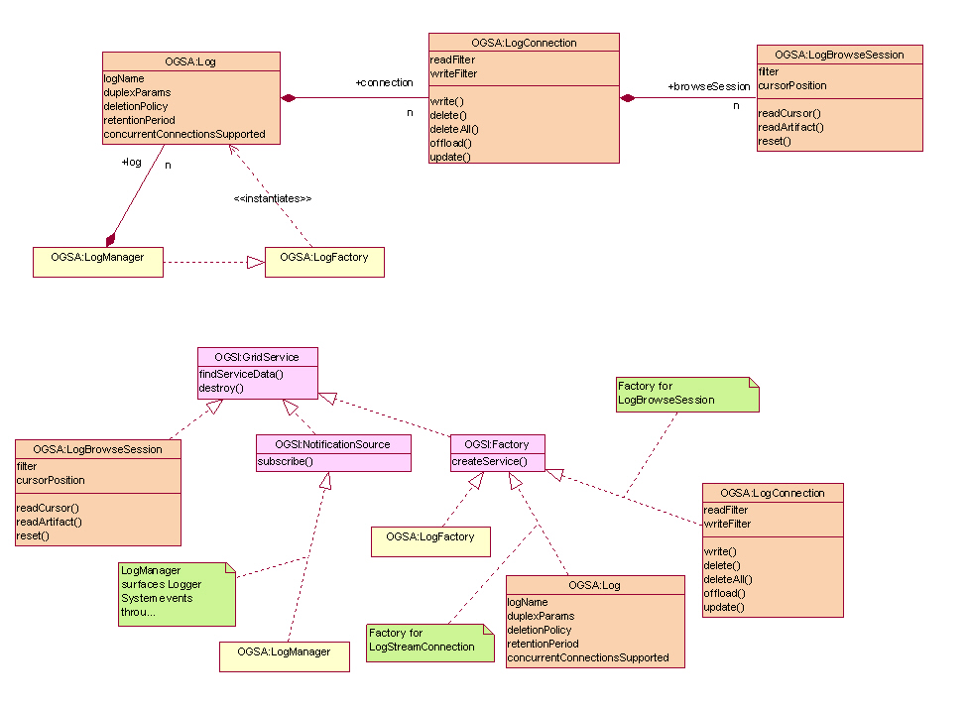
Figure 11: OGSA Logger Services Overview

LogManager service
The LogManager service is responsible for managing an instance of the OGSA Logger Services. The LogManager service implements the OGSA LogManager portType. The OGSA LogManager portType inherits from the WS-Notification NotificationSource portType and the WSRF factory pattern. The LogManager service acts as a factory for Log service instances. Various parameters can be used to configure a particular Log service instance. In addition to basic configuration data, Log policies for the QoSs outlined in §5.12.1.14 are also defined by these parameters. As a NotificationSource, it is responsible for surfacing all OGSA Logger Services state changes, providing a single point of contact for obtaining all management-related events.

Log service
The OGSA Log portType represents the persisted log. All I/O connections, read or write, are made through this portType. The Log service implements the OGSA Log portType. The Log service acts as a factory for LogConnection service instances.

LogConnection service
All access (read or write) to the records in a Log are made through the LogConnection service. The LogConnection service implements the OGSA LogConnection portType. The OGSA LogConnection portType implements the WSRF factory pattern. The LogConnection portType has operations which permit the writing of log records. Custom read and write filters may be set for each instance of a LogConnection. Additionally, the LogConnection service acts as a factory for LogBrowseSession service instances.

LogBrowseSession service
An instance of the LogBrowseSession service is used to read log records from a Log. The LogBrowseSession service implements the OGSA LogBrowseSession portType. The OGSA LogBrowseSession portType inherits from the WS-ResourceProperties. Each LogBrowseSession maintains a cursor for navigating its corresponding Log. A custom read filter may be set for an instance of a LogBrowseSession. Reads are filtered by both the LogBrowseSession filter and the LogConnection read filter. The LogBrowseSession portType has operations to access records by id or by timestamp, position its cursor, or to use its cursor to read a sequence of records.

Dependencies
The Logger Services build upon the base semantics defined by WSRF. As described in §5.12.1.6, the Logger Services represent log artifacts using the schemas defined by the OGSA Event (§ogsadraft10-6.15). Much of the state contained the LogManager, Log, and LogStream services is specified using policy. The Logger Services will use the OGSA Policy mechanisms described §ogsadraft10-6.16 to handle policy. As described in §, the Logger Services must support secure logging. OGSA security mechanisms are described in §ogsadraft10-4.1.4. As described in §5.12.1.13, the Logger Services is required to coexist with the OGSA messaging infrastructure (§ogsadraft10-6.14).

Standardization
None.

Messaging and Queuing
OGSA extends the scope of the base WS-Notification interface to allow for a range of event messages—not just notifications that a resource property has changed.
WS-Notification, WS-Eventing?
Several terms related to this work are:
- Event - Some occurrence within the state of the service or its environment that may be of interest to third parties. This could be a state change or could be environmental, such as a timer event.
- Message - An artifact of an event, containing information about an event that some entity wishes to communicate to other entities.
- Topic - A “logical” communications channel and matching mechanism to which a requester may subscribe to receive asynchronous messages and publishers may publish messages.
A message is represented as an XML element with a namespace-qualified QName, and an XML Schema-defined complex type. A topic will be modeled as an XML element, describing its internal details, including expected messages associated with the topic. TopicSpaces, or collections of topics, will also be modeled.

Services
This work will also define:
- An interface to allow any Web service to declare its ability to accept subscriptions to topics and the topics it supports.
- An interface to describe a messaging intermediary (a message broker) that supports anonymous publication of and subscription to topics.
- An interface (or set of interfaces) that describes the interface to other messaging services such as a Queuing service.
Note that queuing and message qualities of service such as reliability can be considered both an explicit service within an OGSA hosting environment and a transport detail modeled by the wsdl:binding element in the service description.

Dependencies
TBD.

Standardization
TBD.

Event
Events of one form or another have been around for a long time, and are used in many contexts. Generally they are used as an asynchronous signaling mechanism. The most common form is “publish/subscribe” in which a service “publishes” the events that it exports (makes available to clients). The service may publish the events as reliable or best-effort. Clients may then “subscribe” to the event – and when the event is raised a call-back or message is sent to the client. Once again the client can usually request either reliable or best-effort – though the service may not be able to accept a reliable delivery request. There is also a distinction in the reliability of an event being raised and its delivery to a client. A service my attempt to deliver every occurrence of an event (reliable posting), but not be able to guarantee delivery (best-effort delivery).
An event can be anything that the service decides it will be: a change in a state variable (a WSRF resource property), entry into a particular code segment, an exception such as a security violation or floating point overflow, or the failure of some other expected event to occur.
A second form of event is carried with service method invocations and modeled on ExoEvents [4]. The basic idea is simple. Inside the SOAP message invoking a service method is an Event Interest Set (EIS). The EIS specifies the events in which the caller is interested and a callback associated with each event. If an event named in the EIS is raised during the execution of the method—including outcalls on other services—the corresponding call-back is invoked.
The EIS is first class and can be thought of as a part of the calling context (closure). As such it can be modified by the callee and propagated down the call chain. This allows the callee to express interest in different events further down the call chain, and either add itself to a list of subscribers interested in such events, or “catch” events and keep them from propagating further up the call chain. [JT: Original author needs to review changes from v12 to make sure my changes haven’t altered the intended meaning.]
ExoEvents can be used for a wide variety of purposes, including logging activity in the call chain for accounting or debugging purposes, fault-tolerance and exception handling, and implementing language features such as “try-catch” in Java.
As noted above, events share many properties with notifications as defined in the WS-Notification specifications. However, WS-Notification is designed to capture state changes in resource properties only, and are not designed as a general event mechanism. Furthermore, WS-Notification mechanisms are not normally “edge triggered” since they are based on a model that assumes a minimum and maximum time between notifications, e.g., any notifications that occur within the minimum time window will not be sent to the client. A complete event framework would allow for event queuing or batching to cover this kind of functionality. OGSA events will build on WS-Notification mechanisms.
An event is a representation of an occurrence in a system or application component that may be of interest to other parties. Standard means of representing, communicating, transforming, reconciling, and recording events are important for interoperability. Thus OGSA should define standard schema for at least certain classes of OGSA events. Topics to be addressed include: Is there an OGSA Event base class? Is there a standard set contents for events, such as source, name, and details?

Services and schema
- Standard interface(s) for communicating events with specified QoS. These may be based directly on the Messaging interfaces.
- Standard interface(s) for transforming (mediating) events in a manner that is transparent to the endpoints. This should include aggregation of multiple events into a single event.
- Standard interface(s) for reconciling events from multiple sources.
- Standard interface(s) for recording events. These may be based directly on the Message logging interface(s).
- Standard interface(s) for batching and queuing events.
Note: Event services applied to fault tolerance.

Dependencies
It is possible that some forms of event services may be built directly on top of WS-Notification interfaces, although more study is needed.

Standardization
There is an OASIS group working on standard schema for Web service management (WSDM-TC) where they are considering proposals such as WS-Events [http://devresource.hp.com/drc/specifications/wsmf/WS-Events.pdf] and Common Base Event [http://xml.coverpages.org/IBMCommonBaseEventV111-XSD.html]. Is this group addressing what we need, or are there unique OGSA requirements?

Policy and Agreements
These services create a general framework for creation, administration and management of policies and agreements for system operation, security, resource allocation, etc., as well as an infrastructure for “policy aware” services to use the set of defined and managed policies to govern their operation. These services do not actually enforce policies but permit policies to be managed and delivered to resource managers that can interpret and operate on them. Agreements (WS-Agreement) provide a mechanism for the representation and negotiation of terms between service providers and their clients (either user requests or other services). These terms include specifications of functional, performance, and quality requirements/objectives that the suppliers and consumers exchange and that they can then use to influence their interactions. The Agreement mechanism provides a general expression framework for these terms but leaves the specification of particular terms to individual disciplines such as performance, security, data quality etc. Agreements also contain information on priority, costs, penalties or consequences associated with violation of the “contract.” A negotiated agreement represents as well as information on how the service provider and consumer have decided to measure compliance with the agreement.
We can expect that many services in a Grid environment will use policies to direct their actions. Thus, Grids need to support the definition, discovery, communication, and enforcement of policies for such purposes as resource allocation, workload management, security, automation, and qualities of service. Some policies need to be expressed at the operational level—i.e., at the level of the devices and resources to be managed—while higher-level policies express business goals and service level agreements (SLA) within and across administrative domains. Higher-level policies are hard to enforce without a canonical representation for their meaning to lower-level resources. Thus, business policies probably need to be translated into a canonical form that can then be used to derive lower-level policies that resources can understand. Standard mechanisms are also needed for managing and distributing policies from producers (e.g., administrators, autonomic managers, SLAs, etc.) to end-points that consume and enforce them (i.e., devices and resources).
To meet these requirements, OGSA needs to define the representations and functions required to implement an end-to-end distributed policy management service. These representations and functions are likely to include a canonical representation for expressing policies (Policy Information Model and Core XML Schema).

Services and schema
These interfaces provides a framework for creating, managing, validating, distributing, transforming, resolving, and enforcing policies within a distributed environment:
- A management control point for policy lifecycle (Policy Service Manager interface)
- An interface that policy consumers can use to retrieve required policies (Policy Service Agent interface)
- A way to express that a service is “policy aware” (Policy Enforcement Point interface)
- A way to effect change on a resource (e.g., using Common Management Model: §5.24)
The Policy Service Manager controls access to the policy repository. It also controls when notifications of policy changes are sent out, so that multiple updates can be made and notifications are only sent after all updates are complete.
The Policy Service Agent is a management service that other “policy aware” services depend on for delivery of their policies. The agent can provide additional services such as understanding time-period conditions so it can inform policy consumers of when policies become active or inactive.
Services that consume policies will implement the Policy Enforcement Point interface to allow them to be registered with Policy Agents, to allow them to participate in the subscription to and notification of policy changes, and to allow policies to be pushed down onto them when needed. These enforcement points will need to interpret the policies and make the necessary configuration changes in the resource(s) they manage, by using the Common Management Model mechanisms referred to in §5.24.
The OGSA Policy Service provides for a transformation service to fill this purpose and includes a canonical representation of policy in the form of an information model, grammar, and core XML schema. Figure 12 illustrates the set of components that might be included in a Policy Service.
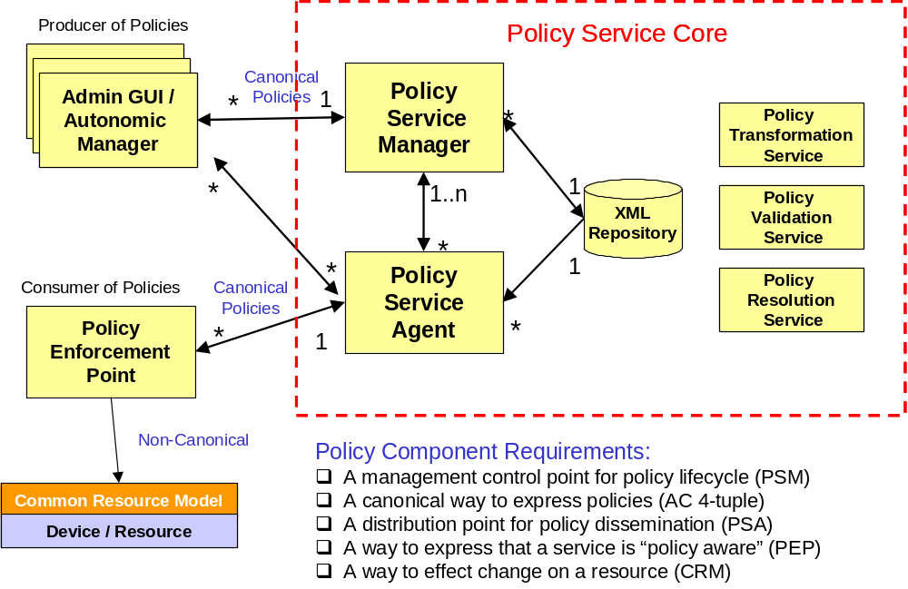
Figure 12: A set of potential policy service components
A set of secondary validation interfaces can allow automated managers and administrators to act on the same set of policies and validate consistency. An interface is also required for translating policies to and from the canonical form so that consumers that have their own policy formats can plug into the service. Finally there is a need for run-time resolution of policy conflicts, which may require specific application knowledge to determine the cost of violating an agreement and selecting the policy that will have appropriate impact.

Dependencies
[Jeff Nick: Ws-Agreement?]

Standardization
Work on WS-Policy, etc., within OASIS (?) is relevant.

Base Data Services
ITF: This material is taken from the “OGSA Data Services” position paper that was presented at the recent OGSA-DAI F2F. Discussion at that meeting will motivate revisions to that position paper, and to the text below.]
OGSA data interfaces are intended to enable a resource-oriented treatment of data, so that data can be treated in the same way as other resources. Thus, for example, we can integrate data into registries and coordinate operations on data using service orchestration mechanisms. A service-oriented treatment of data also allows us to use WS-Addressing endpoint referenes as global names for data, manage the lifetime of dynamically created data by using WSRF lifetime management mechanisms, and represent agreements concerning data access via WS-Agreement.
OGSA data resources are intended to allow for the definition, application, and management of diverse abstractions—what we term data virtualizations—of underlying data sources. A data virtualization is represented by, and encapsulated in, a data resource, a WS-Resource with resource properties that describe key parameters of the virtualization, and with operations that allow clients to inspect those resource properties, to access the data using appropriate operations, to derive new data virtualizations from old, and/or to manage the data virtualization. For example, a file containing geographical data might be made accessible as an image via a data resource that implements a “JPEG Image” virtualization, with resource properties defining size, resolution, and color characteristics, and operations provided for reading and modifying regions of the image. Another virtualization of the same data could present it as a relational database of coordinate-based information, with various specifics of the schema (e.g., table names, column names, types) as resource properties, and SQL as its operations for querying and updating the geographical data. In both cases, the data resource implementation is responsible for managing the mapping to the underlying data source.

Services and schema
We define four base data interfaces (WSDL portTypes) that can be used to implement a variety of different data resource behaviors:
- DataDescription defines WSRF resource properties representing key parameters of the data virtualization encapsulated by the data resource.
- DataAccess provides operations to access and/or modify the contents of the data virtualization encapsulated by the data resource.
- DataFactory provides an operation to create a new data resource with a data virtualization derived from the data virtualization of the parent (factory) data resource.
- DataManagement provides operations to monitor and manage the data resource’s data virtualization, including (depending on the implementation) the data sources (such as database management systems) that underlie the data resource.
We specify that a data resource is any WSRF-compliant WS-Resource that implements one or more of these base data interfaces.

Dependencies
The definitions for these services build on and extend core WSRF interfaces, in particular WS-ResourceProperites and Factory.
They are also expected to build on and extend WS-Agreement interfaces [4], which are used to incorporate agreements into the various data operations.
We also expect that (yet-to-be-defined) OGSA relationship management services will be used to represent and manage relationships among virtualizations, such as multiple virtualizations against the same data source, and dependencies between virtualizations.

Standardization
TBD.
OGSA-DAI.

Other Data Services
A wide variety of higher-level data interfaces can and must be defined on top of the base data interfaces, to address functions such as:
- Data access and movement
- Data replication and caching
- Data and schema mediation
- Metadata management and looking [JT: is this a typo?]
There are likely to be strong relationships to discovery, messaging, agreement, and coordination functions.
Basic data access interfaces allow clients to directly access and manipulate data. A number of such interfaces are required, corresponding to different data types – e.g., files, directories, file systems, RDBMS, XML data bases, object databases, and streaming media. A “file access” service may export interfaces to read, write, and truncate. GridFTP, an existing data access service, provides mechanism to get and put files, and supports third party transfers.

Services and schema
The following is far from being a complete list.
Data replication. Data replication can be important as a means of meeting performance objectives by allowing local compute resources to have access to local data. While closely related to caching (indeed, a “replica store” and a “cache” may differ only in their policies), replicas may provide different interfaces. Services that may consume data replication are group services for clustering and fail-over, utility computing for dynamic resource provisioning, policy services ensuring various qualities of service, metering and monitoring services, and also higher level workload management and disaster recovery solutions. Each may need to migrate data for computation or to replicate state for a given service.
Work is required to define an OGSA-compliant set of data replication services that, through the use of “adapters,” can move data into and out of heterogeneous physical and logical environments without any changes needed to the underlying local data access subsystems. The adapters handle the native “reading” and “writing” of data, and the replication software coordinates the runtime (recoverability, monitoring etc) associated with every data transfer. A central “monitor” sets up and handles communication with the calling service or program and sets up a “subscription-pair” relationship between capture and apply services on a per-replication-request basis to ensure reliability.
Data caching. In order to improve performance of access to remote data items, caching services will be employed. At the minimum caching services for traditional flat file data will be employed. Caching of other data types, such as views on RDBMS data, streaming data, and application binaries are also envisioned. Issues that arise include (but are not limited to):
- Consistency – Is the data in the cache the same as in the source? If not, what is the coherence window? Different applications have very different requirements.
- Cache invalidation protocols – How and when is cached data invalidated?
- Write through or write back? When are writes to the cache committed back to the original data source?
- Security – How will access control to cached items be handled? Will access control enforcement be delegated to the cache, or will access control be somehow enforced by the original data source?
- Integrity of cached data – Is the cached data kept in memory or on disk? How is it protected from un-authorized access? Is it encrypted?
How the cache service addresses these issues will need to available as service data.
Schema transformation. Schema transformation interfaces support the transformation of data from one schema to another. For example, XML transformations as specified in XSLT.

Dependencies
Build on base data services, which in turn build on basic WSRF interfaces, in particular WS-ResourceProperties, WS-ResourceLifetime, and WS-ServiceGroup.

Standardization
TBD.

Discovery Services
Discovery interfaces address the need to be able to organize and search information about various sorts of entities in various ways. In an OGSA environment, it is normally recommended that entities of whatever type be named by WS-Addressing endpoint references, and thus discovery services are concerned with mapping from user-specified criteria to appropriate endpoint references. Different interface definitions and different implementation behaviors may differ according to how user requests are expressed, the information used to answer requests, and the mechanisms used to propagate and access that information.

Services and schema
Not clear.

Dependencies
Build on basic WSRF interfaces, in particular WS-ResourceProperties, WS-ResourceLifetime, and WS-ServiceGroup.

Standardization
HandleResolver?

Job Agreement Service
Job Agreement service is created by the agreement factory service with a set of job terms, including command line, resource requirements, execution environment, data staging, job control, scheduler directives, accounting and notification terms.
The Job agreement service provides an interface for placing jobs on a resource manager (i.e., representing a machine or a cluster), and for interacting with the job once it has been dispatched to the resource manager. The Job service provides basic matchmaking capabilities between the requirements of the job and the underlying resource manager available for running the job. More advanced Job services take into account more advanced job characteristics such as interactive execution, parallel jobs across resource managers, and jobs with requirements based on SLAs.
The interfaces provided by the Job service are:
- Manageability Interface:
  - Supported Job Terms: defines a set of service data used to publish the job terms supported by this job service, including the job definition (command line and application name), resource requirements, execution environment, data staging, job control, scheduler directives, accounting and notification terms.
  - Workload Status: total number of jobs, statuses such as number of running, pending and suspended jobs.
- Job Control: control the job after it has been instantiated. This would include the ability to suspend/resume, checkpoint, and kill the job
The Job agreement service makes use of information in the form of policies which are defined at the VO level, and resource information about available resource managers, queues, host, and job status as provided by the Global Information Service. The Job service uses the WS-agreement protocol with the underlying resource managers in order to submit jobs to the underlying resource managers, and in order to control the running jobs and to access data.

Services and schema
TBD.

Dependencies
TBD.

Standardization
TBD.

Reservation Agreement Service
The Reservation agreement service is created by the agreement factory service with a set of terms including time duration, resource requirement specification, and authorized user/project agreement terms.
The Reservation agreement service allows end users or a Job agreement service to reserve resources under the control of a resource manager to guarantee their availability to run a job. The service allows reservations on any type of resource (e.g., hosts, software licenses, or network bandwidth). Reservations can be specific (e.g., provide access to host “A” from noon to 5pm), or more general (e.g., provide access to 16 Linux nodes on Sunday). Once a reservation is made, a Job service can send a job to a resource manager that is attached to the provided reservation. Some of the policy decisions made by the Reservation service for use with a RM include notions of who can make reservations (e.g., system administrators only), how many hosts a particular user or user group can reserve at a time, when reservations can be made (i.e., “blackout periods”), and what types of hosts can be reserved.
The Reservation agreement service provides one interface, Manageability, which defines a set of service data that describe the details of a particular reservation, including resource terms, start time, end time, amount of the resource reserved and the authorized users.
The Reservation service makes use of information about the existing resource managers that are available and any policies that might be defined at the VO level, and will make use of a logging service to log reservations. It will use the RM Adapter interfaces to make reservations and to delete existing reservations.

Services and schema
TBD.

Dependencies
TBD.

Standardization
TBD.

Data Access Agreement Service
The Data Access Agreement Service is created by the agreement factory service with a set of terms, including (but not limited to) source and destination file path, bandwidth requirements, and fault-tolerance terms (such as retry times).
The Data access agreement service allows end users or a Job agreement service to stage application or required data.
- Manageability Interface --- Define a set of service data for accessing the data movement status information
Other operations --- ??? Need to incorporate DAIS spec, Jay to provide ???
[Jeff Nick: Is this different than the data access services described in the Data section earlier? Are all forms of agreement specialized into typed agreement services?]

Services and schema
TBD.

Dependencies
TBD.

Standardization
TBD.

Queuing Service
The Queuing service provides scheduling capability for jobs. Given a set of policies defined at the VO level, a Queuing service will map jobs to resource managers based on the defined policies. For example, a Queuing service might implement a fairshare policy that makes sure that all users within the VO get reasonable turnaround time on their jobs, rather than being starved out by other users' jobs ahead of them in the queue.

Services
Manageability Interface - Define a set of service data for accessing QoS terms supported by the Queuing services. QoS terms for the Queuing service can include whether the service supports on-line or batch capabilities, average turn-around time for jobs, throughput guarantees, the ability to meet deadlines, and the ability to meet certain economic constraints.
- Enqueue --- enqueue a job into a queue
- Dequeue --- dequeue a job from a queue

Dependencies
Index Service – allows for the propagation of information between resource managers and the metascheduler. It also provides facilities for other services to persist their state data.

Standardization
WS-Agreement: defines fundamental mechanisms based on Agreement services, which represent an ongoing relationship between an agreement provider and an agreement initiator. The agreements define the behavior of a delivered service with respect to a service consumer. The Agreement will most likely be defined in sets of domain specific agreement terms (defined in other specifications), since the WS-Agreement specification is focused on defining the abstraction of the agreement and the protocol for coming to agreement, rather than on defining sets of agreement terms. [Jeff Nick: Here we’ve gone the other way…the queuing service builds on agreement, but is not a specialization of agreement service…it is a queuing service.]
WS-Agreement Job, Reservation and Data Access Terms
GGF GRAAP WG: WS-Agreement
JSDL: Job Terms and Resource Reservation Terms
DAIS: Data Access Terms.

WS-Agreement
TBD.

Services and schema
TBD.

Dependencies
TBD.

Standardization
TBD.

Web Services Distributed Management
A fundamental requirement of Grid management infrastructure is the ability to define the resources and resource management functions of the system in a standard and interoperable way. The capabilities of the Grid management infrastructure rely on the ability to discover, compose, and interact with the resources and the resource managers responsible for them.
The Web Services Distributed Management (WSDM) specification defines the base behavioral model for resources and resource managers in the Grid management infrastructure. A mechanism is defined by which resource managers can make use of detailed manageability information for a resource which may come from existing resource models and instrumentation, such as those expressed in CIM, JMX, SNMP, etc., combined with a set of canonical operations introduced by base WSDM interfaces. The result is a manageable resource abstraction that introduces WSRF compliant operations over an exposed underlying base content model. WSDM does not define yet another manageability (resource information) model.
The Web Services Distributed Management specifications define:
- the base manageable resource interface – that which a resource or resource manager must provide to be manageable
- managed resource identifier
- canonical lifecycle states, the transitions between the states, and the operations necessary for the transitions
- the ability to represent relationships among manageable resources (instances and types) including a canonical set of relationship types
- metadata to convey semantic meaning of manageability information, such as counter or gauge
- versioning information
- a Web service model that can be used to manage Web services with the features above
Additional items that may become within the scope of the WSDM specification are:
- canonical services factored out from across multiple resources or domain specific resource managers, such as an operational port type (start/stop/pause/resume/quiesce)
To summarize, WSDM is a standard for representing manageable resources and resource managers within the Grid management infrastructure. WSDM interfaces are WSRF-compliant and are used as the base abstract interfaces from which specific manageable resource types are derived. Standardization of the base management behavior is required in order to integrate the vast number and types of resources and more limited set of resource managers introduced by multiple vendors.

Services and schema
Interfaces are currently being defined.

Dependencies
WSDM extends WSRF
The related services will become clearer as the WSDM interfaces are defined.

Standardization
WSDM is related to standard management models such as CIM, JMX, SNMP and also to Grid-related models such as the Unicore Resource Schema and GLUE.
WSDM is also related to efforts in other standards bodies, such as in the DMTF.
OASIS WSDM TC.

Security Considerations
This specification defines requirements for interfaces, behaviors, and models used to structure and achieve interactions among services and their clients. While it is assumed that such interactions must be secured, the details of security are out of the scope of this specification. Instead, security should be addressed in related specifications that define how abstract interactions are bound to specific communication protocols, how service behaviors are specialized via policy-management interfaces, and how security features are delivered in specific programming environments.

Editor Information
Ian Foster
Distributed Systems Laboratory
Mathematics and Computer Science Division
Argonne National Laboratory
Argonne, IL 60439
Phone: 630-252-4619
Email: foster@mcs.anl.gov
Hiro Kishimoto
Grid computing and Bioinformatics Laboratory
Fujitsu Laboratories
4-1-1, Kamikodanaka, Nakahara, Kawasaki City, Japan
Phone: +81-44-754-2628
Email: hiro.kishimoto@jp.fujitsu.com

Contributors
We gratefully acknowledge the contributions made to this specification by Takuya Araki, Jamie Bernardin, Dave Berry, Shel Finkelstein, Jeffrey Frey, Dennis Gannon, Andrew Grimshaw, Bill Horn, Kate Keahey, Tan Lu, Fred Maciel, David Martin, Jeffrey Nick, Benny Rochwerger, John Rofrano, Andreas Savva, Frank Siebenlist, Chris Smith, David Snelling, Ravi Subramaniam, Jem Treadwell, Jay Unger, Jeffrin Von Reich, James Warnes, and Ming Xu.

References

