The Open Grid Services Architecture

Status of this Memo
This document provides information to the community regarding the specification of the Open Grid Services Architecture (OGSA). Distribution of this document is unlimited. This is a DRAFT document and continues to be revised.

Abstract
Successful realization of the Open Grid Services Architecture (OGSA) vision of a broadly applicable and adopted framework for distributed system integration, virtualization, and management requires the definition of a core set of interfaces, behaviors, resource models, and bindings. This document, produced by the OGSA working group within the Global Grid Forum (GGF), provides a first, and necessarily preliminary and incomplete, version of this OGSA definition. The document specifies the scope of important services required to support Grid systems and applications in both e-science and e-business, identifies a core set of such services that are viewed as essential for many systems and applications, and specifies at a high-level the functionalities required for these core services and the interrelationships among those core services. The document also lists existing technical standards and standard definition activities within GGF, OASIS, W3C, and other standards bodies that speak to required OGSA functionality, and identifies priority areas for further work.


GLOBAL GRID FORUM
office@ggf.org
www.ggf.org

Full Copyright Notice
Copyright © Global Grid Forum (2002, 2003). All Rights Reserved.
This document and translations of it may be copied and furnished to others, and derivative works that comment on or otherwise explain it or assist in its implementation may be prepared, copied, published and distributed, in whole or in part, without restriction of any kind, provided that the above copyright notice and this paragraph are included on all such copies and derivative works. However, this document itself may not be modified in any way, such as by removing the copyright notice or references to the GGF or other organizations, except as needed for the purpose of developing Grid Recommendations in which case the procedures for copyrights defined in the GGF Document process must be followed, or as required to translate it into languages other than English.
The limited permissions granted above are perpetual and will not be revoked by the GGF or its successors or assigns.
This document and the information contained herein is provided on an "AS IS" basis and THE GLOBAL GRID FORUM DISCLAIMS ALL WARRANTIES, EXPRESS OR IMPLIED, INCLUDING BUT NOT LIMITED TO ANY WARRANTY THAT THE USE OF THE INFORMATION HEREIN WILL NOT INFRINGE ANY RIGHTS OR ANY IMPLIED WARRANTIES OF MERCHANTABILITY OR FITNESS FOR A PARTICULAR PURPOSE.

Intellectual Property Statement
The GGF takes no position regarding the validity or scope of any intellectual property or other rights that might be claimed to pertain to the implementation or use of the technology described in this document or the extent to which any license under such rights might or might not be available; neither does it represent that it has made any effort to identify any such rights. Copies of claims of rights made available for publication and any assurances of licenses to be made available, or the result of an attempt made to obtain a general license or permission for the use of such proprietary rights by implementers or users of this specification can be obtained from the GGF Secretariat.
The GGF invites any interested party to bring to its attention any copyrights, patents or patent applications, or other proprietary rights which may cover technology that may be required to practice this recommendation. Please address the information to the GGF Executive Director (see contact information at GGF website).
Contents
1 Introduction 8
2 OGSA-WG and the Purpose of this Document 9
3 Functionality Requirements 9
3.1 Basic Functionality Requirements 10
3.2 Security Requirements 11
3.3 Resource Management Requirements 11
3.4 System Properties Requirements 13
3.5 Other Functionality Requirements 14
4 OGSA Service Taxonomy 14
4.1 Core Services 16
4.1.1 Service Interaction Services 16
4.1.2 Service Management Services 16
4.1.3 Service Communication Services 17
4.1.4 Security Services 17
4.2 Data Services 19
4.3 Program Execution Services 19
4.3.1 Conceptual Frameworks 20
4.3.2 WS-Agreement Based Scheduler Instantiation 23
4.3.3 Instantiation with “Broker Service” 26
4.4 Resource Management Services 27
5 Service Relationships 27
5.1 Service Composition 28
5.2 Service Orchestration 29
5.3 Types of Relationships 30
5.4 Platform Services 30
5.5 Relationships 31
6 OGSA Services 31
6.1 Handle Resolution 32
6.1.1 Detailed list of services 32
6.1.2 Underlying services 33
6.1.3 Relevant standards 33
6.1.4 Owner working group(s) 33
6.2 Virtual Organizations 33
6.2.1 Detailed List of Services 34
6.2.2 Underlying Services 36
6.2.3 Related Standards 37
6.2.4 Owner WG 37
6.3 Service Groups and Discovery Services 37
6.3.1 Detailed list of services 37
6.3.2 Underlying services 38
6.3.3 Related standards 38
6.3.4 Owner working group(s) 38
6.4 Choreography, Orchestration and Workflow 38
6.4.1 Detailed list of services 38
6.4.2 Underlying services 39
6.4.3 Relevant standards 39
6.4.4 Owner working group(s) 39
6.5 Transactions 39
6.5.1 Detailed list of services 40
6.5.2 Underlying services 40
6.5.3 Relevant standards 40
6.5.4 Owner working group(s) 40
6.6 Metering Service 40
6.6.1 Detailed list of services 41
6.6.2 Standard schema/documents 41
6.6.3 Underlying services 41
6.6.4 Related services 41
6.6.5 Relevant standards 41
6.6.6 Owner working group(s) 41
6.7 Rating Service 41
6.7.1 Detailed list of services 42
6.7.2 Standard schema/documents 42
6.7.3 Underlying services 42
6.7.4 Related services 42
6.7.5 Relevant standards 42
6.7.6 Owner working group(s) 42
6.8 Accounting Service 42
6.8.1 Detailed list of services 42
6.8.2 Standard schema/documents 42
6.8.3 Underlying services 42
6.8.4 Related services 42
6.8.5 Relevant standards 42
6.8.6 Owner working group(s) 43
6.9 Billing and Payment Service 43
6.9.1 Detailed list of services 43
6.9.2 Standard schema/documents 43
6.9.3 Underlying services 43
6.9.4 Related services 43
6.9.5 Relevant standards 43
6.9.6 Owner working group(s)(s) 43
6.10 Installation, Deployment, and Provisioning 43
6.10.1 Detailed list of services 43
6.10.2 Underlying services 43
6.10.3 Relevant standards 43
6.10.4 Owner working group(s)(s) 44
6.11 Application Contents Service 44
6.11.1 List of detailed services 45
6.11.2 Standard schema/document 45
6.11.3 Underlying services 48
6.11.4 Related services 48
6.11.5 Related standards 48
6.11.6 Owner WG 48
6.12 Fault Management 48
6.12.1 Detailed list of services 48
6.12.2 Underlying services 48
6.12.3 Relevant standards 49
6.12.4 Owner working group(s) 49
6.13 Problem Determination 49
6.13.1 Detailed list of services 49
6.13.2 Underlying services 49
6.13.3 Relevant standards 49
6.13.4 Owner working group(s) 49
6.14 Information and Monitoring Service 49
6.14.1 Requirements 51
6.14.2 Producer Service 52
6.14.3 Consumer Service 53
6.14.4 Joint Consumer/Producer (Aggregators, Filters) 54
6.14.5 Relationship with other Services 55
6.14.6 Client Services 55
6.14.7 Peer Services 56
6.14.8 Underlying Services 56
6.14.9 Related documents 56
6.14.10 Owner WG(s) 57
6.15 Logger Services 57
6.15.1 Requirements 57
6.15.2 Detailed List of Services 59
6.15.3 Standard schema/document 61
6.15.4 Underlying services 61
6.15.5 Related services 61
6.15.6 Related standard 61
6.15.7 Owner WG(s) 61
6.16 Messaging and Queuing 61
6.16.1 Detailed list of services 62
6.16.2 Underlying services 62
6.16.3 Relevant standards 62
6.16.4 Owner working group(s) 62
6.17 Event 62
6.17.1 Detailed list of services 63
6.17.2 Underlying services 63
6.17.3 Relevant standards 63
6.17.4 Owner working group(s) 64
6.18 Policy and Agreements 64
6.18.1 Detailed list of services 64
6.18.2 Underlying services 66
6.18.3 Relevant standards 66
6.18.4 Owner working group(s) 66
6.19 Base Data Services 66
6.19.1 Detailed list of services 66
6.19.2 Underlying services 67
6.19.3 Related standards 67
6.19.4 Owner working group(s) 67
6.20 Other Data Services 67
6.20.1 Detailed list of services 67
6.20.2 Underlying services 68
6.20.3 Related services 68
6.20.4 Owner working group(s) 68
6.21 Discovery Services 68
6.21.1 Detailed list of services 68
6.21.2 Underlying services 69
6.21.3 Related standards 69
6.21.4 Owner working group(s) 69
6.22 Job Agreement Service 69
6.22.1 Detailed list of services 69
6.22.2 Underlying services 69
6.22.3 Relevant standards 69
6.22.4 Owner working group(s) 69
6.23 Reservation Agreement Service 70
6.23.1 Detailed list of services 70
6.23.2 Underlying services 70
6.23.3 Relevant standards 70
6.23.4 Owner working group(s) 70
6.24 Data Access Agreement Service 70
6.24.1 Detailed list of services 71
6.24.2 Underlying services 71
6.24.3 Relevant standards 71
6.24.4 Owner working group(s) 71
6.25 Queuing Service 71
6.25.1 Underlying services 71
6.25.2 Relevant standards 71
6.25.3 Owner working group(s) 71
6.26 Open Grid Services Infrastructure 72
6.26.1 Key OGSI Features 72
6.26.2 Other Observations on OGSI 72
6.27 WS-Agreement 73
6.27.1 Detailed list of services 73
6.27.2 Underlying services 73
6.27.3 Relevant standards 73
6.27.4 Owner working group(s) 73
6.28 Web Services Distributed Management 73
6.28.1 Detailed list of services 74
6.28.2 Standard schema/document 74
6.28.3 Underlying services 74
6.28.4 Related services 74
6.28.5 Related standard 74
6.28.6 Owner working group(s)(s) 75
7 Security Considerations 75
8 Editor Information 75
9 Contributors 75
10 Acknowledgements 75
Appendix: Information Sources 76
References 76

Introduction
The Open Grid Services Architecture (OGSA) is a proposed enabling infrastructure for Grid systems and applications: i.e., systems and applications that are concerned with the integration, virtualization, and management of services within distributed, heterogeneous, dynamic “virtual organizations” [5, 6]—whether within industry, e-science, or e-business. Whether confined to a single enterprise or extending to encompass external resource sharing and service provider relationships, service integration, virtualization, and management in these contexts can be technically challenging because of the need to achieve various end-to-end qualities of service when running on top of different native platforms. Work on OGSA seeks to address these challenges by defining an integrated set of Web service (WS)-based service definitions designed both to simplify the creation of secure, robust Grid systems, and to enable the creation of interoperable, portable, and reusable components and systems via the standardization of key interfaces and behaviors.
The purpose of this document is to summarize current understanding of required OGSA functionality and the appropriate rendering of this functionality into service definitions. More specifically, we present functionality requirements (§3), a service taxonomy (§4), relationships among the various services (§5), and finally more detailed descriptions of specific services (§6).
Work on OGSA both builds on, and is contributing to the development of, the growing collection of technical specifications that form the emerging Web services (WS) architecture [1]. (Indeed, OGSA can be viewed as a particular profile for the application of core WS standards.) Some Grid functionality requirements are met by existing or proposed standards. Where this is the case, we so note in this document. In other cases, Grid functionality requirements may require extensions to existing service definitions and/or entirely new service definitions. Where this is the case, we also so note, and describe the current state of any work underway to define such extensions and/or definitions.
While the OGSA vision is broad, work to date has focused on the definition of a small set of core semantic elements. In particular, the Open Grid Services Infrastructure (OGSI) specification [10] developed within the OGSI working group of the Global Grid Forum defines, in terms of Web Services Description Language (WSDL) interfaces and associated conventions, extensions and refinements of emerging Web services standards to support basic Grid behaviors. OGSI-compliant web services—what we call Grid services—are intended to form the components of Grid infrastructure and application stacks.
OGSI defines essential building blocks for distributed systems, including standard interfaces and associated behaviors for describing and discovering service attributes, creating service instances, managing service lifetime, and subscribing to and delivering notifications. However, it certainly does not define all elements that arise when creating large-scale systems. We may also need to address a wide variety of other issues, both fundamental and domain-specific, of which the following are just examples. How do I establish identity and negotiate authentication? How is policy expressed and negotiated? How do I discover services? How do I negotiate and monitor service level agreements? How do I manage membership of, and communication within, virtual organizations? How do I organize service collections hierarchically so as to deliver reliable and scalable service semantics? How do I integrate data resources into computations? How do I monitor and manage collections of services? Without standardization in each of these (and other) areas, it is hard to build large-scale systems in standard fashions, to achieve code reuse, and to achieve interoperability among components—three distinct and important goals. Much of this document is concerned with defining these services.
Our understanding of what is required in OGSA is preliminary and incomplete. Both our understanding of OGSA’s purpose and form, and the details of specific components, are likely to evolve significantly. In the meantime, this document not only provides a basis for debate but also can serve as input to discussions of priorities for OGSA specification development.

OGSA-WG and the Purpose of this Document
This document is a product of the Global Grid Forum’s OGSA Working Group (OGSA-WG), which has the following charter and scope.
- To produce and document the use cases that drive the definition and prioritization of OGSA components, as well as document the rationale for our choices.
- To identify and outline requirements for, and a prioritization of, OGSA services and components.
- To identify and outline requirements for, and a prioritization of, hosting environment and protocol bindings that are required for deployment of portable, interoperable OGSA implementations.
- To identify and outline requirements for, and a prioritization of, models for resources and other important entities.
- To identify, outline, and prioritize interoperability requirements for the various OGSA components.
- To define standard OGSA profiles, i.e., sets of OGSA components that meet specific requirements.
- To define relationships between GGF and other standards bodies activities such as W3C, OASIS, and WSI whose work touches upon OGSA-related issues.
In some cases, work within OGSA-WG may result in the drafting of specifications for OGSA components. However, we expect that the task of completing these specifications will be handled by other working groups.
This document is intended as a contribution to goals 2, 3, and 4. It is not, in its current form, a final product.

Functionality Requirements
The development of this document has been informed by a variety of use case scenarios contributed by OGSA-WG participants or solicited from others. These use cases are collected in a companion document [4]. The use cases have not been defined with a view to expressing formal requirements (and do not contain the level of detail that would be required for formal requirements), but have provided useful input to the definition process.
Analysis of the use cases, other input from OGSA-WG participants, and other studies of Grid technology requirements (see Appendix) lead us to identify both important and apparently broadly relevant characteristics of Grid environments and applications, and functionalities that appear to have broad relevance to a variety of application scenarios. We summarize our findings in the following. We emphasize that this material does not represent a comprehensive or formal statement of functionality requirements from our use cases. However, it does provide useful input for subsequent development of OGSA functions.

Basic Functionality Requirements
The following basic functions are fundamental to just about every application studied.
- Discovery and brokering. Mechanisms are required for discovering and/or allocating services, data, and resources with desired properties. For the National Fusion Collaboratory use case [4], the clients need to discover network services before they are used. Service brokers need to discover hardware and software availability. And the service broker identifies codes and platforms suitable for execution as requested by the client.
- Metering and accounting. Applications and schemas for metering, auditing and billing. For the IT Infrastructure and Management use case [4], the Metering function records usage and duration, especially metering the usage of licenses, the Auditing function audits usage and the application profile on the machine, and the Billing function bills the user based on metering.
- Data sharing. Data management and sharing are common and important Grid applications. Mechanisms are required for accessing and managing data archives, for caching data and managing its consistency, for indexing and discovering data and metadata, and so on.
- Deployment. Data is deployed to the hosting environment that will execute the job (or made available in or via a high performance infrastructure). Also an application (executable) is migrated to the computer that will execute it. [HK: I use term deployment here. Ravi and Ratna Abrol use term “migration” instead. Another comment from Jacques Durand (Fujitsu Software):…"data migration" already has a very specific meaning in the database world, as the one-time operation of transferring and remodeling enterprise data from one repository (database) to another, mostly for reengineering purpose. I believe the term is confusing, as the operation OGSA wants to define, is different - if not much in nature, at least in purpose - from what is commonly referred to by database users. So I would advise for "data deployment" (or assignment...) instead.]
- Virtual organizations [6]. The need to support collaborative VOs introduces a need for mechanisms to support VO creation and management, including group membership services. For the Commercial Data Center (CDC) use case [4], the Commercial Grid System (CGS) creates a VO in a Data Center which provides IT resources to the job upon the customer job request. Depending on the customer’s request, the CGS will negotiate with another remote CGS and create a VO across the CDCs. Such a VO can be used to achieve the necessary scalability and availability.
- Monitoring. A global, cross-organizational view of resources and assets for project and fiscal planning, troubleshooting, and other purposes. Users want to monitor their applications as they run on the Grid, and resource or service owners need to expose certain states so that users of those resources or services may manage their usage by monitoring the exposed state information.
- Policy. It is important to be able to represent policy at multiple stages in hierarchical systems, with a view to automating the enforcement of policies that might otherwise be implemented as organizational processes or managed manually. Several attributes should be handled as policy. An error and event policy guides self-controlling management, including failover and provisioning. From the low-level policies that govern how the resources are monitored and managed to high-level policies that govern how business processes such as billing are managed, there may be policies at every level of the infrastructure. High-level policies are sometimes decomposable into lower-level policies.

Security Requirements
Grids also introduce a rich set of security requirements, of which we highlight just a few here.
- Multiple security infrastructures. Distributed operation implies a need to interoperate with and manage multiple security infrastructures. For the Commercial Data Center use case, isolation of customers in the same CDC is a crucial requirement. The CGS should provide not only access control but also performance isolation. And for the Online Media and Entertainment use case, proper isolation between content offerings has to be ensured. This level of isolation has to be ensured by the security of the infrastructure. In addition, several securities related services are required:
- Single sign-on needs to be supported. A player may traverse several organizations in the M&E environment. For example, a player of EverQuest may buy an EverQuest character on eBay and pay for it via his PayPal account. To support single sign-on a game developer may want to use a 3rd party authentication and authorization service, identify a mapping service, etc.
- Digital rights management and key management.
- Intrusion detection and protection.
- Perimeter security solutions. Many use cases require applications to be deployed on the other side of firewalls from the intended user clients. Inter-Grid collaboration often requires crossing institutional firewalls. OGSA needs standard, secure mechanisms that can be deployed to protect institutions while also enabling cross-firewall interaction.
- Authentication, Authorization, and Accounting. Obtaining application programs and deploying them into a Grid system may require authentication/authorization. This functionality is described in “Multiple security infrastructures” and “perimeter security solutions.” In the CDC use case, the CDC authenticates the customer and authorizes the submitted request when the customer submits a job request. The CDC also identifies his/her policies (including, but not limited to, SLA, security, scheduling, and brokering policies).
- Encryption. The IT Infrastructure and Management use case needs encryption of communication traffic – at the very least for the payload.
- Application and Network-level Firewalls. This is a long-standing problem in the Fusion use case. It is made particularly difficult by the many different policies we are dealing with, and by particularly harsh restrictions at international sites.
- Certification. A trusted party certifies that a particular service has certain semantic behavior. For examples, a company will only use e-commerce services certified by yahoo shopping.

Resource Management Requirements
Resource management is another cross-cutting requirement, encompassing service level agreement (SLA) negotiation, provisioning, and scheduling for a variety of resource types and activities.
- Provisioning. Computer CPUs, applications, licenses, storage, networks, and instruments are all Grid resources that require provisioning. Other new resource types will be invented and added to this list. OGSA needs a framework that allows resource provisioning to be done in a uniform, consistent manner.
- Resource virtualization. Dynamic provisioning implies a need for a resource virtualization mechanism that allows resources to be transitioned flexibly to different tasks as required—for example, when bringing more Web servers on-line as demand exceeds some threshold.
- Optimization of resource usage while meeting cost targets (i.e., deal with finite resources). Mechanisms to manage conflicting demands from various organizations, groups, projects and users and implementing a fair sharing of resource and access to Grid.
- Transport management. For applications that require some form of real-time scheduling, it can be important to be able to schedule or provision bandwidth dynamically for data transfers or in support of the other data sharing applications. For the Fusion use case, reliable transport management is essential to obtain the end-to-end QoS required by the application.
- Usage models that provide for both batch and interactive access to resources.
- Support for the management and monitoring of resource usage and the detection of SLA or contract violations by all relevant parties. Also conflict management is necessary, to resolve different management disciplines which may conflict in their optimization objectives (availability goals vs. performance goals for example). Note: this is not a conflict between users or organizations.
- CPU scavenging is an important tool for an enterprise or VO to use to aggregate computing power that would otherwise go to waste. How can OGSA provide service infrastructure that will allow the creation of applications that use scavenged cycles? For example, consider a collection of desktop computers running software that supports integration into processing and/or storage pools managed via systems such as Condor, Entropia, United Devices, etc. Issues here include maximizing security in the absence of strong trust.
- Scheduling of service tasks. Long recognized as an important capability for any information processing system, scheduling becomes extremely important and difficult for distributed Grid systems. For the Severe Storm Prediction use case [4], dynamic scheduling is an essential component. Compute resources must be provisioned on-demand to satisfy the need to complete a forecast on time.
- Load Balancing. In many applications it is necessary to make sure deadlines are met, or resources are used uniformly. These are both forms of load balancing that must be made possible by the underlying infrastructure. For the CDC use case, monitoring job performance and adjusting allocated resources to match the load and fairly distributing end users’ requests to all the resources are necessary. For the Online Media use case, the amount of workload is a direct result of how many concurrent online game players are being hosted on a game server. If the game server (A) is responsible for a 20 square mile area in the game world, and a battle occurred in that area, many players will rush to that area, causing workload on that server to increase. As players enter that area and leave other areas, other servers’ workload will decrease. So, when the workload of server A gets above a certain threshold, a load balancing routine needs to be triggered to rebalance the resources (i.e. servers). That is, redistribute workloads across servers with idle capacity.
- Advanced Reservation. This functionality may be required to execute the application on reserved resources. For the CDC use case, the CGS decides when to start the request processing based on the customer’s request. The CGS interprets the job specification description language in which the request is written, and checks if the customer has the right to perform the request.
- Notification/Messaging. Notification and messaging are critical in the very dynamic scenario of the Severe Storm Prediction use case. It is completely event driven.
- Logging. Processes like obtaining/deploying application programs might be logged, and the information might be used for accounting. This functionality is represented as “metering and accounting.” For the Severe Storm Prediction use case, logging is required in order to understand what happened in the last "storm" so that performance can be optimized later.
- Workflow management. Many applications can be wrapped in scripts or processes that require licenses and other resources from multiple sources. Applications coordinate using the file system or based on events. A Fusion Grid network service is a workflow of multiple components (remote execution, input and output data transfer, etc.).
- Pricing

System Properties Requirements
We note a number of issues that arose in multiple scenarios but that are best thought of as desirable system properties rather than functions.
- Fault tolerance. Support is required for fail-over, load redistribution and other techniques used to achieve fault-tolerance. For the Service-Based Distributed Query Processing use case, fault tolerance is particularly important for long running queries that can potentially return large amounts of data. For the Severe Storm Prediction use case, better-than-real-time prediction requires extreme fault tolerance. The Grid cannot go down while a severe storm is being tracked.
- Disaster Recovery. Disaster recovery is a critical capability for complex distributed Grid infrastructures. For distributed systems, failure must be considered one of the natural behaviors and disaster recovery mechanisms must be considered an essential component of the design. Autonomous system principles must be fully embraced as we design Grid applications, and should be reflected in OGSA. In case of the Data Center becoming unavailable due to a disaster such as an earthquake or fire, the remote backup Data Center takes over the application systems.
- The self-healing capabilities of resources, services and systems are required. Significant manual effort should not be required to monitor, diagnose and repair faults. Ability to integrate intelligent self-aware hardware such as disks, networking devices etc.
- Strong monitoring for defects, intrusions, and other problems. Ability to migrate attacks away from critical areas.
- Legacy application management. Legacy applications are those that cannot be changed, but they are too valuable to give up or too complex to rewrite. A Grid infrastructure has to be built around them so that they can continue to be used. Realizing the Grid potential to deal with legacy issues was the one of the foremost motivations for the Fusion project.
- Administration. Be able to “codify” and “automate” the normal practices used to administer the environment. The goal is that systems should be able to self-organize and self-describe to manage low-level configuration details based on higher-level configurations and management policies specified by administrators.
- Agreement-based iteration. The Fusion project requires agreement-based interaction capable of specifying and enacting agreements between clients and servers (not necessarily human), and then composing those agreements into higher-level end-user structures.
- Grouping/Aggregation of Services. Composing services using existing services is a core requirement. There are two main types of composition techniques: selection and aggregation. Selection involves choosing to use a particular service amongst many services with the same operational interface (e.g. select the fastest MP3 encoder). Aggregation involves orchestrating a functional flow (workflow) between services. For example, the output of the accounting service is fed into the rating service to produce billing records. One other basic function required for aggregation services is to transform the syntax and/or semantics of data or interfaces.

Other Functionality Requirements
While some use cases involve highly constrained environments (that may well motivate specialized OGSA profiles), it is clear that in general Grid environments tend to be heterogeneous and distributed.
- Platforms. The platforms themselves are heterogeneous, including a variety of operating systems (Unixes, Linux, Windows, and presumably embedded systems), hosting environments (J2EE, .NET, others), and devices (computers, instruments, sensors, storage systems, databases, networks, etc.).
- Mechanisms. Grid software can need to interoperate with a variety of distinct implementation mechanisms for core functions such as security.
- Administrative environments. Geographically distributed environments often feature varied usage, management, and administration policies (including policies applied by legislation) that need to be honored and managed.
A wide variety of application structures are encountered, and must be supported by other system components, including the following:
- Both single-process and multi-process (both local and distributed) applications covering a wide range of resource requirements.
- Flows, i.e., multiple interacting applications that can be treated as a single transient service instance working on behalf of a client or set of clients.
- Workloads comprising potentially large numbers of applications with various of the characteristics listed above.

OGSA Service Taxonomy
As noted above, the purpose of OGSA is to define standard approaches to, and mechanisms for, basic problems that are common to a wide variety of Grid systems, such as communicating with other services, establishing identity, negotiating authorization, discovering services, notification of errors, and managing service collections.
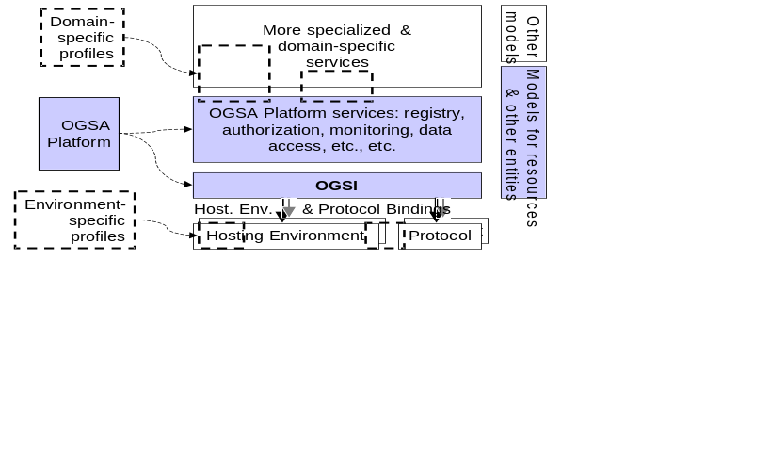
Figure 1: OGSA components (shaded) and related profiles (dashed lines)
As illustrated in Figure 1, the three principal elements of OGSA are the Open Grid Services Infrastructure, OGSA services, and OGSA models.
- Building on both Grid and Web services technologies, the Open Grid Services Infrastructure (OGSI) defines mechanisms for creating, managing, and exchanging information among entities called Grid services. Succinctly, a Grid service is a Web service that conforms to a set of conventions (interfaces and behaviors) that define how a client interacts with a Grid service. These conventions, and other OGSI mechanisms associated with Grid service creation and discovery, provide for the controlled, fault resilient, and secure management of the distributed and often long-lived state that is commonly required in distributed applications.
- OGSA services build on OGSI mechanisms to define interfaces and associated behaviors for various functions not supported directly within OGSI, such as service discovery, data access, data integration, messaging, and monitoring.
- OGSA Models support these interface specifications by defining models for common resource and service types.
We anticipate that these OGSA components will be supplemented by a set of environment-specific profiles addressing issues such as the following. We mention these here for completeness; they are not discussed further in this document.
- Protocol bindings. Environment profiles of this sort enable interoperability among different Grid services by defining common mechanisms for transport and authentication—issues that are not addressed by OGSI, but rather defined as binding properties, meaning that different service implementations may implement them in different ways. Thus, for example, “SOAP over HTTP” is a useful Grid service transport profile. Another example of such a profile is the recently proposed GSSAPI profile for security context establishment and message protection using WS-SecureConversation [7] and WS-Trust [8].
- Hosting environment bindings. Environment profiles of this sort enable portability of Grid service implementations. For example, an “OGSA J2EE Profile” might define standardized Java APIs that allow for portability of Grid services among OGSI-enabled J2EE systems. An “OGSA Desktop Grid Profile” could allow for interoperability among systems that allow untrusted (and untrusting) desktop computers to participate in distributed computations. An “OGSA Scientific Linux Profile” could define standard execution environments for computers that run scientific applications, specifying conventions for the locations of key executables and libraries, and for the names of certain environment variables
- Sets of domain-specific services. Profiles of this sort define interfaces and models in addition to those defined within OGSA to address the needs of specific application domains. For example, an “OGSA Database Profile” might define a set of interfaces and models for distributed database management; an “OGSA eCommerce Profile” might define interfaces and models for e-commerce applications.
We expand briefly upon each OGSA element in the remainder of this section, and provide more details in subsequent sections.
OGSA defines services that occur within a wide variety of Grid systems. We divide these functions into four broad groups: core, data, program execution, and resource management services.

Core Services
“Core” services are implementations of those functions that are generally used by a wide variety of higher-level services and that implement broadly useful capabilities. While dependencies between core services and non core services (by higher-level functions) are likely, there is presently no known requirement that any particular core service be present in order to implement a Grid. The organization of these “core” services into the areas below is for the convenience of explanation and is not meant to imply dependencies among functions that are grouped together.

Service Interaction Services
These are services primarily intended to provide interaction mechanism for the collection of services in the Grid. They provide a means for services to be registered and to locate each other, as well as mechanisms for combining multiple lower-level services into aggregations. They also include functions for deploying the software images that implement services in hosting environments, and for collecting data about their operation for management, accounting, and billing purposes.
This service category includes the following services:
- Virtual organizations
- Service group and discovery services
- Service domain, service composition, orchestration, workflow
- Transaction [Jeff Nick: We should leverage WS-* standards in this area as they evolve, such as WS-Coordination and WS-Transactions.]

Service Management Services
These are functions for managing deployed services. Service management automates and assists with a variety of installation, maintenance, monitoring, and troubleshooting tasks within a Grid system. This includes functions for provisioning and deploying the system components. It also includes functions for collecting and exchanging data about the operations of the Grid. This data is used for both “online” and “offline” management operations and includes information about faults, events, problem determination, auditing, metering, accounting and billing. Service management may also depend on models and schema that describe dependency relationships between different components, installation and provisioning steps and processes, and external capabilities.
This service category includes the following services:
- Metering and Accounting
- Installation, Deployment, and Provisioning
- Fault Management
- Problem Determination [Jeff Nick: We probably should have mentioned this group of services more descriptively than just “core” when we first introduce the “core” term above.]

Service Communication Services
These services provide the basic methods for services to communicate. They support several communication models that may be composed to permit effective inter-service communication.
This service category includes the following services:
- Distributed logging [Jeff Nick: I don’t view logging as a communication mechanism. It is a persistence support function for metering; fault management; pd; etc, and should perhaps be included in the set above.]
- Messaging and queuing
- Event notification [OK? JT]

Security Services
OGSA security architectural components must support, integrate, and unify popular security models, mechanisms, protocols, platforms, and technologies in a way that enables a variety of systems to interoperate securely. A preliminary OGSA Security Architecture document, developed within GGF’s OGSA-Sec working group, seeks to address these goals in a manner consistent with the security model that is currently being defined for the Web services framework. An associated OGSA Security Roadmap document enumerates the security related specifications that will be needed to ensure interoperable implementations of the OGSA Security Architecture.
The security of a Grid environment must take into account the security of various aspects involved in a Grid service invocation, as depicted in Figure 2 and discussed in the following.
As discussed in §4, a Grid service can be accessed over a variety of protocol bindings. Given that bindings deal with protocol and message formats, security functions such as confidentiality, integrity, and authentication fall within the scope of bindings and thus are outside the scope of OGSA proper.
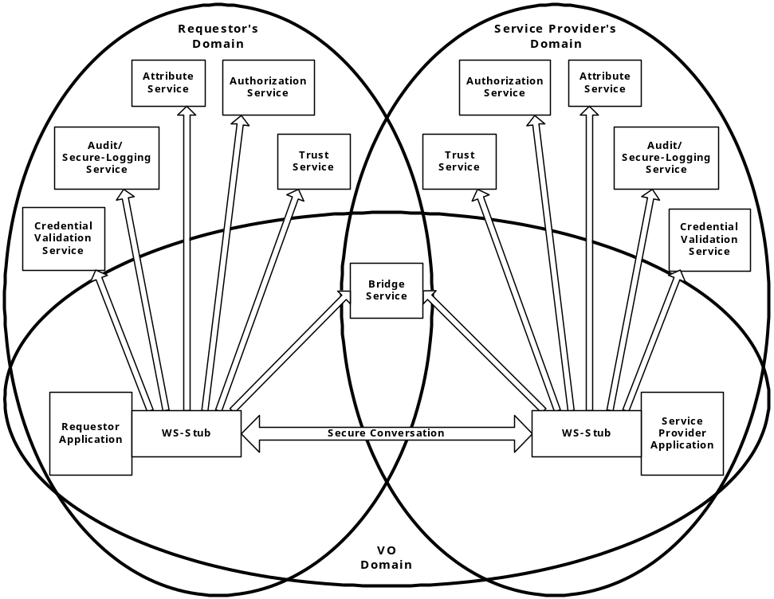
Figure 2: Security services in a virtual organization setting
Each participating end point can express the policy it wishes to see applied when engaging in a secure conversation with another end point. Policies can specify supported authentication mechanisms, required integrity and confidentiality protection, trust policies, privacy policies, and other security constraints. When invoking Grid services dynamically, end points may need to discover the policies of a target service and establish trust relationships dynamically. (See §6.18 for more discussion of policy.)
Once a service requester and a service provider have determined each other’s policies, they can establish a secure channel over which subsequent operations can be invoked. Such a channel should enforce the mutual agreed qualities of protection, including identification, confidentiality, and integrity. The security model must provide a mechanism by which authentication credentials from the service requester’s domain can be translated into the service provider’s domain and vice versa.
This translation is required in order for both ends to evaluate their mutual access policies based on the established credentials and the quality of the established channel.
OGSA’s security model must address authentication, confidentiality, message integrity, policy expression and exchange, authorization, delegation, single logon, credential lifespan and renewal, privacy, secure logging, assurance, manageability, firewall traversal, and security at the OGSI layer. We can expect that existing and evolving standards will be adopted or recognized in the Grid security model.
Figure 2 shows relationships between a requester, a service provider and many of the security services. Note that both requester and service provider are always subject to the security policies dictated by their respective administrative domains. Furthermore, a VO can have its own security policy that can enable the sharing of the submitted resources, but the associated rights will always be capped by the overruling resource-local policy. For many Grid applications, the resource owners and the individual requesters will not “know” each other as they live in different administrative domains while their interactions are dynamically discovered and brokered by scheduler services and such. This implies that trust has to be dynamically established through introductions, and the concept of the VO as a bridge is seen as an important tool to build these dynamic trust relationships.
All security interfaces used by a service requester and service provider need to be standardized within OGSA. Compliant implementations will be able to make use of existing services and defined policies through configuration. Compliant implementations of a particular security related interface would be able to provide the associated and possibly alternative security services.

Data Services
The scale, dynamism, autonomy, and distribution of data sources in Grid environments can lead to significant complexity in data access and management. A variety of interfaces need to be defined to aid developers and users in the management of this complexity. In addition to basic data access interfaces and common resource models for storage and data management systems, these interfaces need to address the need for various transparencies, including heterogeneity, location, naming, distribution, replicas, ownership, and data access costs. Data virtualization services aimed at providing these transparencies can include federated access to distributed data, dynamic discovery of data sources based on content, dynamic migration of data for workload balancing, and schema management. In implementing such services, we need to take into account the wide variety of different data types, such as flat file data, streaming media, and relational data that require different approaches to management. Further, different applications require different forms of support – e.g., some applications cannot be modified and require transparent access via file systems, while others need explicit management of data locality and replication.
These considerations suggest a role for wide variety of potential data management interfaces, including data caching (resolving a file handle to a flat file into a data stream); data replication; data access, via mechanisms for accessing wide range of data types, including flat files, RDBMS, and streaming media; file and DBMS services and possibly federated data management services that are used as part of a vertical utility Grid; data transformation and filtering; schema transformation (allowing different data, service and policy schema to be reconciled so that the services can interact correctly); and Grid storage services, which allow direct access to storage throughout the Grid.

Program Execution Services
Program execution services enable applications to have coordinated access to underlying VO resources, regardless of their physical location or access mechanisms. When an application utilizing the Grid makes use of more than one physical resource during its execution, Program Execution middleware maps the resource requirements of the user application to the multiple physical resources that are required to run that application. The Program Execution services are the key to making VO resources easily accessible to end-users, by automatically matching the requirements of a Grid application with the available resources, while staying within the conditions that the VO has specified with the underlying resource managers.
Interoperability is the key to building up a Program Execution Services infrastructure. In order to allow the higher order constructs such as Program Execution to work with the lower level resource managers, there must be agreement on how these entities will interact with each other, even though the lower level resource managers might be very different from each other, in function and in interface. In order to meet the requirement for interoperability, standards are required which define the interfaces through which resource managers are accessed and managed. Additionally, there is a requirement that the services representing the resource managers act using standard semantics, so that the behavior of the resource manager is predictable to the scheduler.
OGSA-based Grid environments may be composed of many different, interacting Grid services. Each such service may be subject to different policies on how to manage the underlying resources. In order to deal with the complexities of large collections of these services, there need to be mechanisms for Grid service management and the allocation of resources for applications. One such mechanism is defined through the proposed WS-Agreement interface [3]. The specification document for WS-Agreement describes it as “…the ability to create Grid services and adjust their policies and behaviors based on organizational goals and application requirements.” WS-Agreement defines the Agreement-based Grid Service Management model, which is specified as a set of OGSI-compliant portTypes allowing clients to negotiate with management services in order to manage Grid services or other legacy applications.

Conceptual Frameworks
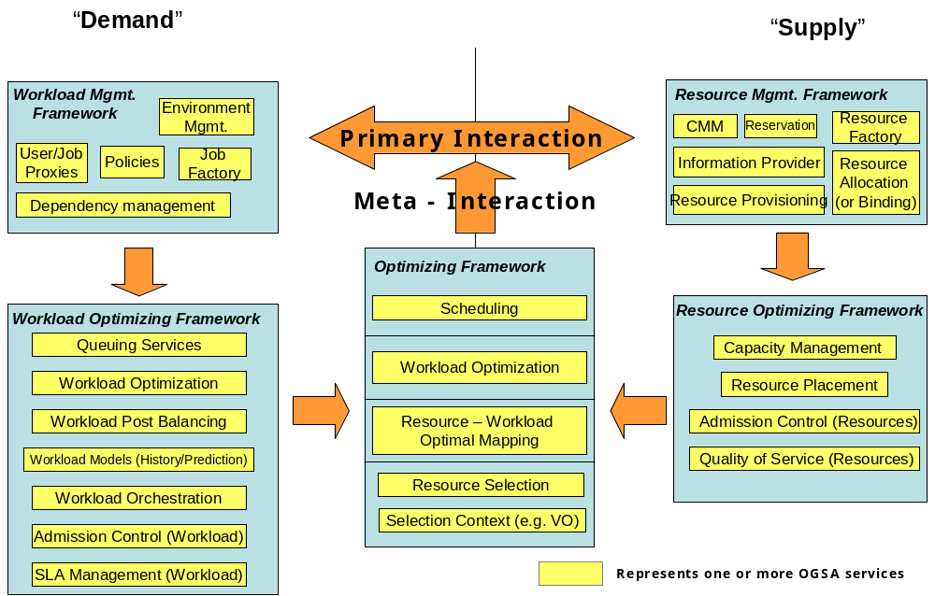
Workload realization is the general set of use cases that take workload requests and map them to appropriate resources within the Grid that can realize these workloads. Grid services manage and co-ordinate access to and consumption of geographically distributed resources by workloads realized on those resources.

Figure 3: Grid Frameworks - Execution
The overall conceptual architecture can be visualized as shown in Figure 3.Error: Reference source not found Workload realization (or execution) can be visualized as a mapping between “demand” in the form of workloads and “supply” in the form of the available Grid resources. In a fundamental scenario, the system has to map the demand to the supply and provide the mechanism to realize these workloads on the resources. This primary mode can be augmented with other services, mechanisms and capabilities that provide alternate modes of interaction, including optimization of the mapping and scheduling a temporal and topological execution profile. In addition, other services manage and enforce the service level agreements with the user, and still other services tweak the resources and manage the available capacity to ensure that a desired quality of service is delivered. The alternate modes are not core to the execution framework, but can be added to augment the efficacy and efficiency of the overall system.
Services that belong to the Resource Optimization Framework are focused on the optimization of the supply side of the mapping. This can be done by admission control, resource utilization monitoring and metering, capacity projections, resource provisioning and load balancing across equivalent resources, and negotiation with workload optimization and/or management services to migrate workloads onto other resources so as to maximize resource utilization.
Services that belong to the Workload Optimization Framework are focused on the demand side of the mapping. These services may queue requests to prevent resource saturation and manage relative request priorities, or may perform post-balancing by migrating workloads to appropriate resources, depending on the potential to be penalized or rewarded for missing or exceeding SLAs respectively.
Services in the Optimizing Framework are focused on resolving any contentions that the myopic views of the respective resource or workload optimization frameworks may create. These services arbitrate and modulate the primary interactions either in an ‘in-band’ or an ‘out-of-band’ manner.
The term “resources” is used in its most general sense, and can include virtualized physical resources such as CPU, storage, memory, and/or virtual resources such as software licenses or data. As shown by Figure 4, workloads are composite entities that have multiple levels of “execution entities”: workloads are made up of jobs which in turn are made up of tasks which in turn are made up of tasklets. Each of these composite entities has a manager.
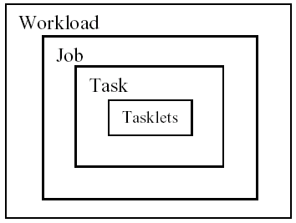
Figure 4: Workload, Job, Task, and Tasklet
A possible set of interactions between Grid services to execute workloads are shown in . The services can be at multiple levels in the Grid and can be composed of other services or service groups.

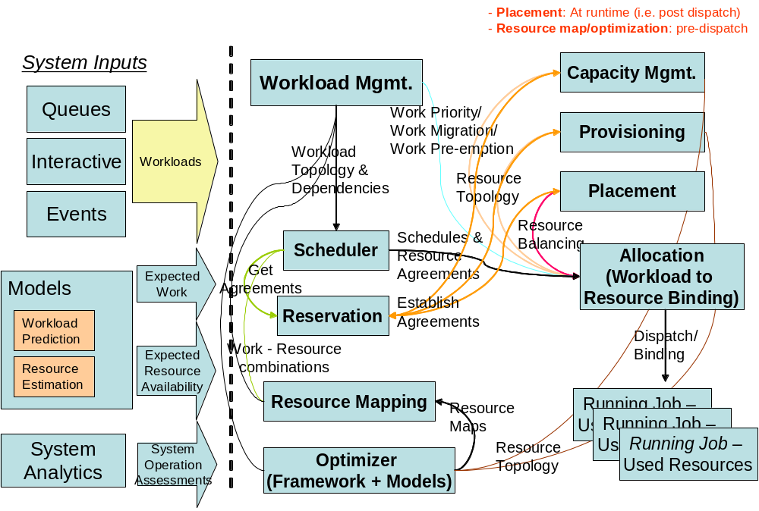
Figure 5: Service interactions for workload execution (partial enumeration)
A physical organization of the services and one of the possible collaboration scenarios is shown in Figure 6.

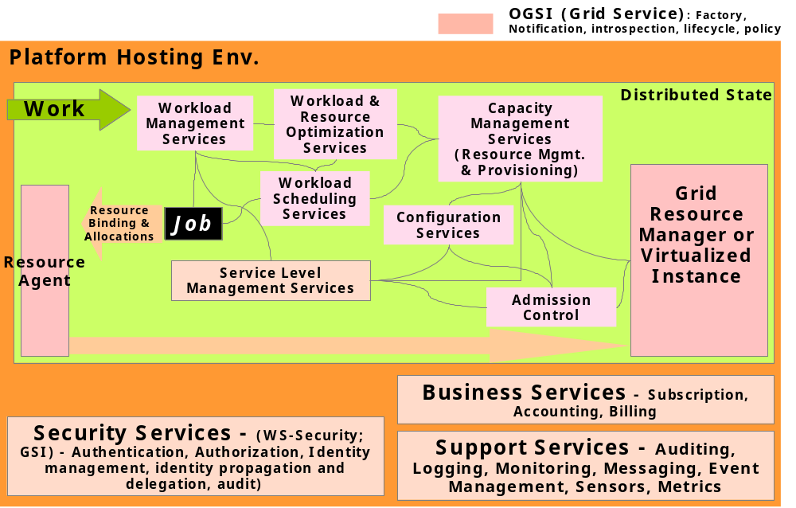
Figure 6: Example Grid execution service interaction

WS-Agreement Based Scheduler Instantiation
To put it in concrete terms, a user who wants to submit a compute job to run on a cluster would have their Grid service client contact a job management service and negotiate a set of agreements that ensure that the job has access to required CPUs, memory, storage space, etc.
WS-Agreement defines fundamental mechanisms based on Agreement services, which represent an ongoing relationship between an agreement provider and an agreement initiator. The agreements define the behavior of a delivered service with respect to a service consumer. The Agreement will most likely be defined in sets of domain specific agreement terms (defined in other specifications), since the WS-Agreement specification is focused on defining the abstraction of the agreement and the protocol for reaching agreement, rather than on defining sets of agreement terms.
Referring back to the job submission example, the client might contact a job management service, which implements the AgreementFactory interface, with creation parameters that say “my job must have a software license for application X, would like to have 8 CPUs, and would like to have 4 Gbytes of RAM.” If the job management service couldn’t provide the software license (the “must have”), the agreement terms would be rejected. If it could provide all of the terms, an Agreement service instance representing the job resources would be created. If, because of available resource constraints, the job management service couldn’t fulfill the terms of the original creation parameters, but could supply either 4 CPUs and 4 Gbytes of RAM, or 8 CPUs and 2 Gbytes of RAM, the job management service could create an AgreementOffer which included two potential agreements: “app X, 4 CPUs, 4 Gbytes” and “app X, 8 CPUs, 2 Gbytes”, one of which the client could choose (because CPUs and memory were terms subject to counter-offers).
By defining various sets of terms for representing different types of resources available within the VO, Community Schedulers can be written which can negotiate with resource managers for the use of the underlying resources on behalf of the user community.
Program Execution services utilize WS-Agreement portTypes both for its client interface and for its interface to underlying resources, with the goal of allowing hierarchical VO deployment – e.g., one Community Scheduler talks to another Community Scheduler-based resource conglomeration. Another key aspect of agreement is to consider the constraints of the service provider based on Service Level Agreements in a business context, and their reflection in underlying resource manager policies. Not all constraints are based simply on the availability or unavailability of resources. Some are management policy specified, based on pricing, usage, higher priorities, and the like.
Figure 7 shows the Grid services required for Program Execution. These services include:
- Agreement Factory Service – create agreement services based on domain specific terms such as job, reservation and data access terms.
- Job Agreement Service – creates, monitors and controls compute jobs.
- Reservation Agreement Service – guarantees that resources are available for running a job.
- Data Access Agreement Service – staging the required application and data.
- Queuing Service – provides a service through which administrators can customize and define scheduling policies at the VO level, and/or at the different resource manager levels.
- Index Service – allows for the propagation of information between resource managers and the metascheduler.
Program Execution services can be flexibly composed to offer a whole spectrum of time-to-result QoS types, ranging from online/interactive to batch with specific or no turn-around time requirements:
- Online/interactive jobs can be sent by the Job Agreement service to the Resource Managers (RMs) immediately, without getting queued.
- Batch jobs will be queued by the Queuing services and dispatched to RMs later. The jobs with specific turn-around time may use the available reservations made with the RMs at specific times so that their deadlines can be met. The jobs with no specific turn-around time can be queued at the VO level or at the backend RM level, until the required resource is available, or can backfill the existing reservations without delaying the start time of the more time-critical jobs.
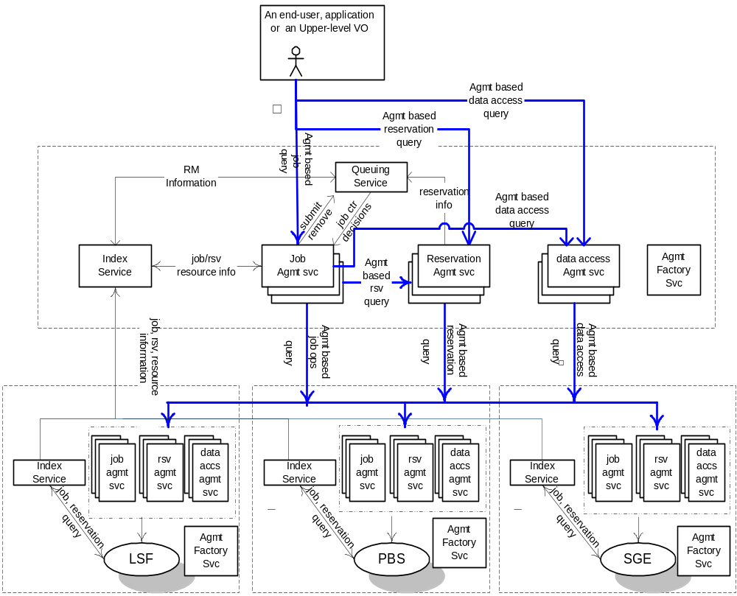
Figure 7: An Instantiation of Program Execution Architecture and Services

Instantiation with “Broker Service”
The Program Execution services must support the types of jobs. After a submitted job-request has been accepted, a broker service is used to select the resources (including the hosting environment) that are necessary to execute the job. [JT: First sentence in this para needs revision.]
After the pre-processing is completed successfully the requester is given a unique reference to the agreement. If necessary resources cannot be allocated, an error should be returned. Otherwise, the agreement can be used to query for information about the job as well as to control it – e.g., to modify job requirements or to cancel the job request.
The submitter can provide the following attributes or terms when submitting a job request.
- The Grid Service, program, or workflow that should be instantiated.
- The starting time of the job, including how long the job will execute.
- Resources, including data, needed by the job. (Resource descriptions could be given in XML.)
- User information.
- SLA information, including priority.
- Application startup script.
When the specified job start time arrives the scheduler must arrange for the job to start executing. If a startup script was specified then the script should be executed. A job may have its resources increased or decreased by the scheduler. Changes in resource allocation must be acknowledged synchronously. When a job terminates, the Program Execution services must carry out the following processing:
- Inform the client of the job’s final status.
- Release the resources allocated to the job by the hosting environment.
- Delete the job from the scheduler’s database.
The scheduling service is responsible for starting and managing all submitted jobs. Each job has a pre-determined start time, but priority and SLA attributes may cause it to be changed. The job state may be retrieved at any time.
Once the resource reservation period has finished then the job must be stopped and the resources used by the job must be returned to the resource management service. Jobs may be temporarily suspended or migrated based on the SLA (priority) associated with each job. Jobs with high priority are executed first.
Scheduling and resource reservation information associated with each job is kept in stable storage so that it is not lost in the event of failure. The scheduling service allows writing and reading of the scheduling data.
Resource reservation information is updated by the resource management service. In addition accounting information, such as which resources were used by the job, and for how long, is also recorded in the database.
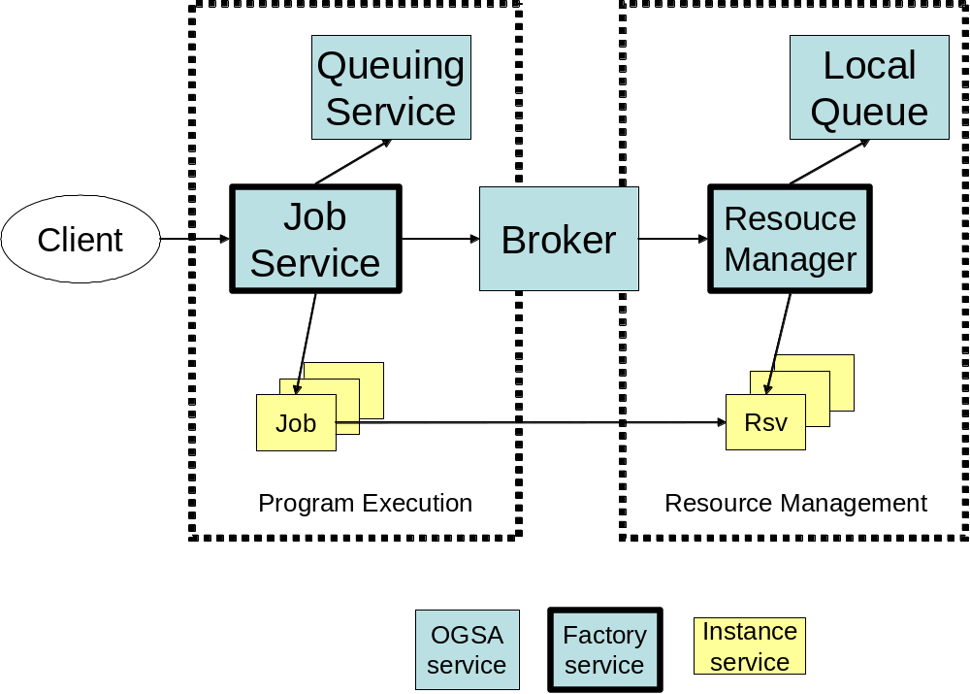
Figure 8: Program Execution with Broker

Resource Management Services
Service orchestration. These interfaces provide ways to describe and manage the choreography of a set of interacting services.
Administration. Standard interfaces for such tasks as software deployment, change management, and identity management.
Provisioning and resource management. Negotiation of service level agreements and dynamic resource allocation and re-distribution consistent with SLA policy, including mechanisms that allow clients and workflows to acquire access to resources and services at a particular (future) time.
Reservation and Scheduling Services. Reservation Services provide the mechanism to make resource reservations at a particular time and for a particular duration. Scheduling Services provide the mechanism to schedule tasks according to their priorities.
Deployment Services. Deploy necessary software (OS, middleware, applications) and data into the hosting environment.

Service Relationships
In §4, we classified services according to a taxonomy in which two services are related (i.e., put into the same category) if their purposes and functionality are similar. However, this taxonomy does not show the relationships that exist between the services when these services are used in practice. Thus, we now present a second categorization based on the perspective of a service provider – i.e., a person implementing or assembling the various components. We define types of relationships between services, and organize the services according to these relationships. We also introduce a new class of service: Platform Services.

Service Composition
A service composition is a Grid service that provides a new set of functions that are derived from, built on, extended from, and/or implemented using functions exposed by other Grid services. All services in the composition are first class services (i.e., each service individually provides distinct functionality and can, if required, operate independently of this service composition) or other compositions. An instance of a service composition (representing a specific set of functional and semantic behaviors) includes (or references) instances of all the services that make up this composition. Each composition has an identity that is shared by the individual component services. The instances may be tightly or loosely coupled to the composite service.
Whether there exists a single mechanism for creating a composite service or whether there are several approaches is an area of continuing effort in several contexts (e.g., OASIS/WSDM, WS-Choreography, ...). At this stage we find it useful to categorize service composition as an initial step in the process of decomposing the service composition problem.
In the tightly-coupled composition, the individual service instances are indistinguishable from the composite to which they belong, and are completely subsumed and hidden by the composite. All interactions with these “composed” services are performed with the composite service. Individual service instances in a tightly coupled composition share the same lifetime and lifecycle characteristics of the composition. In a loosely-coupled composition, the functionality of the loosely coupled services can be accessed independently of the composite service they support.
Service compositions can be either pure or orchestrated. Services in a pure composition share well-defined common state and/or implement a given state in the composite as an aggregate of the individual states in the services. A pure composition can be established either as an implementation composition, meaning that the functionality of the individual services are embedded in a single implemented entity, or as a managed composition, meaning that the individual services in the composition are managed by well-defined internal protocols that provide for a shared identity.
In an orchestrated composition, a master service representing the composition exposes a functionality that is essentially derived by orchestrating a set of loosely coupled services.
[JT: Original author needs to compare the following two paragraphs with v12 and verify that the wording changes I made here are OK.]
OGSA can designate some special composite services and define their functions (and the services they incorporate and the compositional method to be used) similar to other more fundamental services definitions. These composites become first class OGSA services. In other cases, the composition is user-defined.
Service compositions can be heterogeneous, meaning that services in the composition provide dissimilar functions, or homogeneous, meaning that services in the composition are similar in function. A homogeneous composition can be an aggregation of services that are managed as one (more capable) service, as opposed to managing the individual services. In some cases, the service representing the composition will also be the manager for this composite.
Service composition can be used to implement an OGSA batch job scheduler, which provides the same functionalities as existing traditional schedulers for batch systems.
Such OGSA schedulers represent a combination of functionality such as queuing, resource determination, reservation, resource allocation etc., where each of these functions can be implemented by specialized services targeted at these functions, and can be reused for other usage scenarios.
Another example of a service composition is a job. A job may be composed of other jobs or tasks. Since a job is a composition (i.e., a Grid service) it can be managed through well-defined interfaces that are exposed by the service.
A traditional distributed resource management cluster (e.g., PBS, LSF) can also be re-factored using service composition, where the traditional interfaces into such a cluster become the functionality exposed by the composite service representing this cluster.

Service Orchestration
In addition to identifying specific common services, OGSA must describe the common behaviors, attributes, operations, and interfaces needed to allow services to interact with others in a distributed, heterogeneous, Grid-enabled environment.
- Choreography describes required patterns of interaction among Grid services (or, more generally, web services), and templates for sequences (or more structures) of interactions.
- Orchestration describes the ways in which business processes are constructed from web services and other business processes, and how these processes interact.
- Workflow is a pattern of business process interaction, not necessarily corresponding to a fixed set of business processes. All such interactions may be between services residing within a single datacenter or across a range of different platforms and implementations anywhere.
To reduce verbiage, instead of repeatedly referring to “Choreography, Orchestration and Workflow,” we will simply say “Orchestration” in the following.
In the OGSA environment, services, processes and workflows may both be managed by OGSA and be vehicles by which management takes place. OGSI capabilities for stateful web service interaction have much in common with choreography and business process management, but there are technical differences between them (e.g., the use of correlations in the web service world in WSCI and BPEL4WS and explicit Grid service handles/references/locators in the Grid world. Since we may want Grid services to be part of flows and flows to be used in Grids, it will be important to resolve their relationship as soon as possible. This will enable us to take advantage of emerging work at the OASIS Web Services Distributed Management group, which is addressing both Management Of Web Services (MOWS) and Management Using Web Services (MUWS), as well as Change Management for Web Services (and perhaps flows involving them).
OGSI service groups may also play a role in grouping or aggregating services in ways that factor out common usages in Grid service/business process interactions. However, it would be best if such factoring took place directly in organizations such as W3C, OASIS and BPML that are doing work on these concepts. The main role of OGSA should be to determine places where existing work will not meet Grid architecture needs, rather than to create a competing standard. A good summary of many relevant standards appears at: http://xml.coverpages.org/bpm.html.
For example, since a Grid service is a specialized web service with service data, notifications, lifecycles and service groups, we might define ways in which these concepts can/should be leveraged in Grid service interactions that form flows, including ways of monitoring and managing those flows (e.g., using service data and notifications) as well as fault handling. However, there may be mismatches in the lifecycles of (potentially) Grid services and flows that will require thought – another reason why convergence with mainstream web service standards is so important. For example, business processes are typically thought to be long-lasting, not transient, and are not instance-oriented as Grid services are. We are better off cooperating with business process groups, rather than competing with them or defining specializations of these functions. Some concepts that GGF may address, including Quality of Service, Scheduling, Resource Allocation and Provisioning, may want to consider their relationships to business process management and service flows. OGSA should have a role in coordinating how, where and when these aspects get addressed.
Many OGSA services will be constructed using other services; scheduling is one such example. Service-Oriented Architectures are designed to permit invocations of services by other services, so capabilities for services built from services are intrinsic to Grid/web services. Whether additional compositional constructs are needed beyond invocations, workflows/choreography, management, and business transaction/coordination/context (all of which are being addressed by other bodies) has not yet been determined. The notion of composition of stateful services with behavior extended from the services from which the composition is derived is a very important area, and one which web services so far has not addressed, particularly with respect to resource composition and management.

Types of Relationships
OGSA services can be related via “uses” and “extends” relationships.
In a uses relationship, a first service accesses the interface of a second service to use the functionality provided by this second service. For instance, many services use the handle resolver service to convert GSHs to GSRs.
In an extends relationship, a first service extends the functionality provided by a second service by using portType extensibility. A simple example of this relationship is an event service that extends the OGSI notification functionality. Another example is a registry service that extends the service group functionality of OGSI.

Platform Services
We introduce the term platform services to denote services that provide functionalities that are basic, i.e., provide underlying functionalities on which other services build; provide functionalities that are common to (and used by) several high-level services; and that are designed to be used primarily through the “extends” relationship.
The functionality provided by a given platform service is, by definition, present (through extension) in multiple high-level services. As a consequence, platform service functionalities permeate the high-level services, being pervasive within OGSA. For this reason, they do not fit into (and are not shown as part of) the taxonomy of §4.
Platform services form the lower layer of the service relationships, as illustrated in Figure 9. However, a platform service may use or extend other platform services (i.e., there is more than one layer of platform services).

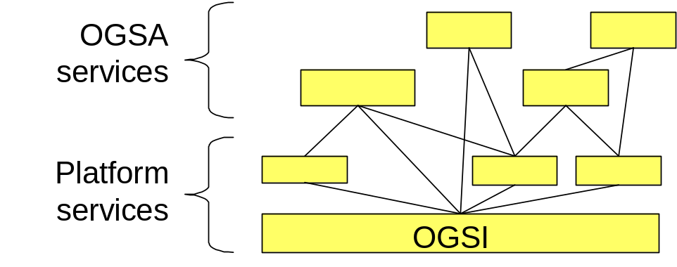
Figure 9: The relationships between OGSI, OGSA platform services, and other OGSA services
As OGSA services are organized and categorized, and as their functionality is defined in more detail, common functionalities among these services will increasingly appear. These functionalities should be re-defined as platform services in order to simplify OGSA. As a consequence, as the work on the definition of OGSA progresses, the number of platform services should increase.
The current set of OGSA platform services is as follows (full descriptions are given in §6):
- OGSI: defines Grid services and the basic mechanisms for creating and managing them, and for exchanging information between them.
- WS-Agreement: provides a set of interfaces that support the negotiation of policies, service level agreements, reservations, etc., and maps the related agreements to Grid services.
- Web Services Distributed Management (WSDM): provides the manageability infrastructure for resources in OGSA. WSDM defines the base behavioral model for resources and resource managers in the Grid, plus management functionality such as relationships and lifecycle management.
- OGSA Data Services (or part of it): provides the basic functionality to manage data in a Grid environment.
The following are areas in which we suspect new platform services remain to be defined:
- Security
- Policy (the management of policies themselves, not the management through policies)
- Information services

Relationships
This section remains to be filled out. The full set of relationships between services will be defined as the services are defined in further detail.

OGSA Services
We provide in §6 a more detailed description of required OGSA functionality. Each section first introduces a specific functionality that must be supported, and then presents the following detailed information:
- A rendering of the functionality in terms of a detailed list of services. This sub-section lists interfaces provided by this service.
- The underlying services that these services depend upon. There are two type of such services: (a) services (infrastructures) which are extended by this service, and (b) services which are used by this services (peer services)
- Any relevant standards that encode all or part of the required functionality. Any related standards that already exist will be specified in this sub-section.
- The owner working group(s) within GGF and/or other standards bodies that have taken responsibility for developing technical specifications.

Handle Resolution
OGSI defines a two-level naming scheme for Grid service instances based on abstract, long-lived Grid Service Handles (GSHs) that can be mapped by HandleMapper services to concrete but potentially less-long-lived Grid Service References (GSRs). These constructs are basically network-wide pointers to specific Grid service instances hosted in (potentially remote) execution environments. A client application can use a Grid Service Reference to send requests (represented by the operations defined in the interfaces of the target service) directly to the specific instance at the specified network-attached service endpoint identified by that GSR.
The format of the GSH is a URI, where the schema directive indicates the naming scheme used to express the handle value. Based on the GSH naming scheme, the application should find an associated naming-scheme-specific HandleMapper service that knows how to resolve that name to the associated GSR. This allows different naming scheme implementations to co-exist, and to provide different QoS properties through their implementations.
The expectation is that different implementations of the two-level naming scheme with the naming directive will enable features such as transparent service instance migration, fault-tolerance through transparent fail-over, high availability through mirroring, and advanced security through fine-grained access control on the name resolution. All these features come with some associated cost, and their applicability will therefore depend on the application itself.
As mentioned, OGSI defines the basic GSH format and portType for the HandleMapper service that resolve a GSH to GSR. The OGSI WG decided to leave the registration of GSH and associated GSR undefined for possible standardization elsewhere. Similarly, the authorization of the naming resolution, as well as the sophisticated features that deal with scalability and robustness, are deferred to other WGs.
One other unresolved issue is how the bootstrap mechanism should work. In other words, given the handle of the very first service to contact, how would a party find the associated resolution service? Currently, this mechanism is left to the implementation, which may decide to use custom configuration data and external naming services, like DNS or the Handle System [JT: Reference to Bibliography item 11 needed here].
Handle resolutions require service invocations and frequent resolutions could therefore affect overall performance. This issue could be addressed by local caching, or possibly by the definition of a generic service that maintains caching information about the GSH-GSR mappings independently from the handle resolution scheme. Caching implementations or strategies are not addressed yet in any WG.

Detailed list of services
TBD.

Underlying services
As the name to network endpoint resolution is a bootstrap service, its implementations could possibly rely on non-Grid services, like DNS or the Handle System.
Furthermore, the name resolution operation is a sensitive operation, which could be subject to access control policy and integrity protection. This would require integration of the associated security services in the resolution and registration operations.

Relevant standards
There are a number of naming services and protocols that could be leveraged for the implementation of OGSI’s handle resolution, such as DNS [9], Avaki’s SGNP, the Handle System, and GT3’s implemented scheme.

Owner working group(s)
There is currently no dedicated working group that drills down on the requirements and possible solutions of the GSH-GSR name resolution.

Virtual Organizations
“Virtual Organizations” are a concept that supplies a “context” for operation of the Grid that can be used to associate users, their requests, and a set of resources. These contexts can be depended on by services as a type of reliable assertion of identity – e.g. this user or resource is a known member of this VO. VO contexts also permit the providers of Grid resources to associate appropriate policy and agreements with the resources they contribute to the Grid. Users and requests that are then associated with the VO are able to exploit those resources in a way that is consistent with those policies and agreements.

Virtual Organization Management provides functions for the creation and management of VOs. These functions include mechanisms for: associating entities such as users and groups with the VO; manipulation of user roles (administration, configuration, use etc.) within the VO; association of services (encapsulated resources) with the VO; and attachment of agreements and polices to the VO as a whole or to individual services within the VO. Finally, creation of a VO requires a mechanism by which the “VO context” is referenced and associated with user requests. (This is most likely to be via a GSH, since a “service” is the likely embodiment of the VO).

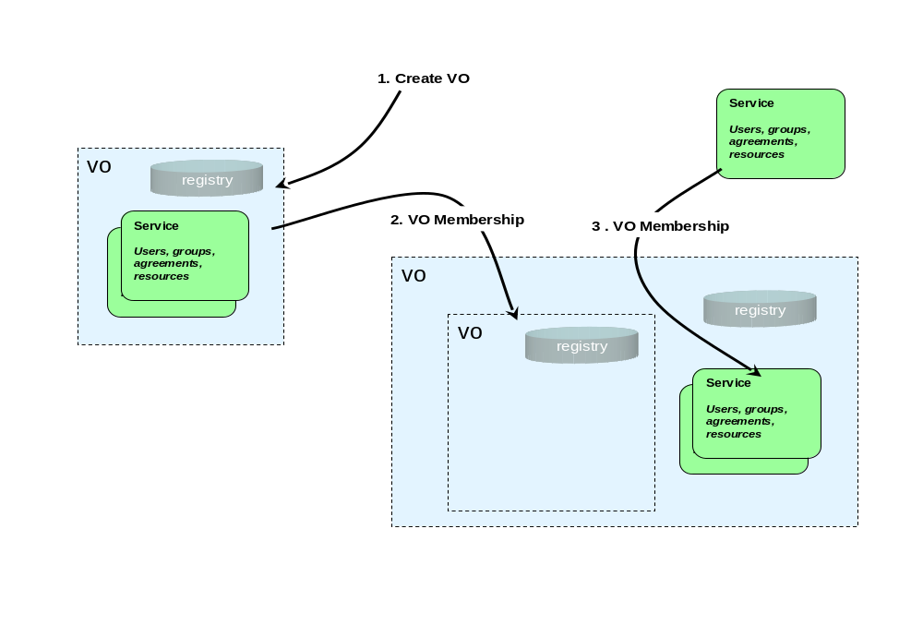
Figure 10: VO creation and membership

Detailed List of Services
VOs can either be stand-alone or combined in a hierarchical containment structure that supports modeling the collection of resources in grids as a set of nested contexts.

Create/Destroy VO – It is expected that VOs will be represented in the service oriented architecture as services and so the general factory pattern should be employed by VO Management Services to allow creation of new VOs. The Create VO service should be modeled as a “factory” that will establish a new service and a reference (handle) for that service that will be used to “address” requests to the new VO. This reference may also serve as a context identifier in the requests (made by users or other services) that are related to a particular VO. VO Management mechanisms should exploit the mechanism for managing service lifecycle (OGSI soft-state) management function of OGSI to establish an initial “time to live” for the new VO, which may be updated as resources, users, groups and polices join and/or leave the VO. An explicit operation may also be provided to destroy a VO. When a VO is eliminated, all relationships that are embodied by that VO are also eliminated. Though interfaces to create new VOs (factories) should be provided, a default VO in a given grid implementation may be extant (without explicit creation), may serve as a “root container,” and may depend on external means (such as DNS names or configuration files) for discovery of its handle.

Relationship to Policies - As with other “factory” interfaces, policies (modeled as Agreements) may be used to specify the requirements for creation of a VO. These policies may contain information that describes how the VO responds to specific requests and how it behaves under specific conditions. The specific components (terms) of these policies (Agreements) may affect both the operation of the VO itself and, indirectly, the behavior of entities that are related to the VO. For example some policies might establish restrictions for membership of entities in the new VO, such as requiring resources and users to support a particular security or authorization mechanism to be able join the VO.

In addition to the policies established by Agreements used in creation of VOs, additional policy templates (Agreements) themselves might be “related” to VOs by the membership mechanism described above. These policies might be applied either as requirements as or defaults to requests that carry a “context” of the VO in the “terms” of their Agreements.

VO Membership Services – The services that represent a VO may support a set of operations for managing the relationships of other entities to the VO. This membership operation can be used to add or delete a relationship of any entity (including an already extant VO) to a VO. Once again, the services for managing Virtual Organizations (VOs) should be built upon the general mechanism for grouping services (OGSA Service Groups), and one or more of these collections may be used as a mechanism for maintaining associations of users, groups, resources and policies with the VO.

In particular, in addition to recording the relationship of an entity to the VO, these membership functions may also update state data related to a VO by storing context information (probably the VO reference) in an element associated with the service that represents the entity. Since entities (VOs, users, resources, policies) may be related to more than one VO, these “back pointers” are actually lists of the VOs with which the entities are associated. The service implementing a VO may also subscribe to events or notifications, to enable it to monitor the states of entities related to a VO so that it can update its information if entities are destroyed, either explicitly or automatically, by life-cycle functions. Refer to Figure 11 for an illustration of a VO structure.

As with many such structures, it is difficult to guarantee the consistency of both the primary registry entries and the “back pointers.” While the information in the VO Registry is considered authoritative, the “back pointer” information in the service data of members of the VO is only contingently consistent, and should be verified by any service that requires authoritative evidence of membership for functions such as security, trust or authorization.

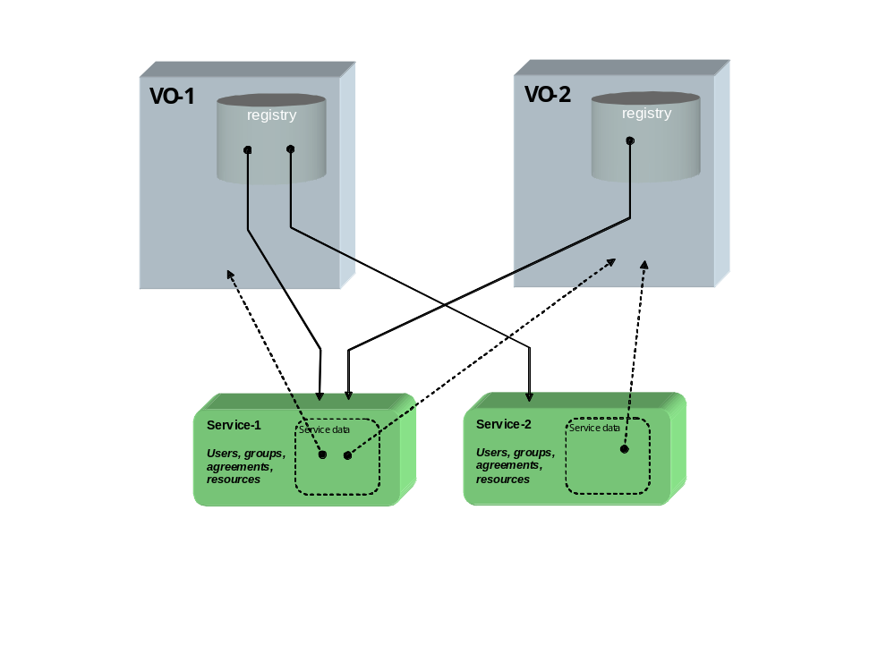
Figure 11: VO membership and “back pointers”

VO Registries –VO Registries enumerate the “population” of entities that are related to a VO. The specific nature of different sorts of entities and their relationship to the VO can be recorded in the registry as a set of attributes in one or more indices. VO Registries permit support for queries against the membership of the VO that will allow resource managers to discover these relationships. For example, a management component such as a scheduler might execute a query against one of these service groups to retrieve a list of a particular class of resources that are available as elements of a VO.

The Membership Service described above acts to maintain the registry of all the entities that are related to VOs. When new relationships between extant entities (including VOs) are made using the Membership Services, entries for them will be added to these indices. These registries can also be maintained by exploiting the general mechanism for state change propagation (OGSI Notification) to permit “pruning” of these indices when entities change their relationship to VOs. The content model for these indices should contain information that will allow both people and programs using and managing the grid to discover VOs that are of interest to them. Specifically, some type of index of attributes for VOs should be implemented that can contain general information that records things such as externally readable names for the VO, the purpose the VO was created to serve, the organization that is responsible for its management, etc.

Underlying Services
VO Services as described above rely heavily on the Service Group/Collection mechanism supplied by OGSI. They may also utilize the soft-state life-cycle mechanism and notifications to bind the relationships between VOs and the entities that compose them, and to maintain consistency of the registries with the state of the actual services that represent those entities.

VO Services also rely on the OGSI-Agreement framework to define a general mechanism for management of VOs. A specific set of Agreement terms will have to be defined that will be particular to policies that control the management of the VO Creation and Membership Services. These will include terms that may define roles with respect to the VO management (e.g. what requesters are permitted to add to, change, or delete relationships of other entities to the VO). They might also include terms that will enforce requirements for adherence to particular functional policies (e.g. security, privacy or trust methods, metering, auditing or accounting mechanisms, and resource usage limitations).

Related Standards
OGSI
WS-Agreements

Owner WG
OGSA Working Group

Service Groups and Discovery Services
Grid Service Handles (GSHs) and Grid Service References (GSRs) together realize a two-level naming scheme, with HandleResolver services mapping from handles to references. However, GSHs are not intended to contain semantic information, and indeed may be viewed for most purposes as opaque. Thus other entities (both humans and applications) need other means for discovering services with particular properties, whether relating to interface, function, availability, location, policy, or other criteria.
Traditionally in distributed systems this problem is addressed by creating a third-level “human-readable” or “semantic” name space that is then mapped (bound) to abstract names (in our case, GSHs) via registry, discovery, metadata catalog, or other similar services. It is important that OGSA defines standard functions for managing such name spaces, as otherwise services and clients developed by different groups cannot easily discover each other’s existence and properties. These functions must address the creation, maintenance, and querying of name mappings. Two types of such semantic name spaces are common—naming by attribute, and naming by path.

Detailed list of services
Attribute naming schemes associate various metadata with services and support retrieval via queries on attribute values. A registry implementing such a scheme allows service providers to publish the existence and properties of the services that they provide, so that service consumers can discover them. We envision special purpose registries being built on the base service group mechanisms provided by the OGSI definition. In other words, an OGSA-compliant registry is a concrete specialization of the OGSI service group.
A ServiceGroup is a collection of entries, where each entry is a Grid service implementing the ServiceGroupEntry interface. The ServiceGroup interface also extends the GridService interface. There is a ServiceGroupEntry for each service in the group (i.e., for each group member). Each ServiceGroupEntry contains a serviceLocator for the referred-to service, and information (Content) about that service. The content element is an XML element advertising some information about the member service. The type of the Content element conforms to one of the QName elements in the ContentModelType SDE of the ServiceGroup interface.
It is the content model of the service group definition that suggests the concrete type and specific use of the registry being offered. The content model of the serviceGroupEntry for a given service group is published in the service data of the service group. The content model is the basis on which search predicates can be formed and executed against the service group, using the findServiceData operation. In other words, it is the content model that forms the basis of the registry index upon which registry searches can be executed. It is envisioned that many application-specific, special-purpose registries will be developed.
It is also envisioned that many registries will inherit and implement the notificationSource interface so as to facilitate client subscription to register state changes. Again, specific state change subscriptions will be possible through the advertisement of the registry-specific service group content model of the service group on which the registry is built.
As stated earlier, we envision many application-specific registry implementations being defined. Whether or not one or more general-purpose registry types should be defined and adopted as part of OGSA is to be determined.
Path naming or directory schemes (as used, for example, in file systems) represent an alternative approach to attribute schemes for organizing services into a hierarchical name space that can be navigated. The two approaches can be combined, as in LDAP. Directory path naming can be accomplished by defining a PathName Interface that maps strings to GSHs. Thus a string such as “/data/genomics_dbs/mouse” could map to a service (GSH) that might deliver portions of the mouse genome, and perhaps also do BLAST searches against the mouse genome. Similarly, “/applications/biology/genomics/BLAST” could map to a GSH that has Interfaces for executing BLAST.
The interface will have methods to insert, lookup, and delete <string, GSH> pairs, and will in essence be a simple table. It is expected that path_name services will be “chained” together, so that evaluation of a path may involve traversing several path_name services, forming a directed graph. This can be used to link disjoint namespaces into namespace cliques.

Underlying services
TBD.

Related standards
TBD.

Owner working group(s)
TBD.

Choreography, Orchestration and Workflow
TBD: Workflow Management description here.

Detailed list of services
OGSA should extend these interfaces to provide a rich set of behaviors (and associated operations and attributes) for business process management, by working either with external groups, with GGF groups, or with both. The following aspects are candidates. If the first is addressed, the others will be greatly simplified.
- Working through relationship between Grid services and business processes so that we do not have redundancy of closely-related concepts
- Definition of choreography, orchestration and workflow for the Grid, allowing web services to be part of such flows, as well as Grid services (with service data, notification, service collections, transient lifecyles, etc.) [Jeff Nick: When we get to convergence between web service and grid service, this will be difficult to label as grid service workflow.]
- Scheduling, quality of service, exception handling and policy applied to Grid flows; security, provisioning and resource management too.
- Management and monitoring of Grid flows; management and monitoring using Grid flows; change management for Grid flows (as in OASIS WSDM group).

Underlying services
- Definition of a job flow, including associated policies
- Assignment of resources to a Grid flow instance
- Scheduling of Grid flows (and associated Grid services)
- Execution of Grid flows (and associated Grid services)
- Common context and metadata for Grid flows (and associated services)
- Management and monitoring for Grid flows (and associated Grid services)
- Failure handling for Grid flows (and associated Grid services); more generally, managing the potential transience of Grid services
- Business transaction and coordination services. [Jeff Nick: First, it is difficult to identify what is Grid-unique here, versus general purpose distributed workflow and scheduling. Second, we must be careful not to reinvent WS-Transaction and WS-Coordination, but rather leverage those specifications.]

Relevant standards
As mentioned above, see http://xml.coverpages.org/bpm.html as well as the OASIS WSDM group. Related works includes WS-Choreography/WSCI, Web Services Business Processes/BPEL4WS, WS-CAF, BPMI/BPML, ebXML BPSS and more.

Owner working group(s)
This item may cross the boundaries of many GGF groups, rather than being the province of a single group. The general issue of what a Grid flow is and how Grid flows relate to business processes may have to be addressed by OGSA, so that we avoid redundancy and proliferation.

Transactions
Transaction services are important in many Grid applications, particularly in industries such as financial services and in application domains such as supply chain management. However, transaction management in a widely distributed, high latency, heterogeneous RDBMS environment is more complicated than in a single machine room with a single vendor’s software. Traditional distributed transaction algorithms, such as two-phase distributed commit, may be too expensive in a wide area Grid, and other techniques such as optimistic protocols may be more appropriate. At the same time, different applications often have different characteristics and requirements that can be exploited when selecting a transaction technique to use. Thus, it is unlikely that there will be a “one size fits all” solution to the transaction problem.

Detailed list of services
TBD

Underlying services
TBD

Relevant standards
Transaction services are also being closely examined in the Web services community. For example, WS-Transactions has been recently “proposed” [2]. This initiative should be tracked closely.

Owner working group(s)
TBD

Metering Service
Different Grid deployments may integrate different services and resources and feature different underlying economic motivations and models. However, regardless of these differences, it is a quasi-universal requirement that resource utilization can be monitored, whether for purposes of cost allocation (i.e., charge-back), capacity and trend analysis, dynamic provisioning, Grid-service pricing, fraud and intrusion detection, and/or billing. OGSA must address this requirement by defining standard monitoring, metering, rating, accounting, and billing interfaces. These interfaces can use or extend those defined by Web Services Distributed Management (WSDM), which provides access to basic resource performance and utilization instrumentation. For example, an operating system might publish counter values corresponding to the state of system activities such as CPU utilization, memory usage, disk and tape I/O activity, network usage, etc. While these interfaces do not provide the values needed for metering and accounting directly (since, for instance, they are not directly related to the consumers), they can provide basic monitoring data to be used by the metering and accounting services.
We address metering in this subsection, and rating, accounting, and billing in the sections that follow.
A Grid service may consume multiple resources, and a resource may be shared by multiple service instances. Ultimately, the sharing of underlying resources is managed by middleware and operating systems. All modern operating systems and many middleware systems have metering sub-systems for measuring resource consumption (i.e., monitored data) and for aggregating the results of those measurements. For example, all commercial Unix systems have provisions for aggregating prime time and non-prime time resource consumption by user and command.
A metering interface provides access to a standard description of such aggregated data (metering serviceData). A key parameter is the time window over which measurements are aggregated. In commercial Unix systems, measurements are aggregated at administrator-defined intervals (cron entry), usually daily, primarily for the purpose of accounting. On the other hand, metering systems that drive active workload management systems might aggregate measurements using time windows measured in seconds. Dynamic provisioning systems use time windows somewhere between these two examples.
Several use cases require metering systems that support multi-tier, end-to-end flows involving multiple services. An OGSA metering service must be able to meter the resource consumption of configurable classes of these types of flows executing on widely-distributed, loosely-coupled server, storage, and network resources. Configurable classes should support, for example, a departmental charge-back scenario where incoming requests and their subsequent flows are partitioned into account classes determined by the department providing the service. The metering of end-to-end flows in a Grid environment is somewhat analogous to the metering of individual processes in a traditional OS. Since traditional middleware and operating systems do not support this type of metering, additional functions must be accommodated by OGSA. In addition to traditional accounting applications, it is anticipated that end-to-end resource consumption measurements will play an important role in dynamic provisioning, and in pricing Grid services.
Finally, in addition to metering resource consumption, metering systems must also accommodate the measurement and aggregation of application-related (e.g., licensed) resources. For example, a Grid service might charge consuming services a per-use fee. The metering service must be able to support the measurement of this class of service (resource) consumption.

Detailed list of services
TBD.

Standard schema/documents
TBD.

Underlying services
A very important construct to be supported for metered usage is the context which serves as the correlator for resource consumption associated with a particular application or user.

Related services
Resource Usage service, Logging service.

Relevant standards
TBD.

Owner working group(s)
The GGF RUS-WG.
The GGF GESA-WG defines services that use the metering service.

Rating Service
A rating interface needs to address two types of behaviors. First of all, once the metered information is available, it has to be translated into financial terms. That is, for each unit of usage, a price has to be associated with it. This step is accomplished by the rating interfaces, which provide operations that take the metered information and a rating package as input and output the usage in terms of chargeable amounts. For example, a commercial UNIX system indicates that 10 hours of prime-time resource and 10 hours of non-prime-time resource are consumed, and the rating package indicates that each hour of prime-time resource is priced at 2 dollars and each hour of non-prime-time resource is priced at 1 dollar. A rating service will apply the pricing indicated in the rating package and translate the usage information into financial information in the terms of 20 dollars of prime-time resource charge, and 10 dollars of non-prime-time resource charge.
Secondly, when a business service is developed, a rating service is used to aggregate the costs of the components used to deliver the service, so that the service owner can determine the pricing, terms and conditions under which the service will be offered to subscribers.

Detailed list of services
[Jeff Nick: I think we should be careful not to step into territory we are not equipped to address! Billing, rating, and accounting systems exist throughout the industry. I would suggest we focus on the plugability of such subsystems to the grid infrastructure to access captured metrics associated with a user (application) context.]

Standard schema/documents
TBD.

Underlying services
TBD.

Related services
TBD.

Relevant standards
TBD.

Owner working group(s)
TBD.

Accounting Service
Once the rated financial information is available, an accounting service can manage subscription users and accounts information, calculate the relevant monthly charges, and maintain the invoice information. This service can also generate invoices and present them to the user. Account-specific information is also applied at this time. For example, if a user has a special offer of 20% discount for his usage of the commercial UNIX system described above, this discount will be applied by the accounting service to indicate a final invoiced amount of 24 dollars.

Detailed list of services
TBD.

Standard schema/documents
TBD.

Underlying services
TBD.

Related services
TBD.

Relevant standards
TBD.

Owner working group(s)
TBD.

Billing and Payment Service
Billing/Payment service refers to the financial service that actually carries out the transfer of money. For example, a credit card authorization service.

Detailed list of services
[Jeff Nick: I think we should be careful not to step into territory we are not equipped to address! Billing, rating, and accounting systems exist throughout the industry. I would suggest we focus on the plugability of such subsystems to the grid infrastructure to access captured metrics associated with a user (application) context.]

Standard schema/documents
TBD.

Underlying services
TBD.

Related services
TBD.

Relevant standards
TBD.

Owner working group(s)(s)
The GGF GESA-WG defines a banking service.

Installation, Deployment, and Provisioning
Computer CPUs, applications, licenses, storage, networks, and instruments are all Grid resources that require installation, deployment and provisioning. Other new resource types will be invented and added to this list. OGSA needs a framework that allows resource provisioning to be done in a uniform, consistent manner.

Detailed list of services
[Jeff Nick: Lots of work to be done here. This section clearly reads on the CMM resource services, rendering resource types as services, with port type operations for various management disciplines, including install. What do we consider the difference between installation and provisioning? I might assert that not all provisioned resources are installed…i.e. they may exist a priori and be dynamically assigned for a particular use, which is a form of provisioning.
Another key service behavior with respect to provisioning is agreement. Yet another would be policy assertion and constraints.]

Underlying services
TBD

Relevant standards
TBD

Owner working group(s)(s)
TBD.

Application Contents Service
In order to install and operate complex systems such as three-tier systems more efficiently and automatically it is necessary to specify and manage as a unit a lot of different application related information. The Application Contents Service provides central management of such application information. Contents include deployment contents such as program binaries and configuration data, descriptions of the hardware resources typically required by each component, and also various elements such as descriptions of procedures for lifecycle management and management policies typically applied to the running system. Systems may already have a history of correct operation, including performance validation. Such information should also be included as part of the application information since it can be used by the Grid system to provide more predictable operation.
In this section a job refers to the service created by the Job Manager possibly as a result of a user submitting a job description document. The application is a logical unit of content and configuration data that may be referred to by a job description as a short-hand method of specifying a well known and tested configuration that can be used to instantiate the desired job. A number of job descriptions may refer to the same application and therefore a number of jobs using the same application content may be instantiated at the same time. There is typically no interaction between the Application Contents Service and the Job or Job Manager after the application content has been used to instantiate the job.
Application and job have different lifecycles and are used by different actors. Consider for example the scenario of a business activity manager (CDC use case) executing a job at a data center. Before the business activity manager can submit the job the application must be developed. The skills and responsibilities needed for these various steps are different and are carried out by different actors.
- Application provider
An Application Provider develops the various programs and also prepares items such as configuration data and descriptions of procedures that are required to execute programs correctly. Then the Application Provider collects these application contents, puts them into a deployable format and registers them with the Grid system.
- Business activity manager
A Business activity manager submits the job description document and creates the job. The Business activity manager monitors job status, changes parameters if necessary, and handles failures. The Business activity manager does not need detailed knowledge of the applications nor the skill to describe things such as low level configuration and procedures to deploy, start, or stop programs. But the Business activity manager must understand the function of application and have the skills for using the tools provided by the Grid system.

The information that defines an application is used by various OGSA services. There may also be some information that is shared by multiple services, or information that may have to be updated at a later stage, e.g., when a new version of the application is developed. The application provider could submit the appropriate information to each OGSA service separately but would then have to manage changes of application contents directly. The purpose of the Application Contents Service is to remove the burden of content management from the application provider.

Application Contents Service
OGSA Services
Application Contents
Management
Application Contents
Access

Deployment Service
Access
Configuration Service
Notification

Registration
Patch

Discover
Application provider

Verification Service

Application Contents repository
Note: The list of services is informational.

Figure 12: Application Contents Service
Figure 12 illustrates the Application Contents Service. The application provider registers and updates the application contents through the Application Contents Management interface. The Application Contents Service also exposes the Application Contents Access interface to various OGSA services that use application contents.

List of detailed services
The following interfaces are defined:
- Application Contents Management Interface to provide a means for the application provider to manage application contents. This interface would include, for example, the ability to register or delete application contents (“Registration”), search for content that has been registered (“Discovery”), and update application contents (“Patch”). It is expected that versioning is supported. That is, registered application contents are not overwritten, but instead updates are stored as differences.
- Application Contents Access Interface to allow various OGSA services to access application contents. OGSA services can also receive notifications when application contents changes.

Standard schema/document
An Application Archive Format that can describe an application in a single file would simplify registering new application content and moving application content between sites. The Application Archive Format is similar in spirit to the ear format of J2EE. In the J2EE world, if an application server follows the J2EE specifications then, regardless of the vendor, it can execute applications contained in ear files within the scope of the J2EE specifications. In addition to interoperability, reasons that archive specifications such as ear have been widely accepted include ease of use, the ability to add signatures, and ease of productization. So, in the Grid world as well, the provision of a basic format for registering applications with the Application Contents Service can accelerate the growth of Grid services.
At this time we cannot list all the necessary elements that define an application. Before determining the different elements that make up an application it is first necessary to determine the OGSA services that use application contents. This is an area currently being studied by OGSA and other WGs.
The following are some possible elements of application contents based on existing data center management systems:
- Application Structure Description
This description defines the logical structure of the application. It corresponds to the Configuration Description (CD) of the CDDLM-WG.
- Deployment Contents
The deployment contents, such as class files or configuration data, that will be loaded on the appropriate hosting environment at deployment time.
- Configuration Parameters for Application
These parameters are used to configure the application. They must be specified at deployment time so that the application runs properly. This information is included in the CD of the CDDLM-WG.
- Configuration Parameters for Hosting Environment
These parameters are used to configure hardware resources, the OS or middleware. This information is included in the CD of the CDDLM-WG.
- Procedures for Lifecycle Management
Such procedures define how to initialize, start and terminate the application. Checkpointing and restarting procedures may also be defined. The procedures may take a variety of forms, e.g., scripts or workflows. They are deployed to the appropriate location, e.g., hosting environment, as part of job instantiation. The procedures are executed when there is a change in the job lifecycle state. The job lifecycle state is now under discussion in CDDLM-WG and OASIS WSDM-TC.
- Management Policies
These are policies that should be followed when an event, such as a failure or a load change, occurs. The policies are registered with the appropriate service, e.g., the fault management service, as part of job instantiation. A policy is applied when the specified event occurs to the job.
- Verification descriptions
Resource descriptions (possibly expressed as constraints) that are known to support correct operation of the application. The descriptions can be used by the appropriate services to verify that the resources allocated when instantiating a job do in fact provide the environment needed to execute the job.
- TBD: Health-check procedures: determine whether the instantiated job is in the expected operational state. Stored in ACS and registered with appropriate service as part of job instantiation.

Example of Application Structure Description
Example Application Structure for a 3 tier system:

Web

LB
EJB
DB
Web

...
web component group

<ASLogicalStructure>
<as name="ASWeb3Tier">
<as name="ASWeb">
<flow/> defines the procedure to deploy, start, stop or remove the job component.
<flow name="..." value="..." portTypeName="..."/>
<as name="LeafASLB">
<flow name="..." value="..." portTypeName="..."/>
</as>
<as name="LeafASWeb">
<scalability scalable="true">
<function>loadbalancer</function>
</scalability>
<flow name="..." value="..." portTypeName="..."/>
<software type="web" name="petstoreWeb" value="petstore.ear">
<version major="1" minor="1" revision="2"/>
</software>
</as>
</as>
<as name="ASEJB" xsi:type="struct:EJBASType">
...
</as>
<as name="ASDB" xsi:type="struct:DBASType">
...
</as>
<flow name="..." value="..." portTypeName="..."/>
</as>
</ASLogicalStructure>

Example of Verified Resource Description
For Web Server:
Number of Hosts: 3
Disk: 30 ~ 60GByte
CPU: Pentinum(R)III, 1130MHz
Memory: 256 MByte ~
OS: Red Hat Enterprise Linux AS, ver. 2.1
Web Container: Java(TM) 2 Platform, Enterprise Edition Application Server, ver. 1.4

<numberOfHosts wsa:count="3"/>
<host>
<allDisk unit="Gbyte">
<minimum wsa:amount="30"/>
<maximum wsa:amount="60"/>
</allDisk>
<CPUDescription>
<CPUType wsa:string="Pentium(R) III"/>
<CPUClock unit="MHz">
<minimum wsa:amount="1130"/>
</CPUClock>
</CPUDescription>
<physicalMemorySize unit="Mbyte">
<minimum wsa:amount="256"/>
</physicalMemorySize>
<OSType wsa:string="Red Hat Enterprise Linux AS"/>
<OSVersion wsa:string="2.1"/>
<WebContainerName wsa:string="Java(TM) 2 Platform, Enterprise Edition Application Server"/>
<WebContainerVersion wsa:string="1.4"/>
</host>
.....

Example of Management Policies
Below is a sample policy that defines the procedure to be followed when the MachineFailure event at level 5 occurs.

<eventPolicyRule>
<policyRuleName>ReplaceWebServerOnMachineDown</policyRuleName>
<eventTypeID>
<notificationID>MachineFailure</notificationID>
<level>5</level>
</eventTypeID>

<jobFlowDefinition>
ReplaceWebServerOnMachineDown.far.xml
</jobFlowDefinition>
<jobOperationName>ReplaceWebServerOnMachineDown</jobOperationName>
<jobPortNamespaceURI>http://..../JobFlowManager</jobPortNamespaceURI>
<jobPortLocalPart>JFIPortType</jobPortLocalPart>
</eventPolicyRule>

Underlying services
Notification interface to provide notification of changes of application contents.
Data Services.

Related services
CDDLM: Deployment Service
OGSA: Job and Job Manager.
Other related services (mainly PE).

Related standards
TBD

Owner WG
TBD

Fault Management

Detailed list of services
TBD

Underlying services
TBD

Relevant standards
TBD

Owner working group(s)
TBD.

Problem Determination

Detailed list of services
TBD

Underlying services
Log services and trace services.

Relevant standards
TBD

Owner working group(s)
TBD.

Information and Monitoring Service
A key component of a grid is a distributed Information and Monitoring Service that can provide both static and dynamic information about the state of Grid resources, services and applications (e.g. computing fabrics, networks, storage, application monitoring). This information can be used for tasks such as fault detection, performance analysis and job scheduling.
It is observed that certain types of information change with greater frequency, but no attempt is made here to distinguish between an information service and a monitoring service.
For grid monitoring, an accepted architecture within the GGF is the Grid Monitoring Architecture (GMA) that has been submitted as an informational document by the Performance Working Group within the Information Systems and Performance Area of the GGF. The Information and Monitoring Service described here is derived from the GMA.
The Grid Monitoring Architecture, shown in Figure 1, consists of three components: consumers, producers and a directory service that is referred to as a registry here to avoid any implied structure. Producers describe the type and structure of information they want to make available. Consumers perform queries to find out what type of information is available and locate producers that provide such information. Once the consumer’s query is satisfied and the information source is known, then the consumer can contact the producer to obtain the relevant data.

event publication information
Consumer
Producer
event publication information
Directory
Service
events
Figure 1: Grid Monitoring Architecture components, reproduced from “A Grid Monitoring Architecture”, a GWD-I (Informational) document from the GGF Performance Working Group (GWD-Perf-16-3).

As explored within the OGSA Use Cases document, the Information and Monitoring Service is required so that a user can either produce or consume information. The OGSA Information and Monitoring Service is derived from the GMA in that it describes consumers and producers but not a registry. The publication and discovery of consumers, producers and event information is provided by additional related OGSA services. Therefore, for an Information and Monitoring Service two sets of operations are considered, the Client/Consumer and Client/Producer operations, as shown in Figure 2.
Consumer
Producer
Client/Consumer operations
Client/Producer operations
Figure 2: Information and Monitoring Service

By standardizing the interface to an Information Monitoring Service and using other standard OGSA services, such as mediation, registration and discovery, an inter-operable OGSA grid Information and Monitoring Service can be built.

Requirements

General
- Fresh and archive data should be handled in a uniform manner.
- The system should associate each measurement with the time when it was made and with the originator or the information
- The information system should not impose limits in the number of contributing nodes.
- There must be no single points of failure.
- Partial network failures should have minimal impact. The system should recover once the network is back.

Producers
- A user must be able to publish data (via a Producer) even if the type of this data is not previously known to the system.
- When registering a Producer it must be possible to specify via an arbitrary predicate what partition of the information is available from that Producer. This is known as the partitioning predicate.
- It shall not be possible to publish data of a type that is not consistent with a type definition already registered within that VO.
- It shall not be possible for a Producer to publish data that are inconsistent with its partitioning predicate.
- Producers may offer varying qualities of service.

Consumers
- A user must be able to locate all Producers of information within the VO and determine their partitioning predicates.
- A Consumer should be able to obtain information from a Producer on a one off basis.
- A Consumer should be able to obtain a stream of new information as and when it becomes available from a Producer.
- Any query should be answerable by a Consumer though the information it needs is widely scattered throughout the system.

Security
- It must be possible to restrict knowledge of the existence of Producers of information to specific authorised users. If the user is not aware of what Producers exist, they do not know there are resources to which they are not allowed access. This makes it much harder for the attacker.
- A Producer must be able to restrict read access to information to specific authorised users. Access must be controllable at a fine level of granularity.
- A Producer must be able to restrict the publishing of information to specific authorised users. We need control over who is permitted to place information into the system. This is both to avoid being flooded with information from a faulty program or from a hacker and also to avoid the publishing of misleading information.

Producer Service
A producer service provides the ability to put events or data into the Information and Monitoring Service. A client must first specify the information they will make available to the Grid, where the type and structure of that information should be well defined. Expected behavior is that the producer service would then inform a registry of the existence of the producer and of the type and structure of information it makes available, thereby allowing for discovery.
The producer may have certain properties and policies; similarly a client may wish to specify a policy describing the required properties of a producer. This could include how the information is held (e.g. using an associated back-end repository), or higher-level service properties such as retention periods, guarantee of delivery and persistency.
A client, using the OGSA Information and Monitoring Service, will instantiate a producer instance to enable it to regularly publish events. During the creation of a producer instance issues such as producer properties, policies and agreements are addressed through future OGSA mechanisms, such as factory, agreement and policy. The creation process will verify that the events are not inconsistent with a recognized description or schema using the OGSA Event or Schema services. The client/producer will then be ready to produce events.
There may be a requirement to relate the lifetime of a producer to an expected frequency of published events. The producer will then refresh its lifetime after each publication. If the producer fails to publish further information before an agreed time, then it times out and destroys itself.
It is assumed that mechanisms to alter properties and/or change policies and agreements will be defined elsewhere in the OGSA platform services. These mechanisms would include checking the status of the producer for information such as subscribed consumers and events currently available.

Producer Properties
It must be possible to request, discover and alter the properties of a producer. These properties include:
- Security Policy.
- Type and structure of information produced.
  - Expected frequency of publication of this information.
- Registry service end-point.
- Consumers currently connected.
  - Indication of what consumers are consuming (not necessarily all information produced).
  - Lifetime of association between consumer and producer.
- Retention policy for information.
- Persistence of information.
- Quality of delivery from producer to consumer.
- OGSA Schema/Event services used.

It is yet to be decided which properties of a producer will be mutable.

List of interfaces
The Producer Service provides the following operations:
- Publish – make a single event or set of events available to a consumer. This needs to be extensible to provide for different implementations with different underlying structures. There should be a common base directly related to OGSA Events described elsewhere. These events could be tuples of information, for example <event_name, event_measurement, event_time>. The mechanism that allows tuples to be published should also allow the publishing of a query expression, such as XUpdate or SQL (e.g. “INSERT INTO newTable (42,’John’,’Doe’,’Y’)”). A producer should be able to accept multiple events simultaneously for publishing.

Consumer Service
A Consumer Service provides the ability to consume events from the Information and Monitoring Service. Similar to a producer, the creation of a consumer instance should allow the specification of both consumer and producer properties, such as the type of data to be consumed, policies and agreements through recognized OGSA mechanisms, such as factory, agreement and policy.
Several types of applications have been identified that incorporate a consumer:
- Archiver – aggregate and store event data in long-term storage for later retrieval or analysis. An archiver could also act as a producer when data is retrieved from storage (see the joint consumer/ producer description below).
- Real-time monitor – collect monitoring data in real time for use by online analysis tools.
- Overview monitor – collect events from several sources and use the combined information to make a decision that could not be made on the basis of data from one producer. For example, one might trigger a call to the system administrator's pager at 2:00 am if greater than 10% of servers are down.
The expected behavior for a consumer is that OGSA Event and Schema services will be used to verify the request for data to be consumed. A registry/mediator service could then be used to locate suitable producers to contact. The consumer can then use OGSA notification services to subscribe to the producer and obtain the relevant data.
The creation of a consumer should be extensible, similar to a producer, with the ability to publish and support additional query languages such as SQL and XPath. A consumer could be created by specifying events of interest using OGSA Event services, or a supported query could be specified to further refine the events returned through predicates defined in the query expression, for example, “where cpuLoad > 0.5”.

Consumer Properties
It must be possible to request, discover and alter the properties of a consumer. These properties include:
- Security Policy.
- Type and structure of information consumed.
- Effectively the query expression, if appropriate.
- Registry service end-point.
- Mediator/Query Planner service address.
- Producers currently connected.
  - Indication of what producers are producing (not necessarily all information required).
  - Lifetime of association between consumer and producer.
- Retention policy for information.
- Amount of information currently available.
- Persistence of information.
- Consumer state (i.e. Is the current query executing?).
- Quality of delivery from producer to consumer.
- OGSA Schema/Event services used.
- Requested properties that a producer must contain.
It is yet to be decided which properties of a consumer will be mutable.

List of interfaces
The Consumer Service provides the following operations:
- GetEvents – retrieve a single event or set of events. The format returned should be extensible to allow for events to be returned in a format corresponding to the query specified at creation time. For example, ResultSet for SQL and Document for XPath.
- QueryOnce – executes the query or retrieves events specified within the Information and Monitoring Service. The operation completes when the query has finished or after the first set of events have been returned. If asynchronous, then a GetEvents operation must be subsequently called to retrieve the events.
- StartQuery – starts the execution of the query or starts to retrieve the events from the Information and Monitoring Service. This operation results in streams of relevant events arriving at the consumer, where these events can then be consumed by the client. Should allow a query to be run against information for a specified period in time:
  - in the past, for example against archive data.
  - in the present, for example against application data.
  - in the future, for example against batch-run overnight data.
The ability to satisfy a query for a specified period in time would depend upon the retention policies of relevant producers.
- StopQuery – stops the consumer service. Effectively stops the previous subscription operation. No fresh events will arrive at the consumer service.
- GetProducers – returns the list of producers that satisfy the Consumer’s query. The user is then free to contact any of the producers directly to retrieve events, using one the other Consumer methods.

Joint Consumer/Producer (Aggregators, Filters)
In addition, consumers and producers could be combined to provide many other services. Examples of these services include event filtering (via mediation, as described by the OGSA Distributed Logging platform service), caching, and intermediate processing of raw data as requested by a consumer. For example, a scheduling consumer might request that a prediction model be applied to the CPU load measurement history from a particular compute resource, and be notified only if the predicted load falls below a specified threshold, indicating that the resource is ready to accept new tasks. A consumer would be used to collect the CPU load measurements and the prediction model is applied to the measurement data. Any resulting events can then be made available to the Information and Monitoring Service through a producer service.

Issues of scalability can be partially addressed by a joint consumer/producer, similar to an aggregator, connecting to producers of similar information and providing one source for all this information to a consumer. This aggregator can ensure that primary producers do not get overloaded.

Relationship with other Services
The Consumer and Producer services require certain underlying services, interact with peer services and could be used by further OGSA platform services.

Underlying Services
Consumer
Producer
Distributed Logging
Mediation*
Query Planning
Registry*
Schema*
Events
Notification
OGSI
Security
Data Access
Agreement
Policy
Metering
Scheduling
Potential Clients
Peer Services
Information & Monitoring Services
Management
* No current OGSA activity.
Figure 3: Relationship of Information and Monitoring Service to other OGSA services.

Client Services
The Information and Monitoring Service is seen as providing consumer and producer interfaces to client OGSA platform services to eliminate the duplication of behavior between those services.

- Scheduling – cannot take place without information concerning the current state of resources. Scheduling could make use of consumers to gain a view of the current state of resources. Scheduling could also use producers to publish scheduling events.
- Metering – for tracking resource utilization for cost allocation (i.e. charge-back), capacity and trend analysis, dynamic provisioning, Grid-service pricing, fraud and intrusion detection, and billing.
- Distributed logging – for logging events to help with problem analysis. This makes use of services for decoupling (i.e. separating) logging artifact creation from logging artifact consumption, using producers and consumers respectively. Filtering and aggregation (using a joint consumer/producer) can control the amount of data generated and stored by the Information and Monitoring Service.

Peer Services
To provide an Information and Monitoring Service, the producer and consumer services described above will need to interact with other OGSA services:
- Mediation and Query Planning – to find producers that can satisfy a consumer’s request (i.e. query) for information. Aims to balance completeness, complexity and performance, due to many producers each capable of providing partial results.
- Registry – intended to group together producers and consumers, most importantly it should record the schema and/or predicate of information that clients produce or wish to consume. A registry provides a repository so that a request for producers capable of satisfying a query can be discovered. Special purpose registries are envisioned being built on Service Groups provided by the OGSI definition.
- Schema/Events – services and standards for events and event descriptions should exist. This enables a consumer to discover possible events it can consume and the validation of query requests and the information produced. The use of recognized standards for events enables these events to be compared and related between potentially different sources within a VO. The possibility should exist to extend the schema temporarily to include user-defined events.

Underlying Services
The consumer and producer services will build on underlying OGSA services:
- OGSI – Grid service descriptions – defining the Grid service’s interfaces and service data. Service state and metadata – for representing and accessing state data and metadata from a service instance.
- Notification – notification mechanisms or an extension of them could be used to pass events from producers to consumers.
- Agreement – allow negotiation for consumers and/or producers fulfilling certain criteria.
- Policy – allow consumers and/or producers to express the properties they possess.
- Data Access – if a consumer or producer is required to be persistent, then it could use the OGSA Data Access and Integration Services (DAIS) to enable this persistence.
- Security – for authenticating and authorizing consumers and producers so that information can be exchanged between them.
- Management – consumers and producers should extend OGSA management to allow service control, such as the starting, stopping and cleanup of a service.

Related documents
Grid Monitoring Architecture (GMA) developed by the Global Grid Forum Performance Working Group (GWD-Perf-16-3).

Owner WG(s)
TBD.

Logger Services
The OGSA Logger Services serve as an intermediary between log artifact producers and log artifact consumers. Producers write log artifacts that may or may not be read at a later time by consumers. As documented in [ref:draft-ggf-ogsa-usecase-2], several Grid usage scenarios require logging services. These scenarios include those based on problem determination, metering resource consumption, failure recovery, transaction processing, and security. The logging requirements generated by these usage scenarios are summarized in the following section.

Requirements
Jan 8 Action Item: Hiro to add “Requirements” subsection to template … BH
Services that consume log artifacts place a number of requirements on the OGSA Logger Services. These requirements are described in the following subsections.

Legacy Logger Systems
To ensure the general acceptance of the basic log semantics and to enable the exploitation of existing implementations, the OGSA Logger Services should support key features found in existing logging implementations [ref:POSIXLogging, ref:LINUXLogging, ref:NTEvents, ref:zOSLoggerSystem. ].

Persistency
One of the basic goals of any logging system is to provide a mechanism to persist log records. The retention period for a log record should be determined by consumer requirements. For example, in a real-time monitoring application, data may become irrelevant in a very short amount of time. Data for an auditing program may be needed months or even years after it was generated. Some applications are best served by circular logs. Other applications depend on persistent log records to recover their state in case of failure. As discussed in §6.15.1.14, the OGSA Logger Services should support a variety of persistency QoSs (e.g., circular logs, logs with policy-specified record retention periods).

Support for Sequential Writes
The OGSA Logger Services should support sequential writes at the granularity of an individual record, with each record representing one log artifact. Writes always append a record to the end of a log stream. Byte-level access is not required.

Stateful Read Cursor
The OGSA Logger Services should permit consumers to sequentially access the records in a log stream using a stateful cursor that is not invalidated by producer writes or reads from other consumers. The system should provide an efficient mechanism to position the cursor using the record timestamp or the record GUID.

Ordering of Log Records
Logs are frequently used to record a time-ordered sequence of events. At a minimum, the OGSA Logger Services should, for a given write connection, permit consumers to efficiently read (time-stamped) records in the same order that they were originally written. As discussed in §, other implementations may choose to provide stricter ordering requirements.

Standard Schema for Log Records
A standard, structured log artifact schema facilitates the effective intercommunication amongst disparate applications. In some cases, such as when performance is paramount and interoperability is not a concern, less structured artifacts are more appropriate. The OGSA Event (§ogsadraft10-6.15) is designed to accommodate varying degrees of structure and should be used as the basis for the structured log artifact.

Decoupling of Producers from Consumers
The ultimate usage of a log artifact (e.g., audit, system management, problem determination) should be determined, potentially at runtime, by the log artifact consumer not the log artifact producer. The OGSA Logger Services should enable the decoupling of the log artifact producer from the log artifact consumer. This requirement is closely related to the requirement expressed in §6.15.1.8.

Broker
The OGSA Logger Services should support mechanisms that permit: (1) multiple producers to write records into log stream and (2) multiple consumers to read records from a log stream. Furthermore, the system should be able to coordinate concurrent reads and writes. This is a fundamental behavior supported by all production OS logger systems. This requirement is closely related to the requirement expressed in 6.15.1.7.

Filtering
Frequently the quantity of logging data generated is much greater then the quantity of data actually consumed. To reduce resource consumption, the OGSA Logger Services should provide filter mechanisms for both read and write operations. A filter on the write operation avoids the cost of storing the record.

Merged Log
Some use cases (e.g., a high-performance, merged log for a clustered system) require that the logger system exploit underlying, hardware-assisted merge mechanisms. These merge mechanisms (e.g., mainframe hardware which permits parallel computation) permit multiple producers operating in separate OS images to concurrently and efficiently write to a common (merged) log stream. The OGSA Logger Services should support the exploitation of hardware-assisted merge mechanisms.

Synchronous and Asynchronous Write Semantics
Some consumers require that every record written by a producer be reflected in the log or explicitly informed otherwise (e.g. transactional logs, metering for billing). Producers supporting this requirement must acknowledge every write. Some producers may choose to wait (i.e., block) on an acknowledgment from the Logger before executing any additional logic. Other producers may choose to continue execution, obtain the acknowledgement using a callback mechanism, and then deal with failure using separate recovery / notification logic. Finally, other consumers do not require any acknowledgement (e.g., fire and forget for non-critical, information-only monitoring). The OGSA Logger Services should support all three patterns.

Deletion of Log Records
Log maintenance (e.g., cleanup) requires a mechanism for performing time stamp-based deletes on existing log records in a log stream.

Coexistence with OGSA Messaging
Patterns for the consumption of events vary according to the needs of the consuming applications. In a distributed environment, RPC-based reads on a log stream may not be the best mechanism for consuming applications to access events. For example, a real time monitoring application may need to be asynchronously notified whenever a high-severity artifact is logged (push mode). Another example would be a consumer that polls for metering data every 24 hours (pull mode). These scenarios are better served by using OGSA Messaging Services brokers than by using the OGSA Logger Services. However, both of the above examples might require that a log be kept of all events that flow through a messaging broker. The OGSA Logger Services should be designed such that an OGSA Messaging Services broker (§ogsadraft10-6.14) can act as logging broker by implementing the Logger interfaces.

Standard Set of Specialized Logstreams
Different applications have different requirements on the features and qualities of service associated with a logstream. To accommodate these demands the OGSA Logger Services should support a finite set of specialized logstreams that somehow span the space of required features and QoSs. Specializations should include the following types.
Secure Logs
Jan 8 Action Item: Important topic, needs additional text … BH
San Diego F2F (February 10, 2004) Action Item: Consensus was yes, this is an important topic that needs additional text … BH
Some applications (e.g., metering, AAA) require that logs be secure. OGSA Security mechanisms are covered in § ogsadraft10-4.1.4.
Globally-ordered logs
Some parallel, transaction-oriented applications require merged logs that maintain a global order based on a common clock.
Circular logs
For some applications it is preferable to specify retention using a space constraint instead of a time constraint.
Duplexed logs
A Log may offer a high reliability QoS by duplexing all writes.
Compressed logs
Compressed logs trade performance for space.

Detailed List of Services
The OGSA Logger Services is composed of four services. They are:
- LogManager service
- Log service
- LogConnection service
- LogBrowseSession service

The portTypes supporting these services and their relationships are shown using UML Figure 13 and are described in the following subsections. These services build upon the base semantics defined by OGSI (§ogsadraft10-6.24). The relationships among the Logger portTypes and the OGSI portTypes are also shown in Figure 13.
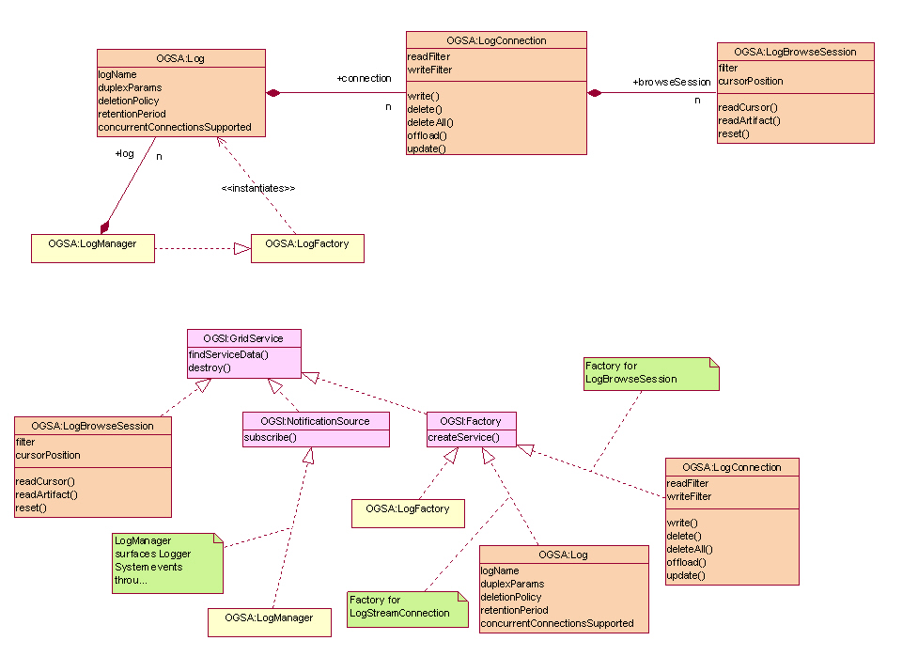
Figure 13: OGSA Logger Services Overview

LogManager service
The LogManager service is responsible for managing an instance of the OGSA Logger Services. The LogManager service implements the OGSA LogManager portType. The OGSA LogManager portType inherits from the OGSI NotificationSource and OGSI Factory portTypes. The LogManager service acts as a factory for Log service instances. A relatively long list of parameters is available to configure a particular Log service instance. In addition to basic configuration data, Log policies for the QoSs outlined in §6.15.1.14 are also defined by these parameters. As a NotificationSource, it is responsible for surfacing all OGSA Logger Services state changes, providing a single point of contact for obtaining all management-related events.

Log service
The OGSA Log portType represents the persisted log. All I/O connections, read or write, are made through this portType. The Log service implements the OGSA Log portType. The OGSA Log portType inherits from the OGSI Factory portType. The Log service acts as a factory for LogConnection service instances.

LogConnection service
All access (read or write) to the records in a Log are made through the LogConnection service. The LogConnection service implements the OGSA LogConnection portType. The OGSA LogConnection portType inherits from the OGSI Factory portType. The LogConnection portType has operations which permit the writing of log records. Custom read and write filters may be set for each instance of a LogConnection. Additionally, the LogConnection service acts as a factory for LogBrowseSession service instances.

LogBrowseSession service
An instance of the LogBrowseSession service is used to read log records from a Log. The LogBrowseSession service implements the OGSA LogBrowseSession portType. The OGSA LogBrowseSession portType inherits from the OGSI GridService portType. Each LogBrowseSession maintains a cursor for navigating its corresponding Log. A custom read filter may be set for an instance of a LogBrowseSession. Reads are filtered by both the LogBrowseSession filter and the LogConnection read filter. The LogBrowseSession portType has operations to access records by id or by timestamp, position its cursor, or to use its cursor to read a sequence of records.

Standard schema/document
None.

Underlying services
The OGSA Logger Services has dependencies on underlying services. These are described in the following subsections.

OGSI
The Logger Services build upon the base semantics defined by OGSI (§ogsadraft10-6.24).

OGSA Event
As described in §6.15.1.6, the Logger Services will represent log artifacts using the schemas defined by the OGSA Event (§ogsadraft10-6.15).

OGSA Policy and Agreements
Much of the state contained the LogManager, Log, and LogStream services is specified using policy. The Logger Services will use the OGSA Policy mechanisms described §ogsadraft10-6.16 to handle policy.

OGSA Security Services
As described in §, the Logger Services is required to support secure logging. OGSA security mechanisms are described in §ogsadraft10-4.1.4.

Related services
As described in §6.15.1.13, the Logger Services is required to coexist with the OGSA messaging infrastructure (§ogsadraft10-6.14).

Related standard
None.

Owner WG(s)
TBD

Messaging and Queuing
OGSA extends the scope of the base OGSI Notification interface to allow Grid services to produce a range of event messages – not just notifications that a serviceData element has changed.
Several terms related to this work are:
- Event - Some occurrence within the state of the Grid Service or its environment that may be of interest to third parties. This could be a state change or could be environmental, such as a timer event.
- Message - An artifact of an event, containing information about an event that some entity wishes to communicate to other entities.
- Topic - A “logical” communications channel and matching mechanism to which a requester may subscribe to receive asynchronous messages and publishers may publish messages.
A message is represented as an XML element with a namespace-qualified QName, and an XML Schema-defined complex type. A topic will be modeled as an XML element, describing its internal details, including expected messages associated with the topic. TopicSpaces, or collections of topics, will also be modeled.

Detailed list of services
This work will also define:
- An interface to allow any Grid service to declare its ability to accept subscriptions to topics and the topics it supports.
- An interface to describe a messaging intermediary (a message broker) that supports anonymous publication of and subscription to topics.
- An interface (or set of interfaces) that describes the interface to other messaging services such as a Queuing service.
Note that queuing and message qualities of service such as reliability can be considered both an explicit service within an OGSA hosting environment and a transport detail modeled by the wsdl:binding element in the service description.

Underlying services
TBD.

Relevant standards
TBD.

Owner working group(s)
TBD.

Event
Events of one form or another have been around for a long time, and are used in many contexts. Generally they are used as an asynchronous signaling mechanism. The most common form is “publish/subscribe” in which a service “publishes” the events that it exports (makes available to clients). The service may publish the events as reliable or best-effort. Clients may then “subscribe” to the event – and when the event is raised a call-back or message is sent to the client. Once again the client can usually request either reliable or best-effort – though the service may not be able to accept a reliable delivery request. There is also a distinction in the reliability of an event being raised and its delivery to a client. A service my attempt to deliver every occurrence of an event (reliable posting), but not be able to guarantee delivery (best-effort delivery).
An event can be anything that the service decides it will be: a change in a state variable (SDE in OGSI), entry into a particular code segment, an exception such as a security violation or floating point overflow, or the failure of some other expected event to occur.
A second form of event is carried with service method invocations and modeled on ExoEvents [4]. The basic idea is simple. Inside the SOAP message invoking a service method is an Event Interest Set (EIS). The EIS specifies the events in which the caller is interested and a callback associated with each event. If an event named in the EIS is raised during the execution of the method – including outcalls on other Grid Services – the corresponding call-back is invoked.
The EIS is first class and can be thought of as a part of the calling context (closure). As such it can be modified by the callee and propagated down the call chain. This allows the callee to express interest in different events further down the call chain, and either add itself to a list of subscribers interested in such events, or “catch” events and keep them from propagating further up the call chain. [JT: Original author needs to review changes from v12 to make sure my changes haven’t altered the intended meaning.]
ExoEvents can be used for a wide variety of purposes, including logging activity in the call chain for accounting or debugging purposes, fault-tolerance and exception handling, and implementing language features such as “try-catch” in Java.
As noted above, events share many properties with Notifications in OGSI (GGF Document “Open Grid Services Infrastructure Version 1.0”, Section 11, pp. 50-54). OGSI Notifications though are designed to capture state changes in SDE’s only, and are not designed as a general event mechanism. Furthermore, Notifications are not normally "edge triggered" since they are based on a model that assumes a minimum and maximum time between notifications, e,g, any notifications that occur within the minimum time window will not be sent to the client. A complete event framework would allow for event queuing or batching to cover this kind of functionality. OGSA events will build on OGSI Notifications.
An event is a representation of an occurrence in a system or application component that may be of interest to other parties. Standard means of representing, communicating, transforming, reconciling, and recording events are important for interoperability. Thus the OGSA Core should define standard schema for at least certain classes of OGSA events. Topics to be addressed include: Is there an OGSA Event base class? Is there a standard set contents for events, such as source, name, and details?

Detailed list of services
- Standard interface(s) for communicating events with specified QoS. These may be based directly on the Messaging interfaces.
- Standard interface(s) for transforming (mediating) events in a manner that is transparent to the endpoints. This should include aggregation of multiple events into a single event.
- Standard interface(s) for reconciling events from multiple sources.
- Standard interface(s) for recording events. These may be based directly on the Message logging interface(s).
- Standard interface(s) for batching and queuing events.
Note: Event services applied to fault tolerance.

Underlying services
It is possible that some forms of event services may be built directly on top of OGSI Notification interfaces, although more study is needed.

Relevant standards
We note that there is an OASIS group working on standard schema for Web service management (WSDM-TC) where they are considering proposals such as WS-Events [http://devresource.hp.com/drc/specifications/wsmf/WS-Events.pdf] and Common Base Event [http://xml.coverpages.org/IBMCommonBaseEventV111-XSD.html]. Is this group addressing what we need, or are there unique OGSA requirements?

Owner working group(s)
No working group has been identified in the GGF. However, the OASIS TC may be the body best placed to address this issue.

Policy and Agreements
These services create a general framework for creation, administration and management of policies and agreements for system operation, security, resource allocation, etc., as well as an infrastructure for “policy aware” services to use the set of defined and managed policies to govern their operation. These services do not actually enforce policies but permit policies to be managed and delivered to resource managers that can interpret and operate on them. Agreements (OGSI-Agreement Specification) provide a mechanism for the representation and negotiation of terms between service providers and their clients (either user requests or other services). These terms include specifications of functional, performance, and quality requirements/objectives that the suppliers and consumers exchange and that they can then use to influence their interactions. The Agreement mechanism provides a general expression framework for these terms but leaves the specification of particular terms to individual disciplines such as performance, security, data quality etc. Agreements also contain information on priority, costs, penalties or consequences associated with violation of the “contract.” A negotiated agreement represents as well as information on how the service provider and consumer have decided to measure compliance with the agreement.
We can expect that many Grid services will use policies to direct their actions. Thus, Grids need to support the definition, discovery, communication, and enforcement of policies for such purposes as resource allocation, workload management, security, automation, and qualities of service. Some policies need to be expressed at the operational level – i.e., at the level of the devices and resources to be managed – while higher-level policies express business goals and service level agreements (SLA) within and across administrative domains. Higher-level policies are hard to enforce without a canonical representation for their meaning to lower-level resources. Thus, business policies probably need to be translated into a canonical form that can then be used to derive lower-level policies that resources can understand. Standard mechanisms are also needed for managing and distributing policies from producers (e.g., administrators, autonomic managers, SLAs, etc.) to end-points that consume and enforce them (i.e., devices and resources).
To meet these requirements, OGSA needs to define the representations and functions required to implement an end-to-end distributed policy management service. These representations and functions are likely to include the following:
- A canonical representation for expressing policies (Policy Information Model and Core XML Schema)

Detailed list of services
These interfaces provides a framework for creating, managing, validating, distributing, transforming, resolving, and enforcing policies within a distributed environment:
- A management control point for policy lifecycle (Policy Service Manager interface)
- An interface that policy consumers can use to retrieve required policies (Policy Service Agent interface)
- A way to express that a service is “policy aware” (Policy Enforcement Point interface)
- A way to effect change on a resource (e.g., using Common Management Model: §6.28)
The Policy Service Manager controls access to the policy repository. It also controls when notifications of policy changes are sent out, so that multiple updates can be made and notifications are only sent after all updates are complete.
The Policy Service Agent is a management service that other “policy aware” services depend on for delivery of their policies. The agent can provide additional services such as understanding time-period conditions so it can inform policy consumers of when policies become active or inactive.
Services that consume policies will implement the Policy Enforcement Point interface to allow them to be registered with Policy Agents, to allow them to participate in the subscription to and notification of policy changes, and to allow policies to be pushed down onto them when needed. These enforcement points will need to interpret the policies and make the necessary configuration changes in the resource(s) they manage, by using the Common Management Model mechanisms referred to in §6.28.
The OGSA Policy Service provides for a transformation service to fill this purpose and includes a canonical representation of policy in the form of an information model, grammar, and core XML schema. Figure 15 illustrates the set of components that might be included in a Policy Service.
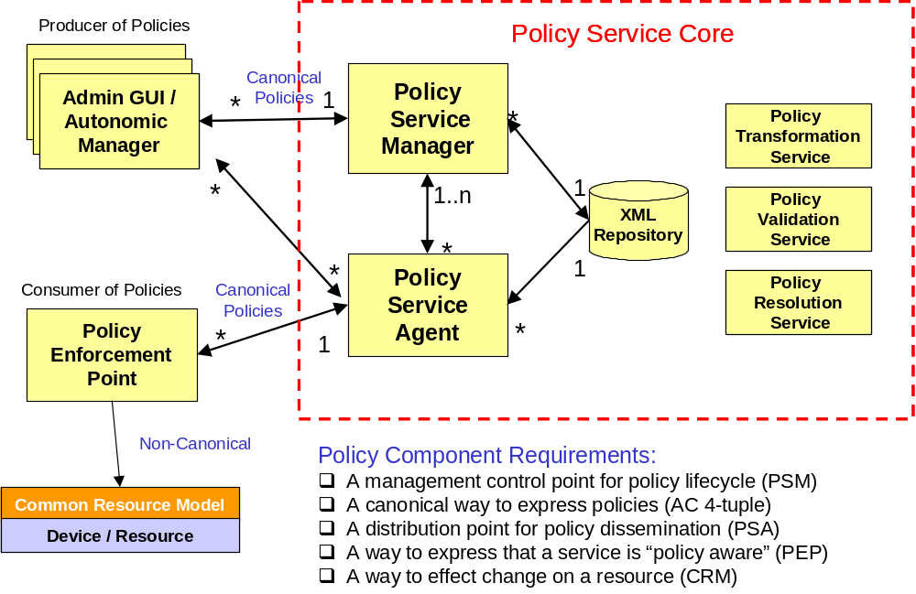
Figure 15: A set of potential policy service components
A set of secondary validation interfaces can allow automated managers and administrators to act on the same set of policies and validate consistency. An interface is also required for translating policies to and from the canonical form so that consumers that have their own policy formats can plug into the service. Finally there is a need for run-time resolution of policy conflicts, which may require specific application knowledge to determine the cost of violating an agreement and selecting the policy that will have appropriate impact.

Underlying services
[Jeff Nick: Ws-Agreement?]

Relevant standards
Work on WS-Policy, etc., within OASIS (?) is relevant.

Owner working group(s)
TBD.

Base Data Services
ITF: This material is taken from the “OGSA Data Services” position paper that was presented at the recent OGSA-DAI F2F. Discussion at that meeting will motivate revisions to that position paper, and to the text below.]
OGSA data interfaces are intended to enable a service-oriented treatment of data, so that data can be treated in the same way as other resources within the Web/Grid services architecture. Thus, for example, we can integrate data into registries and coordinate operations on data using service orchestration mechanisms. A service-oriented treatment of data also allows us to use OGSI Grid Service Handles as global names for data, manage the lifetime of dynamically created data by using OGSI lifetime management mechanisms, and represent agreements concerning data access via WS-Agreement.
OGSA data services are intended to allow for the definition, application, and management of diverse abstractions—what we term data virtualizations—of underlying data sources. A data virtualization is represented by, and encapsulated in, a data service, an OGSI Grid service with SDEs that describe key parameters of the virtualization, and with operations that allow clients to inspect those SDEs, to access the data using appropriate operations, to derive new data virtualizations from old, and/or to manage the data virtualization. For example, a file containing geographical data might be made accessible as an image via a data service that implements a “JPEG Image” virtualization, with SDEs defining size, resolution, and color characteristics, and operations provided for reading and modifying regions of the image. Another virtualization of the same data could present it as a relational database of coordinate-based information, with various specifics of the schema (e.g., table names, column names, types) as SDEs, and SQL as its operations for querying and updating the geographical data. In both cases, the data service implementation is responsible for managing the mapping to the underlying data source.

Detailed list of services
We define four base data interfaces (WSDL portTypes) that can be used to implement a variety of different data service behaviors:
- DataDescription defines OGSI service data elements representing key parameters of the data virtualization encapsulated by the data service.
- DataAccess provides operations to access and/or modify the contents of the data virtualization encapsulated by the data service.
- DataFactory provides an operation to create a new data service with a data virtualization derived from the data virtualization of the parent (factory) data service.
- DataManagement provides operations to monitor and manage the data service’s data virtualization, including (depending on the implementation) the data sources (such as database management systems) that underlie the data service.
We specify that a data service is any OGSI-compliant Web service that implements one or more of these base data interfaces.

Underlying services
The definitions for these services build on and extend core OGSI interfaces, in particular GridService and Factory.
They are also expected to build on and extend OGSI-Agreement interfaces [3], which are used to incorporate agreements into the various data operations.
We also expect that (yet-to-be-defined) OGSA relationship management services will be used to represent and manage relationships among virtualizations, such as multiple virtualizations against the same data source, and dependencies between virtualizations.

Related standards
TBD.

Owner working group(s)
OGSA-DAI.

Other Data Services
A wide variety of higher-level data interfaces can and must be defined on top of the base data interfaces, to address functions such as:
- Data access and movement
- Data replication and caching
- Data and schema mediation
- Metadata management and looking [JT: is this a typo?]
There are likely to be strong relationships to discovery, messaging, agreement, and coordination functions.
Basic data access interfaces allow clients to directly access and manipulate data. A number of such interfaces are required, corresponding to different data types – e.g., files, directories, file systems, RDBMS, XML data bases, object databases, and streaming media. A “file access” service may export interfaces to read, write, and truncate. GridFTP, an existing data access service, provides mechanism to get and put files, and supports third party transfers.

Detailed list of services
The following is far from being a complete list.
Data replication. Data replication can be important as a means of meeting performance objectives by allowing local compute resources to have access to local data. While closely related to caching (indeed, a “replica store” and a “cache” may differ only in their policies), replicas may provide different interfaces. Services that may consume data replication are group services for clustering and fail-over, utility computing for dynamic resource provisioning, policy services ensuring various qualities of service, metering and monitoring services, and also higher level workload management and disaster recovery solutions. Each may need to migrate data for computation or to replicate state for a given service.
Work is required to define an OGSA-compliant set of data replication services that, through the use of “adapters,” can move data into and out of heterogeneous physical and logical environments without any changes needed to the underlying local data access subsystems. The adapters handle the native “reading” and “writing” of data, and the replication software coordinates the runtime (recoverability, monitoring etc) associated with every data transfer. A central “monitor” sets up and handles communication with the calling service or program and sets up a “subscription-pair” relationship between capture and apply services on a per-replication-request basis to ensure reliability.
Data caching. In order to improve performance of access to remote data items, caching services will be employed. At the minimum caching services for traditional flat file data will be employed. Caching of other data types, such as views on RDBMS data, streaming data, and application binaries are also envisioned. Issues that arise include (but are not limited to):
- Consistency – Is the data in the cache the same as in the source? If not, what is the coherence window? Different applications have very different requirements.
- Cache invalidation protocols – How and when is cached data invalidated?
- Write through or write back? When are writes to the cache committed back to the original data source?
- Security – How will access control to cached items be handled? Will access control enforcement be delegated to the cache, or will access control be somehow enforced by the original data source?
- Integrity of cached data – Is the cached data kept in memory or on disk? How is it protected from un-authorized access? Is it encrypted?
How the cache service addresses these issues will need to available as service data.
Schema transformation. Schema transformation interfaces support the transformation of data from one schema to another. For example, XML transformations as specified in XSLT.

Underlying services
Build on base data services, which in turn build on basic OGSI interfaces, in particular OGSI GridService and ServiceGroup.

Related services
TBD.

Owner working group(s)
TBD.

Discovery Services
Discovery interfaces address the need to be able to organize and search information about various sorts of entities in various ways. In an OGSA environment, it is normally recommended that entities of whatever type be named by GSHs, and thus discovery services are concerned with mapping from user-specified criteria to appropriate (GSHs). Different interface definitions and different implementation behaviors may differ according to how user requests are expressed, the information used to answer requests, and the mechanisms used to propagate and access that information.

Detailed list of services
Not clear.

Underlying services
Build on basic OGSI interfaces, in particular OGSI GridService and ServiceGroup.

Related standards
HandleResolver?

Owner working group(s)
TBD.

Job Agreement Service
Job Agreement service is created by the agreement factory service with a set of job terms, including command line, resource requirements, execution environment, data staging, job control, scheduler directives, accounting and notification terms.
The Job agreement service provides an interface for placing jobs on a resource manager (i.e., representing a machine or a cluster), and for interacting with the job once it has been dispatched to the resource manager. The Job service provides basic matchmaking capabilities between the requirements of the job and the underlying resource manager available for running the job. More advanced Job services take into account more advanced job characteristics such as interactive execution, parallel jobs across resource managers, and jobs with requirements based on SLAs.
The interfaces provided by the Job service are:
- Manageability Interface:
  - Supported Job Terms: defines a set of service data used to publish the job terms supported by this job service, including the job definition (command line and application name), resource requirements, execution environment, data staging, job control, scheduler directives, accounting and notification terms.
  - Workload Status: total number of jobs, statuses such as number of running, pending and suspended jobs.
- Job Control: control the job after it has been instantiated. This would include the ability to suspend/resume, checkpoint, and kill the job
The Job agreement service makes use of information in the form of policies which are defined at the VO level, and resource information about available resource managers, queues, host, and job status as provided by the Global Information Service. The Job service uses the WS-agreement protocol with the underlying resource managers in order to submit jobs to the underlying resource managers, and in order to control the running jobs and to access data.

Detailed list of services
TBD.

Underlying services
TBD.

Relevant standards
TBD.

Owner working group(s)
TBD.

Reservation Agreement Service
The Reservation agreement service is created by the agreement factory service with a set of terms including time duration, resource requirement specification, and authorized user/project agreement terms.
The Reservation agreement service allows end users or a Job agreement service to reserve resources under the control of a resource manager to guarantee their availability to run a job. The service allows reservations on any type of resource (e.g., hosts, software licenses, or network bandwidth). Reservations can be specific (e.g., provide access to host “A” from noon to 5pm), or more general (e.g., provide access to 16 Linux nodes on Sunday). Once a reservation is made, a Job service can send a job to a resource manager that is attached to the provided reservation. Some of the policy decisions made by the Reservation service for use with a RM include notions of who can make reservations (e.g., system administrators only), how many hosts a particular user or user group can reserve at a time, when reservations can be made (i.e., “blackout periods”), and what types of hosts can be reserved.
The Reservation agreement service provides one interface, Manageability, which defines a set of service data that describe the details of a particular reservation, including resource terms, start time, end time, amount of the resource reserved and the authorized users.
The Reservation service makes use of information about the existing resource managers that are available and any policies that might be defined at the VO level, and will make use of a logging service to log reservations. It will use the RM Adapter interfaces to make reservations and to delete existing reservations.

Detailed list of services
TBD.

Underlying services
TBD.

Relevant standards
TBD.

Owner working group(s)
TBD.

Data Access Agreement Service
The Data Access Agreement Service is created by the agreement factory service with a set of terms, including (but not limited to) source and destination file path, bandwidth requirements, and fault-tolerance terms (such as retry times).
The Data access agreement service allows end users or a Job agreement service to stage application or required data.
- Manageability Interface --- Define a set of service data for accessing the data movement status information
Other operations --- ??? Need to incorporate DAIS spec, Jay to provide ???
[Jeff Nick: Is this different than the data access services described in the Data section earlier? Are all forms of agreement specialized into typed agreement services?]

Detailed list of services
TBD.

Underlying services
TBD.

Relevant standards
TBD.

Owner working group(s)
TBD.

Queuing Service
The Queuing service provides scheduling capability for jobs. Given a set of policies defined at the VO level, a Queuing service will map jobs to resource managers based on the defined policies. For example, a Queuing service might implement a fairshare policy that makes sure that all users within the VO get reasonable turnaround time on their jobs, rather than being starved out by other users' jobs ahead of them in the queue.
Manageability Interface - Define a set of service data for accessing QoS terms supported by the Queuing services. QoS terms for the Queuing service can include whether the service supports on-line or batch capabilities, average turn-around time for jobs, throughput guarantees, the ability to meet deadlines, and the ability to meet certain economic constraints.
- Enqueue --- enqueue a job into a queue
- Dequeue --- dequeue a job from a queue

Underlying services
Index Service – allows for the propagation of information between resource managers and the metascheduler. It also provides facilities for other services to persist their state data.

Relevant standards
WS-Agreement: defines fundamental mechanisms based on Agreement services, which represent an ongoing relationship between an agreement provider and an agreement initiator. The agreements define the behavior of a delivered service with respect to a service consumer. The Agreement will most likely be defined in sets of domain specific agreement terms (defined in other specifications), since the OGSI-Agreement specification is focused on defining the abstraction of the agreement and the protocol for coming to agreement, rather than on defining sets of agreement terms. [Jeff Nick: Here we’ve gone the other way…the queuing service builds on agreement, but is not a specialization of agreement service…it is a queuing service.]
WS-Agreement Job, Reservation and Data Access Terms

Owner working group(s)
GGF GRAAP WG: WS-Agreement
JSDL: Job Terms and Resource Reservation Terms
DAIS: Data Access Terms

Open Grid Services Infrastructure
The Open Grid Services Infrastructure (OGSI) defines fundamental mechanisms on which OGSA is constructed. These mechanisms address issues relating to the creation, naming, management, and exchange of information among entities called Grid services. A Grid service instance is a (potentially transient) service that conforms to a set of conventions (expressed as WSDL interfaces, extensions, and behaviors) for such purposes as lifetime management, discovery of characteristics, and notification. These conventions provide for the controlled management of the distributed and often long-lived state that is commonly required in distributed applications. OGSI also introduces standard factory and registration interfaces for creating and discovering Grid services.

Key OGSI Features
In the following, we introduce the key OGSI features and discuss briefly their relevance to OGSA.
Grid service descriptions and instances. OGSI introduces the twin concepts of the Grid service description and Grid service instance as organizing principles of distributed systems. A Grid service description comprises the WSDL (with OGSI extensions) defining the Grid service’s interfaces and service data (see next item); a Grid service instance is an addressable, potentially stateful, and potentially transient, instantiation of such a description. These concepts provide the basic building blocks used to build OGSA-based distributed systems: Grid service descriptions define interfaces and behaviors, and a distributed system comprises a set of Grid service instances that implement those behaviors, have a notion of identity with respect to the other instances in the system, and can be characterized as state coupled with behavior published through type-specific operations.
Service state, metadata, and introspection. OGSI defines mechanisms for representing and accessing (via both queries and subscriptions) meta-data and state data from a service instance (service data). As well as providing a uniform mechanism for accessing state, these mechanisms support introspection in that a client application can ask a Grid service instance to return information describing itself, such as the collection of interfaces that it implements.
Naming and name resolution. OGSI defines a two-level naming scheme for Grid service instances based on abstract, long-lived Grid Service Handles that can be mapped by HandleMapper services to concrete but potentially less-long-lived Grid Service References. These constructs are basically network-wide pointers to specific Grid service instances hosted in (potentially remote) execution environments. A client application can use a Grid Service Reference to send requests (represented by the operations defined in the interfaces of the target service) directly to the specific instance at the specified network-attached service endpoint identified by the Grid Service Reference.
Fault model. OGSI defines a common approach for conveying fault information from operations.
Lifecycle. OGSI defines mechanisms for managing the lifecycle of a Grid service instance, including both explicit destruction and soft-state lifetime management functions for Grid service instances and Grid service factories that can be used to create instances implementing specified interfaces.
Service groups. OGSI defines a means of organizing groups of service instances.

Other Observations on OGSI
OGSI does not address how Grid services are created, managed, and destroyed within any particular hosting environment. Thus, services that conform to the OGSI specification are not necessarily portable across various hosting environments, but can be invoked by any client that conforms to this specification—subject, of course, to policy and compatible protocol bindings.
Stateful instances, typed interfaces, and global names are frequently also cited as fundamental characteristics of so-called distributed object-based systems. However, various other aspects of distributed object models (as traditionally defined) are specifically not required or prescribed by OGSI. For this reason, we do not adopt the term distributed object model or distributed object system when describing this work, but instead use the term Open Grid Services Infrastructure, thus emphasizing the connections with both Web services and Grid technologies.
Among the object-related issues that are not addressed within OGSI are implementation inheritance, service mobility, development approach, and hosting technology. The Grid service specification does not require, nor does it prevent, implementations based upon object technologies that support inheritance at either the interface or the implementation level. There is no requirement in the architecture to expose the notion of implementation inheritance either at the client side or the service provider side of the usage contract. In addition, the Grid service specification does not prescribe, dictate, or prevent the use of any particular development approach or hosting technology for the Grid service. For example, there is nothing about OGSI that is Java-specific: one can implement OGSI behaviors in C, Python, or other languages.
Grid service providers are free to implement the semantic contract of the service in any technology and hosting architecture of their choosing. We envision implementations in J2EE, .NET, traditional commercial transaction management servers, traditional procedural UNIX servers, etc. We also envision service implementations in a variety of programming languages that would include both object-oriented and non-object-oriented alternatives.

WS-Agreement
TBD.

Detailed list of services
TBD.

Underlying services
TBD.

Relevant standards
TBD.

Owner working group(s)
TBD.

Web Services Distributed Management
A fundamental requirement of Grid management infrastructure is the ability to define the resources and resource management functions of the system in a standard and interoperable way. The capabilities of the Grid management infrastructure rely on the ability to discover, compose, and interact with the resources and the resource managers responsible for them.
The Web Services Distributed Management (WSDM) specification defines the base behavioral model for resources and resource managers in the Grid management infrastructure. A mechanism is defined by which resource managers can make use of detailed manageability information for a resource which may come from existing resource models and instrumentation, such as those expressed in CIM, JMX, SNMP, etc., combined with a set of canonical operations introduced by base WSDM interfaces. The result is a manageable resource abstraction that introduces WSRF compliant operations over an exposed underlying base content model. WSDM does not define yet another manageability (resource information) model.
The Web Services Distributed Management specifications define:
- the base manageable resource interface – that which a resource or resource manager must provide to be manageable
- managed resource identifier
- canonical lifecycle states, the transitions between the states, and the operations necessary for the transitions
- the ability to represent relationships among manageable resources (instances and types) including a canonical set of relationship types
- metadata to convey semantic meaning of manageability information, such as counter or gauge
- versioning information
- a Web service model that can be used to manage Web services with the features above
Additional items that may become within the scope of the WSDM specification are:
- canonical services factored out from across multiple resources or domain specific resource managers, such as an operational port type (start/stop/pause/resume/quiesce)
To summarize, WSDM is a standard for representing manageable resources and resource managers within the Grid management infrastructure. WSDM interfaces are WSRF compliant and are used as the base abstract interfaces from which specific manageable resource types are derived. Standardization of the base management behavior is required in order to integrate the vast number and types of resources and more limited set of resource managers introduced by multiple vendors.

Detailed list of services
Interfaces are currently being defined.

Standard schema/document
The schema is currently being defined.

Underlying services
WSDM extends WSRF

Related services
The related services will become clearer as the WSDM interfaces are defined.

Related standard
WSDM is related to standard management models such as CIM, JMX, SNMP and also to Grid-related models such as the Unicore Resource Schema and GLUE.
WSDM is also related to efforts in other standards bodies, such as in the DMTF.

Owner working group(s)(s)
OASIS WSDM TC.

Security Considerations
This specification defines requirements for interfaces, behaviors, and models used to structure and achieve interactions among Grid services and their clients. While it is assumed that such interactions must be secured, the details of security are out of the scope of this specification. Instead, security should be addressed in related specifications that define how abstract interactions are bound to specific communication protocols, how service behaviors are specialized via policy-management interfaces, and how security features are delivered in specific programming environments.

Editor Information
Ian Foster
Distributed Systems Laboratory
Mathematics and Computer Science Division
Argonne National Laboratory
Argonne, IL 60439
Phone: 630-252-4619
Email: foster@mcs.anl.gov
Dennis Gannon
Indiana University
Bloomington, IN xxxxx
gannon@cs.indiana.edu
Hiro Kishimoto
Grid computing and Bioinformatics Laboratory
Fujitsu Laboratories
4-1-1, Kamikodanaka, Nakahara, Kawasaki City, Japan
Phone: +81-44-754-2628
Email: hiro.kishimoto@jp.fujitsu.com

Contributors
We gratefully acknowledge the contributions made to this specification by Takuya Araki, Jamie Bernardin, Dave Berry, Shel Finkelstein, Jeffrey Frey, Andrew Grimshaw, Bill Horn, Kate Keahey, Tan Lu, Fred Maciel, David Martin, Jeffrey Nick, Benny Rochwerger, John Rofrano, Andreas Savva, Frank Siebenlist, Chris Smith, David Snelling, Ravi Subramaniam, Jem Treadwell, Jay Unger, Jeffrin Von Reich, James Warnes, and Ming Xu.

Acknowledgements
This work was supported in part by IBM and by the Mathematical, Information, and Computational Sciences Division subprogram of the Office of Advanced Scientific Computing Research, U.S. Department of Energy, under Contract W-31-109-Eng-38 and DE-AC03-76SF0098; by the National Science Platform; and by the NASA Information Power Grid project.

Appendix: Information Sources
In identifying services we draw upon the following sources (references to be provided):
- GGF Grid Protocol Architecture document
- Globus Toolkit and related Grid services.
- Legion project documents.
- UK eScience Architecture Roadmap (Malcolm Atkinson et al.)
- DAIS WG documents
- Data Grid architecture document.
- NPI documents.
- GridLab project’s GAT.
- Unicore.
- TeraGrid.

References

The resource services focus is the objective of the Common Management Models workgroup at GGF.
The passing of information from producer to consumer is considered part of a future OGSA notification service that should provide both push and pull models of notification.

