Web Service Endpoint Identification and Resolution:
Use Cases and Requirements
Version 1.0

Status of This Memo
This memo provides information to the Grid community regarding use cases and requirements associated with web services endpoint identification and resolution. It does not define any standards or technical recommendations. Distribution is unlimited.
Copyright Notice
Copyright © Global Grid Forum (2006). All Rights Reserved.
Trademarks
OGSA is a trademark of the Global Grid Forum.

Abstract
This informational document presents use cases for web service endpoints that involve access policy expression and enforcement, audit entry generation and reconciliation, end point mobility, and endpoint information caching. It explains that existing WS-addressing facilities, such as end point references, are unable to meet the deduced requirements. A number of associated specifications are subsequently introduced, and briefly discussed, that address the requirements. Those specifications define profiles for the creation and use of endpoint references, define identifiers for web service endpoints, and define a resolution service that can be used to obtain current endpoint references. Lastly, recommendations are provided for how applications should use these profiles and specifications to ensure interoperability and facilitate common policy compliance.

Contents
1. Introduction 3
2. Use Cases 4
3. Web Service Endpoint-Related Information Flows 5
3.1 Resource Creation and EPR Issuing. 6
3.2 Resource Discovery and Message Dispatch Preparation. 7
3.3 Message Dispatch, Routing and Delivery. 9
4. Requirements 10
5. Specifications 11
5.1 Unambiguous Web Service Endpoint Profile 11
5.2 Web Service Endpoint Name Specification 12
5.3 Web Service Endpoint Address Identifier Profile 12
5.4 Endpoint Reference Resolution Specification 12
5.4.1 EPR Resolution Service Interface 12
5.4.2 Renewable-Reference Interface 12
6. Recommendations 13
7. Security Considerations 13
Glossary 13
Editor Information 14
Contributors 14
Acknowledgments 14
Intellectual Property Statement 14
Full Copyright Notice 14
References 15
Appendix A 16

Introduction
The W3C’s WS-Addressing specification [WS-Addr] defines a usage pattern for web service implementations that seems destined to become the common standard for interoperability and tooling support. The specification defines the following two essential entities:
- “A Web service endpoint is a (referenceable) entity, processor, or resource to which Web service messages can be addressed.”
- “Endpoint references convey the information needed to address a Web service endpoint.”
The web service endpoint (WSEP) remains an abstract entity in the WS-Addressing specification, while the endpoint reference (EPR) is defined as an XML document. Note that the term “Resource” is often used for “Web Service Endpoint.” The two terms are used interchangeably here.
The WS-Addressing specification does not tell applications how the EPR components should be used to dispatch the message to the web service endpoint. It hints that implementers may use the wsa:Address, and may use additional information in the (optional) ReferenceParameters, but doesn’t exclude the option to use other information from possibly associated WSDL-documents or even external knowledge obtained from contextual information. In other words, in general it is impossible to deduce from the existing WS-Addressing specification alone what components of an EPR are essential for the endpoint dispatching. The EPR-minter would need to provide that information explicitly. Note that this poses no operational problems in most use cases, as the EPR-minter would "know" what contextual information was expected to be available when the messages arrive at the local dispatcher.
One additional complication is the fact that the EPR can be used as “poor-man’s assertion” that binds metadata information about the endpoint to the Endpoint Reference. However, it has no standardized provision to show when it was created, what the binding lifetime is, and neither does it include versioning or any issuer information. In many real-world deployments, it is reasonable to expect though, that over the lifetime of an endpoint, the endpoint owner will mint many EPR, that EPRs will be annotated with different metadata, that EPRs will be stored by and communicated through middlemen and third-parties, that third-parties will annotate EPRs to help clients with policy hints, that clients will cache EPRs, etc. As a consequence, many different incarnations of EPRs may be in existence for the same endpoint, and that it may not be clear which ones are valid or more recent.
The WS-Addressing specification explicitly does not address a number of EPR properties associated with WSEP identification:
- “Endpoint Reference Comparison.
This specification provides no concept of endpoint identity and therefore does not provide any mechanism to determine equality or inequality of EPRs and does not specify the consequences of their equality or inequality. However, note that it is possible for other specifications to provide a comparison function that is applicable within a limited scope.”
However, we frequently encounter in practical distributed systems a need for one or more of the following concepts: endpoint identity, unique endpoint identifiers, the ability to determine whether different EPRs refer to the same endpoint, and the ability to track mobile endpoints after failing to contact the endpoint via a given EPRs.

To address these requirements, we introduce in this document four new specifications. These specifications, which compliment the WS-Addressing specification:
- define a profile for EPR creation that provides for desirable uniqueness properties associated with an EPR (“Unambiguous Web Service Endpoint Profile”);
- define an optional profile for EPR creation that provides for desirable uniqueness properties associated with the wsa:Address element of the EPR specifically ( “Web Service Endpoint Address Identifier Profile”);
- define an endpoint identifier that can be embedded in an EPR to provide an alternative, more stable name for that endpoint (“Web Service Endpoint Name Specification”); and
- specify resolution services that allow for resolution of the most current endpoint’s EPR in case the old EPR fails, or if only a endpoint identifier is available (“Endpoint Reference Resolution Specification”).
The rest of this document is as follows. In Section 2, we present six use cases, each of which requires some form of support for resource names beyond that provided by WS-Addressing. In Section 3, we present in considerable detail the sort of information flows that can occur in practical distributed systems. (This detailed material may be skipped on a first reading.) In Section 4, we abstract from the use cases a set of eight requirements that must be addressed to enable interoperability among Web Service applications. In Section 5, we introduce four specifications that define profiles and interfaces that address these requirements. We conclude in Section 6 with recommendations concerning how applications should use these specifications to guarantee interoperability and achieve common policy compliance.

Use Cases
The following use cases arise frequently in Grid environments. As we explain in subsequent sections, each requires enhanced support for endpoint reference manipulation.
Resource Mobility. Resources, particularly computations and data sets (but also, in some cases, execution environments—for example, virtual machines), may need to be relocated to provide for improved access or to provide more or better physical resources. Such relocation requires the preservation of all of the resource's state, but typically also requires a change in the physical network address and/or access protocol.
Assertion Target. In policy languages—as used, for example, for authorization and management—a stable resource identifier is frequently needed as the target of a policy expression. This identifier may be used as the subject, e.g., “subject with endpoint identifier <Name> is allowed to act according to a client’s policy,” or as the object, e.g., “Administrator has access to <Name>,” or in a delegation example where "Bob delegates to Alice the right to access resource identified as <Name>."
Resource Attributes. When enforced policy-rule expressions rely on resource attributes, often those attributes are obtained from attribute servers. Other subjects will administer those bindings. All parties expect that their resource representations resolve to the same attribute bindings.
Resource Reference Consistency. Clients often use the same resources many times and over an extended period. Ambiguity about the resource to which a given reference will refer in the future will complicate deployment considerably and result in increased costs. Clients and site administrators expect there to be no ambiguity once they have obtained some resource reference representation.
Resource Metadata Caching. A client (or, more generally, a resource consumer) may cache the location of (or other metadata about) one or more resources. A persistent name that can be compared with other names on the client greatly facilitates this process, by, e.g., providing a stable basis for hash coding and equality testing. Note that the ability to correlate the attributes fetched and the applicable policy rules with the applicable endpoint reference is crucial for access to the endpoint.
Audit Label. Resource identifiers are often required for audit entries in various clients, services, and intermediates. For example an advanced router might log audit messages of the form “<Name> received NN messages on 2006-01-05.” In this case, the name of a resource may need to persist much longer than the resource itself. Audit entries may be logged by the client, intermediaries, and the server. We can even distinguish the server’s runtime from the application, as the detailed application-level resource identification is only available at the application level.

Web Service Endpoint-Related Information Flows
To illustrate what kind of WSEP-related information may be exchanged when a resource is created and accessed, we examine the information flows that may occur within a typical scenario, in which:
- (Figure 1) A new resource is created, and a reference to this new resource is provided to various system components.
- (Figure 2) A client interacts with various system components to determine whether to dispatch a message to the new resource.
- (Figure 3) A client dispatches a message to the new resource and receives a response.
Not all scenarios will involve all of the interactions presented here: indeed, most will be significantly simpler. However, most will use one or more of the components discussed. The goal of this presentation is to provide a better understanding of the sort of resource-specific information that may be exchanged at different stages, whether this information has to be correlated, what resource identifiers may be needed, and where and how those identifiers are communicated. To relate this presentation back to the use cases of Section 2, we use the notation (UC: Use Case Name) to indicate where the use cases arise.
In this presentation, we use a common notation to denote resources:
- The term “Web Service Endpoint” (WSEP) is used as an abstract notion and name for the resource.
- The notation <WSEP> is used for any identifier or reference that may be used to communicate the endpoint as a parameter or return value in an interaction, like an EPR, any kind of ws-endpoint-identifier (ws-endpoint-name or wsa:Address), or any kind of identifier upon which applications may have agreed.
- EndPoint Reference (EPR) is the xml-element defined in the ws-addressing specification.
- EndPoint Identifier (EPI) is a name that uniquely identifies the resource, like a ws-endpoint-name or possibly a wsa:Address.
At this point in the document we do not want to make choices or show preferences for any particular form of endpoint identifier, but merely investigate how they are used and where.

Resource Creation and EPR Issuing.
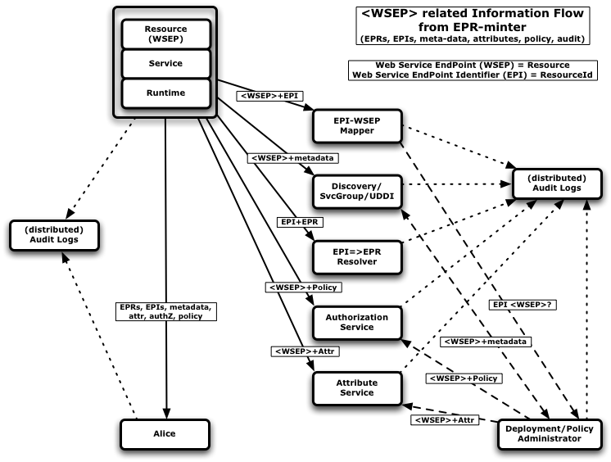
Figure 1. The flow of WSEP-related information from an EPR-minter
We first show in Figure 1 the information flows that may occur when an EPR-minter or WSEP-owner creates a WSEP (resource) or has to issue a new EPR for an existing resource. We show the actual resource as being hosted and front-ended by a service and runtime component. Many service implementations have this clear separation, which allows much of the policy to be enforced inside of the runtime, transparently from the application-level components that manage the resource-specific code and state. Furthermore, the message is dispatched at various levels. The EPR-minter component itself could reside in the runtime, service or application level, depending on the implementation and tooling. The EPR-minter has a clear notion of the resource and the program structure, which is used to construct an EPR with the correct dispatch information such that messages created according to that recipe are routed to the right state and code.
Information about the new resource’s WSEP and/or updated EPR may need to be communicated to different parties, including one or more of each of the following:
- Direct consumer(s) (aka Alice). A client may obtain information about the new resource directly or via a discovery service. In subsequent steps, we will examine the information flows that occur when a client first discovers and then invokes operations on the new endpoint.
- EPI→EPR resolver service(s). A resource may migrate, in which case its EPR becomes invalid. A resolver service addresses this problem by allowing for the registration of an EPR associated with an EPI. The EPI can then be used to refer to the WSEP, and be resolved to an EPR when communication with the WSEP is needed.
- EPI→WSEP mapping service(s). There may, in some cases, be more than one identifier for an endpoint, and thus there is a need to maintain the mapping of all the identifiers that are associated with the same endpoint. A mapping service allows for the registration of such associations; it can then answer to questions concerning whether or not identifiers refer to the same endpoint.
- Discovery service(s). A range of discovery-like services may exist that allow resources to be registered, along with metadata, and then allow references to those resources to be obtained through a reverse lookup.
- Authorization service(s). The EPR-minter may dynamically administer the applicable access control policy rules to allow certain clients access to its new resource.
- Authorization assertions. The EPR-minter may annotate the resource by dynamically managing applicable attribute bindings with attribute services.
We also see in the figure that each party may maintain its own audit log concerning this and subsequent interactions; all such logs will refer to the same WSEP.
Lastly, Figure 1 identifies a Deployment/Policy Administrator, who is responsible for assigning attributes to the resource, for managing access control policy rules associated with that resource, and for annotating the resource with metadata for discovery. Note that any or all of those operations may require log entries for audit purposes.

Resource Discovery and Message Dispatch Preparation.

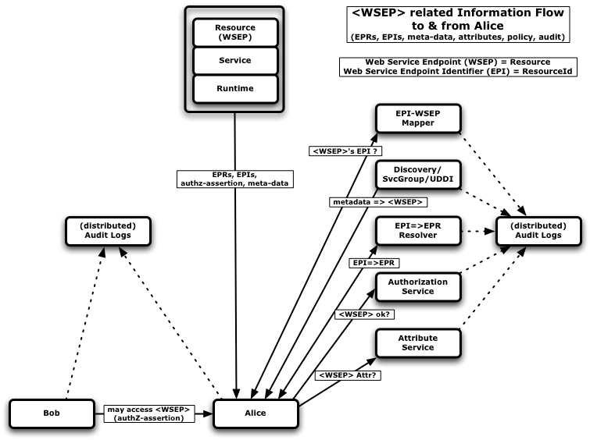
Figure 2. WSEP-related information flows when Alice determines whether to access a resource
Figure 2 illustrates the information flows that occur when Alice as a consumer determines whether to access the WSEP. We see:
- Direct consumer interaction (aka Alice). A client may obtain information about the new resource directly from the EPR-minter possibly through some factory or search application pattern. The Service may have annotated the EPR with metadata, or such policy information may be communicated through separate assertions. In all cases, those claims should clearly pertain to the endpoint in question
- Discovery service(s). The client may obtain a reference or identifier for the resource through a discovery service interaction. Depending on the retruned endpoint information an additional resolution step may be required.
- EPI→EPR resolver service(s). When the client has received the endpoint information as an identifier, then an additional resolution step is required to obtain the EPR needed for message construction and delivery.
- EPI→WSEP mapping service(s). If the client obtains endpoint annotations that use different identifiers for the same resource, then it may need a mapping service to federate the different claims.
- Attribute services(s). The client may need to obtain attribute information associated with the endpoint to evaluate the policy decisions and matching criteria.
- Authorization service(s). The client may need to consult the authorization services that maintain the client-domain’s access policy to determine whether interaction with that resource is allowed.
- Authorization assertions. A third party, Bob, provides Alice with an authorization assertion indicating that Alice may access the specified WSEP (UC: Assertion Target).
Again, we also see in the figure that each party may maintain its own audit log concerning this and subsequent interactions; all such logs will refer to the same WSEP.

Message Dispatch, Routing and Delivery.
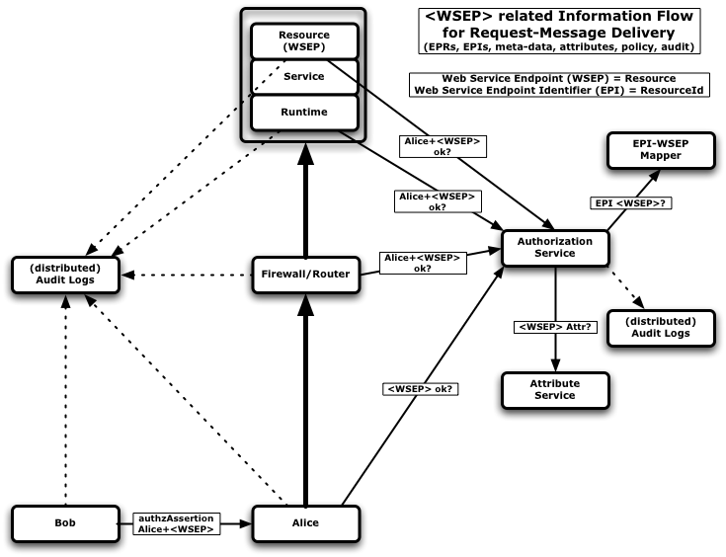
Figure 3. WSEP-related information flows for a message-request from Alice to the resource
Finally, Figure 3 illustrates the information flows that may occur when the client, Alice, dispatches a request to the resource. We see the following steps:
- Client authorization. Alice (perhaps armed with an authorization assertion from Bob) dispatches the request.
- Intermediate policy enforcement. This request is intercepted by a firewall or router, which consults an authorization service to determine whether Alice is allowed to access the specified WSEP.
- Container-level authorization. Assuming successful authorization at the firewall, the request is forwarded to the relevant Web Service container, which itself may consult an authorization service to determine whether the incoming request is authorized.
- Application-level authorization. Assuming successful container-level authorization, the request is dispatched to the resource, which itself may consult an authorization service to perform a further authorization check.
- Attribute service(s). At any step, an authorization service may consult with attribute service(s) to determine properties of the WSEP.
- Mapping service(s). At any step, when the endpoint identifiers used in the message, policy rules or attribute bindings are different, a mapping service can be used to federate the claims.
As before, audit log entries may be generated by the various components involved (UC: Audit Label).

Requirements
We extract from the use cases of Section 2 a set of requirements for an endpoint identification strategy. Note that we assume that all resources are exposed to clients by a Web service interface and that WS-Addressing’s EndPoint References (EPRs) are used as resource references.
Our goal is to identify minimum and independent requirements, so that we can define a collection of specifications that collectively meet all requirements (and thus use cases) but that permit specific implementations to address only those requirements that are important for their users.
Some requirements (e.g., Requirements 1, 6, and 7) are not necessary to meet the use cases, but do provide a better or more consistent implementation, and/or facilitate adoption.
The following requirements must be satisfied to support the above use cases:
- Consistency with current tooling: It is important that any solution not require incompatible changes to existing tooling. There is a large body of implementation experience with existing tooling, and making this experience obsolete would hinder adoption. It is also unlikely the commercial implementations will adopt specifications the alter (rather than simply extend) current functionality.
- Unambiguous referencing: Messages to an identified (named) resource must always either be delivered to only that resource or fail to be delivered to any resource. Equivalently, each message to a resource must contain sufficient information to identify the named resource uniquely within any context in which the message is processed.
Note that this requirement does not require that all EPRs be “unique in space and time.” For example, the wsa:Address plus other information in the message (e.g., reference parameters) plus knowledge about the message context (e.g., the knowledge that “messages are being delivered within a closed network,” and that “reference parameters are only recycled after total reboot of that closed network”) can together ensure that the message will reach exactly one resource.
Note that a simple approach to meeting this requirement is simply to ensure that addresses are unique (see Requirement 8). As described in the preceding paragraph, this requirement can be met without a unique address or EPR. However in this case it may be difficult to identify a single resource identifier. A complex process may be required to extract it from the combined message and context and then assemble it for use in audit logs etc.
A corollary of this requirement is that it is possible to infer that multiple identifiers in the same EPR refer to the same resource (within the same context of course).
- Client side resource-equality testing: In order to support the caching use case, it in necessary that a client be able to compare the EPRs of two resources and test them for equivalence, i.e., whether they refer to the same web service endpoint (resource). Note that this test can only be an "affirmative" test. Note that none of the use cases above require "negative" testing.
- A resource identifier in every message: In order to support the audit and the policy enforcement at intermediaries use cases, it must be possible for a resource to ensure that all messages, subject to audit, carry a resource identifier that can be used to link the message to the resource. Note that this identifier need not be unique (i.e., a resource may be identified by more than one identifier).
- EPR resolution: Given an EPR of a mobile resource, the client must be able to find a valid EPR to that resource based on information available in the former EPR. Note that, as discussed above, resource relocation may include changes in resource access protocol as well as address.
The following requirements are desirable and should be considered carefully when designing a solution to the naming problem:
- Works with current/existing tooling: A solution might require enhancements to exist tooling. While not a “show stopper” as long as Requirement 1 is met, it is desirable that existing tooling be able to handle the solution without modification. For example, message processing intermediates that do not need to use the naming scheme should be able to process the message without knowledge of the scheme.
- Consistency with W3C architecture: While any solution that does not violate normative statements of Web or Web Services specifications is acceptable, it is advisable to adhere to W3C architectural guidelines. This requirement is primarily to facilitate adoption. For example, assuming that a client can inspect and reason about the content of a wsa:Address or the wsa:ReferenceParameters would violate the intent of the WS-Addressing architecture, which stipulates that these components of the EPR are opaque to the client.
- Unique address: If an EPR’s wsa:Address field is guaranteed to be unique in space and time, the limitations of a minimal implementation of Requirement 5 are avoided, while addressing the necessary requirement itself. In particular, the only context required to ensure unique delivery (Requirement 5) is that the implementation is known to comply to a specification requiring unique addresses (Requirement 8). No other contextual restrictions need to be guaranteed.

Specifications
We introduce four specifications (see Table 1) that define profiles and interfaces that address the above requirements. These specifications collectively meet all of the requirements (and in some cases the desirables as well), but not necessarily in a single specification, since some of the desirables contradict each other. The intention is that the different profiles will be used in different scenarios, depending on specific requirements.
Table 1: Summary of specifications
Specification | Summary | Meets Requirements
Unambiguous Web Service Endpoint Profile | Defines restrictions on the creation and use of an EPR to ensure unique delivery in a prescribed context. | 1, 2, 5, 6, 7
Web Service Endpoint Name Specification | Defines a ws-endpoint-name that can be embedded in the metadata section of an EPR. | 1, 2, 6, 7
Web Service Endpoint Address Identifier Profile | Requires that the wsa:Address value of an EPR, which adheres to the “Unambiguous Web Service Endpoint Profile”, is unique in space and time and can be used as an identifier for the endpoint. | 1, 2, 3, 5, 8
Endpoint Reference Resolution Specification | Defines two interfaces relating to EPR resolution. | 4

Unambiguous Web Service Endpoint Profile
This profile defines restrictions on the creation and use of an EPR necessary to ensure unique delivery in a prescribed context. By adhering to this profile, the EPR-minter essentially guarantees to the consumer that the EPR will always either refer to the same endpoint, or fail.
This profile meets requirements 1, 2 (although finding the identifier may be difficult), 5, 6, and 7.
Adherence to this profile is a requirement for the use of both the “Web Service Endpoint Name” as well as the “Endpoint Reference Resolution” specifications. We also note that the “Web Service Endpoint Address Identifier Profile” is essentially a refinement of this profile, stipulating a further restriction.

Web Service Endpoint Name Specification
This specification defines a ws-endpoint-name (formatted as an Internationalized Resource Identifier, or IRI) that can be embedded in the metadata section of an EPR.
For this ws-endpoint-name to be useful as a true IRI for the endpoint, the EPR-minter has to adhere to the “Unambiguous Web Service Endpoint Profile.” Only then can the ws-endpoint-name be used for equivalence testing of EPRs.
The ws-endpoint-name can also be used as a resource identifier in policy expressions, attribute bindings, caching, and (limited) client-side audit.
Note that the standard WS-Addressing transformation from EPR to SOAP message does not include the ws-endpoint-name in the SOAP message. Therefore, the use of this resource identifier will not address the audit and policy enforcement requirements in intermediaries, soap-routers, and server runtimes.
This specification meets requirements 1, 2, 6, and 7.

Web Service Endpoint Address Identifier Profile
This profile restricts the “Unambiguous Web Service Endpoint Profile” further, and defines the requirement placed on an EPR wsa:Address field (IRI) to ensure that it is unique in space and time, and that it by itself identifies the endpoint/resource.
Adherence to this profile allows consumers to use the wsa:Address value as a web service endpoint identifier.
The advantage of this endpoint identifier is that it will be part of SOAP messages, and can thus be used for audit and policy enforcement in intermediaries and server runtimes.
On the client side, its use is equivalent to the use of the ws-endpoint-name, except that the latter may provide more stability in the case of resource mobility.
This specification meets requirements 1, 2, 3, 5, and 8. Note that because we are comparing addresses to meet requirement 2, we are stretching the intent of the opaque requirement of the wsa:Address field. Also, some current tooling may not generate unique addresses in space and time, hence failing on requirement 7.

Endpoint Reference Resolution Specification
The EPR-resolution requirements are addressed in this specification, which defines two distinct service interfaces.

EPR Resolution Service Interface
This specification defines the WSDL and operational semantics for a resolver service that takes an IRI identifier as a WS Endpoint Identifier and returns a new, valid EPR.
This WS Endpoint Identifier can be either the previously defined ws-endpoint-name, or the wsa:Address value when the “Web Service Endpoint Address Identifier Profile” is in effect, or any other IRI that may be used as a unique endpoint identifier. However, in all cases adherence to the “Unambiguous Web Service Endpoint Profile” is also required.
This specification meets requirement 4.

Renewable-Reference Interface
This specification defines the WSDL and operational semantics for a RenewableReference: an endpoint reference to a resource that will return the current application-EPR. The RenewableReference encapsulates how the application-resource is named, and thus can be used with the “Unambiguous Web Service Endpoint Profile.” Note that when the RenewableReference is applied to an EPR profiled with the “Web Service Endpoint Address Identifier Profile,” then the wsa:Address of the RenewableReference could provide a endpoint identifier for the RenewableReference’s resource, which could by inference also be used as an endpoint identifier for the application’s endpoint.
This specification meets requirement 4 without the need for an explicit <Name>.

Recommendations
The following recommendations are intended to ensure interoperability of Web Services implementations.
- Implementations MUST comply with the “Unambiguous Web Service Endpoint Profile.”
  - The ambiguity inherent in EPRs that do not comply with this profile seems unacceptable for real-world deployment.
- Implementations SHOULD comply with the “Web Service Endpoint Address Identifier Profile.”
  - With some care on the EPR-minter side, this profile should be easy to adhere to, with the great benefit of having a readily available wsa:Address as endpoint identifier that is both available from the EPR and the message header.
- Implementations SHOULD implement the “Endpoint Reference Resolution Specification.”
  - Having runtime environemnts that know how to deal with resolution services automatically will provide for more stable deployments and give site administrators greater flexibility in transparently moving endpoints to more applicable hosting environments. The runtime implementation is a one-time cost. The server side, i.e., the EPR-minter, needs the right additional tooling to make the use of resolution services a matter of configuration.
- Implementations SHOULD implement the “Web Service Endpoint Name Specification” if resource mobility is expected.
  - There will be many identifiers for the same endpoint/resource, and some will be more stable than others. For policy administration, a stable identifier is preferred. For the runtime enforcement, attribute fetching, and audit correlation, there is a need to map different identifiers to the same records, but not necessarily to a single unique identifier. In other words, having a stable identifier available in the EPR may help deployment somewhat. However, such a binding could be maintained using other services and does not remove the requirement for general identifier mapping.

Security Considerations
It is recognized that there are security requirements related to identification and resolution. Some aspects of security are covered in the mentioned Profiles and related specifications.

Glossary
EPR A Web Service Endpoint Reference as defined in [WS-Addressing].
EPI A Web Service Endpoint Identifier, which is an IRI for a WSEP (resource).
EPR-Minter The EPR-minter is the entity, typically part of the server-side runtime environment, responsible for creating an EPR to refer to a resource (web service endpoint). The EPR-minter has enough knowledge of the server-side context to ensure that messages targeted based on this EPR arrive at the intended resource.
EPN A Web Service Endpoint Name, which is an implementation of a EPI.
IRI Internationalized Resource Identifier.
RenewableReference An EPR to a stateful WSEP that holds the EPR for another endpoint.
WSEP A Web Service Endpoint,

Editor Information
Frank Siebenlist
Argonne National Laboratory
Phone: +1-408-656-6787
Email: franks@mcs.anl.gov
David Snelling
Fujitsu Laboratories
Phone: +44-208-606-4649
Email: David.Snelling@UK.Fujitsu.com

Contributors
We gratefully acknowledge the contributions made to this document by ???.

Acknowledgments
We are grateful to numerous colleagues for discussions on the topics covered in this document, and to the people who provided comments on the public drafts. Thanks in particular to (in alphabetical order, with apologies to anybody we have missed) ???.

Intellectual Property Statement
The GGF takes no position regarding the validity or scope of any intellectual property or other rights that might be claimed to pertain to the implementation or use of the technology described in this document or the extent to which any license under such rights might or might not be available; neither does it represent that it has made any effort to identify any such rights. Copies of claims of rights made available for publication and any assurances of licenses to be made available, or the result of an attempt made to obtain a general license or permission for the use of such proprietary rights by implementers or users of this specification can be obtained from the GGF Secretariat.
The GGF invites any interested party to bring to its attention any copyrights, patents or patent applications, or other proprietary rights which may cover technology that may be required to practice this recommendation. Please address the information to the GGF Executive Director.

Full Copyright Notice
Copyright (C) Global Grid Forum (2004, 2005, 2006). All Rights Reserved.
This document and translations of it may be copied and furnished to others, and derivative works that comment on or otherwise explain it or assist in its implementation may be prepared, copied, published and distributed, in whole or in part, without restriction of any kind, provided that the above copyright notice and this paragraph are included on all such copies and derivative works. However, this document itself may not be modified in any way, such as by removing the copyright notice or references to the GGF or other organizations, except as needed for the purpose of developing Grid Recommendations in which case the procedures for copyrights defined in the GGF Document process must be followed, or as required to translate it into languages other than English.
The limited permissions granted above are perpetual and will not be revoked by the GGF or its successors or assigns.
This document and the information contained herein is provided on an "AS IS" basis and THE GLOBAL GRID FORUM DISCLAIMS ALL WARRANTIES, EXPRESS OR IMPLIED, INCLUDING BUT NOT LIMITED TO ANY WARRANTY THAT THE USE OF THE INFORMATION HEREIN WILL NOT INFRINGE ANY RIGHTS OR ANY IMPLIED WARRANTIES OF MERCHANTABILITY OR FITNESS FOR A PARTICULAR PURPOSE."

References
[GGF Documents] Catlett, C.: Global Grid Forum Documents and Recommendations: Process and Requirements. GGF, revised April 2002. http://www.gridforum.org/documents/GFD.1.pdf.
[OGSA Glossary] Treadwell, J. (ed.) Open Grid Services Architecture Glossary of Terms. Global Grid Forum OGSA-WG. GFD-I.044, January 2005. http://www.ggf.org/documents/GWD-I-E/GFD-I.044.pdf.
[OGSA-Related Naming Guidelines] Kishimoto, H.: OGSA related working group research group and specification naming guideline, version 1.0. GGF, May 2005.
https://forge.gridforum.org/projects/ggf-editor/document/OGSA_related_working_group_research_group_and_specification_naming_guideline/en/1.
[OGSA Use Cases] Foster, I., Gannon, D., Kishimoto, H. and Von Reich, J. (eds.): Open Grid Services Architecture Use Cases. GGF OGSA Working Group (OGSA-WG), GFD-I.029, October 2004. http://www.ggf.org/documents/GWD-I-E/GFD-I.029v2.pdf.
[OGSA WSRF Basic Profile] Foster, I., Maguire, T. and Snelling, D.: OGSA WSRF Basic Profile 1.0. GGF OGSA Working Group (OGSA-WG), 2005, forthcoming in the GGF document series, 2005. http://www.ggf.org/documents/final.htm.
[WS-ADDRESSING] Gudgin, M. and Hadley, M. Web Services Addressing 1.0 - Core, 2005. www.w3.org/TR/ws-addr-core.
Unambiguous Web Service Endpoint Profile
Web Service Endpoint Name Specification
Web Service Endpoint Address Identifier Profile
Endpoint Reference Resolution Specification

Appendix A

