OGSA-DMI Functional Specification 1.0

Status of This Document

This document provides information to the Grid community on defining an interface for set-up and management of standardized data movements within and across Grid deployments. Distribution is unlimited.

Copyright Notice

Copyright © Open Grid Forum (2007). All Rights Reserved.

Trademark

Open Grid Services Architecture and OGSA are trademarks of the Open Grid Forum.

Abstract

<< TBD >>

Contents

1. Introduction 3
1.1 Goals 3
1.2 Non-Goals 3
2. Notational Conventions 3
2.1 XML Namespaces 3
3. Architecture 4
3.1 Topology 4
3.2 Entities 5
3.2.1 Source 5
3.2.2 Sink 6
3.2.3 Data Transfer Factory 6
3.2.4 Data Transfer Instance 6
3.2.5 Data Transfer Client 7
3.2.6 Data Transfer User 7
3.3 Security 7
3.3.1 Roles 8
4. Data Transfer Factory interface 9
4.1 Properties 10
4.1.1 [undo strategy] 10
4.1.2 [supported protocol] 11
4.1.3 [identity] 12
4.1.4 [role] 13
4.2 Operations 13
4.2.1 requestDataTransferInstance 13
4.2.2 requestDataTransfer 14
4.2.3 Operation Parameters 14
4.3 Faults 18
4.3.1 UnsatisfiableRequestOptionsFault 18
4.3.2 NoTransferProtocolAgreementFault 18
4.3.3 CredentialsFailedFault 18
4.3.4 CustomFault 19
5. Data Transfer Instance interface 19
5.1 Properties 19
5.1.1 [scheduled start time] 19
5.1.2 [estimated completion time] 20
5.1.3 [progress] 21
5.1.4 [status] 21
5.2 Operations 22
5.2.1 Start 22
5.2.2 Stop 22
5.2.3 Restart 22
5.2.4 Suspend 22
5.3 Faults 23
5.4 Lifecycle 23
5.4.1 Lifecycle States 23
5.4.2 Lifecycle Events 25
6. Security Considerations 26
7. Contributors 27
8. Glossary 27
9. Intellectual Property Statement 27
10. Disclaimer 28
11. Full Copyright Notice 28
12. References 28
13. Renderings 29
13.1 Mandatory compositions 29
13.1.1 NextGRID Basic Profile 29
13.2 Optional compositions 30
13.2.1 NextGRID Basic Profile 30
13.2.2 WS-BaseNotifiication 30
13.2.3 WSDM (WS-DistributedManagement) 30

Introduction

Goals

- OGSA-DMI port types are intended to be composable with other WS specification, such as WSDM.
- OGSA-DMI Functional Specification aims to be agnostic to certain specific WS renderings, e.g. WS-I or WSRF. The Functional Specification defines the core interfaces and semantics required to setup and perform a data transfer. Specific renderings into WS-I and alternatives deal with the message level and operation level intricacies of the respective rendering.
- OGSA-DMI will be agnostic to the semantics of the data being moved.

Non-Goals

<< TBD >>

Notational Conventions

Only include this section if applicable.

The key words ‘MUST,” “MUST NOT,” “REQUIRED,” “SHALL,” “SHALL NOT,” “SHOULD,” “SHOULD NOT,” “RECOMMENDED,” “MAY,” and “OPTIONAL” are to be interpreted as described in RFC 2119 [BRADNER1]

When describing abstract data models, this specification uses the notational convention used by the XML Infoset [XML Infoset]. Specifically, abstract property names always appear in square brackets (e.g., [some property]).

When describing concrete XML schemas [XML Schema Part 1, Part 2], this specification uses the notational convention of WS-Security [WS-Security]. Specifically, each member of an element’s [children] or [attributes] property is described using an XPath-like notation (e.g., /x:MyHeader/x:SomeProperty/@value1). The use of {any} indicates the presence of an element wildcard (<xs:any/>). The use of @{any} indicates the presence of an attribute wildcard (<xs:anyAttribute/>).

XML Namespaces

This specification uses a number of namespace prefixes throughout; they are listed in Table 1. Note that the choice of any namespace prefix is arbitrary and not semantically significant (see [BRAY]).

Prefix | Namespace
s11 | http://schemas.xmlsoap.org/soap/envelope
rns | http://schemas.ogf.org/rns/2006/09/rns
wsa | http://www.w3.org/2005/03/addressing
xs | http://www.w3.org/2001/XMLSchema
dmi | http://schemas.ogf.org/dmi/2007/05/dmi
Table 1: Namespaces and prefixes used in this document

Architecture
A typical Grid deployment will often necessitate data to be moved from one location to another. The amount of data will vary from Megabytes to Terabytes or more. Also, as is often the case in distributed environments, the scheduling of data to be available at a particular point in time at a given location has to be taken into account. However, scheduling is out of scope for OGSA-DMI, even though OGSA-DMI should enable scheduling on top of itself.

To provide a resilient service, OGSA-DMI defines two types of interfaces:

- An interface that defines how to set-up a data movement instance.
- An interface describing operations and attributes of a particular data movement instance.
  - Example operations may include “cancel”, “resume”, “suspend”, etc., and
  - Example attributes may include “number of moved bytes”, “number of parallel streams”, “number of retries”, etc.

Figure 1 gives an overview of the functional architecture.

The color-coding of the diagram depicts the use of particular communication mechanisms. , whether standardized or not:

- Orange coloring indicates a specific transfer-protocol communication mechanism, e.g. FTP, GridFTP, ParallelHTTP, etc.
- Light-blue coloring depicts ‘control’ communication between the DMI service and the protocol specific services that will undertake the data transfer, e.g.. SOAP message exchange, local file movement, etc.
- Green coloring depicts Web Service related communication defined within this specification, i.e. rendering specific invocations
- No coloring depicts an unspecified communication mechanism not defined by this specification.

It is important to note that the Source Services and Sink Services, although shown separately in this diagram, may be treated as the same functional entity They are separated in the overview to make it clear that the Source and Sink can be addressed individually not only in a transport protocol specific manner, such as ParallelHTTP, but also as part of different grid deployments.

Not shown in this diagram are the interactions between the Client (or User) and the Source and Sink data sources that are needed in order to select the data that is to be transferred, and where it is to be transferred to, and to record the protocols that can be used to access the source and sink data locations These interactions are out of scope for OGSA-DMI even though their outcome is necessary in order to fully specify the data transfer activity through the information that is embedded within the Data Endpoint Reference (DEPR).

[Needs a “birds-eye” picture and explanation.]

Topology

Grid deployments will support a number of different data movement protocols through different service interfaces, such as FTP, GridFTP, HTTP, UDT, SRMCopy, FTS, RFT, as well as other proprietary protocols and services. Further, not all nodes in a Grid will support all of the available protocols or services.

In an OGSA-DMI enabled Grid there will be at least one OGSA-DMI Factory Service available that will ‘understand’ a number of protocols. This service will undertake a data transfer activity from a data source to a data sink using the most suitable supported protocol that can be used to move the data.
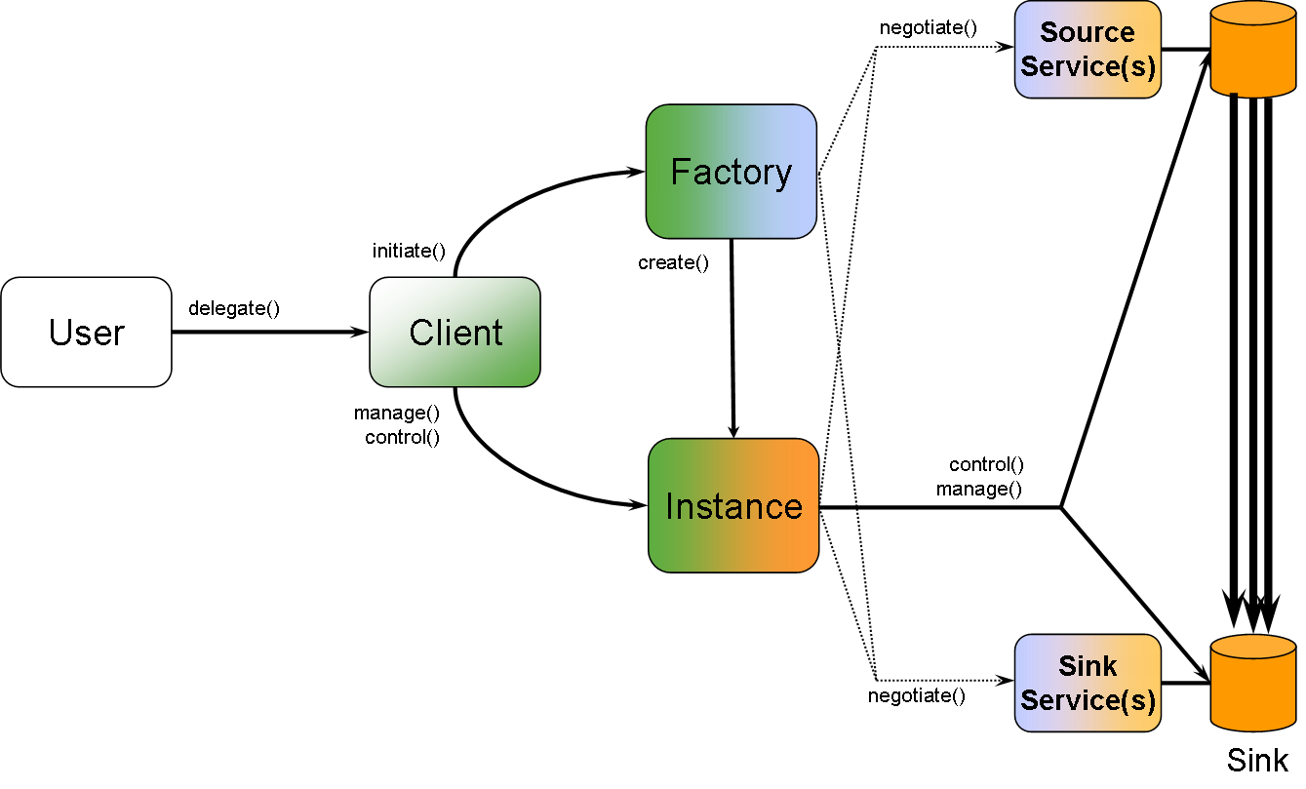
Figure 1: Overview of the functional architecture

[Needs much more elaboration – multiple Factory Services etc.]
Needs an editable diagram!
Not sure how well this will work in a black and white print out!

Entities

This section describes the entities that participate in a data transfer. These entities can be natural (i.e. human beings), or agents. Non-human entities can be hardware or software only, or software governing/controlling hardware.

Source

The source of a data transfer contains all the bytes that need to be transferred in a structured organization. The details of this organization are intentionally left unspecified, i.e. subject to the local and opaque configuration of the Source itself. A source configuration may include, for example, automatic redirection to one of the potentially many replicas of the specified data. This may enable, if configured, striped data transfers to take place where the data is accessed and read from several parallel physical storage locations. Alternatively, it may enable least distance routing so that the actual source replica selected is physically closest to the destination of the data transfer.

From the viewpoint of the other data transfer entities the source’s primary function is to emit an ordered stream of bytes using one of potentially many data transfer protocols. To integrate with an existing Grid fabric, a source must export certain metadata compliant with the fabric specification.

Sink

The sink of a data transfer will eventually receive all bytes that constitute the source of a data transfer, so that the sink’s data structure and size is identical to the source configuration. As with the source, the sink’s organization is intentionally left unspecified: The Sink’s primary function is to collect the ordered stream of bytes off the source, employing the same data transport protocol. To integrate with existing Grid fabric, a source must export certain metadata compliant with the fabric specification.

DMI transfers bytes. DMI does NOT care about what happens with the bytes that are delivered to the Sink, and it does NOT care about what happens to data before it is made available to DMI. DMI does not care about or guarantee the semantics of the data set. Source and Sink are emitters and receivers of ordered streams of bytes.

Data Transfer Factory

The Data Transfer Factory’s (DTF) sole role is to set up and initiate a data transfer between a data Source and a data Sink. A user may give a complete, partial or empty set of values for parameters that shall be used for the next Data Transfer instance. If given a partial or empty set of user-supplied values, the Factory completes the set with default values. In other words, user-supplied values override default values for user-mutable parameters to a data transfer.
To set up a data transfer, the Data Transfer Factory approaches both the Source and Sink in an attempt to negotiate a data transfer protocol and, upon success, protocol specific parameter settings according to the current parameter set. This may include the number of parallel streams, packet size, port numbers, and other parameters. This negotiation may include reliability and scheduling, such as by which date and time the data transfer must be finished.
Eventually, the Data Transfer Factory instantiates a Data Transfer Instance and passes the instance handle back to the client.

A Factory may implement its function in a synchronous or asynchronous. For example, one may choose to deploy a small-scaled Grid to manage replicas in a way that only one data transfer protocol is used, and where all the data nodes (Sources and Sinks) are well known. Such a scenario may allow for a synchronous Factory implementation; the Client’s call blocks while the Factory “negotiates” protocol and parameters between Source and Sink, and commences after the Factory call returns the Data Transfer Instance’s handle. While this RPC-style invocation may suit small Grids or Grids tuned for special applications, most large-scale, loosely coupled Grids require asynchronous data transfer setup.

When implemented asynchronously, the Data Transfer Factory is much reduced in its functionality, merely instantiating the Data Transfer Instance. It is this Data Transfer Instance that takes over the task of negotiating protocol, parameters and scheduling prior to its original task of controlling and monitoring the data transfer itself.

A Data Transfer Factory is a persistent service. Its lifetime is designed so that a Factory can last for months of uninterrupted uptime.

Data Transfer Instance

The Data Transfer Instance’s purpose is to act as the third party instance controlling a data transfer. Towards the Data Transfer Client, it acts as a proxy to the underlying data transfer and may expose certain transfer protocol-specific capabilities and information. Note, however, that OGSA-DMI mandates the support of certain base line capabilities and information elements that each Data Transfer Instance MUST make available to the Data Transfer Client. If configured to do so, it sends notifications to registered clients. If the implementation employs asynchronous Data Transfer Instance creation, the Instance also takes the duty of setting up and configuring the data transfer as described above.

Clients of the Data Transfer Instance may poll information about its status, or apply management and control operations as described below.

The lifetime of a Data Transfer Instance is fairly short-lived compared to a Data Transfer Factory. It starts with the creation of the Data Transfer Instance, and ends with its destruction. Thus, a Data Transfer Instance is used for one, and only one data transfer execution(?). However, destruction is not performed automatically after the last byte of the data has arrived and stored successfully at the Sink. Rather, common configurations of Data Transfer Infrastructure implementations will allow for a Data Transfer Instance to live past the last transferred byte until the user has confirmed its destruction. Some implementers may even decide to keep the Data Transfer Instances even beyond any user’s access, until the Data Transfer service provider decides upon destruction.

Data Transfer Client

The Data Transfer Client contacts the Data Transfer Factory to set up and configure a Data Transfer. It will receive a handle to a Data Transfer Instance, which it can query for its status and other relevant information.

The Client may invoke control and management operations, such as “cancel”, “suspend”, “resume”, “status”, progress”, etc. as available and applicable on the service.

In most situations, the Data Transfer Client is not the same as the Data Transfer User (or their workstation, or the software installed on it). Rather, it will be a software agent located at a remote execution management system that executes parts of a larger workflow that require data transfers. It could also be a web based portal that lets the user manually set up and invoke data transfers.

Data Transfer User

The Data Transfer User is the only actor in the Data Transfer Architecture of the human kind. The identity of the Data Transfer User is immutable, and encoded in software in a format appropriate to the current security infrastructure. For example, if a Data Transfer takes place in a system using Explicit Trust Delegation, the Data Transfer User is properly identified with a PKI X.509v3 certificate. With other security frameworks such as Shibboleth different tokens are employed such as signed SAML tokens.

The identity of the Data Transfer User may or may not be the same as used to authenticate against either Source or Sink of the Data Transfer (see section 4.2.3.3 and 4.2.3.4). These three identities, the Data Transfer User, the identity passed to the Source, and the identity passed to the Sink, are functionally totally independent. They may be all the same, but they may also be all different.

Security

Security is a fundamental part of the overall architecture. However, regarding the security infrastructures already deployed and successfully employed, it does not make sense to attempt to either create or mandate a particular security infrastructure.

Instead, entities are identified with a flexible association mechanism that allows use of different security infrastructures. This specification defines a set of roles that can be associated with entities in a Data Transfer scenario, but the concrete contents and structure of the security information associated with a particular role depends on the infrastructure in use for a certain implementation. Defining the structure of the security information is out of scope for OGSA-DMI. However, the implementations of OGSA-DMI MUST understand, parse and evaluate this information or reject the received message appropriately.

Confidentiality and integrity, either at the message or transport level, however, need to be handled slightly differently. While each data transfer protocol has its own proprietary (or standardized) means of providing confidentiality and integrity, interoperability at the WS layer of a data transfer system is much more exposed to the existing security infrastructure. For example, in UNICORE, point-to-point connections are secured using transport level security, i.e. SSL/TLS. Other existing Grid infrastructures may use message level security such as WS-Security username/password profile, or WS-Security PKI profile.

Therefore transport level or message level security is orthogonal to OGSA-DMI, but entity level security is not.

Roles

Roles play an essential part when it comes to authorizing a data transfer transaction: When potentially transporting Terabytes of data or more, substantial amount of resources (time, network bandwidth, storage space) may be spent undertaking this. Accounting for a resource’s usage is also important, for instance it may usually results in a financial expense even though this may be covered invisibly and transparently in day-to-day Grid usage. Hence, data transport providers and users are equally interested in a robust and reliable, yet interoperable authentication scheme which is necessary to have an audit trail for what happens in the Grid.

The following roles have been initially defined in ETD [5]. As the original definitions are too focused on computational Grids and, within these, on the message path from the user to the execution host, this document amends the original definitions to suit the Data Transport component’s needs. The new definitions and association rules are fed back into future evolutions of ETD in Unicore.

User

The “User” role is associated to the entity that initiates a data transport transaction, either directly or indirectly through an agent. The User role assignment is immutable. Once it has been assigned to an entity (to be precise, to an identity) it cannot be changed anymore.

In other words, the User role is always assigned to the Data Transfer User entity.

Endorser

The “Endorser” role is the only role that can be assigned to more than one entity at the same time. However, once it has been assigned to that entity, it cannot be changed anymore. An Endorser, in the Data Transport Component, is an intermediary entity in the messaging chain that neither assumes the User role nor the Consignor role (see below).

For example, in a computational Grid, a workflow engine may realize that a certain data set is required at a certain location for a job to execute in a workflow. To satisfy this constraint, the workflow engine may set up a data transfer from a second location, so that the job can start executing after the data transfer has finished. In such a scenario, the workflow engine acts as a client to the data transfer transaction, but it does so, on behalf of the User.

In other words, the Endorser role, if applicable, is assigned to any intermediary entity that acts on behalf of the User including the Data Transfer Client entity. The only exception to this are Data Transfer Users that directly initiate Data Transfers, i.e. the Data Transfer User entity is identical to the Data Transfer Client entity. In this case, no Endorser role is assigned to any entity.

Consignor

The Consignor role is assigned to the entity that initiates, manages and controls Data Transfers on behalf of a user. As the architecture functionally decouples initiation from management and control of the data transfer into the Data Transfer Factory and Data Transfer Instance, the Consignor Role is functionally assigned to both entities, the Data Transfer Factory and the Data Transfer Instance. This is no shortfall in the architecture as the Data Transfer Instance is a direct functional derivative of the Data Transfer Factory, hence trusting the Data Transfer Factory means transitively trusting the Data Transfer Instance.

Source

<<TBD>>

Sink

<<TBD>>

Data Transfer Factory interface
This section defines the interface of the Data Transfer Factory (DTF). The purpose of the DTF is to set up a data transfer between a Source and a Sink.

The DTF provides a set of properties describing the current configuration of the Factory. The set of properties MUST minimally include the compulsory attributes defined in this specification. It MAY support the optional attributes defined in this specification, and using the defined extensibility mechanisms any implementation specific attributes. These attributes are defined in the following properties section.

The factory exports two operations that can be used to request a data movement activity. The data movement activity can be invoked directly through a synchronous RPC-like operation (requestDataTransfer) or an asynchronous operation (requestDataTransferInstance) where the data transfer activity is encapsulated within a Data Transfer Instance (DTI). Parameters given in invoking these operations define the requirements specified by the client for the data transfer. If the creation of a DTI fails, the operation exits with a fault. If creating a DTI succeeds, the operation returns an EPR to the DTI.

The abstract interface definition is as follows:
Data Transfer Factory
[supported protocol]*
[service instance] requestDataTransferInstance( [source DEPR], [source credentials],
[sink DEPR], [sink credentials],
[transfer requirements] )

Figure 2: Functional Data Transfer Factory interface
Clean up following text from references to the now deleted RPC-style method invocation

The details of the DTF are described in the following sections.

Properties

The Data Transfer Factory exports the following read-only properties that describes its configuration and capability.

[supported protocol]

The [supported protocol] information element identifies a particular data transfer protocol that is recognized by the DTF and any generated DTI and can be used to initiate a data transfer from a source or a sink. If a protocol specified within a DEPR is not listed as a supported protocol by the DTF then it will not be considered as an option during any negotiation that follows. Multiple [supported protocol] elements may be specified.
A [supported protocol] element does not act as a default protocol. It is just an indicator of which protocols this factory knows about, and, indirectly, which undo strategies are available (subject to the negotiated data movement protocol).
Also, as a consequence, ther cannot be a default undo strategy. An undo strategy cannot be selected until the data movement protocol is determined.

XML Representation

The [supported protocol] information element is rendered in XML as:

<tns:SupportedProtocol name=”xs:anyURI”>
<tns:Undo/>*
</tns:SupportedProtocol>

Where:

/tns:SupportedProtocol
Represents the [supported protocol] information element. Its XML type is defined as xs:anyURI.

For the purpose of this specification, the following character strings identify the described data transfer protocol and are intended for use as values within the [supported protocol] information elements.

All implementations MUST support the following identifiers. However, it is left to the implementation whether they actually implement the described data transfer protocol.

http://www.ogf.org/ogsa-dmi/2006/03/im/protocol/gridftp-v20
This identifier describes the GridFTP as specified in [4]

http://www.ogf.org/ogsa-dmi/2006/03/im/protocol/http/v11
This describes the HTTP/1.1 as specified in [7]

http://www.ogf.org/ogsa-dmi/2006/03/im/protocol/ftp
This describes the FTP as specified in [8]

http://www.ogf.org/ogsa-dmi/2006/03/im/protocol/ftp-passive
This describes the “Passive Mode” of the FTP when a Sink supports only passive FTP transfer mode, e.g. because of firewall restrictions, as described in [8]

http://www.ogf.org/ogsa-dmi/2006/03/im/protocol/parallel-http
This describes the ParallelHTTP as described in [Error: Reference source not found]

[undo strategy]

This section must be relocated in the document as it is no more a global DTF property!
Also, revise the prose accordingly!

The [undo strategy] information element describes the strategy that a Data Transfer implementation uses to clean up the traces of a Data Transfer that failed, either through time constraint violations or other errors.

The data type of the [undo strategy] information element is a character sequence constructed using URL construction rules. Hence [undo strategy] values look like URLs but they are not.

Clients to and implementations of this interface MUST support the following values:

http://www.ogf.org/ogsa-dmi/2006/03/im/undo/full
The service implementation guarantees a complete and successful undo of all changes caused at all entities participating in the Data Transfer. The undo operations MUST complete successfully. In order to comply with this value the Data Transfer agent MUST ensure that:

- Any data transferred to the sink is removed from the sink;
- Any remaining space reservations done at the sink are removed;
- Any remaining bandwidth reservations are undone;
- Others?

http://www.ogf.org/ogsa-dmi/2006/03/im/retry/best-effort
The service implementation guarantees that effort will be spent attempting a complete undo of all changes caused at all entities participating in the Data Transfer. This will be based on best-effort basis, but results are not guaranteed.

http://www.ogf.org/ogsa-dmi/2006/03/im/retry/none
The service implementation does not guarantee to undo any of the change caused at the entities participating in the Data Transfer (e.g. releasing reserved resources, wiping storage space of partial data, etc.). Clients must take the appropriate actions to perform any clean up on their own, which is out of scope for this Data Transfer specification.

XML Representation

The [undo strategy] information element is rendered in XML as:

<tns:Undo> xs:anyURI </tns:Undo>

Where:

/tns:Undo
Represents the [undo strategy] information element. Its XML type is defined as xs:anyURI.

[identity]

This is probably an artifact from the major edits. Also ties in closely with the security section in the architecture (section 3.3)

The [identity] information element describes the identity of an entity participating in a Data Transfer, as described in section 3.2.

To ensure that all participants can make an informed decision each by themselves, proper identity information MUST be conveyed along with the Web Services messages exchanged between the entities. This section defines the abstract format of the information element. Other sections define the bindings of this information element.

Typically, a Grid is deployed with a pre-selected security framework. Hence identity information is expressed in terms and data structures defined by this security framework. The fact that a Grid may support more than one security framework does not invalidate this; moreover identity is either expressed in each configured security infrastructure, or can be translated on-demand into the information domain of another security infrastructure.

To enable cross-Grid data transfers, security must be considered, but no particular security frameworks must be tied into the architecture. Instead, it must be made clear in which context or, regarding this specification, which role is associated with a given identity. The technical format of the identification is intentionally left unspecified. This specification associates identity with a role using a container element. The [identity] information element constitutes the said container element.

The relationship between a [role] and an entity is as follows. One entity can assume exactly one [role] at a time for a requested Data Transfer. But, depending on the [role], more than one entity can assume the same role (e.g. the “endorser” role) for a requested Data Transfer.

The type of the [identity] element is complex; i.e. it does not define or allow content other than child information elements.

XML Representation

The [identity] information element is rendered in XML as:

<tns:Identity>
<tns:Role/>
xs:any*
</tns:Identity>

Where:

/tns:Identity
Represents the [identity] information element. Its XML type is defined as xs:complexType.

/tns:Identity/tns:Role
represents the [role] information element as defined in section Error: Reference source not found.

/tns:Identity/xs:any
Represents the extension point where appropriate identity information is stored in the [identity] element. Its XML type is defined as xs:any, restricted to namespaces other than the XML Schema document’s namespace (symbolised by the local name “tns”).

[role]

The [role] information element describes a particular role, which an entity in a Grid can assume with respect to data transfers described in this document.

The data type of the [role] information element is a character sequence constructed using URL construction rules. Hence [role] values look like URLs but they are not.

The following values are defined for the [role] information element, representing the roles as described in section 3.3.1.

http://www.ogf.org/ogsa-dmi/2006/03/im/role/user
This identifier describes the “User” role as described in section 3.3.1.1.

http://www.ogf.org/ogsa-dmi/2006/03/im/role/endorser
This identifier describes the “Endorser” role as described in section3.3.1.2.

http://www.ogf.org/ogsa-dmi/2006/03/im/role/consignor
This identifier describes the “Consignor” role as described in section 3.3.1.3.

http://www.ogf.org/ogsa-dmi/2006/03/im/role/source
This identifier describes the “Source” role as described in section 3.3.1.4.

http://www.ogf.org/ogsa-dmi/2006/03/im/role/sink
This identifier describes the “Sink” role as described in section 3.3.1.5.

XML Representation

When rendered in XML, the [role] information element is described as follows:

<tns:Role> xs:anyURI </tns:Role>

Where:

/tns:Role
Represents the [role] information element. Its XML type is defined as xs:anyURI.

Operations

The DTF defines two operations that can be used to request a data transfer.

requestDataTransferInstance

This operation is used to create a DTI relating to a request for a specific data transfer activity within the specified constraints..

Invoking this operation will, on success, create a DTI accessed through an EPR returned by this operation. The DTI encapsulates the negotiations that may take place in selecting the protocols and services that will be used to undertake the data transfer, and ultimately the data transfer itself. By creating the instance the interaction with the client can continue in an asynchronous manner using a ‘message style’ model.

Operation Parameters

The following information elements further describe the parameters used in the “requestDataTransfer” or the “requestDataTransferInstance” operations.

[service instance]

The [service instance] information element describes the EPR to a DTI. This handle is minted upon creation of the DTI by the DTF during the “requestDataTransferInstance” operation and sent back to the client of the DTF.

Once the Client receives the EPR its communication with the DTF is complete for the current data transfer, and all future communication by the client for this data transfer is with the DTI using the EPR.

XML Representation

When rendered in XML, the [service instance] information element is described as follows:

<tns:ServiceInstance> wsa:EndpointReferenceType </tns:ServiceInstance>

The following describes the attributes and elements in the Pseudo Schema given above:

/tns:ServiceInstance
This represents the [service instance] information element. Its XML type is defined as wsa:EndpointReferenceType.

[source] or [sink]

The [source] information element describes the source of a data transfer and has the type of a Data Endpoint Reference (DEPR). The [sink] information element describes the sink of a data transfer and has the type of a Data Endpoint Reference (DEPR).

The DEPR used as either the sink or source is obtained in a manner out of bands for this specification and the client to the DTF passes these DEPRs to the factory. The DEPR is minted by a Web Service in close proximity or identical to Web Services that handles and manages the actual data represented by the DEPR. The DEPR is of type wsa:EndpointReferenceType and MUST NOT be null.

The implementation of the Web Service that mints and issues the DEPR element MUST provide at least one protocol contained within a [data transfer protocol] element describing how the data represented by the DEPR can be accessed. If more than one [data transfer protocol] element is specified each element MUST contain a different protocol. The [data transfer protocol] element is contained within the WS-Addressing [metadata] section of the [data EPR] element.

In effect, the [data EPR] element defines a profile on the [metadata] section of a generic WS-Addressing EndpointReference. However, this does not limit the Web Service that mints the [data EPR] element to add other metadata to the [metadata] element using the described extensibility mechanism, which is not defined within this specification.

XML Representation

When rendered in XML, the [source] or [sink] information element is described as follows:

<tns:DataEPR>
<wsa:Address/>
<wsa:ReferenceParameters/>?
<wsa:Metadata>
xs:any*
<tns:Data protocol=”xsd:any” url=”xsd:any” />*
</wsa:Metadata>?
</tns:DataEPR>

The following describes the attributes and elements in the Pseudo Schema given above:

/tns:DataEPR
This represents the [source] information element. Its XML type is defined as wsa:EndpointReferenceType.

/tns:DataEPR/wsa:Address
This represents the [address] element.

/tns:DataEPR/tns:ReferenceParameters
This represents the [reference parameters] element.

/tns: DataEPR/wsa:Metadata
This represents the [metadata] element.

/tns: DataEPR/tns:Metadata/xs:any
This represents the extensibility point for further information about the data.

SJN: CHANGE THIS

/tns: DataEPR/tns:Metadata/tns:DataTransferProtocol
This describes the [protocol] element that can be used to access the data.

[source credentials]

The [source credentials] contain security related information that is used to authenticate and authorize the requested data transfer against the Source.

As per section 3.3, The Data Transfer Component is agnostic to specific Security Frameworks such as PKIX, Kerberos, SAML based systems, Shibboleth, etc. It is not, however, ignoring the necessity to properly authenticate and authorize transactions. The [source credentials] carry such security information without actually knowing or understanding such information, but enable the Source to carry out proper authentication and authorization of the requested Data Transfer.

The type of the [source credentials] element is complex; i.e. it does not define or allow content other than child information elements.

XML Representation

When rendered in XML, the [source credentials] information element is described as follows:

<tns:SourceCredentials> xs:any* </tns:SourceCredentials>

The following describes the attributes and elements in the Pseudo Schema given above:

/tns:SourceCredentials
This represents the [source credentials] information element. Its XML type is defined as xs:complexType.

/tns:SourceCredentials/xs:any
This describes any security information that is required to enable the Source to properly authenticate and authorise the requested Data Transfer. The format of such data must conform to the security framework employed in the current Grid infrastructure.

[sink credentials]

The [sink credentials] contain security related information that is used to authenticate and authorize the requested Data Transfer against the Sink.

The constraints for the [source credentials], as given in section 4.2.3.3 with respect to security frameworks also hold true for the [sink credentials].

The type of the [sink credentials] element is complex; i.e. it does not define or allow content other than child information elements.

XML Representation

When rendered in XML, the [sink credentials] information element is described as follows:

<tns:SinkCredentials> xs:any* </tns:SinkCredentials>

The following describes the attributes and elements in the Pseudo Schema given above:

/tns:SinkCredentials
This represents the [sink credentials] information element. Its XML type is defined as xs:complexType.

/tns:SinkCredentials/xs:any
This describes any security information that is required to enable the Sink to properly authenticate and authorise the requested Data Transfer. The format of such data must conform to the security framework employed in the current Grid infrastructure.

[transfer requirements]

The [transfer requirements] information element describes various constraints on the data transfer request.

The data type of the [transfer requirements] element is complex, i.e. it does not define or allow content other than child information elements.

This element is optional when requesting a data transfer. When present, the DTI MUST use these values to drive the selection of the underlying protocols and services. If not specified then the DTI will use the default values.

Do the timing options define important points within the lifetime of the DMI Instance, or indeed the times when the bytes hit the wire?

XML Representation

When rendered in XML, the [transfer options] information element is described as follows:

<tns:TransferRequirements>
<tns:StartNotBefore/>?

<tns:EndNoLaterThan xsi:nillable=true />
<tns:Undo/>?
</tns:TransferRequirements>

The following describes the attributes and elements in the Pseudo Schema given above:

/tnsTransferRequirements
This represents the [transfer requirements] information element. Its XML type is defined as xs:complexType.

/tnsTransferRequirements/tns:StartNotBefore
This represents the [startNotBefore] information element. The data transfer encapsulated by the DTI MUST not start before the date and time specified by this element. If not specified its default value will be the date and time that the DTI was created.

/tnsTransferRequirements/tns:EndNoLaterThan
This represents the [endNoLaterThan] information element. The value MUST specify a date and time greater than or equal to the value of [endNotBefore] or [startNotBefore] element. The default value that will be used by the DTI will be null indicating that there is no date and time by which the data transfer must complete by.

If a value is specified for this element and the DTI has not reached the “Done” state by the time the specified date and time is reached, then the DTI will be deemed to have failed and MUST enter the “Failed” state. The DTI MUST attempt to halt the underlying data transfer using the selected protocols.

If the [undo] element exists then the results of the partial transfer at the sink MUST be removed so the DTI can enter the “Failed:Clean”

/tns:TransferRequirements/tns:Undo
This represents the [undo] information element. It MUST only apply to the Source of the Data Transfer. Use the definitions as given earlier in the document

Faults

This section needs revision to decompose fault semantics from the syntax (e.g. WSRF BaseFaults).

The Data Transfer Factory MAY throw faults if appropriate. The faults can be divided into two groups.

Another group of faults consists of faults related to other Web Services interface descriptions an implementation of this specification is composed with. This group of faults is out of bands for this specification and not specified.

The third group of faults consist of faults that are related to the invocation of the “requestTransfer” operation. This group of faults in described below.

Each fault described below extends the generic BaseFault as defined in [4].

UnsatisfiableRequestOptionsFault

This fault describes the situation when the options as resolved from [default options], [source options], [sink options] and [timing options] do not allow a successful set up of a Data Transfer.

The wsrf-bf:FaultCause element MAY indicate further information which specific option value(s) caused this fault. The details are implementation specific.

The wsrf-bf:FaultCause element MAY indicate that a re-request of a Data Transfer with identical values for all request parameters may succeed or not. The details how this is communicated are implementation specific.

NoTransferProtocolAgreementFault

This fault describes the situation when attempting to negotiate a data transfer protocol has failed. A possible cause may be mismatching [source protocol] entries at the Source and [sink protocol] entries at the Sink; or different implementations of the same data transfer protocol that render an interoperable use of that transfer protocol impossible.

Extensions of the fault MAY indicate that a re-request of a Data Transfer with identical values for all request parameters may succeed or not. The details how this is communicated are implementation specific.

CredentialsFailedFault

This fault describes the situation when the credentials given as [source credential] or [sink credential] are generally insufficient, invalid, cannot be authorised or authenticated, of the wrong security framework, etc.

The wsrf-bf:FaultCause element MAY indicate further information on the cause for the fault. The details are implementation specific.

Extensions of the fault MAY indicate that a re-request of a Data Transfer with identical values for all request parameters may succeed or not. The details how this is communicated are implementation specific.

CustomFault

This fault element MAY be used to describe any other situations that are unrelated to or specific to the implementation of the Data Transfer Factory.

The details and contents of such faults are implementation specific. However, implementations MUST follow the rules and guidelines given in [4].

Data Transfer Instance interface
This section defines the interface of the Data Transfer Instance (DTI). The purpose of the Data Transfer Instance is to monitor and control the Data Transfer between the Source and the Sink. Users can access the Data Transfer Instance to query the status and progress of the underlying Data Transfer.

The Data Transfer Instance exports a set of properties describing the current state and configuration of the Data Transfer Instance. The set of properties is not limited to the attributes defined in this specification. Implementers may choose to compose in additional attributes as necessary. However the attributes defined in this document MUST be supported by any implementation.

The abstract interface definition is as follows:
Data Transfer Instance
sequence of [undo] (1 .. n)
[scheduled start time]
[estimated completion time]
[total data size]
[bytes transferred]
[status]
Start
Stop
Restart
Suspend

Figure 3: Functional Data Transfer Instance interface

The details of the Data Transfer Instance are described in the following sections.

Properties

The Data Transfer Instance exports the following properties. They are all informational properties, i.e. they can be accessed, but not modified. All properties are dynamic in the sense that their respective value may change during the lifetime of the Data Transfer Instance.

TODO: Expose the negotiated [undo] strategy as an informational value.

[undo strategies]
If one [undo] element, then this is the one that will be attempted. If more than one, then this forms an ordered list of undo strategies that the implementation will attempt before giving up completely.

[scheduled start time]

The [scheduled start time] information element describes the point in time that marks the start of the current attempt of the data transfer, i.e. when the DTI initiates the transfer through the selected protocol.

Support for the [scheduled start time] attribute is MANDATORY for all implementations of this interface.

An implementation of this specification MUST guarantee the [scheduled start time]. If the data transfer does not start at the scheduled start time then it MUST enter a FAILED state.

If scheduling information is not present or available for the current Data Transfer Instance, then the value of the [scheduled start time] element is null.

The data type of the [scheduled start time] element is a composite of a Gregorian calendar date and a time on that day.

XML Representation

When rendered in XML, the [scheduled start time] information element is described as follows:

<tns:ScheduledStartTime xsi:nillable=”true”>
xs:dateTime
</tns:ScheduledStartTime>

The following describes the attributes and elements in the Pseudo Schema given above:

/tns:ScheduledStartTime
This represents the [scheduled start time] information element. Its XML type is defined as xs:dateTime. The cardinality of the XML element is 1, i.e. it MUST be present at all times. If no meaningful value is available, i.e. the Data Transfer has not been scheduled yet, then this MUST be reflected using the attribute and value xsi:nil=”true” as defined in [1].

[estimated completion time]

The [estimated completion time] information element describes a point in time that marks the projected point in time when the Data Transfer may finish, i.e. when the underlying transfer protocol has reported completion of the data transfer.

Support for the [estimated completion time] attribute is OPTIONAL for all implementations of this interface.

The [estimated completion time] is only of informative nature. That is, if an implementation supports this attribute, then the implementation is not obliged whatsoever to guarantee the completion of the underlying Data Transfer at the given date and time. An implementation MAY change the value of this attribute at any given time until the Data Transfer has completed.

The data type of the [estimated completion time] element is a composite of a Gregorian calendar date and a time on that day.

XML Representation

When rendered in XML, the [estimated completion time] information element is described as follows:

<tns:ExtimatedCompletion xsi:nillable=”true”>
xs:dateTime
</tns:ExtimatedCompletion>

The following describes the attributes and elements in the Pseudo Schema given above:

/tns:EstimatedCompletionTime
This represents the [estimated completion time] information element. Its XML type is defined as xs:dateTime. If supported, the cardinality of the XML element is 1, i.e. it MUST be present at all times. If no meaningful value is available, i.e. no meaningful estimation can be given, then this MUST be reflected using the attribute and value xsi:nil=”true” as defined in [1].

[total data size]

[bytes transferred]

The [progress] information element describes the high-level progress of the current active Data Transfer attempt.

Support for the [bytes transferred] attribute is OPTIONAL for all implementations of this interface.

REVISE THE TEXT

The data type of the [progress] element is positive integer including zero, i.e. the integer values starting at “zero” (0) and ending at “one hundred” (100). The unit of the [progress] information element is “percent”.

The value of [progress] MUST be 0, if no data has been sent to the wire for the current data transfer attempt (including the first attempt), when querying for this attribute. The value of [progress] MUST be 100 if the current data transfer attempt was successful and the last byte has been taken off the wire.

XML Representation

When rendered in XML, the [progress] information element is described as follows:

<tns:Progress> xs:positiveInteger </tns:Progress>

The following describes the attributes and elements in the Pseudo Schema given above:

/tns:Progress
This represents the [progress] information element. Its XML type is defined as xs:positiveInteger.

[status]

The [status] information element describes the status of the Data Transfer Instance at the time it is queried for its status.

Support for the [status] attribute is MANDATORY for all implementations of this interface.

The data type of the [status] information element is a character sequence constructed using URL construction rules. Hence [status] values look like URLs but they are not.

The following values are defined for the [status] information element, representing the statuses as described in section .

http://www.ogf.org/ogsa-dmi/2006/03/im/status/created
This identifier describes the status “Created” as described in section 5.4.1.1.

http://www.ogf.org/ogsa-dmi/2006/03/im/status/negotiating
This identifier describes the status “Negotiating” as described in section 5.4.1.2.

http://www.ogf.org/ogsa-dmi/2006/03/im/status/scheduled
This identifier describes the status “Scheduling” as described in section 5.4.1.3.

http://www.ogf.org/ogsa-dmi/2006/03/im/status/transferring
This identifier describes the status “Transferring” as described in section 5.4.1.4.

http://www.ogf.org/ogsa-dmi/2006/03/im/status/unsatisfiable
This identifier describes the status “Failed” as described in section 5.4.1.5.

http://www.ogf.org/ogsa-dmi/2006/03/im/status/done
This identifier describes the status “Done” as described in section 5.4.1.6.

XML Representation

When rendered in XML, the [status] information element is described as follows:

<tns:Status> xs:anyURI </tns:Status>

The following describes the attributes and elements in the Pseudo Schema given above:

/tns:Status
This represents the [status] information element. Its XML type is defined as xs:anyURI.

Operations

The Data Transfer Instance interface does not specify any operations of its own. Instead, operations of already existing frameworks are used to allow Client to access and process the information represented by the Data Transfer Interface.

Start

This operation is used to manually start the data transfer represented by the DTI. The DTI will move to the “Transferring” state from the “Scheduled” state on successful completion of this operation. If the DTI is not in the “Scheduled” state then this operation has no effect.

Stop

On invoking this operation the DTI will if in the “Transferring” or “Suspended” state move into the “Failed” state by attempting to stop the underlying data transfer. Depending on the success of terminating the data transfer the DTI will move into one of the “Failed” substates – “Clean”, “Unclean” or “Unknown”. If the DTI is not in the “Transferring” or “Suspended” state then the operation has no effect.

Restart

On invoking this operation the DTI will if in the “Suspended” state attempt to move to the “Transferring” state. If the DTI is not in the “Suspended” state then this operation has no effect.

Suspend

On invoking this operation the DTI will if in the “Transferring” state attempt to move to the “Suspended” state. If the DTI is not in the “Transferring” state then this operation has no effect.

Faults

As the Data Transfer Instance interface does not define any operations, it cannot indicate an error condition by throwing a fault.

However, as the Data Transfer Instance MAY take over the negotiation phase from the Data Transfer Factory, the semantic conditions of the faults described for the Data Transfer Factory (see section 4.3) also hold true for the Data Transfer Instance when in state “Negotiating”.

Querying the current configuration of a Data Transfer Instance for the fault condition SHOULD be conducted through the implementation of a composed Web Services specification, such as WSDM [1].

Lifecycle

The lifecycle of the Data Transfer Instance (DTI) reflects the overall progress of the underlying data transfer activity, starting from its creation to it being destroyed.

Error: Reference source not found outlines the states and allowed transitions.

Lifecycle States

This section defines the semantics of the states as outlined in Figure 4.

Created

The “Created” state describes the configuration of the DTI after it has been created.

Negotiating

The “Negotiating” state describes the configuration of the DTI when it is performing the negotiation and configuration of the employed data transfer protocol using the user supplied configuration options.

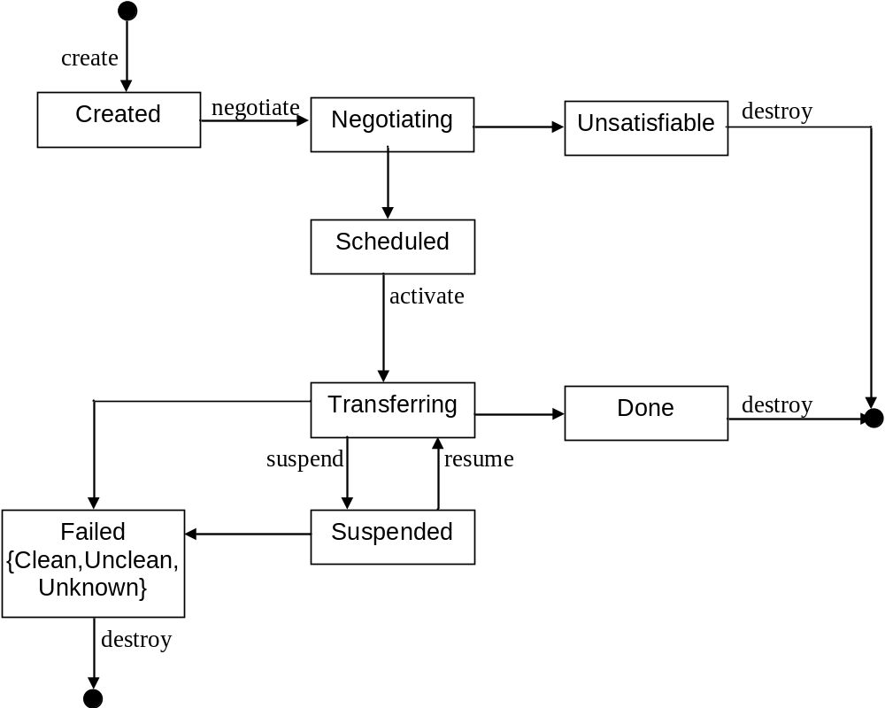 Figure 4: State diagram for the Data Transfer Instance

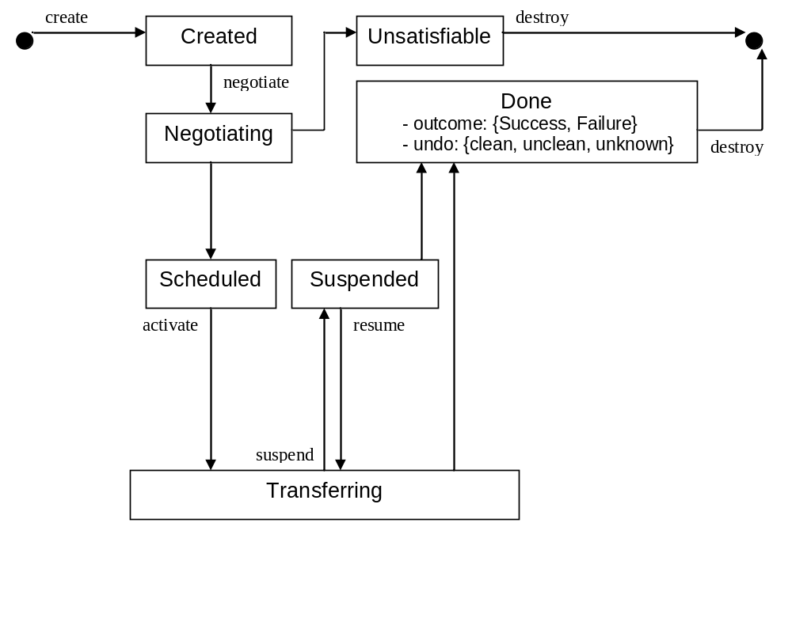
Figure 5: Alternative State diagram (would need revision of textural state description)

Scheduled

In state “Scheduled” the DTI has identified a viable set of underlying data transfer services compliant with the specified requirements and, if required, negotiated sufficient resources to make an attempt to transfer the data. The transfer itself has not yet started as it is not yet due to start (i.e. awaiting an agreed resource reservation) or is to be started manually.

Transferring

A DTI is in state “Transferring” if the data transfer through the underlying protocols selected during the “Negotiating” phase has been initiated.

Unsatisfiable

A DTI reaches the state “Unsatisfiable” if the currently available environment (i.e. the source and sink services, available bandwidth, etc.) is unable to meet the requirements specified as options in the creation of the DTI through the factory. It is not possible to recover from this state with the currently available resources. The resources accessible through this service, and the availability of the resources themselves, may change in the future and thereby allow a feasible solution, but this can only be ascertained by creating a new DTI.

A non-normative description of this state might be “Sorry, I give up, it is useless to even try further for now.”

Done

A DTI reaches the state “Done” (from the “Transferring” state) when the protocols selected to undertake the data transfer have signaled completion and that any temporary files generated during the transfer have been removed.

Failed

The “Failed” state is reached when the protocols that are being used to undertake the current transfer attempt report an unrecoverable failure.

The “Failed” state is qualified by being described as “Clean”, “Unclean” or “Unknown”. This qualified state is determined by the underlying implementation and how it fails. A “Clean” state asserts that all temporary files generated by the underlying implementation during the transfer have been removed. An “Unclean” state asserts that there are temporary files left by the underlying implementation that need to be removed by some other process that will need to be initiated by the client. An “Unknown” state indicates that the client cannot assume that any temporary files have been removed and MAY need to perform further actions to clean up the state of the transfer.

Suspended

The “Suspended” state indicates that the underlying data transfer has been halted. This may not be supported by all data transfer protocols in which case the state will not be reached when triggered by the suspend event.

Lifecycle Events

Create

By invoking the factory operation, a DTI is created during this event, and assumes state “Created”.

Negotiate

The “Negotiate” event triggers the DTI to enter a negotiation phase with the currently available Source and Sink services. The specified the user-supplied options MUST be used in this phase and to constrain the number of viable solutions. Some of the services MAY only support certain users or only have available capacity at certain times, thereby further reducing the number of viable solutions.

This event MUST NOT be sent to a Data Transfer Instance when the Data Transfer Factory is an RPC style implementation. However, this event MUST be sent to a Data Transfer Instance in a message style environment.

The details of how the DTI discovers the available Source and Sink services and carries out the negotiations and reaches agreements (if required) are implementation details.

Activate

When receiving the “Activate” event, the DTI enacts the data transfer using the protocols and service instances (and any resource reservations) selected earlier.

Destroy

The “Destroy” event causes the DTI to clean up its own used resources and liquidate itself.

Suspend

The “Suspend” event causes the DTI to attempt move from a “Transferring” state to a “Suspend” state. This requires that the underlying data transfer protocols are able to halt and resume the data transfer on demand. If this capability is not available in the underlying protocol the DTI will remain in the “Transferring” state. If the capability is available and is successfully applied then the DTI enters the “Suspended” state. If the capability is available and the protocols fail to halt the transfer then the DTI enters the “Failed” state.

Resume

The “Resume” event causes the DTI to attempt to move from the “Suspended” to the “Transferring” state. If the data transfer fails to be resumed the DTI enters the “Failed” state.

Security Considerations

<< TBD >>

DMI neds to support the use case of separate identities at the source and sink.

Roles

DMI identifies roles that nodes may assume when involved in a DMI based data movement.
Possible roles are:
- User
An immutable role assigned to a human being (or its immediate software actor) that initiates a DMI movement
- Endorser
- Consignor
- Data Node

DMI does not mandate implementers use one particular security infrastructure. Does DMI support cross security infrastructure tokens.

- Data source and sink MUST say “no, not allowed”, if the provided credentials are not understood by source or sink.

Please refer to RFC 3552 [RESCORLA] for guidance on writing a security considerations section. This section is required in all documents, and should not just say “there are no security considerations.” Quoting from the RFC:

“Most people speak of security as if it were a single monolithic property of a protocol or system, however, upon reflection, one realizes that it is clearly not true. Rather, security is a series of related but somewhat independent properties. Not all of these properties are required for every application.

We can loosely divide security goals into those related to protecting communications (COMMUNICATION SECURITY, also known as COMSEC) and those relating to protecting systems (ADMINISTRATIVE SECURITY or SYSTEM SECURITY). Since communications are carried out by systems and access to systems is through communications channels, these goals obviously interlock, but they can also be independently provided.”

Contributors
Michel Drescher
Fujitsu Laboratories of Europe, Ltd.
Hayes Park Central, Hayes End Road
Hayes, Middlesex UB4 8FE
United Kingdom

Allen Luniewski
IBM Corp.

Mario Antonioletti
EPCC

Stephen Newhouse
[Microsoft?]

<< TBD >>

Contact information for authors. You can also use this section to recognize contributions by people who are not listed on the title page, but made a useful contribution (it’s OK to mention the nature of the contribution).

The actual Authors (or Editors) listed on the title page are those committed to taking permanent stewardship for this document – receiving communication in the future and otherwise being responsive to its content. The GFSG recommends at most three Author/Editors be listed on the title page, unless there are compelling reasons to list more.

Glossary

<< TBD >>

Recommended but not required.

Intellectual Property Statement

The OGF takes no position regarding the validity or scope of any intellectual property or other rights that might be claimed to pertain to the implementation or use of the technology described in this document or the extent to which any license under such rights might or might not be available; neither does it represent that it has made any effort to identify any such rights. Copies of claims of rights made available for publication and any assurances of licenses to be made available, or the result of an attempt made to obtain a general license or permission for the use of such proprietary rights by implementers or users of this specification can be obtained from the OGF Secretariat.

The OGF invites any interested party to bring to its attention any copyrights, patents or patent applications, or other proprietary rights which may cover technology that may be required to practice this recommendation. Please address the information to the OGF Executive Director.

Disclaimer
This document and the information contained herein is provided on an “As Is” basis and the OGF disclaims all warranties, express or implied, including but not limited to any warranty that the use of the information herein will not infringe any rights or any implied warranties of merchantability or fitness for a particular purpose.

Full Copyright Notice

Copyright (C) Open Grid Forum (2007). All Rights Reserved.

This document and translations of it may be copied and furnished to others, and derivative works that comment on or otherwise explain it or assist in its implementation may be prepared, copied, published and distributed, in whole or in part, without restriction of any kind, provided that the above copyright notice and this paragraph are included on all such copies and derivative works. However, this document itself may not be modified in any way, such as by removing the copyright notice or references to the OGF or other organizations, except as needed for the purpose of developing Grid Recommendations in which case the procedures for copyrights defined in the OGF Document process must be followed, or as required to translate it into languages other than English.

The limited permissions granted above are perpetual and will not be revoked by the OGF or its successors or assignees.

References
Note that only permanent documents should be cited as references. Other items, such as Web pages or working groups, should be cited inline (i.e., see the Open Grid Forum, http://www.ogf.org). References should conform to a standard such as used by IEEE/ACM, MLA, Chicago or similar. Include an author, year, title, publisher, place of publication. For online materials, also add a URL. It is acceptable to separate out “normative references,” as IETF documents typically do. Some sample citations:

[BIRON] Biron, P. et al. XML Schema Part 2 (Second Edition). October 2004. http://www.w3.org/TR/xmlschema-2/
[BRADNER1] Bradner, S. Key Words for Use in RFCs to Indicate Requirement Levels, RFC 2119. March 1997.
[BRADNER2] Bradner, S. The Internet Standards Process – Revision 3, RFC 2026. October 1996.
[BRAY] Bray, T., Hollander, D., Laymann, A., Tobin, R. Namespaces in XML 1.0, http://www.w3.org/TR/REC-xml-names/. W3C, 16 August 2006.
[CATLETT] Catlett, C. GFD-1: Grid Forum Documents and Recommendations: Process and Requirements. Lemont, Illinois: Global Grid Forum. April 2002.
[COWAN] Cowan, J. et al. XML Information Set (Second Edition) February 2004. http://www.w3.org/TR/xml-infoset
[RESCORLA] Rescorla, E. Guidelines for Writing RFC Text on Security Considerations. RFC 3552. July 2003.
[THOMPSON] Thompson, H. et al. XML Schema Part 1: Structures (Second Edition). October 2004. http://www.w3.org/TR/xmlschema-1/

OLD REFERENCES -- Revisit

- WSDM Oasis Standard Specifications 1.0; Vambenepe, W. et al, March 2005;
http://www.oasis-open.org/committees/wsdm/
- WSRF OASIS Standard Specifications; Snelling ,D., Robinson, I., Banks, T. et al, April 2006; http://www.oasis-open.org/committees/wsrf
- Web Services Resource Properties 1.2 (WS-ResourceProperties); Graham, S., Treadwell, J.; April 2006;
http://docs.oasis-open.org/wsrf/wsrf-ws_resource_properties-1.2-spec-os.pdf
- Web Services Base Faults 1.2 (WS-BaseFaults); Liu, L., Meder, S.; April 2006;
http://docs.oasis-open.org/wsrf/wsrf-ws_base_faults-1.2-spec-os.pdf
- Web Services Base Notification 1.3 (WS-BaseNotification); Graham, S., Hull, D., Murray, B.; October 2006;
http://docs.oasis-open.org/wsn/wsn-ws_base_notification-1.3-spec-os.pdf
- GridFTP v2 Protocol Description, GFD.47; Mandrichenko, I., Allcock, W., Perelmutov, T.; May 2005; http://www.ogf.org/documents/GFD.47.pdf
- Hypertext Transfer Protocol – HTTP/1.1, RFC2616; Fielding et al; June 1999; http://www.ietf.org/rfc/rfc2616.txt
- File Transfer Protocol (FTP); Postel, J., Reynolds, J.; October 1985; http://www.ietf.org/rfc/rfc959.txt
- Web Services Addressing 1.0 – Core; W3C; Gudgin, M., Hadley, M., Rogers, T.; May 2006; http://www.w3.org/TR/ws-addr-core/
- Web Services Security: SOAP Message Security 1.1; Nadalin, A., Kaler, C., Monzillo, R., Hallam-Baker, P.; February 2006;
http://www.oasis-open.org/committees/wss

Renderings

Mandatory compositions

NextGRID Basic Profile

An implementation of this interface MUST also implement the NextGRID Basic Profile Facilities:
- Service Description, i.e. WSDL 1.1
- Control Channel, i.e. HTTP(S) and SOAP 1.1
- Architecture Profiling, i.e. OGSA WSRF Base Profile 1.0
- Resource Access, State and Properties, i.e. WSRF 1.2

When implementing these facilities, all normative statements given in each facility MUST be followed; i.e. all MANDATORY elements and operations MUST, and all OPTIONAL elements and operations MAY be provided by the implementation of this specification, respectively.

The properties described in section 5.1, i.e. [scheduled time], [estimated completion time], [progress], [attempts] and [status], if supported, MUST be exposed as ResourceProperties as defined in [3].

Optional compositions

NextGRID Basic Profile

An implementation of this interface MAY also implement the following NextGRID Basic Profile Facilities:
- Authentication, i.e. X.509
- Authentication + Confidentiality, i.e. SSL/TLS
- Resource Access, State and Properties, i.e. WS-Transfer
- Resource Access, State and Properties, i.e. ResourceTransfer

When implementing these facilities, all normative statements given in each facility MUST be followed; i.e. all MANDATORY elements MUST, and all OPTIONAL elements MAY be provided by the implementation of this specification.

WS-BaseNotifiication

An implementation of this interface MAY also implement the NotificationProducer interface as defined in WS-BaseNotification [5]. When implementing WS-BaseNotiffication, , all normative statements given in that specification MUST be followed; i.e. all MANDATORY elements MUST, and all OPTIONAL elements MAY be provided by the implementation of this specification.

WSDM (WS-DistributedManagement)

An implementation of this specification MAY also implement the WSDM family of specifications [1]. When implementing the WSDM family of specifications, then all MANDATORY WSDM sub-specifications MUST be implemented, and all OPTIONAL WSDM-sub-specifications MAY be implanted.

All normative statements given in each sub-specification that is implemented MUST be followed; i.e. all MANDATORY elements MUST, and all OPTIONAL elements MAY be provided by the implementation of this specification.

