Remote Instrumentation Services In Grid Environment (RISGE-RG)
Information about project/research involved in work of the group

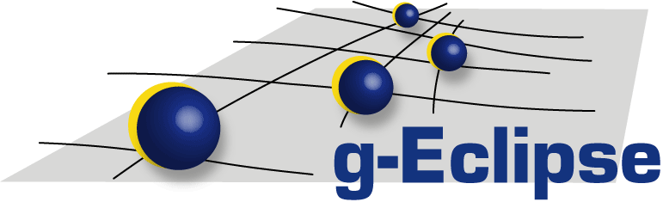

Project acronym:
g-Eclipse
Project (Research) full name:
An integrated, Grid enabled workbench tool for Grid application users, Grid developers and Grid operators based on the Eclipse platform
Start date:
01.07.2006
Duration:
24 months
Project web site:
http://www.geclipse.eu
http://www.eclipse.org/geclipse
Project coordinator:
Mathias Stümpert
(mathias.stuempert@iwr.fzk.de)
Contact person (in terms of OGF):
Mathias Stümpert
(mathias.stuempert@iwr.fzk.de)
Paweł Wolniewicz
(pawel.wolniewicz@man.poznan.pl)
Project participants (institution name,country):
FZK, Germany
PSNC, Poland
JKU, Austria
UCY, Cyprus
Innopract, Germany,
RUR, United Kingdom
IT Innovation, United Kingdom
Project(Research) summary(1/4-1/2 page max):
The g-Eclipse project aims to build an integrated workbench framework to access the power of existing Grid infrastructures. The framework will be built on top of the reliable eco-system of the Eclipse community to enable a sustainable development and to benefit from synergy effects arising from the use of the widely spread Eclipse platform. The project will provide tools to customize Grid users' applications, to manage Grid resources and to support the development cycle of new Grid applications.
The g-Eclipse framework is based on a middleware-independent model and a graphical user interface based build upon this model. By extensively using the Eclipse extension mechanism in combination with object-oriented design patterns the framework can be easily extended by middleware-specific implementations. The result of this approach is a common user interface for all potential middlewares in order to lower the threshold for scientific and industrial applications to be used on a Grid.
In its first project year g-Eclipse provided the middleware-independent architecture and based on this an exemplary implementation for the gLite middleware. This implementation directly enables the use of already existing large Grid infrastructures such as EGEE or int.eu.grid. In the second project year another implementation of this architecture for the GRIA middleware will be provided in order to prove the middleware-independent concept of the g-Eclipse model.
User communities(short description):
The g-Eclipse project directly supports three different user communities, Grid application users, Grid operators and Grid application developers:
- Grid application users will be able to access the Grid with standardized, but customizable user-friendly interfaces.
- Grid operators will be able to reduce the cost of operation as the complexity of the Grid will be reduced with the supporting tools.
- Grid application developers will be empowered to speed up the development cycle of new Grid applications.
Project(Research) relation with objectives of RISGE-RG group:
Remote job control, data access and visualization are key features of the g-Eclipse framework and are furthermore essential for remote device access and control. Therefore there is a close relation between the objectives of g-Eclipse and the RISGE-RG group.

