Notes:
This submission contains proposed replacement wording for §6.13 in draft-ggf-ogsa-ogsa-013a.doc :
https://forge.gridforum.org/docman2/ViewCategory.php?group_id=42&category_id=469
It is composed of content adapted from the draft-ggf-ogsa-logservice-10.doc :
https://forge.gridforum.org/docman2/ViewProperties.php?group_id=42&category_id=469&document_content_id=1538
and represents the output of the Logging System Focus Area of the OGSA-WG.
The submission outline and guidance for content were obtained from service_description_template_v31.doc :
https://forge.gridforum.org/docman2/ViewProperties.php?group_id=42&category_id=357&document_content_id=1586
Change History:
This is Version 2 of the submission, it updates V1 :
https://forge.gridforum.org/docman2/ViewProperties.php?group_id=42&category_id=430&document_content_id=1592
based on comments made during the OGSA-WG call of January 8, 2004.

... BH

OGSA Services

Logger Services
The OGSA Logger Services serve as an intermediary between log artifact producers and log artifact consumers. Producers write log artifacts that may or may not be read at a later time by consumers. As documented in [ref:draft-ggf-ogsa-usecase-2], several Grid usage scenarios require logging services. These scenarios include those based on problem determination, metering resource consumption, failure recovery, transaction processing, and security. The logging requirements generated by these usage scenarios are summarized in the following section. Jan 8 Action Item: Need to add producers and consumers to glossary.

Requirements
Jan 8 Action Item: Hiro to add “Requirements” subsection to template … BH
Services that consume log artifacts place a number of requirements on the OGSA Logger Services. These requirements are described in the following subsections.

Legacy Logger Systems
To ensure the general acceptance of the basic log semantics and to enable the exploitation of existing implementations, the OGSA Logger Services should support key features found in existing logging implementations [ref:POSIXLogging, ref:LINUXLogging, ref:NTEvents, ref:zOSLoggerSystem. ].

Persistency
One of the basic goals of any logging system is to provide a mechanism to persist log records. The retention period for a log record should be determined by consumer requirements. For example, in a real-time monitoring application, data may become irrelevant in a very short amount of time. Data for an auditing program may be needed months or even years after it was generated. Some applications are best served by circular logs. Other applications depend on persistent log records to recover their state in case of failure. As discussed in §6.17.1.14, the OGSA Logger Services should support a variety of persistency QoSs (e.g., circular logs, logs with policy-specified record retention periods).

Support for Sequential Writes
The OGSA Logger Services should support sequential writes at the granularity of an individual record, with each record representing one log artifact. Writes always append a record to the end of a log stream. Byte-level access is not required.

Stateful Read Cursor
The OGSA Logger Services should permit consumers to sequentially access the records in a log stream using a stateful cursor that is not invalidated by producer writes or reads from other consumers. The system should provide an efficient mechanism to position the cursor using the record timestamp or the record GUID.

Ordering of Log Records
Logs are frequently used to record a time-ordered sequence of events. At a minimum, the OGSA Logger Services should, for a given write connection, permit consumers to efficiently read (time-stamped) records in the same order that they were originally written. As discussed in §6.17.1.0.2, other implementations may choose to provide stricter ordering requirements.

Standard Schema for Log Records
A standard, structured log artifact schema facilitates the effective intercommunication amongst disparate applications. In some cases, such as when performance is paramount and interoperability is not a concern, less structured artifacts are more appropriate. The OGSA Event (§ogsadraft10-6.15) is designed to accommodate varying degrees of structure and should be used as the basis for the structured log artifact.

Decoupling of Producers from Consumers
The ultimate usage of a log artifact (e.g., audit, system management, problem determination) should be determined, potentially at runtime, by the log artifact consumer not the log artifact producer. The OGSA Logger Services should enable the decoupling of the log artifact producer from the log artifact consumer. This requirement is closely related to the requirement expressed in §6.17.1.7.

Broker
The OGSA Logger Services should support mechanisms that permit: (1) multiple producers to write records into log stream and (2) multiple consumers to read records from a log stream. Furthermore, the system should be able to coordinate concurrent reads and writes. This is a fundamental behavior supported by all production OS logger systems. This requirement is closely related to the requirement expressed in 6.17.1.6.

Filtering
Frequently the quantity of logging data generated is much greater then the quantity of data actually consumed. To reduce resource consumption, the OGSA Logger Services should provide filter mechanisms for both read and write operations. A filter on the write operation avoids the cost of storing the record.

Merged Log
Some use cases (e.g., a high-performance, merged log for a clustered system) require that the logger system exploit underlying, hardware-assisted merge mechanisms. These merge mechanisms (e.g., zSeries Coupling Facility) permit multiple producers operating in separate OS images to concurrently and efficiently write to a common (merged) log stream. The OGSA Logger Services should support the exploitation of hardware-assisted merge mechanisms.

Synchronous and Asynchronous Write Semantics
Some consumers require that every record written by a producer be reflected in the log or explicitly informed otherwise (e.g. transactional logs, metering for billing). Producers supporting this requirement must acknowledge every write. Some producers may choose to wait (i.e., block) on an acknowledgment from the Logger before executing any additional logic. Other producers may choose to continue execution, obtain the acknowledgement using a callback mechanism, and then deal with failure using separate recovery / notification logic. Finally, other consumers do not require any acknowledgement (e.g., fire and forget for non-critical, information-only monitoring). The OGSA Logger Services should support all three patterns.

Duplication of Log Streams
Jan 8 Action Item: Need to investigate this requirement, remove or motivate … BH
To facilitate the manipulation and maintenance of logs, the OGSA Logger Services should provide the capability to create a new log stream by copying records from an existing log stream.

Deletion of Log Records
Log maintenance (e.g., cleanup) requires a mechanism for performing time stamp-based deletes on existing log records in a log stream.

Coexistence with OGSA Messaging
Patterns for the consumption of events vary according to the needs of the consuming applications. In a distributed environment, RPC-based reads on a log stream may not be the best mechanism for consuming applications to access events. For example, a real time monitoring application may need to be asynchronously notified whenever a high-severity artifact is logged (push mode). Another example would be a consumer that polls for metering data every 24 hours (pull mode). These scenarios are better served by using OGSA Messaging Services brokers than by using the OGSA Logger Services. However, both of the above examples might require that a log be kept of all events that flow through a messaging broker. The OGSA Logger Services should be designed such that an OGSA Messaging Services broker (§ogsadraft10-6.14) can act as logging broker by implementing the Logger interfaces.

Standard Set of Specialized Logstreams
Different applications have different requirements on the features and qualities of service associated with a logstream. To accommodate these demands the OGSA Logger Services should support a finite set of specialized logstreams that somehow span the space of required features and QoSs. Specializations should include the following types.
        - Secure Logs
Jan 8 Action Item: Important topic, needs additional text … BH
Some applications (e.g., metering, AAA) require that logs be secure (e.g., encrypted). OGSA Security mechanisms are covered in § ogsadraft10-4.1.4.
        - Globally-ordered logs
Some parallel, transaction-oriented applications require merged logs that maintain a global order based on a common clock.
        - Circular logs
For some applications it is preferable to specify retention using a space constraint instead of a time constraint.
        - Duplexed logs
A Log may offer a high reliability QoS by duplexing all writes.
        - Compressed logs
Compressed logs trade performance for space.

Detailed List of Services
Feb 9 This section needs rewrite, current thinking is to refactor as follows …
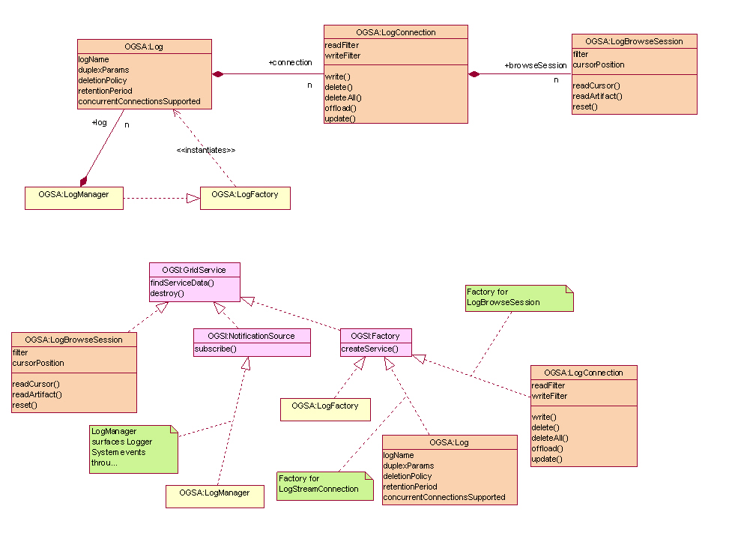

end refactoring … BH

The OGSA Logger Services is composed of five services. They are:

- LogManager service
- Log service
- LogStream service
- LogStreamConnection service
- LogBrowseSession service

The portTypes supporting these services and their relationships are shown using UML Figure 1 and are described in the following subsections. These services build upon the base semantics defined by OGSI (§ogsadraft10-6.24). The relationships among the Logger portTypes and the OGSI portTypes are also shown in Figure 1.
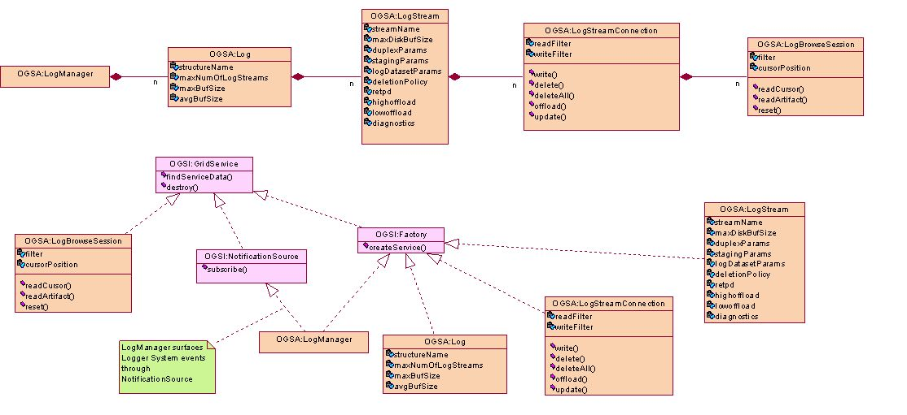
Figure 1: OGSA Logger Services Overview

LogManager service
The LogManager service is responsible for managing an instance of the OGSA Logger Services. The LogManager service implements the OGSA LogManager portType. The OGSA LogManager portType inherits from the OGSI NotificationSource and OGSI Factory portTypes. The LogManager service acts as a factory for Log service instances. As a NotificationSource, it is responsible for surfacing all OGSA Logger Services state changes, providing a single point of contact for obtaining all management-related events.

Log service
The Log service implements the OGSA Log portType. The OGSA Log portType inherits from the OGSI Factory portType. The number of LogStream instances that can be created is specified when a Log service is instantiated (using the factory operations in LogManager portType). If the underlying system supports a hardware-assisted merge facility then the details of the connection to the enabling hardware (e.g., zSeries Coupling Facility) are specified when the Log service is instantiated. The Log service acts as a factory for LogStream service instances.

LogStream service
The LogStream service implements the OGSA LogStream portType. The OGSA LogStream portType inherits from the OGSI Factory portType. A relatively long list of parameters is available to configure a particular LogStream service instance. In addition to basic configuration data, LogStream policies for the QoSs outlined in §6.17.1.14 are also defined by these parameters. The LogStream service acts as a factory for LogStreamConnection service instances.

LogStreamConnection service
All access (read or write) to the records in a LogStream are made through the LogStreamConnection service. The LogStreamConnection service implements the OGSA LogStreamConnection portType. The OGSA LogStreamConnection portType inherits from the OGSI Factory portType. The LogStreamConnection portType has operations which permit the writing and importing of log records. Custom read and write filters may be set for each instance of a LogStreamConnection. Additionally, the LogStreamConnection service acts as a factory for LogBrowseSession service instances. The LogStreamConnection service

LogBrowseSession service
An instance of the LogBrowseSession service is used to read log records from a LogStream. The LogBrowseSession service implements the OGSA LogBrowseSession portType. The OGSA LogBrowseSession portType inherits from the OGSI GridService portType. Each LogBrowseSession maintains a cursor for navigating its corresponding LogStream. A custom read filter may be set for an instance of a LogBrowseSession. Reads are filtered by both the LogBrowseSession filter and the LogStreamConnection read filter. The LogBrowseSession portType has operations to access records by id or by timestamp, position its cursor, or to use its cursor to read a sequence of records.

Standard schema/document
None.

Underlying services
The OGSA Logger Services has dependencies on underlying services. These are described in the following subsections.

OGSI
The Logger Services build upon the base semantics defined by OGSI (§ogsadraft10-6.24).

OGSA Event
As described in §6.17.1.5, the Logger Services will represent log artifacts using the schemas defined by the OGSA Event (§ogsadraft10-6.15).

OGSA Policy and Agreements
Much of the state contained the LogManager, Log, and LogStream services is specified using policy. The Logger Services will use the OGSA Policy mechanisms described §ogsadraft10-6.16 to handle policy.

OGSA Security Services
As described in §6.17.1.0.1, the Logger Services is required to support secure logging. OGSA security mechanisms are described in §ogsadraft10-4.1.4.

Related services
As described in §6.17.1.13, the Logger Services is required to coexist with the OGSA messaging infrastructure (§ogsadraft10-6.14).

Related standard
None.

Owner WG(s)
TBD

