GLUE 2 Specification

Status of This Document

This document provides information to the Grid community [topic]. [for non-recommendations track documents, add: It does not define any standards or technical recommendations.] Distribution is unlimited.

Copyright Notice

Copyright © Open Grid Forum (applicable years). All Rights Reserved.

Trademark

Open Grid Services Architecture and OGSA are trademarks of the Open Grid Forum. [include if applicable]

Abstract

Informative document abstract. Include an overview of the topic, the main issues addressed, and outcomes presented.

Contents

Abstract 1
1. Introduction 3
2. Notational Conventions 3
3. Main Entities 4
3.1 Site 4
3.2 Element 4
3.3 Service 5
3.4 Resource 5
3.5 Share 6
3.6 Activity 6
3.7 Virtual Organization 6
3.8 Policy 6
4. Conceptual Model of the Computing Element 7
4.1 Computing Element 8
4.2 Computing Resource 9
4.3 Execution Environment 9
4.4 Application Environment 10
4.5 Computing Service 10
4.6 Computing Share 11
4.7 Job 11
5. Conceptual Model of the Storage Element 13
6. Collection of Questions and Open Issues 14
7. Template 15
8. Security Considerations 15
9. Contributors 15
10. Glossary 16
11. Intellectual Property Statement 16
12. Disclaimer 16
13. Full Copyright Notice 16
14. References 17

Introduction

In this document, we present a conceptual information model for Grid entities described in natural language enriched with a graphical representation using the UML Class Diagram. As a conceptual model, this is meant to be implementation-independent. When a mature version will be available, mapping to concrete data models will be provided (e.g., relational, LDAP, XML Schema and RDF). From the semantic viewpoint, the concrete data model should represent the same concepts and relationships of the conceptual information model; nevertheless it can contains simplifications specific to the target data model in order to improve query performance or other aspects.
This information model is based on the experience of several modeling approaches being used in current production Grid infrastructures (e.g., GLUE Schema 1.x [glue-1.x], NorduGrid schema [ng-schema], Naregi model [naregi-schema], etc). The proposed initial collection of entities is motivated also by the use cases document [glue-usecases]. The properties listed for each entity are a temporary reallocation of those defined in the GLUE Schema 1.3 and NorduGrid schema (other schema can be considered in the next phase). They should not be considered as final and they will be revised in the next version by also adding the definition, unit of measure, data type and multiplicity. Besides the main entities this proposal currently contains well-defined entities for the Computing Element. For the Storage Element, there is only an initial UML Class Diagram, more details will be added in the next version.

Notational Conventions

Only include this section if applicable.

The key words ‘MUST,” “MUST NOT,” “REQUIRED,” “SHALL,” “SHALL NOT,” “SHOULD,” “SHOULD NOT,” “RECOMMENDED,” “MAY,” and “OPTIONAL” are to be interpreted as described in RFC 2119 [BRADNER1]

Main Entities

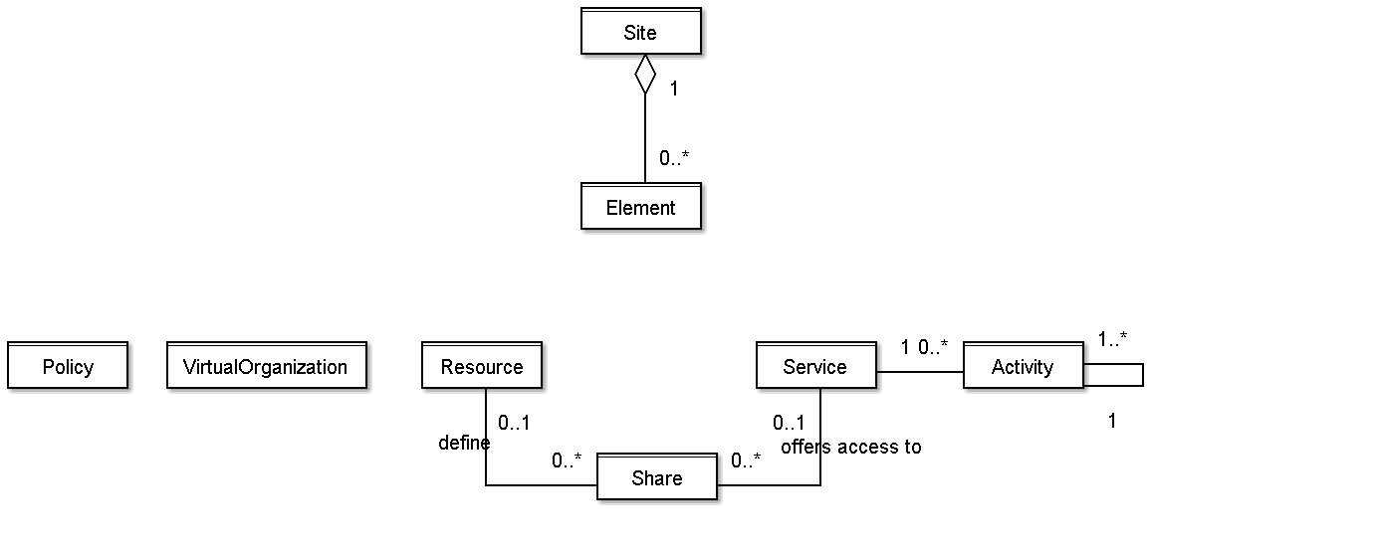
Figure 1 Glue 2.0 Main Entities and their relationships

Site

Entity | Inherits from |  |  | Description
Site |  |  |  | Administrative domain grouping resources and services managed by the same set of person; the administrative site can span different physical locations; the location attributes in this entity are meant to be used for the core location
Property | Type | Mult. | Unit | Description

Properties from old schemas: URI (ex-UniqueID), Name, Description, Contact (Email, Web page, ...), Location (Latitude, Longitude, ...?), Sponsor, OtherInfo

Element

Entity | Inherits from |  |  | Description
Element |  |  |  | It groups concepts that participate in the creation of an entity useful in a Grid environment. The element is autonomous and can be composed by services and the exposed resources.
Property | Type | Mult. | Unit | Description

The Element class is introduced in order to enable the identification and grouping of a set of concepts via a persistent name. It describes an entity in a Grid environment. The following specialization of the element entity are considered: Computing and Storage.

The simplest Element is composed by one single service (e.g., a GridFTP server). Other types of Element can include both services and the exposed resources where services and related resources have many to many relations. In an element, the same resource part of it can be shared across multiple services. For instance, for storage systems you can consider SRMv1 and SRMv2.2 services on top of the same resource, while for computing systems you can consider the CREAM and GRAM services exposing the same batch system.

Service

Entity | Inherits from |  |  | Description
Service |  |  |  | An abstracted, logical view of actual software components having a well-defined interface and offering one or more functionalities; it does have network endpoint(s); it abstracts some functionality
Property | Type | Mult. | Unit

- the service entity will have extension hooks like key,value pairs or tag set
- there will be the need to create service-specific schema . Tentative service specializations (types):
  - Computing: specialization of the service with additional information
  - Storage Management
  - File Transfer
  - ...
- properties from old schemas: URI (ex-UniqueID), Name, Type, Version, Endpoint, Status, StatusInfo, WSDL (?), Semantics, StartTime, Owner (?), AccessControlBaseRule (AuthorizationInfo), ServiceData=set of (Key,Value), Authentication (nordugrid-cluster-issuerca-hash, nordugrid-cluster-trustedca nordugrid-cluster-issuerca), SupportedProfile

Resource

Entity | Inherits from |  |  | Description
Resource |  |  |  | An entity that is useful in a Grid environment and offered through service(s). A resource usually represents aggregated information
Property | Type | Mult. | Unit | Description

- the following entities are considered (to be refined):
  - Computing
  - Storage (+ files)
  - Data
  - Network
  - Instrument

Share

Entity | Inherits from |  |  | Description
Share |  |  |  | A utilization target for a set of resources defined by policies and characterized by status information
Property | Type | Mult. | Unit | Description

- the following specialization of the share entity are considered:
  - Computing
  - Storage

Activity

Entity | Inherits from |  |  | Description
Activity |  |  |  | An activity is a unit of work managed by a service; an activity can have relationships to other activities being managed by different services, therefore it shares a common context.
Property | Type | Mult. | Unit | Description

Grid jobs are example of activities for a Computing Service. Example of activity relationships (propagation):
- Broker submits a grid job to a selected Execution Service, upon completion the Execution Service submits a logging record to a Accounting Service

Virtual Organization

Entity | Inherits from |  |  | Description
Virtual Organization |  |  |  | A virtual organization (VO) comprises a set of individuals and/or institutions having direct access to computers, software, data, and other resources for collaborative problem-solving or other purposes. Resources utilized by a VO are expected to be provisioned via SLA’s . The VO can exhibit the internal structure in terms of groups of individuals and/or institutions and their roles
Property | Type | Mult. | Unit | Description

Policy

Entity | Inherits from |  |  | Description
Policy |  |  |  | Statements, rules or assertions that specify the correct or expected behavior of an entity
Property | Type | Mult. | Unit | Description

- for example, an authorization policy might specify the correct access control rules to a share

Conceptual Model of the Computing Element

The conceptual model is based upon the main entities and uses specializations of Element, Resource, Share and Service entities. Further computing related concepts such as Execution Environment, Application Environment, Job are introduced.

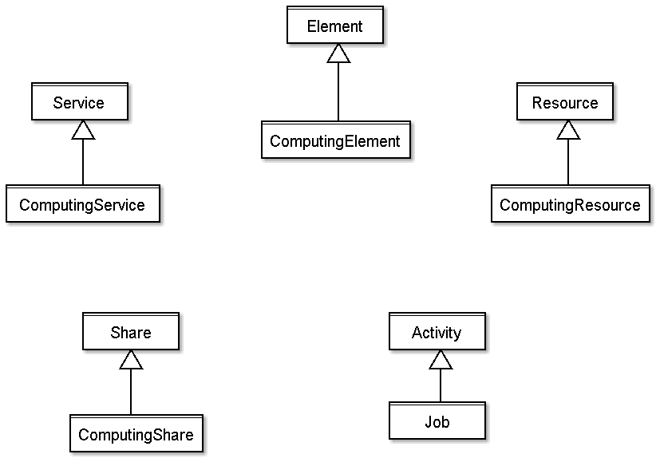
Figure 2 Inheritance Relationship for the Computing Element related concepts

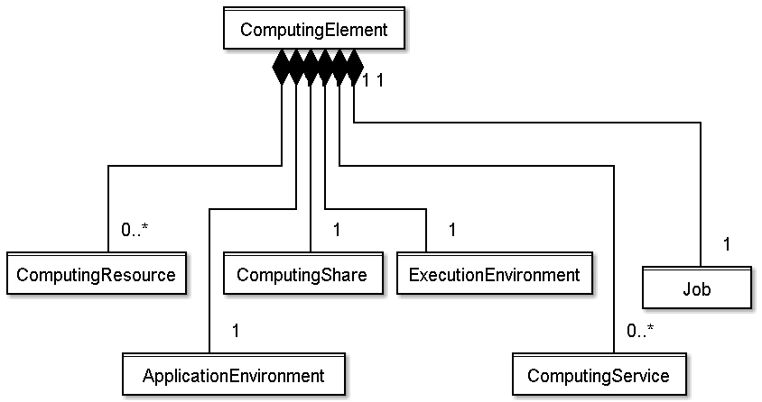
Figure 3 Composition relationship for the Computing Element

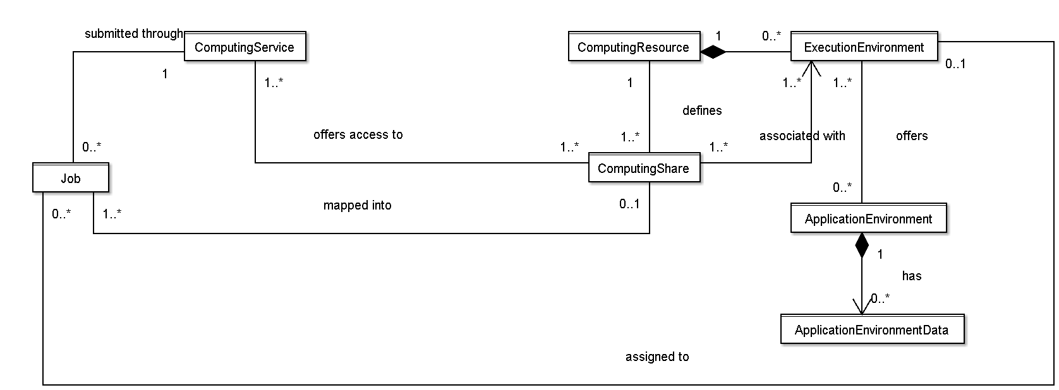
Figure 4 Entities and relationships for the Computing Element model

Computing Element

Entity | Inherits from |  |  | Description
Computing Element | Element |  |  | It groups the concepts that participate in the creation of an entity providing computational activity in a Grid environment. It considers computing services and the exposed computing resources where services and related resources have many to many relations
Property | Type | Mult. | Unit | Description

Examples
- Service A exposes Resource A forming the simplest computing element
- if a computing resource is exposed by many computing services, then these computing services are part of the computing element (Resource A exposed by Service A, B, C);
- if a computing service exposes many computing resources, then these computing resources are part of the computing element (Service A exposes Resource A, B and C) ;
- a computing element contains connected set of computing services and resources
  - Service A exposing Resource A and Service B exposing Resource B form two different computing elements
  - Service A exposes Resource A, Service B exposes Resource A and B form a computing element
- Properties from previous schemas: URI, Name, LRMS(Type, Version, Note) (if the hypothesis that a CE maps to a set of resources managed by the same LRMS), nordugrid-cluster-support?, nordugrid-cluster-localse (similar to Glue.CESEBind.SEUniqueID), TotalJobs, RungningJobs, WaitingJobs, nordugrid-cluster-prelrmsqueued, nordugrid-cluster-owner, OtherInfo (e.g., to adversite a URL of a web page giving info about this element)

Computing Resource

Entity | Inherits from |  |  | Description
Computing Resource | Resource |  |  | Grouping concept for a set of different types of execution environments; the aggregation is defined by the common management scope (e.g., a local resource management system like a batch system defines an aggregation scope); The OS can be the simplest case of LRMS. The Computing Resource may contain aggregated status information
Property | Type | Mult. | Unit | Description

Properties fromold schemas: URI/LocalID (?), Total, Used, Physical/LogicalCPUs, Shared directories (e.g., TmpDir, ScratchDir, DataDir), Homogeneity, NetworkInfo (type of internal network available among the execution environments), Aggregated/Global Benchmark Info (?), CPUDistribution (number of boxes:number of CPUs, it can be repeated, e.g.: 1:16 3:2), nordugrid-cluster-sessiondir-free, nordugrid-cluster-sessiondir-total, nordugrid-cluster-cache-free, nordugrid-cluster-cache-total

Execution Environment

Entity | Inherits from |  |  | Description
Execution Environment |  |  |  | A description of hardware and software characteristics that defines the environments available to and requestable by a Grid job when submitted to a Computing Service; the description also includes information about the total/available/used instances of the execution environment
Property | Type | Mult. | Unit | Description

  - the software part is described by the Application Environment entity (besides the OS)
  - the execution environments can be of different types
    - a typical implementation of an execution environment is a computing node
    - a virtual machine image that can be requested by a job represents also a possible execution environment
      - different virtual machine images/execution environments can coexist on the same node
- Properties: URI/LocalID (?), Type (e.g., virtualnode, realnode, smp, thread, multicore), LogicalUnitNumber (?), Total, Used, Unavailable, Physical/LogicalCPUs, CPU (Vendor, Model, Version, ClockSpeed, InstructionSet, OtherDescription), Memory (RAMSize, VirtualSize), OS (Name, Release, Version), Node benchmark (e.g., SPECInt2000, SPECfp2000), NetworkConnectivity (Inbound, Outbound), PlatformType (e.g., IA64),

Application Environment

Entity | Inherits from |  |  | Description
Application Environment |  |  |  | Description of the application software environment available within one or more execution environments
Property | Type | Mult. | Unit | Description

- it should be used also for application environments described in terms of a simple tag (like the attribute RunTimeEnvironment in GLUE 1.3)
- properties from old schemas: ID (URI, local, global, relative?), Catalogue/NameServer, Name, Version, Status (e.g.: tested, dynamic, installable), Lifetime, Bootstrapping (InstalledRoot, EnvironmentSetup, ModuleName), SoftwareData: (key,value)

Computing Service

Entity | Inherits from |  |  | Description
Computing Service | Service |  |  | Specialization of service for creating, monitoring, and controlling computational activities called jobs
Property | Type | Mult. | Unit | Description

properties: staging capabilities attributes, suspend capabilities

Computing Share

Entity | Inherits from |  |  | Description
Computing Share | Share |  |  | A utilization target for a set of computing resources defined by policies and characterized by status information
Property | Type | Mult. | Unit | Description

- this is a specialization of the share concept applied to computing resources
- a typical implementation of a share is via a batch queue with the associated policies and status information
- the same share can be implemented using different batch system configuration/strategies
- in complex batch systems, it is possible to define different set of policies for the same batch queue, this will imply a share for each set of policies
- a share can be implemented by virtual machines management systems (to be extended)
- the model supports heterogeneity by being able to represent different execution environments associated to the same share
- properties: LocalID, Name, Max(WallTime, CPUTime, TotalJobs?, RunningJobs, WaitingJobs, nordugrid-cluster-prelrmsqueued, Memory, DiskSpace, SlotsPerJob, StageInStreams, StageOutStreams), Min (CPUTime, WallTime), Default (WallTime, CPUTime), preemption, priority?, authorization?, state (runningJobs, waitingJobs, totalJobs?, estimatedResponseTime, WorstResponseTime, freeJobSlots, Status?), meta-information (e.g., human-readable description, scheduling policy, comment), directory? (Data?, Application?), DefaultSE?, nordugrid-cluster-sessiondir-lifetime

Job

Entity | Inherits from |  |  | Description
Job | Activity |  |  | An activity managed by a computing service
Property | Type | Mult. | Unit | Description

- Job: An activity managed by a computing service.
  - it is typically described by an XML document compliant to the JSDL specification
  - at the moment, this entity refers to only a single job
  - need to model different types of jobs (e.g., single processor job, collection of jobs, workflows); a job type can be useful
  - some of the job attributes should possibly map the OGF usage record spec, JSDL and the BES activity attributes
  - important is the state model
  - it would be nice to have a timestamp-like information like (tag, timestamp), to be used for instance for status change info
  - properties: ID (globalID, localID, globalOwner, localOwner, nordugrid-job-jobname), Requests/Environment (nordugrid-job-reqwalltime, nordugrid-job-reqwalltime nordugrid-job-reqcputime, nordugrid-job-runtimeenvironment, nordugrid-job-cpucount, nordugrid-job-stdout nordugrid-job-stderr nordugrid-job-stdin), Status (nordugrid-job-comment, nordugrid-job-status, nordugrid-job-queuerank, nordugrid-job-rerunable, nordugrid-job-exitcode, nordugrid-job-errors, nordugrid-job-executionnodes, nordugrid-job-execcluster, nordugrid-job-execqueue, nordugrid-job-usedwalltime nordugrid-job-usedmem nordugrid-job-usedcputime, nordugrid-job-completiontime, nordugrid-job-submissionui, nordugrid-job-submissiontime, nordugrid-job-clientsoftware, nordugrid-job-gmlog, nordugrid-job-sessiondirerasetime, nordugrid-job-proxyexpirationtime)

Conceptual Model of the Storage Element

A preliminary UML figure is included below.
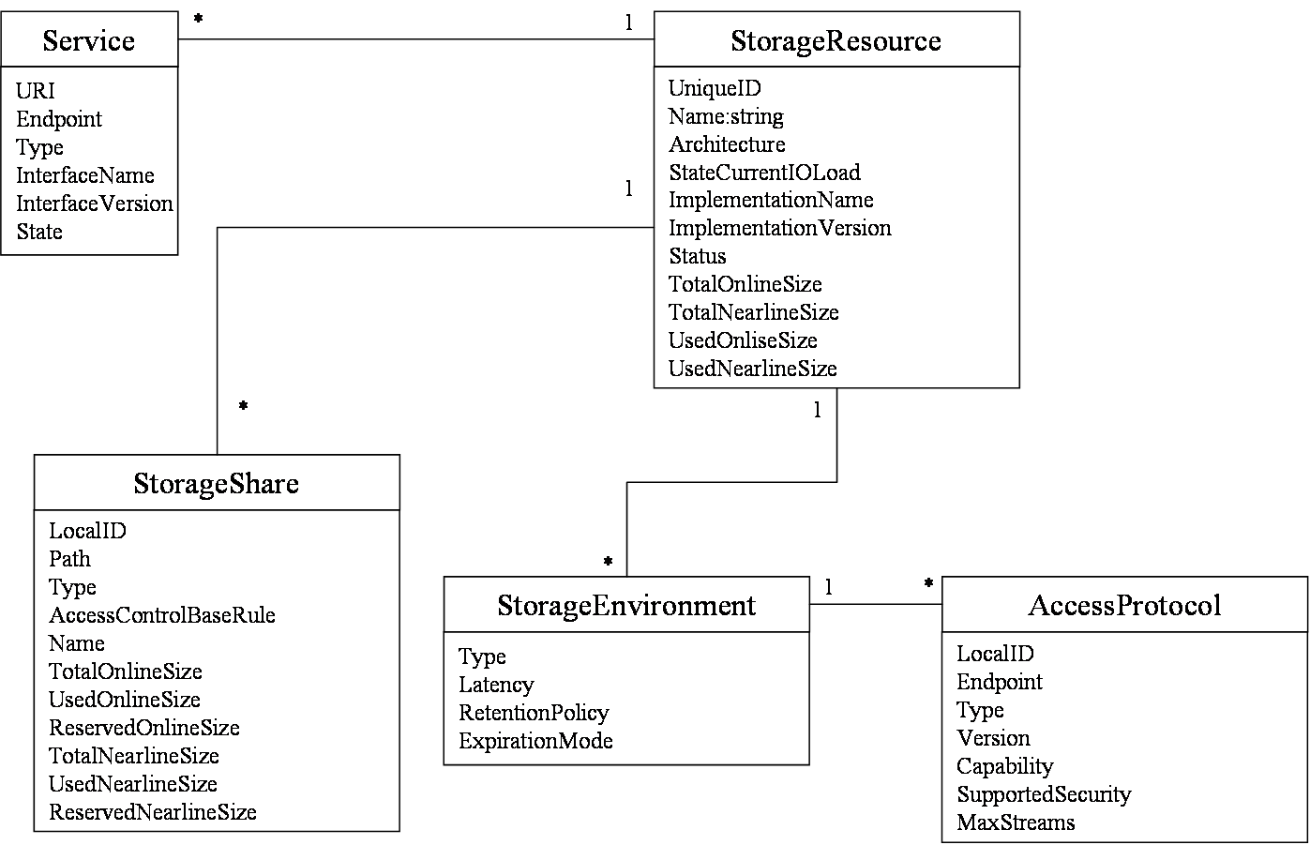
Figure 5 Entities and relationships for the Storage Element model. Very first sketch!

Collection of Questions and Open Issues

This section serves as a placeholder for open issues, it will not be part of the document.
- static vs. dynamic attribute values
  - first, we should define what is static and dynamic
    - a possible improvement is to distinguish among configuration vs. monitoring
  - should static/configuration-related attribute be separated from dynamic attributes?
  - from time to time, people ask for that
    - pro: easier implementation
    - con: UML/Schema less readable and more complex
  - possible approach:
    - at the UML class diagram level, static vs. dynamic is not described by separation into different classes, but with annotations/tagged values
    - at the concrete data model level (relational, XMLSchema), static vs. dynamic can be considered in order to simplify the implementation
- do we need a common authorization entity?
  - such kind of info is needed in several classes and we should have a common way to define them and to relate them to the various classes
  - how would this relate to the share
- how to deal with extensibility?
  - in GLUE 1.3: tag-like approach: capability[*], (key,value)[*]
- In which entities and in which way we should display owner information?
  - Contact support and ownership information, is it enough to have it at the site level or should we have also at the "element" level?
- when reviewing the directory information in Computing Resource, consider the standardization activity on Grid job environment
- service and endpoint; in our modeling, does a service have only one endpoint or can have multiple endpoints?
  - if many endpoints, then we need per-endpoint information
  - in Web Services world, a service instance has a single endpoint;
  - this needs to be discussed
- how to deal with interactive jobs? where do we publish information about the service providing interaction with jobs? (a different service specialization together with the computing service?)
- policy information is part of services or resources?
- execution environments: how to deal with software packages that will be available only to certain VO's
- application environment:
  - can we improve the modeling when the application environment is available homogeneously to the whole computing resource?
  - what about if they are available to only a certain VO/set of VOs?
- computing share:
  - authorization policy vs. share
  - does this fully cover the concept of VOView of GLUE 1.3?
  - do we need priority in share? what is the use case for having them?
  - how to reflect policy on heterogeneous execution environment?
    - e.g., a share is associated to AMD and INTEL-based execution environment? do I want to be able to represent policy per type of execution environment? is it the trivial solution of splitting the share in two shares enough?
  - how to reflect authorization policies in the share? they should support not only VO's but also privilege attributes like one defined by VOMS
  - local vs. Grid job state information in shares (e.g., in nordugrid schema: nordugrid-queue-gridrunning nordugrid-queue-gridqueued nordugrid-queue-localqueued, nordugrid-queue-running)
  - status like production/draining/queuing/closed is per share or per service?
  - consider that waiting jobs can refer either to job waiting in the batch queue or in the front-end grid layer (e.g., during file staging); decide if the waitingJobs attribute refer to both or if we should add one more category (e.g. nordugrid-queue-prelrmsqueued )
    - this consideration also applies to MaxWaiting
  - in GLUE we have assignedJobSlots and maxRunningJobs; we believe that modeling only the max running is enough

Template

Entity | Inherits from |  |  | Description
Property | Type | Mult. | Unit | Description

Security Considerations

Please refer to RFC 3552 [RESCORLA] for guidance on writing a security considerations section. This section is required in all documents, and should not just say “there are no security considerations.” Quoting from the RFC:

“Most people speak of security as if it were a single monolithic property of a protocol or system, however, upon reflection, one realizes that it is clearly not true. Rather, security is a series of related but somewhat independent properties. Not all of these properties are required for every application.

We can loosely divide security goals into those related to protecting communications (COMMUNICATION SECURITY, also known as COMSEC) and those relating to protecting systems (ADMINISTRATIVE SECURITY or SYSTEM SECURITY). Since communications are carried out by systems and access to systems is through communications channels, these goals obviously interlock, but they can also be independently provided.”

Contributors

Contact information for authors. You can also use this section to recognize contributions by people who are not listed on the title page, but made a useful contribution (it’s OK to mention the nature of the contribution).

The actual Authors (or Editors) listed on the title page are those committed to taking permanent stewardship for this document – receiving communication in the future and otherwise being responsive to its content. The GFSG recommends at most three Author/Editors be listed on the title page, unless there are compelling reasons to list more.

Glossary

Recommended but not required.

Intellectual Property Statement

The OGF takes no position regarding the validity or scope of any intellectual property or other rights that might be claimed to pertain to the implementation or use of the technology described in this document or the extent to which any license under such rights might or might not be available; neither does it represent that it has made any effort to identify any such rights. Copies of claims of rights made available for publication and any assurances of licenses to be made available, or the result of an attempt made to obtain a general license or permission for the use of such proprietary rights by implementers or users of this specification can be obtained from the OGF Secretariat.

The OGF invites any interested party to bring to its attention any copyrights, patents or patent applications, or other proprietary rights which may cover technology that may be required to practice this recommendation. Please address the information to the OGF Executive Director.

Disclaimer
This document and the information contained herein is provided on an “As Is” basis and the OGF disclaims all warranties, express or implied, including but not limited to any warranty that the use of the information herein will not infringe any rights or any implied warranties of merchantability or fitness for a particular purpose.

Full Copyright Notice

Copyright (C) Open Grid Forum (applicable years). All Rights Reserved.

This document and translations of it may be copied and furnished to others, and derivative works that comment on or otherwise explain it or assist in its implementation may be prepared, copied, published and distributed, in whole or in part, without restriction of any kind, provided that the above copyright notice and this paragraph are included on all such copies and derivative works. However, this document itself may not be modified in any way, such as by removing the copyright notice or references to the OGF or other organizations, except as needed for the purpose of developing Grid Recommendations in which case the procedures for copyrights defined in the OGF Document process must be followed, or as required to translate it into languages other than English.

The limited permissions granted above are perpetual and will not be revoked by the OGF or its successors or assignees.

References
Note that only permanent documents should be cited as references. Other items, such as Web pages or working groups, should be cited inline (i.e., see the Open Grid Forum, http://www.ogf.org). References should conform to a standard such as used by IEEE/ACM, MLA, Chicago or similar. Include an author, year, title, publisher, place of publication. For online materials, also add a URL. It is acceptable to separate out “normative references,” as IETF documents typically do. Some sample citations:

[glue-wg] The Glue Working Group of OGF, https://forge.gridforum.org/sf/projects/glue-wg
[glue-usecases] Glue 2.0 Use Cases (early draft), https://forge.gridforum.org/sf/go/doc14621
[glue-1.x] The Glue Schema 1.3, https://forge.gridforum.org/sf/go/doc14185
[ng-schema] The NorduGrid/ARC Information System, NORDUGRID-TECH 4,https://forge.gridforum.org/sf/go/doc14273
[naregi-schema] NAREGI information and data model, https://forge.gridforum.org/sf/go/doc14300

