OGSA Basic Execution Service
Version 1.0

Status of This Memo
This document is in draft stage and should be considered as in flux. Distribution is unlimited.

Copyright Notice
Copyright © Global Grid Forum (2004, 2005). All Rights Reserved.

Abstract
The OGSA V1.0 document section 3.4, pages 17-25, describes an EMS (Execution Management Services) architecture consisting of a number of different services. This document describes one of these services – the “service container” – which is the focus of the Basic Execution Service (BES) specification developed by this working group. BES models execution of services in “containers” that may be implemented in a variety of ways, e.g., by a single Unix or Windows host, by a queuing system, by a hosting environment such as .Net or J2EE, or by more specialized execution containers yet to be invented. BES defines a set of port-types as well as resource properties (attributes) for the simplest – most basic container.
This document defines the scope and motivation for this work followed by an abstract definition of the BES interface. This interface is then rendered using the OGSA profiles into normative text in Appendix A.
This document reflects the decisions taking by the working group as to the essential capabilities of a ‘Basic Execution Service’. Where relevant we have also captured the decisions as to the capabilities that are not part of a BES and the reasons behind the decisions at the end of the document. This section will be deleted from the document before submission to the editor.

Contents
1. Introduction 3
2. Assumptions 3
3. Service Interface 4
3.1 CreateActivityFromJSDL 4
3.2 GetActivityStatus 5
3.3 RequestActivityStateChanges 8
3.4 StopAcceptingNewActivities 8
3.5 StartAcceptingNewActivities 9
3.6 GetActivityJSDLDocuments 9
4. Subscribing to Generated Events 9
5. Exposing Container Activity 10
6. Management 10
7. Security Considerations 10
8. Authors Information 11
9. Contributors 11
10. Acknowledgments 11
11. Intellectual Property Statement 11
12. Full Copyright Notice 11
13. References 12
14. Appendix A – OGSA WSRF Base Profile Rendering 12
14.1 CreateActivityFromJSDL 12
14.2 GetActivityStatus 12
14.3 RequestActivityStateChanges 12
14.4 StopAcceptingNewActivities 12
14.5 StartAcceptingNewActivities 12
14.6 GetActivityJSDLDocuments 13
15. Issues Discussed & Resolved During Telecons 13

Introduction
The purpose of this document is to describe a web service interface to initiate, monitor & control activity on computational resources. This web service interface enables the creation, destruction and status determination of ‘activities’ (e.g. jobs, services, resources, …) within a container – an abstract representation of computational capability. Such a container may be a single machine, a cluster managed through a Distributed Resource Manager (DRM) such as Load Leveler, Sun Grid Engine, Portable Batch System, etc. or an interface into a web service hosting environment. Operational differences between container implementations are not expected to be reflected in the service implementation.
Considerable effort has been undertaken within the OGSA-WG EMS (Execution Management System) design team to define the different services and their interactions. The current high-level architecture for the execution of ‘legacy’ binary applications is encapsulated in this diagram.

Provisioning
Deployment
Configuration
Information Services
Service
Container
Accounting Services
Execution Planning Services
Candidate Set Generator (Work -Resource mapping)
Job Manager
Reservation
Figure 1: This figure is taken from the OGSA 1.0 informational document and has been modified slightly to reflect the I/O model of JSDL. Specifically, the “data container” has been replaced by a “disk” symbol. There is an assumption in JSDL that the execution context of a “job” as storage that can be accessed with the same path everywhere in the execution context, e.g., there is a shared file system.
The purpose of this service interface is to tackle the issues surrounding the ‘Service Container’ and to form part of the OGSA Basic Execution Profile. Other services described within the above architecture are considered to be out of scope of this activity.

Assumptions
The word ‘activity’ will be used frequently from this point in the document. Within the context of this document an activity could be the execution of a legacy binary or the initiation of a web service within a container. From the perspective of an external observer this is a self contained operation. If it can be further decomposed, such decomposition does not visible through the service interface.
By the time we reach the point of invoking the Basic Execution Service (BES) we assume that the following issues have been resolved:
- The placement decision (where the ‘activity’ is going to run) has already been determined by some unspecified means. This may have used some a set of ’resource attributes’ associated with the BES instance in a registry or used to annotate the BES instance itself.
- Naming. An essential pre-requisite to many distributed computing activities is a ‘naming’ scheme that provides a globally unique identifier in time and space. BES expects to use the WS-Name schema being defined within the OGSA-Naming-WG. It is not our intention to duplicate work in this area.
- Job Submission Description Language (JSDL). BES will use JSDL. There are several assumptions, some explicit, and some implicit. One of the most relevant here is that JSDL provides a stage-in/stage-out model and associated “local” file system capability in which data is copied to/from the locus of execution. The presumption is that there is a local file system that is visible everywhere within the locus of execution – whether it is a single host or a large cluster.
- The ‘activity’ that is going to be initiated within the container has already been determined elsewhere and is fully specified in the JSDL document. Therefore we assume that the JSDL document presented to the service is ‘concrete’ in nature. This does not preclude the JSDL document being initially specified using, for example, logical file names but that these logical file locations have been replaced by real file locations by the time the document reaches the BES.

Service Interface
The interface port-types for the OGSA-BES service container are described in this section. The port-types are described using a combination of English and IDL. In Appendix A the port-types are rendered using the definitions found in the OGSA WSRF Base Profile document, i.e., conformant with the OGSA WSRF Base Profile.

CreateActivityFromJSDL & CreateSuspendedActivityFromJSDL
This operation is used to initiate a new activity within the BES container as specified in a JSDL document. Depending on the invoked operation the activity will either immediately enter the ‘New’ state (CreateActivityFromJSDL) or a ‘Suspended’ state (CreateSuspendedActivityFromJSDL) – see Figure 2.
Input(s):
- JSDLDocument jobDescriptionDocument Accepts an XML document conforming to JSDL 1.0 describing a single activity that is to be started within the BES container.
Output(s):
- WS-Name activityIdentifier On success a WS-Name identifying the requested activity is returned from the service.
Fault(s):
- NotAcceptingNewActivities: The BES-container is not accepting any new activities at this state.
- BadlyFormedJSDLDocumentFault: The XML contained within the JSDL document is badly formed, i.e. it is not good XML. The relevant parsing error is returned in the body of the fault.
- UnsupportedJSDLFault: This is a well formed XML document which describes a version of JSDL that is not supported by the container.
- UnsupportedFeatureFault: The well formed supported JSDL document contains an operation or a non-standard extension that is not supported by the BES. The feature that is not supported by the BES is returned in the body of the fault.
- JobSpecificationFault: Despite a well formed JSDL document that is understood by the BES the specified activity cannot be undertaken, e.g. mis-specified executable location or ftp file transfer. The unsupported JSDL elements are returned with the body of the fault.
- BackendFault: The implementation could not create the activity. For example, an access control fault, IO fault, or some other problem.

GetActivityStatus
The activity specified within the JSDL document may contain many different operations – staging in, job execution, staging out, etc. To capture the state of this potentially complex activity within the job we define an operation that allows the state of several of these activities to be retrieved from the BES.
Input(s):
- WS-Name[] activityIdentifiers Passes in a vector of WS-Names (generated from the createActivityFromJSDL operation) which relate to the activities from which we require state information.
Output(s):
- ActivityStatus[] activityStatus An XML document containing a vector of ActivityStatus elements.
Fault(s):
- None. However, if a WS-Name specified in the input vector cannot be resolved to an activity within the BES then its state is marked ‘NotKnown’ and the only returned elements are the ActivityIdentifier and OverallStatus elements.
The state of each specified action within an activity, and the overall state of the activity referenced by the WS-Name are returned to the requester within an ActivityStatus element with the following structure:

<ActivityStatus>
<ActivityIdentifier>WS-Name</ActivityIdentifier>
<OverallStatus state=”(enumerated state)”
laststate=”(enumerated state)”
otherstate="(this container specific states)"? />
<StageInStatus id=”file string” state=”(enumerated state)”
laststate=”(enumerated state)” />*
<StageOutStatus id=”file string” state=”(enumerated state)”
laststate=”(enumerated state)” />*
</ActivityStatus>*
The state attribute records the current state of the activity or action, while the laststate attribute records the proceeding state of the activity or action. This enables the consumer of the state document to determine the state the activity or action was suspended from if it is now in a suspended state.
With possibly a large number of files being defined as part of the job, and potentially a large number of activities being reported on within a single request, the returned state document may become very large.
During discussion several other additional items where identified, which could be returned within the ActivtyStatus element:
- <ResourceAllocation>: Lists the resources that have been allocated to this activity. The allocated resources may differ from those requested by the activity within the JSDL document.
- <UsageRecord>: Use the UsageRecord schema to record the resource that has been consumed so far by the activity.
Currently, there are no plans to do any further work on these items.
The JSDL document comprises three sets of possible actions:
- Staging-in: Each staging-in action will have its own state.
- Execution: The single execution action is reflected in the overall activity state.
- Staging-out: Each staging-out action will have its own state.
There may be multiple staging-in/out actions but only a single execution action. The state of each staging-in/out action is reported in the ActivityStatus document. Note that the order invocation of each stage-in/stage-out action with respect to other stage-in/stage-out actions is implementation dependent. We define a hierarchical state model where the state of the overall activity (directly referenced by the WS-Name) is derived from the state of the actions (staging-in/out & execution) specified within the JSDL document.
As the three identified sections within the JSDL document (staging-in, execution & staging-out) are optional (i.e. an empty JSDL document is legal), it is possible that not all states within the state diagram will be relevant for a particular JSDL document. BES requires that all legal states transitions are transitioned even if they are not relevant for a particular JSDL document. For instance, if an empty JSDL document is submitted to the BES then all the states from ‘new’ to ‘done’ will be transitioned through (i.e. Staging-in, Execution, etc) even though there is no underlying specified activity.
The state names described below have been aligned with those contained within the CIM schema where applicable.
Overall State of the Activity
The BES is able to report on its view of the overall state of a particular activity. However this ‘meta-state’ is dependent in turn on the state of the individual actions specified within the BES.
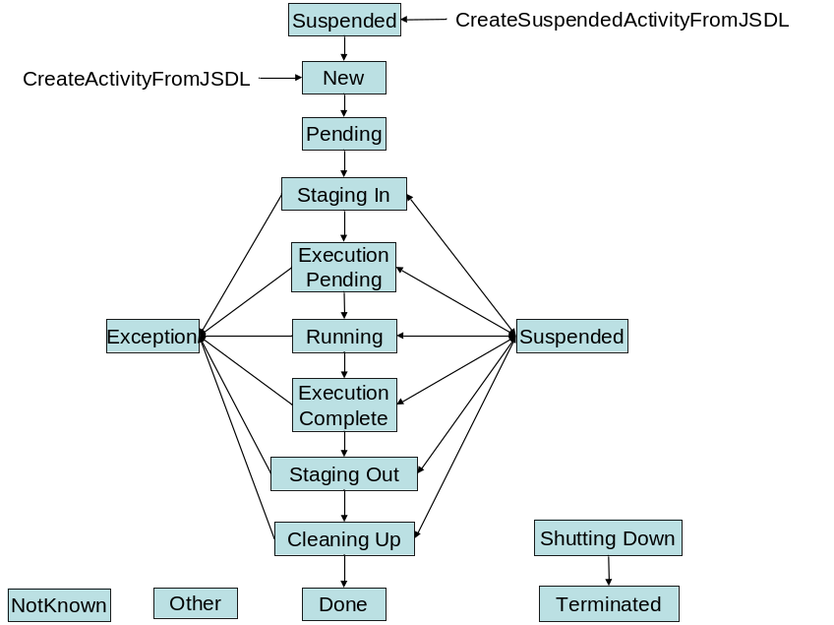
Figure 2: State diagram relating to the container activity referenced through the WS-Name.
These states are defined as follows:
- New: The JSDL document specified by the ‘createActivityFromJSDL’ operation has been parsed and accepted as by the BES. The ‘staging-in’ actions are all in the ‘not-started’ state.
- Pending: One or more of the ‘staging-in’ actions have moved beyond the ‘not-started’ state into the ‘pending’ state.
- Staging-In/Staging-Out: One or more of the ‘staging-in/staging-out’ actions are in the ‘active’, ‘blocked’ or ‘suspended’ states. It is possible that one or more of these actions may still be in the ‘not-started’ or ‘queued’ states.
- Execution Pending: All of the ‘staging-in’ actions have reached the ‘completed’ state. The executable is in place but the required resources (e.g. available memory or processors) are not yet available so the execution cannot yet start. Execution is pending until these resources are available.
- Running: The resources available to start the execution action and the activity has started.
- Execution Complete: The execution action has successfully completed and the output files are available for staging-out.
- Cleaning-Up: All of the ‘staging-out’ actions have reached the ‘completed’ state.
- Complete: All of the ‘staging-out’ actions have reached the ‘completed’ state.
- Exception: If any of the actions enter the ‘exception’ state then the whole activity enters the ‘exception’ state.
- Suspended: If any of the actions enter the ‘suspended’ state the whole activity enters the ‘suspended’ state.
- Shutting Down: This is a state that the activity enters into following a request to ‘terminate’ the activity. Following such a call the BES will attempt to cancel any activity that has not already ‘failed’ or ‘completed’.
- Terminated: All of the actions have entered an ‘exception’, ‘completed’ or ‘terminated’ state.
- Other: An activity within the BES can transition to the ‘other’ state from any other state. This container specific state is further qualified in the ‘OverallStatus’ element. .
- NotKnown: The state of this activity cannot be determined. Instead of throwing a fault the error is recorded within the ActivityStatus document.
State of the staging-in/out actions
The states of the stage-in and stage-out actions are defined as follows, and the transition between states in the following state diagram.
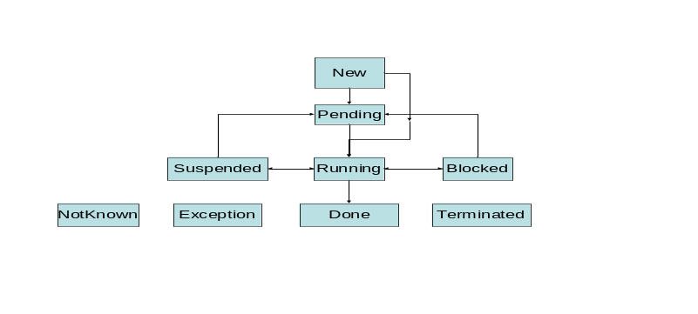
Figure 3: State diagram relating to an action (staging-in/out) specified within the JSDL document.
- New: The action has been recognised by the BES but has not progressed any further in terms of activity within the container.
- Pending: The action has entered into a state that is external to the service but still internal to the container. For instance, the executable may have entered into a queue within a batch scheduling system or the file transfer may be queued into some service.
- Running: The action is underway.
- Blocked: The action cannot proceed any further at this time due to the unavailability of some resource external to the BES.
- Suspended: The action will not progress any further at this time at the instigation of the BES.
- Done: The action is complete/done.
- Exception: This state can be reached from any state except Completed. This state is triggered by the BES due to un-recoverable external action or event.
- Terminated: This state can be reached from any state except Completed. This state is triggered by the BES due to other operations on the BES.
- NotKnown: The state of this action cannot be determined. Instead of throwing a fault the error is recorded within the ActivityStatus document.

RequestActivityStateChanges
This operation applies a set of state change requests to a set of activities within the BES.
Input(s):
- StateChangeRequest [] requests A vector of requested state changes identifying the target state and the WS-Name identifying the activity. The RequestedStateChange element has two attributes:
  - from: An optional attribute that is an enumeration of the activity state referenced through the WS-Name that the activity state MUST be in order for the state change request to be applied
  - to: A required attribute that specifies the requested state that the activity is to move to if the from element (if specified) is in the required state. This is an enumeration that can be one of Terminate, Suspend or Resume.
The ‘to’ and ‘from’ attributes enables a conditional state change request to be applied to the activity.

<bes:StateChangeRequest>
<ActivityIdentifier>WS-Name</ActivityIdentifier>
<bes:RequestedStateChange from=”Running” to=”Terminate” />
</bes:StateChangeRequest>
Output(s):
- StateChangeResponse[] responses A vector detailing the response of the BES to the requested state change operation. The response can be one of Succeed (indicating the request was passed on to the named activity), Fail (indicating the request was not passed on to the named activity – as it could not be located) and IllegalStateChangeRequest (the requested state cannot be reached from the current state – violates BES state model).

<bes:StateChangeResponse>
<ActivityIdentifier>WS-Name</ActivityIdentifier>
<bes:Response>Succeeded</bes:Response>
</bes:StateChangeResponse>
Fault(s):
- None. However, failure to locate an activity for a specified WS-Name will result in a Fail being returned as part of the bes:Response element.
The BES attempts to initiate the requested state change in each activity specified in the list. As a consequence of this operation the specified activity MAY move from its current state to the requested state. This operation may fail immediately if the transition is not supported by the state model or the activity cannot be located, otherwise the request will be successfully passed on to the activity. However, this does not mean the activity will move into the requested state. The eventual success of this operation (i.e. to move the activity into the requested state) must be determined through other operations (e.g. GetActivityState) or by subscribing to any generated events.
If the ‘Terminate’ request is successful then the activity enters into a ‘Terminated’ state, possibly transitioning through the ‘Shutting Down’ state. Invoking a ‘Terminate’ operation on a ‘Terminated’ activity has no further effect. How long the activity remains in the ‘terminated’ state before the WS-Name no longer returns a reference to the activity is not defined.
‘Suspend’ or ‘Resume’ requests will not succeed if the current activity state does not support a transition to these new states and the response will be marked with an ‘IllegalStateChangeRequest’.

StopAcceptingNewActivities
This operation moves the BES into a state where it stops accepting new activities.
Input(s):
- None.
Output(s):
- None.
Fault(s):
- None.

StartAcceptingNewActivities
This operation moves the BES into a state where it starts accepting new activities.
Input(s):
- None.
Output(s):
- None.
Fault(s):
- None.

IsAcceptingNewActivities
This operation reports on the current ability of the BES in accepting new activities.
Input(s):
- None.
Output(s):
- Boolean response. Return true if the service is accepting new activities or false if it is not..
Fault(s):
- None.

GetActivityJSDLDocuments
This operation returns the JSDL document that encapsulates the activity associated with the specified WS-Name. This JSDL document may be different from the JSDL document initially passed into the BES as the BES may alter its contents to reflect policy or process within the service. Effectively, this document reflects the activity being run as opposed what it was asked to run. If the submitter wishes to retrieve this document they should retain their own copy.
Input(s):
- WS-Name[] activityIdentifiers
Output(s):
- ActivityJSDLDocument [] documents.
Fault(s):
- None. However, if no JSDLDocument can be matched to the WS-Name within the BES then the ActivityJSDLDocument element is returned without the JobDescription element.
The output from this operation associates the returned JSDLDocument with its corresponding WS-Name by encapsulting both in an ActivityJSDLDocument element.:Failure to map a WS-Name to its corresponding JSDL representation within the BES is passed back to the client by the absence of the JSDLDocument

<bes:ActivtyJSDLDocument>
<ActivityIdentifier>WS-Name</ActivityIdentifier>
<jsdl:JobDescription>

...
</jsdl:JobDescription>
</besLAcitivtyJSDLDocument>

Subscribing to Generated Events
The BES describes a two level state model – an overall activity state referenced directly by a WS-Name and the state of each action (e.g. stage-in or stage-out transfer) that may take place as part of the overall activity. The changes in state of the overall activity and each action within the activity may be of interest to a client and must therefore be exposed for subscription.
[ISSUE 4/8/05: How should these be referenced/identified? DP will look into JSDL extensions to support this. Information on the event subscription could be placed in the JSDL document returned by GetActivityJSDLDocuments.]
Two mechanisms have been identified for event subscription:
- On activity creation. This is desirable to provide a single invocation that can submit a job and subscribe to its eventual state changes. To support this model a subscription matrix or state change mask would have to provided with/in the JSDL document enabling an initial set of subscriptions to be defined as part of the activity initiation – ensuring that no initial state changes where missed. Alternatively, the JSDL document may be submitted directly into a ‘hold’ state (such as the ‘submit on hold’ used in LSF or WS-GRAM) allowing subscriptions to be set up before being ‘released’ and the activity continuing.
[ISSUE 4/8/05: Decide on which mechanism OR both?]
- After activity creation: The events that have been subscribed to will need to be altered during the lifetime of the activity and a mechanism must be provided to support this.
[ISSUE: 4/8/05: Define a mechanism!]
In general there is no expectation that a subscription for state changes within an activity referenced by a WS-Name would continue beyond the duration of that activity within a BES.
[DISCUSSION 11/8/05: Should each sub activity have their own activity? WS-Names are OK but we do not want to make things more complicated!]
Proposal
Use the JSDLDocument as the basis of setting and reporting on the setting of event subscriptions. Embed requests for subscriptions in the JSDLDocument – place a subscription element where they are required – and use the GetActivityJSDLDocument to return a JSDLDocument with the current subscription details embedded within them.

Exposing Container Activity
The BES does not mandate that the activity started within the container provide a specific web service interface for management or control purposes. Profiles on the BES specification may mandate that the use of certain JSDL extensions (e.g. the POSIXApplication) will result in a web service interface (e.g. a POSIX control interface) to the resulting activity that can be referenced by the WS-Name (endpoint) returned from the ‘CreateActivityFromJSDL’ operation. Such interfaces are out of scope of this document.

Management
Currently no generic management infrastructure has been specified for OGSA services. We would expect such an infrastructure to support the termination of a BES following a duly authorized request. In terminating a BES, the impact on the activities taking place within the BES container is undefined.
- Security Considerations
Security considerations are significant in execution management, both in terms of access control (authorization) to the various services, as well as identity mapping issues, e.g., run this activity as “Fred”. Authorization and authentication is outside of the scope of this document and is dependent on the ongoing activity within the OGSA Authorisation Working Group.
One requirement of such an infrastructure will be the ability to restrict the access to information contained within BES. For instance, the only person who may be able to obtain the state of an activity is the person who requested that the activity be instantiated. A specified person could be given rights to administer a job (e.g. manipulate the job state).
- Authors Information
Andrew Grimshaw
Mark Morgan
Chris Smith
Darren Pulsipher
Steven Newhouse
Add your name here …
- Contributors
We gratefully acknowledge the contributions made to this document by
- Acknowledgments
We are grateful to numerous colleagues for discussions on the topics covered in this document, and to the people who provided comments on the public drafts. Thanks in particular to (in alphabetical order, with apologies to anybody we have missed) ….
- Intellectual Property Statement
The GGF takes no position regarding the validity or scope of any intellectual property or other rights that might be claimed to pertain to the implementation or use of the technology described in this document or the extent to which any license under such rights might or might not be available; neither does it represent that it has made any effort to identify any such rights. Copies of claims of rights made available for publication and any assurances of licenses to be made available, or the result of an attempt made to obtain a general license or permission for the use of such proprietary rights by implementers or users of this specification can be obtained from the GGF Secretariat.
The GGF invites any interested party to bring to its attention any copyrights, patents or patent applications, or other proprietary rights which may cover technology that may be required to practice this recommendation. Please address the information to the GGF Executive Director.
- Full Copyright Notice
Copyright (C) Global Grid Forum (2004, 2005). All Rights Reserved.
This document and translations of it may be copied and furnished to others, and derivative works that comment on or otherwise explain it or assist in its implementation may be prepared, copied, published and distributed, in whole or in part, without restriction of any kind, provided that the above copyright notice and this paragraph are included on all such copies and derivative works. However, this document itself may not be modified in any way, such as by removing the copyright notice or references to the GGF or other organizations, except as needed for the purpose of developing Grid Recommendations in which case the procedures for copyrights defined in the GGF Document process must be followed, or as required to translate it into languages other than English.
The limited permissions granted above are perpetual and will not be revoked by the GGF or its successors or assigns.
This document and the information contained herein is provided on an "AS IS" basis and THE GLOBAL GRID FORUM DISCLAIMS ALL WARRANTIES, EXPRESS OR IMPLIED, INCLUDING BUT NOT LIMITED TO ANY WARRANTY THAT THE USE OF THE INFORMATION HEREIN WILL NOT INFRINGE ANY RIGHTS OR ANY IMPLIED WARRANTIES OF MERCHANTABILITY OR FITNESS FOR A PARTICULAR PURPOSE."
- References
OGSA WSRF Basic Profile definition
OGSA Authorization
WS-Naming
RNS

- Appendix A – OGSA WSRF Base Profile Rendering

CreateActivityFromJSDL
<WSDL Goes here >

GetActivityStatus
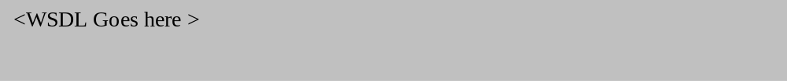

RequestActivityStateChanges

StopAcceptingNewActivities

StartAcceptingNewActivities

GetActivityJSDLDocuments

Issues Discussed & Resolved During Telecons
To be deleted on submission:
At GGF 14 it was decided that specifying the attributes that describe the service was out of scope of the BES specification at this time. It was noted that work with CIM and the GLUE schema going on elsewhere within the Grid community would be relevant to BES in the future.
At GGF 14 we discussed supporting multiple job description documents in the CreateActivityFromJSDL. It was decided that it was not worth the trouble.
RESOLVED 28/7/05: In GetActivityStatus, instead of throwing a fault, failure to discover an activity state is recorded in the ActivityStatus document output.
RESOLVED 28/7/05: Should we adopt/use/extend the CIM state model that has an integer enumeration that can indicate the operational state of the job or the transitions between these states? We have aligned the BES states to those in the CIM where sensible equivalents exist.

Job State | Identifier | Description
New | 2 | Indicates that the job has never been started.
Starting | 3 | Indicates that the job is moving from the 'New', 'Suspended', or 'Service' states into the 'Running' state.
Running | 4 | Indicates that the Job is running.
Suspended | 5 | Indicates that the Job is stopped, but may be restarted in a seamless manner.
Shutting Down | 6 | Indicates the job is moving to a 'Completed', 'Terminated', or 'Killed' state.
Completed | 7 | Indicates that the job has completed normally.
Terminated | 8 | Indicates that the job has been stopped by a 'Terminate' state change request. The job and all its underlying processes are ended and may be restarted (this is job-specific) only as a new job.
Killed | 9 | Indicates that the job has been stopped by a 'Kill' state change request. Underlying processes may have been left running and cleanup may be required to free up resources.
Exception | 10 | Indicates that the Job is in an abnormal state that may be indicative of an error condition. Actual status may be surfaced though job-specific objects.
Service | 11 | Indicates that the Job is in a vendor-specific state that supports problem discovery and/or resolution.
RESOLVED 4/8/05: GetActivityJSDLDocuments – when extracting a set of JSDLDocuments relating to the specified activities how should the WS-Name be inserted so as to identify the JSDL document with the activity? It was felt that as the BES owns the activity – and therefore its associated JSDL document – the WS-Name should be inserted into the document. The JSDLDocument submitted to the service may not represent the running activity. If the original document may be required at a later date then the client should keep a record. Otherwise we want what the activity thinks it is running.
Telecon notes 4/8/05: We have a two level state model – state changes in the activity specified by WS-Name and the action (stage-in/out) operation that may exist within the JSDL document (how can these be identified)? Draft text for notification/event generation section.

