OGF / DMTF Work Register
Version 9/26/2006
Date Initiated: 09/26/2006

Alliance Organizations

The Open Grid Forum (OGF) and the Distributed Management Task Force (DMTF)

Background and Mission

The Open Grid Forum (OGF) is the name of the newly formed organization resulting from the merger of the Enterprise Grid Alliance (EGA) and the Global Grid Forum (GGF), both of which have been Alliance Partners with the DMTF. The EGA has had a mission to improve grid computing tools and standards in a way aligned with developer and user needs and to foster understanding and adoption of grid computing in order to facilitate the rapid development of grid computing standards and adoption of grid computing. The OGF has had a mission to promote and develop grid technologies and applications via the development and documentation of "best practices", implementation guidelines and standards. The newly formed OGF encompasses both missions as one, leading to the pervasive adoption of grids.

The mission of the Distributed Management Task Force, Inc. (DMTF), is to lead the development of management methods and infrastructure standards for distributed desktop, network, enterprise and Internet environments.

Alliance Benefits

- Collaboration on the creation of a broader Common Information Model (CIM), for grids, that leverages the requirements of both the DMTF and the OGF working groups, resulting in a unified CIM utility computing model for industry-wide use.
- Leveraging of technical and marketing resources in both the DMTF and the OGF working groups.
- Coordination of development processes and priorities between the DMTF and the OGF, ensuring that the DMTF modeling standards address grid technology needs, and that OGF grid services address management requirements.
- Education about OGF activities to DMTF members and OGF participation at the DMTF Management Developers Conferences, Alliance Partner Summits, and technical meetings.
- Education on DMTF technologies, such as CIM, WBEM, and SPAM to OGF members, and DTMF participation at OGF conferences and technical meetings.

Alliance Scope

The purpose of this Work Register is to provide a formal channel for the DMTF and the OGF to collaborate, communicate and coordinate management modeling and services in support of grid technologies. Both organizations would provide requirements input, modeling and service proposals, and standards review feedback to the other. The liaison relationship would cross-leverage each organization's domain expertise, wherein the DMTF is responsible for distributed management infrastructure and resource modeling (i.e., the CIM Schema and WBEM infrastructure), and the OGF is the peer organization responsible for grid standards.

At a high level, the model standardization efforts are a high priority for the DMTF with input encouraged from the OGF. The OGF should provide input to the standardization process drawing on its experiences in trying to devise interoperable solutions and tools to speed the adoption of grid computing.

It is important for several of the industry organizations working in the web services space (such as the DMTF, OGF, OASIS, SNIA, W3C) to collaborate. This agreement addresses the specific liaison relationship between the DMTF and the OGF. Both the DMTF and the OGF will work to ensure that the other standards are used as building blocks (versus defining alternatives), wherever possible. High level activities such as the Reference Model developed originally by the EGA and now within the OGF may lead to content which the OGF may desire to contribute, in whole or in part, to the DMTF for inclusion in DMTF standards, or as standards in and of themselves, if it is decided to be mutually agreeable to both the DMTF and the OGF. The OGF recognizes and agrees that contributions so made would come under the IPR Policy of the DMTF.

It is noted that this work register is “non-exclusive” – i.e. the two organizations may pursue alliances with other organizations as needed.

Alignment is needed between most Working Groups in the OGF and the DMTF. Grid service standardization will be cross-leveraged in theDMTF's CIM and WBEM standards, with CIM Schema definitions utilized and extended by the OGF. Model extensions will be submitted to the DMTF, while grid resource and service proposals will be submitted to the OGF for standardization there. Figures 1 and 2 show a high-level process flow for each of these activities.

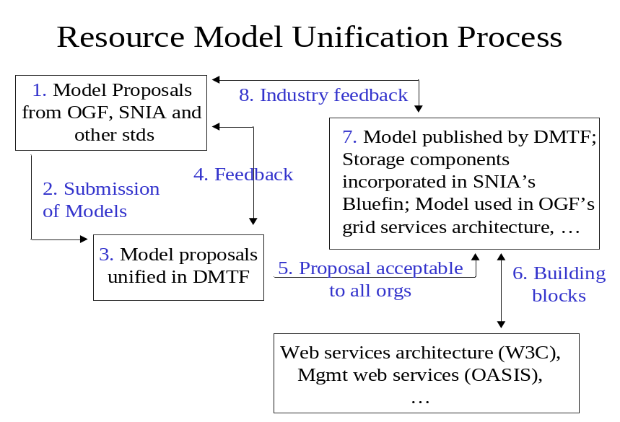
Figure 1. Resource Model Unification Process

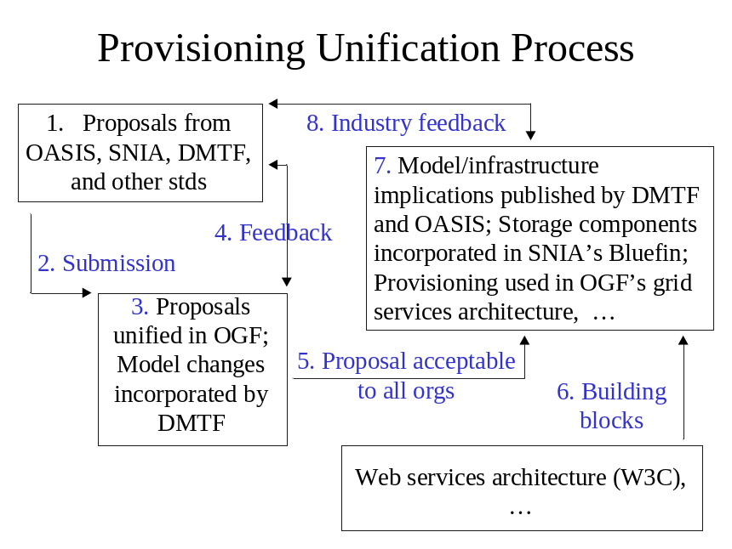
Figure 2. Grid Service Unification Process

The OGF has separate work areas addressing Infrastructure, Data, Compute, Architecture, Applications, Management, Security, and Liaisons. Within these work areas, specific working and research groups are conducting work that is complementary to that in the DMTF CIM Schema. Specifically, these groups (and their corresponding DMTF WGs) are:

- Grid User Services (GUS in Grid Operations Area) - Corresponding to the DMTF's Support WG
- Open Grid Services Architecture and the Resource Managent Design team (OGSA in ARCH) - Corresponding to work in the DMTF's Utility Computing and Behavior and State WGs
- Data Access and Integration Services (DAIS in DATA) - Working with the DMTF's CIM Core Schema and Database WGs
- Grid Storage Management (GSM in DATA) - Complementary to the DMTF's CIM Core Schema WG
- Grid High Performance Networking (GHPN in Infrastructure Area) - Complementary to the DMTF's Network WG
- All WGs and RGs in Grid Security - Complementary to the DMTF's Security, Protection, and Management WG
- Network Measurement (NM in Infrastructure Area) - Complementary to the DMTF's Network WG
- Configuration Description, Deployment and Lifecycle Management (CDDLM in Management Area) - Corresponding to the DMTF's Application and Metrics WG
- Job Submission Description Language (JSDL in Compute Area) - Overlapping the Job Submission Model in the OGF's DIAS and the DMTF's CIM Core Schema WG

Collaborative effort is required between these OGF and DMTF groups. Collaborative effort is also required between marketing organizations for joint announcements as technical specifications are released.

Milestones / Dates
.
- DMTF participation in OGF WG and RG discussions. (All those listed above.)
- Map the work underway within the OGF to the CIM schema. This task will assist the OGF to internally organize working groups on model boundaries.
- Identify OGF work that includes the CIM schema
- Identify OGF work that does not include the CIM schema
- Identify areas of the CIM schema that address grid enablement
- Identify areas of the CIM schema that do not address grid enablement
- Use the CIM schema to assist OGF WGs to better understand how they connect with each other
- Use the CIM schema to assist OGF WGs to identify potential areas of disconnect
- Use the CIM schema to identify potential new OGF WGs that are needed to address the empty zones

- "The DMTF will publicize the following: (February, 2006)
(1) namespaces to identify XML schemas for properties produced from a particular version of a CIM model
(2) the XML schemas themselves
Completing this milestone will allow:
- OGF specifications (and other specifications) to refer to the XML schemas for properties without embedding the schemas in the body of the specifications
- XML schemas for properties for CIM resources to be consistent across multiple specifications "
- The DMTF and the OGF will work to define and publicize a draft generic abstract wsdl:portType mapping for classes in the CIM model (1Q/2006)

Each 'extrinsic' operation on a CIM class will be modeled as a wsdl:operation
Properties of the CIM class which are rendered in XML schema (detailed in xml schema and namespace milestone) will be available through the wsdl:types section

It is envisioned that some set of qualifiers will be mapped to xml schema and wsdl constructs. The specifics of this mapping are viewed as explicitly part of the work to render the model. As such the OGF has no specific requirements for qualifiers at this time but may have requirements as the work product develops.

The intent of this deliverable is to make available a set of standard wsdl:portTypes representing the CIM modeled aspect of classes (extrinsics and properties only). It is envisioned that these portTypes will be mixed in with additional capabilities from Grid disciplines to support Basic Execution Services, Data Virtualization and other areas as they are developed.

Work Register Review Date

The work register should be reviewed and updated every year.

Contacts

OGF:

- Mark Linesch, Forum Chair, mark.linesch@hp.com
- Tom Roney, OGF liaison for the DMTF, troney@ncsa.uiuc.edu
- Andrew Grimshaw and Manuel Pereira, OGSA Co-Chairs, grimshaw@cs.virginia.edu and mpereira@us.ibm.com
- Fred Maciel, OGSA Resource Management Team Chair and Liaison, Fred.Maciel@hds.com
- Susan Malaika, DAIS Liaison, malaika@us.ibm.com, co-chairs Norman Paton and Dave Pearson, norm@cs.man.ac.uk and dave.pearson@oracle.com
- Dejan Milojicic and Stuart Schaefer , CDDLM Co-Chairs, dejan.milojicic@hp.com and shs@softricity.com
- Eric Boyd, Richard Hughes-Jones and Mark Leese, NM Co-Chairs, eboyd@internet2.edu, rich@a3.ph.man.ac.uk and M.J.Leese@dl.ac.uk
- David Wallom, Juduth Utley, and Laura McGinnis, PGS co-chairs, david.wallom@bristol.ac.uk, jputley@earthlink.net, and lfm@psc.edu
- Arie Shoshani and Peter Kunszt, GSM WG co-chairas, Shoshani@lbl.gov and pkunszt@mail.cern.ch
- Dimitra Simeonidou , GHPN chair, dsimeo@essex.ac.uk
- Olle Mulmo and Dane Skow, Security Area Directors, mulmo@pdc.kth.se and dane@fnal.gov
- Steve McGough, Darren Pulsipher, Ali Anjomshoaa, JSDL WG co-chairs, asm100@doc.ic.ac.uk, darrenp@pulsipher.org and ali@epcc.ed.ac.uk
- Carole Goble, Geoffrey Fox, and Susanne Balle, Semantic Grid Research Group co-chairs, carole@cs.man.ac.uk, gcf@indiana.edu, and susanne.balle@hp.com,

DMTF:

- Winston Bumpus, President, president@dmtf.org
- Todd Guay, VP Technology and Database WG Chair, vp-technology@dmtf.org
- Mike Baskey, DMTF Liaison to the OGF, mbaskey@us.ibm.com
- John Crandall, CIM Core WG Chair, core-chair@dmtf.org
- Karl Schopmeyer, Applications/Metrics and Behavior and State WGs Chair, applications-chair@dmtf.org
- Jim Davis, Interop WG Chair, interop-chair@dmtf.org
- Mark Carlson, Policy WG Chair, policy-chair@dmtf.org
- Hector Trevino, Network WG Chair, network-chair@dmtf.org
- Tom Maquire, Utility Computing WG Chair, utility-chair@dmtf.org
- Marvin Waschke, Support WG Chair, support-chair@dmtf.org
- Paul Agbabian, Security, Protection, and Management Chair, spam-chair@dmtf.org

