Agenda for OGSA-WG and fellow WG F2F meeting
- August 15 - 19 in San Francisco Bay Area -
Draft 10 (August 12, 2005)

Venue: Fujitsu facility in Sunnyvale
Address: H bldg, 1250E, Arques Avenue, Sunnyvale, CA94086
Directions to Fujitsu: http://tinyurl.com/69aof
Campus Map: http://www.fih.fujitsu.com/fih/about/contacts/hq2_fujitsu.pdf

Entrance Procedure:
All visitors will need to identify themselves at a front desk, show a picture ID and obtain a visitor badge before entering the meeting room.

Wi-Fi internet access is available at the meeting room. (Setup details will be provided on site.)

Local contact:
Ms. Yoko Stein, +1-408-530-4574

Meeting room:
Meeting room 334 is in the main building (H bldg) and next to the cafeteria.

Coffee and juice will be provided at the meeting room. Cafeteria is open for breakfast (7-9am) and Lunch (11:15am-1:30pm). It closes at 2:00pm.

Dial-in (by Freeconference.com, No toll free number):
Toll number: 1-323-785-4156
The pass code: 71815

Glance network:
Address: http://ogsa.glance.net
Pass code: MMDD (0815 for Aug. 15)

Contact:
1-312-399-3176 (Hiro’s mobile)

Accommodation:
The following hotel is recommended. It offers free internet access and large rooms (all non-smoking).
Corporate Inn Sunnyvale
805 E El Camino Real, Sunnyvale, CA 94087 United States
Phone: 408 220-1000
Fujitsu rate: 105 USD/night

The full hotel list where you can get Fujitsu rates is available
https://forge.gridforum.org/projects/ogsa-wg/document/sunnyvale-hotel-list/
Attendees List

Michael Behrens (R2AD, LLC)
Fred Brisard (Computer Associates)
Michel Drescher (Fujitsu)
Donal Fellows (University of Manchester)
Andrew Grimshaw (University of Virginia)
Marty Humphrey (University of Virginia)
Soonwook Hwang (NAREGI)
Hiro Kishimoto (Fujitsu)
Allen Luniewski (IBM)
Fred Maciel (Hitachi
Tom Maguire (IBM)
Steve McGough (Imperial College)
Dejan Milojicic (HP)
Mark Morgan (University of Virginia)
Takuya Mori (NEC)
Pramila Mullan (French Telecom)
Steven Newhouse (University of Southampton)
Manuel Pereira (IBM)
Darren Pulsipher (Xango)
Andreas Savva (Fujitsu)
Stuart Schaefer (Softricity)
Frank Siebenlist (ANL)
Ellen Stokes (IBM)
Ravi Subramaniam (Intel)
Jun Tatemura (NEC)
Steve Tuecke (Univa)
Jay Unger (IBM)
Andrea Westerinen (Cisco)
Pete Ziu (Northrop Grumman)

EGA (Aug. 16 morning)
Alan Clark (Novell)
Raj Kumar (HP)
Parviz Peiravi (Intel)
Paul Strong (Sun)

Telephone Bridge
Neil Chue Hong (EPCC)
Steve Loughran (HP)
Chris Smith (Platform)
Marvin Theimer (Microsoft)
Mary Thompson (LBNL)
Jem Treadwell (HP)
Von Welch (NCSA)

Apologies
Dave Berry (NeSC)
Mathias Dalheimer (Fraunhofer ITWM)
Abdeslem Djaoui (Rutherford Labs)
Ian Foster (ANL)
Chris Jordan (SDSC)
William Lee (Imperial College)
David Snelling (Fujitsu)

Meeting schedule at a glance
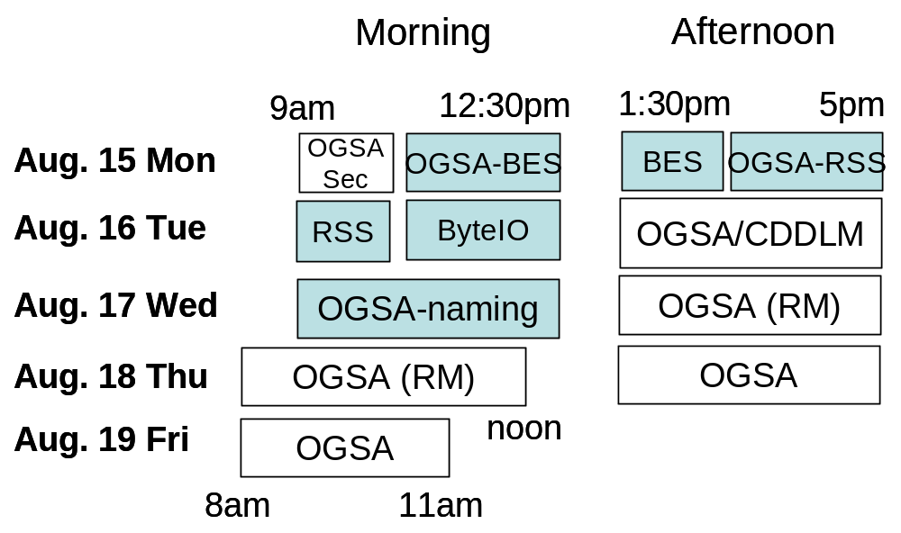
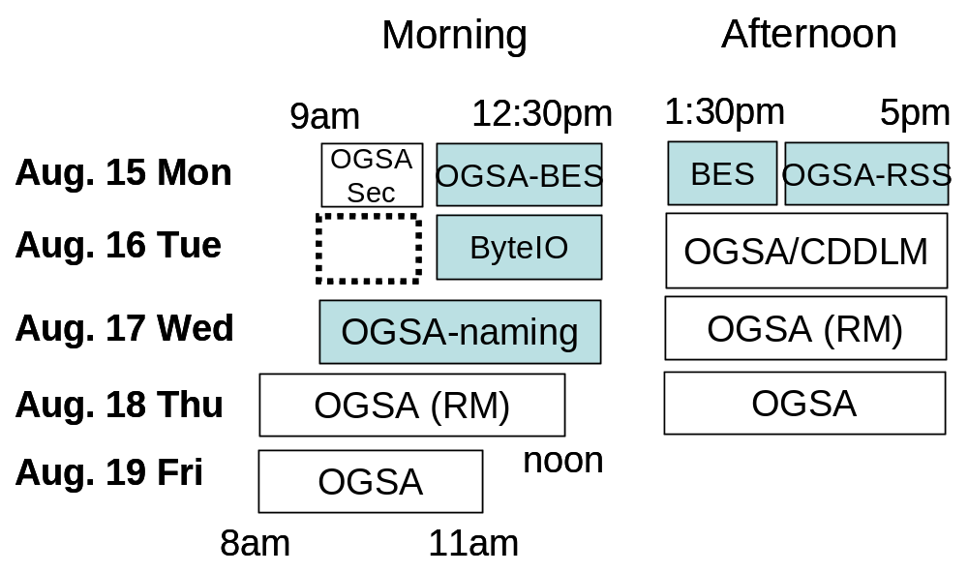
Aug. 15 (Mon), 9am ~ 10:30pm
OGSA-WG Security Design Team (Takuya and Frank)
With OGSA-AuthZ-WG

1) Early discussion (10 min)
  - Note taker
  - Role call and self introduction
  - Agenda bashing

2) OGSA-AuthZ-WG document discussion (30 min)
- Attributes used in OGSA Authorization (in PC period)
- Use of SAML for OGSA Authorization (before PC)

3) OGSA-data service authorization discussion (30 min)
- See email thread on the ogsa-d-wg list
http://www-unix.gridforum.org/mail_archive/ogsa-d-wg/2005/07/msg00009.html

4) Next step for collaboration discussion (20 min)

Aug. 15 (Mon), 10:45am ~ 12:30pm
OGSA-BES #1 (Andrew, Steven, and Darren)

- Agenda bashing [10 mins]

- Review of current draft & discussion [50 mins]

- Discussion about renderings I [60 mins]

Aug. 15 (Mon), 1:30pm ~ 3pm
OGSA-BES #2 (Andrew, Steven, and Darren)

- Discussion about renderings II [60 mins]

- Discussion about implementations [30 mins]

Aug. 15 (Mon), 3:15pm ~ 5pm
OGSA-RSS #1 (Donal and Soonwook)

- Early Discussion
  - Note taker assignment
  - Agenda bashing

- RSS Architecture Overview, Current Status and Plan
- Presentation
- Discussion on overall architecture design.

- Resource Selection Services for a Single Job Execution
- Presentation
- Discussion:
  - Selection policy issue:
    - What kind of selection policies we should consider?
    - Where should we put selection policy, EPS or CSG, or both?
  - Reservation Service Issue:
    - How does the RS affect on the design of EPS and CSG?

- Open discussion

Aug. 16 (Tue), 9am ~ 10:30pm
TBD

Aug. 16 (Tue), 10:45am ~ 12:30pm
OGSA-ByteIO (Mark and Neil)

- Use Case Overview -- 15 minutes

- ByteIO Interface Bashing (there were changes in the last GGF) -- 30 minutes

- Going through the draft recommendation document) -- 1 hour

- Discussion of Experience documents and implementations (call to arms) -- 15 minutes

Aug. 16 (Tue), 1:30pm ~ 5pm
OGSA-WG and CDDLM-WG (Dejan and Hiro)

- (1:30-1:45) Introduction
learn more about EMS broader picture, in the past wee overviewed CDDLM

- (1:45-3:15) Defining architectural relationship
This is really related to the pictures we discussed above, Fig 5 in the OGSA arch & Fig 7 in CDDLM Foundation

- (3:15-3:45) In depth overview of the CDDLM interfaces (if needed)

- (3:45-4:15) Description and integration of ACS, BES & CDDLM

- (4:15-4:45) Integration roadmap

- (4:45-5:00) Next steps

Above times are approximate, they may change as needed, e.g. if we cover some of the later items in earlier sessions

Aug. 17 (Wed), 9am ~ 12:30pm
OGSA-naming (Manuel and Andrew)

- Agenda bashing as usual

- Discuss updated document & decide if we are ready to send it out for public comment

- RNS discussion
  - Is RNS the high-level name scheme that we want?
  - Is there any feedback we (the OGSA-WG) want to offer to the GFS-WG independent of feedback from any single member (i.e., are there any issues that we think are critical?)

- Interoperability testing of WS-Naming resolution functions.

Aug. 17 (Wed), 1:30pm ~ 5pm
OGSA-WG #1 (Tom and Hiro)

1) Early discussion (10 min)
  - Note taker
  - Agenda bashing

2) Normenclature (30 min)
- Try to make nomenclature (information vs. data vs. resource model) uniform among participants.

3) Scenario discussion I (75 min)
- Get a scenario related to job submission, then follow all the information related to the resource model while we go through through the steps of discovery, resource selection, deployment, execution, etc.
  - Commercial Data Center (see OGSA use cases)
  - Server Consolidation

<break>

3) Scenario discussion II (75 min)
- Continuation of the previous session.

Aug. 18 (Thu), 8am ~ noon
OGSA-WG #2 (Tom and Hiro)

1) Early discussion (10 min)
  - Note taker
  - Agenda bashing

2) General discussion on CIM (60 min)
- Review Fred’s document, “Resource Modeling in OGSA”

<break>

3) Resource CIM model profiling pilot study (120 min)
- Using EMS container and activity as an example
- See Hiro’s slides “OGSA Resource Modeling Work Plan Proposal”

4) Next Steps (30 min)

Aug. 18 (Thu), 1:30pm ~ 5pm
OGSA-WG #3 (Tom and Hiro)

1) Early discussion (10 min)
  - Note taker
  - Agenda bashing

2) OGSA-data architecture (60 min)
- Allen Luniewski explains current data architecture doc draft

<break>

3) Architecture and glossary 1.5 (60 min)
  - Open issues, resolution process, schedule

4) Roadmap document (60 min)
- Open issues, resolutions

Aug. 19 (Fri), 8am ~ 11am
OGSA-WG #4 (Tom and Hiro)

1) Early discussion (10 min)
  - Note taker
  - Agenda bashing

2) OGSA-WG next step discussion (60 min)
- OGSA WSRF BP 1.0 interop

3) OGSA re-charter discussion (60 min)
- OGSA-WG’s charter document is obsolete
- New charter draft explaining agreed next steps

<break>

4) GGF15 preparation and schedule (45 min)
  - GGF15 session plan
  - Next F2F (Oct 6 & 7)

5) Wrap-up

Mark and Andrew are in the process of taking the last version of the document (July 11), and - Putting into GGF format - Schema and WSDL of resolution porttypes - Normative schema and description for extending WS-Addressing (right now we have an example, not a schema) - Example message exchanges for resolution

