Agenda for OGSA-WG interim F2F meeting
Hosted by NeSC & Imperial Collage
Draft 0.2 (May 17, 2005)

Dates / Time: May 23rd (Mon) 9am to May 24th (Tue) 6pm (OGSA-WG)
May 22nd (Sun) 9am to 6pm (OGSA-BES-WG)
May 26th (Thu) 9am to 6pm (OGSA-data & OGSA-ByteIO WG)

Meeting Room: Rooms 217 & 218 Huxley building,
Department of Computing, Imperial College London.

Address: Huxley Building, 180 Queens Gate,
Imperial College London
South Kensington Campus, SW7 2AZ

Nearest tube stations:
Gloucester Road or South Kensington.

Local contacts:
Steve McGough: +44 (0)20 759 48409 (office) +44 (0)78 8520 6866 (mobile)
David McBride: +44 (0)20 759 48341(office)

Dial-in:
<TBA>

Glance network:
address: http://ogsa.glance.net
Pass code: MMDD (0214 for Feb. 14)

Information package:
https://forge.gridforum.org/docman2/ViewCategory.php?group_id=42&category_id=1024

Accommodation:
Rydges Kensington Plaza Hotel
Hotel home page:
http://www.rydges.com/locations/Rydges.asp?name=Rydges-Kensington-Plaza-Hotel-London&hotel=RUKENS&cat=CitySuburban
The Rydges link via Imperial http://www.imperial.ac.uk/conferences/form.asp?form_id=4&hotel_id=rydges

Attendees List
Name | BES-WG | OGSA-WG |  | DATA
Name | May 22 (Sun) | May 23 (Mon) | May 24 (Tue) | May 26 (Thus)
Hiro Kishimoto | ✓ | ✓ | ✓ | ✓
Allen Luniewski |  | ✓? | ✓? | ✓?
Fred Maciel | ✓ | ✓ | ✓
Chris Smith | ✓ | ✓
Jem Treadwell |  | ✓ (late am) | ✓
Mark Morgan | ✓ | ✓ | ✓ | ✓
Tom Maguire | ✓ | ✓ | ✓
Andreas Savva | ✓ | ✓ | ✓ | ✓
Steven Newhouse | ✓ | ✓ | ✓
Mathias Dalheimer | ✓ | ✓ | ✓
Jay Unger | ✓ | ✓ | ✓ | ✓ ?
David Snelling | ✓ | ✓ | ✓ | ✓
Dave Berry |  | ✓ | ✓ | ✓
Abdeslem Djaoui |  | ✓ | ✓
Peter Kunst |  |  |  | ✓
Bill Allcock |  |  |  | ✓
Ann Chervenak |  |  |  | ✓
Andrew Grimshaw | ✓ | ✓ | ✓
Takuya Mori | ✓ | ✓ | ✓
Kazushige Saga | ✓ | ✓ | ✓ | ✓
Soonwook Hwang | ✓ | ✓ | ✓ | ✓
Michel Drescher | ✓ |  |  | ✓
Neil P Chue Hong |  |  |  | ✓
William Lee | ✓ | ✓
Stephen McGough | ✓ | ✓ | ✓
Mario Antonioletti |  |  |  | ✓
Ravi Subramaniam | ✓ | ✓ | ✓
Total | 19 | 22 | 20 | 16

Phone bridge

Apologies
Ian Foster ANL
Frank Siebenlist ANL
Michael Behrens R2AD, LLC
Pete Ziu NGC
Manual Pereira IBM

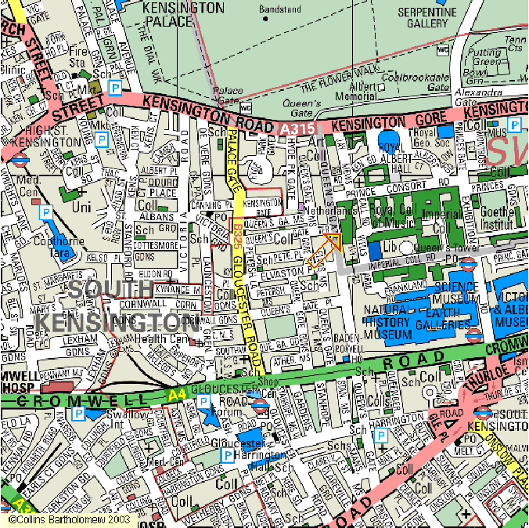

Directions
Rooms 217 & 218 are on the 2nd floor of the Huxley building. To confuse things slightly this is the level that you enter the Huxley building from Queens Gate (road). To enter these rooms you need swipe-card access to the corridor. We will place someone at this door at the start of each session. If you arrive and no-one is present you can call 48409 and someone will come and let you in.

Reaching rooms 217 & 218 from Queen’s Gate (road):
Enter the Huxley Building (180 Queen’s Gate) through the set of sliding doors. Turn immediately left to the swipe-card access doors.

Reaching 217 & 218 from Exhibition Road:
Enter the Tanaka Building (white framed greenhouse) through the rotating doors and walk straight ahead and slightly to the right. This should take you down a corridor that leads to an exit (rotating door) out onto the walkway. Go straight ahead and slightly to the left of the Electrical Engineering building. Follow along past the Student Travel agents and the student common room on your left. Keep going past the cash machines and follow the walkway as it turns right and immediately left. At the end of the walkway there is a set of doors to your right. Go through the doors and take the stairs down immediately on your left. At the bottom of the stairs go through the glass double doors and turn right to the swipe-card access doors.

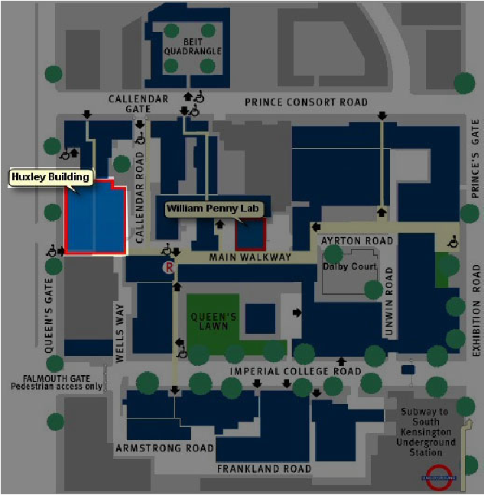

May 22 (Sun), 9am ~ 6pm
OGSA-BES WG
Andrew Grimshaw, Steve Newhouse, Darren Pulsipher

1-1) xxx

<TBA>

May 23 (Mon), 9am ~ 6pm
OGSA WG, day one

2-1) Welcome (30 min)
  - Note taker
  - Self-introduction (in person and on bridge)
  - Agenda bashing

2-2) EMS architecture discussion I (90 min)
  - Summary of OGSA-BEA-WG meeting on May 22nd
  - Resource Selection Service discussion
    - Use case discussion based on GSA-RG document
    - Mathias will give short presentation

<break>

2-3) EMS architecture discussion II (6 0 min)
  - Re-factoring among EMS and Data

<Lunch> noon – 1pm

2-4) Profile definition discussion (120 min)
  - Document review
  - Close all open issues in tracker
  - GGF Editor submission schedule

<break>

2-5) WSRF Basic Profile discussion (120 min)
  - Document review
  - Close all open issues in tracker
  - GGF Editor submission schedule

<Group Dinner>
May 24 (Tue), 9am ~ 6pm
OGSA WG, day two

3-1) One hour summary session (60 min)
  - Note taker
  - Summary of day two (May 23rd)
    - Let people who might want to dial in get a summary
  - Agenda review and bashing

3-2) OGSA roadmap discussion (120 min)
  - Document review
  - Close all open issues in tracker
  - GGF Editor submission schedule

<Lunch> noon – 1pm

3-3) Documents submission discussion (60 min)
  - Are they ready for GGF editor submission?
  - How long will they take to be ready?

3-4) GGF14 session discussion (60 min)
  - Review GGF14 session plan
  - Define preparation tasks and owners
  - Timelines until GGF14

<break>

3-5) OGSA-Data WG status report (60 min)
  - This would keep people up to date even if they don't attend the Data meeting on the 26th, and also prepare those people who will be attending the Thursday meeting, so that we can dive straight into technical discussion on the Thursday.

3-6) Wrap up
- Teleconference schedule

<Group Dinner>
May 26 (Thu), 9am ~ 6pm
OGSA-data & OGSA-ByteIO WG
Dave Berry, Allen Luniewski, Mark Morgan, Neil Chue Hong

4-1) xxx

<TBA>

JSDL-WG may have F2F meeting on May 25th (Wed).

