Program Execution

Program Execution is the key component of Grid middleware that enables applications to have coordinated access to the underlying resources of the VO, regardless of their physical location or access mechanisms. When an application utilizing the Grid makes use of more than one physical resource during its execution, Program Execution middleware maps the resource requirements of the user application to the multiple physical resources that are required to run that application. Community schedulers are the key to making the resources of the VO easily accessible to end-users, by automatically matching the requirements of a Grid application with the available resources, while staying within the conditions that the VO has specified with the underlying resource managers.

Interoperability is the key to building up a Program Execution Grid. In order to allow the higher order constructs such as Community Schedulers to work with the lower level resource managers, there must be agreement on how these entities will interact with each other, even though the lower level resource managers might be very different from each other, in function and in interface. In order to meet the requirement for interoperability, standards are required which define the interfaces through which resource managers are accessed and managed. Additionally, there is a requirement that the services representing the resource managers act using standard semantics, so that the behavior of the resource manager is predictable to the community scheduler.

Grid environments based on OGSA will be composed of many different, interacting Grid services. Each of these services in turn is subject to different policies on how to manage the underlying resources. In order to deal with the complexities of large collections of these services, there need to be mechanisms for Grid service management and the allocation of resources for applications. One such mechanism is defined through an interface called WS-Agreement. The specification document for WS-Agreement [refer to spec] describes it as “…the ability to create Grid services and adjust their policies and behaviors based on organizational goals and application requirements.” WS-Agreement defines the Agreement-based Grid Service Management model, which is specified as a set of OGSI-compliant portTypes allowing clients to negotiate with management services in order to manage Grid services or other legacy applications.

To put it in concrete terms, if a user wants to submit a compute job to run on a cluster, they would have their Grid service client contact a job management service, and would negotiate a set of agreements which ensured that the user’s job would have access to a number of cpus, memory, storage space, etc.

WS-Agreement defines fundamental mechanisms based on Agreement services, which represent an ongoing relationship between an agreement provider and an agreement initiator. The agreements define the behavior of a delivered service with respect to a service consumer. The Agreement will most likely be defined in sets of domain specific agreement terms (defined in other specifications), since the WS-Agreement specification is focused on defining the abstraction of the agreement and the protocol for coming to agreement, rather than on defining sets of agreement terms.

Referring back to the job submission example, the client might contact a job management service, which implements the AgreementFactory interface, with creation parameters that say “my job has to have a software license for application X, would like to have 8 cpus, and would like to have 4G of RAM”. If the job management service couldn’t provide the software license (the must have), the agreement terms would be rejected. If it could provide all of the terms, an Agreement service instance representing the job resources would be created. If, because of available resource constraints, the job management service couldn’t fulfill the terms of the original creation parameters, but could supply either 4cpus and 4G of RAM, or 8cpus and 2G of RAM, the job management service could create an AgreementOffer which included two potential agreements: “app X, 4cpus, 4G” and “app X, 8cpus, 2G”, one of which the client could choose (because cpus and memory were terms subject to counter offers).

By defining various sets of terms for representing different types of resources available within the VO, Community Schedulers can be written which can negotiate with resource managers for the use of the underlying resources on behalf of the user community.

Program Execution services utilize WS-Agreement portTypes both for its client interface and its interface to underlying resources, with the goal of allowing hierarchical VO deployment, e.g., one Community Scheduler talks to another Community Scheduler-based resource conglomeration.

Figure 1 shows the Grid services required for Program Execution. These services include:

- Agreement Factory Service – create agreement services based on domain specific terms such as job, reservation and data access terms.
- Job Agreement Service – creates, monitors and controls compute jobs
- Reservation Agreement Service – guarantees resources are available for running a job
- Data Access Agreement Service – staging the required application and data
- Queuing Service – provides a service where administrators can customize and define scheduling policies at the VO level, and/or at the different resource manager levels
- Index Service – allows for the propagation of information between resource managers and the metascheduler.

Program Execution services can be flexibly composed to offer a whole spectrum of time-to-result QoSes, ranging from online/interactive to batch with specific or no turn-around time requirements. Online/interactive jobs can be sent by the job agreement service to the RMs immediately, without getting queued. Batch jobs will be queued by the Queueing services and dispatched to RMs later. The jobs with specific turn-around time may use the available reservations made with the RMs at specific times so that the deadline can be met. The jobs with no specific turn-around time can be queued at the VO level or the backend RM level, until the required resource is available, or backfill the existing reservations without delaying the start time of the more time-critical jobs.

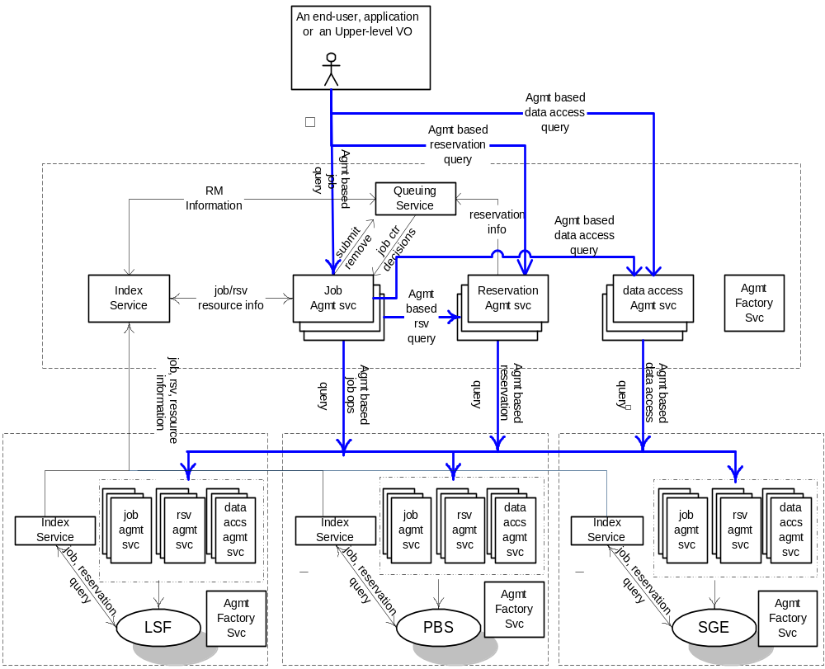
Figure 1 Program Execution Architecture and Services

Job Agreement Service
Job Agreement service is created by the agreement factory service with a set of job terms, including command line, resource requirements, execution environment, data staging, job control, scheduler directives, accounting and notification terms.

The Job agreement service provides an interface for placing jobs on a resource manager (i.e. representing a machine or a cluster), and for interacting with the job once it has been dispatched to the resource manager. The Job service provides basic matchmaking capabilities between the requirements of the job and the underlying resource manager available for running the job. More advanced Job services take into account more advanced job characteristics such as interactive execution, parallel jobs across resource managers, and jobs with requirements based on SLAs.

The interfaces provided by the Job service are:
- Manageability Interface ---
  - Supported Job Terms: defines a set of service data used to publish the job terms supported by this job service, including the job definition (command line and application name), resource requirements, execution environment, data staging, job control, scheduler directives, accounting and notification terms.
  - Workload Status: total number of jobs, statuses such as number of running, pending and suspended jobs.
- Job Control – control the job after it has been instantiated. This would include the ability to suspend/resume, checkpoint, and kill the job.

The Job agreement service makes use of information in the form of policies which are defined at the VO level, and resource information about available resource managers, queues, host, and job status as provided by the Global Information Service. The Job service uses the WS-agreement protocol with the underlying resource managers in order to submit jobs to the underlying resource managers, and in order to control the running jobs and to access data.

Reservation Agreement Service
The Reservation agreement service is created by the agreement factory service with a set of terms including time duration, resource requirement specification, authorized user/project agreement terms.

The Reservation agreement service allows end users or a Job agreement service to reserve resources under the control of a resource manager to guarantee their availability to run a job. The service allows reservations on any type of resource (e.g. hosts, software licenses, or network bandwidth). Reservations can be specific (e.g. provide access to host “A” from noon to 5pm), or more general (e.g. provide access to 16 Linux cpus on Sunday). Once a reservation is made, a Job service can send a job to a resource manager that is attached to the provided reservation. Some of the policy decisions made by the Reservation service for use with a RM include notions of who can make reservations (e.g. admins only), how many hosts a particular user or user group can reserve at a time, when reservations can be made (i.e. “blackout periods”), and what types of hosts can be reserved.

The Reservation agreement service provides the following interfaces:
- Manageability – define a set of service data that describes the details of a particular reservation, including resource terms, start time, end time, amount of the resource reserved and the authorized users

The Reservation service makes use of information about the existing resource managers available, any policies that might be defined at the VO level, and will make use of a logging service to log reservations. It will use the RM Adapter interfaces to make reservations and to delete existing reservations.

Data Access Agreement Service
The Data Access Agreement Service is created by the agreement factory service with a set of terms, including (not excluding to) source and destination file path, bandwidth requirements, fault-tolerance terms (such as retrial times).

The Data access agreement service allows end users or a Job agreement service to stage application or required data.

- Manageability Interface --- Define a set of service data for accessing the data movement status information
- Other operations --- ??? Need to incorporate DAIS spec, Jay to provide ???

Queuing Service
The Queuing service provides scheduling capability for jobs. Given a set of policies defined at the VO level, a Queuing service will map jobs to resource managers based on the defined policies. For example, a Queuing service might implement a fairshare policy that makes sure that all users within the VO get reasonable turnaround time on their jobs, rather than being starved out by other users' jobs ahead of them in the queue.

· Manageability Interface - Define a set of service data for accessing QoS terms supported by the Queuing services. QoS terms for the Queuing service can include whether the service supports on-line or batch capabilities, average turn-around time for jobs, throughput guarantees, the ability to meet deadlines, and the ability to meet certain economic constraints.
- Enqueue --- enqueue a job into a queue
- Dequeue --- dequeue a job from a queue

Underlying services

- Index Service – allows for the propagation of information between resource managers and the metascheduler. It also provides facilities for other services to persist their state data.

Related standards

- WS-Agreement: defines fundamental mechanisms based on Agreement services, which represent an ongoing relationship between an agreement provider and an agreement initiator. The agreements define the behavior of a delivered service with respect to a service consumer. The Agreement will most likely be defined in sets of domain specific agreement terms (defined in other specifications), since the OGSI-Agreement specification is focused on defining the abstraction of the agreement and the protocol for coming to agreement, rather than on defining sets of agreement terms.
- WS-Agreement Job, Reservation and Data Access Terms

Owner WG
GRAAP: WS-Agreement
JSDL: Job Terms and Resource Reservation Terms
DAIS: Data Access Terms

