4.3 Program Execution 1
4.3.1 Conceptual Frameworks 2
4.3.2 WS-agreement base scheduler instantiation 5
4.3.3 Instantiation with “broker service” 8

Program Execution
Program execution services enable applications to have coordinated access to underlying VO resources, regardless of their physical location or access mechanisms. When an application utilizing the Grid makes use of more than one physical resource during its execution, Program Execution middleware maps the resource requirements of the user application to the multiple physical resources that are required to run that application. The Program Execution services are the key to making VO resources easily accessible to end-users, by automatically matching the requirements of a Grid application with the available resources, while staying within the conditions that the VO has specified with the underlying resource managers.
Interoperability is the key to building up a Program Execution Services. In order to allow the higher order constructs such as Program Execution to work with the lower level resource managers, there must be agreement on how these entities will interact with each other, even though the lower level resource managers might be very different from each other, in function and in interface. In order to meet the requirement for interoperability, standards are required which define the interfaces through which resource managers are accessed and managed. Additionally, there is a requirement that the services representing the resource managers act using standard semantics, so that the behavior of the resource manager is predictable to the scheduler.
OGSA-based Grid environments may be composed of many different, interacting Grid services. Each such service may be subject to different policies on how to manage the underlying resources. In order to deal with the complexities of large collections of these services, there need to be mechanisms for Grid service management and the allocation of resources for applications. One such mechanism is defined through the proposed WS-Agreement interface [3]. The specification document for WS-Agreement [refer to spec] describes it as “…the ability to create Grid services and adjust their policies and behaviors based on organizational goals and application requirements.” WS-Agreement defines the Agreement-based Grid Service Management model, which is specified as a set of OGSI-compliant portTypes allowing clients to negotiate with management services in order to manage Grid services or other legacy applications.

Conceptual Frameworks
Workload realization is the general set of use cases that take workload requests and map them to appropriate resources within the Grid that can realize these workloads. Grid services manage and co-ordinate access and consumption of geographically distributed resources by workloads realized on those resources.
The overall conceptual architecture can be visualized as shown in Figure 1. Workload realization (or execution) can be visualized as a mapping between “demand” in the form of workloads and “supply” in the form of the available Grid resources. In a fundamental scenario, the system has t o map the demand to the supply and provide the mechanism to realize these workloads on the resources. This primary mode can be augmented with other services, mechanism and capabilities that provide alternate modes of interaction including optimization of the mapping and scheduling a temporal and topological execution profile. In addition, other services manage and enforce of the service level agreements with the user and still other services tweak the resources and manage the available capacity to ensure a desired quality of service is delivered. The alternate modes are not core to the execution framework but can be added to augment the efficacy and efficiency of the overall system.
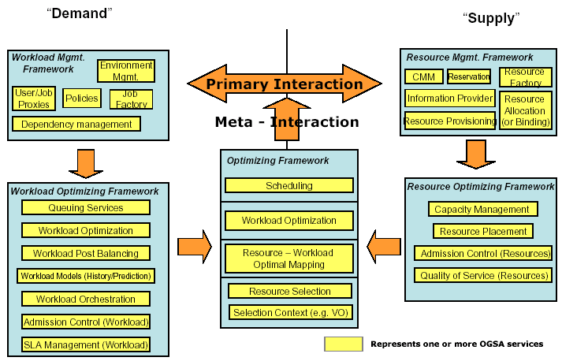
Figure 1 Grid Frameworks - Execution
Services that belong to the Resource Optimization Framework are focused on the optimization of the supply side of the mapping. This can be done by admission control, resource utilization monitoring and metering, capacity projections, resource provisioning and load balancing across equivalent resources, negotiation with workload optimization and/or management services to migrate workloads onto other resources so as to maximize resource utilization.
Services that belong to the Workload Optimization Framework are focused on the demand side of the mapping. These services may queue requests to prevent resource saturation and manage relative priorities in requests, perform post-balancing by migration workloads to appropriate resources depending on the potential to violate or be rewarded for missing or exceeding SLAs respectively.
Services in the Optimizing Framework are focused on resolving any contentions that the myopic views of the respective resource or workload optimization frameworks may create. These services arbitrate and modulate the primary interactions either in an ‘in-band’ or ‘out-of-band’ manner.
Resources are used in its most general sense and can include virtualized physical resources like CPU, storage, memory and/or virtual resources like software licenses or data. Workloads are composite entities and have multiple levels of “execution entities”; workloads are made of jobs which in turn are made of tasks which in turn are made of tasklets. Each of these composite entities has a manager.
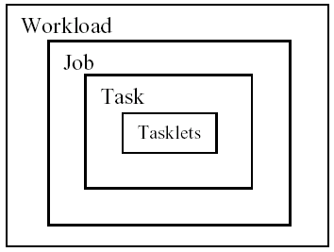
Figure 2 Workload, Job, Task, and Tasklet
A possible set of interactions between Grid services to execute workloads are shown in Figure 3. The services can be at multiple levels in the Grid and can be composed of other services or service groups.

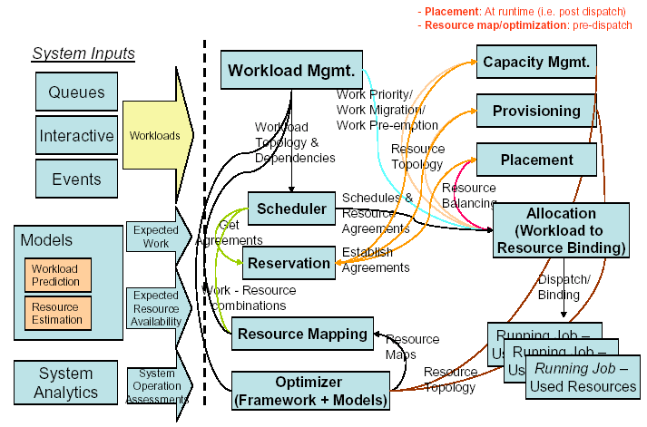
Figure 3. Service interactions for workload execution (partial enumeration)
A physical organization of the services and one of the possible collaborations scenarios is shown in Figure 4.

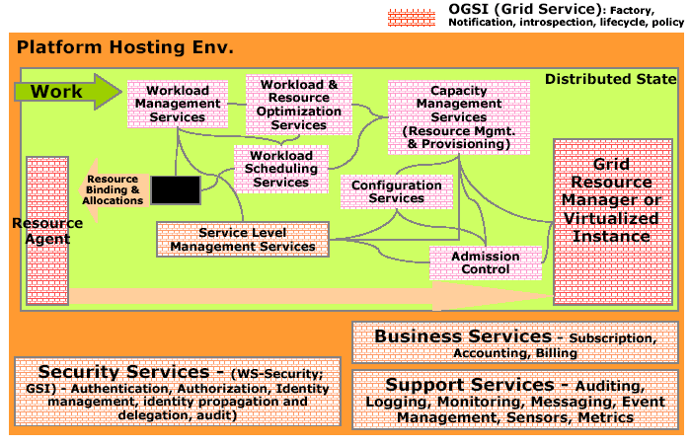
Figure 4. Example Grid execution service interaction

WS-agreement base scheduler instantiation
To put it in concrete terms, if a user wants to submit a compute job to run on a cluster, they would have their Grid service client contact a job management service and negotiate a set of agreements that ensure that the user’s job has access to required CPUs, memory, storage space, etc.
WS-Agreement defines fundamental mechanisms based on Agreement services, which represent an ongoing relationship between an agreement provider and an agreement initiator. The agreements define the behavior of a delivered service with respect to a service consumer. The Agreement will most likely be defined in sets of domain specific agreement terms (defined in other specifications), since the WS-Agreement specification is focused on defining the abstraction of the agreement and the protocol for coming to agreement, rather than on defining sets of agreement terms.
Referring back to the job submission example, the client might contact a job management service, which implements the AgreementFactory interface, with creation parameters that say “my job has to have a software license for application X, would like to have 8 cpus, and would like to have 4G of RAM”. If the job management service couldn’t provide the software license (the must have), the agreement terms would be rejected. If it could provide all of the terms, an Agreement service instance representing the job resources would be created. If, because of available resource constraints, the job management service couldn’t fulfill the terms of the original creation parameters, but could supply either 4cpus and 4G of RAM, or 8cpus and 2G of RAM, the job management service could create an AgreementOffer which included two potential agreements: “app X, 4cpus, 4G” and “app X, 8cpus, 2G”, one of which the client could choose (because cpus and memory were terms subject to counter offers).
By defining various sets of terms for representing different types of resources available within the VO, Community Schedulers can be written which can negotiate with resource managers for the use of the underlying resources on behalf of the user community.
Program Execution services utilize WS-Agreement portTypes both for its client interface and its interface to underlying resources, with the goal of allowing hierarchical VO deployment, e.g., one Community Scheduler talks to another Community Scheduler-based resource conglomeration. Another key aspect of agreement is to consider the constraints of the service provider based on Service Level Agreements in a business context and their reflection in underlying resource manager policies. Not all constraints are simply availability or unavailability of resources. Some are management policy specified based on pricing, usage, higher priorities, and the like.
Figure 5 shows the Grid services required for Program Execution. These services include:
- Agreement Factory Service – create agreement services based on domain specific terms such as job, reservation and data access terms.
- Job Agreement Service – creates, monitors and controls compute jobs
- Reservation Agreement Service – guarantees resources are available for running a job
- Data Access Agreement Service – staging the required application and data
- Queuing Service – provides a service where administrators can customize and define scheduling policies at the VO level, and/or at the different resource manager levels
- Index Service – allows for the propagation of information between resource managers and the metascheduler.
Program Execution services can be flexibly composed to offer a whole spectrum of time-to-result QoSes, ranging from online/interactive to batch with specific or no turn-around time requirements. Online/interactive jobs can be sent by the job agreement service to the RMs immediately, without getting queued. Batch jobs will be queued by the Queueing services and dispatched to RMs later. The jobs with specific turn-around time may use the available reservations made with the RMs at specific times so that the deadline can be met. The jobs with no specific turn-around time can be queued at the VO level or the backend RM level, until the required resource is available, or backfill the existing reservations without delaying the start time of the more time-critical jobs.
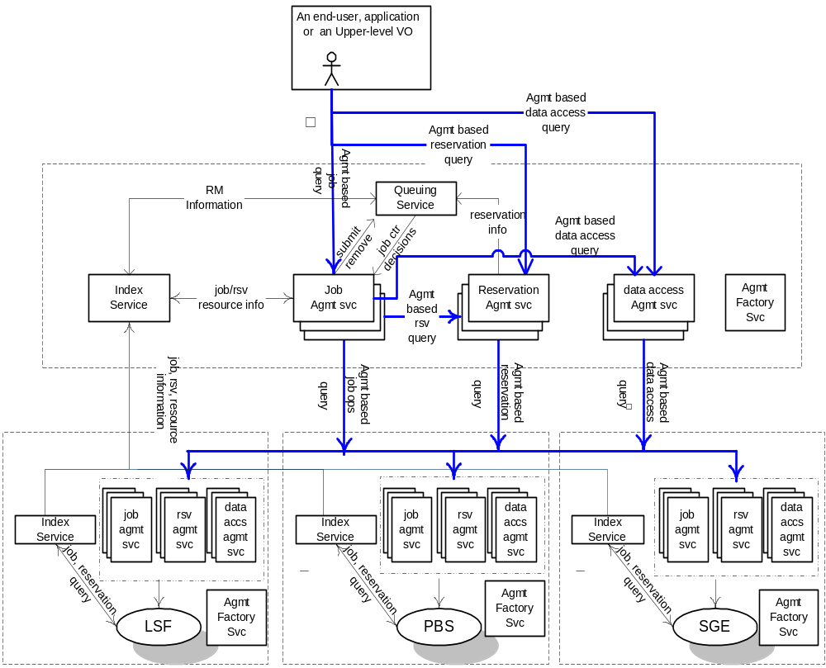Figure 5 An Instantiation of Program Execution Architecture and Services

Instantiation with “broker service”
The Program Execution services must support the types of jobs. After accepting a submitted job-request. A broker service is used to select the resources (including hosting environment) that are necessary to execute the job.
After the pre-processing is completed correctly the requester is given a unique reference to the agreement. If necessary resources cannot be allocated, an error should be returned. The agreement can be used to query for information about the job as well as control, e.g., to modify job requirements or to cancel the job request.
The submitter can provide the following attributes or term when submitting a job request.
- The Grid Service, program, or workflow that should be instantiated
- The starting time of the job, including how long the job will execute
- Resources, including data, needed by the job. (Resource descriptions could be given in XML.)
- User information
- SLA information, including priority
- Application startup script
When the specified job start time arrives the scheduler must arrange for the job to start executing. If a start up script was specified then the script should be executed. A job may have its resources increased or decreased by the scheduler. Changes in resource allocation must be acknowledged synchronously. When a job terminates, the Program Execution services must carry out the following processing
- Inform the client of the job’s final status
- Release the resources allocated to the job by the hosting environment
- Delete the job from the scheduler’s database
The scheduling service is responsible to start the job. Jobs have a pre-determined start time but priority and SLA attributes may cause changes in the start time. The scheduling service manages all submitted jobs. The job state may be retrieved at any time.
Once the resource reservation period has finished then the job must be stopped and the resources used by the job returned to the resource management service. Jobs may be temporarily suspended or migrated based on the SLA (priority) associated with each job. Jobs with high priority are executed first.
Scheduling and resource reservation information associated with each job are kept in stable storage so that information is not lost in the event of failure. The scheduling service allows writing and reading of the scheduling data.
Resource reservation information is updated by the resource management service. In addition accounting information such as which resources were used by the job, and for how long are also recorded in the database.
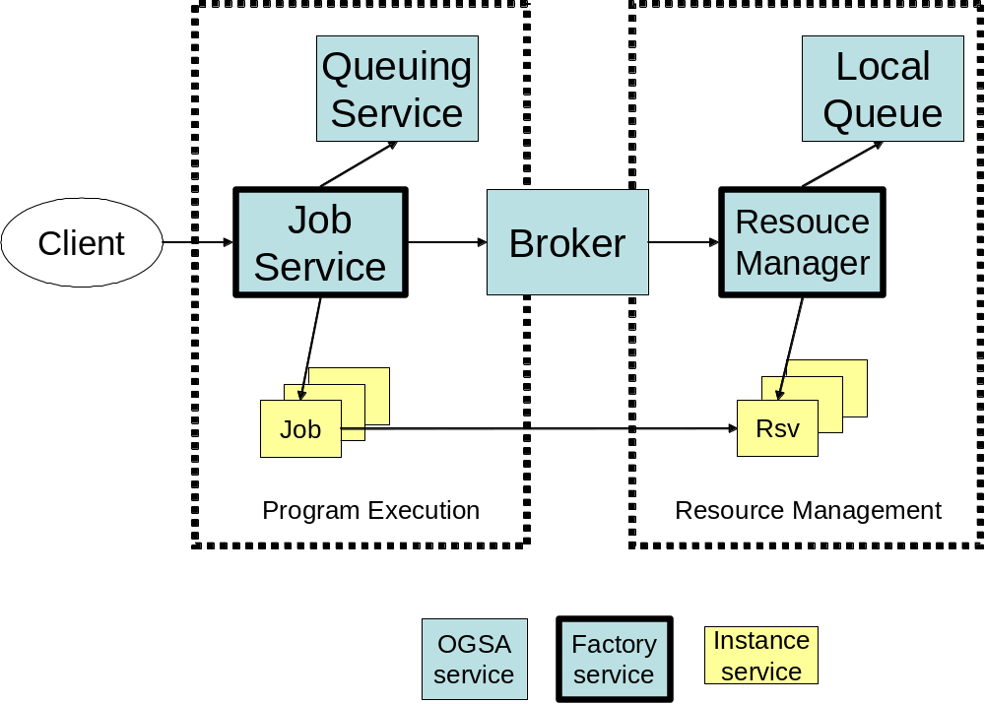
Figure 6. Program Execution with Broker Service

