OGSA-Interested Party Survey rev. 04
Nov. 24, 2004
Grid scenarios present a number of significant challenges to end-users, application developers, and IT managers. OGSA will address these complex challenges by defining a set of standards that together, like the interlocking pieces of a puzzle, provide the foundation on which to build robust Grid applications and Grid management systems. Thus, OGSA will define the services, their interactions, and the design philosophy based on the community’s experiences, inputs, and feedback.
The purpose of this survey is to solicit input from all OGSA stakeholders in order to refine the OGSA roadmap document and OGSA version 2.0 architecture document.
The OGSA roadmap document will define priorities for OGSA interfaces, based on community input, identify dependencies among interfaces, and describe community requirements for timing the definition of the OGSA interfaces. Thus we need your input to complete this process including:
- What specifications are most important for your activity?
- Which ones need to be done before the others?
- Which specifications are you or other “users” ready to work on, or are already working on?
- Which specifications are not being worked on to your knowledge? Or which areas have multiple competing specifications so hindering adoption?
The OGSA v2.0 document will be a revised version of the current OGSA version 1.0 document in two aspects. OGSA version 2.0 will be more mature and respond to existing and emerging major Grid activities. It will still be presented at the same abstract level as OGSA version 1.0. In addition there will also be a drill-down toward concrete interface definitions. Your input for one or both aspects will be highly appreciated. If you are defining or implementing one or more OGSA related interfaces, please provide feedback including:
- What specifications are you defining or implementing?
- Do your interfaces satisfy OGSA requirements described in the version 1.0 document? Do they fit well in the OGSA version 1.0 capability framework?
- Do you have additional requirements for OGSA? Do you have other ideas, which should be a part of OGSA?
- Do you have the expertise to develop these specifications? Are you willing to work with the OGSA-WG to make these specifications part of OGSA, and hence define OGSA compliance?
This is the draft revision of OGSA-WG interested party survey template. Please use this template to describe your activity.
If you have any comment or suggestion to improve this template, please send it to OGSA-WG mailing list (ogsa-wg@ggf.org).
Hiro Kishimoto (hiro.kishimoto@jp.fujitsu.com)

Name
Party’s, project's or individual's name and web site (if any)

Outline

Category
Select the most suitable categories with respect to this party. Choose from the following ones and delete the others.
- Standards development group or research group (e.g. GGF WG/RG, OASIS TC, etc.)
- Open source software development or distribution project (e.g. Globus, NMI, OMII, etc.)
- Grid testbed or application project (e.g. TeraGrid, National Fusion Collaboratory, etc)
- Commercial software and / or hardware vender
- Grid user company
- Other (please specify)

Description
Describe this party’s activity in 5-10 lines. Including goals, party size, supporting organizations, and related materials if applicable.

Contact person
Name and email address of contact person for this party.

Schedule
Schedule of this party, for example major release date.

Synergy with OGSA

Role
Select one or more suitable roles for the party. Choose from the following ones and delete the others.
- Grid requirements gathering
- High level architecture design
- Low level architecture design
- Specification (e.g. API) development
- Grid software development
- Grid operation
- Other (please specify)

Area or capability
Please answer yes if the party is working in the following areas or capabilities.
The following capabilities (except Grid application) are defined in the OGSA version 1.0 document and each has its own “role-involvement” chart.

- Grid application: yes / no
Involvement: High – Mid – Low
Role: High level arch design – Actual specs development – Implementation

- Execution management services: yes / no
Involvement: High – Mid – Low
Role: High level arch design – Actual specs development – Implementation

- Data services: yes / no
Involvement: High – Mid – Low
Role: High level arch design – Actual specs development – Implementation

- Resource management services: yes / no
Involvement: High – Mid – Low
Role: High level arch design – Actual specs development – Implementation

- Security services: yes / no
Involvement: High – Mid – Low
Role: High level arch design – Actual specs development – Implementation

- Self-management services: yes / no
Involvement: High – Mid – Low
Role: High level arch design – Actual specs development – Implementation

- Information services: yes / no
Involvement: High – Mid – Low
Role: High level arch design – Actual specs development – Implementation

- Naming service: yes / no
Involvement: High – Mid – Low
Role: High level arch design – Actual specs development – Implementation

- Infrastructure services: yes / no
Involvement: High – Mid – Low
Role: High level arch design – Actual specs development – Implementation

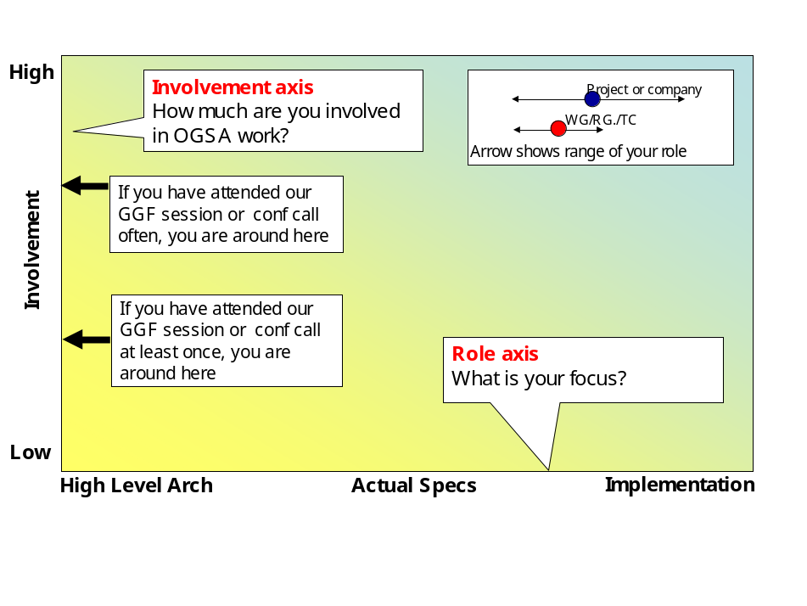
Fig 1 Role-involvement chart

Input to OGSA
In order to synchronize OGSA and this party, your input is essential. Please read chapter 3 of the OGSA version 1.0 document and let us know your feedback with respect to each OGSA capability relevant to you. Does the current capability description align with your activity? If there are any conflicts and / or gaps, please describe the problems and any solution proposals.
If the party is developing actual specifications, which may eventually be identified as “OGSA compliant”, please provide a summary of each and expected dates for the following:
- Specification publication date
- Reference implementation release date
- Early adoption date
- Mainstream adoption date
If your feedback is not available at this moment but will be ready in the near future, please note its planned date.
If the party does not work on a capability (answered no at §3.2), please answer N/A.

Execution management services

Data services

Resource management services

Security services

Self-management services

Information services

Naming service

Infrastructure services

Expected output from OGSA
OGSA version 2.0 is intended to be a group of documents consisting of three layers (see figure below). Tier 1 includes the following “Root documents”:
- Roadmap version 1.0 document
- Architecture (OGSA version 2.0) document (Revision of OGSA document version 1.0)
- Glossary version 2.0 (Revision of OGSA Glossary document version 1.0)
Tier 2 includes the following “Design team documents”:
- Service Description describes the services in each capability using a combination of natural language and UML, listing the interfaces and operations defined by each service.
- Scenarios demonstrate how these services can implement the use cases, using a combination of natural language and UML.
Tier 3 consists of Expert WG documents. These documents provide a normative definition of the services using a mixture of WSDL and natural language. These should be GGF Recommendation documents or equivalents from other standards development organizations.
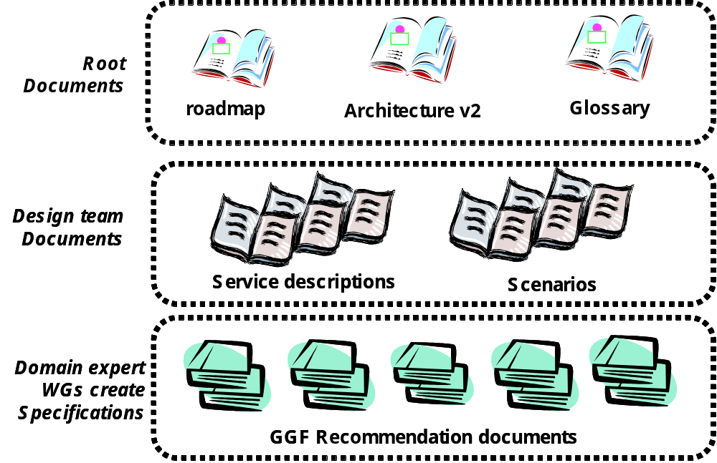
Fig 2 OGSA version 2.0 document structure
If the party is planning to produce and / or consume any of the above documents, please specify name of the document and when you need it.
Because the document publication schedule is still under discussion, this is a hypothetical question; if the schedule is as follows, does it fit with your schedule?
Table 1 Hypothetical OGSA version 2.0 documents schedule
Document name |  | WG draft publication | Reference Implementation release
Roadmap document version 1.0 |  | GGF13 (‘05/3) | n/a
Architecture and glossary version 2.0 |  | GGF14 (‘05/6) | ‘05/11
Service descriptions  Scenarios | EMS | GGF14 (‘05/6) | ‘05/11
Service descriptions  Scenarios | Data Services | GGF14 (‘05/6) | ‘05/11
Service descriptions  Scenarios | Resource Mgmt | GGF15 (‘05/9) | GGF17 (‘06/6)
Service descriptions  Scenarios | Security services | GGF17 (‘06/6) | GGF19 (‘07/3)
Service descriptions  Scenarios | Self Management | GGF17 (‘06/6) | GGF19 (‘07/3)
Service descriptions  Scenarios | Information Services | GGF16 (‘06/3) | GGF18 (‘06/9)
Service descriptions  Scenarios | Naming Service | ‘04/12 | ‘05/11

Execution management services

Data services

Resource management services

Security services

Self-management services

Information services

Naming service

Infrastructure services

General comments for OGSA
If the party has any general comments, not covered in any of the previous sections, please add them here.

https://forge.gridforum.org/projects/ogsa-wg/document/draft-ggf-ogsa-spec/en/19
In OGSA version 1.0 document, naming service is explained as a service under information capability.

