Open Grid Service Infrastructure Primer
(Draft)
Abstract
This is a working draft of the OGSI Primer. The aim is to provide an introduction to the OGSI specification with progressive examples, but without relying on any particular implementation.
The Primer is a non-normative document, which means that it is not a definitive (from the GGF's point of view) specification of OGSI, intended to provide an easily readable description of OGSI. It is intended towards quickly understanding the basic fundamentals for creating OGSI-based Grid Services. The examples and other explanatory material in this document are here to help you understand OGSI, but they may not always provide definitive or fully-complete answers. In such cases, you should refer to the relevant normative parts of the Grid Service Specification that can be found on the OGSI working group web site.
Making comments and contributions.
The OGSI Primer is a being produced by the OGSI working group of the GGF. The web site of the working group lists its charter, mailing list and previous products, including the draft of the OGSI specification for which the Primer will act as an introduction.
The Primer will be developed during 2003 and during its development comments from the OGSI working group are encouraged.
You can put you comments directly on the OGSI-WG mailing list, or use the GridForge web site. Contributions to the document are coordinated via the mailing list and associated conference calls.


Copyright © Global Grid Forum (2002). All Rights Reserved.
For details, see the Full Copyright Notice on page 73.

Contents
1. About this Primer 7
1.1. Who should read this Document? 7
1.2. Related Documents 7
2. Grids and their Requirements 9
2.1. What are Grids? 9
2.2. Features and Requirements of Computational Grid Systems 9
2.3. Why a ‘Service-Oriented’ Architecture? 11
2.4. Exploiting Web Services Architecture 11
2.5. What is needed to provide and use Grid Services? 12
2.5.1. A ‘Service-Oriented’ Architecture 12
2.5.2. The Client Side 12
2.5.3. The Server side 13
2.6. Associated and dependent standards 13
3. Background Technology 14
3.1. The Essentials of Web Services 14
3.1.1. Interactions defined by messages 14
3.1.2. Exploiting Web Services standards and facilities 14
4. Describing Grid Services 17
4.1. Web Services Description Language (WSDL) 17
4.2. The ‘Counter’ Example 19
4.3. Grid Services Description Language (GWSDL) 19
4.4. Identifying state in Web and Grid Services 21
4.4.1. Counter Web Service 21
4.4.2. Counter Grid Service 22
4.4.3. GWSDL interface of the Counter Grid Service 23
4.5. Terminology 25
5. The Concepts of Grid Services 26
5.1. The Factory and Instance pattern 26
5.2. The Lifetime of Instances 26
5.3. Using portType extension 27
5.4. The OGSI portTypes 27
5.4.1. The Registry Service 27
5.4.2. Handles and References 27
5.4.3. HandleResolver Service 28
5.5. Identity, Handles, References and Locators 28
5.5.1. Passing Handles and references: the Locator 28
5.5.2. The Lifetime of Handles 29
5.5.3. The Identity of Grid Service Instances 29
5.6. Operation Faults 29
5.7. Introducing ServiceData 30
5.7.1. The Structure of ServiceData 31
5.7.2. The validity of ServiceData Element values 33
5.7.3. ServiceData Operations 33
5.8. Extensibility of Grid Service Operations 34
5.9. Introducing Notification 35
6. Implementing Web and Grid Services 38
6.1. Server-Side Programming Patterns 38
6.1.1. Monolithic Service Implementation 38
6.1.2. Implementation within a Container 39
6.1.3. Container-managed State 39
6.1.4. Replicated Copies of a Service Instance 40
7. Using Grid Services 42
7.1. Client-Side Programming Patterns 42
7.2. Reasons for Registries 43
7.2.1. Example: a simple registry of service factories 45
7.3. Service discovery and Invocation 47
7.4. Binding to a Service 48
8. The GridService portType 50
8.1. The basic requirement: GridServiceportType 50
8.1.1. Terminology: Service Description and Service Instance 50
8.2. GridService Service Data 51
8.2.1. Using serviceData, an Example from GridService portType 52
8.2.2. ServiceData Initial values 53
8.2.3. ServiceData and portType Inheritance 53
8.2.4. ServiceData Bindings 53
8.3. GridService Operations 53
8.3.1. Querying ServiceData 53
8.3.2. GridService Examples 54
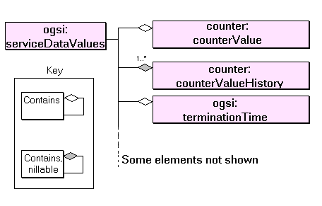 54
9. Handle Resolution 55
9.1. The handleResolverScheme SDE 55
9.2. The findByHandle operation 56
9.2.1. Input 56
9.2.2. Output 56
9.2.3. Faults 56
10. Finding Services: ServiceGroups and Registries 57
10.1. The Registry Interfaces 57
10.1. The purpose of registries in OGSA 57
10.1.1. OGSI support for service registries 57
10.2. Registration PortType 59
10.2.1. Making Discoveries 60
10.2.2. Lifetime of Registration 60
10.3. Service Registration 60
10.4. An Example Registry 60
6.21.2. Abstract ServiceGroups 60
[Explain the abstract concept, and illustrate with concrete examples] 60
11. Creating Transient Services: The Factory 61
11.1. The createServiceExtensibility SDE 61
o The createService operation 61
11.1.1. Input 61
11.1.2. Output 61
11.1.3. Faults 62
11.2. Example 62
12. GridService Notification 63
Notification Source and Notification Sink 63
Subscription Model 63
Lifetime Management of the Subscription 64
Notification Clients 64
13. Grid Services Security 65
13.1. Approach & Scope 65
13.2. List of Topics to address 65
14. Advanced Topics 66
14.1. Advanced Registries [?] 66
14.2. Recommendations for Change Management 66
14.3. Describing Operation semantics 66
14.4. Monitoring Execution 66
15. Glossary of Terminology 67
16. Comparison with other Distributed Architectures 68
17. Editor Information 69
18. Contributors 69
19. Acknowledgements 69
20. Document References 70
i. Copyright Notice 71
21. The Index 71

Table of Figures
Figure ‎2-1: Common features of computational grid systems. 9
Figure ‎3-1: The basis of Web Service computing 14
Figure ‎3-2: Web Services facilities used in a Computational Grid 15
Figure ‎4-1: WSDL markup elements 18
Figure ‎4-2: Markup language for Grid Services 20
Figure ‎4-3: An increase operation to the Counter Web Service 21
Figure ‎4-4: An increase operation to a Counter Web Service that supports multiple counters 21
Figure ‎4-5: An increase operation to a Counter Grid Service Instance 23
Figure ‎4-6: Operations to two different Counter GSIs representing a counter each 24
Figure ‎4-7: Consumer requesting the value of the counter through the counterValue SDE 25
Figure ‎5-1: Main Components of OGSI Services 28
Figure ‎5-2: Example ServiceData Values 31
Figure ‎5-3: ServiceData Operations 33
Figure ‎5-4: Typical Notification scenario 36
Figure ‎6-1: Simple monolithic Grid Service 38
Figure ‎6-2: Container approach to the implementation of argument demarshalling functions. 39
Figure ‎6-3: Container with state management 40
Figure ‎6-4: Use of multiple references for the same Grid Service Instance 41
Figure 6-‎7-1: A client-side runtime architecture 42
Figure ‎7-2: Factories and a dedicated Registry as information sources 44
Figure ‎7-3: ServiceGroup structure and its relation to ServiceGroupEntry 45
Figure ‎7-2: Resolving a GSH 49
Figure ‎10-1: GWSDL Description of Service Group. 59

About this Primer
This chapter introduces the structure of this document its intended audience and other material that might be relevant.

Who should read this Document?
This is an introductory document to the Open Grid Services Infrastructure (OGSI) specification that is aimed at a wide audience of architects and developers, implementers and users.
No prior knowledge of the Grid or Web Services is assumed, though an awareness of distributed computing will help. If you need extensive background material on grids, The Anatomy of the Grid (see [1] in the ‘References’ section) should help. However,
- Chapter ‎2 summarizes the background of grid computing, the requirements and context which inspired OGSI, and its relationship to the architectures and systems on which it builds. This chapter is suitable for a non-technical audience.
- Chatper 3 gives an overview of Web Services whose specifications and technology form the basis for OGSI. It describes some major mechanisms underlying Web Services.
- Chapter ‎4 is more technical. It describe outlines WSDL before considering the concepts that are introduced by OGSI. These are the functions required in the Grid that are additional to Web Services. Chpater 4 also contains a simple example of a Web Service. If you are already familiar with Web Services you may want only to look at the example.
- Chapter 5 explains how these services can be constructed in implementations.
- Chapter ‎6 introduces large scale features that are enabled by the form of the individual Grid Services. These are the features necessary to create large-scale applications and systems.
- From chapter ‎7 onwards, the details of Grid Services interfaces are explained in a way that parallels the Grid specification. This makes it easy to correlate the information in the two documents.
Examples are used throughout the Primer to illustrate the features that the Specification requires. The examples are deliberately simple, to avoid any need for knowledge of more realistic, but complex, Grid applications. Also, though they contain correct interface definitions for the functions described, implementations are not provided. This is because the Specification aims to define a standard for interoperability while leaving freedom to implement Grid Services in a wide variety of ways. For details of implementation, you should investigate one of the Grid Service toolkits such as GT3[10] and identify sample services that correspond to the ones described here.

Related Documents
This document is a companion document to the Open Grid Service Infrastructure (OGSI) specification [3]. The Specification is the complete and authoritative description of Grid Services and should always be used to resolve questions of detail or ambiguity.
This document is, as far as possible, a self-contained introduction to the concepts of Grid Services and their main features that should quickly provide insight into the way Grid Services can be used and operated. Some of its sections are aligned to corresponding topics in the OGSI specification, but it has more introductory material and uses illustrative examples that are not constrained by the need to be complete in detail, though this is also a goal wherever possible.

Grids and their Requirements

What are Grids?
Grid computing is a way of organizing computing resources so that they can be flexibly and dynamically allocated and accessed, often to solve problems requiring many organizations’ resources. The resources can include central processors, storage, network bandwidth, databases, applications, sensors and so on. The objective of grid computing is to resources (that is, processing capacity, information, input sensors, output and storage devices and networking facilities) so they can be more efficiently exploited. The advantage of sharing is clearest when the need for resources is unpredictable, short-term, or changes quickly or where it is simply larger than any single organization’s capability to provide for it. For example, some kinds of problem that might take days to solve on a single installation’s processing resources can be reduced to a few minutes with the right kind of parallelization and distribution of the task. This reduction in turn-around time has opened up areas and styles for computing applications that have previously been impractical. Similarly, information sharing can lead to discoveries and analytical predictions which are simply not possible with only part of the information. Such sharing may be enabled by sharing of access to storage resources, if the information is voluminous, or by agreeing pervasive standards for data description and access.

Features and Requirements of Computational Grid Systems
This section describes the main features of one kind of grid system as background to the motivation for OGSI, namely a grid which enables the sharing of processing capacity, sometimes called a Computational Grid. Figure ‎2-1 illustrates the concept.
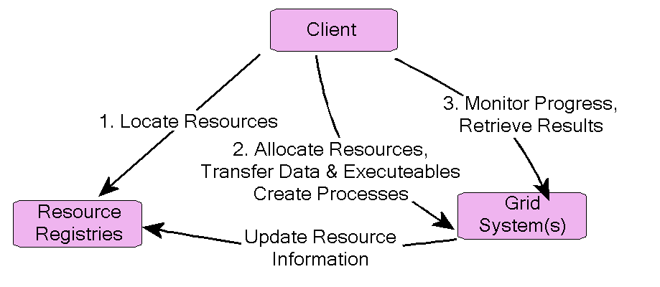
Figure ‎2-1: Common features of computational grid systems.
The ‘client’ shown in the diagram need not be an end-user system, but an agent acting on its behalf, and there may be many such clients or agents, acting independently with no central control over the components shown. To make use of the resources, a client first uses information sources, here called a ‘Resource Registries’, associated with the resources to discover resources needed for execution of a task: multiple sources may need to be consulted to locate all the resources needed for a computation. Having located them, the client contacts the owning resource manager to request allocations for CPUs, secondary storage, or their virtualized representations. Assuming these are successful, it then directs transfer of input data and executables and execution of the task, receiving a reference to the execution in return. These actions may be accomplished in several stages or as one consolidated action depending on the nature and complexity of the task. As resources are allocated, the resource manager may need to update the information in the registry to enable reasonable bids for resource allocation from other clients. Lastly, the client monitors execution of the task using the reference it previously received. It can retrieve the results, or be sent status of the task as it progresses.
The construction of a computational grid, and other kinds of grid systems, requires facilities common to general distributed computing architectures, such as a mechanism for identifying information by globally understood references which can be passed from one system to another, and for subscribing to updates to information sources as the information changes. However, grids make extreme demands on distributed programming because they are large scale and exploit wide ranging networks consisting of a variety of protocols and systems which may span organizational boundaries. Some of these issues are addressed by standards which are not part of the scope of OGSI: interoperability amongst heterogeneous systems is addressed by Web Services standards (described in chapter 3), security issues relevant to widely interconnection systems is being addressed by other groups within the GGF (see chapter ). OGSI exploits these standards, adding to them where necessary, and focuses on the mechanisms that enable resources to be located, managed and exploited at large scale. The concepts are introduced fully in chapter 5, but to summarize briefly, the main requirements addressed by OGSI are:
- Defining a framework which establishes a necessary common basic behaviour, while allowing wide scope for extension and refinement (such as optimization) and specialisation to particular uses.
- As part of the basic behaviour, allowing systems to describe their own interfaces (a facility known as introspection) as a means of flexibly enabling extensions, and to describe their underlying capabilities, such as the speed of a CPU or the currency or progeny of a database. The particular vocabularies for comparing capabilities are not part of OGSI, but the framework for identifying, describing, querying and modifying the information is central, and is known as ‘statefulness’. The information itself is known as the ‘state’.
- As part of the basic behaviour, establishing a system of communication of information about systems which requires the least synchronization amongst them while still providing a useful aggregation of information and behaviour. This attribute of OGSI is known as ‘soft-state’.
- As one aspect of statefulness and soft-state, describing a basic style of behaviour which gives artefacts (identities, information, resource allocations) an explicit point of creation and an explicit, limited lifetime. This provides a natural recovery mechanism for resources in the case of failed processes.
The next section explores another fundamental need; the form of standards which allow wide interoperability.

Why a ‘Service-Oriented’ Architecture?
In computing terms, a ‘service’ is simply a function that can be invoked via a well-defined remote interface; it allows largely independent development and management of the caller (client) and the service provider. A Service-Oriented Architecture is a way of performing computational tasks using a collection of interconnected services rather than a consolidated unit. Service-Oriented Architectures (SOAs) are not new: RPC , CORBA , Java RMI , DCOM are all forms of SOA discussed in chapter 16, but the more recent development of Web Services standards (described in the next section and chapter 3) allows greatest flexibility in the interface description, interconnecting protocol and the underlying platform for clients and servers, all of which are advantageous in constructing grid systems. In this section we review the essential components of a SOA and in the next, their relationship to OGSI.
A service is defined in terms of the messages one uses to interact with it and the behavior expected in response. This behavior may depend on the state of resources such as files, databases or sensors that are encompassed by the service and the state may change in response to messages from one or more clients, or on internally generated events such as timers or external physical events. The messages, state and other behavior must be described by a service definition.
A good service definition permits a variety of implementations. For example, an FTP server speaks the FTP Protocol and supports remote read and write access to a collection of files. One FTP server implementation may simply write to and read from the server’s local disk, while another may write to and read from a mass storage system, automatically compressing and uncompressing files in the process. If variants are possible, then discovery mechanisms that allow a client to determine the properties of a particular implementation of a service are important.
From the client’s point of view, an important aspect of the implementation of a service is the protocol that is used to communicate requests. A well-constructed server side implementation may permit several protocols. For example, http and https can both be used to retrieve Web pages from Web servers, but the latter is preferable if security is important.

Exploiting Web Services Architecture
A Web Service is a particular type of service whose interfaces are defined using the Web Services Description Language (WSDL) and which focuses on simple, Internet-based standards (such as eXtensible Markup Language (XML) and the http protocol used to access Web pages) to enable heterogeneous distributed computing.
OGSI describes Grid Services using Web Services as a basis. This means exploiting
- The mechanisms for encoding message transmission protocols that are described as bindings in Web Services. There are many ways of encoding messages and Web Services separates these concerns from the XML definitions of application interfaces: OGSI standardizes interfaces at the application level, independent of the bindings.
- The conventions used in Web Services to separate the primary application interfaces (function calls and their parameters) from functions which can be managed by standardized, generic middleware. This includes issues such as authentication and access control for an operation, and correlation of messages that come from the same client and isolation of an operation or operations from the effects of concurrent calls from other clients.
- The techniques used in Web Services to separate service- and network- management functions from the application interface. The management issues include Workload balancing, performance monitoring, and problem diagnosis.
Construction of Version 1.0 of the OGSI specification to the requirements already described has required extensions to WSDL . The extensions are described in detail in chapter 5, but they can be summarized as
- A mechanism for defining an interface in terms of an ‘extension’ of one or more simpler interfaces. This is a reliable way of establishing the basic behaviour of a Grid Service.
- Enabling a XML-based language for describing the information (or ‘state’ ) associated with a service.
In the future, OGSI may be able to exploit developments in Web Service standards which can reduce, or eliminate the need for grid-specific extensions. Indeed, this is anticipated in developments by the Web Services Description Working Group and the OGSI working group of the GGF, which developed the specification, is committed to update it when this becomes possible.

What is needed to provide and use Grid Services?
In this section we introduce the requirements for the implementations of clients and servers participating in a grid system and a connecting Service Oriented architecture. A client may, of course, also be a Grid Service in its own right, but the two aspects can be separately addressed. Further details of possible implementations are described in chapter 6.

A ‘Service-Oriented’ Architecture
In computing terms, a ‘service’ is simply a function that can be invoked via a well-defined remote interface; it allows largely independent development and management of the caller (client) and the service provider. A Service-Oriented Architecture is a way of performing computational tasks using a collection of interconnected services rather than a consolidated unit. Service-Oriented Architectures (SOAs) are not new: RPC , CORBA , Java RMI , DCOM are all forms of SOA discussed in chapter 16, but the more recent development of Web Services standards (described in chapter 3) allows greatest flexibility in the interface description, interconnecting protocol and the underlying platform for clients and servers. An assumption underlying Web Services is that clients can design applications based on the use of services and delay selection of a particular server until the time of execution of the application. This delayed and flexible selection is clearly advantageous in constructing grid systems.

The Client Side
There are two meanings to the term ‘client’. The end-users of a grid system are its ultimate clients, but they may be shielded from the internal workings and requirements of the underlying systems by intermediaries such as Web portals whose main objective is ease of use for the end-user. Secondly, there are the direct clients of Grid Services, which may be part of such a Web portal and are part of the concern of this Primer. An example of this type of client is illustrated in Figure ‎2-1 on page. OGSI specifies many things that are required of services in order for them to be used by clients in a standard way.
Since OGSI is based on Web Services standards, a client which is capable of interacting with a Web Service can also interact with a Grid Service and theprovided the interface description has been translated from GWSDL into WSDL. The normal process for developing services and applications in a Service-Oriented Architectures can then be followed: the client may use the interface description during development of a grid application to construct calls to the service and can locate a suitable server and communicate with it using Web Service protocols during execution of the application.

The Server side
The provider of a Grid Service can take many forms, and the specification is designed to impose the least possible restriction on its implementation which can range from dedicated hardware components, through operating system services and custom-built applications. However since the OGSI standard is built on Web Services, so a platform for hosting Grid Services may be built on existing systems for hosting Web Services, such as those based on the J2EE component model. Such as system can provide many of the basic behaviours of a Grid Service via standard layers and services known as the ‘hosting environment’, and exploitation of such an environment and associated development tools is an efficient way of developing grid applications.
The details of the interfaces between a Grid Service implementation and a hosting environment will depend on the particular system, but some aspects of such systems that can be described in generic terms. Firstly, the application-specific operations and state of the service can be described using an interface description language or tools specific to that system, such as Java for a J2EE system. This interface description can be translated into a form described by Web Services and OGSI for consumption by clients. Secondly, the runtime system creates the interface between the service implementation and the hosting environment. This may include management of the state of the service, converting messages to and from the implementation language and provision of standard operations for Grid Services.

Associated and dependent standards
The OGSI specification itself provides only basic levels of function. It enables Grid Services to be created, managed, discovered and destroyed, but does not say anything about the resources, databases and applications that make up a grid. Standard descriptions of these facilities are required and OGSI provides a language and building blocks from which descriptions can be constructed. The work of defining high level constructs is in progress among working groups of GGF. These include standard techniques for accessing data, for configuring resources, scheduling and allocating them and monitoring system performance and accounting and paying for use. The Architecture for these standards is collectively called the Open Grid Services Architecture (OGSA) .

Background Technology
This chapter provides a high-level overview of Web Services which form the foundation for OGSI. It necessarily leaves out much detail but describes the structure and important features and why these are important, especially in the context of Grids. The next chapter goes into more technical detail and illustrates Web Services and Grid Services via a simple example.
A more thorough and precise view of Web Services can be found in the Web Services Architecture document .

The Essentials of Web Services

Interactions defined by messages
For the purposes of this Primer we will define a Web Service as something that can be described using the Web Services Description Language (WSDL)[4]. Web Services are centered on these service definitions at a level which can be mapped to high-level application constructions such as function or method calls and their parameters. Also important is the translation of the definitions into messages, encodings and protocols used to communicate between clients and servers. However, these encodings and protocols are defined independently from the high-level description and form a family of transmission styles with a variety of characteristics such as privacy, performance, reliability and so on. The specification of encodings can be thought of as an addendum to the high-level description. Note that Web Service standards say nothing about the application interfaces (APIs) which clients and servers use to manipulate the messages. This approach ensures that interoperability is the main focus of attention.

Exploiting Web Services standards and facilities
The use of the WSDL language enables communication between users of the service and its implementors, but it also allows exploitation of a growing body of related standards and their implementations. These related standards provide facilities which simplify and support the Service itself. The simple concept of some of these facilities is shown in Figure ‎3-3.

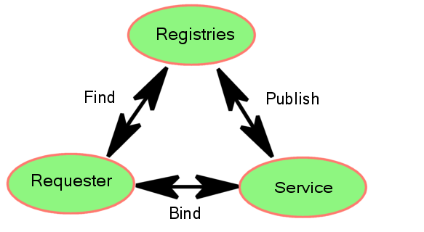
Figure ‎3-3: The basis of Web Service computing
The Services are created and deployed on a server which is able to interpret messages described by WSDL and an associated message encoding, protocol. The server may enable several styles of encoding and/or protocol each of which called a binding because it binds a high-level service definition to a low-level means of invoking the service. The server publishes its presence in a Registry (sometimes called a directory) which is also known to potential clients. From the Requester’s point of view, a Registry represents a collection of servers which may provide suitable implementations of the interfaces that it needs to use and may find them using criteria associated with bindings such as the security and transport protocols.
The design an implementation of Registries is a large and important topic and many different solutions exist. It is the objective of the OGSI specification to be able to exploit standards, such as UDDI which have been created for use by Web Services. There may be aspects of Registries and service description which need specific extensions or enhancements for grid computing and OGSI aims to enable these, and adopt new Web Services standards as these develop. Figure ‎3-4 illustrates one sense in which the Computational Grid described in Chapter 2 extends the concepts of Web Services.

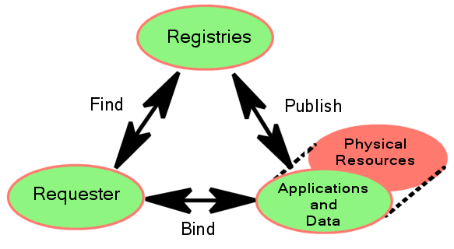
Figure ‎3-4: Web Services facilities used in a Computational Grid

In many Web Services, and indeed for many used in Grid systems, the Service presents an interface to the combination of data, application and physical resources needed to perform the service. However, in Computational Grid, a Service may represent the physical resources more explicitly, separately from data and applications which exploit them. In this case, information visible to clients can change more dynamically. As section 2.2 described, OGSI provides a framework of Service descriptions, including descriptions of state which improve the manageability of distributed, dynamic information at large scale.
The definition of bindings is an aspect of Web Services which OGSI exploits directly. Although any kind of message encoding and security protocol can be used between a Server and Requester within the framework of Web Services, standard encodings are needed to ensure easy, pervasive interoperability and the Web Services Interoperability Organization (WS-I) exists to make suitable recommendations. However, leading-edge implementations of Web services, including grid applications, may, from time to time, adopt protocols which are not yet standardised. The Grid Security Infrastructure was an example of this when the Primer was written and other examples may appear as new protocols are developed. Interoperability with such leading-edge applications requires implementation of the relevant protocols.

Describing Grid Services

Web Services Description Language (WSDL)
WSDL is an XML document for describing a contract between a Web Service and its consumers about the format of the messages that can be exchanged and the message exchange patterns that the service can support. Figure 4-5 outlines the structure and major parts of a WSDL document together with their relationships.
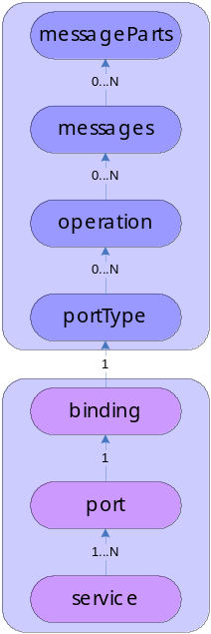
Figure 4-5: WSDL document structure
Figure 4-6 describes the structure of a WSDL document in more detail. The root XML element called the wsdl:definitions is on the left of the diagram. It may contain subsidiary elements, shown via the ‘contains’ linkage, such as wsdl:import and wsdl:types. Subsidiary elements can be repeated as shown by the range indicator; for example all subsidiary elements of wsdl:definitions can appear any number of times (0..*).
The subsidiary elements of wsdl:definitions are divided into three vertical sections
- The elements in the top section (‘import’ and ‘types’) allow imports from external files and definitions of datatypes for use in subsequent elements.
- The middle section (‘message’, ‘portType’ and the elemetns they contain) is the abstract definition of the service interface its operations and their parameters. These definitions determine what a client of the service can do.
- The bottom section defines the binding(s) of the abstract definition to concrete message formats, protocols and endpoint addresses through which the service can be invoked.
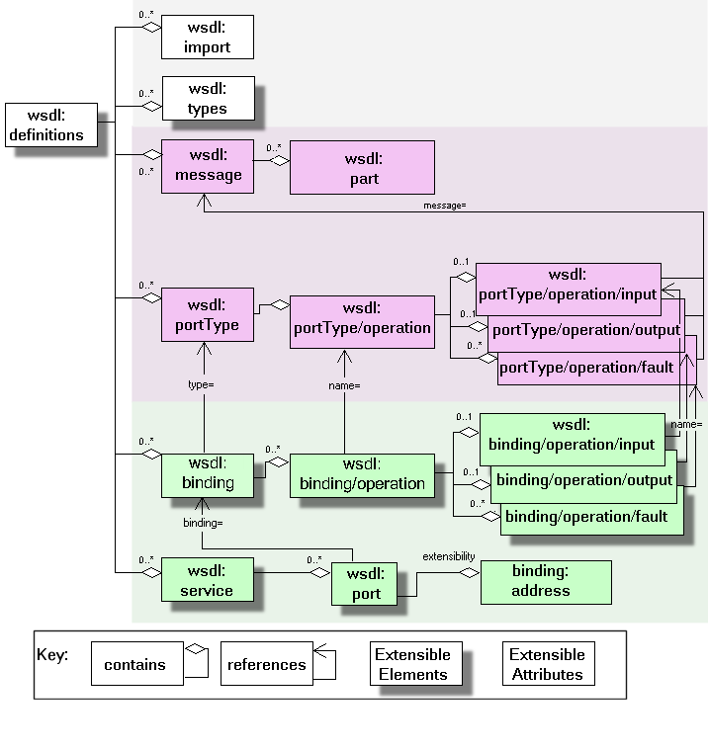
Figure 4-6: WSDL markup elements
At the heart of a WSDL description is the portType definition. It is a concept similar to a Java interface or a C++ class. A portType may contain several operations (similar to Java or C++ method signatures) which reference (shown in the diagram as arrows) messages to describe their inputs, outputs and faults (exceptions). A message may be composed of many parts where each part can be of a different type. The message parts can be thought of as input and output parameters; a message simply combines them (Section 4.3 contains a simple example).
The types of message parts are defined within the types component of wsdl:definition. This element is extensible, meaning that it can contain arbitrary subsidiary elements to allow general data types to be constructed. The default type system in WSDL is XML Schema, which we won’t discuss here in detail. In order to understand our example it is sufficient to know that at the end of the definition we link the type names of message parts to their XML definitions. WSDL allows the other elements to contain subsidiary extension elements as a means of allowing flexible description of interface types; these extension points are shown in the diagram. The purpose of other extensions is decribed in appendix A.3 of WSDL[4].
Another important part of the WSDL definition is the binding. It describes the concrete implementation of messages: that is a data encoding, messaging protocol, and underlying communication protocol. The XML elements of a binding are operations which reference the corresponding abstract messages by name. An important aspect of WSDL bindings is their capacity for extension with new subsidiary element definitions. WSDL allows any and all data encoding, message and communications protocols to be described. The usefulness of a particular description depends on having client and server systems that are able to interpret the WSDL descriptions to encode/decode the messages.

Grid Services Description Language (GWSDL)
Extra features of OGSI are introduced to basic Web Services by redefining the WSDL portType element. The main structure of a WSDL document for a Grid Service shown in Figure 4-7, called GWSDL, is very similar to that of Figure 4-5 (page 17).
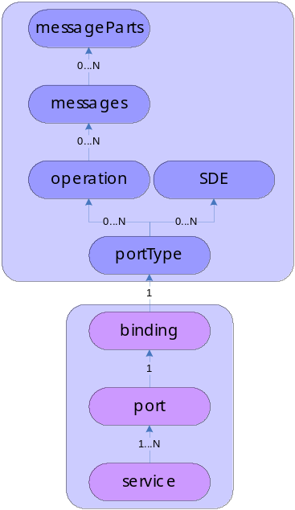
Figure 4-7: GWSDL document structure
The differences between WSDL and GWSDL are better illustrated by Figure 4-8:
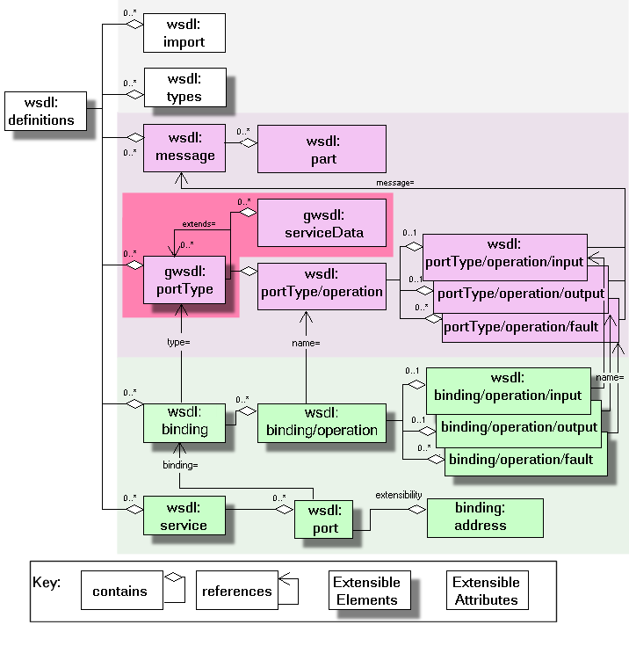
Figure 4-8: Markup language for Grid Services
- In OGSI, a portTypes can be constructed by referencing an existing portType or portTypes, and adding new definitions as required. This enables standard behaviour to be defined authoritatively, and referenced by service definitions that need to incorporate it. Standard behaviour is important to clients which may need to use services which are widely distributed and independently implemented.
- While a WSDL portType contains only operations, an OGSI portType can contain ServiceData elements which help describe the identity and interfaces of the service and how its state can be viewed by a client.
As an example, section 4.3 contains a GWSDL version of the Counter service.
These additions to the WSDL document schema are prefixed with gwsdl to identify their definition by OGSI. They may be incorporated into subsequent versions of WSDL, eliminating the need for new markup elements defined by OGSI. They have been addressed by the current “work in progress” draft of WSDL 1.2 in the W3C Web Services Description Working Group [WSDL 1.2 DRAFT], but because WSDL 1.2 is currently “work in progress”, OGSI cannot directly incorporate the entire WSDL 1.2 body of work.
Instead, OGSI defines an extension to WSDL 1.1, isolated to the wsdl:portType element, that provides the minimal required extensions to WSDL 1.1. These extensions to WSDL 1.1 match equivalent functionality agreed to by the W3C Web Services Description Working Group. The Global Grid Forum commits to updating OGSI when WSDL 1.2 [WSDL 1.2] is published as a draft specification by the W3C.

The ‘Counter’ Example
In this section, some of the Grid Services concepts and terminology are introduced through the Counter Service example, which is used as a vehicle for the discussion throughout the rest of the document. The relationship between Web and Grid Services is also demonstrated.

Counter Web Service
The WSDL for a simple Counter Service with two operations (increase and getValue) is shown in Listing 4-1 bellow (the bindings and service sections are not presented):
<wsdl:definitions xmlns:wsdl="http://schemas.xmlsoap.org/wsdl/"
xmlns:xs="http://www.w3.org/2001/XMLSchema"
xmlns:counter="http://www.gridforum.org/namespaces/
2003/05/ogsiprimer/counter/webservice"
targetNamespace="http://www.gridforum.org/namespaces/
2003/05/ogsiprimer/counter/webservice">
<wsdl:types>
<xs:schema/>
</wsdl:types>
<wsdl:message name="increaseMsg">
<wsdl:part name="value" type="xs:positiveInteger"/>
</wsdl:message>
<wsdl:message name="getValueMsg">
<wsdl:part name="value" type="xs:positiveInteger"/>
</wsdl:message>
<wsdl:portType name="counterPortType">
<wsdl:operation name="increase">
<wsdl:input message="increaseMsg"/>
</wsdl:operation>
<wsdl:operation name="getValue">
<wsdl:output message="getValueMsg"/>
</wsdl:operation>
</wsdl:portType>
</wsdl:definitions>
Listing 4-1: WSDL document for the Counter Web Service
In the Web Services world, the Counter Web Service is an agent whose interface is described in WSDL and it is the logical receiver of operation requests.

Figure 4-9: An increase operation to the Counter Web Service
The Counter Web Service of Error: Reference source not found implements the WSDL interface presented in Listing 4-1. The interface does not say anything about the state that must be maintained by the implementation of the Web Service. However, for the Counter Web Service to be useful, state has to be maintained in an implementation-specific way (e.g., in memory, in a database, in a file, etc.). Multiple consumers that have discovered the Counter Web Service through a registry, can use its operations to change the counter’s state (any security-related issues are outside the scope of this discussion and are not considered). In Figure 4-9, a consumer of the service submits a request for an increase operation.
If a Counter Web Service was to be extended so that multiple counters were supported, an ID would have to be introduced. The ID would identify the particular counter on which an operation was to be executed. Although the interface of the Counter Web Service would have to change in order to accept the ID, the same Counter Web Service is still going to be the logical receiver of the operations (Figure 4-10).

Figure 4-10: An increase operation to a Counter Web Service that supports multiple counters
Listing 4-2 has the modified WSDL of the Counter Web Service that can support multiple counters.
<wsdl:definitions xmlns:wsdl="http://schemas.xmlsoap.org/wsdl/"
xmlns:wsdl="http://schemas.xmlsoap.org/wsdl"
xmlns:xs="http://www.w3.org/2001/XMLSchema"
xmlns:counter="http://www.gridforum.org/namespaces/
2003/05/ogsiprimer/counter/basic "
targetNamespace="http://www.gridforum.org/namespaces/
2003/05/ogsiprimer/counter/basic ">
<wsdl:types>
<xs:schema/>
</wsdl:types>
<wsdl:message name="increaseMsg">
<wsdl:part name="counterId" type="xs:positiveInteger"/>
<wsdl:part name="value" type="xs:positiveInteger"/>
</wsdl:message>
<wsdl:message name="getValueRequestMsg">
<wsdl:part name="counterId" type="xs:positiveInteger"/>
</wsdl:message>
<wsdl:message name="getValueResponseMsg">
<wsdl:part name="value" type="xs:positiveInteger"/>
</wsdl:message>
<wsdl:portType name="counterPortType">
<wsdl:operation name="increase">
<wsdl:input message="increaseMsg"/>
</wsdl:operation>
<wsdl:operation name="getValue">
<wsdl:input message="getValueRequestMsg"/>
<wsdl:output message="getValueResponseMsg"/>
</wsdl:operation>
</wsdl:portType>
</wsdl:definitions>
Listing 4-2: Modified version of the Counter Web Services WSDL that supports multiple counters

Counter Grid Service
In OGSI-terms, a Grid Service is a general term referring to a template, a contract, an interface described in GWSDL and the Grid Service Instances that must adhere to it. The term Grid Service does not characterize a component that can be part of a Grid application (i.e., it does not refer to an agent that can receive operation requests). Instead, it is Grid Service Instances that are the logical recipients of operation requests.
In the OGSI world, a Grid Service Instance (GSI) has to be explicitly created (by a factory or by the hosting environment), assigned a Grid Service Handle (GSH) which uniquely identifies it, and then registered with a handle resolver so it can be found by other Grid Service Instances. A GSH, which is a unique, abstract name, for a Grid Service Instance, a Grid Service Reference (GSR) provides the necessary endpoint related information to access the identified Grid Service Instance. An example of the steps that may be required for a Grid Service Instance to be discovered, created, and consumed is described in Section (page 28).
Once a Grid Service Reference (GSR) to a Grid Service Instance is available to a consumer, the GSI can be used to offer equivalent functionality with its Web Service counterpart. However, the OGSI-specific characteristics of a GSI can be used to provide richer solutions.
The Counter Grid Service Instance of Figure 4-11 is equivalent to the Counter Web Service presented in Error: Reference source not found. Different service consumers can call operations on the same Counter GSI in order to change or access the state of the counter. This example differs from the one of Error: Reference source not found in that the state is logically attached to the instance. The semantics of a Grid Service Instance, as defined by OGSI, specify that state has to be maintained between consumer-service interactions. This is done in an implementation specific way (i.e., the OGSI standard does not talk about how state is to be maintained).

Figure 4-11: An increase operation to a Counter Grid Service Instance
In contrast to the Counter Web Service, each Counter Grid Service Instance is associated with lifetime properties that can be used to manage the lifecycle of a counter. Also note that the OGSI specification does not deal with the semantics of concurrent access to the same Counter Grid Service Instance by multiple clients. Hence, the consistency semantics of state related information are application-specific.
The GWSDL interface of the Counter Grid Service looks very similar to its Web Service equivalent. Apart from the obvious namespace change, the only other difference is the introduction of portType extension using the "extends" attribute (Listing 4-3). This indicates to GWSDL processors that the counterPortType extends the functionality defined by the ogsi:GridService portType.
<wsdl:definitions xmlns:gwsdl="http://www.gridforum.org/namespaces/2003/03/OGSI"
xmlns:wsdl="http://schemas.xmlsoap.org/wsdl"
xmlns:xs="http://www.w3.org/2001/XMLSchema"
xmlns:counter="http://www.gridforum.org/namespaces/
2003/05/ogsiprimer/counter/basic"
targetNamespace="http://www.gridforum.org/namespaces/
2003/05/ogsiprimer/counter/basic">
<wsdl:types>
<xs:schema/>
</wsdl:types>
<wsdl:message name="increaseMsg">
<wsdl:part name="value" type="xs:positiveInteger"/>
</wsdl:message>
<wsdl:message name="getValueMsg">
<wsdl:part name="value" type="xs:positiveInteger"/>
</wsdl:message>
<gwsdl:portType name="counterPortType" extends="ogsi:GridService">
<wsdl:operation name="increase">
<wsdl:input message="increaseMsg"/>
</wsdl:operation>
<wsdl:operation name="getValue">
<wsdl:output message="getValueMsg"/>
</wsdl:operation>
</wsdl:portType>
</wsdl:definitions>
Listing 4-3: GWSDL document for a basic Counter Grid Service
Once a Grid Service Instance that adheres to the above GWSDL is created, it behaves in exactly the same way as the Counter Web Service but it offers the additional functionality defined by OGSI. The GWSDL of a Grid Service Instance will, of course, contain the necessary bindings and service elements, as required by WSDL.
The implicit association between a Grid Service Instance and state allows us to replicate the functionality of the multiple Counter Web Service without significant changes to the interface. All that is required is a new Grid Service Instance. One could argue that a new Web Service identical to the one of Error: Reference source not found could be deployed if multiple counters were required while keeping the same interface. However, OGSI encourages the instantiation of transient Grid service instances to represent state, so it is more natural to represent each separate counter as a Grid service instance. The OGSI model encourages, but does not mandate, an one-to-one association between a resource, in this case the counter, and a Grid Service Instance. By doing so, we get the additional benefit of lifetime and identity management for resources, as specified by OGSI.

Figure 4-12: Operations to two different Counter GSIs representing a counter each
In addition to state management, Grid Service Instances can provide access to information through attribute-like constructs, called Service Data Elements (SDEs). An SDE is declared in the Grid Service's interface and accessed through operations defined by OGSI's GridService portType.
The Counter Grid Service may expose the value of the counter through an SDE. The getValue operation will no longer be necessary. The GWSDL of the Counter Grid Service with an SDE is shown in Listing 4-4 bellow:
<wsdl:definitions xmlns:gwsdl="http://www.gridforum.org/namespaces/2003/03/OGSI"
xmlns:sd="http://www.gridforum.org/namespaces
/2003/03/serviceData"
xmlns:wsdl="http://schemas.xmlsoap.org/wsdl"
xmlns:xs="http://www.w3.org/2001/XMLSchema"
xmlns:counter="http://www.gridforum.org/namespaces/
2003/05/ogsiprimer/counter/basic"
targetNamespace="http://www.gridforum.org/namespaces/
2003/05/ogsiprimer/counter/basic">
<wsdl:types>
<xs:schema/>
</wsdl:types>
<wsdl:message name="increaseMsg">
<wsdl:part name="value" type="xs:positiveInteger"/>
</wsdl:message>
<wsdl:message name="getValueMsg">
<wsdl:part name="value" type="xs:positiveInteger"/>
</wsdl:message>
<gwsdl:portType name="counterPortType" extends="ogsi:GridService">
<wsdl:operation name="increase">
<wsdl:input message="increaseMsg"/>
</wsdl:operation>
<sd:serviceData name="counterValue"
type="xs:positiveInteger"
minOccurs="1"
maxOccurs="1"
mutability="mutable">
<sd:documentation>
The value of the counter.
</sd:documentation>
</sd:serviceData>
</wsdl:portType>
</wsdl:definitions>
Listing 4-4: GWSDL for a simple Counter Grid Service with an SDE
It is now possible to access the counterValue SDE through operations specified by the GridService portType (Figure 4-13).

Figure 4-13: Consumer requesting the value of the counter through the counterValue SDE
Note that OGSI says nothing about how the value of an SDE is maintained, if it is maintained at all (for example, a business process associated with an SDE could calculate the value of an SDE through some application-specific logic).

Terminology
Web Service: A software identified by a URI [RFC 2396], whose public interfaces and bindings are defined and described using XML. Its definition can be discovered by other software systems. These systems may then interact with the Web Service in a manner prescribed by its definition, using XML based messages conveyed by Internet protocols. (Web Services Glossary, WS-Arch W3C Working Group, Draft 14 May 2003)
Web Service Consumer: A software component that sends messages to a Web Service.
Stateful Web Service: A Web Service that maintains some state between different operation invocations issued by the same or different Web Service Consumers.
Grid Service: A general term used to refer to all aspects of OGSI. The term “Grid Service” is sometimes used to refer to a Grid Service Description document and/or a Grid Service Instance for a particular service.
Grid Service Description: A WSDL-like document that defines the interface of Grid Service Instances. The defined interface must extend the OGSI GridService portType.
Grid Service Instance: A stateful Web Service whose interface adheres to that defined by a Grid Service Description and whose lifetime management properties are well defined.
Service Data Element: An attribute-like construct exposing state information through operations defined by the GridService portType.
Grid Service Handle: A URI that permanently identifies a Grid Service Instance.
Grid Service Reference: A temporal, binding-specific endpoint that provides access to a Grid Service Instance.

The Concepts of Grid Services
This chapter introduces the ideas that are essential features of Grid Services. These are:
- The Factory and Instance pattern.
- The lifetime of Instances
- The use of ‘extension’ to create complex portTypes from simpler, ones, how this is enabled by Grid Service WSDL and the behaviors every Grid Service must have as a result of extending the basic OGSI gridService portType.
- The basic Services defined by OGSI: ServiceGroup, HandleResolver and Factory,
- The Identity of a Grid Service Instance: Handles, References and Locators
- Faults
- Service Data
- Extensibility of Operations
- Notification
The next chapters (Chapters 6 and ‎7) describe how Grid Services can be implemented and what large scale features are needed to create and/or use services based in a grid. More detailed explanations of the standard portTypes can be found in subsequent chapters, starting with the core GridService portType in Chapter 8.

The Factory and Instance pattern
The Factory design pattern is commonly used in Objected-Oriented software systems to organise the creation of multiple, similar artefacts. In an object system, a factory object can be designed and used to create multiple similar product objects. In OGSI, a Factory Service is used to create multiple Grid Service Instances.
As with factories making real, physical things, it’s usual for the products to be similar to each other, but distinct in their identity. In OGSI, the Factory pattern gives each Grid Service Instance a unique identity which can be used by the Requester to refer to the state associated with the Instance. This unique identity is called the Grid Service Handle, and is independent any binding used to transmit requests to the instance.

The Lifetime of Instances
In many cases, the artefacts (our Grid Service Instances) which are created to accomplish a task are only needed for a limited time. They may represent physical resources such as storage allocations, processor and bandwidth reservations or the right to use sensors and databases. In such cases an explicit lifetime can be associated with an Instance when it is created. Requesters may sometimes need to be aware of the lifetimes of the Instances they use or create, but often the lifetime will only be significant in the case of any failure in the progress of a task. In that case, when their lifetime expires, the Instances can be safely destroyed and the resources which they represent can be safely recycled. This convention is essential in a large scale, distributed system (such as a Grid) where it is not possible to take account of Requesters dependencies when sweeping up Service Instances which seem to be redundant.

Some Grid Services, such as Factories, are inherently more permanent, and may have no explicit lifetime. A Requester may keep the Handle representing such a service for long periods. However, there is provision in OGSI for the lifetime of Handles which is described in Section 5.5.2.

Using portType extension
Grid Service Description can use portType extension to define standard operations by the use of the ‘extends’ attribute. For example, the Counter Grid Service (Section ) begins:
<gwsdl:portType name="counterPortType" extends="ogsi:GridService">
This declaration causes the inclusion of the definitions for ServiceData from the ogsi:GridService portType (described fully in chapter ). All Grid Service Descriptions include these definitions. In summary, they are:
- The Handle of any Grid Service Instance created to implement the description.
- The names of all the portTypes that the Instance implements.
- The identity of the Factory that created the Instance.
- The termination time of the Instance.
In addition, the GridService portType provides operations that allow a client to query and modify the state reported by ServiceData, including the termination time.
Finally, the GridService portType provides an operation to destroy the Instance.

The OGSI portTypes
Figure ‎5-14 shows an interaction between components defined by OGSI that is a typical pattern for the use of Grid Services. The Services are introduced in the sections which follow, and described in more detail in subsequent chapters.
The starting point for the interaction is that the Requester is an end user or a Web Server acting on behalf of end users, and has installed applications which need to make use of remote services. The Requester has configuration information which provides references to a Registry Service.

The Registry Service
In OGSI, a Registry service can be described using or extending the ServiceGroup and ServiceGroupRegistration portTypes. A registry contains many references to Services which can be located by specifying details of the Interface that is needed. A Requester which needs to create a Counter may search for a CounterFactory portType and receive back information, including a Handle, which identifies the Factory.

Handles and References
The Handle itself is not sufficient to allow the Requester to send messages. What is needed is a description of a binding which can be processed by the Requester’s infrastructure to translate the application-level operations into network messages. In OGSI, these Handle-specific bindings are called Grid Service References and can be described in WSDL. It is convenient for the Requester for a Service, such as a Registry, which supplies a Handle to pass this WSDL document with the Handle, but it can an also be discovered from the HandleResolver.

HandleResolver Service
A HandleResolver service is a basic part of an OGSI grid, also known to the Requester via configuration information. It is used to retrieve up-to-date or otherwise improved References to a Service identified by a Handle. References may become out-of-date because the Service Instances which they refer to have been relocated by the Server. Also, there may be several possible References to an Instance, with characteristics such as high performance which is available only to Requesters local to the Instance. A requester can use the HandleResolver at any time to obtain the best possible binding.
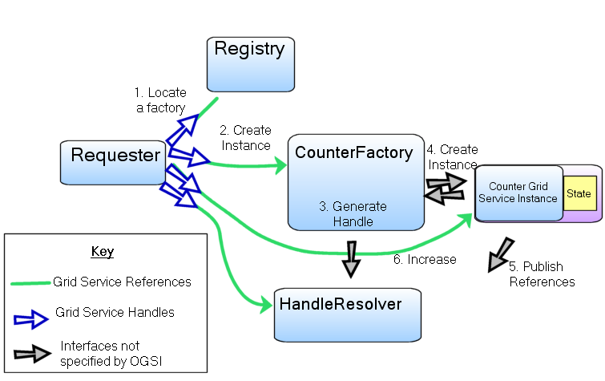
Figure ‎5-14: Main Components of OGSI Services

Identity, Handles, References and Locators

Passing Handles and references: the Locator
Handles and References may be passed as input and/or output parameters, and it is often convenient to pass a collection of References and Handles so that the eventual user (a client application or its supporting middleware) of the target instance can choose the most appropriate way of calling it. For example, a client that is local to the Instance may use a Reference representing a binding describing unencrypted transmission. Conversely, if the client is remote, and the Locator has been stored for some time before use and its references are no longer valid, the client may choose one of the Handles, for example a handle described by a secure resolution scheme such as SGNP , and resolve it to a GSR that describes an encrypted protocol.
A Locator may also contain the name (fully qualified name in the xml namespace) of the interface for the target service. This can be used by the recipient of the Locator to discover the interface description, check that the handles and references refer to implementations that are suitable for the client, and allow client infrastructure to enable access to the service. In some cases, References themselves may contain interface references or descriptions, but this is not always the case.
Many handle resolution schemes are possible; the OGSI specification does not restrict or mandate any particular one and allows multiple schemes to be used in parallel,

The Lifetime of Handles
Handle schemes may be selected and adopted by the administrators of Grid Services implementations according to their particular needs, and as those needs evolve, or the Handle schemes evolve, the need may arise to change schemes. Although a long-term consideration, OGSI anticipates the disruption to clients caused by such a change by allowing the use of the attribute ogsi:goodUntil to describe the time limit on the validity of a Handle. A requester can refresh a Handle by using operations on the relevant Instance.

The Identity of Grid Service Instances
Each Grid Service Instance is distinguished from all others by means of its Handles and References. Use of the same Handle to call (via resolution) operations on multiple occasions, even by different clients, must mean the operations act on the same Instance.
However, a Grid Service can have multiple Handles and/or References and a client may receive different versions from several sources as Locators are passed around. Comparing versions of these received from different sources is not useful as a way of identifying the target Grid Service Instance as being the same one. If a service requires Clients to be able to establish equivalence of several Locators, Handles or References, it must provide an operation to do this. The details of the comparison are dependent on the service.
For example, a counter service may provide access to each counter Instance by multiple clients. One way of implementing the service is to establish multiple copies of the same Instance with multiple (different) references to those copies as a way of providing workload distribution. Nevertheless, each reference is equivalent to the others provided the copies are correctly synchronised during updates. A service may also place additional information in its Handles to distinguish copies of the service from each other. The Counter Instance may provide different Qualities of Service (such as fast or slow response times) to different clients based on information in the Handle, yet still preserve the semantics of the Counter service across all clients of the Instance.
The semantics of the service description may, like the counter, require that the service moves through a series of well-defined states in response to a particular sequence of messages, thus requiring state coherence regardless of how Handles are resolved to References. However, other service descriptions may be defined that allow for looser consistency between the various members of the distributed service implementation. The copies of the Service Instance, identified by different Handles and References may respond differently in some respects, yet still be the same Instance.

Operation Faults
A common procedure is used for handling operation faults generated by Grid Services. This simplifies problem determination by having a common base set of information that all fault messages contain. It also allows for "chaining" of fault information up through a service invocation stack, so that a recipient of a fault can drill down through the causes to understand more detail about the reason for the fault. OGSI defines a base type (ogsi:FaultType) for all fault messages that Grid Services must return. This approach simply defines the base format for fault messages, without modifying the WSDL fault message model. All Grid Service operations must return the ogsi:fault (which is of type ogsi:FaultType) in addition to any operation-specific faults. For example an application specific fault (myFault) could be included in the definition as follows
<wsdl:definitions ...>
<types>
<xsd:schema ...>
<xsd:complexType name="MyFaultType">
<xsd:complexContent>
<xsd:extension base="ogsi:FaultType"/>
</xsd:complexContent>
</xsd:complexType>
<xsd:element name="myFault" type="tns:MyFaultType"/>
</xsd:schema>
</types>
<message name="myFaultMessage">
<part name="fault" element="tns:MyFault"/>
</message>
<gwsdl:portType ...>
<wsdl:operation ...>
<input ...>
<output ...>
<fault name="myFault" message="tns:myFaultMessage"/>
<fault name="fault" message="ogsi:faultMessage"/>
</wsdl:operation>
</gwsdl:portType>
</wsdl:definitions>

A Grid service operation may return a more refined fault (i.e, an extension derived through the xml schema mechanisms) in place of a particular fault that is required by an operation definition. For example, if an operation is specified to return a fault with the element myFault under some circumstances, then a particular implementation of that operation may return an extension of myFault in its place. This should be done by returning the myFault message with an xsi:type of the more refined fault.
It is recommended that all faults from a Grid service use either the FaultType directly or and extension of FaultType. However there may be circumstances in which faults from a Grid service are not derived from FaultType, such as when the Grid service uses legacy portTypes in addition to OGSI portTypes.

Introducing ServiceData
The idea of stateful Grid Service Instances (which was introduced in section 4.3) is based on the ability to assign a global identity and lifetime to state managed by the Instances. ServiceData is a way to describe some parts of the state. The ‘Counter’ Grid Service example in Error: Reference source not found (on page Error: Reference source not found) shows how a ServiceData element (SDE) can be introduced to expose the value of the counter and, in general, a Grid Service can add declarations to the Service Description to expose as much or as little as necessary of its state for its clients.
The advantages of using ServiceData are:
- Generic operations are provided to get and set the values of the SDEs and retrieve collections of values from the different SDEs.
- Interfaces are available allow clients to receive notification of changes to the value of SDEs during the lifetime of a Service Instance. (See section 5.9)
- OGSI provides a convention for all SDEs to have lifetimes which can help qualify the validity of information in a distributed system.
ServiceData is designed to support the general requirements for information management in a Grid which include the discovery, introspection, monitoring and management of Grid Service Instances. SDEs can provide descriptive information about an Instance which includes both meta-data (information about the service instance, such as the interfaces it supports and the way it is configured) and state data (runtime properties of the service instance, like the counter value).

The Structure of ServiceData
The ServiceData declarations in a service description define the structure of an XML document which is delivered (though possibly rendered in some form convenient for the Requester) in response to a query operation on the ServiceData and reports the values of the ServiceData Elements.
The report document has a ‘ServiceDataValues’ element at its root, and each ServiceData Declaration (SDD) in the Service Description describes the structure of a subsidiary element of the report. For example, the declaration for the counterValue SDE from section 4.3 is as follows:
<sd:serviceData name="counterValue"
type="xs:positiveInteger"
minOccurs="1"
maxOccurs="1"
mutability="mutable">
<sd:documentation>
The value of the counter.
</sd:documentation>
</sd:serviceData>
Part of the structure of the xml document generated by the counter service to report the value of the SDEs is shown graphically in Figure ‎5-16.
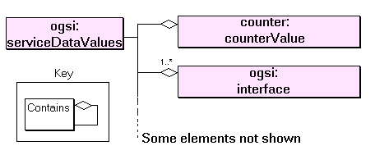
Figure ‎5-16: Example ServiceData Values
The declaration of the counterValue SDE causes the inclusion of one element named ‘counter:counterValue’ which contains an integer. Since the counter service extends the basic gridService portType, all of the SDEs declared in that portType are also present in the counter. These include the ‘osgi:interface’ SDE whose value consists of one or more elements each of which contains the name of an interface (portType) implemented by the Instance. This and the other SDEs defined by the gridService portType are described in Chapter 8.
To be clear about the terminology we distinguish between the ‘value of an SDE’ or an ‘SDE value’ which may consist of several ‘SDE value elements’.
The ServiceData Declaration may use seven attributes to describe the structure of the ServiceData values. The first 5 of these attributes parallel those of xml schema elements because, like xml declarations, they describe the structure of xml documents.
- Its name and type.
- minOccurs and maxOccurs. These constrain the number of occurrences of the element. Simple values like the counterValue are singletons (minoccurs=1 and maxoccurs=1). Compound values like ogsi:interface consist of an unordered collection of elements.
- nillable (true or false). This can provide a special ‘nil’ value for the element. The meaning of this nil depends on the particular SDE. An example of its use can be found in the description of the gridServiceHandle SDE in section 8.2.
- modifiable. If false, the serviceData element should be regarded as ‘read only’ by the requestor, though its values may change as a result of other operations on the service’s interface. If true, the setServiceData may be used to modify the value.
Note that the counterValue is not modifiable because its value is not changed via the setServiceData operation, but via the ‘increase’ operation. These two operations have different semantics which are discussed in the next section.
- mutability. This describes the way in which the ServiceData is initialised, and whether its value can change during the lifetime of the Instance. An SDE declared with a mutability attribute of ‘static’ is initialized from the WSDL description, while a ‘constant’ declaration is initialized when the Service Instance is created: both types keep the same value of the SDE for the lifetime of the service. An ‘extendable’ SDE can have new value elements added during the lifetime of the service, but none of them can be subsequently changed or removed. A ‘mutable’ SDE has no constraints on the value elements: any and all may be changed or removed and new ones added at any time provided the other constraints, such as maxoccurs are still valid. The ‘counter:counterValue’ is mutable because its value changes over time. The ‘ogsi:interface’ SDE is constant.
Many serviceData elements are most naturally defined in a service’s interface definition, and can be supplied with initial values also included with the definition. The initial value of the counter may be defined by

<sd:staticServiceDataValues>
<counterValue inputElement= 0/>
</sd:staticServiceDataValues>

Situations can also arise where it is useful to add or remove serviceData elements during the lifetime of an Instance. The means by which such updates are achieved is not defined by OGSI; for example, a service instance may implement operations for adding a new service data element. The GridService portType includes SDEs which allow a client to discover the ServiceData definitions dynamically, and find their values.

The validity of ServiceData Element values
All ServiceData Element values such as those illustrated in Figure ‎5-16 may carry attributes defining their period of validity. These are:

- gsi:goodFrom: Declares the time from which the value is valid. This is typically the time at which the report was created.
- ogsi:goodUntil: Declares the time until which the value is valid.
- ogsi:availableUntil: This declares the time until which the ServiceData Element itself is expected to be available, perhaps with updated values. After this time, a client may no longer be able to get a copy of this element.

ServiceData Operations
OGSI defines operations, via the GridService portType, which ‘find’ and ‘set’ the state reported by the ServiceData Elements. The form of the operation and the relationship of the SDE values and the state was introduced in section Error: Reference source not found and is shown in Figure ‎5-18 .
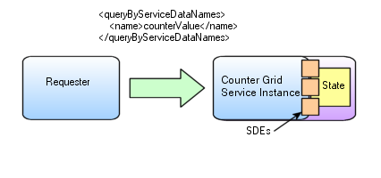
Figure ‎5-18: ServiceData Operations

Here the Counter value is defined as an SDE using the WSDL in section Error: Reference source not found and a query operation uses the name of the SDE to select the value, and the Service returns a document like the following:
<ns1:serviceDataValues xmlns:ns1="http://www.gridforum.org/namespaces/2003/03/serviceData">
<ns3:CounterValue
xmlns:ns2="http://www.gridforum.org/namespaces/2003/05/ogsiprimer/counter/state"
xmlns:ns3="http://www.gridforum.org/namespaces/2003/05/ogsiprimer/counter"
xmlns:xsi="http://www.w3.org/2001/XMLSchema-instance"
xsi:type="ns2:CounterValueType"
goodFrom="2002-04-27T10:20:00.000-06:00">
<value xmlns="">111</value>
</ns3:CounterValue>
</ns1:serviceDataValues>

The ‘findServiceData’ operation produces a report of the values of SDEs associated with the state of the instance and there has two significant features. Firstly, the syntax of the operation which selects the values to be returned may be defined by the service. OGSI defines a default syntax in (illustrated in Figure ‎5-18) containing the names of the SDEs which are required, but each Grid Service can define its own syntax to provide greater power in the selection of reported values. This is an example of ‘operation extensibility’ described in more detail in the next section. Secondly, the values which are reported need not be from a consistent point in time. Each element of the report may carry its own ‘goodFrom’ and ‘goodUntil’ attribute to indicate the freshness and longevity of the value. Even when times are not provided, the consumer of the report should make no assumptions about the coherence of the values.
The ‘setServiceData’ operation has the same features as ‘find’; it also has an input syntax which is extensible and can be defined by the Grid Service with default systems called setByserviceDatNames and deleteByServiceDataNames defined by OGSI . These systems use a collection of SDE names and values and the values are used to update the state of the Instance. In the default systems, the client cannot assume that the replacing of any service data elements is carried out with any coherency: the way in which multiple values in the input data are treated and their effect on the state of the Instance and on subsequent findServiceData operations is defined as if each value is independently of all others and independently of other processes which may be updating or querying the state of the Instance. As an example, consider the effect of the following input value to a setServiceData operation on an instance of the Counter Grid Service.

<ogsi:setByServiceDataNames>
<counterValue> 100 </counterValue>
</ogsi:setByServiceDataNames>

The implementation of the service may store the new value in a temporary buffer before applying it to the underlying state of the Instance. A findServiceData operation which is invoked just after the completion of the setServiceData may report a CounterValue different from 100 because the state has not, at that time, been updated. In the case of the Counter service, the Increase and getValue operations are provided to manipulate the counter in a synchronized way.
An example of the use of the setServiceData operation is the configure and management of services description in the Common Configuration Model of OGSA .

Extensibility of Grid Service Operations
Several OGSI operations accept an input argument that is an untyped extensibility element. This allows for a general pattern of behaviour to be expressed by the Service Description, including a specific default refinement of the pattern, while allowing for other refinements, via extensions, which may be appropriate to particular services or tasks. An extensible operation is a useful way to define interfaces, like the OGSI portTypes, which are intended to be extended by more concrete and specific portTypes. In order to allow a client to discover the valid extensions that are supported by such an operation, OGSI defines a common approach for expressing extensible operation capabilities via static service data values.
The findServiceData and setServiceData operations described in section 5.7.3 are both examples of extensible operations. The NotificationSource::subscribe operation described in section 5.9 is another. An extensible operation may contain one extensible input parameter which can contain an xml element of a type described by the values of an SDE associated with the operation name. For example, the input arguments for the setServiceData operation are described by the ServiceData values in the GridService portType:
<ogsi:setServiceDataExtensibility
inputElement=”ogsi:setByServiceDataNames” />

<ogsi:setServiceDataExtensibility
inputElement=”ogsi:deleteByServiceDataNames” />
These declaration provide two initial value elements for the SDE called setServiceDataExtensibility which can have any number of additional values, and has a mutability attribute of ‘static’. The two values permit two possibilities for the input to the operation and the service determines which kind of input is being used from the name attribute of the xml element used when the input message is received.

Introducing Notification
Notification is a common software design methodology that allows clients (sinks) to be notified of changes that occur in a service (source). For example, instead of a client periodically asking a counter grid service instance if there are any changes to its counter value (polling approach), it makes one single call to the service instance requesting to be notified whenever a state change occurs. From then on the counter grid service instance will contact the client as soon as any change occurs and send it a notification message that may specify the type of change and/or information relating to the changed state.
The notification framework allows for asynchronous, one-way delivery of messages from a source to a subscribed sink. Any service that wishes to support subscription of notification messages must support the NotificationSource interface. OGSI allows for notification on the service data elements of a Grid Service instance. As part of its service Data, the NotificationSource maintains a set of service data elements to which a requestor may subscribe for notification of changes. If notification on implementation-specific internal state is desired, then additional service data elements may be defined for that purpose.
To start notification from a particular service one has to invoke the subscribe operation on the notification source interface, giving it the GSH of the notification sink. A subscription request also contains a subscription expression that is an XML element that describes what messages should be sent from the source to the sink, as well as when messages should be sent, based on changes to values within a service instance's serviceData values.
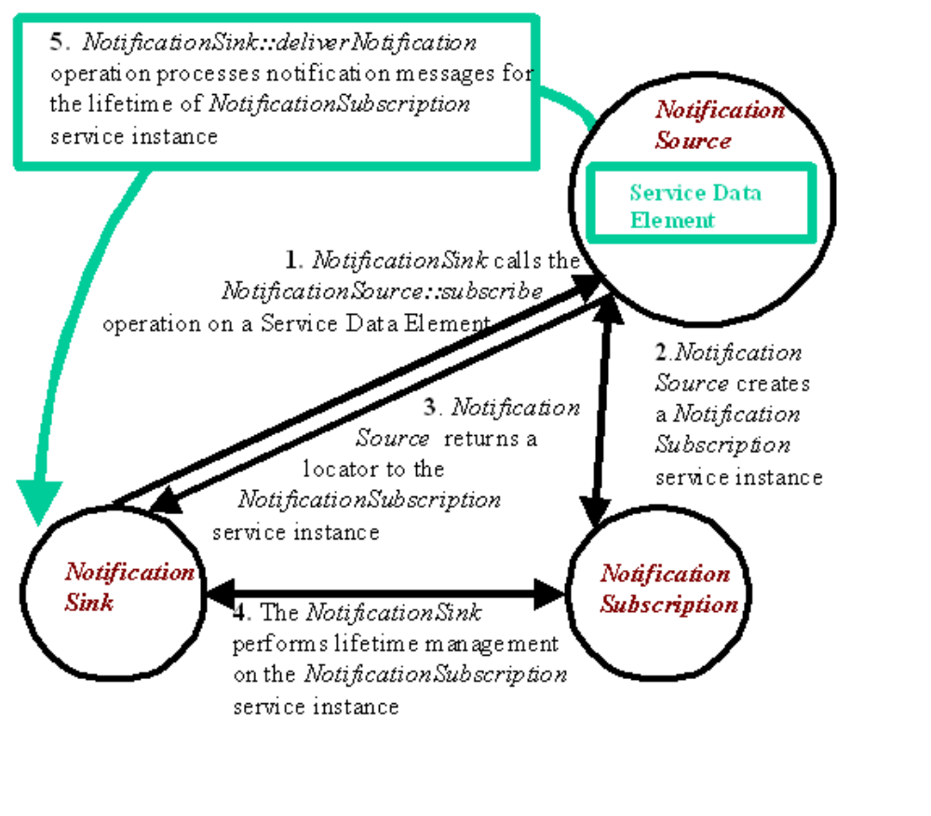
Figure ‎5-19: Typical Notification scenario
As illustrated in Figure 4.3, a subscription request causes the creation of a subscription Grid Service instance that can be used by the client to manage the subscription, and to discover its properties. A locator to this subscription instance is returned as part of the output from the subscribe operation, as well the currently planned termination time.
Following a successful subscription, a stream of notification messages then flows from the source to the sink, whenever a change to the subscribed SDE's occurs, until the subscription is either explicitly destroyed or is timed out.
For example in the last Counter example from Section 3.2, the value of the counter is exposed through a service data element and is accessed through the queryByServiceDataNames operation (pull model). With notification support, counter service instance will automatically notify all sinks (subscribed client) whenever changes occur to its value. To following example adds notification support to the counter example from section 3.2
<?xml version="1.0" encoding="UTF-8"?>
<definitions name="NotificationCounter" targetNamespace="http://www.gridforum.org/namespaces/2003/05/ogsiprimer/counter/notification" xmlns:tns="http://www.gridforum.org/namespaces/2003/05/ogsiprimer/counter/notification"
xmlns:counter="http://www.gridforum.org/namespaces/2003/05/ogsiprimer/counter"
xmlns:ogsi="http://www.gridforum.org/namespaces/2003/03/OGSI"
xmlns:gwsdl="http://www.gridforum.org/namespaces/2003/03/gridWSDLExtensions"
xmlns="http://schemas.xmlsoap.org/wsdl/">
<import location="../../ogsi/ogsi.gwsdl"
namespace="http://www.gridforum.org/namespaces/2003/03/OGSI"/>
<import location="counter_port_type.gwsdl"
namespace= "http://www.gridforum.org/namespaces/2003/05/ogsiprimer/counter"/>
<gwsdl:portType
name="NotificationcounterPortType"
extends="counter:CounterPortType ogsi:NotificationSource"/>
</definition>
Any client that is interested in receiving notification, only has to support the NotificationSink. That is, a Web Service is not required to also implement the GridService portType in order to act as a notification sink. This enables the notification clients to live outside an OGSI hosting environment and still subscribe to notification messages.
The OGSI Notification framework defines one simple type of subscription, as defined by the subscribeByserviceDataNames operation extensibility. For a subscriveByServiceDataNames subscription, the notification message that is sent from the source to the sinks is simply a serviceDataValues element.
A client (sink) that uses a subscribeByServiceDataNames to a the CounterValue SDE of a NotifcationCounter service instance will receive an serviceDataValues element similar to the one below, whenever the value (111 in the example) in the CounterValue SDE is changed
<ns1:serviceDataValues xmlns:ns1="http://www.gridforum.org/namespaces/2003/03/serviceData">
<ns3:CounterValue
xmlns:ns2="http://www.gridforum.org/namespaces/2003/05/ogsiprimer/counter/state"
xmlns:ns3="http://www.gridforum.org/namespaces/2003/05/ogsiprimer/counter"
xmlns:xsi="http://www.w3.org/2001/XMLSchema-instance"
xsi:type="ns2:CounterValueType">
<value xmlns="">111</value>
</ns3:CounterValue>
</ns1:serviceDataValues>

Implementing Web and Grid Services
In this section, we examine the relationship between OGSI and the existing and developing Web Services framework (description languages, tools and implementation platforms) on which it builds and depends. We examine both the server-side programming patterns for Grid Services and several conceptual hosting environments for Grid Services. The patterns described in this section are enabled but not required by OGSI. We discuss these patterns in this section to help put into context concepts and details described in the other parts of the Primer and in the Specification. In particular, the discussion of implementing robust services provides more information on the relationship between handles and references, and the discussion of replicated service instances answers some questions about the issue of identity.

Server-Side Programming Patterns
The OGSI Specification does not dictate any particular server-side implementation architecture. A variety of approaches are possible, ranging from implementing the Grid Service instance directly as an operating system process to a sophisticated server-side component model such as J2EE. In the former case, most, or even all, support for standard Grid Service behaviors (invocation, lifetime management, registration, etc.) is encapsulated within the user process - for example via linking with a standard library. In the latter case, many of these behaviors will be supported by the hosting environment.
To illustrate a range of possibilities for implementation, and the features of the Specification that enable this range we describe different hosting patterns of increasing complexity in the following sections.

Monolithic Service Implementation
In Figure ‎6-, we depict a scenario where the entire behavior of the Grid Service, including the demarshalling/decoding of the network message, has been encapsulated within a single executable. The protocol termination represents a communications component such as an http server with the Grid Service implemented directly using the servlet interface. Although this approach may have some efficiency advantages, it provides little opportunity for reuse of functionality between Grid Service implementations.
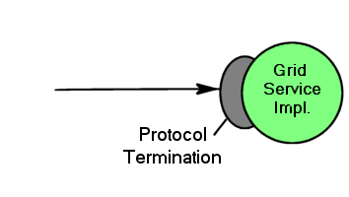
Figure ‎6-1: Simple monolithic Grid Service

Implementation within a Container
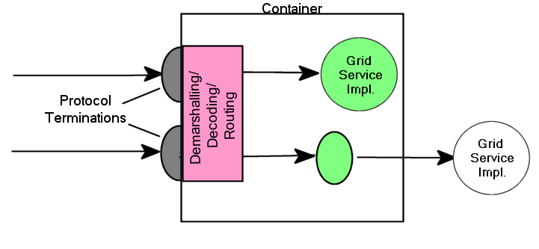
Figure ‎6-2: Container approach to the implementation of argument demarshalling functions.
In Figure ‎6-, the invocation message is received at a network protocol termination point (e.g., an http server, as is the case for many Grid Services.) This converts the data in the invocation message into a format consumable by the hosting environment. We illustrate two Grid Service instances (the circles) implemented as container-managed components (for example EJBs within a J2EE container). Here, the message is dispatched to these components, with the container frequently providing facilities for demarshalling and decoding the incoming message from a format(such as an XML/SOAP messag) into an invocation of the component in native programming language. Demarshalling from protocol terminations to the native language is accomplished by generated components called skeletons that correspond to the stubs on the client-side. In some circumstances (the upper circle), the entire behavior of a Grid Service is completely encapsulated within the component. In other cases (the lower circle), a component will collaborate with other server-side executables, to delegate certain operations to standard components or perhaps through an adapter layer designed to translate language invocation syntax, to complete the implementation of the Grid Service behavior, or

Container-managed State
A container implementation may provide a range of functionality beyond simple argument demarshalling. For example, the container implementation may provide lifetime management functions, automatic support for authorization and authentication, request logging, intercepting lifetime management functions and terminating service instances when a service lifetime expires or an explicit destruction request is received. Thus, we avoid the need to re-implement these common behaviors in different Grid Service implementations.
Figure ‎6-3 shows a container that consists of multiple execution environments that can be selected to host a Grid Service instance and is a possible implementation of the J2EE container described in the EJB specification . In this implementation the state of the instance can be saved by the container at operation boundaries and restored in case a service instance fails due to software or hardware errors.
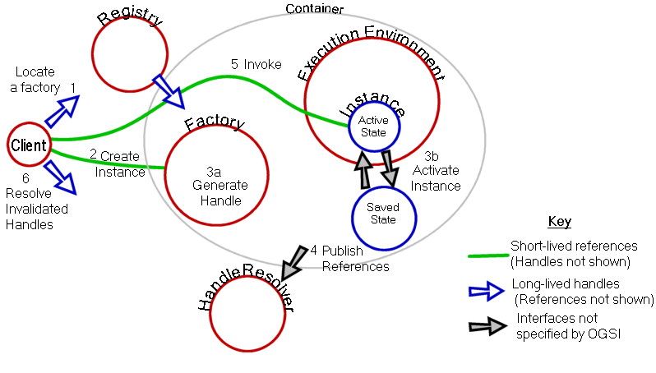
Figure ‎6-3: Container with state management
Figure ‎6-3 includes Grid HandleResolver and Registry services so that the order of events required to create and access the service can be seen. The client has a permanent reference to the HandleResolver and uses it to resolve service Handles that become invalid. The client also has a handle to the registry service that it can use (1) to locate a suitable factory and, via the factory (2), create a Grid Service Instance (3a). The container is responsible for allocating the execution environment for the instance, establishing the service Reference and supplying this to the HandleResolver (4), and initialising the service state and managing the store/load operations. The factory returns to the client a Locator containing a Handle and a Reference to the new service Instancehthat can be used to invoke service operations (5). If the execution environment fails, the container may allocate a new one with a new service Reference, load the state and supply the new reference to the HandleResolver. The client uses the Handle to obtain the updated Reference (6).

Replicated Copies of a Service Instance
[This illustrates the use of multiple references simultaneously by different clients to access the same service Instance. See OpFAQHandleResolution for input material.]
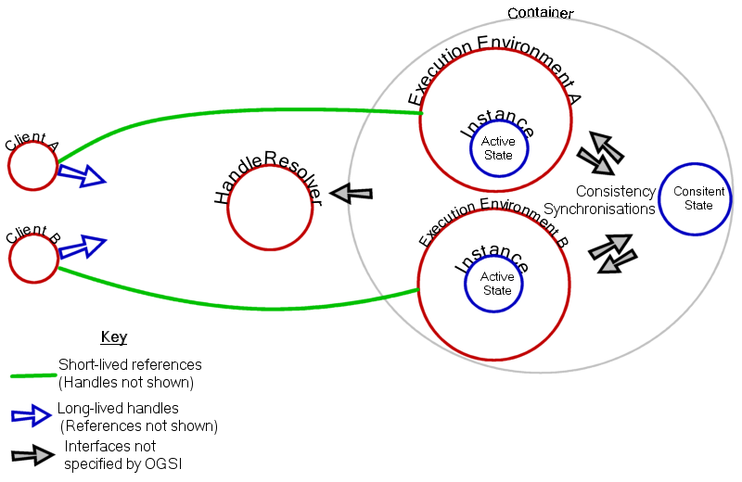
Figure ‎6-4: Use of multiple references for the same Grid Service Instance

Using Grid Services
This chapter introduces the following concepts that are needed to use the service instances described by the previous chapter.
- Locating services and communicating with them
- Ways in which collective information is used.
We examine the client-side programming patterns for Grid Services. The patterns described in this section are enabled but not required by OGSI. We discuss these patterns in this section to help put into context concepts and details described in the other parts of the Primer and in the Specification. Ways of locating grid service instances, example use of a simple registry of factories, invoking and binding to grid service instances are also examined.

Client-Side Programming Patterns
An important issue, that requires some explanation, particularly for those not familiar with Web Services, is how OGSI interfaces are likely to be invoked from client applications.
OGSI exploits an important component of the Web Services framework: the use of WSDL to describe abstract interfaces and, separately, multiple protocol bindings, encoding styles, messaging styles (RPC vs. document-oriented), security tokens and so on, for a given Web Service. The Web Services Invocation Framework [WSIF] and Java API for XML RPC [JAXRPC] are examples of infrastructure software that provide the capability to separate interface from bindings and provide multiple bindings. There are many other examples. In each case, the basic structure is similar, and it provides a client-side architecture that can also be used to access OGSI services.
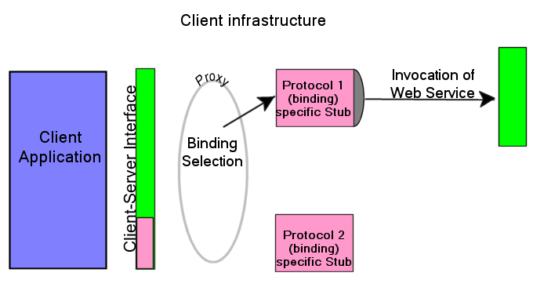
Figure 6-‎7-23: A client-side runtime architecture

In Figure 6-‎7-23: A client-side runtime architecture, the client application accesses a client-side representation of the Web Service, sometime called a proxy. The proxy calls, or uses components (shown as protocol-specific stubs) that marshal parameters for the invocation of the Web Service over a chosen binding, and adding other necessary information such as protocol headers or security tokens obtained from the client’s runtime environment.
There is a clear separation between the client application and the stub by the client-side interface that consists of the methods, procedure calls, parameters, exceptions and other interface features needed to invoke the service and receive responses and handle faults generated by the service. The client interface also defines exceptions that describe, in a generic way, errors arising from the binding mechanisms. These are dependent on the particular client infrastructure.
The client’s interface to the service can be generated by taking the WSDL description of the Web Service interface and transforming it into interface definitions in a programming language specific way (e.g. Java interfaces or C#) suitable for the particular client-side architecture. The parameter marshalling and message routing stubs are generated from the various binding options provided by the WSDL. Generation of the interface and stubs can take place at various stages of development, deployment and execution of the client application: dynamic Web Service invocation leaves the generation of the binding and service address until execution time.
This approach allows certain efficiencies, for example, detecting that the client and the Web Service exist on the same network host, and therefore avoiding the overhead of preparing for and executing the invocation using network protocols.
It is possible, but not recommended, for developers to build customized code that directly couples client applications to fixed bindings of a particular service. Although certain circumstances demand potential efficiencies gained this style of customization, this approach introduces significant inflexibility into a system and therefore should only be used under extraordinary circumstances.
We expect the stub and client side infrastructure model that we describe to be a common approach to enabling client access to Grid Service instances where each remote instance is represented by a proxy. This includes both application specific services as well as common infrastructure services that are defined by the OSGI Specification and described in this Primer. So, for most developers using Grid Services, the infrastructure and application level services appear in the form of a class library or programming language interface that is natural to the caller.
The WSDL and the GWSDL extensions required by OGSI can be supported by heterogeneous tools and enabling infrastructure software. The techniques for doing this are discussed in Section Error: Reference source not found.

Reasons for Registries
Registries are sources of information about services (including resources) in a Grid. They are themselves Grid Services, and their function is to provide references to other services, perhaps based on some selection criteria such as the serviceType, resource capacity, availability or current load. The criteria aren’t determined by the Grid Specification and depend on the registry and the kind of information it provides. Thes following examples give a flavor of how registries and service information can be organized.
- Central directories are the starting point for enquiries about Grid Services and resources. Their locations may be well-known to potential clients and may keep lists of more local registries.
- Partner Catalog UDDI registry: Web Services to be used by a particular company can be published to a Partner Catalog (rolodex like) UDDI registry. A Partner Catalog UDDI registry sits behind the firewall. This kind of private UDDI registry contains only approved, tested, and valid Web Service descriptions from legitimate business partners. The business context and metadata for these Web Services can be targeted to the specific requestor.
- Local directories can contain references to factories capable of creating services instances (including resource allocations, for example). Local information can contain more detailed, precise and/or dynamic information.
- Factories may keep a list of the service instances they have created.
- Instances keep information about their own current status that registries (or clients can use) to refresh information got from other sources.
The factory (penultimate) example shows how a registry can be only one of several functions provided by a service. The Grid Service Specification describes a Registration portType containing few basic operations that a registry must provide, but this can be combined with other portTypes or extended with additional operations and message types. Figure (2?) shows some of the alternatives described above.
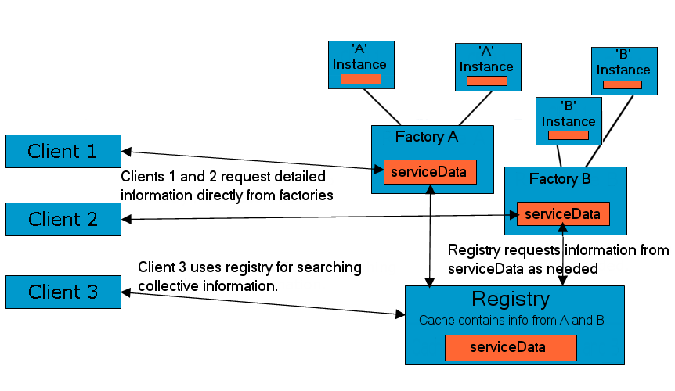
Figure ‎7-25: Factories and a dedicated Registry as information sources
OGSI defines three portTypes that may be used to build registries: ServiceGroup. ServiceGroupEntry and ServiceGroupRegistration.
A ServiceGroup is a collection of entries where each entry points to a member Grid service instance as well as a Grid service implementing the ServiceGroupEntry interface that is used for the purpose of managing the individual entries in the ServiceGroup (see Fig. 7.). All the member Grid service instances of a ServiceGroup must conform (i.e. be a, or subtype of,) at least one of the portTypes listed in the membershipContentRule SDE. Each ServiceGroupEntry contains a locator for the member Grid service instance and information (content) about that service. The content element is an XML element advertising some information about the member service. The content model forms the basis on which search predicates can be formed and executed against the ServiceGroup with the findServiceData operation. The ServiceGroupRegistartion portType extends the ServiceGroup portType and provides a management interface (add and remove operations) for a ServiceGroup. The add operation creates a ServiceGroupEntry and adds it to the ServiceGroup while the remove operation removes each ServiceGroupEntry that matches an input expression. More details about the three ServiceGroup portTypes can be found in Chapter x.

ServiceGroup
ServiceGroupEntry
entry

content
A member GridService Instance
A member GridService Instance
ServiceGroupEntry
membership
ContentRule
SDE
Locator

entry

content
content
content
Figure ‎7-3: ServiceGroup structure and its relation to ServiceGroupEntry

Example: a simple registry of service factories
This example registry records the service factories currently running in one service container and is based on a ServiceGroup port, not a ServiceGroupRegistration port. It's a way of keeping track of current activity on one server. Any kind of factory can be registered. The registered services need have nothing in common except what is required by the OGSI standard. The main metadata of interest are the sets of port types provided by each service instance created by the factories. Hence, the metadata in this registry comes from the standard service data elements prescribed by OGSI for the Factory port-type. The ogsi:CreateServiceExtensibilityType elements in a factory port list as QNames of all the port-types of the service instances that the factory can create.
For this example, suppose that there are just three factories, all for variants of a counter service.
- The basic counter has a Counter port and a GridService port.
- The "private" counter, that enforces access control for a resticted set of users, has a SecureCounter port and a GridService port.
- The "shared" counter, that is intended for concurrent use by more than one client, has a Counter port, a NotificationSource port and a GridService port.
As part of its serciceDataValues this registry (ServiceGroup) would contain the following values
<!-- Specific values for this registry. -->
<ns:serviceDataValues xmlns:ns=…>

<!-- Description of basic-counter factory. -->
<ogsi:entry xmlns:ogsi= …>
<serviceGroupEntryLocator nil="true"/>
<memberServiceLocator>
<ogsi:handle>http://exemplar.org/ogsa/services/CounterFactory</ogsi:handle>
</memberServiceLocator>
<content>
<ogsi:CreateServiceExtensibilityType>
<createsInterface>Counter</createsInterface>
<createsInterface>GridService</createsInterface>
</ogsi:CreateServiceExtensibilityType>
</content>
</ogsi:entry>

<!-- Description of private-counter factory. -->
<ogsi:entry>
<serviceGroupEntryLocator nil="true"/>
<ogsi:memberServiceLocator>
<ogsi:handle>http://exemplar.org/ogsa/services/PrivateCounterFactory</ogsi:handle>
</memberServiceLocator>
<content>
<ogsi:CreateServiceExtensibilityType>
<createsInterface>SecureCounter</createsInterface>
<createsInterface>GridService</createsInterface>
</ogsi:CreateServiceExtensibilityType>
</content>
</ogsi:entry>

<!-- Description of shared-counter factory. -->
<ogsi:entry>
<serviceGroupEntryLocator nil="true"/>
<memberServiceLocator>
<ogsi:handle>http://exemplar.org/ogsa/services/SharedCounterFactory</ogsi:handle>
</memberServiceLocator>
<content>
<ogsi:CreateServiceExtensibilityType>
<createsInterface>Counter</createsInterface>
<createsInterface>GridService</createsInterface>
<createsInterface>NotificationSource</createsInterface>
</ogsi:CreateServiceExtensibilityType>
</content>
</ogsi:entry>

</ns:serviceDataValues>
Notes on the example above
- Elements with the ogsi prefix are defined in the OGSI standard.
- The serviceGroupEntryLocator elements are all annulled. The content of this registry is build using standard OGSI GridService::setServiceData operation, it doesn't use the add operation from the ServiceGroupRegistration portType.
- The memberServiceLocator elements contain handle elements that give the GSHs of the registered factories. The given GSHs follow the HTTP scheme for GSHs used by Globus Toolkit 3; other forms for handles are possible.
A client can use the registry to select factories for particular kinds of counter as follows.
Client invokes findServiceData on the registry's GridService port. Client includes this as the queryExpression parameter of the invoked operation:
<ogsi:queryByServiceDataNames>
<name>ogsi:entry</name>
</ogsi:queryByServiceDataNames>
Service returns the serviceDataValues document shown above as the result parameter of the
The result of the operation is a dump of all the metadata for all the services (all entry elements).
Client runs these metadata through an XPath serach-engine (an XSLT processor is a likely implementation of this) using this query:
//ogsi:EntryType[content/ogsi:CreateServiceExtensibilityType/createsInterface="NotificationSource"]
to find all the factories for counters that do notification. Client is then left with
<ogsi:entry>
<serviceGroupEntryLocator nil="true"/>
<memberServiceLocator>
<ogsi:handle>http://exemplar.org/ogsa/services/SharedCounterFactory</ogsi:handle>
</memberServiceLocator>
<content>
<ogsi:CreateServiceExtensibilityType>
<createsInterface>Counter</createsInterface>
<createsInterface>GridService</createsInterface>
<createsInterface>NotificationSource</createsInterface>
</ogsi:CreateServiceExtensibilityType>
</content>
</ogsi:entry>
Client runs a further XPath search using query
//ogsi:handle
to extract the GSH of the selected service.

Service discovery and Invocation

What is the bootstrap sequence for a client
Depending on how a client intends to interact with a Grid service, it will need a GSH or GSR to start with. The client might read such information through an out-of-band mechanism such as a configuration file. If a Registry is used to locate a Grid Service or Factory for that Grid Service, then the GSH/GSR of the Registry service needs to be known up front by the client. Different VOs may have very different needs for their bootstrap services, but these services must be available to clients through some out-of-band mechanism. Such services are managed by the hosting environment, are usually deployed and created at container start-up and live for as long as the container persists.

bootstrapping to find information about resources and factories

Binding to a Service

[Resolvers this needs an example]
[Spec Section 3.3 Client Use of Grid Service Handles and References]
A client gains access to a Grid Service instance through Grid Service Handles and Grid Service References. A Grid Service Handle (GSH) can be thought of as a permanent network pointer to a particular Grid Service instance. The GSH does not provide sufficient information to allow a client to access the service; the client needs to “resolve” a GSH into a Grid Service Reference (GSR). The GSR contains all the necessary information to access the service. The GSR is not a “permanent” network pointer to the Grid Service instance because a GSR may become invalid for various reasons; for example, the Grid Service instance may be moved to a different server.
OGSI provides a mechanism, the HandleResolver (see §10) to support client resolution of a Grid Service Handle into a Grid Service Reference. In Figure ‎7-2, a client application needs to resolve a GSH into a GSR.
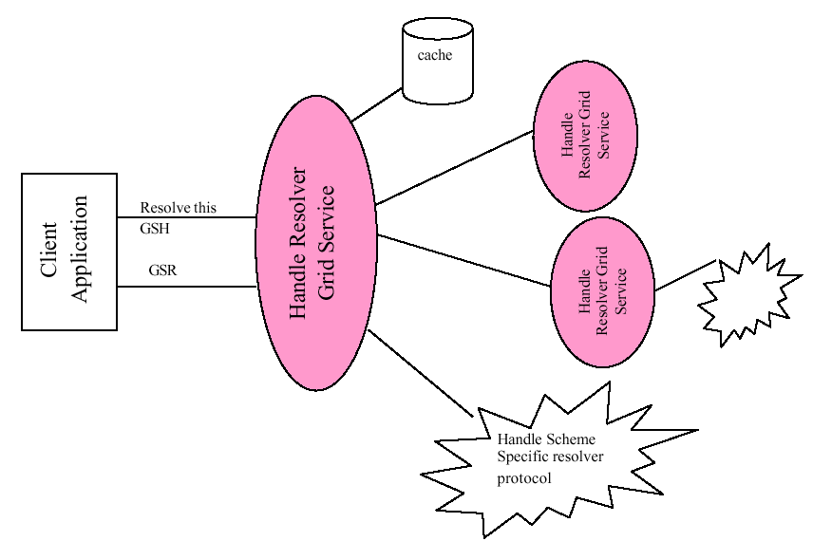
Figure ‎7-2: Resolving a GSH
The client resolves a GSH into a GSR by invoking a HandleResolver Grid Service identif ied by some out-of-band mechanism. The HandleResolver can use various means to do the resolution; some of these means are depicted in Figure 2. The HandleResolver may have the GSR stored in a local cache. The HandleResolver may need to invoke another HandleResolver to resolve the GSH. The HandleResolver may use a handle resolution protocol, specified by the particular kind (or scheme) of the GSH to resolve to a GSR. The Handle resolver protocol is specific to the kind of GSH being resolved. For example, one kind of handle may suggest the use of HTTP GET to a URL encoded in the GSH order to resolve to a GSR.

The GridService portType
To be a Grid Service a service must implement the interface and behavior that enables clients to manage it like other Grid Services. In summary, the behaviors allow clients to locate or create service instances, call them and arrange for their destruction when they are no longer needed. These behaviors are defined in the Grid Service Specification as portTypes, beginning with the basic GridService that is common to all OGSI services.

The basic requirement: GridServiceportType
[This is based on Section 9 of the spec].
We start with the GridService portType, which must be implemented by all Grid Services and thus serves as the base interface definition in OGSA. This portType is analogous to the base Object class within object -oriented programming languages such as Smalltalk or Java, in that it encapsulates the root behavior of the component model. The behavior encapsulated by the GridService portType is that of
- The required elements the serviceDataSet and the semantics associated with these elements.
- Managing the termination of the instance

Terminology: Service Description and Service Instance
(This is from the spec, Section 7.1)
We distinguish in OGSA between the description of a Grid Service and an instance of a Grid Service:
- A Grid Service description describes how a client interacts with service instances. This description is independent of any particular instance. Within a WSDL document, the Grid Service description is embodied in the most derived portType (i.e. the portType referenced by the wsdl:service element describing the service) of the instance, along with its associated portTypes, serviceDataDescriptions, messages, and types definitions.
- A Grid Service description may be simultaneously used by any number of Grid Service instances, each of which:
  - embodies some state with which the service description describes how to interact;
  - has one or more Grid Service Handles;
  - and has one or more Grid Service References to it.
A common form of Grid Service Reference (defined in Section ?) is a WSDL document comprising a service element, that carries an attribute that refers to a most derived portType defined by the service description of that instance.
A service description is primarily used for two purposes. First, as a description of a service interface, it can be used by tooling to automatically generate client interface proxies, server skeletons, etc. Second, it can be used for discovery, for example, to find a service instance that implements a particular service description, or to find a factory that can create instances with a particular service description.
The service description is meant to capture both interface syntax, as well as (in a very rudimentary, non-normative fashion) semantics. Interface syntax is, of course, described by portTypes.
Semantics may be inferred through the name assigned to the portType. For example, when defining a Grid Service, one defines zero or more uniquely named portTypes, and then collects a set of portTypes defined from a variety of sources into a final or most derived portType. Concise semantics can be associated with each of these names in specification documents – and perhaps in the future through Semantic Web or other formal descriptions. These names can then be used by clients to discover services with the sought-after semantics, by searching for service instances and factories with the appropriate names. Of course, the use of namespaces to define these names provides a vehicle for assuring globally unique names.

GridService Service Data
[Enumerate the servicedata elements and describe their purpose.]

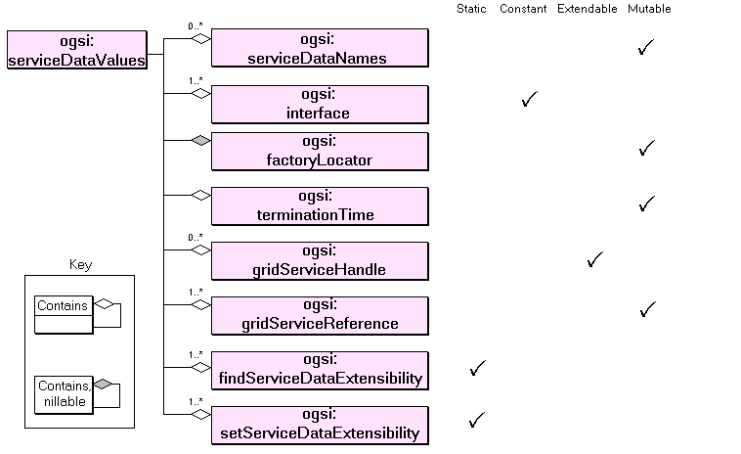
[This is from Section 6.2 of the spec]
For example, the following portType declares two serviceData elements, with qualified names “tns:sd1” and “tns:sd2”. Any service that implements this portType MUST have as part of its state these two ServiceData elements.
<wsdl:definitions xmlns:tns=”xxx” targetNamespace=”xxx”>
<gwsdl:portType name="exampleSDUse"> *
<wsdl:operation name=…>
…
<sd:serviceData name="sd1" type=”xsd:String”
mutability=”static”/>
<sd:serviceData name="sd2" type=”tns:SomeComplexType”/>
…
<sd:staticServiceDataValues>
<tns:sdl>initValue</tns:sd1>
</sd:staticServiceDataValues>
</gwsdl:portType>
…
</wsdl:definitions>

Using serviceData, an Example from GridService portType
[From Section 6.2.2 of the Spec]
Let’s examine how serviceData can be used by reviewing an example, namely the GridService portType, described in §9. The (non-normative) serviceData elements declared for the Grid Service portType are as follows.
<wsdl:definitions …
<gwsdl:portType name=”GridService” …>
<wsdl:operation name= …>
…
<sd:serviceData name=”interface” type=”xsd:QName”
minOccurs=”1” maxOccurs=”unbounded”
mutability=”constant”/>
<sd:serviceData name=”serviceDataName” type=”xsd:QName”
minOccurs=”0” maxOccurs=”unbounded”
mutability=”mutable” nillable=”false”/>
<sd:serviceData name=”factoryHandle”
type=”ogsi:HandleType”
minOccurs=”1” maxOccurs=”1
mutability=”constant” nillable=”true”/>
<sd:serviceData name=”gridServiceHandle”
type=”ogsi:HandleType”
minOccurs=”0” maxOccurs=”unbounded”
mutability=”extendable”/>
<sd:serviceData name=”gridServiceReference”
type=”ogsi:ReferenceType”
minOccurs=”0” maxOccurs=”unbounded”
mutability=”mutable”/>
<sd:serviceData name=”findServiceDataExtensibility”
type=”ogsi:OperationExtensibilityType”
minOccurs=”1” maxOccurs=”unbounded”
mutability=”static”/>
<sd:serviceData name=”terminationTime” type=”ogsi:terminationTime”
minOccurs=”1” maxOccurs=”1”
The normative description of the individual serviceData elements are in (§9.1).
The following is an example set of serviceData element values for a Grid Service.
…
xmlns:crm=”http://gridforum.org/namespaces/2002/11/crm”
xmlns:tns=”http://example.com/exampleNS”
xnlns=”http://example.com/exampleNS”>
<sd:serviceDataValues>
<ogsi:interface>crm:GenericOSPT</ogsi:interface>
<ogsi:interface>ogsi:GridService</ogsi:interface>
<ogsi:serviceDataName>ogsi:interface
</ogsi:serviceDataName>
<ogsi:serviceDataName>ogsi:serviceDataName
</ogsi:serviceDataName>
<ogsi:serviceDataName>ogsi:factoryHandle
</ogsi:serviceDataName>
<ogsi:serviceDataName>ogsi:gridServiceHandle
</ogsi:serviceDataName>
<ogsi:serviceDataName>ogsi:gridServiceReference
</ogsi:serviceDataName>
<ogsi:serviceDataName>ogsi:findServiceDataExtensibility
</ogsi:serviceDataName>
<ogsi:serviceDataName>ogsi:terminationTime
</ogsi:serviceDataName>
<ogsi:serviceDataName>ogsi:setServiceDataExtensibility
</ogsi:serviceDataName>
<ogsi:factoryHandle>someURI</ogsi:factoryHandle>
<ogsi:gridServiceHandle>someURI</ogsi:gridServiceHandle>
<ogsi:gridServiceHandle>someOtherURI</ogsi:gridServiceHandle> <ogsi:gridServiceReference>…</ogsi:gridServiceReference>
<ogsi:gridServiceReference>…</ogsi:gridServiceReference>
<ogsi:findServiceDataExtensibility
inputElement=”ogsi:queryByServiceDataNames” />
<ogsi:terminationTime after=”2002-11-01T11:22:33”
before=”2002-12-09T11:22:33”/>
<ogsi:setServiceDataExtensibility
inputElement=”ogsi:setByServiceDataNames” />

ServiceData Initial values
See example text in the spec (Section 6.3.1)

ServiceData and portType Inheritance
See example text in the spec (Sections 6.4 and 6.4.1)

ServiceData Bindings
[From the spec Section 6.2, last para]
The wsdl:binding associated with various operations manipulating serviceData elements will
indicate the encoding of that data between service requestor and service provider. For example, a binding might indicate that the serviceData element values are encoded as serialized Java objects.

GridService Operations
[Summary of Querying and modyfing servicedata, termination time. Destrying a service. Sufficient to inform the following example]

Querying ServiceData
[From Section 9.2.1.1 of the spec)
For example, a findServiceData invocation with this QueryExpression:
<ogsi:queryByServiceDataNames>
<name>ogsi:findServiceDataExtensibility</name>
<name>ogsi:setServiceDataExtensibility</name>
</ogsi:queryByServiceDataNames>
might return this Result:.
<sd:serviceDataValues>

<ogsi:findServiceDataExtensibility
inputElement=”ogsi:queryByServiceDataNames”/>
<ogsi:setServiceDataExtensibility
inputElement=”ogsi:setByServiceDataNames”/>
<ogsi:setServiceDataExtensibility>
inputElement=”ogsi:deleteByServiceDataNames”/>
</sd:serviceDataValues>

GridService Examples
[Develop the example of the Counter with Servicedata defined]

Handle Resolution
As discussed in Chapter 4, a Grid service instance is identified by one or more Grid Service Handles (GSHs). However, a GSH does not contain enough information for a consumer to communicate with the identified Grid service instance. The consumer needs to get hold of at least one Grid Service Reference (GSR) which contains the necessary information for communicating with the identified Grid service instance (Chapter 4).
Grid service instances that implement the HandleResolver portType, also referred to as handle resolvers, can be used to map a GSH to one or more GSRs. The OGSI specification is silent on the semantics or the mechanisms of the mapping. It is up to service implementers to define the characteristics of the relationship between a GSH and its associated GSRs. Implementers are also responsible for the way the information about that relationship is made available to the handle resolver, as illustrated in Figure ??. Of course, as with any other Grid service instance, a handle resolver is free to implement any logic behind the HandleResolver portType. OGSI only requires a handle resolver to adhere to the following:
- It must include a Service Data Element called handleResolverScheme; and
- It must support an operation called findByHandle.

The handleResolverScheme SDE
A handle resolver advertises the URI schemes that it understands through the handleResolverScheme SDE. As already described in Chapter 4, a GSH is a URI for which OGSI does not impose a particular URI scheme. However, host environments or factories may decide to adopt a particular URI scheme for identifying new Grid service instances. It is expected that the community will agree on standard URI schemes. For example, a factory for counter Grid service instances may use the “counter:global-unique-identifier” scheme for the GSHs of new instances or another factory may use the http://www.counter.com/grid/service/instance/10 scheme.
A particular handler resolver may only understand GSHs of a particular URI scheme. A consumer of the Grid service instance implementing the HandleResolver portType may get the names of the supported URI schemes through the handleResolverScheme SDE.
For example, a handle resolver for GSHs identifying counter Grid service instances will set the value of the handleResolverScheme SDE to “counter”. A handle resolver that also supports GSHs using the “http” scheme will have two SDEs: “counter” and “http”:
<serviceDataValues>
<handleResolverScheme>counter</handleResolverScheme>
<handleResolverScheme>http</handleResolverScheme>
</serviceDataValues>
The service data declaration of the handleResolverScheme SDE defines that its value can change throughout the lifetime of the handle resolver (mutability=”true”) but only by the handle resolver (modifiable=”false”). Also, a value of xsi:nil is allowable indicating that the handle resolver may be able to resolve all URI schemes.

The findByHandle operation

Input
The only operation that is declared as part of the HandleResolver portType is the findByHandle operation, which accepts a locator as input, the HandleSet, containing one or more GSHs. As the definition of the locator dictates, the GSHs contained in the HandleSet must point to the same Grid service instance. The handle resolver is free to choose any of the GSHs in the HandleSet for the resolution process.
The HandleSet may also contain one or more GSRs to the same Grid service instance. The implementer of the handle resolver is free to ignore these GSRs or use them for the resolution process.
The GSRExclusionSet is an optional input to the findByHandle operation. It is a locator that contains one or more set of GSRs that the handle resolver must not return as part of the result of the resolution process. The handle resolver does not care why these GSRs had to be excluded. If the GSRExclusionSet locator contains any GSHs, they are going to be ignored by the handle resolver.

Output
The output of the findByHandle operation is a locator that contains one or more GSRs, the outcome of the resolution process. All the GSHs in the HandleSet will also be included in the locator. The handle resolver may decide to include additional GSHs to the same Grid service instance, if it deems that this is necessary.

Faults
A number of faults may be generated as a result of calling the findByHandleOperation operation.
- The InvalidHandleFault is returned when one of the GSHs in the HandleSet input parameter violates the syntax of its URI scheme.
- When the resolver cannot return a GSR that is not already contained in the GSRExclusionSet input parameter, the NoAdditionalReferencesAvailableFault is returned.
- However, even if the GSRExclusionSet input parameter is empty but the resolver is still unable to return a GSR, the NoReferencesAvailableFault is returned. which may be extend to carry more information about what may have gone wrong: NoSuchServiceFault, NoSuchServiceStartedFault, ServiceHasTerminatedFault, and TemporarilyUnavailableFault.
- It is possible that the handle resolver knows of another handle resolver that may be capable of performing the resolution. The RedirectionFault is returned in such a situation with the GSH of the new handle resolver.
- If another fault occurs, the Fault is returned.
[Suggestion: this is the place to answer questions about the relationship between a service implementation and the HandleResolver?. There is some input in OpFAQHandleResolution]
[Suggestion: is this the place to explain solutions to the bootstrap problem - how to get a reference to the handle resolver]
[Suggestion: explain the rationale behind the GSRExclusionSet? input to findByHandle ]
[Question: In Section 7.5.1.1. the spec recommends only including minumal info in the WSDL version of a GSR. What other information is possible? Why is it discouraged]

Finding Services: ServiceGroups and Registries
[This needs a major update following changes to the spec]

The Registry Interfaces
There are two components to a registry – Registration and Discovery. Registration places a services reference in the registry, Discovery allows a client to retrieve it. Though it’s logical to think of these as two parts of the same service, this is not necessarily the best way to organize the information. The Discovery service can use the registered references to find out more information (or more dynamic information, such as the current load) about the services, or pass this on to a third party that provides selection among a group of similar services, or qualities of its own such as scalability.

The purpose of registries in OGSA
A registry is the very general concept. In computing, we may define it as a catalogue of objects, described and indexed by the objects' metadata. The objects may be either inside the computing system (i.e. the objects consist entirely in data); or they may be real-world items, with only metadata inside the computing system; or they may be computing-system proxies for real-world objects. In all cases, the essence of the registry pattern is that a registry stores some part of an object's metadata without storing either the object itself or (for a real-world object) its proxy.
Given a registry, clients may inspect the metadata and use them to reason about the catalogued objects. Typically, clients then use the metadata to locate and access some of the catalogued objects. Often, the only use of the registry is to locate the objects.
OGSI is concerned with registries of Grid Services. Grid Services can be used to build other kinds of registries, but OGSI has specific port-types that can be used to build registries where the entries describe Grid Services.
The essential requirement of a service registry is that the metadata include a GSH for each catalogued service. The registry itself does not resolve a GSH to a GSH, although the service running the registry may also include a HandleResolver port for this purpose. From OGSA's point of view, "locating" a service instance through a registry means finding its persistent handle, not finding its reference, the latter function being the role of a handle resolver.

OGSI support for service registries
In OGSA, service registries have two uses:
- finding service factories from which to make new instances;
- finding existing instances.
The same OGSI port-types cover both uses:
- serviceGroup
- serviceGroupEntry
- serviceGroupRegistration
From the OGSI specification:
The ServiceGroup port-type provides an interface for representing a service group comprising zero or more member services. [...] The ServiceGroup port-type extends the GridService port-type.
[The serviceGroupEntry] port-type defines the interface through which individual entries in a service group should be managed. Each ServiceGroupEntry service refers to a grid-service instance that is a member of the ServiceGroup
[The ServiceGroupRegistration] port-type provides a management interface (add and remove operations) for a service group. The ServiceGroupRegistration port-type extends the ServiceGroup port-type.
Thus, in OGSI, a service group may be used to create a service registry.
The service implementing the registry provides either a ServiceGroup or a ServiceGroupRegistration port. If the set of registered services is updated only through local, non-grid interfaces, then the registry service has a ServiceGroup port; call this a "locally-managed" registry. If the set of registered services can be altered by clients working over the grid, then the registry service has instead a ServiceGroupRegistration port; call this a "grid-managed" registry. Since ServiceGroupRegistration extends ServiceGroup, the registry service needs only one of these two port types.
The registry facility also has one ServiceGroupEntry port for each registered service. Since any given grid-service can only have one copy of a given port-type, this means that the registry has one subsidiary service, providing ServiceGroupEntry, as a "registration proxy" for each registered service. In fact, the intention is to have the appearance of one proxy service-instance per registered service in order to use the lifetime-management facilities of the GridService port. In practice, a registry may implement these proxy services in some light-weight form in order to save resources. That is, a registry for a trivial number of services may use conventional service-instances for its proxy services, using ordinary service containers, while a registry intended for thousands of registrants may be built as a specialized service-container with a more-scalable implementation of the proxies.
A service instance is registered by
- creating a new proxy service-instance with the ServiceGroupEntry port-type;
- adding an element of type ogsi:EntryType (see below) to the service data of the ServiceGroup or ServiceGroupRegistration port.
Deregistration is the reverse process. A registration proxy can be set to terminate at a certain time, in the normal manner of OGSI services, thus limiting the lifetime of a registration.
In a grid-managed registry, clients can call the add operation of the ServiceGroupRegistration port to register a service and the remove operation of that port to deregister services. Each call to add registers one service. Each call to remove deregisters a set of related services. In a locally-managed registry, the registration and deregistration mechanisms are outwith OGSI.
The ogsi:Entry contains:
- an ogsi:Locator element pointing to the registration proxy for the registered service;
- an ogsi:Locator element pointing to the registered service itself;
- an ogsi:EntryContent element that contains zero or more unconstrained metadata describing the registered service.
Thus a client of the registry reads the metadata of registered services by reading the ogsi:EntryContentType elements from the ServiceGroup port.
[Some words here or hereabouts concerning how the registry limits what comes in. _MembershipRule and all that.]

Registration PortType
Below is a diagram of the WSDL markup elements that describe the Service Group portType.
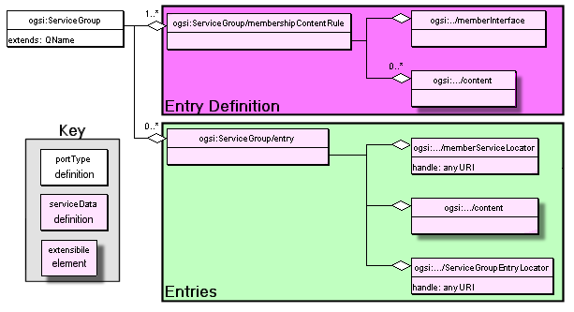
Figure ‎10-27: GWSDL Description of Service Group.

{AD details of the 3 portypes and their SDE -go here]

[ AD here follows some old material which needs to be deleted]

A registry service must implement the Registration portType that has the following operations
Registration :: RegisterService
Add or atomically update an entry in the registry. This operation takes as input
A Locator (Containing one or more handles and maybe references to the service) being registered.
Descriptive information about the service. The format of the information depends on the kind of registry and is described by ServiceDataElement values of the type gsdl:registrationExtensibilityType. An example might be a UDDI description of the service.
If the operation is successful, (no fault is generated) the newly registered service will subsequently be returned
Registration :: UnregisterService
Remove a Grid Service Handle from the registry.

Making Discoveries
Registration information is made available as a WS-Inspection (WSIL) document.. – other forms of information may be available too, depending on the implementation of the discovery service. The WSIL document contains references to all of the services contained in the registry and can be retrieved from the registry as the serviceData element GridServiceRegistryWSInspection using the normal operations for querying service Data.

Lifetime of Registration
As with other stateful interfaces in OGSA, GSH registration is a soft state operation and must be periodically refreshed, thus allowing discovery services to deal naturally with dynamic service availability.
This soft-state registration requires the service to periodically refresh is

Service Registration
What does an instance have to do to be registered? Should it rely on the Factory to do it?
What does a factory have to do to be registered?

An Example Registry
We need something realistic that illustrates sub-setting via attributes, eg selection of CPUs, based on ServiceData elements describing speed in Mhz?

6.21.2. Abstract ServiceGroups

[Explain the abstract concept, and illustrate with concrete examples]

Creating Transient Services: The Factory
From a programming model perspective, a factory is an abstract concept or pattern. A consumer may use a factory to create an instance of a Grid Service and receive a locator for it. Any service may be a factory of other grid service instances without having to adhere to a specific interface. Nevertheless, the OGSI specification defines a standard portType for a factory Grid Service Instance for those service implementers wishing to provide a general, rather than service-specific, interface for creating new instances.
The OGSI specification suggests that any newly created Grid Service Instance should be registered with a handle resolver in order to receive a GSH. The mechanism by which this may take place is implementation-specific.
As with all Grid Services, the factory has to extend the GridService portType and introduces one SDE and one operation.

The createServiceExtensibility SDE
As explained in Section [??], for each extensible operation in a portType there should be a service data declaration of type OperationExtensibilityType. The createServiceExtensibility SDE is such a declaration. Its type is CreateServiceExtensibilityType which extends OperationExtensibilityType to include the set of portTypes that the grid service instance to be created should support. Implementers of the Factory portType may decide to provide additional extensibility elements that should be declared through this SDE.

The createService operation

Input
The createService operation of the Factory portType accepts two arguments as input.
- TerminationTime. This is optional and allows the client calling the createService operation to specify the earliest and latest initial termination times of the Grid Service Instance to be created. The factory will select an initial termination time from the window specified by the client and will return it.
- CreationParameters. This too is an optional argument and must conform to one of the extensibility parameter declarations defined as values of the createServiceExtensibility SDE. It is used when the requestor wishes to send additional information to the service instance implementing the factory portType. For example, a factory may advertise through the createServiceExtensibility SDE more than one supported combinations of interfaces that created service instances can support. A requestor can use the CreationParameters to select which of the combinations the new service instance must support.

Output
As a result of requesting the creation of a new service instance, the requestor receives:
- A Locator (refer to Section Error: Reference source not found, page Error: Reference source not found) to the newly created service instance.
- The CurrentTerminationTime, which is an element identifying the planned termination time for the newly created service instance. Of course, consumers may request for this value to change through the operations provided by the GridService portType (Section 8, page 51). A consumer can also get the time that the grid service instance was actually created from this element from the timestamp attribute.
The service instance implementing the Factory portType may also decide to return an ExtensibilityOutput element which is specific to the service instance created.

Faults
The different faults that may be communicated back to the consumer are:
- ExtensibilityNotSupportFault. The type of the CreationParameters was not supported by the service instance that received the request.
- ExtensibilityTypeFault. The value of the CreationParameters input element could not be validated its declared type.
- ServiceAlreadyExistsFaultI. If the service instance that was supposed to be created already existed, this fault is returned which also carries the locator to it.
- Fault. Any other fault that may occur.

Example
[Savas to fill this in]

GridService Notification

Notification Source and Notification Sink

A Grid Service which wants to notify its clients of changes to its state should implement NotificationSource portType. Such a grid service (also called source) can send notification messages to any number of clients. Client (also called sink) that wish to receive notification messages should implement NotificationSink portType.

A notification message is an XML element that is sent from the source to the sink. The type of the notification message is determined by the subscription expression. A subscription expression also describes what messages should be sent and when it should be sent based on changes to values within the serviceDataSet of the grid service instance implementing NotificationSource interface.

Subscription Model

To enable notifications, a Grid Service must implement the Notification Source portType which has the following operation

NotificationSource :: subscribe

Notification Clients can use this operation to subscribe to changes to the target instance's service data. The life-time of the subscription is managed by a separate grid service instance called subscription instance.

This operation takes as input
- a subscription expression
- the locator of the notification sink to which messages will be delivered
- initial expiration time of the subscription as requested by the client

This operation outputs
- the locator to the subscription instance
- initial termination time of the subscription as decided by the source

Client can obtain the list of subscription expression types from the subscribeExtensibility SDE values of the grid services instance. OGSI defines one subscription expression type called subscribeByServiceDataNames. This type can be used to subscribe for notification messages whenever there are any changes in service data elements.

The notifiableServiceDataName SDE of NotificationSource portType can be used to hold the QNames of the SDEs to which the Notification Clients can subscribe for changes. The subscribeByServiceDataNames allows the client to set the minimum and maximum intervals between notification messages.

Lifetime Management of the Subscription

Notification Clients are responsible for managing the life-time of subscription using the soft-state life time management as explained in section 2.2. The subscribe operation discussed above results in the creation of a subscription instance of type NotificationSubscription.

NotificationSubscription portType extends Grid Service portType. The Service Data Elements of NotificationSubscription portType contains properties of the subscription (subscription expression, locator of the notification sink).

Notification Clients

Notification Clients can be a grid service or a Web Service and should implement the NotificationSink portType. The NotificationSink portType defines only one operation called deliverNotification which is used by source to deliver the XML messages.

A Web Service implementing the NotificationSink portType does not need to implement Grid Service portType. This enables Web Services living outside OGSI hosting environment to subscribe to notifications.

Grid Services Security
Depending on the domain and the nature of the Grid Services, a service implementor can and would implement layers of security - from transport level to message level to service level. In this context most probably one would require an interoperable security layer that spans multiple administrative domains.

Approach & Scope
This section addresses Grid Services security in a descriptive way (as opposed to prescriptive directions) and touches security only with respect to the primitives in OGSI/OGSA. This section :
- summarizes the important ideas, topics and concepts (as resulted from discussions and specifications from the various grid security wgs)
- provides links to detailed work in each of the above areas (thus neither duplicating nor reiterating the rest of the grid security work)
- provides examples (abstract examples and patterns) how they could be used
- will not have implementation details
The most important is to explain how security is factored out of the application (and is orthogonal to OGSI) and provide references to introductory material that explains (in a generic fashion) how security protocols can be plugged in to Client and Server infrastructure. What those infrastructures do with the security is not the business of OGSI, but some simple examples would be reassuring to the Primer audience.

List of Topics to address
- ServiceData access, visibility and exposure controls - how to express, exchange and process serviceData security artifacts
- WSDL security - i.e. security of the exposed interfaces including restricting operations
- Standards for identity and access control policies
- Examples of how to handle resolution protocols
- Explain VOs and how they are achieved using Kerberos/X.509
- X.509 and Kerberos usage in a grid scenario
- Infosec issues - firewall traversal, any ACL and other requirements for grid installation
  - Examples/explanation of how gateways can be constructed for Web Services as part of a firewall.
- Trust mechanisms - establish, bootstrap and use
  - Some simple examples of authorization for operations, and the importance of propagation of the authorization would be reassuring to the Primer audience.

Advanced Topics

Advanced Registries [?]

Recommendations for Change Management
< Change management from the gss spec>

Describing Operation semantics
[How operations may interact with each other, where to document this]

Monitoring Execution
[nice example – Monitoring a Datamining operation?]

Glossary of Terminology
Thse terms and abbreviations are used in the text and are defined where they are first used. The list below may help you if you dip into the text without reading from the beginning.
TBD – To Be Done.

Comparison with other Distributed Architectures
[Comparison to Corba, EJB, BPEL?]
*This was 3.1. Relationship to Distributed Object Systems in the spec.*
As we describe in much more detail below, a given Grid Service implementation is an addressable, and potentially stateful, instance that implements one or more interfaces described by WSDL portTypes. Grid Service factories (§12) can be used to create instances implementing a given set of portType(s). Each Grid Service instance has a notion of identity with respect to the other instances in the distributed Grid, (§7.5.2.1). Each instance can be characterized as state coupled with behavior published through type-specific operations. The architecture also supports introspection in that a client application can ask a Grid Service instance to return information describing itself, such as the collection of portTypes that it implements.
Grid Service instances are made accessible to (potentially remote) client applications through the use of a Grid Service Handle (§7.5.2) and a Grid Service Reference (§7.5.1). These constructs are basically network-wide pointers to specific Grid Service instances hosted in (potentially remote) execution environments. A client application can use a Grid Service Reference to send requests (represented by the operations defined in the portType(s) of the target service) directly to the specific instance at the specified network-attached service endpoint identified by the Grid Service Reference.
We expect that in many situations, client stubs and helper classes isolate application programmers from the details of using Grid Service References. Some client side infrastructure software assumes responsibility for directing an operation to a specific instance that the GSR identifies.
Each of the characteristics introduced above (stateful instances, typed interfaces, global names, etc.) is frequently also cited as a fundamental characteristic of so-called distributed object-based systems. However, there are also various other aspects of distributed object models (as traditionally defined) that are specifically not required or prescribed by OGSI. For this reason, we do not adopt the term distributed object model or distributed object system then describing this work, but instead use the term Open Grid Services Infrastructure, thus emphasizing the connections that we establish with both Web Services and Grid technologies.
Among the object-related issues that are not addressed within OGSI are implementation inheritance, service mobility, development approach, and hosting technology. The Grid Service specification does not require, nor does it prevent, implementations based upon object technologies that support inheritance at either the interface or the implementation level. There is no requirement in the architecture to expose the notion of implementation inheritance either at the client side or the service provider side of the usage contract. In addition, the Grid Service specification does not prescribe, dictate, or prevent the use of any particular development approach or hosting technology for the Grid Service. Grid Service providers are free to implement the semantic contract of the service in any technology and hosting architecture of their choosing.
We envision implementations in J2EE, .NET, traditional commercial transaction management servers, traditional procedural UNIX servers, etc. We also envision service implementations in a wide variety of programming languages that would include both object-oriented and non-object-oriented alternatives.

Author Information
Tim Banks (Editor)
IBM
Hursley Park, Winchester, UK. SO21 2JN.
Email: tim_banks@uk.ibm.com

Abdeslem Djaoui,
CLRC
Rutherford Appleton Laboratory, UK, OX11 0QX.
Email: a.djaoui@rl.ac.uk

Dr. Savas Parastatidis,
North-East Regional e-Science Centre
School of Computing Science, University of Newcastle upon Tyne, UK
http://savas.parastatidis.name

Also we acknowledge the authors of the OGSI Specification that provided source material: Steven Tuecke, Karl Czajkowski, Ian Foster, Jeffrey Frey, Steve Graham, Carl Kesselman, Tom Maguire, Thomas Sandholm, Dr. David Snelling and Peter Vanderbilt.

Acknowledgements
We are grateful to numerous colleagues for contributions and discussions on the topics covered in this document, in particular (in alphabetical order, with apologies to anybody we've missed):
Marc Brooks, John Carter, Kate Keahey, Guy Rixon, Krishna Sankar, Jem Treadwell,

Document References
[1] The Anatomy of the Grid: Enabling Scalable Virtual Organizations, I. Foster, C. Kesselman, S. Tuecke, Authors. International Journal of High Performance Computing Applications, 15 (3). 200-222. 2001.
Available at http://www.globus.org/research/papers/anatomy.pdf.
[2] The Physiology of the Grid: An Open Grid Services Architecture for Distributed Systems Integration, I. Foster, C. Kesselman, J. Nick, S. Tuecke, Authors. Globus Project, 2002. Available at http://www.globus.org/research/papers/ogsa.pdf
[3] Open Grid Services Infrastructure (OGSI) Version 1.0. June 27, 2003. S. Tuecke, K. Czajkowski, I. Foster, J. Frey, S. Graham, C. Kesselman, T. Maquire, T. Sandholm, D. Snelling, P. Vanderbilt, Graham, C. Kesselman, D. Snelling, P. Vanderbilt.
Available at: http://forge.gridforum.org/projects/ogsi-wg/document/Final_OGSI_Specification_V1.0/en/1/Final_OGSI_Specification_V1.0.pdf
[4] Web Services Description Language (WSDL) 1.1 W3C Note 15 March 2001
Available at http://www.w3.org/TR/wsdl
[5] Web Services Description Language (WSDL) Version 1.2, W3C Working Draft 3. March2003, World Wide Web Consortium.
Available at http://www.w3.org/TR/2003/WD-wsdl12-20030303
[6] Secure Grid Naming Protocol (SGNP): Draft Specification for Review and Comment. GGF4 Submission May 3, 2002
Available at http://sourceforge.net/projects/sgnp/
[7] Java (TM) API for XML-Based RPC (JAX-RPC).
Available at http://java.sun.com/xml/jaxrpc/docs.html
[8] Welcome to WSIF: Web Services Invocation Framework
Available at http://www.apache.org/wsif
[9] OGSA.
Available at ?
[10] Enterprise JavaBeans TM Specification, Version 2.1. Sun Microsystems
Available at ?
[11] The Object Management Group CORBA specification.
Available from the OGM Web Site:CORBA http://www.omg.org/corba/
[12] Java RMI specification (tbd)
[13] DCOM documentation (tbd)
[14] Description of RPC (tbd)
[15] The Web Services Architecture. Available at http://www.w3.org/TR/ws-arch/wsa.pdf
[16] Universal Description, Discovery, and Integration (UDDI) 3.0 specification. Available at http://uddi.org/pubs/uddi-v3.00-published-20020719.htm
[17] The Web Services Interoperability Organisation. http://www.ws-i.org/
[18] The Grid Security Infrastructure. Described at http://www.globus.org/security/
[19] The Common Configuration Model Specification.

Copyright Notice
Copyright © Global Grid Forum (2002). All Rights Reserved.

This document and translations of it may be copied and furnished to others, and derivative works that comment on or otherwise explain it or assist in its implementation may be repared, copied, published and distributed, in whole or in part, without restriction of any kind, provided that the above copyright notice and this paragraph are included on all such copies and derivative works. However, this document itself may not be modified in any way, such as by removing the copyright notice or references to the GGF or other organizations, except as needed for the purpose of developing Grid Recommendations in which case the procedures for copyrights defined in the GGF Document process must be followed, or as required to translate it into languages other than English.

The limited permissions granted above are perpetual and will not be revoked by the GGF or its successors or assigns.

This document and the information contained herein is provided on an "AS IS" basis and THE GLOBAL GRID FORUM DISCLAIMS ALL WARRANTIES, EXPRESS OR IMPLIED, INCLUDING BUT NOT LIMITED TO ANY WARRANTY THAT THE USE OF THE INFORMATION HEREIN WILL NOT INFRINGE ANY RIGHTS OR ANY IMPLIED WARRANTIES OF MERCHANTABILITY OR FITNESS FOR A PARTICULAR PURPOSE.

Intellectual Property Statement
The GGF takes no position regarding the validity or scope of any intellectual property or other rights that might be claimed to pertain to the implementation or use of the technology described in this document or the extent to which any license under such rights might or might not be available; neither does it represent that it has made any effort to identify any such rights. Copies of claims of rights made available for publication and any assurances of licenses to be made available, or the result of an attempt made to obtain a general license or permission for the use of such proprietary rights by implementers or users of this specification can be obtained from the GGF Secretariat.

The GGF invites any interested party to bring to its attention any copyrights, patents or patent applications, or other proprietary rights which may cover technology that may be required to practice this recommendation. Please address the information to the GGF Executive Director (see contact information at GGF website).
GLOBAL GRID FORUM
office@gridforum.org
www.ggf.org

The Index

The GridForge web site is at https://forge.gridforum.org/projects/ogsi-wg
The process by which Grid Service Instances can be created, registered, and discovered and identifies is discussed in detail in the later chapters.

