Virtual Organizations
“Virtual Organizations” are a concept that supplies a “context” for operation of the grid that can be used to associate users, their requests, and resources. These contexts can be depended on by services as a type of reliable assertion of identity, e.g. this user or resource, is a known member of this VO. VO contexts also permit the providers of grid resources to associate appropriate policy and agreements with the resources they contribute to the grid. Users and requests that are then associated with the VO are able to exploit those resources consistent with those policies and agreements.

Virtual Organization Management provides functions for the creation and management of VOs. These functions include mechanisms for associating entities like users/groups with the VO, manipulation of user roles (administration, configuration, use etc.) within the VO, association of services (encapsulated resources) with the VO, attachment of agreements and polices to the VO as a whole or individual services within the VO. Finally creation of a VO requires a mechanism by which the “VO context” is referenced and associated with user requests. (This is most likely via a GSH since a “service” is the likely embodiment of the VO).

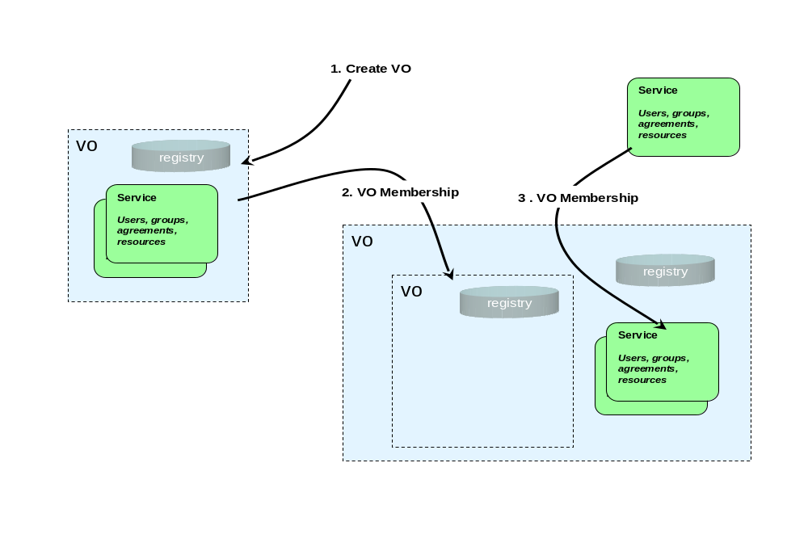

List of detailed services
VOs can either be stand-alone or can be combined in a hierarchical containment structure that supports modeling the collection of resources in grids as a set of nested contexts.

Create/Destroy VO – It is expected that VOs will be represented in the service oriented architecture as services and so the general factory pattern should be employed by VO Management Services to allow creation of new VOs. The Create VO service should be modeled as a “factory” that will establish a new service and a reference (handle) for that service that will be used to “address” request to the new VO. This reference may also serve as a context identifier in the requests (made by users or other services) that are related to a particular VO. VO Management mechanisms should exploit the mechanism for managing service lifecycle (OGSI soft-state) management function of OGSI to establish an initial “time to live” for the new VO which may be updated as resources, users, groups and polices are join and/or leave the VO. An explicit operation may also be provided to destroy a VO. When a VO is eliminated all relationships that are embodied by that VO are also eliminated. Though interfaces to create new VOs (factories) should be provided a default VO in a given grid implementation may be extant (without explicit creation), serve as a “root container” and may depend on external means (such as DNS names or configuration files) for discovery of its handle.

Relationship to Policies - As with other “factory” interfaces policies (modeled as Agreements) may be used to specify the requirements for creation of a VO. These policies may contain information that describes how the VO responds to specific requests and how behaves under specific conditions. The specific components (terms) of these polices (Agreements) may affect both the operation of the VO itself and indirectly also the behavior of entities that are related to the VO. For example some policies might establish restrictions for membership of entities in the new VO such as requiring resources and users to support particular security or authorization mechanism to be able join the VO.

In addition to the policies established by Agreements used in creation of VOs additional policy templates (Agreements) themselves might be “related” to VOs by the membership mechanism described above. These policies might be applied either as requirements or defaults to requests that carry a “context” of the VO in the “terms” of their Agreements.

VO Membership Services – The services that represent a VO may support a set of operations for managing the relationship of other entities to the VO. This membership operation can be used to add/or delete a relationship of any entity (including an already extant VO) to a VO. Once again the services for managing Virtual Organizations (VOs) should be built upon the general mechanism for grouping services (OGSA Service Groups) and one or more of these collections may be used as a mechanism for maintaining associations of users, group, resources and policies with the VO.

In particular in addition to recording the relationship of an entity to the VO these membership functions may also update state data related to VO by storing context information (probably the VO reference) in an element associated with the service that represents the entity. Since entities (VOs, users, resources, policies) may be related to more than one VO these “back pointers” are actually lists of the VOs the entities are associated with. The service implementing a VO may also subscribe to events or notifications to enable it to monitor the state of entities related to a VO so that it can update its information if entities are destroyed either explicitly or automatically by life-cycle functions. As with many such structures it is difficult to guarantee the consistency of the both the primary registry entries and the “back pointers”. While the information in the VO Registry is considered authoritative, the “back pointer” information in the service data of members of the VO is only contingently consistent and should be verified by any service that requires authoritative evidence of membership for function like security, trust or authorization.

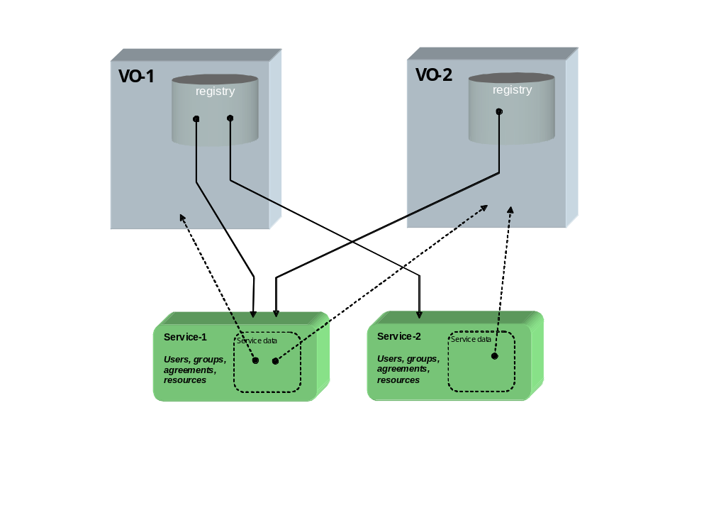

VO Registries –VO Registries enumerate the “population” of entities that are related to a VO. The specific nature of different sorts of entities and their relationship to the VO can be recorded in the registry as a set of attributes in one or more indices. VO Registries permit queries to be supported against the membership of the VO that will allow resource managers to discover these relationships. For example a management component like a scheduler might execute a query against one of these service groups to retrieve a list of a particular class of resources that are available as elements of a VO.

The Membership Service described above act to maintain the registry of all the entities that are related to VOs. When new relationships between extant entities (including VOs) are made using the Membership Services entries for them will be added to these indices. These registries can also be maintained by exploiting the general mechanism for state change propagation (OGSI Notification) to permit “pruning” of these indices when entities change their relationship to VOs. The content model for these indices should contain information that will allow both people and programs using and managing the grid to discover VOs that are of interest to them. Specifically some type of index of attributes for VOs should be implemented that can contain general information that records things like: externally readable names for the VO, the purpose the VO was created to serve, the organization that is responsible for its management, etc.

Underlying services
VO Services as described above rely heavily on the Service Group/Collection mechanism supplied by OGSI. They may also utilize the soft-state life-cycle mechanism and notifications to bind the relationships between VOs and the entities that make them up and maintain consistency of the registries with the state of the actual services that represent those entities.

VOs Services also rely on the OGSI-Agreement framework to define a general mechanism for management of VOs. A specific set of Agreement terms will have to be defined that will be particular to policies that control the management of the VO Creation and Membership Services. These will include terms that may define roles with respect to the VO management (e.g. what requestors are permitted to add to, change, or delete relationships of other entities to the VO). They might also include terms that will enforce requirements for adherence to particular functional policies (e.g. security, privacy or trust methods, metering, auditing or accounting mechanism, resource usage limitations).

Related standards
OGSI
WS-Agreements

Owner WG
OGSA Working Group

