fOperating Framework for a Virtual Connection Network

Using the NPG framework to describe a network of networks

John Vollbrecht, Leon Gommans
October 11, 2012

Introduction

A Network Provider Group (NPG) is a virtual network using resources from autonomous networks each of which provide resources to the group. The NPG framework describes how the organizations of such a group collaborate with each other to create the virtual infrastructure that allows users to make connections between network edge points.

The Network Provider Group is an instance of a Service Provider Group (SPG) as described in XXXX, where the service being provided is a connection.

An NPG allocates resources from participating networks to a connection for a period of time. Resource allocation to one connection means that it is not available for someone else. The allocation of resources requirement means that the NPG and its members network must have some way to track and reserve components used by the connections they make. Some examples of connection networks are the telephone network initiated in the late 1800s, the X.25 and ATM networks built in the 1970s and 80s, and various versions of “software defined network” that are being deployed and evaluated today.

Connection networks are defined here in contrast to packet networks such as the Arpanet and the IP Internet that multiplex packets in a best effort manner over shared resources.

Each network in an NPG is autonomous and may be part of many NPGs. The network contributes resources to a connection for an NPG for a period of time and may offer the same resource to a different NPG at a different time. An NPG has no resources of its own.

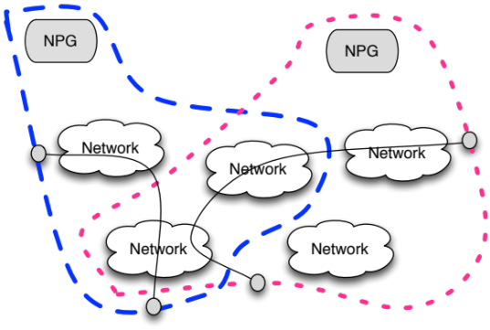
Fig 1 Networks in multiple NPGs

Networks participating in an NPG allocate a resource exclusively to an individual connection. This capability is needed by software defined networks currently being developed to support applications such as big science sharing experimental and computing resources, outsourcing applications providing guaranteed connectivity to cloud computing, and IP network providers dynamically provisioning connectivity between routers.

An NPG makes a connection by concatenating segments from member networks. NPG virtual networks determine which member resources to set up, maintain and tear down for a particular connection. The infrastructure that connects networks such that segments can be concatenated is assumed to be present. The NPG framework describes organizational aspects of creating, using and modifying the NPG capabilities.

The NPG framework assumes that the requestor of a connection is known by a user organization which is known by and accountable to the NPG for the actions of the user. The user organization mIght be a University, a company, an ISP, or a virtual organization with members authenticated by other organizations. The combination of user organization and NPG might collaborate with computing, storage and other resource providers to interconnect the resources for a user. This paper deals only with the Network Provider Group though we hope that some of the ideas are useful in developing Grid capabilities

Overview of Network Provider Group

An NPG has two main organizational dimensions: 1) its relationship with users of the group; and 2) its relationship with providers within the group. For both of these dimensions the NPG has three levels: organization, policy and operation.

NPG dimensions

The two dimensions allow one to look independently at the NPG: externally, as it interacts with the user; and internally, as its providers interact to create these services.

From the user view the NPG is a provider of service to the user. The user and NPG have a service agreement that defines the way the two organizations interact.

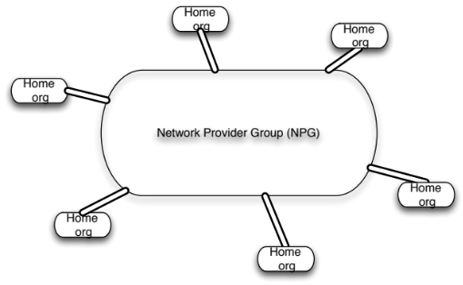
Fig 2 External view of NPG

From the provider’s view the NPG is an organization made up of a set of autonomous providers interacting with each other to provide connections. Providers in an NPG include those providing connection segments and those that provide support services such as network topology and connection monitoring. The interaction is coordinated by NPG agents.

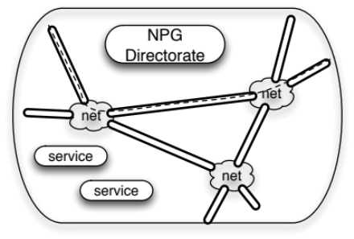
Fig 3 Internal view of NPG

NPG Levels
Levels describe organizational capabilities and the functions carried out at the level. Each level has agents from NPG provider and userorganiation. The agents carry out the functions of the level and are coordinated by NPG agents.

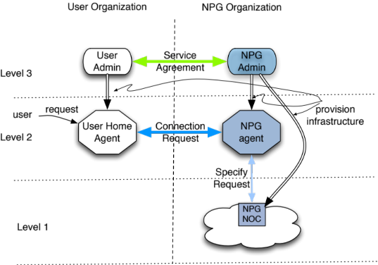Fig 4 User view of Level Interaction

Figure 4 shows the user view of levels. At the enterprise level [L3] the user organization and the NPG create an agreement defining characteristics of service, how it will be used and responsibilities of each side. At the policy level [L2] a connection is requested and if approved it is scheduled for the operation level. At the operation level the connection is instantiated and monitored.

Figure 5 shows the internal view of levels. In each level the NPG agent coordinates the activity of providers.
The coordination is based on agreements between the NPG and providers.
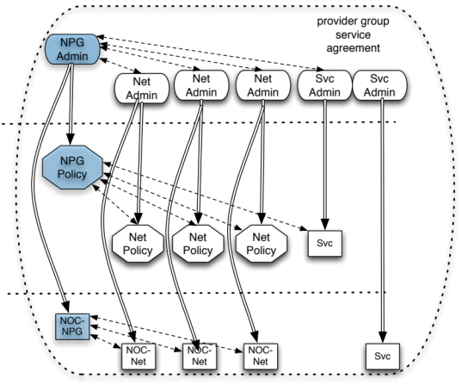
Fig 5 Provider view of level

At the enterprise level [L3] the NPG admin agent establishes agreements with each provider that define responsibilities and liabilities for providing the NPG service. At the policy level [L2] the NPG Policy agent coordinates other agents to decide if a request can be satisfied and if so which providers will contribute resources to it. The operation level [L1] controls the physical connection; the NPG NOC agent coordinates provider agents in establishing, monitoring and auditing connections.

Example of NPG coordination
At L2 the NPG receives a request for a connection with particular attributes. One of the attributes might be reliability. The user cares about reliability of the whole connection. Each provider segment cares about its own reliability and the relationship of the two must be calculated. [see example box]

The NPG agent at L2 is responsible for correlating user and provider attributes for a particular connection.
Connection reliability example

Suppose user requires 95% reliability.

Two segment connection
requirements derived below.

User Reliability UR = .95
Segment 1 Reliability = S1R
Segment 2 Reliability = S2R
By definition UR == S1R x S2R

For identical segment reliabilities

SR**2 >= .95
SR >= .975

The correlation is done by agents of the participating organizations. The agents may be people, computer processes, or some combination of both. Coordination may be done by detailed rules or by open ended negotiating.

One approach is to have the user specify a minimum requirement and the NPG find a set of segments that meet or exceed the requirements. Another is to determine a range of possible requirements based on provider availability and let the user decide the connection that best fits its needs. Either way it is done by an NPG specific agent.

NPG and Principals

Every organization has a Principal which is responsible for the actions of the organization as a whole, to whom agents are accountable and who is accountable to other Principals. Each provider and home organization participating in an NPG has a Principal.

In a small business the Principal might be the owner, in a corporation it would be the board of directors, in a group formed by a set of networks such as GLIF it might be an exective board, for an individual acting alone it is its the individual.

An NPG is a virtual organization and also has a Principal. An NPG Principal is ultimately accountable for commitments the NPG makes to users and for enforcing agreements among providers.

An NPG Principal could be a corporation operating the way MasterCard coordinates banks, an executive, an executive appointed by a group of National networks who collaborate to provide a connection service.

When participating in an NPG, a Principal delegates responsibility and authority to an Enterprise [L3] agent. The L3 agent delegates authority and responsibility to L1 and L2 agents. In this way each agent gets its authority from the Principal.

Figure 6 shows an NPG conceptualized as a virtual provider organization which has three organizational levels. The NPG Principal delegates authority to the Directorate, and the Directorate coordinates activity at each level. The provider Principals delegate to agents at each level the authority to participate in NPG activities under conditions defined in policy defined by the Principal.

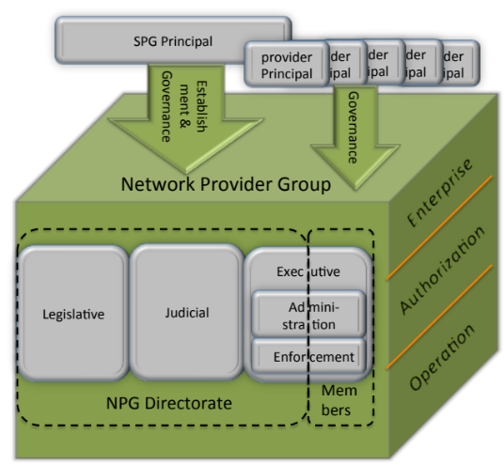
Fig 7 NPG and Principals

This description of an NPG, its Directorate and providers and the Primcipals of each is a basis of defining an Authentication and Authorization model for the NPG and its users. Section 5 starts to define such a model.

Creating a Network Provider Group

This section discusses how an NPG might be created. The purpose is to give insight into following sections describing Authentication and Authorization requirements as well as show how it provides a framework for organizations to work together in a variety of ways. Yet another goal of this section is to give some insight into what is required to put together such a group.

Preconditions for an NPG
An NPG uses Network and service providers to do the actual work of an NPG. To create an NPG these resources must be in place.

If such providers do not exist then an NPG cannot be formed. If they do exist they must be able to collaborate with each other. One part of collaboration is to physically interconnect with each other. Another is for providers to use a set of common message exchange protocols to coordinate with each other.

Physically Interconnected Provider Nets

A Provider net creates connections between edge points. Logically it is a distributed switch where a connection can be made between ports on the edge of the network (see fig 8). Each port can multiplex one or more connections. Users attach to the network at ports and make connections using slots on the port.

Connections on provider net last for a period of time.

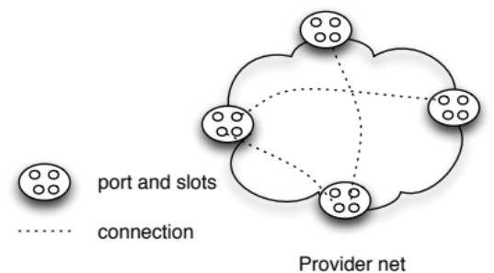

Fig 8 Ports, slots and connetions

To create an NPG, provider nets must be attach to each other at ports.
Such a port is called a networked port, as opposed to a user port. Networked ports must have corresponding multiplexing slots. A connection that crosses multiple networks is made by creating segments in each network and concatenating them at networked ports. Figure 9 below shows this.

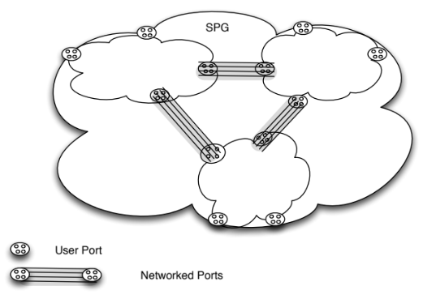

Fig 9 Provider Nets interconnected

Note that ports and slots have characteristics which may be different. When ports with different characteristics are connected, the lesser characteristic applies to the connection as a whole.

Provider Agents

To participate in an NPG the provider nets must have a way that connections can be initiated and monitored. This requires policy and control agents. Policy agents decide whether the requestor is authorized to make a particular connection and whether resources are available. The control agents create connections authorized by the policy agent

An infrastructure of provider networkss with policy and control agents is needed to start an NPG.

A potential NPG may need to work with potential providers to agree on messaging protocols. Once the NPG is operating, new providers implement these exchanges. The NPG can modify these protocols as appropriate over time.

The agents may be people, computer processes, people using computer to aid them, or computer process which requires user input. An NPG might start with one type of agent and evolve to another. For example, policy agent might initially be an engineer who makes decision based on written policy. At some point a computer process might evaluate the request and resource availability, recommend a set of resources, and ask the engineer for permission to implement. That could evolve to agents communicating directly and making decisions based on automated policy.

Create an NPG Principal

This section considers what motivates the desire to start an NPG and the kind of Principals that might be created. The NPG Principal delegates responsibility to agents of provider Principals based on agreements between Principals.
The following considers two scenarios for creating an NPG.

Scenario 1 - Initiated by group of Providers

An NPG might be initiated by a group of providers that each need to extend the capabilities of their network so that users on one can connect to users on another. They initially physically connect their networks and assign engineers to be policy and control agents. They define loose reliability and availability attributes to NPG created connections so providers have no liability. This provides best effort service with no risk to the providers, and no certainty to the users.

The Principal in this case is a loose group of providers who create a shared messaging protocol for defining and instantiating connections. This may be done by phone or email and use standard forms for clarity. The group may define a computer protocol for communication to simplify connection initiation if the number of users grows.

If the NPG wants to go beyond best effort, the Principal needs to have power to define standards, to provide resources to users and to allocate liability to providers who do not meet commitments.

Scenario 2 - Initiated by Organization to provide service
In this scenario an organization sees that a connection service is needed and could be created by combining capabilities from several existing providers. The initiating organization becomes the Principal and defines the service to be provided to users and the service required from providers. The Principal accepts liability for connections provided to the user and allocates liability to providers. Allocation of responsibility is done by legal agreements – service agreements.

The Principal creates and modifies agreements as user and provider requirements and abilities evolve. The Principal may create user and provider organizations to suggest needed modifications.

Users choose to use the NPG and providers choose to participate in it. The Principal is responsible for making if worthwhile for both and for itself.

Role of Principals in Authorization

The NPG Principal decides what risks it is willing to take, accepts liability for connections and allocates liability to providers for segment of the connection. A business decision is made based on risks, rewards and liabilities.

The NPG Principal defines what types of connections an NPG will provide. It is accountable to the user for the quality and capabilities of a connection. It delegates responsibility to provider Principals for portions of a connection. A provider must know that a request for a segment in an NPG is authorized by the NPG Principal.

A provider Principal is accountable to the NPG Principal for the service it provides. It must authorize any segment it provides to the NPG which acknowledges its responsibility.

The user Principal accepts the service defined in its agreement and its liabilities.

Authorization Model

This section discusses how Principal and agents delegate responsibility delegate authority and responsibility within each organization and how they use service agreements to manage interactions between organizations. The discussion here deals assumes an NPG Principal and a single home and provider Principal. At the general level the cases are identical. How this is implemented depends may be different in different deployments.

NPG initialization
Each NPG Principal provides credential to it agents which show the agent is authorized to act for the Principal in defined ways. One way of doing this would be with an Authentication Certificate. RFC 2904 describes other ways this might be accomplished.

Principals exchange keys that validate their credentials to each other.

The NPG Principal makes a list of key/ Principal combinations that it makes available to its agents.

Each user and provider Principal makes the key/Principal combination of the NPG available to its agents. Note that these Principals may be part of more than one NPG so they may have a list of key/Principal combinations.

Enterprise Level Authorization

At the enterprise level provider and home org L3 agents make a service agreement with the NPG L3 agent. They offer credentials from their Principal and check each other’s credentials using key/Principal information received from their Principal.

At this level the agents take information from their Principals and create a detailed service agreement, and each turn the agreement into a set of policy rules for its L2 agent and operating rules for its L1 agent.

Policy Level Authorization

At this level the agents are dealing with requests for connection, determining what the user is allowed to do and what providers are willing to do. Policy level [L2] agents validate each other’s credentials in the same way that enterprise agents do. Each uses the other’s to access their policy for this request.

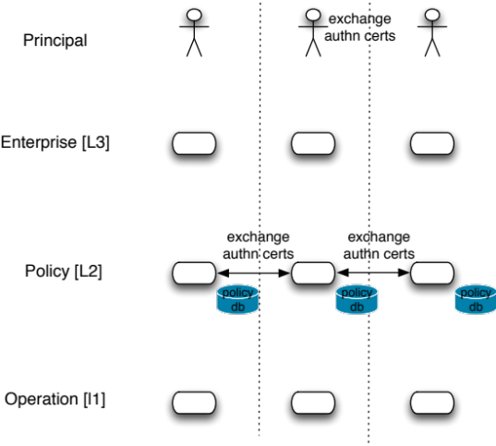
Fig 9 use Principal identify to select policy

Operation Level Authorization

Operation level provider agents get connection specifications based on L2 requests. Operation agents only act on requests authorized by their own L2 agent.

NPG operation level agents get requests from user agents for information about a connection and get information from provider agents. These validate each other’s credentials in the same way that enterprise and policy agents do.

Summaryv

OGF-NSI uses the term STP Service Termination point for slots and STP Group for Ports
NSI uses NSA for policy agent and NRM for control agent
To be defined – Open Flow, SDN
RFC2904 ---

